KNX and Multimedia
KNX Association

Table of Contents
1 General 3
1.1 Foreword 3
1.2 Definition of Multimedia and Multimedia Systems 3
2 Types of multimedia systems 4
2.1 Audio Systems 4
2.1.1 Typical Audio Systems 4
2.1.2 Extended Audio System 4
2.2 Intercom Systems 5
2.2.1 'Audio to Audio’ Intercom Systems 5
2.2.2 “Audio and Video” to “Audio and Video” Intercom Systems 6
3 Integration of multimedia control systems in building system technology 7
3.1 Basic Controls on the Multimedia Systems 7
3.2 Basic Principles of Multimedia Systems 8
3.2.1 “Audio System” controllable via KNX 8
3.2.2 ”Audio via IP” System controllable via KNX 12
3.2.3 Intercom System directly controllable via KNX 13
3.2.4 “Audio and Video to Audio and Video” Intercom Systems controllable via KNX 14
3.2.5 Intercom system controllable via a KNX/IP interface 15
3.2.6 ”Intercom via IP” System controllable via KNX 16
3.2.7 Multirooming 17

NOTE: THIS CHAPTER IS INTENDED AS AN INFORMATIVE APPENDIX TO THE ADVANCED COURSE

General

Foreword
Multimedia technology has developed quickly in recent years. Nowadays, multimedia systems have high standards as regards the audio and video quality which the user can utilise in daily life. It offers him the opportunity to make his daily life more convenient and safer.
Nowadays a door intercom system is fitted as standard in most new buildings. In the high-end construction sector, regardless of whether it is a private or commercial building, in addition to the transmission of sound, it extends communication with a unidirectionally transmitted image. An option is therefore created to see who is standing in front of the door and whether the person is alone or accompanied by another person.
Furthermore, some functional buildings such as airports, public authorities or railway stations frequently use audio/video technology which makes current information available to the customers. Flight times, delays or current offers etc. are thus circulated via audio information or visually.
Nowadays, multimedia systems adopt a permanent, if frequently unconscious place in our daily lives, regardless of their scope or design. We are now at the next step of being able to integrate these systems in building automation system and to control them.

Definition of Multimedia and Multimedia Systems
The term “multimedia” stands for a system or transmission technology which enables different content and formats to be routed or played back.
It can include a combination of audio, video, still images, text or even animation.
A “multimedia system” frequently represents a combination of different multimedia components which together produce a functional system. These components can in most cases record and play audio content or even display the multimedia content.

Types of multimedia systems

Audio Systems
An audio system generally consists of electronic equipment for recording or reproducing sound. In order to be clear, we are going to distinguish audio systems in two categories.
These are: “Typical audio systems” and “Extended audio systems”.

Typical Audio Systems
A typical audio system contains one audio source and one audio output, e.g. an MP3 player with a connected headset. This is the simplest representation of an audio system.

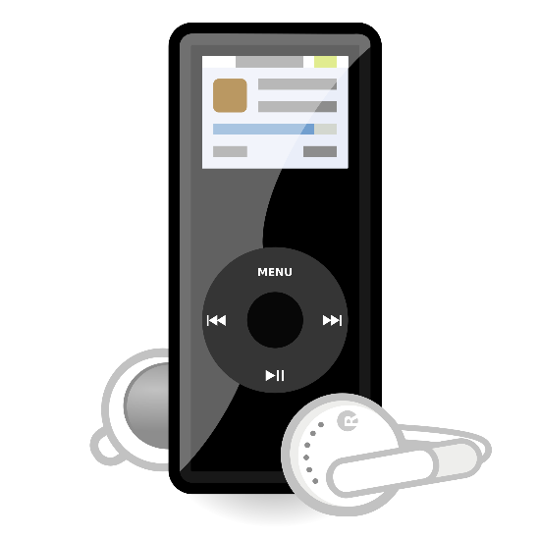
Figure 1: Digital MP3 player

Extended Audio System
An extended audio system can contain different audio sources, an audio mixing unit and various audio outputs. A typical application is for example concert halls where various microphones are used to transmit the tone from different musical instruments to an audio mixing unit and amplifier (analogue or digital). The properties of each input can then be selected and set on these two components.
A number of loudspeakers can be connected to the output of the audio mixing unit to reproduce the required tone. Amplifiers can be connected to the microphone and/or the loudspeaker cables so that the signal can be transmitted without any loss.

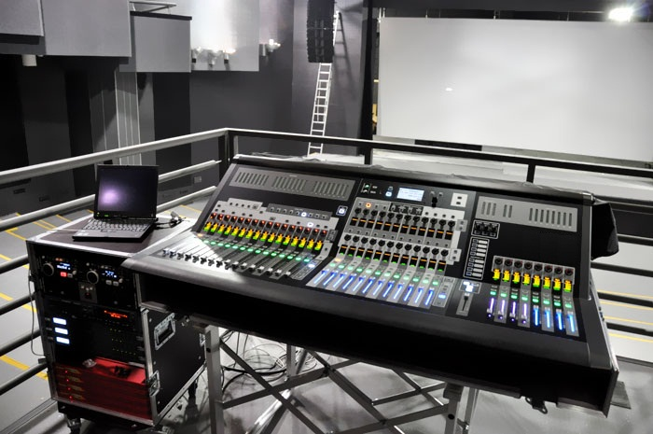
Figure 2: An extended audio system with a digital mixer

Intercom Systems
An intercom system basically consists of two devices, a transmitter and a receiver, similar to the KNX sensor/actuator technology. Each device combines the two functions which work bidirectionally. Generally both act as a transceiver which means they can both send and receive.
Using the transceiver type, it is possible to divide the intercom systems into two categories.

'Audio to Audio’ Intercom Systems
An “audio to audio” intercom system usually consists of two or more devices which are frequently equipped with an audio recording and playback function. A participant talks to and listens to another participant from the same system.

Note: In some cases, these types of intercom systems use call centres to connect the participants. To save time and space, we must restrict ourselves to the description of peer-to-peer intercom systems.


Figure 3: An “Audio to Audio” intercom system

“Audio and Video” to “Audio and Video” Intercom Systems
The “audio and video” to “audio and video” intercom systems consist of cameras and audio devices with recording and playback functions. Participants from this type of system can both see and listen to each other.

NOTE: A variant of this system is the door intercom system which enables the user inside the building to see the visitor outside the door but does not allow the visitor to see the user inside the room. Both participants can speak and listen to each other.
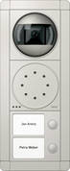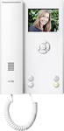
Figure 4: A door intercom system

Both these categories can have extended functions, such as sending and receiving data to other devices or systems. A common example is the door opening function by pressing a button, or recording the calls to a video recording device, if nobody has opened the door when the doorbell is pressed. Moreover, the intercom systems have also started to use IP technology as a transmission medium, extending their functions.

Integration of multimedia control systems in building system technology

Basic Controls on the Multimedia Systems
In the framework of building automation, we focus on controlling multimedia systems that offer extended functions realised with a bus system.

Therefore, we can maximise the control of the audio system by implementing the following functions with KNX, thereby increasing comfort:
- Zone on/off
- Volume adjustment
- Source selection
- Mute
- Tone control
- Zone broadcast
- Select radio station
- etc.
A feedback response can be received for the following functions too:
- Amplifier on/off
- Volume level
- Source name
- Title of the current song
- Title of the radio station or RDS
As far as intercom systems are concerned, some of the available functions that can be implemented on KNX are the following:
- Door unlocking
- Recording date and time of calls
- Recording the picture of the person who might have called
- Triggering of other functions via KNX (such as lighting control when the door is opened, enabling the alarm system, etc.)
- etc.
A feedback response can be received for the following actions:
- Status of the door (open or closed, locked or unlocked)
- Displaying the details of missed calls
- Displaying the picture of the person who has made a call
- etc.

Basic Principles of Multimedia Systems

“Audio System” controllable via KNX
The following example shows an audio system which communicates directly with KNX.

Figure 5: An audio system which can be controlled directly via KNX

The audio sources i.e. the CD player, tuner, music server or microphone are connected to the amplifier. This amplifier “strengthens” the analogue input signals so that they can be transmitted over longer distances without loss or disruption. The outputs of the amplifier are connected to the inputs of the audio actuator. This includes an integrated KNX bus coupler to enable control signals to be received and converted.
It is possible that an audio amplifier is needed at the output of the actuator to achieve better quality of the signal at the input of the speakers.
As this audio actuator is a KNX device, it can be parameterised and programmed using ETS. Some of the available group objects are:
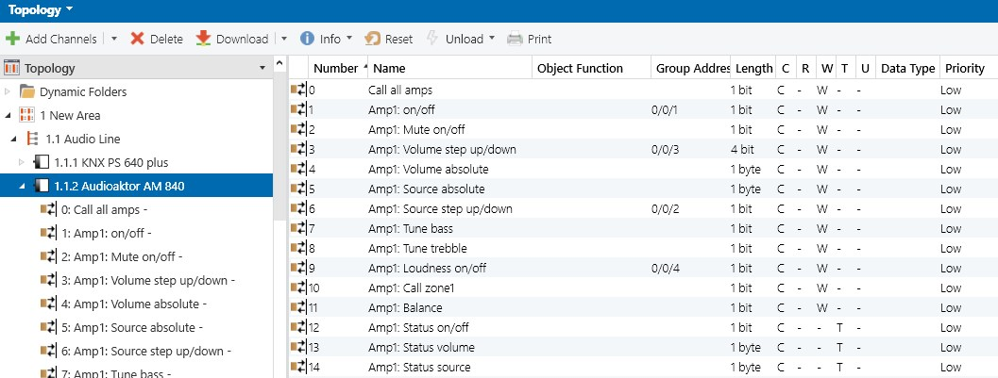
Figure 6: List of the group objects

No. | Name | Function
1 | Amp 1: on/off | 1-bit telegram, to switch on or off channel 1 of the actuator
2 | Amp 1: Mute on/off | 1-bit telegram, to switch on or off the sound of channel 1 of the actuator
3 | Amp 1: Volume step up/down | 4-bit telegram, to set the volume up or down of channel 1 of the actuator
4 | Amp 1: Volume absolute | 1-byte telegram, to set an absolute volume value (e.g. 50%) to channel 1 of the actuator
5 | Amp 1: Source absolute | 1-byte telegram, to set an absolute source value (e.g. set the tuner’s frequency to 97.1) to channel 1 of the actuator
6 | Amp 1: Source step up/down | 1-bit telegram, to select the source of audio for channel 1 of the actuator
7 | Amp 1: Tune bass | 1-bit telegram, to select the level of bass of channel 1 of the actuator
8 | Amp 1: Tune treble | 1-bit telegram, to select the level of treble of channel 1 of the actuator
9 | Amp 1: Loudness on/off | 1-bit telegram, to switch on or off the loudness effect for channel 1 of the actuator
10 | Amp 1: Call zone 1 | 1-bit telegram to activate zone 1
11 | Amp1: Balance | 1-bit telegram to select the balance of channel 1 of the actuator
12 | Amp 1: Status on/off | 1-bit telegram, to read the actual status of channel 1 of the actuator
13 | Amp 1: Status volume | 1-byte telegram, to read the actual volume status of channel 1 of the actuator
14 | Amp 1: Status source | 1-byte telegram, to read the actual source status of channel 1 of the actuator

A common application for the end user is the use of a 4-fold push button to switch on the audio system and to select CD player 1 as the audio source. Moreover volume control of the speakers in this room could also be possible. The group addresses that are needed are those that control these elements:
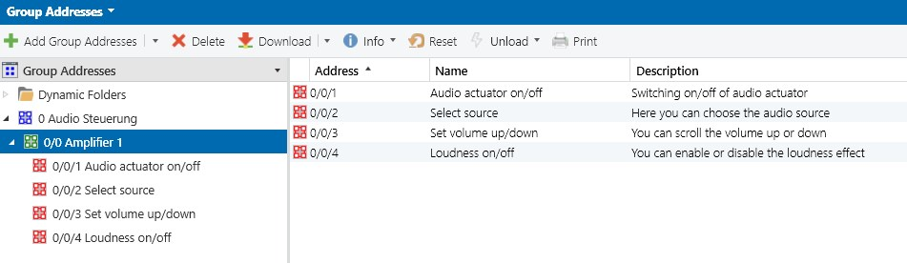
Figure 7: List of the group addresses

The group objects of the audio actuator, but also the group objects of the 4-fold push button have to be linked to the corresponding group addresses, as shown in the image below. The speakers of the desired room are connected to ‘Channel 1’, so that all the indicated controls refer to ‘Channel 1’.

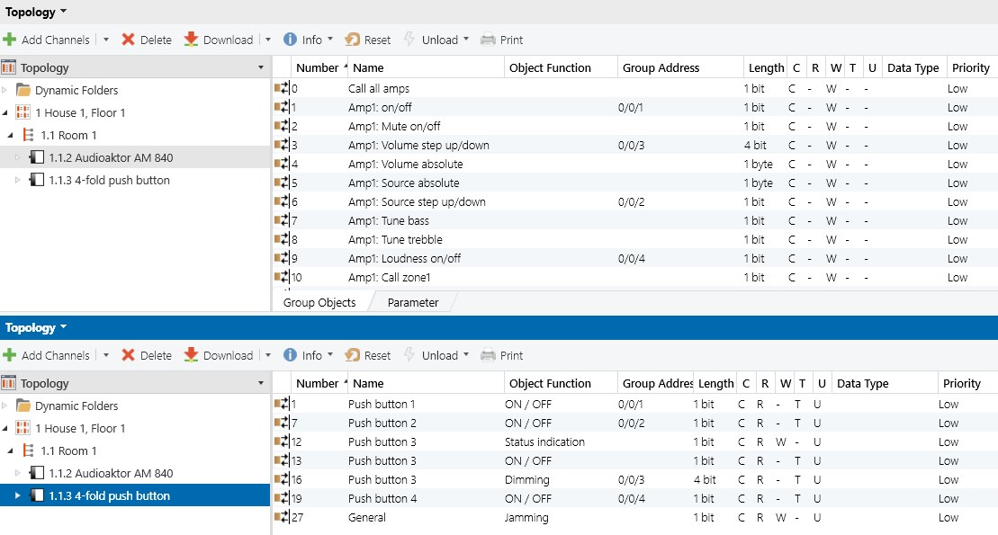
Figure 8: Linking group objects with the group addresses
With the above configuration, the end user can:
- switch the audio actuator on or off by using push buttons 1 and 2
- select audio source by using push buttons 3 and 4
- scroll the volume up or down by using push buttons 5 and 6
- enable or disable the loudness effect by using push buttons 7 and 8

Another common solution for controlling audio systems is represented in the diagram below. The audio system is linked via a KNX/IP interface with KNX.

Figure 9: Audio system control via a KNX/IP gateway

While in the previous solution the communication is realised directly from the audio actuator to the bus, this solution uses an indirect connection between KNX and the audio system using a KNX/IP interface. That means that the central unit is no longer a KNX addressable device but an IP network addressable device using TCP/IP for communication. Moreover, as an IP device the audio system can also be controlled by other multimedia devices with an IP interface, such as touch panels, computers or mobile devices.

”Audio via IP” System controllable via KNX
The following example shows an “Audio via IP” system, which communicates with KNX via a special KNX to IP gateway and sends control signals.

Figure 10: An “Audio via IP system” controllable via KNX
The audio central unit consists of two segments. The first segment has analogue inputs, to which all audio sources are connected. The second segment consists of a network interface (TCP/IP) that also acts as an analogue-to-digital converter. Thus, the analogue signal from the audio sources is converted to digital and is transferred to the speakers via the IP network.
The speakers also contain a network interface, which converts the digital signal from the network to analogue in order to be reproduced at the speakers.

The communication with KNX is implemented with a special KNX/IP interface. This interface is configured so that data is transmitted from KNX to the audio system and vice versa. That gateway is both a KNX addressable device as well as an IP network addressable device.

It is important to mention that the term ‘multiroom audio controller’ is used by most of the KNX manufacturers producing devices for audio control, which are either equipped with a KNX BCU or a KNX/IP interface.

Intercom System directly controllable via KNX
The following example shows a door intercom system as a sub-category of intercom systems, which communicates directly with KNX.

Figure 11: Door intercom system controllable via KNX

Door intercom systems – apart from the voice communication function – usually have a number of command functions such as “Door unlocking”, “Switch on” or “Switch off” the luminaire in the immediate vicinity of the door.
Through the integration of a door intercom system into the KNX world, the scope of the building functions is increased. Added value can be generated by using the existing KNX devices available such as actuators. For example, to activate the control of one or more switching channels with diverse lighting circuits, when the door bell has been pressed and the external brightness has fallen below a certain level. Functions can also be triggered to other systems or secondary reactions such as “arming” the alarm system.
KNX can in turn extend the functionality by managing the sources of the door intercom system i.e. the input signals of the door station and the bolt contact to route them to the KNX and trigger the parameterised functions. KNX can also record the details of a visit such as the date and time when the person rings on the door. An image or a short video including a soundtrack could for example be stored.

“Audio and Video to Audio and Video” Intercom Systems controllable via KNX
The following example shows an “Audio and Video to Audio and Video” intercom system (door video phone system) which communicates directly with KNX. The functionality is the same as the ‘Audio to Audio’ intercom system, extended with video communication.

Figure 12: A door intercom system with video telephone

Intercom system controllable via a KNX/IP interface
A further solution for controlling the intercom system is using an IP intercom controller. This is addressed via a KNX/IP interface to trigger or apply functions. Therefore, the intercom system is an IP addressable device and can be accessed by all the IP devices as it works like a computer as a device in the IP network.

The controllable system can be either an “Audio to Audio” or “Audio and Video to Audio and Video” intercom system, or even a combination of these systems.

Figure 13: Door intercom system controllable via a KNX/IP interface

”Intercom via IP” System controllable via KNX
This example shows an IP intercom system, controllable via KNX. This is a fully digital solution which is offered by various manufacturers. The greatest advantage is that all the components have IP capability and can be accessed by all the devices in an existing network. It therefore does not require its own infrastructure such as cables etc. but can be based on an existing structure or extended.

Figure 14: “Door intercom via IP” system controllable via a KNX/IP interface

Multirooming

The term multiroom or multirooming refers to the possibility of hearing and controlling music in each room of the apartment or house. The user is therefore not only limited to audio but there are also systems available for video transmission.
A multiroom system distributes a certain number of sources in the individual multiroom zones. The zones are defined areas in which the source is reproduced. Zones can extend over individual rooms or over several rooms. In this context, the sources used can be classic playback devices such as a radio or CD player. Streaming services, internet radio and NAS storage can however also be used. A prerequisite for this is an appropriate playback device.
It should be possible for the user to integrate this system into the system as a whole and the control should be uncomplicated. The residential or commercial environment should be analysed precisely and a cable-based or radio-based system selected depending on the environment.
KNX manufacturers count on established hi-fi manufacturers for multirooming and have corresponding cooperative partnerships. The control can be implemented via KNX sensors and the KNX signals are routed through a gateway to the systems of the hi-fi manufacturers.

Figure 15: Multirooming system controllable via KNX

