Security Technology
KNX Association

Table of Contents
1 Basic Principles 3
1.1 General 3
2 KNX and Intruder Alarm Technology 5
2.1 General 5
2.1.1 Structure of a VdS Alarm System 5
2.1.2 KNX Alarm Control Unit 6
2.1.3 VdS-certified KNX Alarm Control Unit 7
2.1.4 Monitoring Functions with KNX 8
2.2 Installation and Topology 9
2.2.1 Installation 9
2.2.2 Topology 9
2.3 Project design 11
2.3.1 Group Addresses 11
2.3.2 Parameters 12
2.3.3 Flags 13
2.4 KNX Devices 14
2.4.1 Power Supply 14
2.4.2 Binary Input 14
2.4.3 Binary Output 16
2.4.4 Sensors 17
2.4.5 KNX Zone Terminal 19
3 Informative Appendix 20
3.1 Sensors 20
3.2 Intruder alarm control unit 21
3.3 Alarm 21
3.4 Setting / Arming Device 22
3.5 Panic Alarms 22
3.6 Monitoring 22
3.6.1 Opening Surveillance, Lock Monitoring 22
3.6.2 Peripheral Protection, Surface Surveillance 26
3.6.3 Interior Surveillance 27
3.6.4 Tamper Monitoring 30
3.7 Groups 31
3.7.1 Zones 31
3.7.2 Sabotage zones 33
3.7.3 Lock Zones 33
3.7.4 Set Zone 33
3.7.5 Panic Zone 34
3.7.6 External Local Alarm Signal 35
3.7.7 Internal Local Alarm Signal 35

NOTE: THIS CHAPTER IS INTENDED AS AN INFORMATIVE APPENDIX TO THE ADVANCED COURSE

Basic Principles

General

Intruder alarm systems are technical installations which are used to protect property and people. The main tasks of intruder alarm systems include:
- preventing break-ins and theft
- alerting people to provide assistance (police, security guard)

Depending on the programming, the intruder alarm system reacts e.g. if a person breaches the outer shell of the building or breaks into protected premises.
The most well-known type of alarm is the acoustic alarm which is combined in most cases with an optical alarm. The intruder alarm system also enables an alarm to be issued via the public telephone network e.g. to notify the police or security company. The issue of alarms using visual/acoustic signalling devices has the greatest deterrent effect as the attention of the neighbourhood is concentrated on the property that has triggered the alarm. Special care must be taken when planning and commissioning the intruder alarm system as well as the briefing of the operating personnel in order to avoid false alarms.
Experience has shown that people in the surrounding area no longer react to intruder alarm systems after a few false alarms and therefore do not pay attention to a real alarm. In this case, even the best alarm system becomes pointless. It is not possible to make a general statement about which is the best type of alarm as each intruder alarm system is tailor-made to the property and location in terms of its design and functional scope.

Panic alarm systems offer the user the possibility of triggering an alarm manually. As with the intruder alarm system, a triggered alarm can be optical, acoustic and/or silent. The triggering can be carried out e.g. via a visible push-button alarm or a hidden switch. For example, a bank trips the alarm using a hidden device which is then sent silently to the police via the public telephone network. The functions of the panic alarm system can nowadays be implemented in the majority of intruder alarm systems.

There are also hazard warning systems available. Alarm system is the collective term for:

- Fire alarm system
- Intruder alarm system
- Panic alarm system

The hazard warning system offers additional protection against:

- Water leaks, burst pipes
- Gas leaks

In principle, a distinction is made between intruder alarm systems with VdS approval and without VdS approval.
The VdS guideline for the planning and installation of intruder alarm systems VdS 2311 divides intruder alarm systems into the categories A, B and C, where class A corresponds to the lowest security risk and class C is the highest risk.

Class A:

- Low protection against sabotage attempts
- Detectors have a medium level of response
- Only suitable for monitoring non-commercial risks

Class B:

- Medium protection against sabotage attempts
- Detectors have a medium level of response
- Monitoring of the system for sabotage and functional reliability

Class C:

- Increased protection against sabotage attempts
- Detectors have an increased level of response
- Monitoring of the system for sabotage and functional reliability

For intruder alarm systems without VdS approval, there is a subdivision into systems which are implemented using VdS-approved components and systems using components without approval.
When implementing an intruder alarm system, it should be ensured that all the components used have VdS approval (denoted by a number code). The VdS approval should be judged in this context like an MOT certificate, CE mark or a comparable distinction.

KNX and Intruder Alarm Technology

General
KNX enables simple security and monitoring applications to be implemented. The requirements that are placed on the property or the installation must be taken into account. It is not possible to set up intruder alarm systems in line with VdS. You can determine whether a VdS system is required from the structural constraints or insurance standards.

It should be pointed out only “simple” applications can be implemented. In addition, systems, which have been implemented with KNX, cannot be called intruder alarm systems. The term ‘information centre, information system etc.’ is used to avoid confusion.

Structure of a VdS Alarm System

The following example shows an alarm system with an optional KNX gateway that has been set up in accordance with VdS.

Figure 1: VdS alarm control unit with KNX gateway

If the alarm control unit has a KNX gateway, it is possible to display information and the states of the alarm control unit on a visualisation screen. In addition, the information can continue to be used within the KNX installation e.g. in order to switch on the lighting centrally (panic function) or the window contacts can influence the room temperature control and switch it to frost protection mode. It is only possible to take information from the alarm control unit. It is not possible to trigger functions such as “set” or “unset“. The communication is unidirectional i.e. it cannot influence the VdS side from the KNX side.

KNX Alarm Control Unit
If there are no VdS stipulations, safety functions can be implemented with KNX components.
It is possible to carry out a central evaluation of the alarm control unit which is not VdS-certified. It communicates directly with KNX. Either KNX sensors or VdS sensors can be used. VdS sensors can be coupled to the KNX network e.g. with push-button interfaces or binary inputs. An optional visualisation unit can be used as an information display or signalling unit.
KNX components can be used repeatedly for different functions. The movement detector can for example switch on the lighting, arm the system and also trigger alarms.

Figure 2: VdS components in combination with KNX components

VdS-certified KNX Alarm Control Unit

VdS-certified KNX alarm control units are available on the market. These systems have VdS-compliant, secure communication channels such as safety bus systems or inputs and outputs for VdS-compliant systems.
The control panels of alarm or hazard detection systems also have a KNX interface. If this alarm control panel is integrated in a KNX network, alarm functions can be visualised or linked with non-safety related comfort functions. The KNX interface then operates as unidirectional.

The features of these devices are:
- Fail-safe, basic configuration
- Uninterruptible power supply (USP)
- Connections for VdS zones
- Connections for alarm signalling devices (siren / flashing light)
- Safety bus system for extending the installation
- KNX bus monitoring (voltage and communication)
- Safely encrypted IP communication
- System operating terminal (external or integrated)
- Tamper monitoring
- And many more …

If you look at the extent of the group objects available, you will quickly realise that further safety functions can also be configured.

Object no. | Function | Name | DPT | Length | C | R | W | T
1 | In operation | Device status | 1.002 | 1 bit | x | x |  | x
2 | Internal Set Area 1 | Set | 1.001 | 1 bit | x |  | x
3 | Internal Set Area 2 | Set | 1.001 | 1 bit | x |  | x
4 | Internal Set Area 2 | Set | 1.001 | 1 bit | x |  | x
13 | Delayed Set Area 1 | Set | 1.001 | 1 bit | x |  | x
14 | Delayed Set Area 2 | Set | 1.001 | 1 bit | x |  | x
15 | Delayed Set Area 3 | Set | 1.001 | 1 bit | x |  | x
17 | Reset Area 1 | General | 1.001 | 1 bit | x |  | x
18 | Reset Area 2 | General | 1.001 | 1 bit | x |  | x
19 | Reset Area 3 | General | 1.001 | 1 bit | x |  | x
27 | Status Internal Set Area 1 | Activation | 1.002 | 1 bit | x | x |  | x
28 | Status Internal Set Area 2 | Activation | 1.002 | 1 bit | x | x |  | x
29 | Status Internal Set Area 3 | Activation | 1.002 | 1 bit | x | x |  | x
52 | Ready Set Internal Area 1 | Activation | 1.002 | 1 bit | x | x |  | x
53 | Ready Set Internal Area 2 | Activation | 1.002 | 1 bit | x | x |  | x
54 | Ready Set Internal Area 3 | Activation | 1.002 | 1 bit | x | x |  | x
87 | Intruder Alarm Area 1 | Alarm | 1.002 | 1 bit | x | x | x
88 | Intruder Alarm Area 2 | Alarm | 1.002 | 1 bit | x | x | x
89 | Intruder Alarm Area 3 | Alarm | 1.002 | 1 bit | x | x | x
140 | Flashing Light | Alarm | 1.002 | 1 bit | x | x |  | x
141 | Siren | Alarm | 1.002 | 1 bit | x | x |  | x
424 | KNX Zone 1 | Zone | 1.002 | 1 bit | x |  | x | x
425 | KNX Zone 2 | Zone | 1.002 | 1 bit | x |  | x | x
426 | KNX Zone 3 | Zone | 1.002 | 1 bit | x |  | x | x

Table 1: Example of group objects of a KNX hazard detection control panel

If this type of system is configured so that safety functions are communicated bidirectionally via KNX, the complete system is not VdS-compliant. Examples of non VdS-compliant applications are: Setting/deactivating with KNX sensors, opening and closing (deactivation/arming of areas) of monitored garage doors or interior surveillance with KNX zones.

Figure 3: Typical wiring of a KNX alarm control unit

Monitoring Functions with KNX
A further option is setting up security and monitoring applications solely with KNX components. You can also use VdS components as sensors or signalling devices which are linked to the KNX installation via push-button interfaces, binary inputs or binary outputs. Alternatively, “standard” KNX components can be used for various tasks. For example, the movement detector can switch the lighting in the room on detection of movement in connection with a logic time switch in separate modules or in a visualisation e.g. during usual business hours. Outside business hours, all the outside lighting and corridor lighting is switched on when movement is detected. This deters any intruders and attracts the attention of the neighbours. These options can be extended as required, depending on the available KNX components. For example, the simultaneous activation of a siren.

Figure 4: Structure with KNX

Installation and Topology

Installation
If KNX is used for simple safety and monitoring applications, the basic principle applies: The medium must be protected! The low-voltage installation should be particularly robust. Surface-mounted installations can be carried out e.g. with steel conduits instead of plastic conduits.
Designs with open cable routing should be avoided for safety applications.

Topology
When setting up new installations or extending the functions of existing installations, it is advisable to set a topology in which the devices for security and/or monitoring applications are either put on the main line or in exclusive lines/areas depending on the number of devices. The benefit of this type of topology is keeping the bus load low. Commands such as switching on and dimming the lighting or regulating the installation by the user could send out security-related telegrams with a delay. The consequences would be either false alarms or fault signals.

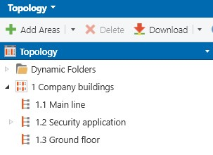
Figure 5: Structure of the lines

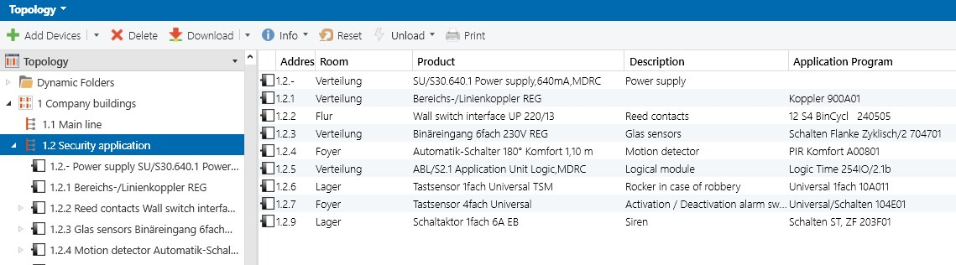
Figure 6: Example of devices used

Project design
The following examples are only used for representation and should only be seen as a planning aid.

Group Addresses

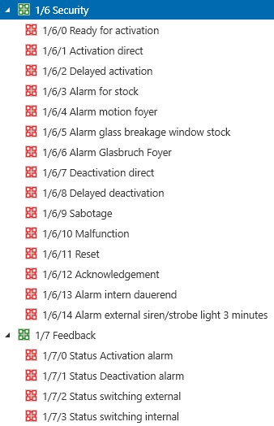
Figure 7: Group addresses on 3 levels

A simple and understandable philosophy should be applied when setting up the group address structure. The group address structure that is selected is not defined. In the example shown, main group 1 has been taken as this has been selected for the ground floor. The middle groups 0-5 can be used e.g. for the functions: General, Lighting, Blinds, Heating, and Ventilation etc. A clear and unique description of the function should be used with all formats of the group address structure.

Parameters

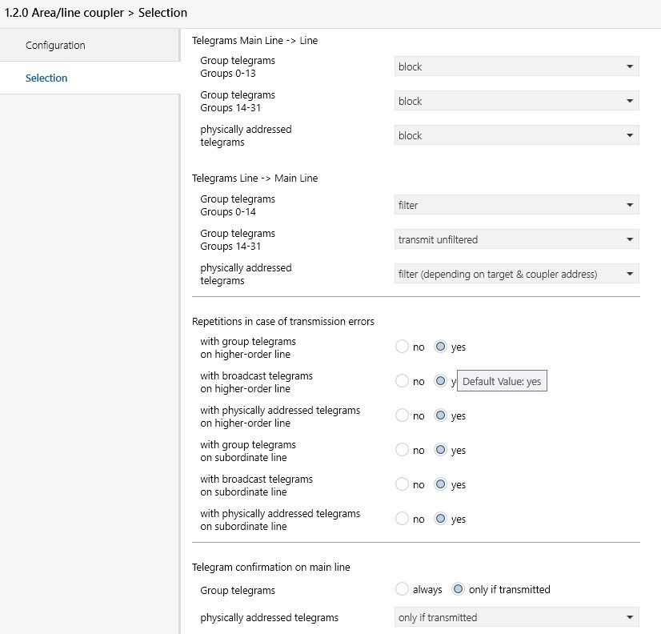
Figure 8: Parameters of the line coupler

The parameterisation could be carried out for a safety and/or monitoring application as shown in Figure 7. The line coupler should always be used so that security-related telegrams can pass through however user-defined telegrams such as switching, dimming, blind control etc. are blocked in order to keep the bus load in the secure area as low as possible. The “Route” function should be avoided.

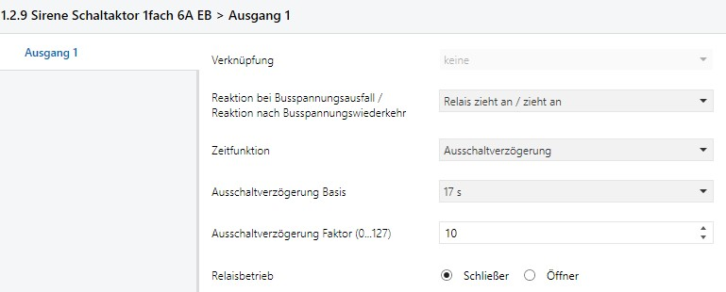
Figure 9: Parameters of the switch actuator

The siren in the outside area has been set to the maximum duration and the behaviour of the contact on bus voltage failure or recovery has been also been configured.

Flags

Figure 10: Changing the priority

A further option for the security and/or monitoring application is the configuration of the flags. The “Alarm” priority guarantees that the telegram is forced through before other telegrams with a lower priority and the appropriate measures are initiated promptly. Care should be taken when selecting the priorities. If the “Alarm” priority is set for each object, each telegram would be treated equally. See also the chapter “Fail-safe Planning”.

KNX Devices

Power Supply
For implementing the tasks of a security and/or monitoring system, KNX device manufacturers offer power supplies which can be coupled with a battery module. Should the mains voltage fail, the KNX bus is supplied with power for a limited period, depending on the number of devices.

Figure 11: KNX power supply with uninterruptible supply and changeover contact for remote signalling

Binary Input
Various applications can be implemented for use as a security and/or monitoring system. The technical documentation of the manufacturer should be taken as a basis when selecting the area of application of the binary input. Depending on the version, window actuators have 1 or more channels for moving shutter motors as well as additional binary inputs for combination with window contacts. The combination of a shutter that queries whether the window is open/closed offers a variety of functions that can be implemented (heating control, security and/or monitoring applications etc.).

Example 1: The contacts of the binary input are connected to the KNX power supply. It can be parameterised that a signal is sent on the bus in the event of a falling pulse edge. Depending on the parameter settings, this signal can be a fault signal to inform the user or it can trigger an alarm. Alternatively, an existing auxiliary switch from the circuit breaker of the power supply or another security-related system can be used. It should be noted that the contact of an auxiliary switch is a “normally closed contact” (protection against wire breakage).

Figure 12: KNX binary input connected to the signal output of the KNX power supply

Example 2: The binary input is used (e.g. DIN rail mounted or flush-mounted) to link VdS components with the KNX installation. Glass breakage sensors, key-operated switches, smoke detectors, reed contacts etc. can be given “bus capability”. A VdS reed contact with a tamper contact is connected for example to channel A for opening surveillance and to channel B for tamper monitoring.
It has been set in the parameters that an alarm is sent when the reed contact is opened and the system is armed. The falling edge at the tamper contact would trigger an immediate alarm if there are no logic conditions. Different components with potential-free contacts can be used in the same way. In addition, components which require an auxiliary supply can be connected to the existing unchoked output of the power supply, provided that the specifications match.

Figure 13: KNX binary input in connection with VdS-approved components

Binary Output
With the continued further development of KNX devices by the manufacturers, functions such as current detection are now possible. When using the binary output for security and/or monitoring applications, the level of security is increased by the current detection function. With the configured object “Status, Feedback”, it can now also be checked whether the load is working.

Example: The binary output is connected to channel A with a VdS-approved, security-related load. It has been set in the parameters that the load operates when the contact is closed. The theoretical switching state is recorded by the feedback object. A threshold can be set through the optional current detection function which is exceeded by the load during operation. The linking of the current detection with the switching of the output can trigger a fault signal or an alarm if it fails to comply.

Figure 14: KNX binary output linked to VdS-approved components

Sensors
KNX sensors are an important part of the KNX system. Sensors form the interface between the user or the physical size and the KNX bus. Using switch sensors, the user calls up previously configured functions such as arming/deactivating the system, switching the lighting, moving the shutters, movement/presence detected, switching on the siren. They convert physical variables into electrical values which are then sent on the bus as a telegram.

Switch sensors are used as an operator interface. Examples are: simple push buttons, group push buttons, switch sensors, room temperature thermostats, and multifunction sensors.

Figure 15: Sensors

Example 1: A simple push-button in the bedroom is installed so that it can be operated from the bed in an emergency. It is set in the parameters that the rocker triggers an alarm once it has been pressed for 3 s to avoid incorrect operation. The reset is then carried out e.g. on a multifunction switch sensor, whose operation is protected by entering a PIN code.

Example 2: A multifunctional sensor, visualisation (touch panel) or graphic display can represent the data of a KNX installation in a visually recognisable form such as states of the safety functions or the monitored areas such as set, unset, ready set, tamper, fault and alarm or opened window.
Modern visualisation screens have considerably more functions than merely graphical representation for the user. Visualisation screens can be used as a central information system due to the wide range of functions and options available.
Below are some examples for the different functions:

- Sending emails (routing of signals e.g.: alarm, fault etc.)
- Communication with the internet (remote access, status monitoring etc.)
- Logic functions with an almost unlimited scope
- Network camera
- Door communication

Security and/or monitoring applications are extended by the use of e.g. network cameras. Alarms or other signals can be sent via the internet. The user comfort can further be increased as the user can check the state of his installation externally e.g. with a smart phone.

KNX Zone Terminal
The KNX zone terminal is used to configure simple security and monitoring functions using sensors from security technology. It is not possible however to install any intruder alarm systems in the framework of the VdS regulation governing the prevention of damages. The structure is as follows:
Figure 16: Principle of zones

The zone terminal acts as the link between security zones and the KNX. The requirements of the zone must be defined when designing a KNX project. The information of the zone terminal becomes effective if the information can be used for several evaluation purposes (e.g. window detector zone for alarm signals, collision detection for shutters and frost protection for heating mode).
The number of sensors per zone such as magnet contacts, glass-breakage sensors, motion detectors or fire detectors is indicated in the same way as for intruder alarm systems with max. 20 intruder detectors.
Each zone is completed with a resistance of 2.7 kΩ in the last detector.
The main benefit of the zone terminal lies in the monitoring of the sensor circuit for isolation/short circuits. Both normally open and normally closed contacts can be used.

Two operating modes can be implemented with the zone terminal.
In the ‘Report’ mode, the states of zones A-D are reported but not stored.
However, in ‘Monitor’ mode, the states of the zone are both reported and stored. It is only possible to change to this mode if no signals (‘Zones A-D’ and ‘Supply Voltage Fault’) are present. The states of the zones (alarm) must be acknowledged (‘Set/unset’ object is set to ‘0’). These states must also be reset (‘Reset zones“ object is set to ‘1’).

Informative Appendix

Sensors
Detectors (sensors) are divided into automatic and non-automatic detectors. Automatic detectors record an attempted break-in or sabotage and trigger the alarm. Non-automatic detectors trigger a targeted alarm.
The difference between active and passive detectors is likewise indicated.
An active detector consists mainly of a transmitter and receiver, whereby the detector monitors itself and triggers an alarm on failure of the transmitter or receiver. The passive detector is only able to record certain values or their change in value and to send a signal to the intruder alarm control unit when the set threshold is exceeded. A fault signal is however not automatically issued in the event of a failure. A further classification of the detectors is carried out according to the physical principle.

Electro-acoustic detectors use sound waves, whereby the frequency is dependent on the design and application.

- Active glass-breakage sensor
- Passive glass-breakage sensor
- Seismic detector
- Ultrasonic movement detector

Electro-optical detectors use heat rays in the form of infrared.

- Photoelectric barriers
- Infrared movement detector
- Infrared barriers
- Money clips

Electric detectors use electromagnetic waves or electric capacity changes.

- Microwave detectors
- Microwave links
- Capacitive field change sensor

Electro-mechanical detectors are divided according to the different types of contacts:

- Normally closed/normally open contacts
- Trip wire contacts
- Hook contacts
- Vibration detectors
- Strike plate contacts

It is possible to have a combination of different physical principles in one detector.

Intruder alarm control unit
An intruder alarm control unit evaluates the signals from the detectors and initiates the appropriate measures (alarm signals). Depending on the design of the control unit, the different states of the system can be read by the user and (or) offer the user various operation modes. The main tasks of the intruder alarm system include the recording, processing and routing of signals and information such as intruder, sabotage and fault signals. Further tasks are:

- Recording and evaluating the signals from the detectors
- Triggering of alarm device(s)
- Monitoring the supply device
- Display of faults based on the zones / detectors
- Display of set/unset state

Alarm
The following alarm types are possible:

- Acoustic alarm
- Optical alarm
- Silent alarm

In the case of an acoustic alarm, a loud signal tone is produced by a signalling device. The loud signal tone focuses the attention of the surrounding neighbourhood on the property. The use of the acoustic alarm outside is limited to 180 seconds. There is no limit when it is used inside.
When an optical alarm is triggered, a strobe light or flashing light is generated by a signalling device which attracts the attention of the neighbourhood. In practice, a combination of an acoustic and optical alarm is frequently used.
The silent alarm is used if there is an unpredictable situation for the staff or environment. It is most widely used in banks where the employees can trigger an alarm unnoticed by the perpetrator. In the case of a silent alarm, no signalling devices are triggered in contrast to an acoustic or optical alarm. Security staff are alerted using telecommunication options.
Alarms are divided into:

- Internal alarm
- External alarm
- Remote alarm

The internal alarm only triggers the alarm inside the property. No external signalling devices are activated and no messages are issued outside the building.

The external alarm trips the signalling devices such as strobe lights and/or sirens.
The emergency services are notified with the remote alarm using telecommunication options.

Setting / Arming Device
If an intruder alarm system is set, an alarm is triggered when an attempted break-in is detected. If the system is unset, there is no alarm.
The system is set or unset using an arming device.
There are electromechanical, intelligent and proximity arming devices.

An electromechanical arming device consists of a switching lock which is linked with the mechanical locking of the access door.

With the intelligent arming device, the system is set e.g. using a combination lock (by entering a number combination). This arming device must also be linked to a mechanical lock-out of the access door.

The proximity arming device consists of a sensor unit, an evaluation unit and a distribution board.
Key-operated transponders, which contain the actual identification, can be read in and deleted. Used together with the locking element in the door frame as well as a key bolt switching contact for lock monitoring, the mechanical lock-out of the access door is guaranteed.
The connection of the arming device and lock-out can be carried out electrically or mechanically. It must however be ensured that it is not possible to enter the protection area accidentally when the intruder alarm system is set (positive drive).

Panic Alarms
Panic alarms are push buttons which are operated should someone find themselves in danger. A remote alarm is activated immediately after operation of the push button. A panic alarm may then only trigger a local alarm if the transmission route of the remote alarm is disrupted.
A further possibility is a silent alarm at an alarm receiving office (security staff).

Monitoring

Opening Surveillance, Lock Monitoring
The monitoring of windows, doors, skylights or similar to detect if they are opened or closed is called opening surveillance.
The locked or bolted status of doors, windows or skylights is observed using lock monitoring. A disruption in a lock monitoring circuit or zone does not lead to an alarm but prevents the system from being set. To achieve the enforced contact separation when setting an intruder alarm system, the lock state of doors, gates and windows must be monitored. An unlocked component prevents the intruder alarm system from being armed. In “set” mode, a fault in the lock monitoring does not lead to an alarm being sent.

Magnet reed contacts are used for the opening surveillance of doors, windows and skylights. They consist of a magnet and a reed contact. The magnet is mounted on the window sash or the door panel. The reed contact is mounted directly next to or above the magnet on the door or window frame.

Figure 17: Opening surveillance

The reed contact is closed under the influence of the magnetic field.
If the window or door is opened, the magnet moves away from the reed contact and the influence of the magnetic field on the contact is disrupted. The reed contact is opened again and the zone is interrupted. This is classed as an attempted break-in by the intruder alarm control unit. A magnet reed contact may only be fitted within the monitored area (inside surface of the window or door). The reed contact is connected as four-core.

Figure 18: Opening surveillance

There are different magnet reed contacts for a variety of areas of application.

Universal magnet reed contact
The design of the magnet reed contact allows it to be screwed or drilled in position. The maximum distance between the reed contact and the magnet is 15 mm.
When installing on ferromagnetic materials (e.g. steel door), surface-mounted assembly must be used. The spacers provided should be used.

Magnet reed contact with protection against external magnetic fields
This magnet reed contact also has a tamper contact (normally open contact) which is triggered when exposed to an external magnetic field (e.g. the reed contact being influenced by another magnet) and the zone is shorted.
The distance between the magnet and the reed contact can be up to 15 mm.

Figure 19: Magnet reed contact with protection against external magnetic fields

High-performance magnet reed contact
The high-performance magnet reed contact is particularly suitable for use on garage doors and heavy metal doors. Due to its increased magnetic system, the SMKG can be used directly on metal doors and gates.
The distance between the magnet and the reed contact can be up to 30 mm.

Roll gate contact
The roll gate contact is used on roll gates or other large gates. It is particularly resistant to dust, damp and chemicals such as oil and petrol. Due to its design, it can be installed on the edge of the gate on the floor. It withstands vehicles running over it with rubber tyres without any damage. It should be inserted into the floor for heavier loads. The distance between the magnet and reed contact can be up to 45 mm.

Lock monitoring for doors
The key bolt switching contact is used for the lock monitoring of doors. It has a two-way contact and can therefore be used as a normally closed or a normally open contact. The installation is carried out behind the strike plate so that the contact can be operated via the bolt lock.

Figure 20: Lock monitoring for doors

With double locks, the key bolt switching contact should be mounted so that it only responds on the second turn of the key. The protection type of the key bolt switching contact complies with IP 67.

Windows
The lock monitoring of windows can be carried out directly or indirectly. Direct monitoring is achieved with the module for windows. A special circular magnet is mounted on the push rod of the window sash. The reed contact is mounted in the appropriate position on the window frame.
Indirect monitoring is carried out with thrust bolts. The thrust bolt is mounted in the window frame. If the window is closed but not locked, the thrust bolts push the window open again a crack. The magnet reed contact is thus addressed and the corresponding zone is disrupted.

Monitoring of panes of glass by passive glass-breakage sensors
Passive glass-breakage sensors use a piezoelectric microphone to register vibrations that are caused by forcible damage to the pane and evaluate them. The corresponding zone is short-circuited when the glass is damaged. They should be wired into the zone so that their cable connection to the control unit cannot be disrupted by other detectors. The maximum monitoring range is 2 m. It is possible to mount several sensors on one pane of glass.

Figure 21: Monitoring of panes of glass by passive glass-breakage sensors

The sensor is fixed onto the inside of the double glazing (silica glass) that is to be monitored using adhesive. The connection is carried out as 4-core.
Single glazing, laminated or coated glass and safety glass may not be monitored with glass-breakage sensors.

Figure 22: Window with a glass-breakage sensor

Peripheral Protection, Surface Surveillance
Peripheral protection involves the monitoring of all doors, windows and openings that lead outside as well as any other possible access points.
Surfaces (panes of glass, doors, and external walls) can be monitored using surface surveillance which is used to detect someone breaking in (damage to the surface), climbing through (damage to the surface and penetration of the protection area) or reaching through (damage to the surface and reaching into the protection area).

Surface surveillance with vibration detectors
The vibration detector of the intruder alarm system evaluates the vibrations caused when surfaces are destroyed (panes, glass blocks, door panels, walls). If vibrations of a specified level are registered, the alarm contact is closed and the zone is shorted.

Figure 23: Surface surveillance with vibration detectors

Vibration detectors should always be wired into the zone so that their cable connection to the control unit cannot be disrupted by other detectors. The detector is glued or screwed onto the surface that will be monitored. The wiring is four-core. The effective range is 1.15 m for glass and 0.55 m for concrete, steel and wood.

Interior Surveillance
Movements within closed rooms or the opening of monitored access points are analysed directly via interior surveillance. The change in specific physical variables is classed as an attempted break-in and reported. The change in specific physical variables is classed as an attempted break-in and reported. Rooms are monitored by motion detectors with various methods of operation.

Passive infrared motion detectors
The infrared motion detectors react to thermal movement via photodiodes that are sensitive to infrared. The monitoring area is divided into zones and planes by an optical lens. If the heat radiation in a zone changes within a short time period, the motion detector evaluates this as an attempted break-in. In this case, the alarm contact is addressed which interrupts the zone.
The motion detector is most adept at picking up movement in a direction that is at a tangent to the detector.
As a result, sources of error can be produced by draughts, heating systems, air conditioning systems, direct sunlight and other heat sources.
For this reason, infrared detectors should not be directed at heating systems or windows.
Motion detectors can have different lens systems.
With the volumetric lens (full room monitoring), entire rooms can be monitored. The long zone lens is suitable for long rooms (hallways) and the curtain lens is used for surface surveillance in order to detect someone climbing in.
The size of the monitoring area can be adjusted on the device.
The motion detector must be connected to the power supply for detectors on the intruder alarm control unit.

The alarm contact (normally closed contact) is included in the intruder zone while the tamper contact (normally closed contact) is looped into the sabotage zone.
It is possible to carry out a walk test on the motion detector.
This can be activated by a switch inside the motion detector or by applying +12 V at the test input. The motion detector also has a memory logic (alarm memory) i.e. it stores any attempted break-in that is detected when the system has been set. When the system has been deactivated, an LED indicates which detector registered the attempted break-in.

Several detectors contain anti-masking circuitry. They are therefore in the position to detect whether they are covered by an object and are thereby restricted in their function.

In addition to cover surveillance which adapts itself automatically to the local conditions, passive infrared detectors of VdS class C for high security requirements have an alarm memory as well as processor monitoring, whereby a high level of detection and interference immunity is guaranteed.
The monitoring area of this movement detector can be changed from volumetric to long-range or creep zone protection by replacing the lens.
The signalling of the fault and cover surveillance is carried out by a potential-free contact. The connection of the movement detector is eight-core or ten-core if the walk test and alarm memory should be controlled remotely.

Infrared motion detector
The detector is fitted with a long-range lens and has anti-masking technology. The sabotage zone is interrupted by a removal contact if the detector is disconnected from the wall. The function of this contact can be deactivated.

Dual detector
This motion detector carries out monitoring using both infrared and an electromagnetic field.
Its monitoring area is volumetric. Its monitoring techniques are electronically linked so that the motion detector only reports an alarm if both elements have detected an attempted break-in.
The sizes of the two monitoring areas can be set separately.
The dual detector has both anti-masking circuitry and an alarm memory and can also carry out a walk test.

Panic alarm
The panic alarm contains an alarm contact (normally closed contact) which is triggered manually with a push-button action. When it is triggered, this alarm contact interrupts the panic zone. The built-in tamper contact (normally closed contact) interrupts the sabotage zone when an attempt is made to open the contact.
The connection of the detector is carried out as six-core. It can be supplied as a surface- or flush-mounted version.

Contact locks
The contact lock serves as a remote switching device. When used as an arming device, a locking element should be inserted in the access door to the protection area so that it is not possible to enter the armed area accidentally.
The contact lock is fitted with two changeover contacts - one is operated when the lock is turned anti-clockwise and the other when the lock is turned clockwise. Operation is carried out via a conventional profile half cylinder. It is possible to choose between a key or switching function for the contacts.
This enables for example the combined use of the contact lock as a remote reset button and arming device from one or more locations. Built-in LEDs enable the display of the operating states of the control unit (e.g. set/unset and ready set). An acknowledgement buzzer is integrated into the contact lock. The required number of cores for the connection cable differs depending on the function of the contact lock. 12 cores are however sufficient in any case.

Switchgear unit (for installation only in monitored area)
The switchgear unit is used primarily as an internal arming device.
The unit contains two changeover contacts which can be used together as an intermediate switch. An impulse contact is provided which closes briefly when setting and deactivating the system.
These contacts are operated by a built-in lock.
Built-in LEDs enable the display of the operating states of the control unit (e.g. set/unset and ready set). The acknowledgement buzzer is likewise available.
The integrated tamper contact interrupts the sabotage zone when an attempt is made to open the switchgear unit. The connection is 12-core.

Locking element
The locking element is used to keep doors shut when the system is set, if a contact lock or the proximity arming device are used to arm the system and a positive opening operation is not guaranteed. It is also possible to keep adjacent doors electrically closed when the system is set. The locking element is controlled by the key bolt switching contact which is inserted in the strike plate of the door.
The set acknowledgement signal of the intruder alarm control unit disables further control by the key bolt switching contact in ‘set’ mode which leads to the door being locked for this switching phase.

Key bolt switch lock
Key bolt switch locks are used to set intruder alarm control systems with low risks. They are integrated into the access door to the protection area in addition to the existing lock. The door is locked when the intruder alarm system is in set mode which prevents anyone from entering the protection area. The key bolt switch lock is operated with a conventional profile half cylinder.
There is no resistance circuit present in the set zone. This must be carried out in the distribution box.
An external set/unset LED is connected to the two free cores which are then inserted in the door. The connection of the key bolt switch lock is six-core.

Block locks
The block lock is used to set intruder alarm control systems. It can only be locked if the system and all its functions are ready for arming.
It is installed in the door that is used to exit the protection area.
When the intruder alarm system is set, the access door to the protection area is locked which prevents anyone from entering.
The block lock can be used as an inhibit lock in connection with another switchgear unit. In this case, it cannot be unlocked while the intruder alarm system is armed. It prevents anyone entering the protection area by any other doors when the system is set.
The block locks have a double-bit insert which does not require the use of a security card.
A conventional profile half cylinder can be inserted in the block lock. The return lock-out device of this cylinder must however be adjustable to 45° on both sides.

Proximity Arming Device
The proximity arming device in connection with locking elements and key bolt switching contacts guarantees a positive activation of the intruder alarm control unit.

Note: An additional intelligent lock is required for commercial properties of security class SG5 and SG6.

Tamper Monitoring
The attempt to shut down the whole or part of an intruder alarm system or to interfere with its function must always lead to a sabotage alarm.
The cables and parts of the installation are therefore monitored.
In the set mode of an intruder alarm system, a fault in the tamper monitoring circuit must lead to an intruder alarm.

Groups

Zones
The principle of a zone is based on a circuit that is shorted or interrupted by the alarm contacts of the detectors (activated when an attempted break-in is detected). The intruder alarm control unit registers these short circuits or interruptions by voltage and current measurements and initiates the appropriate measures. The various zone circuits are outlined below. Please take the exact current and voltage values for the resistance diagrams from the technical data section of the installation instructions for the intruder alarm control unit.

In security technology, there is a distinction between unmonitored cables (secondary circuits) and cables that are monitored for short-circuit and interruption (primary circuits).
Secondary circuits are subdivided into closed- and open-loop circuits.
Closed-loop circuits are closed in the normal state and there is a flow of current.

Secondary circuits:

Figure 24: Closed-loop circuit – flow of current

If at least one of the contacts is opened, the flow of current is interrupted, which leads to a signal being sent.
Open-loop circuits are open in their normal state and there is no flow of current.

Figure 25: Open-loop circuit – no flow of current

If at least one contact is closed, there is no flow of current which leads to a signal being sent. Both these circuits can be manipulated relatively easily. Primary circuits are used for this reason.

Primary circuit:
Figure 26: Primary circuit - 1 contact closed

There is a defined current during normal operation. In the event of disruption, there is no flow of current whereas the flow increases significantly in the event of a short-circuit. Both situations lead to a signal being sent.

Sabotage zones

Sabotage zones have an EOL resistance of 2.7 kΩ in the same way as primary circuits. All the tamper contacts (housing contacts) of the detectors and the branching boxes are included in the sabotage zone. A zone can have a maximum of 20 devices.

Figure 27: Sabotage zones

Lock Zones

Lock zones are secondary circuits without EOL resistors.

Figure 28: Lock zone

The normally open contacts of all strike plate contacts are included in the zone. When using locking elements, the state of the element (open/closed) should be monitored and included in the zone.

Set Zone

The set zone can be implemented with an EOL resistance of 2.7kΩ as with primary circuits in intruder alarm systems.
A short-circuit or an interruption of the set zone leads to the strengthening of the intruder alarm system.

Figure 29: Set zone

Alternatively, in addition to the EOL resistance of 2.7 kΩ, a resistance of 560 Ω can be connected in series. The bridging of this 560 Ω resistance leads to the deactivation of the intruder alarm system. A short-circuit or disruption of the external set zone leads to a sabotage alarm.

Figure 30: Set zone

Panic Zone

Panic zones are implemented as primary circuits with an EOL resistance of 2.7 kΩ.

Figure 31: Panic zone

The disruption of a panic zone always leads to the triggering of a remote alarm.

External Local Alarm Signal

The supply cables to the signalling devices are not monitored for intruder alarm control units. A short-circuit or disruption of these cables is not detected.

Figure 32: External local alarm signal

A further possibility is the supply cable to the external signalling devices as primary circuits, which are monitored for short-circuit or interruption.
The alarm circuits for the external signalling devices must be implemented with an EOL resistance of 1 kΩ each. A short-circuit or disruption of the alarm circuit leads to a sabotage alarm.

Figure 33: Tamper signal – EOL resistance of 1 kΩ each

Internal Local Alarm Signal

The supply cables to the signalling devices are not monitored for the intruder alarm control units. A short circuit or disruption of these cables is not detected.

Schematic diagram:

Figure 34: Internal Local Alarm Signal

Verband der Sachversicherer (Association of Insurers): Alarm systems with VdS approval are recognised by German insurance companies.

