IP Communication
KNX Association

Table of Contents
1 Basic knowledge about networks 3
1.1 Network classes 3
1.2 Layered communication 7
1.3 Data transmission through networks. The OSI model and the TCP/IP suite 9
1.3.1 The OSI Reference Model 9
1.3.2 The TCP/IP Suite 11
1.3.2.1 The Link Layer of the TCP/IP stack 12
1.3.2.2 The Internet Layer of the TCP/IP stack 13
1.3.2.3 TCP/IP Addressing 14
1.3.2.3.1 IPv4 14
1.3.2.3.2 IPv6 16
1.3.2.4 The Transport Layer at the TCP/IP stack 17
1.3.2.5 The Application Layer of the TCP/IP stack 18
1.3.2.6 Equipment related to layers 20
2 IP Communication in KNX systems 22
2.1 KNX IP Layered communication 22
2.2 Addressing of KNX IP Devices 23
2.2.1 KNX IP Address 23
2.2.2 KNX IP Routing Multicast address 24
2.3 KNXnet/IP Protocol 26
2.3.1 Tunneling 28
2.3.1.1 Address Range 28
2.3.1.2 Tunneling Examples 29
2.3.1.3 Remote access to a KNX Installation via Tunneling connection 32
2.3.2 Routing 34
2.3.2.1 Address Range 34
2.3.2.2 Routing Example 34
SOURCES AND REFERENCES 35

The objective of this unit is to offer an overview of IP network technologies that allows the KNX specialist on the one hand to understand the basic configurations of TCP/IP networks and on the other hand to adequately assimilate the use of this IP technology in their KNX installations.

Basic knowledge about networks

Network classes
There are basically two criteria for classifying networks: the transmission technology and the scale.

Basically, there are two types of transmission technology that are in widespread use: broadcast links and point-to-point links.

Point-to-point transmission connects individual pairs of machines (exactly one sender with exactly one receiver) and it is called unicasting. In this case, short messages (packets), may have to first visit one or more intermediate machines, so it is important to find the best of the many possible routes.

In contrast, on a broadcast network, the communication channel is shared by all the machines on the network; packets sent by any machine are received by all the others. An address field within each packet specifies the intended recipient. Upon receiving a packet, a machine checks the address field. If the packet is intended for the receiving machine, that machine processes the packet; if the packet is intended for some other machine, it is just ignored. As you can observe, basically a KNX TP line acts as a broadcast network.

Broadcast systems usually also allow the possibility of addressing a packet to all destinations by using a special code in the address field. This mode of operation is called broadcasting. Some broadcast systems also support transmission to a subset of the machines, which is known as multicasting. As you can observe, basically a KNX group message is multicasting.

The second criterion for classifying networks is by scale. Distance is important as a classification metric because different technologies are used at different scales.

Table 1: Networks classified by scale
Interprocessor  distance | Processors  located in same | Example
1 m | Square meter | PAN (Personal Area Network)
10 m | Room | LAN (Local Area Network)
100 m | Building
1 km | Campus
10 km | City | MAN (Metropolitan Area Network)
100 km | Country | WAN (Wide Area Network)
1.000 km | Continent
10.000 Km | Planet | Internet

PAN (Personal Area Network): A common example of a PAN is a PC connected to peripherals (keyboard, mouse…) using Bluetooth.

LAN (Local Area Network): A LAN is a network, restricted in size, that operates within and nearby a single building (home, office, or factory). When LANs are used by companies, they are called enterprise networks. At this point we have to distinguish between:
- Wireless LANs: use standard IEEE 802.11, known as WiFi.
- Wired LANs: IEEE 802.3, called Ethernet, is the most common type of wired LAN
Wired LANs run at speeds of 100 Mbps to 1 Gbps (newer LANs can operate at up to 10 Gbps), have low delay (up to nanoseconds), and make very few errors. Compared to wireless networks, wired LANs exceed them in all dimensions of performance. Wired LANs use mostly copper wires but also more and more optical fiber. They use a range of different transmission technologies, but the topology of many wired LANs consists of point-to-point links.

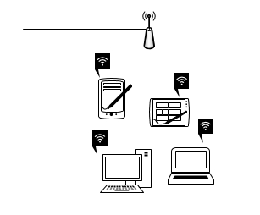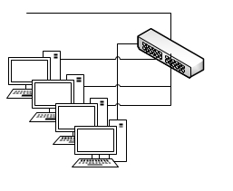
To wired network
Access point
To rest of network
Ethernet switch

Figure 1: Basic structure of a Wireless and a Wired LAN
The figure above shows a sample topology of switched Ethernet. Each computer speaks the Ethernet protocol and connects to a box called a switch with a point-to-point link. A switch has multiple ports, each of which can connect to one end device (e.g. computer). The job of the switch is to relay packets between end devices that are attached to it, using the address in each packet to determine which computer to send it to. To build larger LANs, switches can be plugged into each other using their ports.

It is also possible to divide one large physical LAN into two smaller logical LANs, called Virtual LAN or VLAN.

MAN (Metropolitan Area Network): A MAN covers a city (e.g., a local cable TV network). Another example of a MAN that has been standardized as IEEE 802.16, is popularly known as WiMAX.

WAN (Wide Area Network): a WAN spans a large geographical area, often a country or continent. Typical WAN is the one used by a big company with offices in many cities. When each of these offices contains computers (hosts) intended for running user (i.e., application) programs, the network that connects these (local) hosts is then called the subnet.

Figure 2: Basic WAN scheme

In most WANs, the subnet consists of transmission lines and switching elements. Transmission lines can be made of copper wire, optical fiber or even radio links. Most companies do not have transmission lines, so instead they lease the lines from a telecommunications company. Switching elements are called routers (specialized computers/devices that connect two or more transmission lines).

- VPN (Virtual Private Network): Instead of leasing expensive dedicated transmission lines, a company could connect its offices to the Internet, allowing it to make connections between offices as virtual links using the underlying capacity of the Internet. This arrangement is very frequent and is called a VPN (Virtual Private Network).
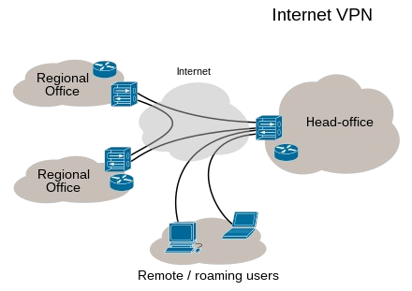
Figure 3: VPN classic scheme

- ISP (Internet Service Provider): another variation of WAN is that the subnet may be run by a different company. In this case, the subnet operator will also connect to other networks that are part of the Internet. Such a subnet operator is called an ISP (Internet Service Provider), the subnet is an ISP network and the subnet´s offices are its customers that receive Internet service.

Internetworks: A collection of interconnected networks is called an internetwork or internet. The Internet uses ISP networks to connect enterprise networks, home networks, and many other networks.

The general name for a machine that makes a connection between two or more networks and provides the necessary translation, both in terms of hardware and software, is a gateway. Gateways are distinguished by the layer at which they operate in the protocol hierarchy.

We will deal with layers and protocol hierarchies in the next section.

Layered communication

A layered network model has several advantages, because it reduces complexity (dividing one big communication challenge into several smaller ones). This also helps to standardize interfaces and ensures interoperable technology that, therefore, accelerates evolution and facilitates modular engineering. Finally, easier teaching and learning is another advantage of this work strategy based on layers.

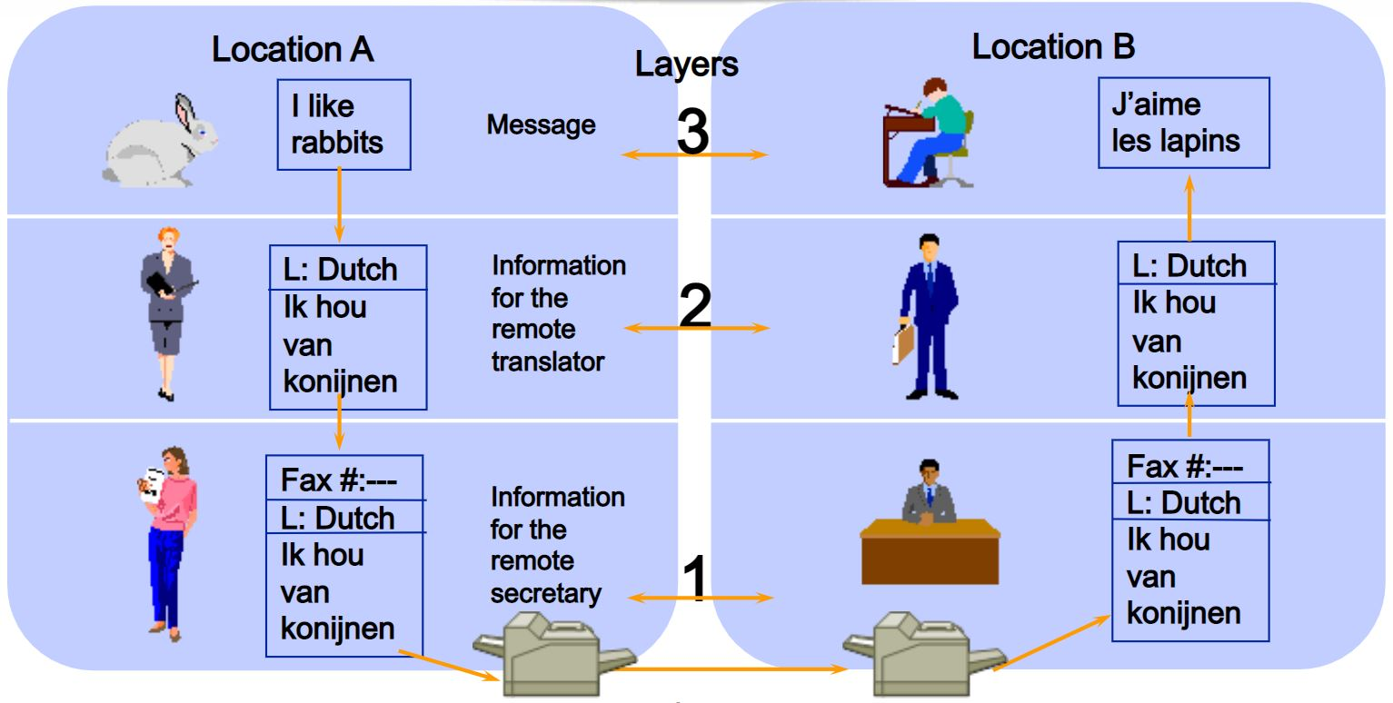
Figure 4: Example of abstract layered communication
As an example of a layered communication, let´s imagine two philosophers (peer processes in layer 3), one of whom speaks Urdu and English and one of whom speaks Chinese and French. Since they have no common language, they each engage a translator (peer processes at layer 2), each of whom in turn contacts a secretary (peer processes in layer 1).

Philosopher 1 wishes to convey his affection for Oryctolagus cuniculus to his peer. To do so, he passes a message (in English) across the 2/3 interface to his translator, saying ‘‘I like rabbits,’’ as illustrated in the figure above.

The translators have agreed on a neutral language known to both of them, Dutch, so the message is converted to ‘‘Ik vind konijnen leuk.’’ The choice of the language is the layer 2 protocol and is up to the layer 2 peer processes.

The translator then gives the message to a secretary for transmission, for example, by email (the layer 1 protocol). When the message arrives at the other secretary, it is passed to the local translator, who translates it into French and passes it across the 2/3 interface to the second philosopher.

Note that each protocol is completely independent of the other ones as long as the interfaces are not changed. The translators can switch from Dutch to, say, Finnish, at will, provided that they both agree and neither changes his interface with either layer 1 or layer 3. Similarly, the secretaries can switch from email to telephone without disturbing (or even informing) the other layers.

Each process may add some information intended only for its peer. This information is not passed up to the layer above.

So, in a layered communication, no data is directly transferred from layer ‘n’ on one machine to layer ‘n’ on another machine. Instead, each layer passes data and control information to the layer immediately below it, until the lowest layer is reached. Below layer 1 is the physical medium through which actual communication occurs.

A set of layers and protocols is called a network architecture and a list of the protocols used by a certain system, one protocol per layer, is called a protocol stack.

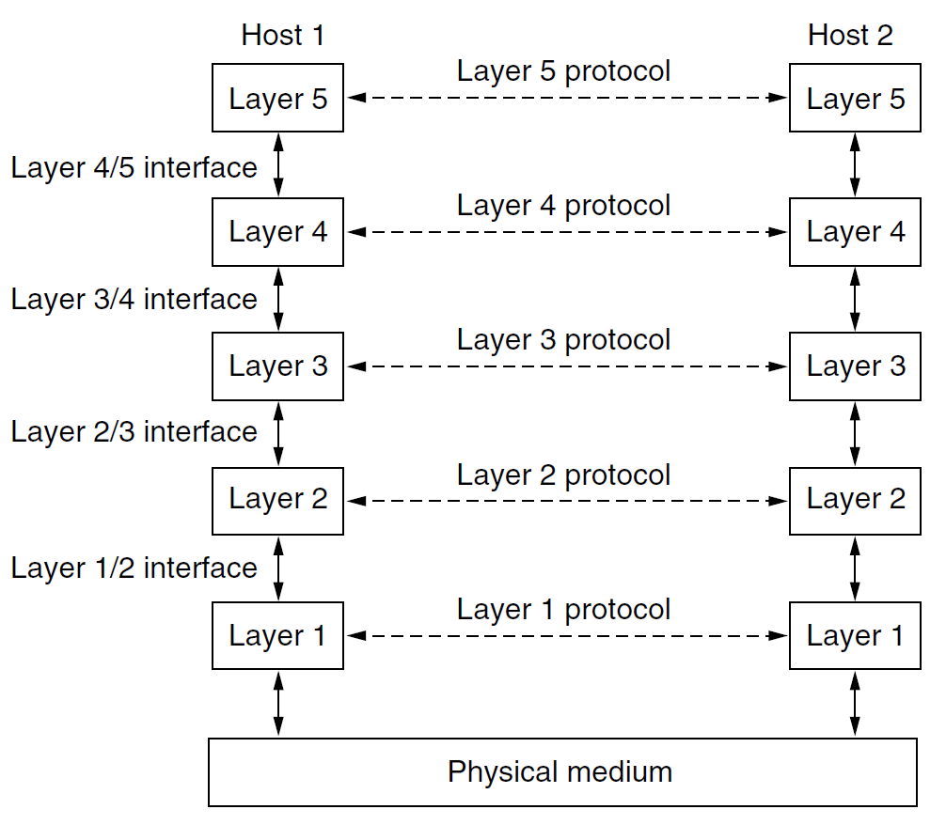
Figure 5: Layers, protocols and interfaces

Key points for the design of any layered communication are reliability (error detection, error correction), routing management (addressing), flow-control (quality of service) and defense against threats (confidentiality, authentication, integrity…).

Data transmission through networks. The OSI model and the TCP/IP suite
Now that we have seen layered networks in the abstract, we will describe two important network architectures: the OSI reference model and the TCP/IP reference model.

The OSI Reference Model
The OSI model refers to a computer network framework that is comprised of seven layers, described as follows:
Table 2: OSI Layers
Layer |  | Protocol data unit (PDU)
Host  layers | 7 | Application | Data
 | 6 | Presentation
 | 5 | Session
 | 4 | Transport | Segment, Datagram
Media  layers | 3 | Network | Packet
 | 2 | Data link | Frame
 | 1 | Physical | Bit, Symbol

- The Application Layer (Layer 7): is the one that the user interacts with. It is focused on end-user processes and delivering any application the user wants to access.
- The Presentation Layer (Layer 6): is designed to prepare and translate data from the network format to the application format or vice versa, determining how data is presented for each of these entities in terms of syntax and structure.
- The Session Layer (Layer 5): is the layer responsible for establishing, maintaining, and ending connections between different applications, controlling the terms on which applications interact with each other (e.g., dictating how long a system will wait for a response from another application).

- The Transport Layer (Layer 4): is one of the most well-known layers of the OSI model as it is the layer responsible for transferring data between end systems and hosts (it dictates what gets sent where, and how much of it gets sent). And, if something goes wrong, it also has the responsibility of end-to-end error recovery.

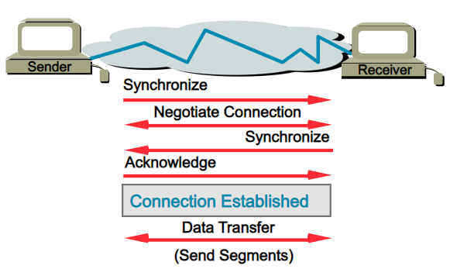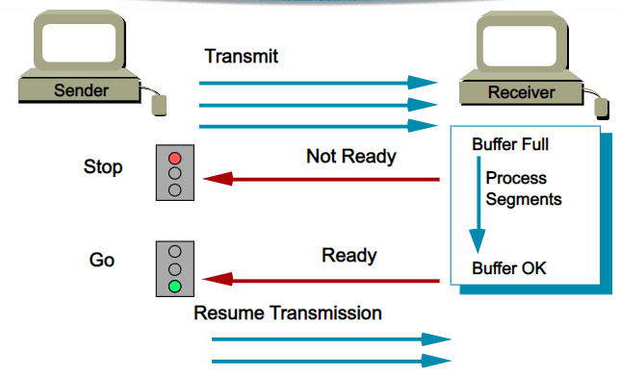
Figure 6: Transport Layer is responsible for connection establishment (left) and sending segments with flow control (right)

- The Network Layer (Layer 3): must deal with most of the routing within a network, dealing with packet forwarding and setting the route that packets travel through a network, i.e., determining how a packet travels to its destination.

- The Data Link Layer (Layer 2): it handles node-to-node data transfers, providing a well-defined service interface to the network layer, dealing with transmission errors, and regulating the flow of data so that slow receivers are not swamped by fast senders. It can be divided into sublayers:
  - The Media Access Control (MAC) Layer: very helpful for Broadcast networks, as it determines how a connected device accesses data in terms of permissions to the shared channel. At this level, physical addresses or MAC addresses of the devices are defined. The frames will use these addresses to specify the origin and destination of the data they carry.
  - The Logical Link Control (LLC) Layer: it controls elements like flow control, frame synchronization, and scans for errors.

- The Physical Layer (Layer 1): it is the hardware layer of the OSI model, which includes network elements such as hubs, cables, ethernet, and repeaters. It can also be used e.g., to check that cables and devices are connected correctly.

In resume, the OSI model acts as a roadmap of what is happening within a network – from the Physical Layer straight up to the Application Layer that we or our users interact with – and helps to see how information is transferred across a network.

We could assume that the lower the number in the stack, the "closer to hardware" and the higher the number, the more "heavy on software".

Knowing the OSI model inside and out gives us a better understanding of how devices throughout our network connect to each other.

Figure 7: OSI Reference Model Data Encapsulation

The TCP/IP Suite

TCP/IP is a suite of standards that manage network connections. The name of the suite comes from two of them: the Transmission Control Protocol and the Internet Protocol.

The Internet Protocol Suite, the official name for TCP/IP stack, was created before the OSI model and only consists of four layers.

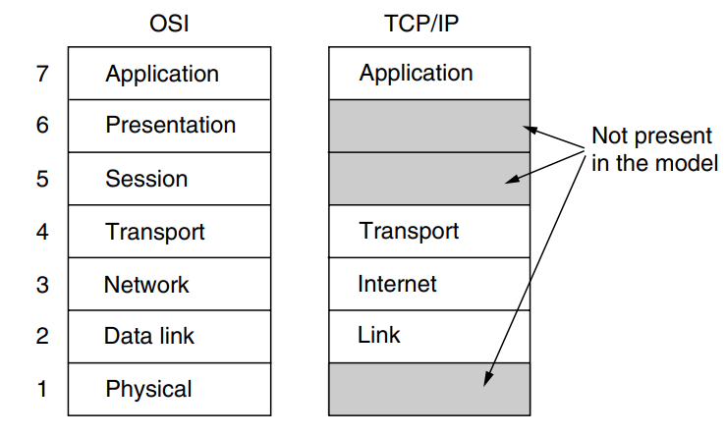
Figure 8: Comparison between OSI model and TCP/IP model
We can assume that higher layers are more tied to applications, such as the Web, and lower layers are more tied to transmission links, such as Ethernet.

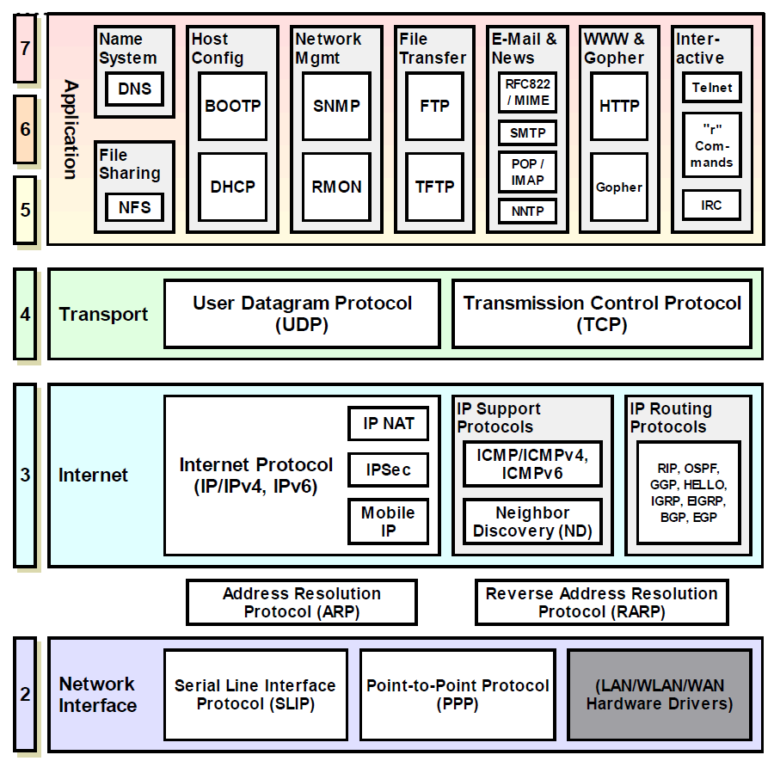
Figure 9: Some important protocols of the TCP/IP Suite by layer

The Link Layer of the TCP/IP stack
The Link Layer at the bottom of the TCP/IP stack prepares data to be applied to the network. NOTE: the Physical Layer does not exist in the TCP/IP stack and so those definitions must be included in the requirements for a Link Layer protocol.
The most important part in the TCP/IP Link Layer is the Media Access Control (MAC), as the MAC element takes care of the software that manages transmissions within networks.
At the Link Layer, the MAC address is more important than the IP address. The MAC address is unique and is printed on every network card´s firmware.
MAC addresses are made up of 6 bytes (48 bits) where the first three bytes identify the manufacturer of the network card. The other three bytes identify the card.

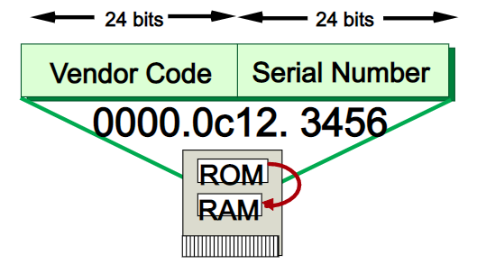
Figure 10: MAC address in ROM memory on a network interface card

The Internet Layer of the TCP/IP stack

Above the Link Layer is the Internet Layer, which deals with addressing and routing packets so that they can cross interconnecting networks to arrive at a remote location on a remote network.
The internet layer defines an official packet format and protocol called IP (Internet Protocol), plus a few companion protocols like e.g. ICMP, IGMP or ARP.

- ICMP (Internet Control Message Protocol): this protocol is used for the exchange of information and error messages via the Internet Protocol (IP), i.e. an ICMP package is stored in the data part of the IP protocol.

- IGMP (Internet Group Management Protocol): IGMP is based also on the IP protocol and enables group communication via IPv4-multicasting, i.e. the simultaneous distribution of IP packages via one IP address. Groups can be managed dynamically. Management takes place in the routers and/or switches, to which receivers of a multicast group are connected. IGMP is mainly needed in larger networks. In this way, it is avoided that the transmission of multicast addresses leads to a network overload.
As we will study in the next section, this protocol is used in KNX IP communication: When ETS in the “ETS Connection Manager” polls for available IP routers or IP gateways, this will be done via the KNX multicast IP. Subsequently, all KNX IP devices within reach will reply. The router / switch located in between will now bundle all replying devices to a multicast group address. This implies that future multicast transmissions will always be routed to the KNX devices only (multicasting) and not anymore to all network devices (no broadcasting).

- ARP (Address Resolution Protocol): We have seen that MAC address is assigned by the manufacturer for each ethernet network card. In the next section we will define IP addressing and will see that there is no direct relationship between MAC address and IP address. So that, before an IP packet can be sent via Ethernet, the destination MAC Address must be known. ARP protocol is used to find this address.

TCP/IP Addressing
The main feature of the Internet Protocol is its standard for addressing devices on networks.
It is easy to assume that two endpoints can´t have the same address, because If two computers connect with the same address, the routers of the world wouldn’t know which one was the intended recipient of a transmission to that address.
One advantage is that addresses only need to be unique within an address space. This is very interesting for private networks because they can create their own address pool and distribute addresses regardless of whether those addresses are already in use in other networks in the world.
Another concept to keep in mind when dealing with addresses is that they only need to be unique at one moment in time.

IPv4
An IPv4 address is made up of four elements or octets (8-bit binary numbers). Each octet is separated by a dot and is usually represented by decimal numbers (from 0 to 255).
The IPv4 address consist of 2 parts:
- Network Identifier (Network ID): Also called Network prefix. Made by a certain number of bits starting at the leftmost bit.
- Host Identifier (Host ID): The rest of the bits are used to uniquely identify the respective host.
Note: Host address 0 is used to identify a network and cannot be used to address a host. Host address 255 is used for broadcast messages and cannot be used as a host address either.
Example: IP Address 227.82.157.77, split into an 8-bit Network ID and a 24-bit Host ID

Table 3: Parts of an IP Address
0 | 8 | 16 | 24 | 32
Binary | 11100011 | 01010010 | 10011101 | 10110001
Dotted Decimal | 227 | 82 | 157 | 177
 | Network ID | Host ID

In the IPv4 IP address space, there are five classes: A, B, C, D and E. Each class has a specific range of IP addresses (and ultimately dictates the number of devices you can have on your network). Primarily, class A, B, and C are used by most devices on the Internet. Class D and class E are for special use.
Here we need to distinguish between private and public IP addresses:
- Private IP Addresses: are used for data transmission within private networks and can be freely chosen by the network operator within certain rules.
- Public IP addresses: assigned by the Internet Assigned Numbers Authority (IANA), which is part of the Internet Corporation for Assigned Names and Numbers (ICANN).
Unlike public addresses, private addresses are not unique in the world. Everyone is free to use them but, of course, a private address in the local network must still be unique.
The table below shows the five available IPv4 classes, along with the number of networks each can support and the maximum number of hosts (devices) that can be on each of those networks.

Table 4: Summary of available IPv4 classes
Class | Public IP Range | Private IP Range | Subnet Mask | number of Networks | number of Hosts per Network
A | 1.0.0.0 to  127.0.0.0 | 10.0.0.0 to  10.255.255.255 | 255.0.0.0 | 126 | 16,777,214
B | 128.0.0.0 to  191.255.0.0 | 172.16.0.0 to  172.31.255.255 | 255.255.0.0 | 16,382 | 65,534
C | 192.0.0.0 to  223.255.255.0 | 192.168.0.0 to  192.168.255.255 | 255.255.255.0 | 2,097,150 | 254
D | N/A | 224.0.0.0 to 239.255.255.255 | N/A | N/A | Multicasting
E | N/A | 240.0.0.0 to 255.255.255.255 | N/A | N/A | Research / Reserved/ Experimental

IPv6
IPV4 offers us more than 4 billion addresses, which may have seemed enough when it was created, but over time, it has proven to be insufficient. The IPv6 address includes 16 octets, instead of four in the IPv4 address. This gives the address a total of 128 bits and makes a pool of more than 340 undecillion addresses (3,4x10³⁸)
A clever feature of IPv6 addresses is that trailing zeros can be omitted. This makes backwards compatibility a lot simpler. If your current IP address is 192.168.1.100, you also have the IPv6 address 192.168.1.100.0.0.0.0.0.0.0.0.0.0.0.0.
But there is a complication in the notation for IPv6, as the IPv6 address is written in hexadecimal and broken up into 2-octet sections using a colon (“:”) as separator. For the previous example: 192.168.1.100 = C0.A8.01.64 in hexadecimal
As an IPV6 address this is: C0A8:0164:0000:0000:0000:0000:0000:0000
The notation of this address can be seen a bit different, as Leading zeros within a block may be omitted and one or more consecutive blocks with a value of 0 may be omitted once, so the previous address will be shown just as ‘C0A8:164’.
IPv6 addresses have been available since 2006, but the problem is that not all equipment on the internet is IPv6-compatible. Many home routers can’t handle IPv6 addresses, and most ISPs haven’t implemented the IPv6 system.

The Transport Layer at the TCP/IP stack
The Transport Layer is responsible for managing the data transfer. The tasks include encryption and segmenting a large file into chunks. The receiving transport layer program must reassemble the original file.
Two end-to-end transport protocols have been defined here:
- The first one, TCP (Transmission Control Protocol), is a reliable connection-oriented protocol that allows a byte stream originating on one machine to be delivered without error on any other machine on the internet.
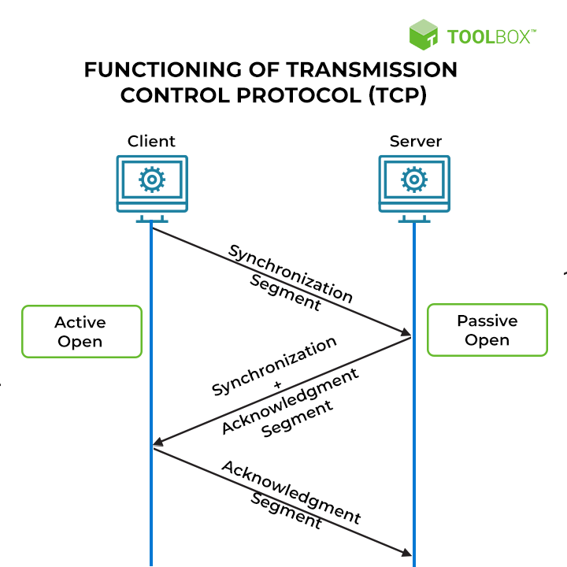
Figure 11: Functioning of Transmission Control Protocol

- The second protocol in this layer, UDP (User Datagram Protocol), is an unreliable, connectionless protocol for applications that do not want TCP’s sequencing or flow control and wish to provide their own.
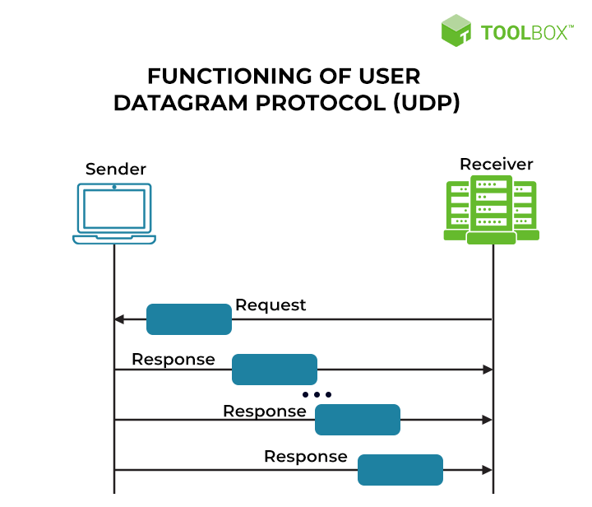
Figure 12: Functioning of User Datagram Protocol

Although TCP protocol is, by far, more reliable than UDP, there are some characteristics of the UDP protocol that will make it interesting for use in our KNX IP communication, i.e.:
- UDP is faster and more efficient than TCP.
- Unlike UDP, TCP cannot be used for multicast or broadcast services.
- UDP is suitable for live and real-time data transmission, which TCP cannot support.

The Application Layer of the TCP/IP stack
On top of the transport layer is the Application Layer. It contains all the higher-level protocols. The early ones included virtual terminal (TELNET), file transfer (FTP), and electronic mail (SMTP). Many other protocols have been added to these over the years (more than 500!), including the Domain Name System (DNS), for mapping host names onto their network addresses, HTTP, the protocol for fetching pages on the World Wide Web, and RTP, the protocol for delivering real-time media such as voice or movies.

The Application Layer doesn’t just include apps that the computer user can access. Some applications are also services to other applications. These applications do not need to be concerned with how data is transferred, just that it is sent and received.

TCP/IP applications

The applications defined as protocols in the TCP/IP suite are not end-user functions, but network administration tools and services. Some of these applications, such as the File Transfer Protocol (FTP), define programs that can be accessed directly by the user.
Protocols resident in the Application Layer include HTTP and HTTPS, which manage the request and transfer of web pages. The email management protocols Internet Message Access Protocol (IMAP), the Post Office Protocol (POP3), and the Simple Mail Transfer Protocol (SMTP) are also categorized as TCP/IP applications.

One interesting protocol is MQTT (MQ Telemetry Transport). Is a lightweight, publish-subscribe, machine to machine network protocol for Message queue/Message queuing service. It is designed for connections with remote locations that have devices with resource constraints or limited network bandwidth and must run over a transport protocol that provides ordered, lossless, bi-directional connections (typically TCP).

For the network administration most of the work is related to DNS, DHCP, NAT and SNMP applications.
- The Simple Network Management Protocol (SNMP): is a network messaging standard that is universally implemented in network equipment.
- The Domain Name System (DNS) is an essential service on private networks that translates web addresses to actual IP addresses for website access over the Internet. Works together with the DHCP system.
- The Dynamic Host Configuration Protocol (DHCP) creates an automatic IP address allocation method, so has become widely used on private networks as it cuts down the manual tasks that a network administrator must perform in order to configure all the endpoints on a large network.
- Network Address Translation (NAT) is a TCP/IP application that also helps to reduce the demand for IPv4 addresses. The NAT gateway attaches port numbers to outgoing requests from the private network to the internet, enabling large businesses to perform all their external communications with one IP address. When the response to the request arrives, the presence of the port number in the header enables the gateway to direct the packets to the originator of the request on the private network. NAT gateways not only help to reduce the demand for IPv4 addresses but they also create a firewall because, in theory, hackers cannot guess the private IP addresses of each endpoint behind the gateway.
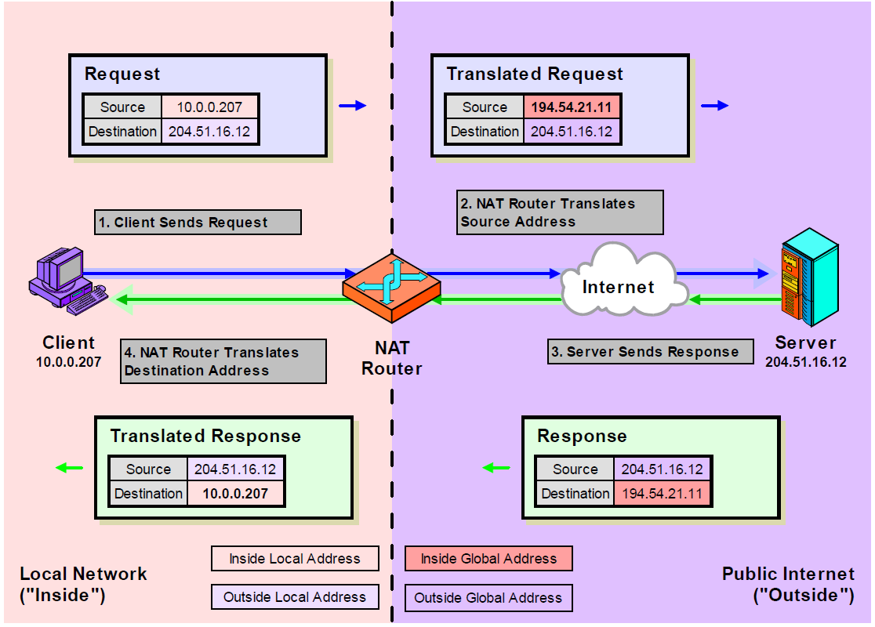
Figure 13: Network Address Translation is used to increase security

- A particular case of NAT is Network Address and Port Translation (NAPT): sometimes devices/services with private IPv4 addresses should also be accessed via WWW (e.g., a web server in the internal network). In these cases, port forwarding can be set up on the gateway/router. But when using port forwarding, we MUST ALWAYS PAY ATTENTION TO SECURITY!

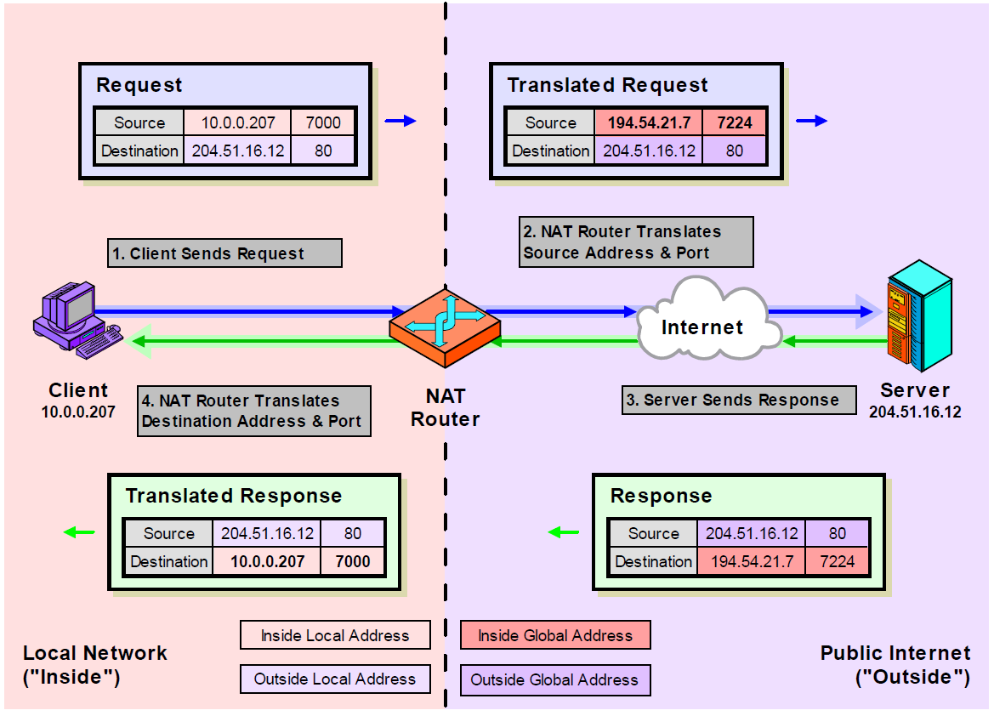
Figure 14: NAPT table

Equipment related to layers
In networks there also several kind of devices, which is important to distinguish. The difference between a router, a switch, a bridge, and a repeater can be described referring to their position in relation to the TCP/IP and OSI stacks.
- Router: sends data out over the internet. It also deals with endpoints on the local network, but only when they communicate beyond that router’s domain. The router is the home of the Internet Layer. In OSI terms, it is a Layer 3 device.
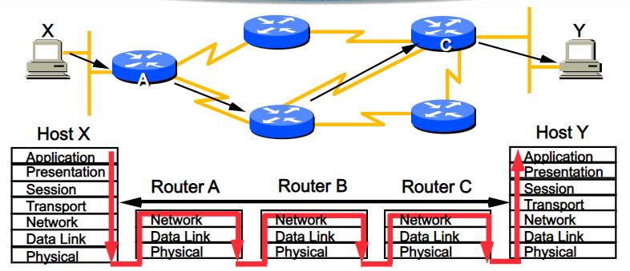
Figure 15: Example with some routers helping to connect two individual addresses in a layered communication
- Switch: connects all the computers on the network. Each computer in an office only needs one cable connection to a switch, so, a message gets from one to another computer in the office through the switch. A switch operates at the Link Layer. In the OSI stack, it is at the Media Access Control sub-level of the Data Link Layer. That makes it a Layer 2 device.
- Bridge: connects one hub to another. Can be used to connect a LAN and a wireless network together. A bridge is a switch with just one connection. Sometimes switches are called multi-port bridges. Bridges don’t need very complicated processors. They are just a pass-through, so they are principally Physical Layer devices. However, because they engage in addressing, they do also have some Link Layer capabilities. This makes them (OSI) Layer 1/Layer 2 devices.
- Repeater: it extends the range of a signal. On cables, the electric pulse dissipates over distance, and in Wi-Fi, the signal gets weaker as it travels. A repeater is also known as a booster. On cables, it applies a new boost of electricity to transmissions and on wireless networks, it retransmits signals. A repeater needs almost no software and is a purely physical device, so it doesn’t really have any involvement with the protocols in the TCP/IP stack. In OSI, it is a pure Layer 1 device.

Figure 16: Network Equipment related to layers

IP Communication in KNX systems

KNX IP Layered communication
The data transfers described in the “Telegram” chapter refer to communication via TP.

So-called IP routers are however increasingly used in current KNX installations. The basic functionality and area of application of an IP Router is already described in the “Couplers” chapter. In this section the implementation of the KNXnet/IP protocol is explained in more detail.

IP communication in KNX is also structured according to the OSI reference model described before.
- Application layer protocol in KNX systems is called the ‘KNXnet/IP Protocol’, as mentioned before.
- The Transport layer encapsules the data sent from the Application layer using UDP protocol and the specific port 3671, that suits better for our KNX multicast communication, as it was also explained in the previous section.
- The Network layer (IP) has to deal with address translation via ICMP or IGMP protocol, depending on the service used (tunneling or routing respectively) as we will describe later. And the ARP protocol helps to translate the IP into a MAC address for both cases.
- Finally, Ethernet is used as the Physical layer.

For every message sent, additional information for the respective layer (a header) is always added to the KNXnet/IP information in a similar way as for the TP protocol.

Ethernet header | IP header | UDP header | KNXnet/IP
Figure 17: General structure of a KNX message sent on an IP network

Figure 18: Layers and protocols used for KNX IP communications

Addressing of KNX IP Devices

As we have seen in a previous section, any network device has at least two addresses:
- The MAC (Media Access Control) address, that is linked to the hardware and cannot be modified (e.g.: 00-24-6D-F4-B4-D4).
- The IP address (Internet Protocol), that is assigned manually or automatically via DHCP. E.g.: 192.168.71.234, in the case of IPv4 (IPv6 is currently not used in KNXnet/IP).

The IP address can be compared to the physical/individual address in KNX. It is entered in the memory of the network device. The MAC address represents a unique “serial number”. It is the IP address of the hardware and is permanently linked to it.

KNX IP Address

Every KNX IP Device need an IP address that defines it as a host in its network ID. This IP address will be used for the KNXnet/IP protocol when a Tunneling connection is open and will be managed by the ARP protocol as described before.

We will describe later what are the Tunneling and the Routing Services in the KNXnet/IP protocol.
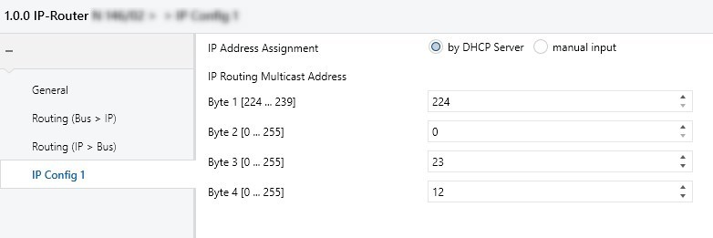
Figure 19: Example of configuration for the KNX IP Address in the Parameter dialog

KNX IP Routing Multicast address

When we have an IP Backbone in a KNX system, there is no electrical continuity in that main structure of our KNX topology, so it is, in principle, not possible to insert a telegram in the main line/backbone line so that it reaches directly all the line/area couplers on that side.

The lack of “electrical continuity” can be solved using a special IP address (type D) called IP Multicast Address.

For the ARP protocol, in case of multicast, a defined MAC address consisting of 6 bytes is sent in the network layer as destination address. For Multicast telegrams, this address always starts with 01-00-5E- and is then supplemented by a so-called 4 byte long multicast IP. As we have seen, in IPv4 the address range from 224.0.0.0 to 239.255.255.255 has been defined for a wide variety of network – applications. The multicast IP address 224.0.23.12 is reserved for KNXnet/IP.

A MAC address however always consists of 6 bytes. That’s why a 4 byte multicast IP address can’t be padded to the predefined 3 bytes (01-00-5E-) as otherwise the address would be 7 bytes long. The padding is therefore realized as shown below:

The lower 23 bits of the multicast IP address are inserted in the MAC address, resulting in MAC addresses ranging from 01-00-5E-00-00-00 to 01-00-5E-7F-FF-FF. It is possible that several multicast IP addresses are mapped on the same MAC address (for example 224.0.0.1 and 233.128.0.1).

KNX Multicast IP |  |  |  |  |  |  |  |  |  |  |  |  |  |  |  | 224 |  |  |  |  |  |  |  | 00 |  |  |  |  |  |  |  | 23 |  |  |  |  |  |  |  | 12 |  |  |  |  |  |  |  | dez.
 |  |  |  |  |  |  |  |  |  |  |  |  |  |  |  | E0 |  |  |  |  |  |  |  | 00 |  |  |  |  |  |  |  | 17 |  |  |  |  |  |  |  | 0C |  |  |  |  |  |  |  | h.
 |  |  |  |  |  |  |  |  |  |  |  |  |  |  |  | 1 | 1 | 1 | 0 | 0 | 0 | 0 | 0 | 0 | 0 | 0 | 0 | 0 | 0 | 0 | 0 | 0 | 0 | 0 | 1 | 0 | 1 | 1 | 1 | 0 | 0 | 0 | 0 | 1 | 1 | 0 | 0 | bin.
1 |  |  |  |  |  |  |  | 0 |  |  |  |  |  |  |  | 158 |  |  |  |  |  |  |  | 0 |  |  |  |  |  |  |  | 23 |  |  |  |  |  |  |  | 12 |  |  |  |  |  |  |  | dez.
01 |  |  |  |  |  |  |  | 00 |  |  |  |  |  |  |  | 5E |  |  |  |  |  |  |  | 00 |  |  |  |  |  |  |  | 17 |  |  |  |  |  |  |  | 0C |  |  |  |  |  |  |  | h.
0 | 0 | 0 | 0 | 0 | 0 | 0 | 1 | 0 | 0 | 0 | 0 | 0 | 0 | 0 | 0 | 0 | 0 | 0 | 0 | 1 | 1 | 1 | 0 | 0 | 0 | 0 | 0 | 0 | 0 | 0 | 0 | 0 | 0 | 0 | 1 | 0 | 1 | 1 | 1 | 0 | 0 | 0 | 0 | 1 | 1 | 0 | 0 | bin.

Figure 21: Composition of the Multicast MAC Address in KNX IP

The complete multicast MAC address in KNXnet/IP is therefore 01-00-5E-00-17-0C.

It is possible to change the predefined KNX multicast IP addresses in the parameters of KNXnet/IP devices.


Figure 20: Changing the multicast IP address in the Parameter dialog

In this way it is possible to establish communication between different from each other separated KNX installations within the same IP network. Please note that all IP routers of an installation are listening on the same multicast IP address.

KNXnet/IP Protocol

The KNXnet/IP telegram contains some additional information compared to the TP telegram.

Ethernet header | IP header | UDP header | KNXnet/IP

KNXnet/IP
Header Length | Protocol Version | Service Type  Identifier | Total Length | KNXnet/IP Body
1 byte | 1 byte | 2 bytes | 2 bytes | Variable length
Figure 21: Parts of the KNXnet/IP telegram in a KNX IP communication

- Header Length (1 byte): The header size is always the same. It is transmitted nevertheless as the size may change with further versions of the protocol. It is used to find the start of the complete KNXnet/IP frame. The header size is indicated in bytes.
The transmitted value is 06h.

- Protocol Version (1 byte): The protocol version indicates the status of the KNXnet/IP protocol. It is binary coded and is currently version 1.0.
The transmitted value is 10h.

- KNXnet/IP Service Type Identifier (2 byte): The KNXnet/IP type identifier indicates which action should be carried out. The following table shows the defined address ranges and actions.

Address range in hex |  | KNXnet/IP action
From | To
0200 | 020F | KNXnet/IP Core
0310 | 031F | KNXnet/IP Device Management
0420 | 042F | KNXnet/IP Tunneling
0530 | 053F | KNXnet/IP Routing
0600 | 06FF | KNXnet/IP Remote Logging
0740 | 07FF | KNXnet/IP Remote Configuration and Diagnosis
0800 | 08FF | KNXnet/IP Object Server

A detailed list of all the defined addresses can be found in the KNX specifications, volume 3 (System Specifications), part 8 (KNXnet/IP), chapter 1.

- Total Length (2 bytes): The total length of the KNXnet/IP frame is indicated in bytes in the “Total Length” field. The bytes of the previous fields (Header Length, Protocol Version and Service Type Identifier) are also part of the total length. If the total number of bytes transmitted is greater than 252 bytes, the first “Total Length” byte is set to FF (255). Only in this case the second byte includes additional length information.

- KNXnet/IP Body (variable length): The KNXnet/IP Body describes the useful data within a KNXnet/IP frame. The useful data adopts a different structure depending on the information content that should be sent. It consists of a connection header, including the Message Code (1 byte) and an additional length information (1 byte). Furthermore, the IP Body contains the so-called cEMI frame.

Ethernet header | IP header | UDP header | KNXnet/IP

KNXnet/IP
Header Length | Protocol Version | Service Type  Identifier | Total Length | KNXnet/IP Body

KNXnet/IP-Body
Connection Header | cEMI Frame
Figure 22: Parts of the KNXnet/IP Body in a KNX IP communication

The cEMI frame basically contains the TP telegram structure. The check field is not used in IP communication as error detection is done via the IP protocol. Moreover a second control field (1 byte) is included behind the TP control field. In the second control field the Type of the destination address (1 bit) and the routing counter (3 bits) are included. In the last 4 bits there the so-called Extended Frame format (EFF) can be given, e.g.:
0000_{bin}: for standard frames
01xx_{bin}: for LTE frames (see serial data communication and KNX protocol in the
KNX Tutor course documentation)
As the type of the destination address and the routing counter are already described in the second control field, the first 4 bits of the N_PDU are set to 0000.

 |  |  |  |  |  |  |  |  | Control field |  | Source address |  | Destination address |  | Type destination address(1b); Rout.counter.(3b); length.(4b) | TPCI/APCI & data |  | Check field
TP: |  |  |  |  |  |  |  |  | BC |  | 11 | 01 | 09 | 01 | E1 | 00 | 81 | 3B
IP: | 06 | 10 | 05 | 30 | 00 | 11 | 29 | 00 | BC | D0 | 11 | 01 | 09 | 01 | 01 | 00 | 81
 | Header length. | Protocol Version. | Service Type identifier. |  |  | Total length (KNXnet/IP). | Message Code. | Length additional information (future applications) | Control field. | Type Destination addr..(1b); Rout.count.(3b); Ext. Frame Format(4b). | Source address. |  | Destination address. |  | 0000 + length(4b). | TPCI/APCI & data.

Figure 23: Example of KNX TP Telegram compared to KNXnet/IP telegram

Tunneling
Tunneling is necessary for the connection-oriented transmission of KNX telegrams in an IP frame with ETS. This is always the case if a physical address should be addressed as a destination address i.e. when programming the physical address or downloading the application program of KNX devices. Communication in tunneling is always carried out via the IP address of the KNXnet/IP device that is to be “tunneled”.

Address Range
The tunneling variant is always used when a KNXnet/IP device should be addressed directly via Ethernet e.g. to load the application into a TP device. For this case, there is an address range of 0420h to 042Fh in the KNXnet/IP type identifier field. Two addresses are currently defined:
- 0420h : TUNNELING_REQUEST
- 0421h : TUNNELING_ACK
The TUNNELING_REQUEST address is used to send and receive individual KNX telegrams between KNXnet/IP Client and Server.

The TUNNELING_ACK address is sent by a KNXnet/IP device to confirm the receipt of TUNNELING_REQUEST information.

Tunneling Examples
Two examples of tunneling are shown in the following section.

- Example 1: IP gateway in the main/backbone line as a universal coupler
- Example 2: IP router as a coupler between TP lines

Example 1 | Example 2
Figure 24: Examples of use of the KNXnet/IP Tunneling service

When a device in a TP line needs to be programmed by ETS via Ethernet in the two examples above, the settings of the interface should always be performed first.
You can choose one of the supported KNX communication types:
- KNXnet/IP (tunneling)
- KNXnet/IP (routing)
- USB
- IP (EibLib/IP)

USB and IP routers/interfaces are recognized and displayed automatically by ETS; they do not need to be created. An interface that is not recognized automatically cannot be used by ETS even if you create it manually.

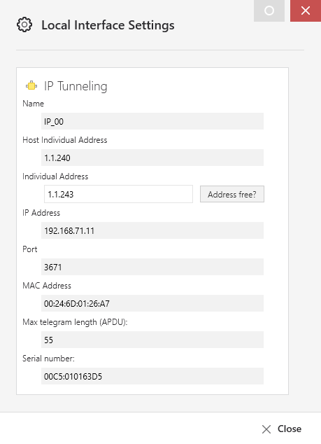
Figure 25: A KNXnet/IP Router/Interface is detected automatically

The following information amongst others is displayed depending on the selected type.

1 | Name | Enter a user-friendly name for the interface
2 | Host Individual address | Individual address of the host device
3 | Individual address | Individual address to be selected for the host device
4 | IP address | IP address found for the interface;  if recognized/resolved
5 | Port | 3671 (default)
6 | MAC | MAC hardware address of the interface,  as far as it can be determined
7 | APDU | Maximum telegram length (payload)
8 | Serial number | Only visible after the device has been programmed

If several KNXnet/IP devices are displayed (e.g. the different IP routers, if they are functioning as main/backbone couplers), it is now important to select precisely the KNXnet/IP device that is connected to the TP line (area) of the device to be programmed. The local individual address must then be correctly set.
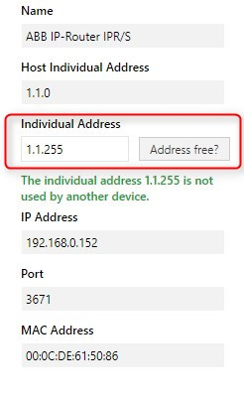
Figure 26: Local Interface settings

It is important that the address matches the line or area of the device to be addressed. Moreover, the address shall currently not be in use in the installation or project. It is advised to select 255 as bus device number as it probably does not exist in the installation.

A KNXnet/IP router of line 1.1 thus has individual address 1.1.0 as coupler address and address 1.1.255 as local individual address.

Remote access to a KNX Installation via Tunneling connection

The main vulnerability of a remotely accessible KNX installation is the use of the – well-known and fixed – port 3671 (UDP).

It is important to know that opened ports offer services that are potentially vulnerable to attacks! So these ports should be closed or filtered.

A closed port still offers medium security because it responds to a scan, so closing a port maybe is not enough as it still reveals that your system is up and might provide some additional fingerprinting information to potential intruders.

In these cases it is better to filter the port, as filtered ports do not respond to a port scan at all, so they don't appear to exist.

In summary, port forwarding is not safe and should never be a way to access remotely to any KNX installation.

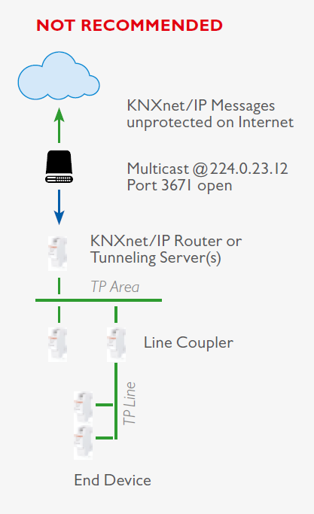
Figure 27: Remote access scenario using port forwarding

There are basically two recommended scenarios that guarantee a safe remote connection to a KNX installation:

- On one hand, the use of a VPN connection is recommended.

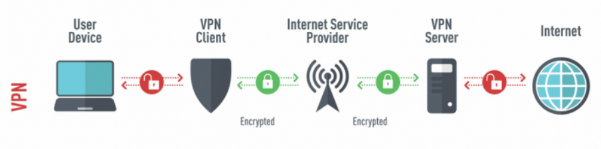
Figure 28: General layout of a VPN connection

- On the other hand, the use of KNX devices with a manufacturer-specific secure access solution

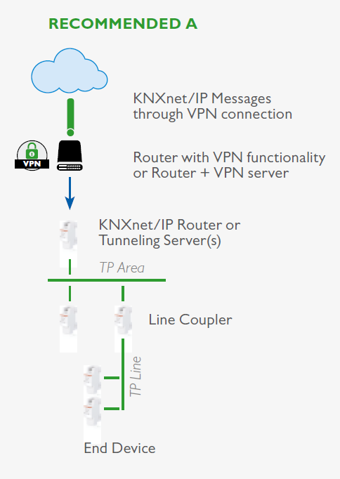
Figure 29: KNX recommended scenarios from the KNX Secure position paper

Routing

Routing is necessary for connectionless and simultaneous transmission of KNX telegrams to several devices from one network to another network via an IP coupler or IP router. This corresponds to group communication in TP communication.

Address Range
There is an address range of 0530h to 053Fh within a routing telegram in the KNXnet/IP type identifier field. Two addresses are currently defined:
- 0530h : ROUTING_INDICATION
- 0531h : ROUTING_LOST_MESSAGE

ROUTING_INDICATION is used to send KNX telegrams via IP networks without a connection.
ROUTING_LOST_MESSAGE is used to display any KNXnet/IP routing information that has been lost (connectionless).

Routing Example
If IP routers are used as line or backbone couplers in a KNX installation, they route a TP telegram to the primary IP side if the corresponding group address is entered in the filter table and the parameter is set to “filter”. The telegram is then sent via UDP with the multicast address 224.0.23.12 (port 3671) defined for KNX. A successful transmission is not confirmed. Data loss on the IP side is however relatively unlikely.

An IP router that receives a KNXnet/IP telegram on its primary IP side via the KNX multicast address will evaluate the KNXnet/IP telegram and only route it on its secondary TP side if the corresponding group address is entered in the filter table and the parameter is set to “filter”.
Figure 30: Example of use of the KNXnet/IP Routing service

Note:
Direct communication between two IP devices is normally only possible via the respective IP addresses of the IP devices. That means that if an IP device sends information to another IP device, the destination address is always the IP address of the recipient.

In the case of KNXnet/IP routing, the network structure which was pre-assigned by the IP and subnet addresses is removed by using the multicast IP. If two networks should now be linked together via the KNX multicast IP, it should be ensured that intermediate network routers also let the multicast IP through. By default, a network router will first block all multicast addresses so that no attacks can be carried out externally. This also applies to newer network switches. Preset filter functions can prevent the multicast IP from being forwarded.

SOURCES AND REFERENCES

- Computer Networks. 5th Edition (2011). A.S. Tanembaum, D.J. Wetherall
- The TCP/IP Guide v 3.0 (2005). C.M. Kozierok

For the coordination the protocol IGMP is used in IPv4

