KNX Secure
KNX Association

Table of Contents
1 Cybersecurity and KNX: a storm in a teacup? 3
2 Is the current KNX system not secure? 4
3 KNX Secure – an extension of the KNX standard 5
3.1 Introduction 5
3.2 Two KNX secure characteristics 7
3.3 Possible uses for KNX Secure 9
4 KNX Secure – ETS 10
4.1 Introduction 10
4.2 Password mandatory 10
4.3 "Security" Information accessible via Project Details Window 12
4.4 Brief description - Generating and downloading security keys in the ETS 13
4.5 Presentation of KNX Secure 14
4.6 Setting options for group addresses 15
4.7 KNX IP Secure 18
4.8 Access to bus with security 24
4.9 Security support of software on interfaces 25
4.10 ETS reports 25
5 KNX Security Proxies 26
5.1 Reasons for the Introduction of Security Proxies 26
5.2 Repercussions of using couplers with security proxy functionality 26
5.3 Repercussions on ETS 27
5.3.1 New representation of group addresses 27
5.3.2 Security Domains 27
5.3.3 Transfer Domains 28
5.3.4 Preview Filter Table 29
6 Summary 30

Cybersecurity and KNX: a storm in a teacup?
Cybersecurity is often a controversial discussion topic: Some people are worried about burglars hacking the weather station on the roof, others sidestep the problem as if there wasn't a care in the world.
In principle, properly designed KNX installations are secure. However, it is also a fact that KNX applications in buildings have become more versatile and thus more sensitive to attacks. The need for security increases with the threat.
The popularity of Smart Home is attracting the greed of hackers. No wonder. With the Smart Home systems currently hitting the market, often quickly and cheaply, data security is often of a lesser importance. Skills for a diligent and secure application are also in short supply.
It is different with KNX: KNX is installed by professionals.
The installation rules include protective measures against unauthorised access to the building network. KNX systems in operation are later also supervised competently. Hackers therefore have little opportunity with KNX.
Nonetheless: Warnings from IT security experts against attacks on building networks must not be thrown aside. Whether Smart Home or Smart Building: The threat situation is changing. Intelligent applications in buildings are accordingly becoming more versatile.
- Wireless communication, which is not a closed medium as twisted pair, is increasingly being used in KNX.
- KNX systems also incorporate security-related systems to use synergy effects. Access management, gate controllers and alarm systems can be targets for attack. If a crafty rascal finds a security loophole here, he can copy telegrams, open doors remotely or even take the alarm system out of service.
- Hackers could view unprotected data from presence detectors, on energy consumption and from administration programs and do all sorts of no good.
- Manipulations of lighting controls, heating control systems and other processes in the building system may also pose a risk.
- This is still not the whole story: Building networks are offering increasingly larger areas for attack through new applications with Internet routers, WLAN, IP protocol, servers, tablets, smartphones and IoT components.

Is the current KNX system not secure?
In principle, building automation with KNX is secure. As KNX works data driven (whether a light is switched on or a blind is pulled down cannot be interpreted directly from the bus signals), what the effect is of a message cannot be inferred directly from the telegram traffic, at any rate not without access to the ETS project or seeing at the same time its effect on the installation.
A properly designed installation follows security rules. To ensure this, the security checklist issued by KNX may be helpful (see https://www.knx.org/wAssets/docs/downloads/Marketing/Flyers/KNX-Project-Preparation/KNX-Project-Preparation_en.pdf).

A few extracts from this checklist:
- Both inside and outside, physical media should be isolated against direct access;
- Couplers should be configured to prevent unwanted telegram traffic in parts of the installation outside this line;
- In certain KNX devices, locking via a BCU password that can be set in the ETS offers protection against unauthorised parameter changes.
- If IP is used as a communication medium, conventional security mechanisms for IP networks are to be applied. An access to a KNX system should be possible from the Internet only via a VPN connection.

KNX Secure – an extension of the KNX standard

Introduction
In order to adjust to the current and future building automation developments as regards data security, KNX has increased the security requirements on the KNX technology and developed the security architecture "KNX Secure".
The new KNX Secure devices are the consistent implementation of an early development of additional protective measures. The specified protective mechanisms are based on security algorithms standardised internationally according to ISO 18033-3 and use recognised encryption according to AES 128 CCM.
Meanwhile, KNX Secure is also standardised as a technology in Europe (as part of the EN 50090 range, part 3-4) as well as worldwide (as EN ISO 22510).
KNX is therefore the first field bus system in the world that makes a manufacturer independent security concept for intelligent home and building applications.
This means maximum data protection through authentication and encryption of data communication. The following methods are used:

- Authentication
Telegrams are authenticated in such way, that recipients can recognise these as originating from a trusted sender.
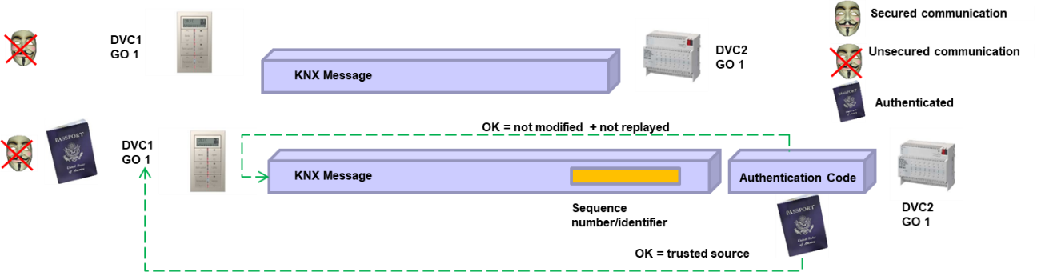
Figure 1: KNX plain telegram – KNX telegram with authentication
The top telegram shows a plain telegram exchanged between devices 1 and 2. Additional data is attached to the bottom telegram (an authentication code), which proves that the telegram originates from device 1 and not from an unknown device. In a manner of speaking, device 1 is showing its passport to device 2. Should the telegram be manipulated regarding this authentication code, then device 2 will discard the telegram.

- Encryption
Encryption, that may be used on top, makes the actual user data illegible and impossible to manipulate.
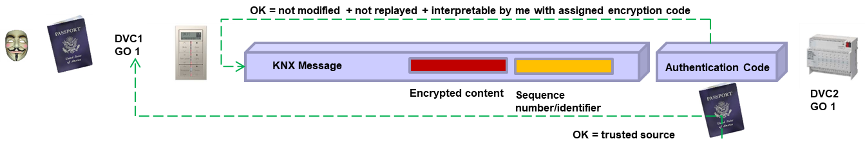
Figure 2: KNX telegram with additional encryption of user data
The user data is also encrypted, as shown in red in the top figure.
Telegrams could thus also only be authenticated, so that data content remains visible, for example for a visualisation software. Thanks to authentication, these can however not be manipulated or resent.

- Sequence number
A sequence number prevents the dreaded replay attack (i.e., recording telegrams and again injecting them into the system at a later point in time). The sequence number is shown in orange in the top figures and is contained both in an authenticated telegram and in one that is encrypted as well. If a device has already received a message from a given sender with a sequence number known to it, the device must discard the message. Accordingly: KNX Secure devices manage for all their communication partners (via the individual address) a log with the last sequence number received for every communication partner.

- Secure commissioning
Also, during the planning and commissioning stage with the ETS, communication with the devices is secure. This is described in more detail in section 4.

Two KNX secure characteristics
KNX Secure consists of two types of security:

- KNX IP Secure to protect KNX IP communication
Earlier conventional KNX IP routers can be exchanged for new KNX IP Secure routers. These extend the KNX IP protocol by additional authentication and encryption. With this method, IP communication is secured at telegram level. IP routers that do not support IP Secure, discard KNX IP Secure telegrams.
Figure 3: KNX IP Secure

- KNX Data Secure to protect runtime communication, for example group telegrams.
KNX Data Secure encrypts and authenticates telegrams from end device to end device over all transfer paths.
For this, all participating components must be KNX Data Secure devices: KNX devices that do not support KNX Data Secure discard KNX Data Secure telegrams. As explained below, ETS prevents secure group addresses being connected with group objects that do not support KNX Data Secure.
In addition to full securing of complete KNX areas and KNX lines, only individual KNX applications at particular risk can also be secured with KNX Data Secure. In addition to secure functions, plain functions are also possible in parallel - even inside a KNX Data Secure device. This means that a KNX Data Secure device can have group objects that are connected with secure group addresses, some others with plain group addresses.
Figure 4: KNX Data Secure
Both security mechanisms can be combined with one another and operated in parallel. With KNX Secure, KNX installations can be secured per application or overall.

KNX Secure devices are recognisable as the letter "X" is printed on the label.
KNX Secure devices can usually be operated securely as well as plain. With this, an existing KNX installation remains flexible for changes and extensions, if, for example, in the near future not all KNX devices are available as KNX Secure, or if obsolete devices have to be exchanged.
It remains the responsibility of planners, installation engineers, system integrators and building users to apply the security measures provided and possible extensions with KNX Secure sensibly. Potential threats and risks, as well as balancing additional costs against benefits are the yardstick for design. Prerequisites are proper planning and installation of the KNX system. All participants are required to ensure that a KNX project with KNX Secure applications also remains at all times protected against hacker attacks. Consequently, during project handover to building users, installation engineers and building technicians, the project monitoring, safekeeping of security keys as well as the overall responsibility for this must be well arranged.

Possible uses for KNX Secure
- Hotels – security functional demarcation between separate guest rooms
- Energy consumption data – encryption of KNX data protects privacy
- Booking systems – telegram encryption at IP level prevents external access
- Access control – authentication and encryption
- Presence data – no real time tracking that can conclude on the presence of individuals
- Alarm systems - prevention of wanted false alarms

KNX Secure – ETS

Introduction
ETS has already been made fit with version 5.5 for KNX Data and IP Secure.
Intelligent functions support planning and commissioning with KNX Secure devices. During configuration in ETS, control mechanisms protect against incorrect settings.
The ETS ensures that both project password and device certificates are activated in secure mode. In the dialogue, it generates automatically and securely the allocation of security keys for KNX Secure devices and runtime keys for the secured group addresses and saves the security keys in the project.
KNX Secure devices are also commissioned in a fully secure manner.

Password mandatory
If a KNX project is created in the ETS and when one single KNX Secure device is included in the project, the ETS will require the setting of a corresponding project password.
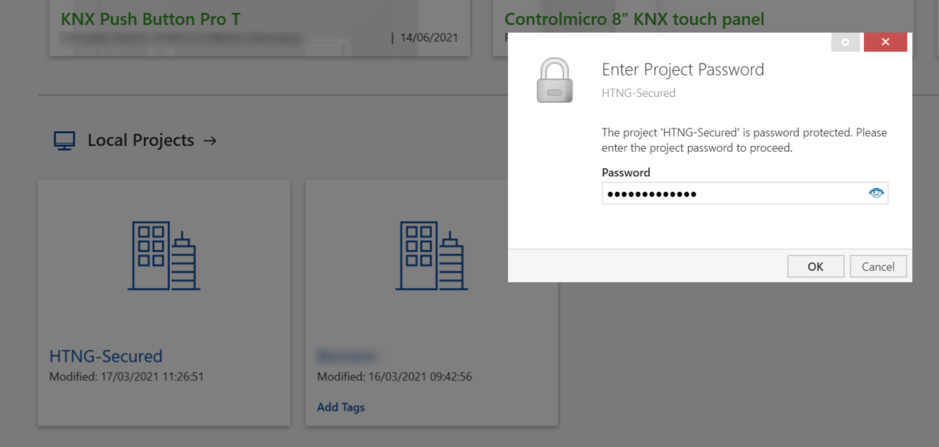
Figure 5: Password-protected ETS project

Figure 5 shows an ETS project with KNX Secure devices: only if the password has been entered can the project be opened, and the details viewed.

During the password allocation, the ETS also states the password strength.

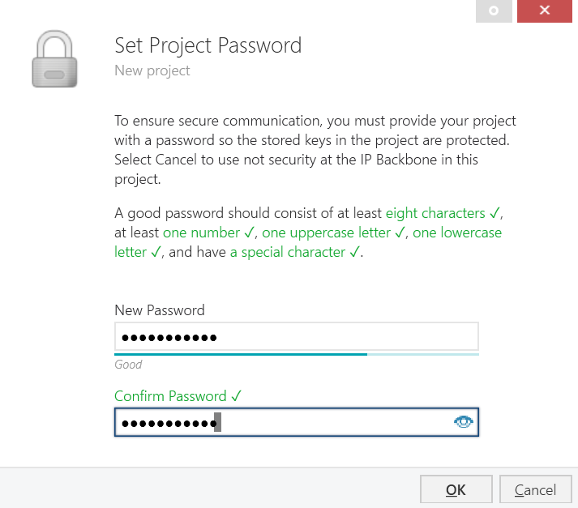
Figure 6: Allocation of a project password that has the right combination of letters, numbers and characters
On re-opening the project, the password must be entered; if need be, it can also be displayed in clear text via . This means that if projects are exported and exchanged, projects cannot be opened without the password; this is to protect the security information stored in the project, e.g., the runtime keys mentioned earlier.

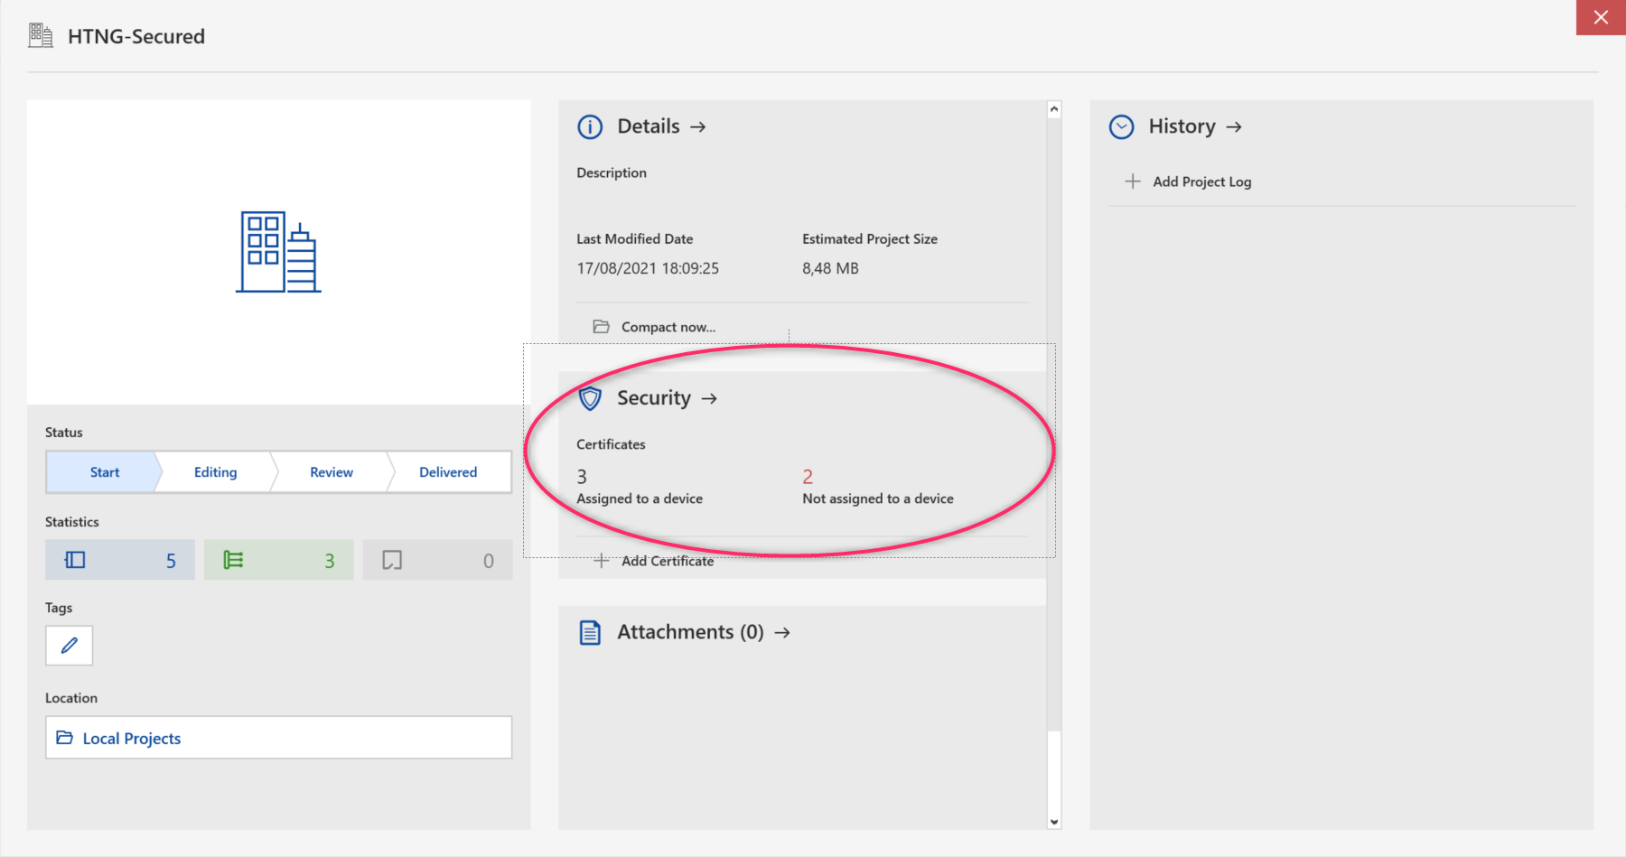
Figure 7: Details of a project containing KNX secure device

"Security" Information accessible via Project Details Window
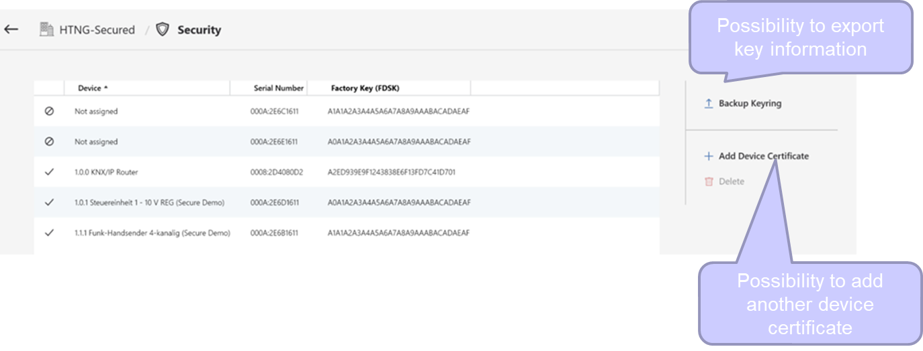
Figure 8: "Security" information accessible via project details window
The above view can be opened when clicking the arrow behind 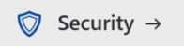 in the project details.
For all KNX Secure devices in the ETS project, the read-in factory keys (Factory Default Set Up Key – FDSK for short) are stored in a list matching the relevant serial numbers of the respective devices. There is more information on the role of the factory default set-up keys in section 4.4. This information is obviously also included in the project export.

This information (including the allocated runtime keys) can also be separately exported by pressing on the arrow in front of , as an additional backup next to the knxproj export or the printed-out report (see also clause 4.10).
However, this export should only be provided to authorised persons.
If you wish to include additional KNX Secure devices in the installation, you must press the arrow in front of  in the project details window or directly via the 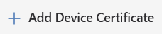 in the above displayed security information window. All KNX Secure devices are delivered with a standardised QR code: if your PC has an integrated webcam, it can be read in automatically. Otherwise, you must enter it manually. This FDSK is indispensable for secure commissioning of KNX Secure devices.
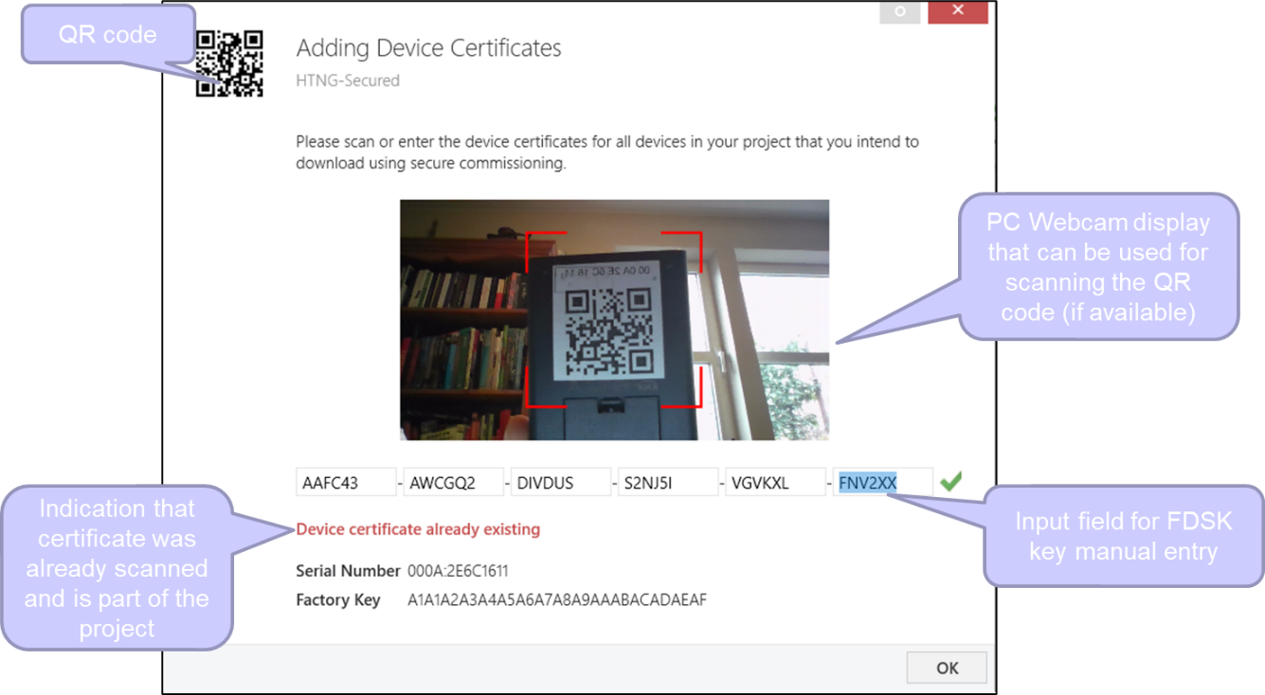I
Figure 9: Reading in/entry of device certificates of KNX Secure devices
It is recommended to remove the QR code from the product after it has been scanned and keep it in a safe place (e.g., as part of the documentation of the installation). With the knowledge of the FDSK, an attacker may decode recorded commissioning traffic (including all the keys) even afterwards (however only limited to the device to which the FDSK belongs).

Brief description - Generating and downloading security keys in the ETS
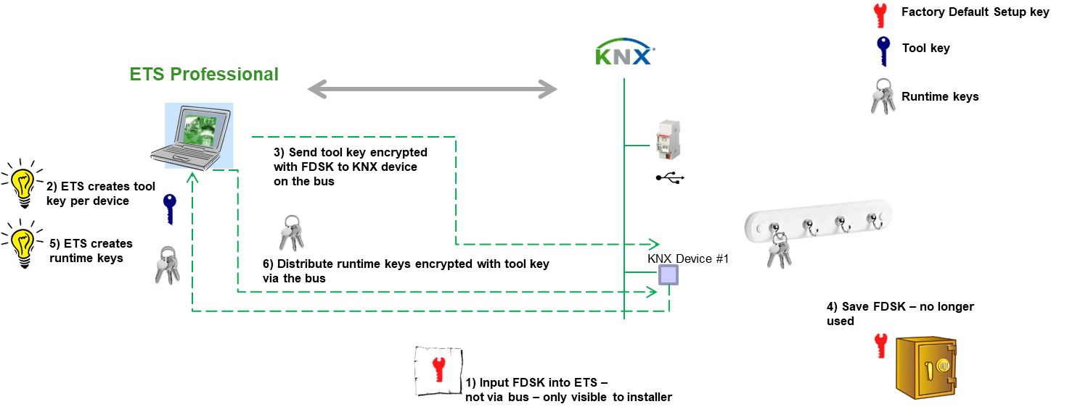
Figure 10: Method of generating and downloading security keys
After the FDSK has been read into the ETS via the method described in section 4.3 (the FDSK is thus never transferred via the bus in clear text), in the background, the ETS generates a secret device key for every KNX Secure device. For each secured group address connected with the KNX Secure device that has been generated during the planning (see section 4.6), ETS also generates secret runtime keys. All these keys are obviously stored in the project and are visible to the user only in the project security report, see section 4.10.
ETS will transfer the device key - itself encrypted with the FDSK - to the KNX Secure device. As soon as the device has confirmed that it has saved the tool key, the ETS will transfer the application, parameters and group addresses to the KNX Secure device by means of secure communication (encrypted with the device key). The FDSK key will then no longer be needed, unless the device is reset to the ex-works state (using manufacturer-specific mechanisms). If a device is reset to the ex-works state, then all safety-related data is also deleted.

Presentation of KNX Secure
KNX Secure devices are for example marked accordingly in the topology view, so that they can be distinguished easily from non-secure KNX devices. KNX Secure devices have a blue coloured shield symbol .
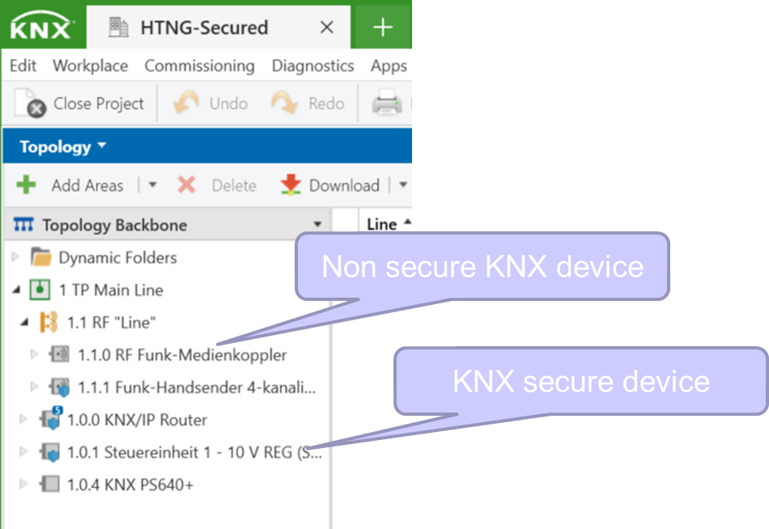
Figure 11: Illustration of KNX Secure devices in the topology
The same shield symbol is used to mark group objects that have been connected by means of a secure group address.

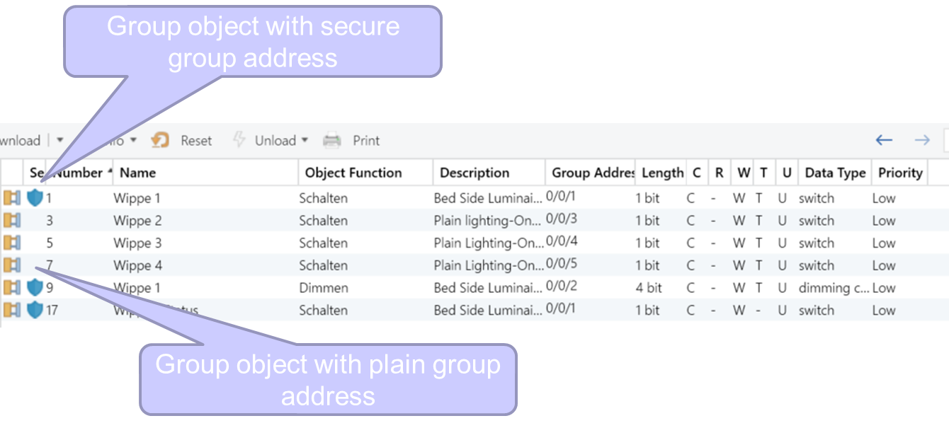
Figure 12: Selecting a KNX Secure device – Group object list
If the group address view is selected, the same is visible. Non-secure group addresses are shown without the shield symbol, secure with a shield symbol.
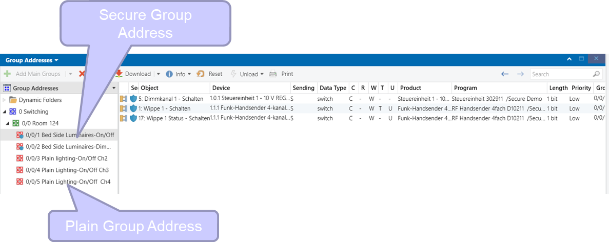
Figure 13: Selecting a secure group address and the corresponding associations

Setting options for group addresses
When a group address is created, there is the option to determine in the settings whether the security should be 'automatic'', 'on' or 'off'.
Figure 14: Group address security setting | - 'On' means that if the group address is connected with a group object in a KNX Secure device, security for the object is always switched on. Vice versa, this means that these group addresses cannot be connected with group objects in a non-secure KNX device (see Figure 15).  - 'Off‘ means that the group address, even with a group object that supports security, does not ensure that encrypted telegrams are sent by the group object. Therefore: communication via the group address is always unencrypted.  - 'Automatic' means that when the group address is connected with group objects in a KNX Secure device, security for the group address is activated. However, if the group address is then connected with an object in a non-secure KNX device, the notification from Figure 16 appears and the group address is then reset to plain if confirmed with OK. If need be, previously loaded devices must be re-downloaded.
Important: if a group object is already connected with a group address with activated security, it can no longer be connected to group addresses with deactivated security. The ETS will then display the security notice from Figure 16. If security is however required, this can actually mean that a non-secure KNX device must possibly be exchanged for a KNX Secure device.

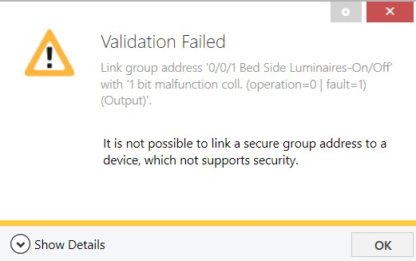
Figure 15: Attempt to connect a secure group address with a group object in a non-secure KNX device (with 'On' setting)

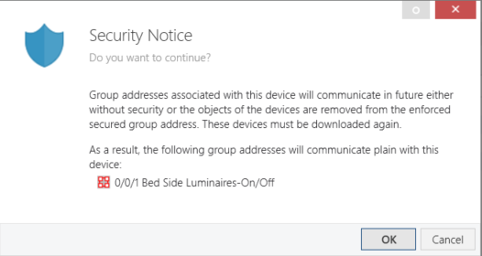
Figure 16: Attempt to connect a secure group address with a group object in a non-secure KNX device (with 'Automatic' setting)

KNX IP Secure
In the topology view, you can determine whether for the IP backbone security is activated or not. For this, you must click on the word "Topology".

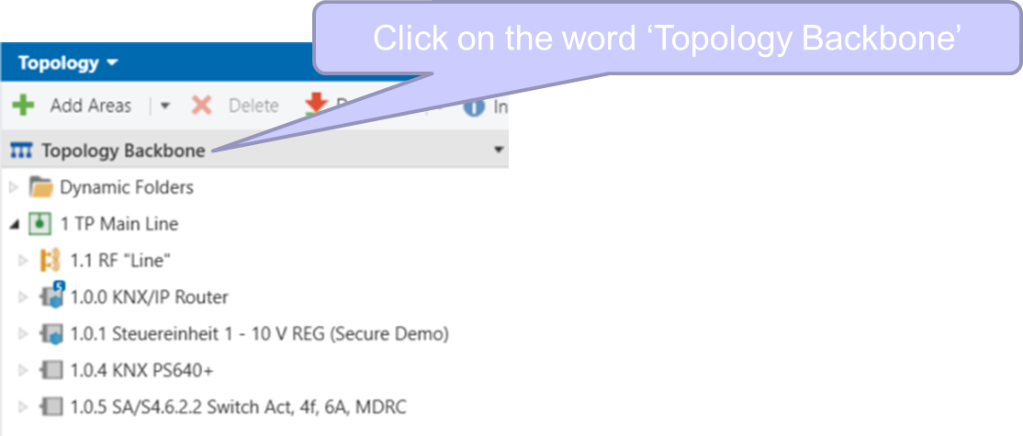
Figure 17: IP backbone settings (1)

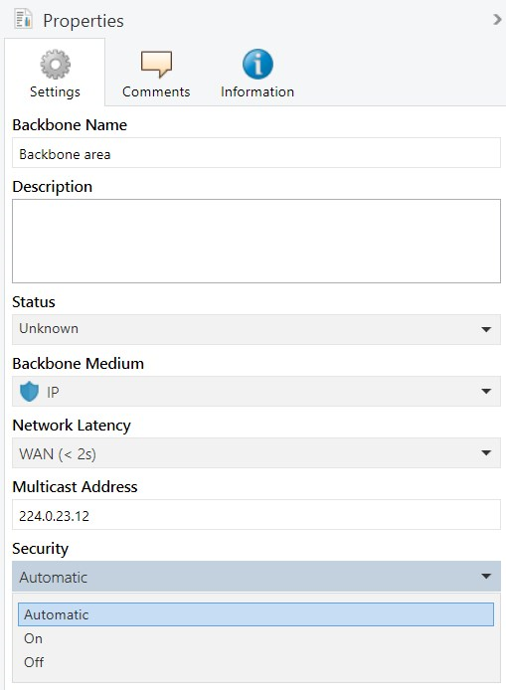
Figure 18: IP backbone settings (2)
The names for the security settings have similar meanings as those from section 4.6:
- Security "On": KNX IP devices that do not support KNX IP Secure cannot be added to the backbone (or in the main line).
- Security "Off": even if a KNX Secure device is inserted into the backbone (or into the main line), then still will the communication be operated as plain.
- Security "Automatic": if a KNX IP Secure device is inserted into the backbone (or into the main line), security is switched on automatically. If a non-secure KNX IP device is subsequently inserted into the backbone (or into the main line), then the notification as given in Figure 19 will appear.
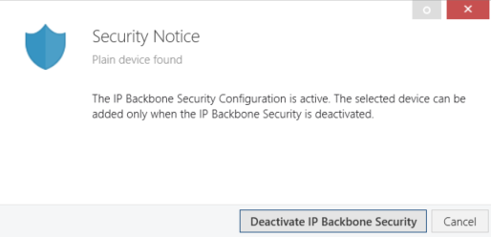
Figure 19: Security notification, if a non-secure KNX IP device is inserted into the backbone, when a KNX IP Secure device is already present in the backbone (with 'Automatic' setting)
If a KNX IP Secure device can be operated as a tunnelling interface, you can determine in its Properties dialog (Settings Tab) whether it must be commissioned securely or whether secure tunnelling is activated. If you wish, both can be switched off.
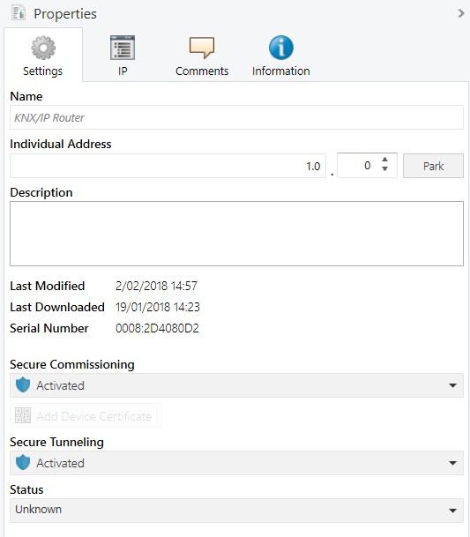
Figure 20: Selecting a KNX IP Secure device – Properties – Settings
If secure tunnelling is activated, the commissioning password chosen by ETS is visible in the tab “IP”, as well as the authentication code set by the user (if available). Both must be entered with accessing the tunnelling server for the first time.

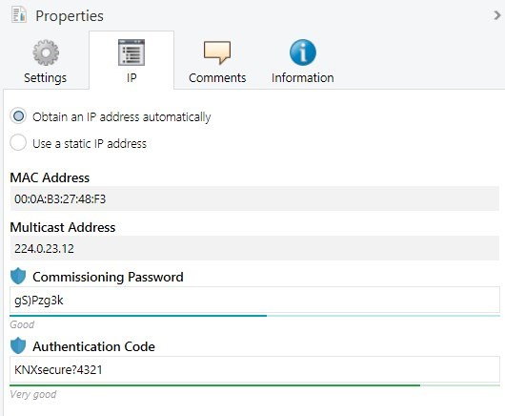
Figure 21: Selecting a KNX IP Secure device – Properties – IP
Via which individual addresses the tunnelling server is sending is visible when the information under the device is expanded. When the individual address is selected, the user password is displayed in Properties/Settings.
There is also there the possibility to create a keyring dedicated for visualization software programs by pressing  : ETS will then again prompt the user to enter a password. This file contains only the keys really needed as well as additional information useful to connect to the interface. Needless to say, also this export should only be provided to authorised persons.
ETS always accesses KNX routers or KNX tunnelling interfaces in the role as "Administrator"; therefore, the password is always the one that is set generally for the IP router/tunnelling interface, not the different passwords possibly set for the individual tunnelling connection.
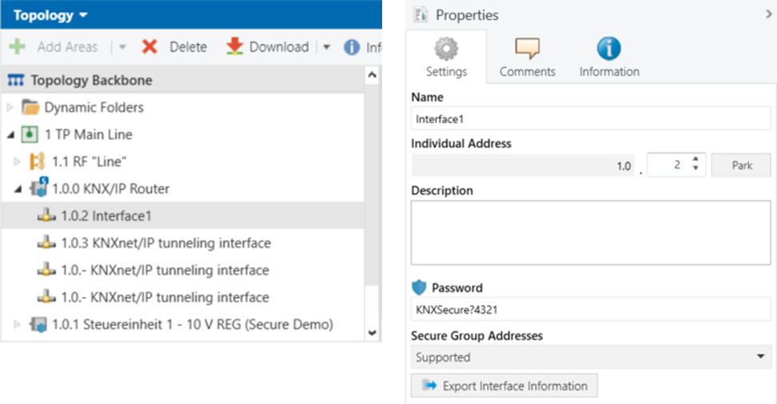
Figure 22: Selecting a KNX IP tunnelling interface in the topology
When the secure tunnelling interface is used to access the bus, ETS queries for the general commissioning password and authentication code (if available), for instance when starting the group monitor.
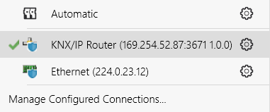
Figure 23: Selecting a KNX IP tunnelling interface (as part of KNX IP Router) for the purpose of bus access

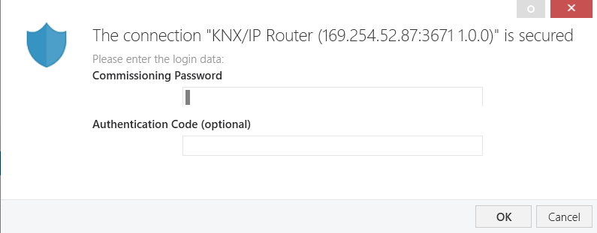
Figure 24: Querying the commissioning password and authentication code
If both cannot be entered correctly, the following error message appears.
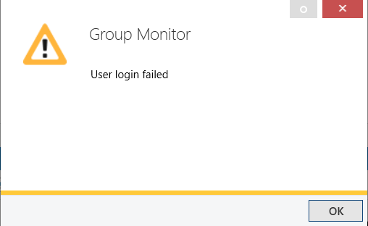
Figure 25: Error message - failed connection with KNX Secure IP tunnelling interface
If the tunnelling interface wants to listen or send securely to certain group addresses, these addresses must be assigned explicitly to this tunnelling interface in the ETS, but need not be loaded into the tunnelling interface. By assigning them to the interface, the respective recipients of these messages (the individual KNX Secure devices) are informed that the tunnelling interface (with its individual address) will also send secure telegrams to them.
N.B.: if the individual address of the tunnelling interface is changed, all devices that are connected with the secure group addresses must be reloaded.
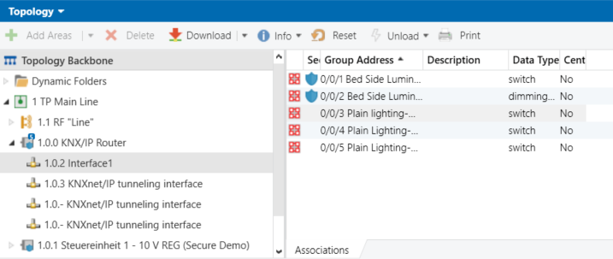
Figure 26: Allocating secure group addresses to an IP tunnelling interface

Access to bus with security
If an installation is monitored via an interface and the corresponding ETS project is not open, the source and destination addresses in an encrypted communication can be seen in the monitor, but the user data cannot be interpreted when the communication is encrypted.
If a hacker records the telegrams and plays them back, these are discarded by the devices (see explanation on sequence numbers in section 3.1).
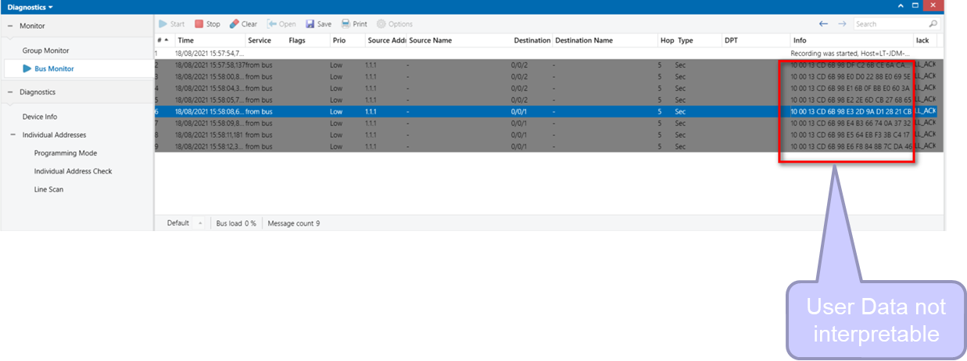
Figure 27: Monitoring the telegram traffic without matching ETS project open
If the matching ETS project is opened (including the security keys), the user data will be properly displayed by the ETS.

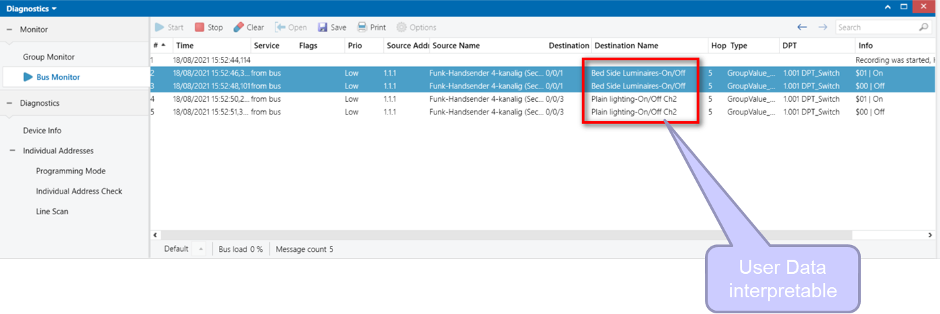
Figure 28: Monitoring the telegram traffic with matching ETS project open
KNX Data Secure devices use a longer KNX telegram format for transferring authenticated and encrypted data. However, this has no effect on the reaction time of the devices.

Security support of software on interfaces
It is now possible as installer to indicate in ETS whether or not a visualization software that is linked to a particular interface is able to handle secure communication. This to avoid that group addresses are potentially attributed in a secure way to the interface, however the visualization software connected to it is unable to process them, as it does not support KNX Secure.
Two conditions have to be fulfilled to be able to communicate securely from a visualization software to a KNX installation: first the IP interface needs to support KNX IP Secure communication and secondly, the visualization software needs to be able to handle keyring export files and also communicate securely.
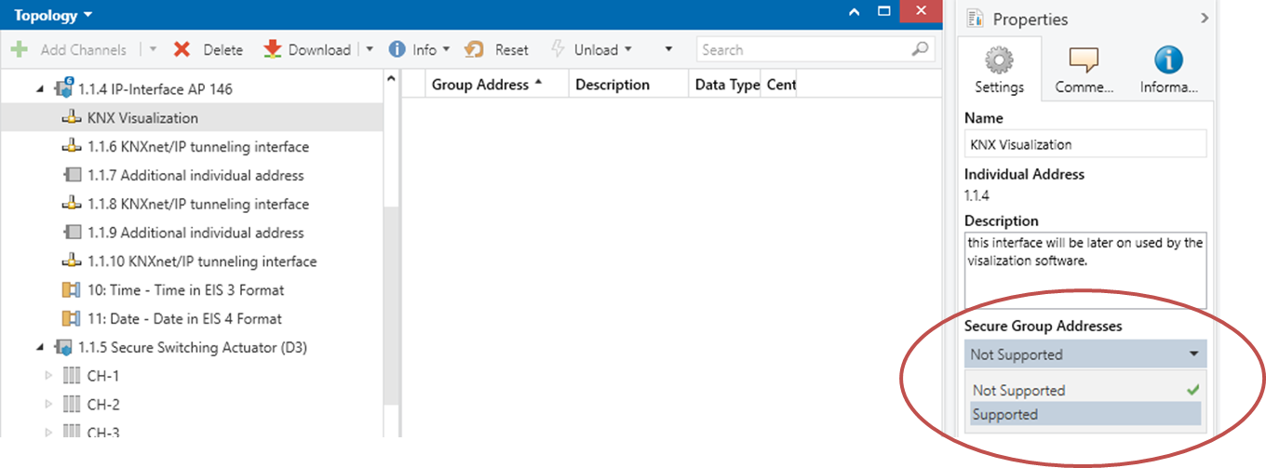
Figure 29: security support of software on interfaces

ETS reports
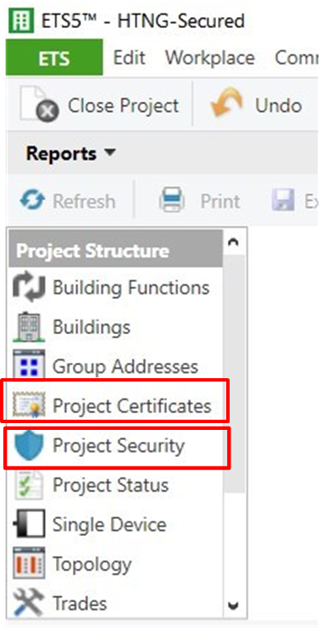  Figure 30: Security settings printing options | In the Reports view, since ETS 5.5 the option to print out project security details and the project certificates has been added.  This allows to hand over the factory default setting key or the currently valid device key/passwords for the individual KNX Secure devices used in the project to the building owner. Should the ETS project be lost, this information is at least available via the documentation and is essential to restart the devices after a reset.  However, this printout should be provided to authorised persons only.

KNX Security Proxies

Reasons for the Introduction of Security Proxies
- Many of the current KNX installations are TP based, where (physical) access to devices can be better protected. However, when extending an installation with KNX RF, the need is higher to protect this open medium. If not having an instance in the installation that can bridge TP with RF and convert plain telegrams coming from TP into secure telegrams on RF, also the relevant devices in the TP installation would have to be exchanged for KNX Secure devices.
- Some sections in a building may need more protection than others, e.g., an entry hall to a public building, where hackers would be given free reign.
- It may be interesting to be able to block point to point or broadcast communication into a certain section of the installation, in this way preventing that a hacker can redownload devices entering the network via a more accessible or open section of the installation.

Repercussions of using couplers with security proxy functionality
All above clauses describe the situation when using KNX Secure without having a security proxy in the installation. As explained, there is no possibility to have group addresses in the entire installation, that are once linked to a group object requiring security and once to a group object that sends/receives the same message plain.
As soon as a security proxy is inserted into a section of the installation, the same rule continues to apply, however only for the section of the installation behind the secure proxy.
The below figure shows a section of the installation (on the left-hand side), in which devices communicate in plain: in this security domain, the group address needs to be plain. It is not possible here to have a KNX device where secure communication is enabled for a particular group object.
The section of the installation behind the security proxy (on the right-hand side) requires communication to be secured: in this security domain, the group address needs to be secured. It is not possible here to insert a KNX device not using security.
The security proxy in the middle ensures that messages are converted plain to secure and vice versa.
A security proxy also allows to make sure that from this secure domain it is not possible to “infiltrate” a plain domain via broadcast or point-to-point communication (this can be set accordingly in the ETS sidebar of the security proxy). In this way it can be prevented that a device in the plain domain is reconfigured via the secured domain. A legitimate client (like the ETS with the proper tool key) is however able to temporarily open this “gate”.
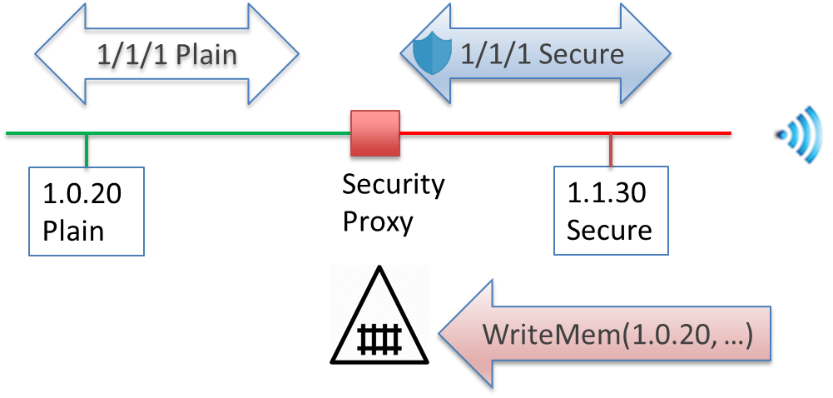
Figure 31: Group communication via security proxy – Point-to-Point and Broadcast via security proxy

Repercussions on ETS

New representation of group addresses
From ETS6 onwards, on top of the two representations for a plain group address  and a secure group address 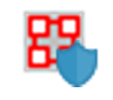 (as shown in clause 4.5), a selected group address in the group address view can now have a grey shield , i.e. this is a group address that travels across different security domains, i.e. the payload is sometimes communicated plain in some sections of the installation and in some sections (behind a security proxy) secured.

Security Domains
If a telegram crosses a security proxy, it enters another security domain, in which the previous rule of never combining a plain group object with a secured group object via a group address continues to apply, however inside this security domain.
So, for the below figure, if the IP router 1.0.0 would include a security proxy functionality, then also the IP backbone would become a separate security domain.
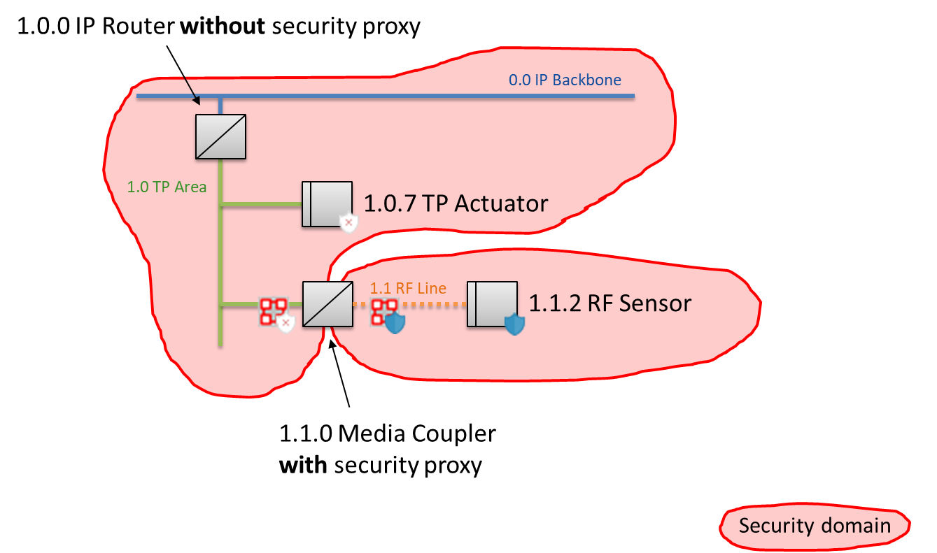
Figure 32: Security domains because of the use of Security proxies
During the planning stage, in the background ETS will treat every network segment as separate security domain, i.e., it will assume that later couplers will be inserted that have security proxy capability. If a coupler is inserted without security proxy capability, then previously separated security domains are simply merged together. The reverse of course happens when a coupler without security proxy is later replaced by one that does have that functionality.

Transfer Domains
In the case where a telegram travels across several security domains, when deciding on whether the payload must continue to be secured or not, in the background ETS applies the rules:
- the secure payload should stay as long as possible secure and
- the number of conversions from plain to secure (and vice versa) should be kept to a bare minimum.
Imagine an installation where a group address is linked to a secure object in line 1.1 and a plain object in line 2.1. In between line 1.1 and 2.1, referred to as the “transfer domain”, the ETS will also make sure that the payload is communicated secure in the transfer domain, as the transfer domain has already an adjoining security domain, in which the group address is communicated securely.
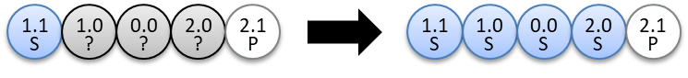
Figure 33: Example 1 Transfer Domains
Imagine, the same group address would already be linked plain in line 1.0, then ETS will extend the plain domain up to the line 1.0.
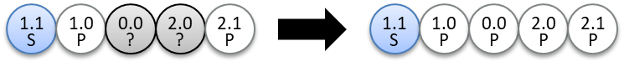
Figure 34: Example 2 Transfer Domains

In the case where the group address is also linked to a secure object in 3.1 and a plain object, the result would be the following:
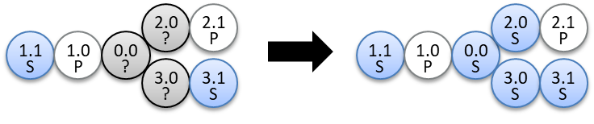
Figure 35: Example 3 Transfer Domains

Preview Filter Table
When performing a “Preview Filter Table”, which now also works when selecting a segment as well as a coupler, the following is displayed:
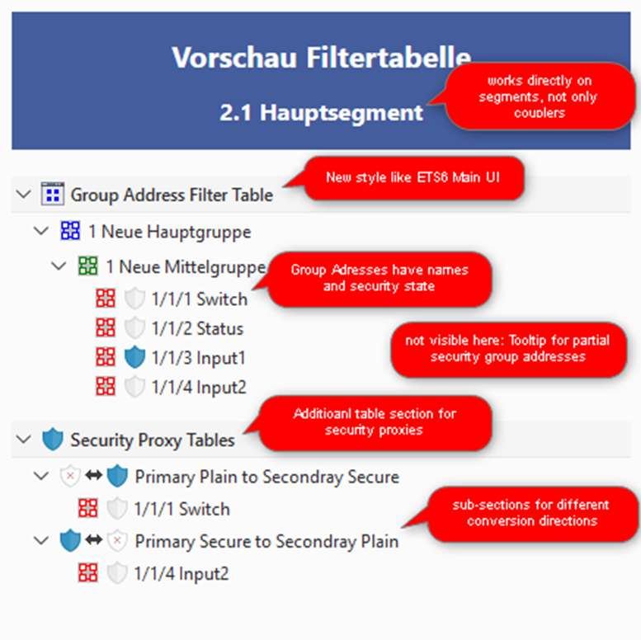
Figure 36: Preview filter table from ETS6 onwards
- it lists all the group addresses and their types that will be included in the filter table when loaded;
- It also shows which group addresses will be converted from plain to secure and vice versa.

Summary
- In a KNX installation, KNX IP Secure and KNX Data Secure devices can be used in parallel.
- In a KNX system, secure and plain applications can be used in parallel. Not all devices have to be secure.
- If several IP routers are used in a system and one of these is changed to KNX IP Secure, all the others must also be changed to IP Secure.
- A group object in a device that is already connected to a secure group address, can no longer be connected with a different non-secure group object. Without security proxies in the installation, this rule applies for the entire installation. With a security proxy in the installation, this applies to the relevant security domain.
- Within a same security domain, a group address needs to be either plain or secure for all connected group objects. If one device does not offer security and security is indispensable, this non-secure KNX device may have to be exchanged for a KNX Secure device.
- The new security functions can be integrated seamlessly into existing systems. KNX Secure is an upward-compatible extension: existing devices ignore KNX Secure messages.

This setting is not possible with current KNX Secure devices, i.e. the group objects of a KNX Secure device can be operated either with authentication + encryption, or without authentication + encryption. There is no "Authentication only" setting option in the ETS.

