Logic Operations
KNX Association

Table of Contents
1 Introduction 3
2 Logical Connection of Group objects 3
2.1 Switch Actuator (Binary Output) with Logic Function 3
2.1.1 Group object - Switch 3
2.1.2 Group object - Logic 3
2.1.3 OR Function with ON/OFF Delay 5
2.1.4 AND Function 8
2.1.5 Extended Logic (Direct Relay Control) 11
2.1.6 Extended Logic (Object Logic Output) 12
3 Logical Connection of Group Addresses 13
3.1 Logic Module 13
3.1.1 Problematic Situations 13
3.1.2 Available Parameter Settings of Logic Modules 14
4 Extensive Logical Connection of Group Addresses 24
4.1 Application Unit (Example) 24
4.2 Graphical Project Design in a Logic Diagram 25
5 Tasks 26
5.1 Linking Actuator Objects 26
5.1.1 OR function without time delay or with ON and OFF delay 26
5.1.2 Example: Automatic Room Air Conditioning with Enabling (AND function) 26
5.1.3 AND Function without time delay and with ON/OFF Delay 27
Test the function of the following sequences: 27
5.1.4 Linking Group Addresses (1) – Logic Module or Switch Actuator “Extended Logic” 27
5.1.5 Linking Group Addresses (2) – Graphical Project Design (Application
Module) 27
6 Logic Operations (Appendix) 28
6.1 Basic Functions and Elements 28
6.1.1 AND Function (Conjunction) and AND Element (AND) 28
6.1.2 OR Function (Disjunction) and OR Element (OR) 30
6.1.3 Negation and NOT Element (NOT) 32
6.2 Compound Elements 33
6.2.1 NAND Element (NAND) 33
6.2.2 NOR Element (NOR) 34
6.2.3 EQUIVALENCE Element 35
6.2.4 EXCLUSIVE OR Element (XOR) 36

Introduction
A large number of functions in building control systems cannot be traced back to a single circumstance. Functions or states of devices or circuits are frequently made dependent on several conditions.
The logic operation of the various trigger factors can be implemented in various ways in a KNX system. Different solutions can lead to the objective depending on the type and number of the required conditions.
The KNX components that are available on the market from various manufacturers provide a range of variants which enable frequently requested logic operations to be implemented. The group objects and parameter settings of these devices use the basic principles of digital technology.
The basic functions of the logic operations and some compound elements are explained in an appendix at the end of the chapter.

Logical Connection of Group objects

Switch Actuator (Binary Output) with Logic Function
The majority of the manufacturers of KNX components already have logic objects available in the standard application of their switch actuators (binary outputs).
As different logic functions are available dependent on the manufacturer and product, no general statements can be made. The functional processes on two switch actuators of different manufacturers are taken as a basis in the following explanations.

Group object - Switch
The “Switch” group object of a switch actuator behaves in a similar way to an OR function for all the assigned group addresses, whereby the last group address sent determines the status of the output.

Group object - Logic
A logic operation can be activated separately for each available output.
One or two logic operations of the group objects are activated dependent on the product and manufacturer.
Additional logic functions can be activated in the applications via “extended logic”.
Figure 1: Parameter window (extract) e.g. 4-fold switch actuator

Via the function Logic operation/Logic, it is possible to link the switching of the output with specific conditions. The following can be selected:
- AND function
- OR function
- XOR function
- Gate function
Figure 2: Functional diagram of the logic operations e.g. 4-fold switch actuator

Two logic objects are available: the Switch group object is first of all evaluated with the Logic operation 1 group object. The result is linked with the Logic operation 2 group object.

The activation of the logic function means that the switch object of the respective channel (output) interacts with the logic objects of the associated channel (output).

OR Function with ON/OFF Delay
A logic object can be activated for the respective switch contact. The following logic operations are available:
- AND function
- OR function
- XOR function
Figure 3: Parameter window for logic operation (extract) e.g. 8-fold switch actuator
In addition to activating the logic operation, the ON/OFF delay can also be used.
Several alternatives can be selected here which the delays have an effect on.
Figure 4: Parameter window for ON/OFF delay (extract) e.g. 8-gang switch actuator
It should be noted that the ON/OFF delay does not affect the logic object.
It is therefore possible to switch circuits for specific applications directly (via logic objects) and with a time delay (via switch objects).

Flow Diagram of OR Function
Figure 5: Flow diagram of OR function

Case 1: The actuator follows the ON and OFF signals that are active in the switch object.
Case 2: The actuator follows the ON and OFF signals that are active in the logic object.
Case 3: If the signals of the switch object and the logic object intersect each other, the output is switched on by the first ON signal and switched off by the last OFF signal sent.

OR Function with ON and OFF Delay
Note: The OR function with an ON and OFF delay reacts differently depending on the manufacturer. A flow chart of a product e.g. 8-fold switch actuator is shown as an example.

The ON and OFF delay is configured on the switch object.
The logic object functions without a delay.

Figure 6: Flow diagram of OR function with ON and OFF delay
Case 1: The output switches on once the ON delay has elapsed. The OFF period starts when the OFF command has been sent and the output switches off once it has elapsed.
Case 2: As the logic object is operating without a delay, the output is switched directly by ON and OFF signals from the logic object.
Case 3: If the logic object receives an ON command while the ON delay of the switch object is active, the output is switched on. If the switch object and the logic object receive an OFF signal, the output is switched off once the OFF delay has elapsed.
If the logic object only receives an OFF signal once the OFF delay of the switch object has elapsed, the output is switched off by this OFF signal (not shown).

AND Function
The activated AND function enables a circuit to be switched dependent on one or several conditions. (Manufacturer- and product-dependent) timing functions such as ON, OFF and ON/OFF delays can also be parameterised.

Note: When using an AND function, it should be ensured that an AND condition which has been caused by a physical variable (e.g. temperature or brightness) is not reset by a manual operation (e.g. "Central OFF"). This problem can likewise be solved by the cyclical sending of a signal.

AND Function without Delay
Figure 7: Flow diagram of AND function without delay

Case 1: The ON signal in the switch object sets a marker. The output is only switched on when the logic object receives a ‘1’. If a ‘0’ is sent to the logic object, the output switches off.
Case 2: The ON signal in the logic object sets a marker. The output is only switched on when the switch object receives a ‘1’. If a ‘0’ is sent to the logic object, the output switches off. If the switch object receives a ‘0’ as useful data before the logic object, the AND condition is no longer met and the output is switched off.

AND Function with ON and OFF Delay
For the manufacturer- and product-dependent AND function, it should be noted that an activated timing function only influences the switch object and/or the staircase lighting object, dependent on the parameterisation.

The logic object functions without a delay.

The ON and OFF delay and their effect on the switch object are defined in the following parameter window of the 8-fold switch actuator which has been selected as an example.

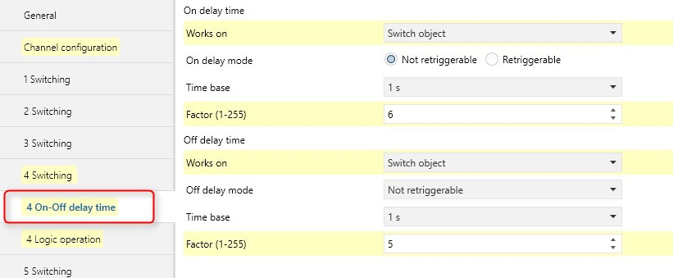
Figure 8: Parameter for effect of the ON/OFF delay (extract) e.g. 8-fold switch actuator
Simple logic gates can be implemented with the logic function. The following objects are available as input objects per channel: – Switch Object Channel X – Staircase Lighting Object Channel X – Logic Object A Channel X. The output of the logic function can only be processed internally in the switch actuator; that means that the logic result is routed to the relay of the respective channel and not sent on the bus.
The input objects “Switch object” and “Staircase lighting object” are always interconnected with an OR gate for the basic logic function. The output of this OR gate leads to a freely configurable gate: AND, OR, XOR. The following diagram shows a logic operation with an AND function.

Figure 9: Flow diagram of AND function of 8-fold switch actuator

Figure 10: Flow diagram of AND function of 8-fold switch actuator

Case 1: An ON signal has been sent to the logic object. The switch object likewise receives a ‘1’ as useful data. The output is switched on once the set ON delay (t_{e}) has elapsed. A ‘0’ in the switch object starts the OFF delay (t_{a}). The output switches off once the delay period has elapsed.

Case 2: A ‘1’ is sent to the switch object as useful data. If a ‘1’ is sent to the logic object during the set ON period, the output is switched on once the ON delay of the switch object has elapsed. A ‘0’ in the switch object starts the OFF delay (t_{a}). If the logic object receives a ‘0’ during the OFF delay, the output is switched off directly.

Summary: To use the ON and OFF delays fully, the logic object must receive a ‘1’ as a useful signal before the switch object and may only be deactivated by a ‘0’ once the OFF delay has elapsed (t_{a}).

Extended Logic (Direct Relay Control)
Additional dependencies and behaviour patterns of the switch actuators can be configured e.g. via “Extended Logic” dependent on the manufacturer and product. The options are shown with the example of an 8-fold switch actuator.
With the parameter setting “Extended Logic”, up to three logic objects can be linked with different gates which then influence the relay output (parameter line: “Time 1 Output” “Controls relay directly”). In addition, “Gate functions” and “Filters” can be activated for technical processes.
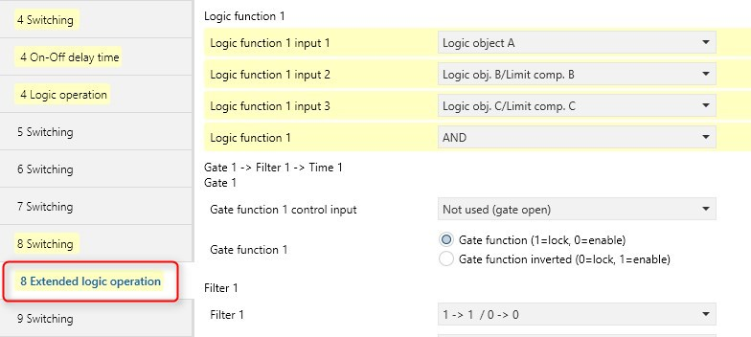
Figure 11: Parameters for "Extended Logic" (controls relay directly) – 8-fold switch actuator
When using the “Extended Logic” function, the logic objects of the respective channels are queried depending on the parameterisation of the possible logic gates e.g. AND function) and the result is transferred “internally” to the relay output (Logic Output Channel X). The standard switch object of the respective output (channel) no longer has a function (still shown).

Figure 12: Group objects for "Extended Logic" (controls relay directly) – 8-fold switch actuator

Extended Logic (Object Logic Output)
With the parameter setting “Extended Logic”, up to three logic objects are used to combine the group addresses assigned to the group objects into a new group address.
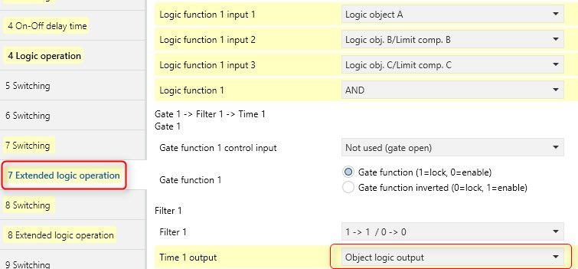
Figure 13: Parameters for "Extended Logic" (Object Logic Output) – 8-fold switch actuator
Different gate functions can be used and connected with each other. The result of the gate function is then sent as a group address on the bus via the group object "Logic Output" (parameter line: “Time 1 Output” “Object Logic Output”).
“Gate functions” and “Filters” can be activated for technical processes.
The standard switch object of the respective output (channel) no longer has a function (still shown).

Figure 14: Group objects for "Extended Logic" (Object Logic Output) – 8-fold switch actuator

Logical Connection of Group Addresses
In many building functions, there are a variety of tasks that are defined by various group addresses and must be linked together. The requirement can also arise to combine several group addresses into a new group address due to the limited number of associations in a group object.
There is the requirement for other applications to be able to address several objects with various bit widths (1 bit, 8 bit) at the same time with a transmitted address.
Furthermore, various applications have time-limited functions which must be made possible by filtering group addresses.

Logic Module
The logic modules that are available from various manufacturers offer a range of parameters for managing the logic operations mentioned above.

Problematic Situations

Telegram Transfer Times
When using status response objects, it should be noted that problems can be caused by the transfer times of telegrams. Telegrams may no longer arrive at the same time due to the time adjustment so that the logic result at the gate may be incorrect.

Cyclical Sending
The cyclical sending of sensors can have serious consequences if they are led via logic operations which then cannot carry out cyclical sending themselves. By way of example, an alarm trigger function should be disabled or enabled via a gate in the same way as a watchdog circuit. If an AND function is set for this input, an alarm would pass through to the other input exactly once. The inputs are however sometimes set for cyclical sending to compensate for possible transmission errors caused by repetitions.
It is important to know here that in contrast to PLC gates, KNX logic gate modules can also send cyclically (i.e. function practically only as transparent converters).

Available Parameter Settings of Logic Modules
Each KNX installation has its own requirements.
The application possibilities on a logic module are shown as an example.
The logic module offers functions which are not possible with sensors and actuators alone. By carrying out three different functions at the same time (e.g. logic, threshold values and scenes), all the additional functions can generally be carried out in small KNX installations with a logic module.
The logic module for example makes different functions available in a device for special logic operations between sensors and actuators. The 12 possible functions can be seen from the parameter overview.

Figure 15: Parameter window of "Logic Module" (extract)

The following applies to all the parameter windows and functions of the selected logic module:
Behaviour of the inputs
After receipt of a telegram, all the inputs first save the values in order to make them available (e.g. for logic functions) for further processing. When a new telegram reaches the input, the values are overwritten accordingly.
Disable objects
Disable objects always block the function on receipt of an ON telegram at the group object “xx Disable xx”. On receipt of an OFF telegram at the group object “xx Disable xx”, the function is enabled.
Send delay
The send delay indicates how long the logic module waits (depending on the parameterised send condition), before it sends a new value as an output telegram.
Cyclical sending
Some functions of the logic module enable the cyclical sending of an output value. The set cycle is then maintained until an output value changes. When a value is changed, the output is immediately sent and the next sending cycle is started.
Data types and datapoint types (DPT)
Different datatypes can be selected for some functions of the logic module. The datapoint type (DPT - Interworking Standard) is applied where applicable.

Format Converter
If Format Converter is selected as a function in the General parameter, a line appears in the ETS parameter window. The function is always prefixed with the name of the line for which the format converter has been selected (e.g. A – Format converter).
Data (e.g. 1 byte values) can be converted into another format (e.g. 8 x 1 bit) by the format converter.
Figure 16: Parameters for “Format Converter” function
The Format Converter function breaks down an input telegram into several output telegram of a different format or generates an output telegram from several input telegrams of another format. That means that telegrams are broken down or put together at format level. No specific datapoint type (DTP) can therefore be assigned to the input and output objects. An assignment between the object and a datapoint type (DTP) arises due to the context of the ETS project in which this function is used.
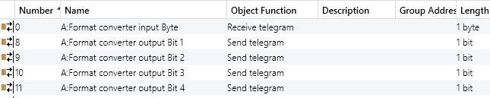
Figure 17: Group objects (extract) of ‘Format Converter’
In the event of bus voltage failure or when the logic module is reprogrammed, the input values are not saved.

Logic Gates
If the function Logic is selected in the General window, 3 further lines appear in the ETS parameter window. The function is always prefixed with the name of the line for which the logic gate has been selected (e.g. A – Logic Input 1 - 4).
Logic gates can be used to logically process states of the KNX installation which are report via telegrams. An output for example can only be sent from an AND gate if the input for twilight = 1 and the input for movement = 1. A change in the input signals causes the output to be sent (depending on the parameterisation). The input values are saved on bus voltage failure (if configured). If the logic module is reprogrammed, the saved input values are always deleted.

Figure 18: Parameters (extract) of ‘Logic (Gate) Inputs/Output’

Min/Max-Value Indication
If the function Min/Max-Value Indication is selected in the General window, the line appears in the ETS parameter window which carries the name of the selected function (e.g. A – Min/Max-Value Indication). With the min/max-value indication, the largest temperature value for example is determined from 2 sent telegrams. This value from different sensors can then be passed to a temperature controller as a measured value.
Figure 19: Parameters (extract) of ‘Min/Max-Value Indication’

Threshold Value Detection
If Threshold Values is selected as a function in the General window, 2 lines appear in the ETS parameter window. The function is always prefixed with the name of the line for which the threshold values have been selected (e.g. A – Threshold Value 1).
The function is used to detect if a value exceeds/falls below a set threshold value. The temperature of a cold store can for example be monitored for a maximum value and a message sent when it is exceeded.
Figure 20: Parameters (extract) of ‘Threshold Value’
Each threshold value function makes 2 independent threshold values available which can be parameterised in the lines Threshold Value 1 (or 2). The datapoint types available for selection are shown in the diagram.

Scenes
If Scenes is selected as a function in the General window, further lines appear in the ETS parameter window. The function is always prefixed with the name of the line for which the scenes has been selected (e.g. A – Scenes Common).

Figure 21: Parameters (extract) of ‘Scenes Common’

Scenes are used to retrieve default settings. There are e.g. 6 group objects available as outputs. The data type is defined once for each output. Different values can then be assigned to these outputs in each scene.
Figure 22: Parameters (extract) of ‘Scene Outputs’

A scene for a cosy evening by the fire can be defined in a lounge. If this scene is retrieved via a bus telegram, the preset values for the scene are sent on the bus to the actuators as telegrams. A standard lamp can thus for example be switched on, the ceiling lighting dimmed to 10 % and the heating setpoint lowered to 19 °C.

Figure 23: Parameters (extract) of ‘Scene 1’

Temperature Comparator
If Temperature Comparator is selected as a function in the General window, a line appears in the ETS parameter window with the selected function e.g. A – Temperature Comparator.
2 different temperature values can be compared with the temperature valuator. Different telegrams can be sent depending on the result.
Figure 24: Parameters (extract) of ‘Temperature Comparator’

Gate
If Gate/Filter is selected in the General window, 2 lines appear in the ETS parameter window, each with a gate/filter.
The filter function enables the filtering out of telegrams. Telegrams can be routed or blocked with a gate depending on a set condition.
Note: The gate/filter functions operates at the format level of telegrams (e.g. 1 bit,
1 byte, 2 byte) and not on datapoint types (EIS type). An assignment between the object and a datapoint type is only carried out due to the context of the ETS project in which this function is used.
Figure 25: Parameters (extract) of ‘Gate/Filter’

Staircase Light
If the function Staircase Light is selected in the General window, a line appears in the ETS parameter window in which 2 configurable staircase lights are available.
The staircase lighting function mirrors a staircase lighting timer. On receipt of an ON telegram, the delay is started. An OFF telegram is sent to the group object at the input once the delay has elapsed.
Figure 26: Parameters (extract) for ‘Staircase Light’

Multiplier
If Multiplier is selected in the General parameter window, 2 lines appear in the ETS parameter window.
The multiplier can be used to pass on several telegrams to the output on receipt of a telegram at the input. The output telegrams can be four 1 bit and/or four 1 byte telegrams.
Figure 27: Parameters (extract) of ‘Multiplier 1 bit Outputs’

With the parameter Reaction of the 1-Byte output x, it is defined how a binary output of the multiplier should behave. The option as input telegram corresponds to the function of the simple multiplier. The outputs can however also be inverted or only react to a telegram. For example, the option send if ON causes a telegram to be sent to the input while an OFF telegram causes no reaction at the output.

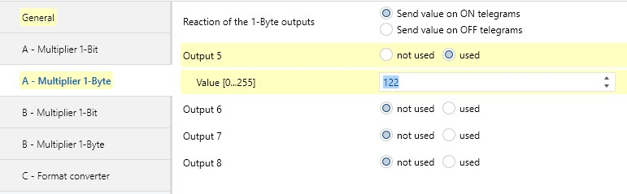
Figure 28: Parameters (extract) of ‘Multiplier 1 byte Outputs’

The group objects (example} show that a 1 bit input address can send four 1-bit output addresses and one 1-byte output address on the bus.
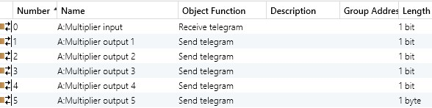

Figure 29: Group objects (extract) of ‘Multiplier (Input/Outputs)’

Toggle Value
If Toggle Value is selected as a function in the General window, a line appears in the ETS parameter window with the name of the function.
With this function, a preset setpoint value can be sent as a reaction to a 1 bit input telegram. It is therefore possible e.g. to predefine a setpoint for the room temperature when you are present (e.g. 20 °C) and when you are absent (e.g. 18 °C).

Figure 30: Parameters (extract) of ‘Toggle Value’

Counter
If the Counter function is selected in the General window, a line appears in the ETS parameter window with the name of the selected function.
The counter is a telegram counter. Group address telegrams from sensors and actuators can thus be counted. The counter can register a telegram max. every 30 ms (corresponds to 33 Hz).
Figure 31: Parameters (extract) of ‘Counter’

Time delay
If Time delay has been selected as a function in the General window, two lines appear in the ETS parameter window on which 2 time delays per line can be used.
The time delay can be used for 1 bit telegrams as an ON and/or OFF delay. For all other data types, it is used as a send delay for telegrams. This telegram delay causes the delay to be started when a telegram arrives at the input and the telegram is only passed on once the period has elapsed. If a further telegram with a different value arrives during the delay, this new value is passed on at the end of the delay period.

Figure 32: Parameters (extract) of ‘Timer 1 + 2 (3 + 4)’
Notes:

Extensive Logical Connection of Group Addresses
If a variety of logic operations are required for technical building functions, the use of application units is recommended. Various manufacturers offer corresponding device versions with a different range of functions.

Application Unit (Example)
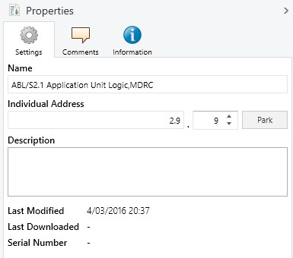
Figure 33: Application unit
The project design and commissioning of the logic functions of an application unit mainly take place directly in ETS.

The assignment of parameters is carried out in a graphical logic diagram which is opened for example via the "Parameters..." button. This is where the logic functions, the inputs and outputs as well as the connections are created and the parameters of the functions are edited.

Graphical Project Design in a Logic Diagram
The graphical user interface for the parameterisation of the application unit shown in the example uses various ETS basic functions and ETS interfaces. It is directly integrated into the ETS program and can therefore be operated in the usual ETS environment.
The required function modules are dragged onto the editing surface via drag and drop and the required connections are linked together by pressing the left mouse button.
Clicking with the right mouse button on a module opens up the parameter editing.

Figure 34: Graphical user interface
The configuration of the logic functions is carried out in the ‘Project Design’ module of ETS and represented in a graphical logic diagram based on DIN 40900.
Notes:

Tasks
The following tasks are recommended for the previous explanations.
The tasks can be adapted accordingly dependent on the available KNX components.

Linking Actuator Objects

OR function without time delay or with ON and OFF delay
Configure an x-fold switch actuator and activate the OR function in the parameters of channel x. Send the required group addresses to the switch or logic object with a switch sensor.
Test the function of the following processes:
- OR function without delay
- OR function with ON and/or OFF delay
Familiarise yourself with the flow diagrams in the chapter on the OR function (case 1 and case 2).

Example: Automatic Room Air Conditioning with Enabling (AND function)
Assign a switch sensor the task of switching a room air conditioner via a switch actuator.
The room contains a room thermostat with two-step control and bus capability. Alternatively, a conventional room thermostat can be given bus capability via a binary input.
Assign the parameters so that the thermostat regulates the room temperature via the switch object and the switch sensor enables or disables the closed-loop control via the logic object (AND function).
Create the necessary group addresses as main and middle groups.
Create the required subgroups, e.g.
35 = Thermostat for cooling room xx
36 = Switch sensor for cooling room xx
and link these addresses with the relevant objects.
Transfer the modified information into the devices and test the function.
Configure a Central OFF function and extend this to the devices for air conditioning.
Link the Central OFF group address with the switch object and test the function.
Link the Central OFF group address with the logic object and test the function.

Summary: If group addresses with the value ‘1’ which have been generated by physical processes are not permitted to be reset by a central ‘OFF’ command, the group address is sent cyclically.

AND Function without time delay and with ON/OFF Delay
Configure a 4-fold switch actuator and activate the AND function in the parameters of the channel.

Test the function of the following sequences:
- AND function without delay
- AND function with ON delay
- AND function with ON and OFF delay
Familiarise yourself with the flow diagrams in the section describing the AND function (Case 1, Case 2, Case 3).

Linking Group Addresses (1) – Logic Module or Switch Actuator “Extended Logic”
The KNX system is used in a school building for signal and monitoring functions. The following additions should increase the security of the building:
- The message ‘Window open’ should be extended into an alarm signal (protection against danger) at a particular time of day and routed to the technical supervisor (caretaker).
The group address for the message ‘Window open’ is e.g. linked in a logic module as an input address to a second group address for ‘Alarm duration’ using an AND function to form a new output group address ‘ALARM – Window open’.

Group address | Meaning of the group addresses
1/0/11 | Message “Window open”
1/0/13 | Alarm duration
1/0/15 | ALARM "Window Open "

Linking Group Addresses (2) – Graphical Project Design (Application Module)
A classroom should be heated during lessons if the temperature controller sends the signal ‘Heating ON’, both windows in the room are closed and the classroom is occupied. Lesson time is signalled with a binary input (or time switch), each of the two windows is monitored with a window contact and the use of the classroom is recorded with a motion detector. None of the sensors operate with inverted logic.
- Number of used inputs: 5
- Input 1: Heating ON
- Input 2: Time switch
- Inputs 3 and 4: Window contacts
- Input 5: Motion detector
- Logic gate
The group address of the output controls the heating actuator.
Test the function.

Logic Operations (Appendix)

Basic Functions and Elements

AND Function (Conjunction) and AND Element (AND)
The sentence «If the weather is nice tomorrow and my brother has time, we are going sailing» contains an AND function. Statement A (nice weather) and statement B (my brother has time) must apply i.e. be true to make statement X (going sailing) true. This connection can be represented in a truth table. A ‘1’ state means «true» or «applicable». A ‘0’ state means «false» or «not applicable». Four cases (combinations) are possible. The cases can follow any order in principle but should correspond to a specific pattern.
Figure 35: Truth table and circuit diagram of an AND function and an AND element
An electronic circuit in which only a ‘1’ state is present at output X when ‘1’ states are present at input A and at input B, is called AND, an AND element or an AND gate.
An AND element can be implemented by a circuit diagram. Nowadays however integrated semiconductor circuits are used almost exclusively.

Any circuit that fulfils the truth table of an AND function is an AND element.

The AND function can be expressed mathematically with the help of logic algebra:

X = A ^ B ^ Symbol for the AND function (standardised).

The diagram shows the graphical symbol of an AND element with two inputs. The designations of the inputs and the output can be freely selected. I1, I2 is often used for the inputs and O for the outputs.
Figure 36: Graphical symbol of the AND element with 2 inputs
The ‘1’ state is only present at the output of an AND element if there is also a ‘1’ state at all the inputs.

OR Function (Disjunction) and OR Element (OR)
The sentence «If I inherit some money or win the lottery, I will travel round the world» leads to an OR function. The world trip will be made if statement A (inheritance) or statement B (lottery win) or both statements become true. You could argue whether the trip would also be made if both statements come true. The grammatical mode of expression is not precise enough here. For an OR function, the world trip would also have to be made if A and B become true. The truth table in Diagram 2.3 indicates the connection (‘1’ state = «true», ‘0’ state = «false»).
An electronic circuit in which a ‘1’ state is always present at output X if there is a ‘1’ state at input A or input B or at both inputs is called an OR element.
Figure 37: Truth table and circuit of an OR function and an OR element
The represented circuit is only used for clarification. OR elements are nowadays almost exclusively configured as integrated semiconductor circuits.

Any circuit that fulfils the truth table of an OR function is an OR element.

The OR function can likewise be expressed mathematically with the help of logic algebra:

X = A v B v = Symbol for the OR function (standardised).

The information in the standardised graphical symbol ≥1 means that the number of ‘1’ states at the inputs must be ≥1 if there should be a ‘1’ at the output.

Figure 38: Graphical symbol of the OR element with 2 inputs
The designations of the inputs and the output can be freely selected. I1, I2 is often used for the inputs and O for the outputs.

The ‘1’ state is always present at the output of an OR element if there is a ‘1’ state at one of the inputs at least.

Negation and NOT Element (NOT)
The sentence «If my mother-in-law comes to visit, I am not going to the theatre this evening» is a negation. If the statement A (mother-in-law comes to visit) is true, statement X (going to the theatre) is not true. If statement A is not true, statement X is true and I am going to the theatre. The associated truth table (diagram) has only 2 cases.
An electronic circuit in which the state at input A is always opposite to the state at output X, is called NOT, NOT element or inverter (negator).
Figure 39: Truth table, circuit and graphical symbol (standardised) of a negation or a NOT element

A NOT element can be structured according to the circuit diagram. It must again be noted that NOT elements are usually configured in semiconductor technology.

Any circuit that meets the truth table of a negation is a NOT element.

The negation can also be expressed mathematically with the help of logic algebra.

X = | A |  | The translated line is the symbol of negation.
The state at the output of a NOT element is always the opposite of the state at the input.

Compound Elements

NAND Element (NAND)
If an AND element is combined with a NOT element in accordance with the diagram, all the output states X of the AND element are negated.
Column X indicates the AND function.
X is only ‘1’, if A = 1 and B = 1 (Case 4).
X is however also the input of the NOT element.
If a ‘0’ lies at input X of the NOT element, output Z = 1. If a ‘1’ lies at input X of the NOT element, output Z = 0.
Column Z indicates a negated AND function. The designation NAND is formed from the English expression NOT AND.
Figure 40: Origination of the NAND function with truth table of the circuit
NAND elements are used very frequently. Unique graphical symbols have been developed for them.
Figure 41: Truth table and graphical symbol of the NAND element with 2 inputs
The graphical symbol is produced from the symbol of the AND element with a circle at the output. This circle denotes the negation of the output.

The following sentence applies for the logic operation of the NAND element:
A ‘1’ state is present at the output of a NAND element if a ‘1’ state is not present at all the inputs.

The NAND function can be represented as follows using logic algebra:

Z = | A ^ B

The long line above the AND function of A and B indicates that the complete AND function has been negated.

NOR Element (NOR)
The truth table (diagram) applies for the combination of an OR element with a NOT element. An OR function is first formed from the input variables A and B:
X = A v B
X is simultaneously the input of the NOT element. All the states of output X appear as negated in column Z
(output X = 0 Z = 1, output X = 1 Z = 0).
Figure 42: Origination of a NOR element with truth table of the circuit and graphical symbol (standardised)
Z indicate the negated OR function. The designation NOR is formed from the English expression NOT OR (NICHT-ODER). There is no German equivalent for NOR.
NOR elements are used as frequently as NAND elements. There is therefore a separate graphical symbol (diagram) for NOR elements. The symbol is produced from the symbol of the OR element. The negation is shown by a circle at the output.
The following sentence applies for the logic operation of the NOR element:

A ‘1’ state only lies at the output of a NOR element if the ‘1’ state is not present at any of the inputs.
The following algebraic equation applies for the NOR function:

Z = | A v B

EQUIVALENCE Element
A logic circuit is frequently required in which a ‘1’ state is always present at the output if the two input states are identical i.e. they are either both ‘0’ or both ‘1’. This type of circuit is called EQUIVALENCE (equivalence = equal value). It is configured from basic elements.
Figure 43: Graphical symbol of the EQUIVALENCE element with truth table
EQUIVALENCE elements also have their own graphical symbol. Diagram 2.9 shows the symbol and the truth table.

The ‘1’ state is always present at the output of an EQUIVALENCE element if the inputs have identical states.

The algebraic equation for the EQUIVALENCE function has the following format:

Z | = | (A | ^ | B) | v | (A | ^ | B)

EXCLUSIVE OR Element (XOR)
If the output of the EQUIVALENCE element is negated by the series connection of a NOT element, an element is created that always has the ‘1’ state at the output if the input states are different.
This type of element is called EXCLUSIVE OR (= unequal value). The name suggests that this element is an OR element in which case it is not possible to have a ‘1’ state at the output if both inputs have a ‘1’ state (Case 4). The designation XOR was formed from the English expression EXCLUSIVE OR.
Figure 44: Origination of an EXCLUSIVE OR element with truth table and graphical symbol (standardised)

The ‘1’ state is then always present at the output of an EXCLUSIVE OR element if the two inputs have different states.
An algebraic equation for EXCLUSIVE OR can be taken in the following format from the circuit in Diagram 6.10:

X | = | (A | ^ | B) | v | (A | ^ | B)

This expression is not fully negated since the NOT element is series-connected. The following equation is produced for EXCLUSIVE OR:

Z | = | (A | ^ | B) | v | (A | ^ | B)

