KNX TP Telegram
KNX Association

Table of Contents
1 TP Telegram: general 3
2 TP Telegram structure 3
3 TP Telegram: time requirement 4
4 TP Telegram acknowledgement 5
5 Chapter telegram: “Informative annex” 6
5.1 Numbering systems 6
5.1.1 Decimal system 6
5.1.2 Binary system 6
5.1.3 Hexadecimal system 6
6 TP Telegram: control field 8
7 TP Telegram: source address 9
8 TP Telegram: target address 10
9 TP Telegram: check byte 11

TP Telegram: general
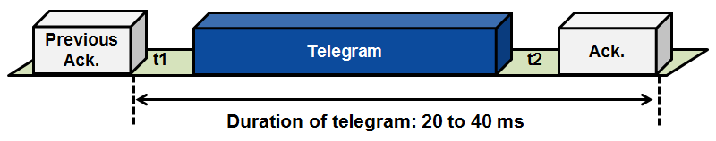
Figure 1: TP telegram: general

When an event occurs (e.g. when a pushbutton is pressed), the bus device sends a telegram to the bus. The transmission starts after the bus has remained unoccupied for at least the time period t1.

Once the transmission of the telegram is complete, the bus devices use the time t2 to check whether the telegram has been received correctly.

All “addressed” bus devices acknowledge the receipt of the telegram simultaneously.

TP Telegram structure
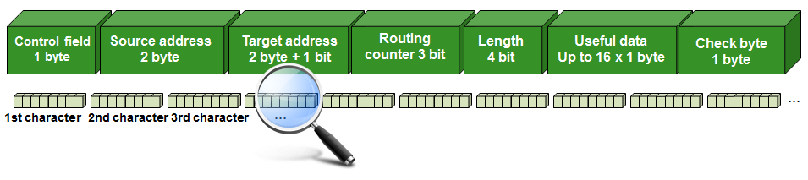
Figure 2: TP telegram: structure

The telegram consists of bus-specific data and the actual useful data, which provides information about the event (e.g. pressing a push button).
The entire information is transmitted in the form of 8-bit long characters.

Test data for the detection of transmission errors is also included in the telegram: this guarantees an extremely high level of transmission reliability.

TP Telegram: time requirement

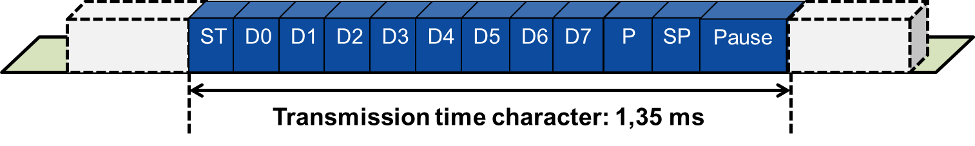

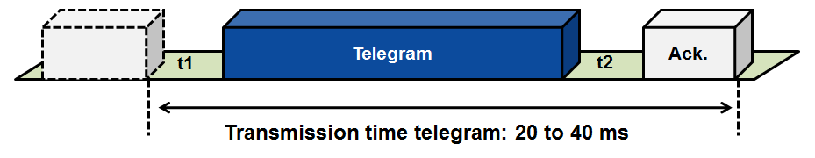
Figure 3: TP telegram: time requirement

The telegram is transmitted at a bit speed of 9600 bit/sec, i.e. one bit occupies the bus for 1/9600 sec or 104 µs.

A character consists of 11 bits. Together with the pause of 2 bits in between characters, this adds up to a transmission time of 1,35 ms (13 bits) per character.

Depending on the length of the payload, the telegram consist of 8 to 23 characters, the acknowledgement is only one character (11 bit). Taking into account the priority-dependent waiting time of t1 (50 bits) and a time between telegram and acknowledgment t2 (15 bits), a message will occupy the bus between 20 to 40 ms.

A switching telegram (including acknowledgement) occupies the bus for about 20 ms. Telegrams for text transmission occupy the bus for up to 40 ms.

Example:

(t1 50 bit) + (8x13 bit) + (1x13 bit = CRC) + (t2 15 bit) + (Ack.11 Bit) = 193 bit
193 Bit x 0,104 ms = 20.07 ms

TP Telegram acknowledgement
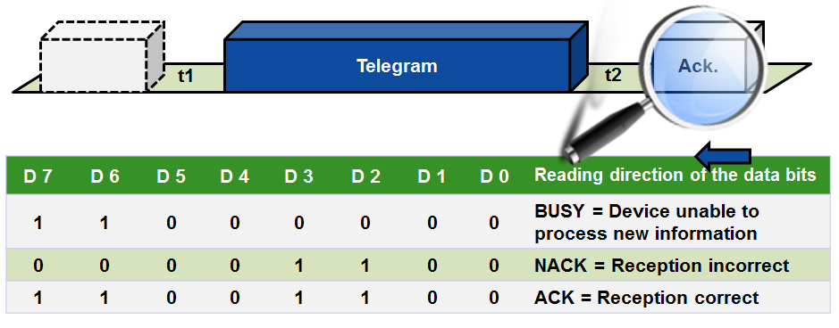
Figure 4: Telegram acknowledgement

The receiving bus device checks on the basis of the check byte contained in the telegram the correct reception of information and acknowledges accordingly.

If a negative acknowledgement (NACK [transmission error detected] or BUSY [device unable to process new information]) is received to a telegram sent on the bus, the sender will repeat the telegram. The number of repeated telegrams is typically limited to three times. This is also the case when an acknowledgement is missing.

Chapter telegram: “Informative annex”
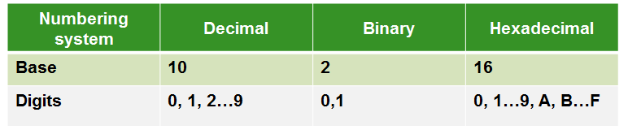
Figure 5: Numbering systems

Numbering systems
The terms ‘base’ and ‘digit’ are used in the classification of numbering systems.
In every numbering system, the largest digit is smaller than the base by 1.

Decimal system
This is the most common numbering system. People think in terms of decimal numbers. If no details are given about the numbering system, the decimal system is assumed.

Binary system
This numerical representation is very important in computing as a storage location in memory can only assume two states (0, 1). The content of such a storage location in memory is called a bit.

Hexadecimal system
A combination of 4 bits of the binary system produces a hexadecimal number. This results in a clearer representation of data.
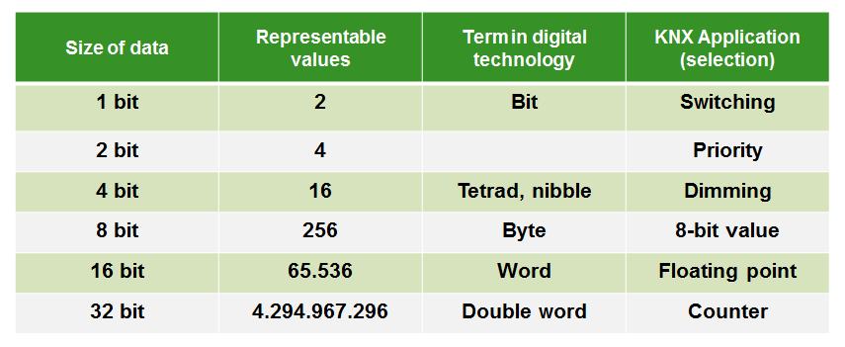
Figure 6: Data formats
Data formats
Different data formats are necessary for processing data. The contents of the data formats can be presented in binary, decimal or hexadecimal form.

Number conversions
In order to be able to switch between the different numbering systems, values must be converted.

Converting a binary or hexadecimal number into a decimal number
The number is split up into its individual powers, which are then added up.
e.g.: 0A9_{HEX} = 0 x 16² + 10 x 16¹ + 9 x 16⁰
= 0 x 16 x 16 + 10 x 16 + 9 x 1
= 169_{DEC}

Converting a decimal number into a binary or hexadecimal number
The number is constantly divided by the base of the target numbering system (binary or hexadecimal) until the original number equals zero. The remainder of each division form the digits of the converted number, when read from back to front.
e.g.: Division Remainder
169 : 2 = 84 1
84 : 2 = 42 0
42 : 2 = 21 0
21 : 2 = 10 1 Reading order
10 : 2 = 5 0
5 : 2 = 2 1
2 : 2 = 1 0
1 : 2 = 0 1
169_{DEC} = 1010 1001_{BIN}

Converting binary numbers into hexadecimal numbers
Often binary numbers can be converted more quickly if they are split into tetrads. Each tetrad then corresponds to a number in the hexadecimal system. Leading zeros may be added.
e.g.: 0000 1010 1001 _{BIN}
0 A 9 _{HEX}

TP Telegram: control field
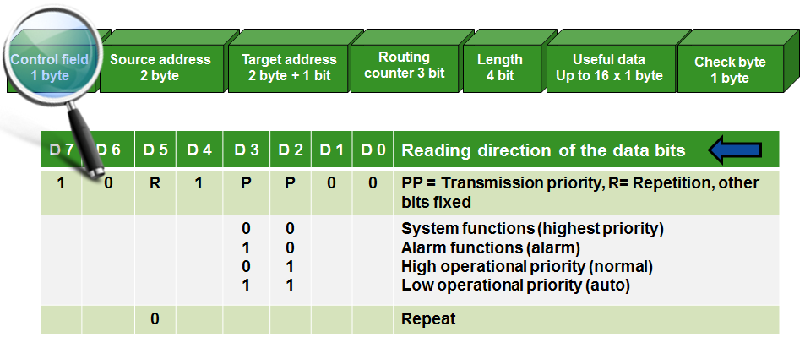
Figure 7: TP Telegram: control field
If one of the addressed bus devices has returned a negative acknowledgement and the telegram transmission is repeated, the repeat bit is set to 0.
In this way, it is ensured that bus devices that have already executed the appropriate command will not execute the command again.

The transmission priority is only observed if several bus devices attempt to transmit simultaneously.

The required priority (apart from system priority) can be set for every group object using the ETS™. The standard setting is low operational priority.

TP Telegram: source address
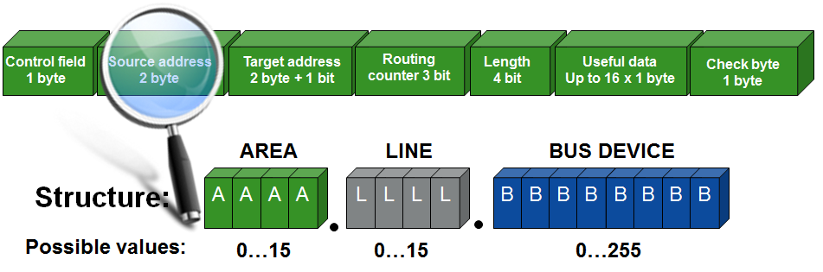
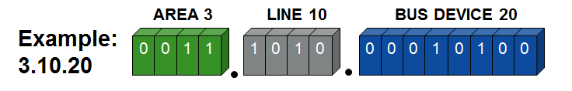
Figure 8: TP Telegram: source address

In the above example 3.10.20 represents the individual address of the bus device 20 in line 10 in area 3.

TP Telegram: target address
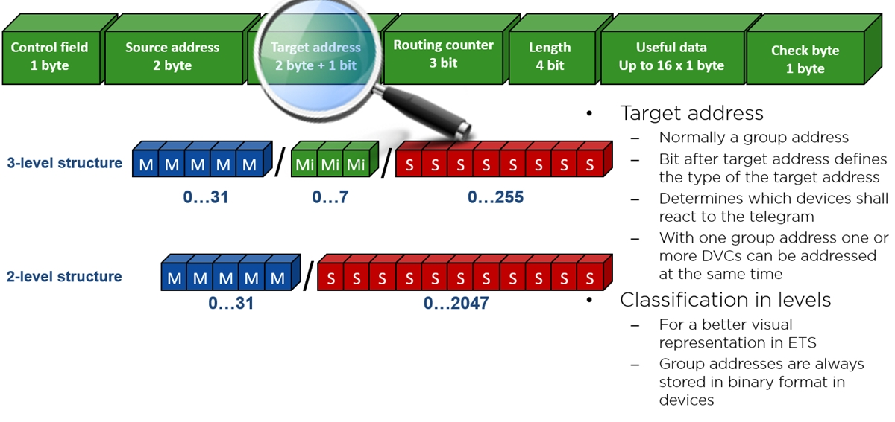
Figure 9: TP Telegram: target address

The target address is normally a group address.

The target address can also be an individual address (system telegrams). On the basis of bit 17 the receiver can determine whether the target address is a group or individual address:

If the 17th = 0 | The target address is an individual address. Only one bus device is addressed.
If the 17th bit = 1 | The target address is a group address. All bus devices with this address are addressed.

TP Telegram: check byte
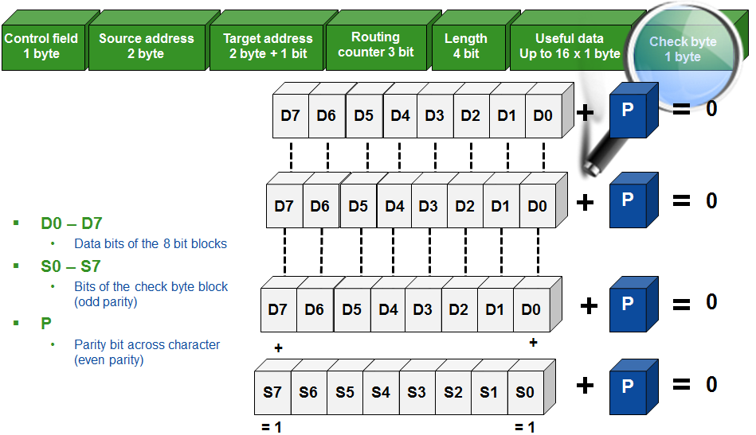
Figure 11: TP Telegram: check byte

In order to detect errors in telegram transmission, test data is transmitted in the form of parity bits (character check) and check bytes (telegram check).

Each character of the telegram is checked for even parity i.e. the parity bit P gets the value 0 or 1 to make the sum of all the bits (D0-D7 plus Pz) equal to 0.

In addition all characters of the telegram are checked for odd parity for each bit position, i.e. the check bit S7 gets the value 0 or 1 to make the sum of all data bits D7 equals 1.

The combination of character check and telegram check is called cross check.

