Visualization Systems
KNX Association

Table of Contents
1.1 General 3
1.2 Requirements for a Central Display 4
1.3 Terminology 4
1.3.1 “Visualization and Control” 4
1.3.2 “Datapoint Type” 5
1.3.3 “Process Point” 5
1.3.4 Static Images 6
1.3.5 Dynamic Image Elements (Variables) 7
1.4 Transfer of the KNX Project Design Data 9
1.5 Notes for Recording the Status in the Visualization 10
1.6 Notes for Starting the Visualization 10
1.7 Types of Bus Communication 12
1.7.1 Program Start-up: 12
1.7.2 Normal Operation 12
1.7.3 Data Recording Modes 14
1.8 Connection of the Visualization to the Bus System 14
1.8.1 Direct Connection via Hardware Interface 14
1.8.2 Indirect Connection via Gateway (Hardware) or Server (Software, e.g. OPC) 15
1.8.3 Bus Access via KNXnet/IP Server 17
1.9 Exporting Project Data: Support by ETS 19
1.10 Physical Access Point in the Bus System 21
1.10.1 Fundamentals 21
1.10.2 Traffic management: telegrams sent across Lines/Areas 23
1.10.3 Use of IP Routers instead of Line Couplers 25
2 Types of Visualization 29
2.1 KNX Device with Embedded Visualization Software 29
2.1.1 Description 29
2.1.2 Finding a KNX Device with Embedded Visualization 29
2.1.3 Configuring a KNX Device with Embedded Visualization 31
2.2 Mobile Visualization Software 32
2.2.1 Description 32
2.2.2 Finding a Mobile Visualization software for KNX 32
2.2.3 Configuring a Mobile Visualization Software 33
2.3 Webservers and Logic Controllers 34
2.3.1 Description 34
2.3.2 Finding a Webserver and a Logic Controller for KNX 34
2.3.3 Configuring a Webserver and Logic Controller 35
2.4 Client/Server based Visualization 36
2.4.1 Description 36
2.4.2 Finding Client/Server based Visualization 38
2.4.3 Configuring a Client/Server based Visualization 38
2.5 New user interfaces. Voice control and intelligent assistants 39
2.5.1 Description 39
2.5.2 KNX Interfaces with Smart Assistants 40
2.5.3 Configuring a KNX Interface with Smart Assistants 41
2.5.4 Comparison between Smart Assistants 42

General
A KNX installation has a distributed structure, in which all devices communicate with each other when required. It is not strictly necessary to control them centrally.
Nevertheless, the technology allows establishing control stations that can represent functions in graphical format, both as remote operating elements and display elements.

Depending on the size of the installation, it may however be advisable to have a central supervision of the datapoints and systems involved.

For example, if the installation is an apartment, it is possible that we can settle for a small display screen including all needed controls.

If the facility is larger, for example a hotel with hundreds of rooms or an office building, the need for central supervision increases considerably, since it is more practical to check the status of all facilities from a central location, taking advantage of the interconnection that a distributed system as KNX offers.

However, this central control and supervision presupposes the need to manage the telegram traffic correctly, without posing a problem for the rest of the facilities distributed throughout the building. We will deal with this aspect in later sections.

We could summarize that the need for a central visualization and control of a KNX installation increases proportionally with its size.

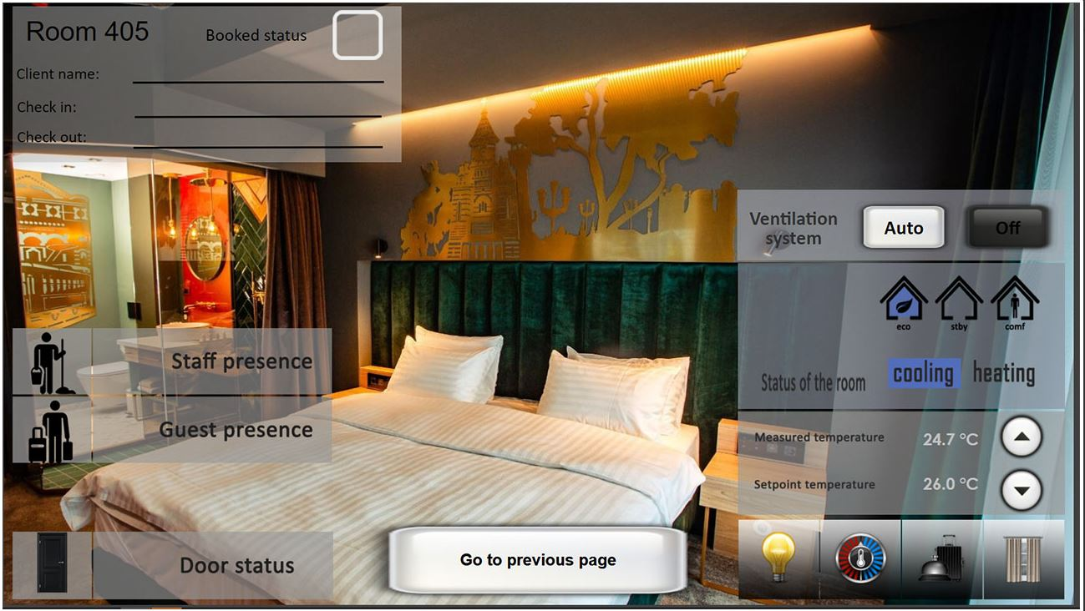
Figure 1: Example of an installation with various input and output variables

Requirements for a Central Display
The operator would like to be able to detect from a central location whether e.g.:
- Lights are still switched on somewhere in the installation, although they should already be turned off,
- Blinds remain closed somewhere in the installation, although they should already have been retracted,
- Windows or doors remain open, which may cause security risks;

In general, the operator would therefore like to have collective status messages of certain groups of functions or devices. He would further like to know the exact location (building/floor/room) where the light is still switched on and would like to be able to switch it off from a central location.
When monitoring building services systems, the operator would like to:
- be aware of any alarms or faults
- see images of integrated video cameras
- see the current status of consumption or view metering statistics
- know the location in the building of a displayed fault
- know when the defect occurred

The high current demands in security, efficiency and accessibility result in the fact that the concept of visualization and control is expanded with the supervision of the different systems present and with the management of the available resources, in this way resulting in a Management System of our building.

Increased users demand to have the operational data displayed independent from hardware / software platforms (e.g. type of PC and OS). If this is ensured, service providers can take over the buildings management’s tasks with the goal of cost optimization and do not need to be onsite all the time. Platform independence however also means that the original data and communication channels have to be available in a format that allows the use without special software or PC environments.

Terminology

“Visualization and Control”
“Visualization” is the representation of states (observation) and “Control” the selection of states (operation). In building automation technology, this is generally understood to be a software package, in which parameters can be assigned relatively easily and can be implemented on a minicomputer. The term ‘minicomputer’ covers PCs, CPUs that have been prepared for this special task, smaller devices like logic controllers for DIN rail mounting, but also mobile platforms mostly used in mobile phones and tablets. In the widest sense, you can also refer to miniature panels as depicted here as ‘visualization terminals’. Many of the statements made here however also apply to the operation of panel units.

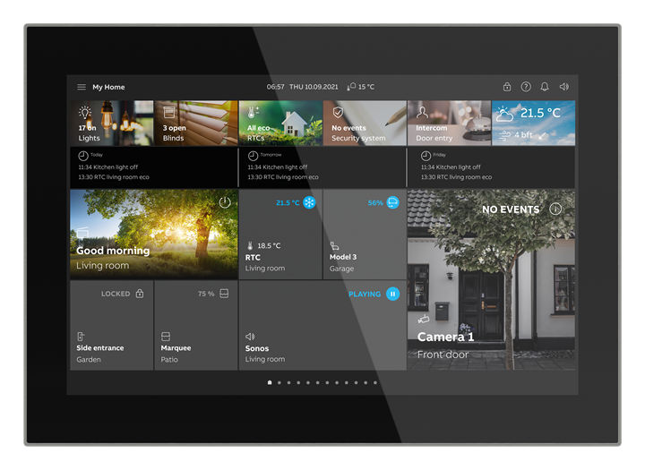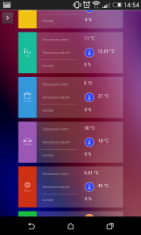
Figure 2: Visualization terminal and smartphone as display and operating element for KNX

“Datapoint Type”
The format of information to be displayed (=DPT in ETS) is determined by the datapoint type. That does not only include the value of a function, but also its further interpretation. For example, a 2-byte hexadecimal value could be an unsigned integer, a signed integer, or a floating point value. Moreover, units (like “lux”, “°C”, “m/s”, etc.) describe the value better for the user.

Another example to demonstrate the importance of using and configuring DPTs in visualization are 1-byte values. For example, if we want to represent a 1-byte lighting control/status on a slider with a scale of 0-100 and its DPT setting is 5.010 (Unsigned Integer) instead of 5.001 (Scaling or Percentage), values will appear incorrectly on the display and only show a part of the range of that value (the interpretation of a 0-100 raw value actually only represents 40% of the value). Sometimes visualization software packages allow us to apply a scale factor (100/255 = 0.3921), but it is not needed if the DPT is set correctly for the use case or if it was correctly assigned in ETS before exporting the project to the visualization software.

So a datapoint type is a “template”, which is put on a value to make it readable in a display or a monitor. It describes a class of different values with a common format.

“Process Point”
The process point is the ‘interface’ between the information for display/selection and their graphical representation on the screen, i.e. the display type of a certain value.

The term “process point” is very important but unfortunately not well-known – most people also use “datapoint” for the individual information on the monitor. This is however not very practicable, as this may give rise to confusion as one loses one definition layer, which ensures a better category assignment of the data.

A process point is based on a certain datapoint type. It however adds important information that should not be neglected for proper display and use of the required information:
- Which group address “carries” the information?
(There can be more than one: in the case of actuators that do not have a status object, all group addresses assigned to e.g. a switching object must also be known to the process point to always display the correct status of the switch actuator).
- Is a value only used for display, or also for control (“Transmit flag”)?
- Which user level may have access for read only, or for read / write? (= Lights should be switchable and not only displayed)
- Which additional tasks have to be performed with the values of this process point? (e.g. save data cyclically in a “value data base”, create event messages, alarms, start another display page depending on a certain condition, mandatory confirmation of an alarm, etc.)
- When was the last time this object was updated with its current value (timestamp)

Static Images
As a visual aid for the user of the visualization program, static background images can be created or imported which e.g. show the ground plan of the visualized area or enable a 3D representation of the room.

Current states cannot be indicated using a static background image. Nevertheless, an adequate aesthetics of the background images undoubtedly improves user satisfaction of the implemented technological solution. In short, our solution has to be good but also has to look good.

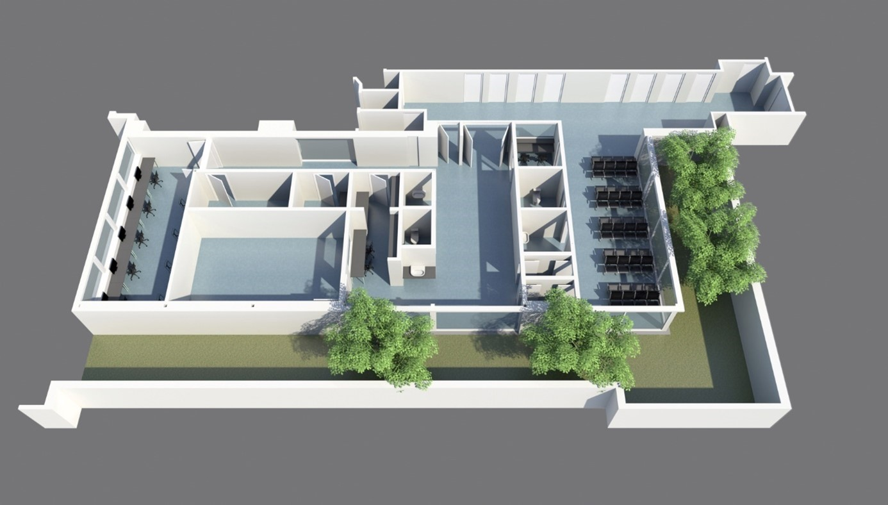
Figure 3: Example of 3D static image used as a background.

Dynamic Image Elements (Variables)
By using dynamic image elements or variables, the required information/states can be displayed on the screen.

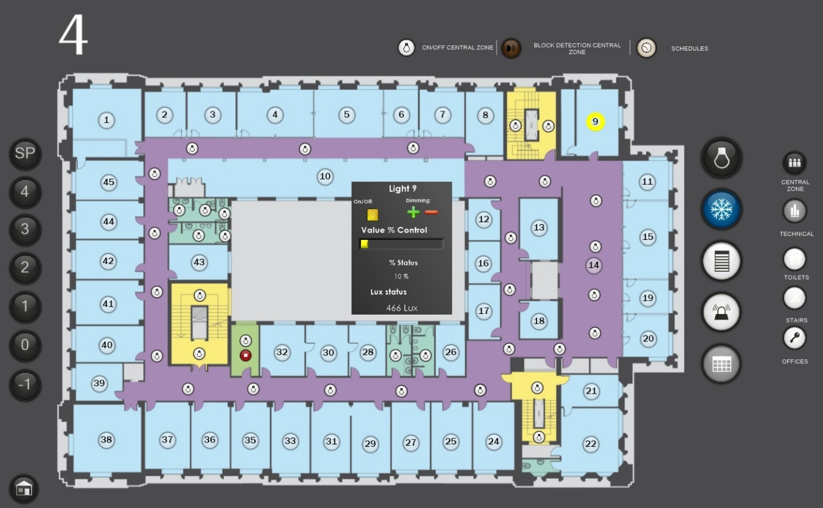
Figure 4: Display options of dynamic image elements, including pop-up windows

The appearance of an image variable is modified depending on the process state (shape, color, text, flashing, etc.). Switching and positioning commands can moreover be sent on the bus. A range of predefined types of variables can be selected. The individual types can be freely positioned on the screen and overlay part of the static background image. The appearance, color, function etc. are set via parameters. The size can be changed in the usual way by dragging the image. One or more process points must be assigned to each variable, which is allocated from the list of process points using ‘drag and drop’.
Simple visualization packages don’t provide “datapoints” or “process points” as separate items, but include all in the image variables. In this situation it is quite easy and quick for the user to assign group addresses, activate the “switchable” function (=activate “send flag”), set up the display format, units etc., but since this needs to be done from scratch again and again, it is only acceptable in smaller projects, not in large ones.

In visualizations that include a large number of elements and controls per screen, the use of pop-up elements is highly recommended, as they allow you to considerably reduce the number of visible graphic elements. In the previous image you can see a plan of a building with dozens of lighting circuits to monitor and control. Thanks to the use of pop-up windows, the user interface is greatly optimized.

The characteristics of high performance visualization and control software packages include:
- one central or several networked visualization/operator terminals
- the creation and parameterization of the process points for display,
- the reading in of images as pixel or vector graphics (dwg, svg),
- an integrated image editor for vector graphics with a macro library,
- various dynamic picture elements (variables) for the display of current states, values, information (multi-picture elements, multi-text elements, etc.).
- the printing of event, overview and parameter logs as well as color screenshots,
- display, operation and logging, in several languages
- powerful additional functions such as statistical functions, Internet ADSL, ISDN connections, event and timer programs.
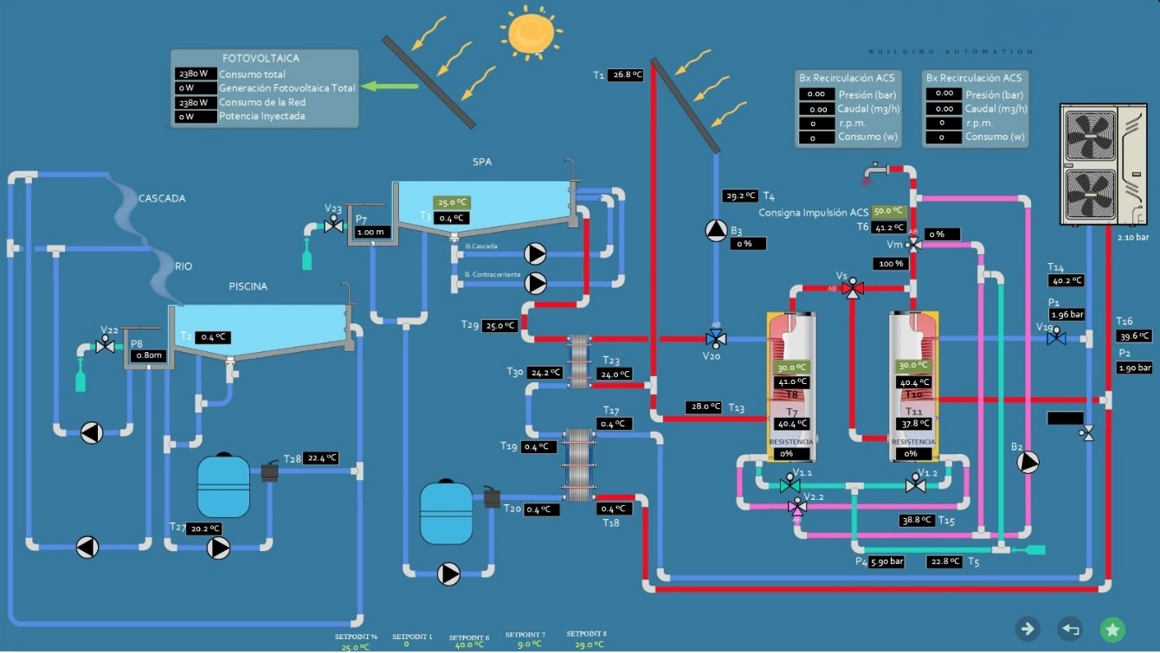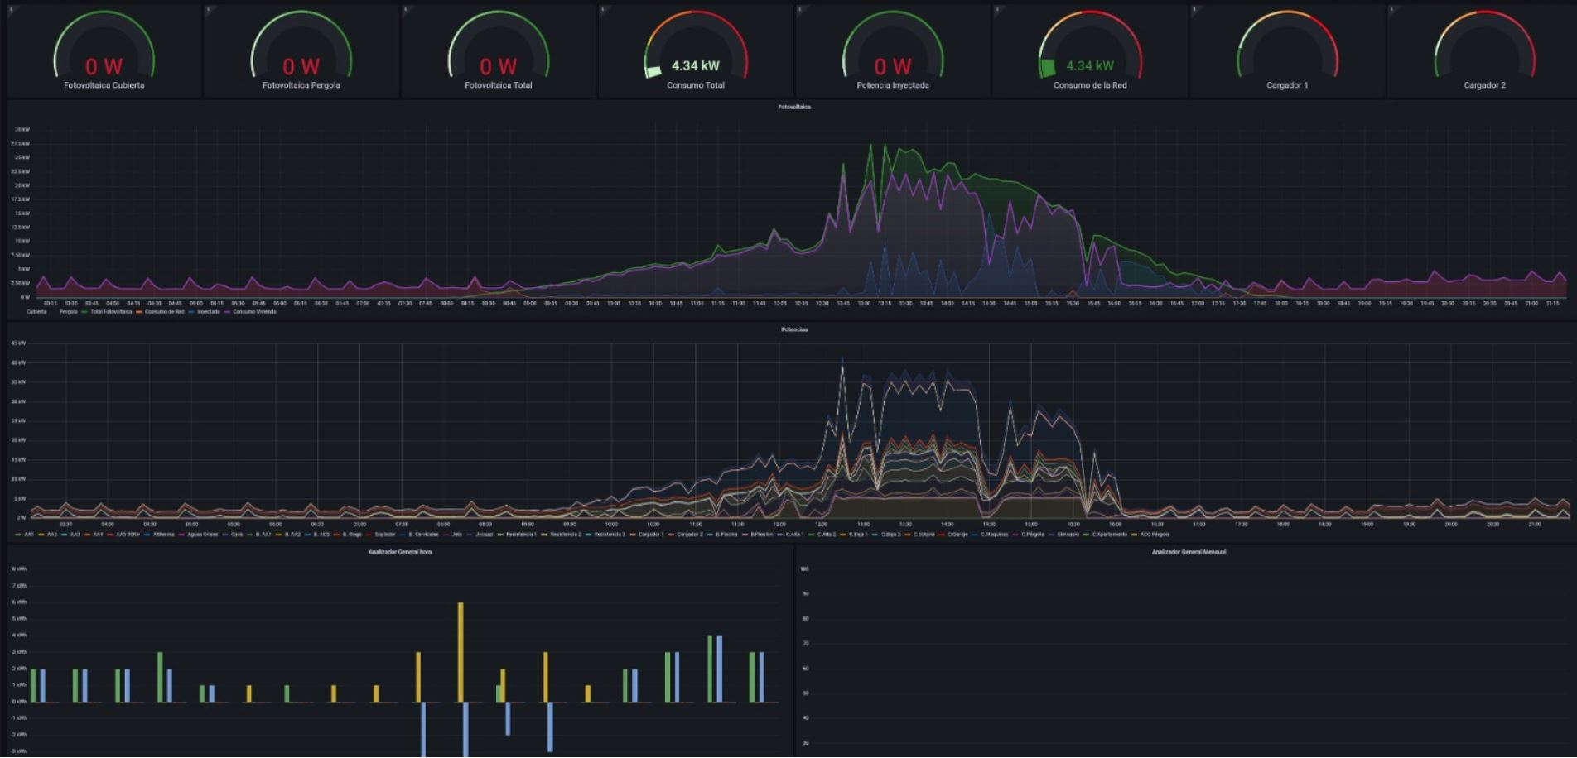
Figure 5: Screen image from an industrial application: various, freely selectable, graphical and numerical representations of several process points. The data represented in the lower graphic can also be recorded and evaluated over longer periods.

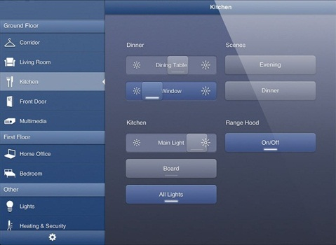
Figure 6: Picture from a home application: user-friendly visualization, clear layout with freely configurable operator and display functions

Transfer of the KNX Project Design Data
The assignment of group addresses to sensors and actuators is carried out when designing an installation using the KNX Engineering Tool Software (ETS).
The data that has been configured in ETS can in many cases be directly transferred to the visualization program. The following data is transferred:
- Existing bus devices and their comments
- Existing group objects and their settings (flags, DPT’s…)
- Configured group addresses and their comments
A further possibility of transferring the functionality of the bus devices is to read out the existing bus devices directly from the bus system. You will, however, only receive the numerical structure of the addresses and their data field width and no text descriptions.
The group addresses can also always be entered manually, if no suitable data interface between ETS and the software exists.

Figure 7: Structured Project Design

Notes for Recording the Status in the Visualization
The states that should be recorded in a KNX installation are detected by the visualization by listening to the bus telegrams. In most KNX actuators, it is however also possible to carry out a switching operation not directly with a telegram, but to start event sequences that trigger switching operations with a delay via a timer or only via a logic operation depending on other states. In other cases, the actuator may be blocked as a result of some criteria (safety, efficiency...) and not respond to the switching orders it receives.

This means that the value of the control telegram cannot be used in these cases as a status image. In most of the applications, additional ‘status objects’ are therefore available in which the current state of a process point is mirrored. If these objects do not automatically transmit in the event of a change, they must be read out cyclically by the visualization software via read requests.

Note: The read flag must be set in the status object, so that the bus device responds to the read request.

Notes for Starting the Visualization

As already mentioned above, the visualization gets its information during operation from the bus devices by listening to the relevant telegrams on the bus (control telegrams and status telegrams).

We can call this normal situation the "permanent regime" of our system. However, sometimes some "transient states" occur that we must consider. For visualization software, the most prominent transitory period is during its own restart. After a restart of the visualization program e.g. after a voltage breakdown, it must ‘query’ the current states of the bus devices, as they are only updated in the visualization after a corresponding telegram on the bus.

This interrogation of the states is referred to as the “read on init” process and is carried out automatically once the visualization is started up, i.e. the states of all bus devices are read out one after the other.

To do so, the read flag must be set in the corresponding object of the bus device and the group address entered in the process point must be defined as a ‘sending group address’ in the object. This address in this way becomes ‘readable’ and the visualization knows which object must be read out of which bus device, when updating the process point.

Several group addresses can be linked in a process point – similar to the group object of a bus device. It now depends on the correct setting of the process point, whether it has been initialized correctly after start-up. To ensure clarity of the status information, there should only be one KNX device per group address with a read flag set (group speaker) and the visualization may only send one query per process point.

Figure 8: Diagram that represents the behavior of the visualization with respect to a process point

Note: This "read on init" process in a large installation, made up of multiple lines or even several areas, with a central visualization can result in serious telegram bottlenecks in the different line and area couplers of the system. This scenario must be avoided, without sacrificing the safety and performance of the installation. In a later section we will talk about solutions for visualization and control in large KNX installations.

Important for older installations: A central address or an address that is used by several bus devices may never be implemented as a sending group address in the group objects of the bus devices. The response telegram as the result of a read request will be interpreted as a normal write telegram, at least by all affected bus devices with mask 1.x. An individual function is queried but a central function is sent back with the effect that actuators suddenly switch lights or move blinds throughout the installation although they should not. In bus devices with other masks this can be avoided by deactivating the “Update” flag.

Nevertheless, what is described in the previous paragraph should not be a concern in current devices (from System 2 onwards) since readings can made on independent status objects and update flags are commonly not set for these group objects.

Types of Bus Communication
The following section provides a summary of the communication types which a KNX visualization must use to continually display current operating states.

Program Start-up:
When starting the program, basically all groups should be read out, including those that are not set as “readable”. It thus depends on the quality of the ETS project, whether the image and information display works correctly.
Read flags may be set only once per group address, only in this case it is guaranteed, that the read telegrams will trigger exactly one response telegram upon start-up.
In general, the status objects shall be connected to the visualization, as they are the only objects that always guarantee a correct status display. Switch or value objects for example can send incorrect values, depending on the parameter settings.

Visualization – Reading out the status – read flag
Figure 9: General strategy to read status information

Normal Operation
During normal operation, the process image is stable, and only few changes take effect now and then. It is now important to verify such process point changes immediately. Further strategies are possible in this situation:
- permanently listening into the bus: all telegrams that are relevant to the display are also routed to the visualization.
- Mirroring and reading back after transmitting: the value of a sent telegram is first “mirrored” i.e. displayed immediately on the visualization once it has been changed and then verified, by the visualization sending a read telegram to collect the new status of the controlled channel (a method that becomes increasingly obsolete with automatic responding status objects).

Visualization – Reading back after sending

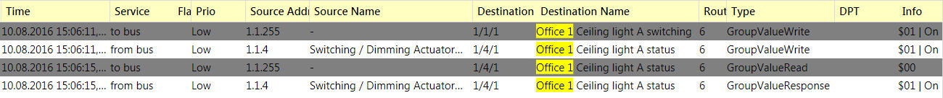
Figure 10: Behavior in transient condition: specific process points are checked for their current state once a telegram is sent

- cyclic read back: this method to keep status information as up to date as possible is only used if the status objects do not automatically report their status or an automatic status transmission after a change would lead to an unacceptably high bus load. Examples for this kind of devices are operational hours counters. They usually count with a resolution of one second. If they would send a telegram on each value change, the data capacity of the bus would be full. To avoid this, the visualization can do a cyclical update of these values, e.g. every 120 seconds.

Visualization – reading out cyclically
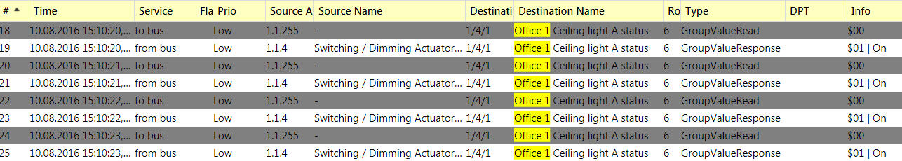
Figure 11: Specific picture elements are updated at defined intervals

Data Recording Modes

Visualizations are not only used for current operations such as display changes and operate functions, but mainly for data tracking. The operator can in this way later analyze precisely what the user behavior was, the consumption of resources versus users, and many more things (operation statistics). It is also possible to draw decisions on the maintenance activities and schedules. Figure 5 is a good example of this.
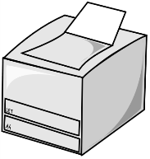
Laser printer

Figure 12: Logged events can be stored in various databases and evaluated at a later date.

Connection of the Visualization to the Bus System
The device on which the visualization program is installed can be connected to the KNX system in numerous ways.

Direct Connection via Hardware Interface
In small or medium-sized systems even today a single possible direct interface is preferred, especially when there is only one KNX system, without any coupling to a building management system, a further bus system or the Internet. In order to perform that type of coupling, a data interface must be used that is supported by the respective visualization package. Current known interfaces are RS 232, FT 1.2, USB, UDP/IP or TCP/IP – protocol-based.

Indirect Connection via Gateway (Hardware) or Server (Software, e.g. OPC)
Large installations usually have a building management or control system (BMS). On the field level, several different bus systems may exist. The BMS should thus collect the data from all the underlying field bus systems. There are two possible solutions:

Connection via Gateway
In this case, the visualization of the BMS is supplied with data by the field bus systems via 1 or several gateways. This means that they are still connected directly to the BMS while the routing of the data from / to the individual segments is carried out using hardware protocol converters (gateways).

Connection via OPC Server
In OPC – in contrast to direct connection – each bus segment provides the necessary data on a server. The format of the data follows the definitions of the OPC foundation (OPC = Object Linking and Embedding for Process Control). This does not mean that each bus system can communicate with the same OPC server. On the contrary, there are often as many OPC servers as bus systems in one installation. The BMS however draws a big advantage from the fact that all data exists in the same format on OPC servers. In this way a parallel access to all these different servers via the local data network is possible, which is usually Ethernet communication (TCP/IP or UDP/IP).

The OPC server itself is nothing more than a software program for data transfer, intermediate saving (buffering the process image) and if necessary, conversion. The OPC specification also requires that an OPC server is multi-client capable, i.e. it can be accessed simultaneously by multiple monitoring stations. The OPC server can run on any standard PC (but should preferably be implemented on a real server workstation, due to higher endurance quality), but it can also be implemented (embedded) in specific hardware. Even an OPC server needs to have a direct data access point to the bus. If it is a PC-based server (pure software), it must access one of the available hardware interfaces via one of the supported peripheral interfaces see the types already stated above in 1.8.1 (direct connection). An embedded OPC server combines hardware interface and server software, and offers the advantage of a higher level of reliability compared to a PC, consuming less power, as having no moving mechanical parts, and serving for only one single task, the risk of a crash is negligible.

The advantage of an OPC server in general is that the process image of the bus installation is stored in its memory, and is always up to date, even if the monitoring system of the BMS is temporarily out of service. Following a restart of the monitoring system, the process image is displayed on the screen within a considerably shorter period compared to a direct bus access on the KNX network.
Figure 13: OPC server operation concept

Connection via Webserver and HTML
Nowadays, many providers run visualizations on HTML-based, so-called webservers. This means that the display interface can be represented on almost any standard browser and thus a proprietary display tool is no longer required. On the other hand, the webserver requires a bus access again. This bus access can be local (a webserver embedded in a KNX device) or distributed via the KNXnet/IP services described below. Some of these KNX webserver devices have an ETS standard application which defines all the communication objects within the ETS project. The integrator therefore no longer needs to worry about the correct configuration of the filter tables of couplers or IP routers.
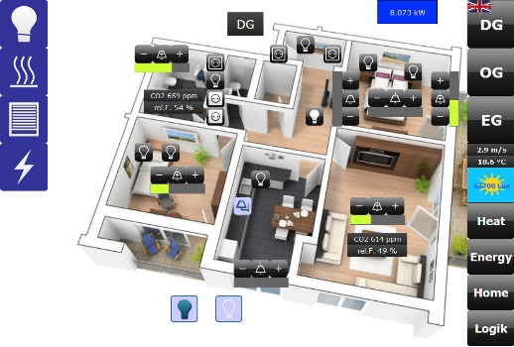
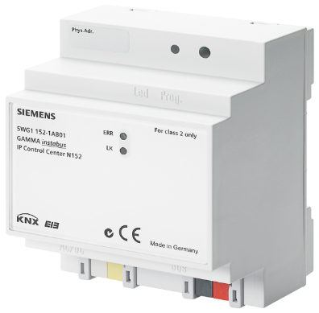
Figure 14: KNX visualization device with embedded web server

Bus Access via KNXnet/IP Server
With the introduction of the KNXnet/IP specification, location independent KNX network access via Ethernet is possible. In this case the access point to the KNX network is a KNXnet/IP capable device, e.g. a so-called IP router or IP Interface. Three core services are defined to connect a KNXnet/IP visualization to the bus:

- Routing
- Tunneling
- Object server

These services distinguish themselves as follows:

- “Routing” is comparable to a line coupler’s function, but on Ethernet. The filter tables of the IP routers are decisive for the data exchange. On the IP network, communication is done via a common so-called IP multicast address. Its notation reads like all other IP addresses. The address 224.0.23.12 is published worldwide and standardized as the default KNX multicast address. For this type of communication to function, this multicast address must be able to pass through or be activated in the network routers. A visualization via multicast therefore does not need a specific access point to the KNX system. The visualization is therefore a member of the multicast group e.g. 224.0.23.12 together with the IP routers and can exchange telegrams. Multicast protocols are not allowed to be sent over the Internet.
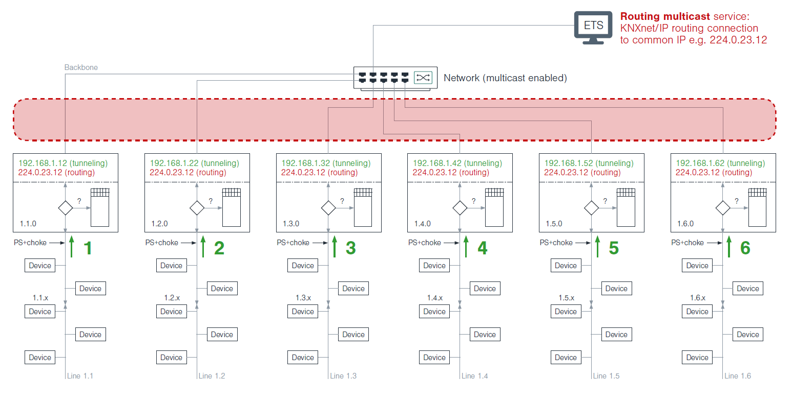
Figure 15: Schematic representation of a Routing Multicast connection in a KNX system

- “Tunneling” is the unlimited, direct access to KNX via an IP gateway (IP Router or IP Interface). In this mode, filter tables are ignored; the bus telegrams are literally “tunneled” through the filter table of the router. Benefit: the filter tables do not have to match. Disadvantage: Only one line is addressed. Tunneling is also used by ETS if bidirectional, unlimited bus access is required e.g. when programming devices. Unlimited tunnel links are retained between the KNXnet/IP devices or services involved with a relatively short timeout and can therefore be interrupted unintentionally in the event of longer running times in the network. In contrast to routing, tunnel links can be established on any network routers and are thus suitable for remote access via the Internet.

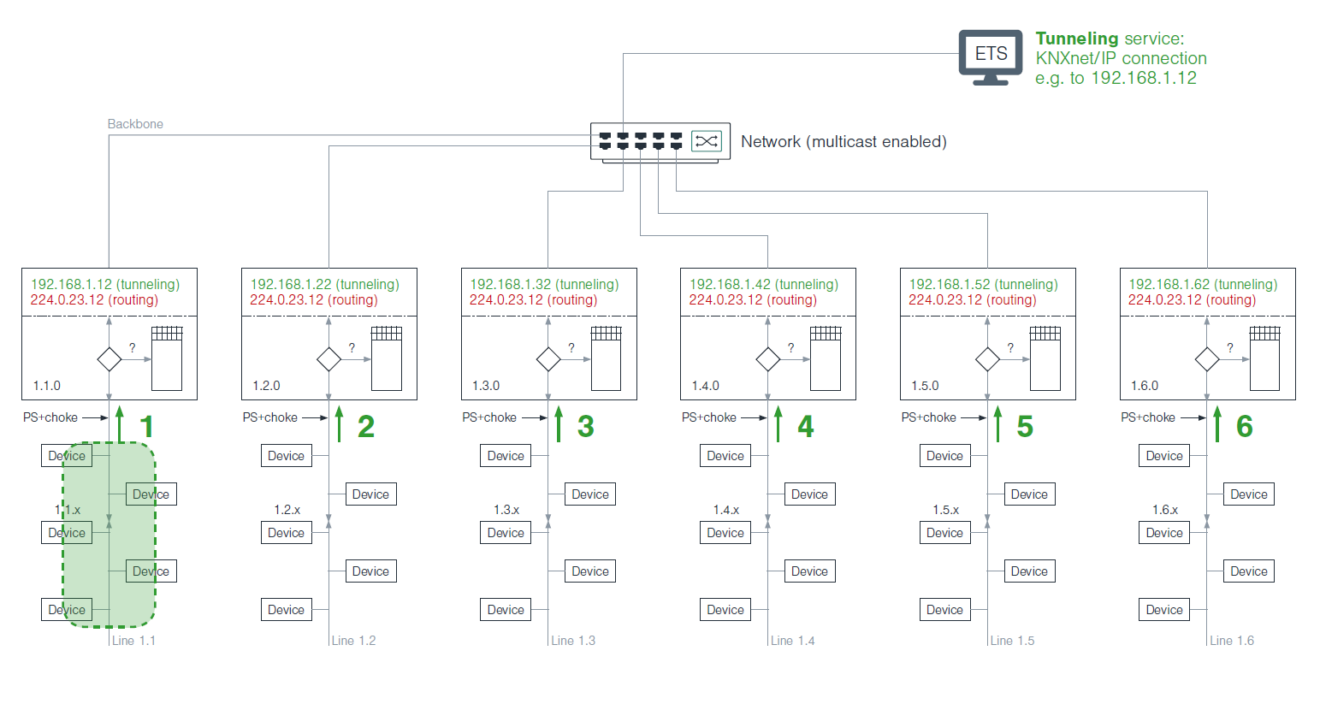
Figure 16: Schematic representation of a Tunneling connection in a KNX system

- “Object server” mode is also a tunnel access but only for group communication i.e. GrpValue Write, GrpValue Read and GrpValue Response. The timeout of this type of connection is significantly higher and thus predestined for remote access at large distances. An indicator is the response time during the ping test: if it is greater than 1000 ms, the object server mode should be selected rather than the tunneling mode.

As an example of this, a KNX IP BAOS device is a universal IP interface and IP gateway for the KNX installation bus. BAOS stands for "Bus Access and Object Server" and provides an interface to KNX installations both at telegram level (KNXnet/IP tunneling) and at data point level (KNX group objects / application layer) with semantic metadata for rooms and functions. It can also be used as bus interface for ETS and can support the storage of all data point values, even if the device is not connected. Used as an integrated web server, the device can visualize buildings, rooms and functions in a standard web browser on a PC or mobile device.

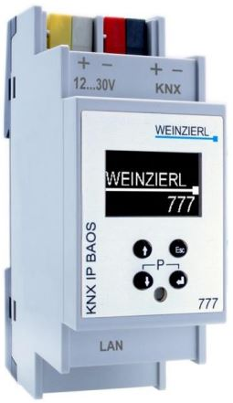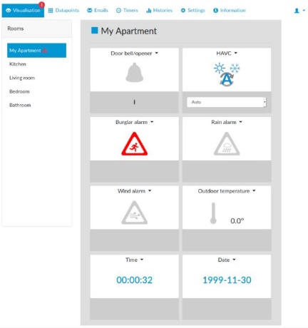
Figure 17: KNX IP BAOS device with embedded web server

Exporting Project Data: Support by ETS
To get the necessary group address data from ETS into the visualization, a suitable interface that the integrator can use to read out the data is needed.

Group addresses alone are not sufficient information – you will also need the information about the assigned datapoint format (called DPT in ETS). In addition, it is advisable to have knowledge about the active communication flags of the objects assigned to the group addresses. Only with that knowledge, can a visualization immediately decide which datapoints are readable, and which are not (e.g. for cyclic update services).

Some providers use the possibilities of ETS to prepare specially formatted datapoint lists while others directly access the ETS project. As the data interface of ETS is exposed and therefore accessible to developers e.g. of apps, it is no longer a problem to transfer the required information from the project.

The so-called “OPC export” can be produced from ETS6:

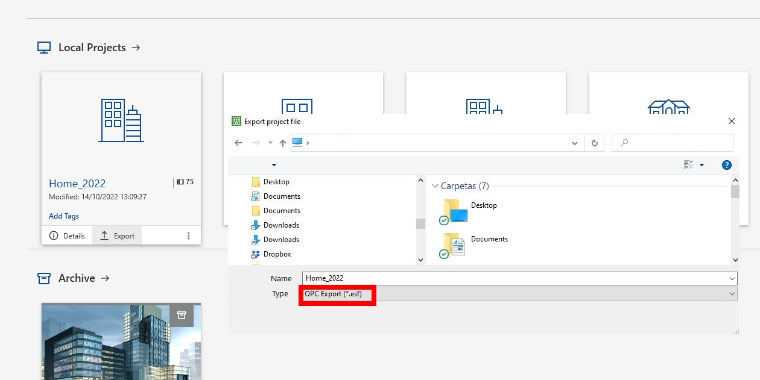
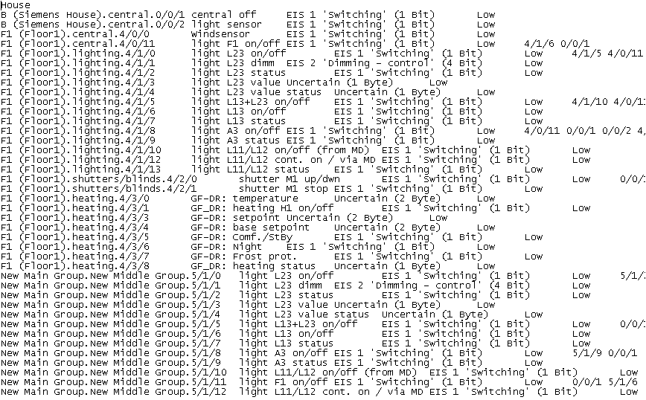
Figure 18: OPC data export from ETS and the resultant OPC file

Even if many programs still demand this format, it has become obsolete as it is incomplete. As you can see from Figure 18: OPC data export from ETS and the resultant OPC file, 1 byte values are already “uncertain” and for switching and dimming, the terms EIS 1 and EIS 2 (the previous denomination for Data Point Types back in EIB times) is still used.
For this, it may be better to opt for the group export of ETS6:

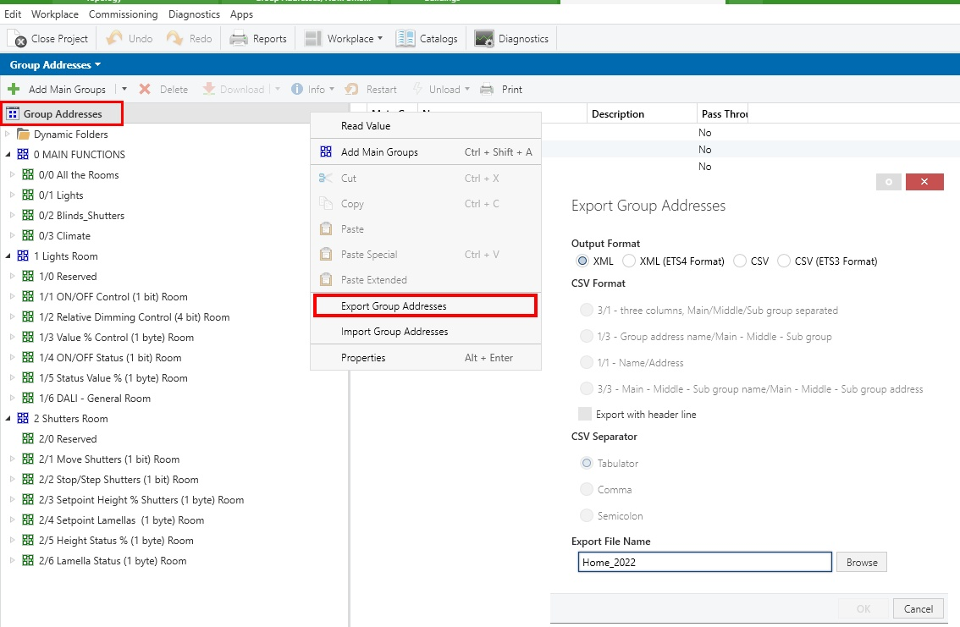

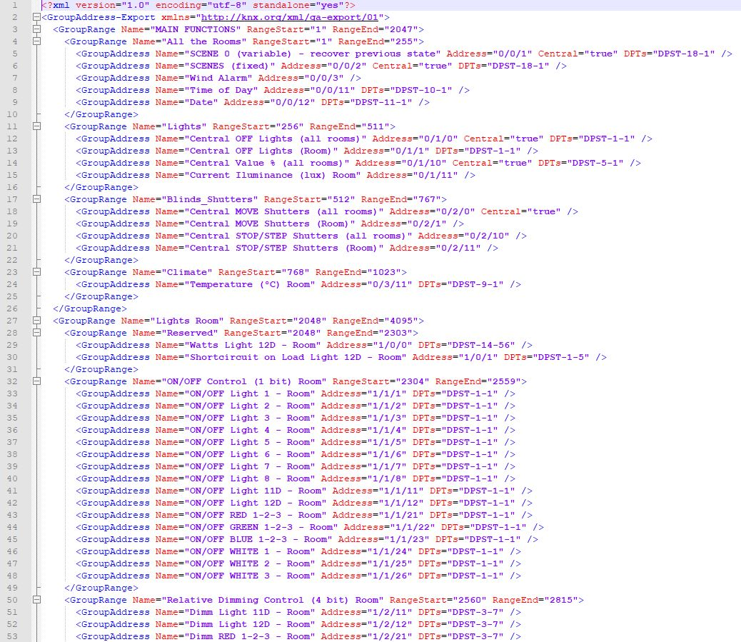

Figure 19: Group export in ETS6 and the resulting file in XML format

Physical Access Point in the Bus System

Fundamentals

In principle, the visualization can be connected to any point in the bus system, no matter what type of coupling is chosen (OPC, KNXnet/IP or direct).

If the bus system only consists of a line, the visualization can only logically be connected to this line.

If the bus system consists of several lines, it is advisable to connect the visualization to the main line, to enable optimum access to all lines.
Figure 20: Single physical access point when there is one area with several lines via USB (any other interface is also possible)

If several areas are used, the visualization is best connected to the backbone line. It is thus guaranteed that the information from the various areas and lines can reach the visualization using the shortest route.

However, this scenario cannot be considered as optimal in any case since a central visualization will surely require that the control and status telegrams arrive from all the lines to the main line of the area. And, if the system consists of several areas, even up to the backbone line.

In these cases, the traffic on the main lines and the backbone line can easily exceed the maximum data rate limit of the system, that is, we will have a bandwidth problem on the main lines and on the backbone line.
Based on the information in the “Telegram” chapter we can calculate the maximum telegram rate in one KNX TP line, i.e. about 45 telegrams per second. But it is advisable to reduce this number to 10-12 telegrams per second for runtime, as we must ensure that the download of devices can still work at any time. This traffic rate is still reasonable, as it means that in one single day there can be about one million telegrams per line!

If we have a central visualization in a KNX system with more than, e.g. 4 lines, and we have 12 telegrams per second on each line we will have more traffic in the main line than the maximum limit. Now imagine a KNX TP system with 15 areas and 15 lines each, with a central visualization in the backbone line. That may be tricky.

Of course, we can try to drastically reduce the traffic of each line, reducing the cyclical sending, eliminating active status telegrams or reducing the scope of the visualization to the essential minimum. Although all these sacrifices may surely clash with the user's requirements.

Moreover, the buffers of the line couplers will have to process a much larger number of telegrams than normal, which will saturate them, resulting in “Busy” type acknowledgements that will lead to the sure loss of a large number of telegrams on the bus.
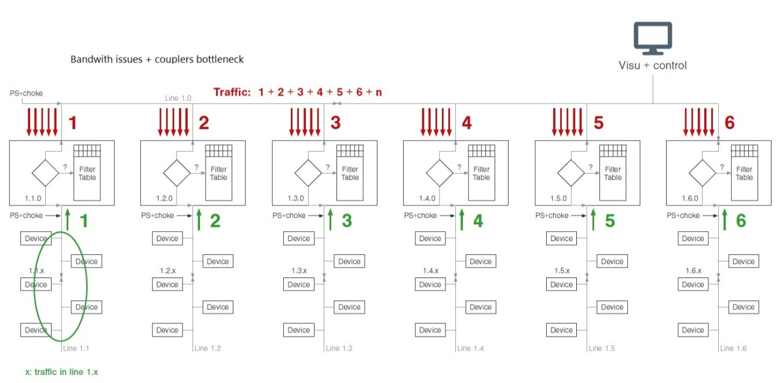
Figure 21: Too much traffic in the main line with a central visualization and a single access point
All of this assuming that the traffic of each line remains independent, that is to say, that we have not opened the coupler filters in both directions trying to "guarantee" that the traffic reaches our central visualization.

The next section explains the methods to ensure that the traffic on each individual line is kept independent and that only telegrams are forwarded to the main line to reach the central visualization.

Traffic management: telegrams sent across Lines/Areas
As mentioned before, if information across lines or areas should be processed by the visualization or if commands from the visualization are sent on other lines or areas, the behavior of the coupler must be taken into account:
Each line/backbone coupler has a filter table that contains the information as to whether a global telegram is required in its line (area) or whether a local telegram is also required outside its line (area).
This filter table is created by the ETS program in the course of the project design.
The visualization is however not taken into account by ETS, and this information is therefore omitted. But a visualization can be regarded as a complex KNX device using a larger number of group addresses.
Three different options for preparing the couplers for use with a visualization therefore exist:

Enabling the Filter Table
The behavior of the filter table is set separately per direction for each coupler via the parameter list:
Direction of primary line ↔ secondary line:
- Block (no telegrams are routed)
- Enable (all telegrams are routed)
- Normal (filter table decides whether telegrams are routed)
The first step is to consider in detail the route of each telegram to be visualized or sent by the visualization to the bus devices.
Using ETS, the filter table should then be enabled in the relevant coupler for the corresponding direction and the program should be reloaded.
By enabling the filter table, all the telegrams are routed in the appropriate direction. This will have a negative influence on the bus dynamics in larger installations, primarily, if a large number of central functions and control systems have been configured. This possibility is only meaningful in installations where the enabling of the filter tables does not lead to the overloading of individual lines. As the determination of the actual bus load when enabling filter tables can only be carried out manually and is very time-consuming, the filter tables should generally be used.

Correcting the Filter Table via Dummy Devices
To ensure that the ETS program takes into consideration the group addresses used by the visualization when creating the filter table, dummy devices can be configured in the line where the visualization accesses the bus. All group addresses shall be entered in these “devices”, which the visualization listens to or sends.
Specially developed applications are available as dummy devices, which are part of the product databases of several manufacturers. These dummy devices have the advantage that they offer objects of all common sizes and allow up to 500 group addresses to be linked in one dummy. Only the communication flag and the write flag shall be set for the objects as otherwise – in case of automated data transfer from ETS to visualization - the visualization may later attempt to access such groups, although not physically existing in the line in which the visualization is installed.
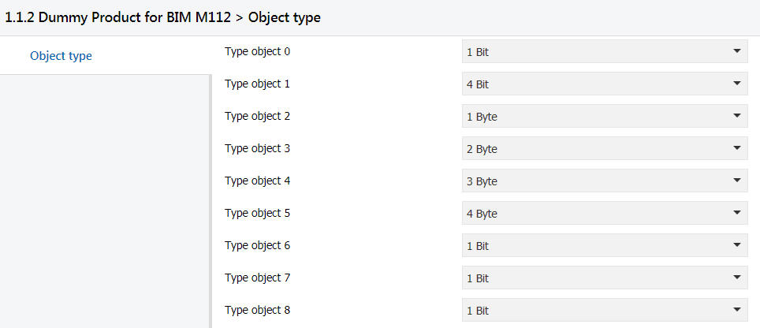
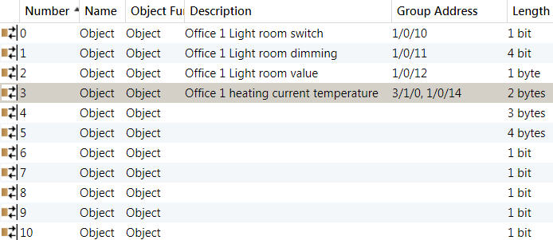

Figure 22: Parameters and objects of a dummy application

After extending the project by dummy devices using ETS, the filter tables of all affected couplers must be reloaded. Dummy devices are only used to take into account the visualization settings when creating the filter table. These devices do not need to and cannot be put into operation.

If none of the above described options is implemented, telegrams that are required by the visualization for status display may not be routed to the line, in which the visualization is installed or a command telegram may not be routed to the line, in which the target actuator is located.

Manual editing of the Filter Table

Editing each couplers filter table manually is equivalent to using dummies, but it has two advantages:
- If an appropriate group address strategy is used for each line of the tool, it is possible to enable permissions for group addresses not yet used, which saves having to edit when adding new addresses
- Adding address groups in bulk saves a lot of time compared to editing dummies.

For more details about this ETS characteristic you can refer to the chapter "Couplers".

Use of IP Routers instead of Line Couplers

Since 2004, it has been made possible to use so-called IP routers instead of line couplers. In principle, these IP routers offer the same services as line couplers. The decisive difference is however the change in protocol (embedding of the KNX telegrams in a UDP/IP data frame) and the high difference in speed.

KNX telegrams sent (routed) via LAN are transmitted at least 1,000x quicker than on the KNX TP medium, a decisive advantage when the visualization is directly connected to the LAN.

If a direct coupling is used via the IP routers and the Routing Multicast connection (see also the explanation above in clause 1.8.3), one is able to realize the fastest visualization as well as being independent in terms of location. The worldwide standardized protocol KNXnet/IP guarantees access to all the IP routers simultaneously within a common IP network. Data congestion is therefore no longer an issue, but in a massive project we can still have bottleneck problems with couplers due to a possible overflow in their buffers, as it has been described in previous clause 1.10.1.

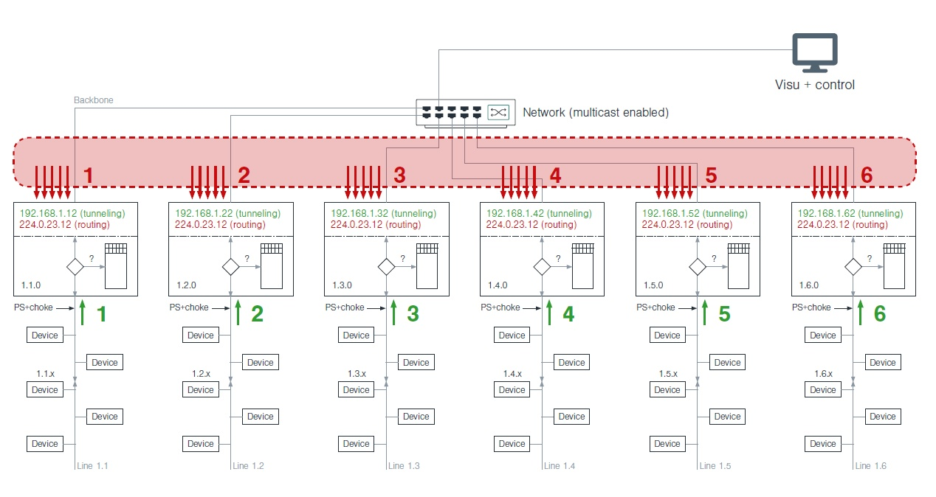
Figure 23: Visualization software connected via Routing Multicast service to a KNX system with multiple lines. No bandwidth issue but an overflow in the coupler´s buffers is still possible.

Solution for massive KNX installations using BMS software

At the beginning of this section we have observed that telegram traffic management is especially important when dealing with a KNX installation with multiple lines. In order to have central visualization and control in this type of projects, we must guarantee that we will not suffer problems in this regard. In other words, the KNX installation should not be conditioned, or its capacities diminished by the need for a centralized visualization.
However, we have also observed that the need for this type of central supervision and management solutions becomes more important the larger the size of our KNX installation.

The best solution that allows you to combine both needs is the use of a BMS software like the one shown in the image below. This software has the ability to establish simultaneously one tunneling connection per KNX TP line accessible via an IP Router.

Hence, one big advantage of this solution is the saving of time for the integrator, since it is not necessary to manipulate the filter tables of the IP couplers in any way. In this scenario we will neither have any problem with the bandwidth or with coupler buffers, as long as the filtering of the couplers is used and the traffic on each line does not exceed the recommended limit of 12 telegrams per second.

In this case we are talking about a server-client solution, where the BMS Server is the software that is responsible for communicating with all the KNX lines and the visualization is a client of this server. In the next section this will be explained in detail.

Another advantage of this solution is that the server only consumes a single tunneling connection from each IP Router. On top of that, it is possible that it supports multiple visualization clients, so in a KNX installation there could be tens or even hundreds of simultaneous visualizations of smaller or larger size without detriment to the performance of our KNX system.
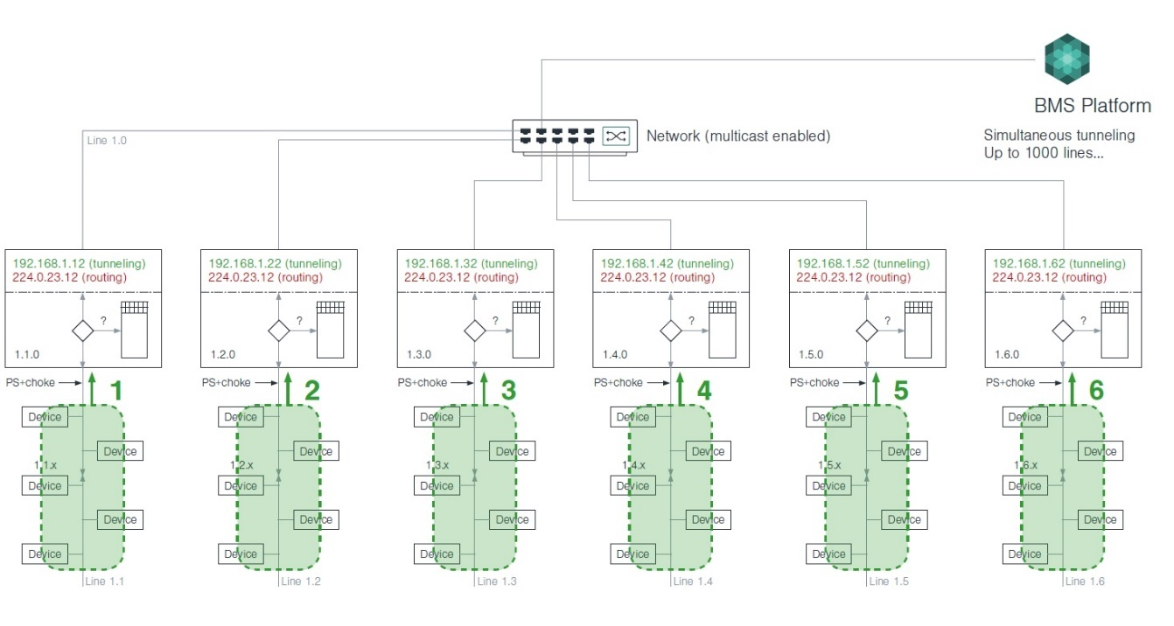
Figure 24: BMS software and multiple tunneling connection for big KNX installations.

Solution for multi-site visualization using BMS software and IP Interfaces

The fact that a BMS software uses a tunneling type connection opens up the possibility of using this solution in multi-site projects, such as chain of stores, bank offices, restaurants, supermarkets, etc.

In this type of projects, where each small installation is located in different geographical locations, the difficulty lies in proper network management (VPN, security...).

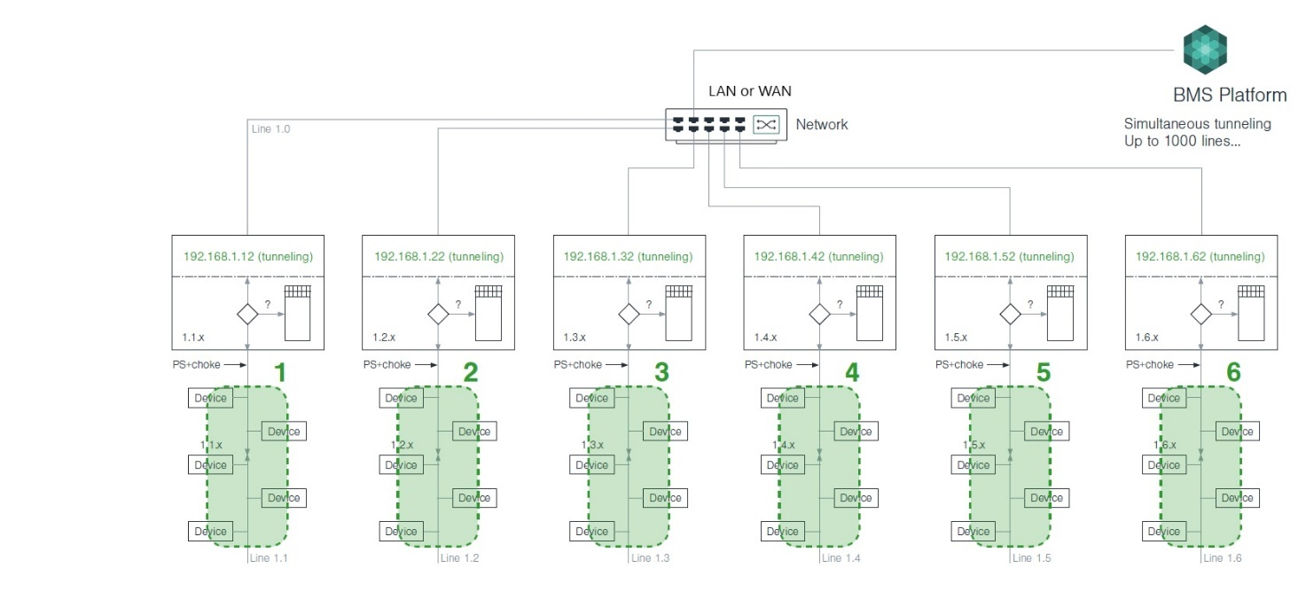
Figure 25: Multiple KNX installations at different sites integrated using IP interfaces, a BMS software and the proper WAN configuration.

Another advantage of this solution is that, for the BMS software, each process point is made up of the IP address of the KNX IP interface/router plus the group address. As the IP address is different on each line/location, it is possible to program the KNX devices on each line/location identically (using the same small ETS project for each one with the same individual and group addresses), which also drastically simplifies the integrator's work.

Solution for old KNX TP installations using BMS software and IP Interfaces

The Figure 21 in the previous section showed a KNX TP system with multiple lines, where the telegram traffic on the main line becomes unsustainable.

In order to have a central visualization and solve the data traffic problem, it is not necessary to replace the TP couplers with IP Routers. In this case it would be enough to add an IP interface for every KNX TP line (in parallel with each TP coupler) and use a BMS as the server for the visualization (client).

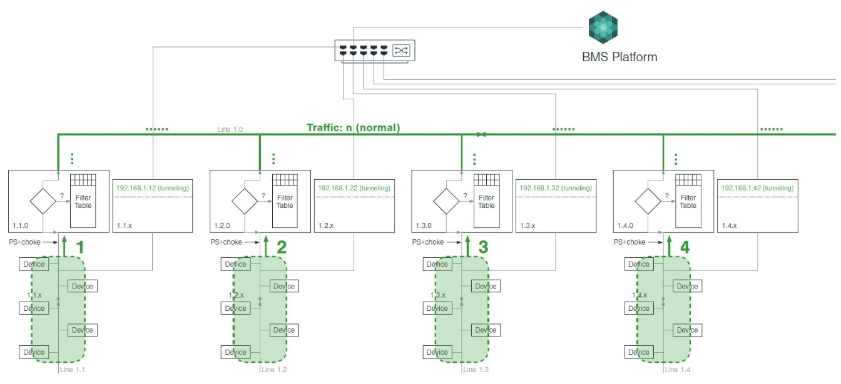

Figure 26: Solving a problem with traffic in a saturated TP installation using BMS and IP Interfaces

Types of Visualization

There are various different types of KNX visualization. These can be classified as follows, e.g., by size of the KNX project they are intended for:
- KNX devices with embedded visualization software, e.g. a touch panel with an embedded KNX bus coupling unit, therefore configurable either via ETS directly, via a DCA (Device Configurator App for ETS), via an ETS plug-in (deprecated, no longer possible for new devices) or even by using an external configuration tool.
- Mobile devices, such as a smartphone or a tablet, which has the visualization software installed on it. Usually the connection to the bus is achieved via WiFi using a KNXnet/IP router/interface, connected with a common Ethernet/WiFi access point. As any device that has a WiFi transceiver can use this type of visualization, this type of visualization is very flexible and easy to use.
- Webservers, embedded in DIN rail devices with TP and/or IP connection to KNX.
- Client/Server based visualization, where the visualization software runs on a central device as server and can be accessed by other devices as clients. A client can either be a touch panel, a television set, a computer, or ever a mobile device, such as a smartphone or a tablet.

KNX Device with Embedded Visualization Software

Description
Compared to only a few years ago where they only had limited functionality, a KNX device can nowadays be immensely powerful and integrate comprehensive graphics on displays and touch panels. Such a device is usually a display unit or touch panel, with an embedded KNX controller, to connect to the bus and monitor and control elements in a KNX installation. More powerful visualization devices may even have an Ethernet adapter allowing connection to a broadband network and accessing even more services or devices.

Finding a KNX Device with Embedded Visualization
Many manufacturers today at least have one solution for visualizing an installation in their product portfolio. Usually they can be found in catalogues under the section “touch panels”, “displays”, “room controllers”, “signaling”, or similar.

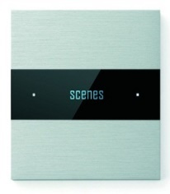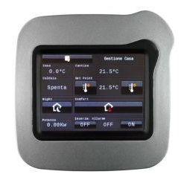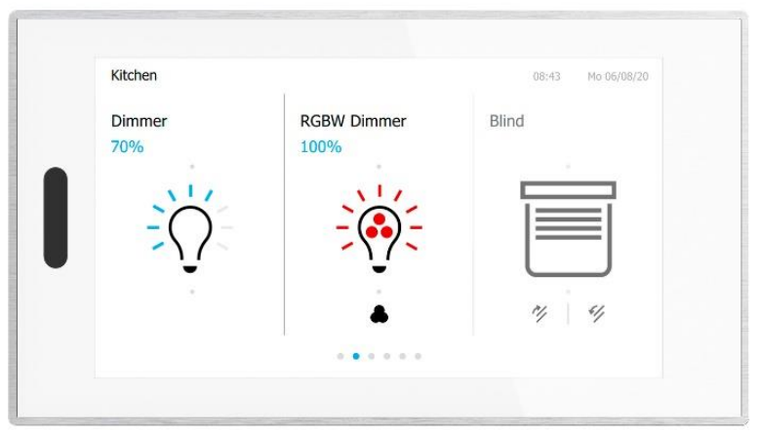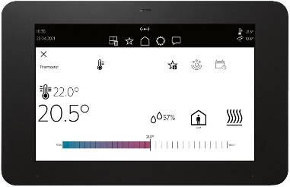
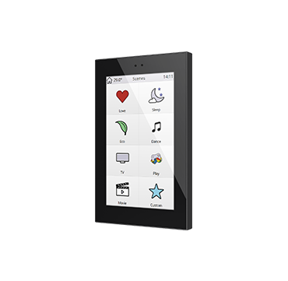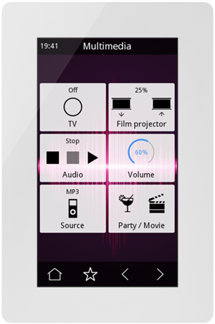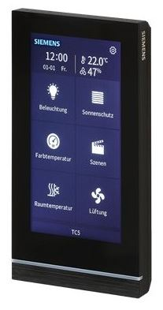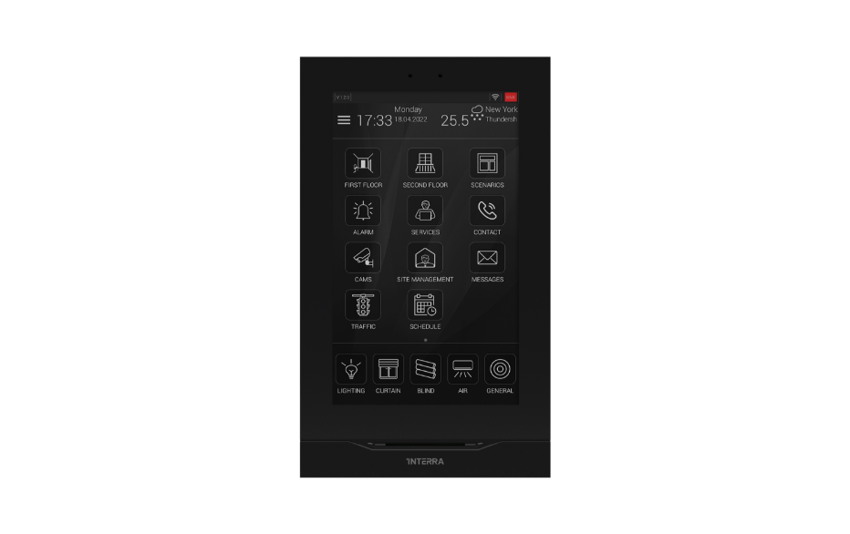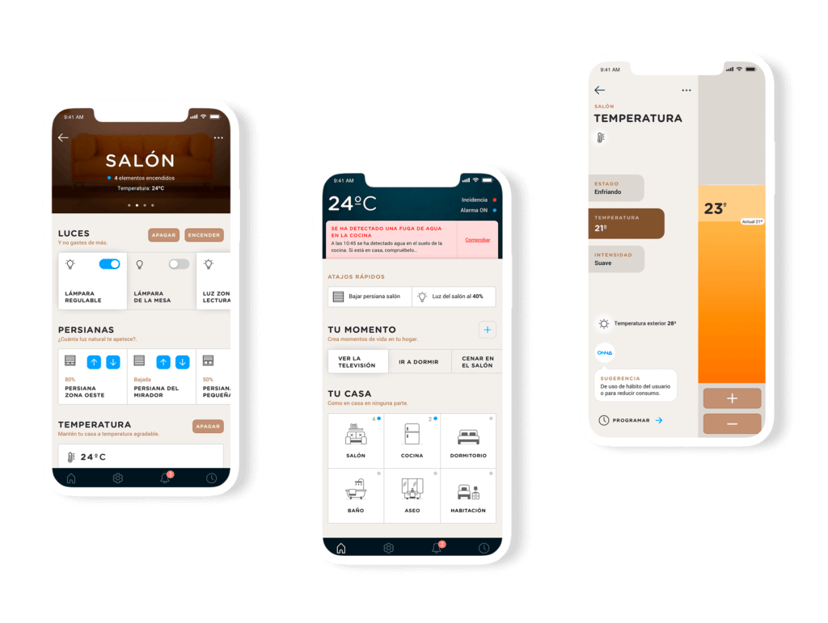
Figure 27: KNX devices with embedded visualization

In recent times a hybrid option between this type and the next one (mobile visualization software) has emerged, where a touch screen can also be “cloned” in a smartphone or tablet using an app (iOS, Android…) with secure cloud access.
This solution is interesting as it allow local or remote secure access to the KNX device; and the only requirement for the user is to have internet connection at the site. Moreover, the secure connection between the KNX touch screen and the smartphone app is made automatically, without any additional network configuration.

However, these types of devices rarely offer remote access via KNXnet/IP, so they cannot be used, for example, to remotely program other KNX devices in the installation.

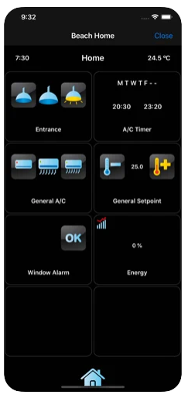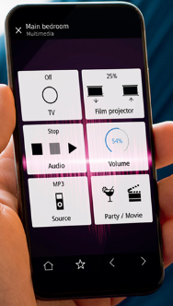
Figure 28: Example of iOS app linked to a KNX touch screen for local and remote operation.

Configuring a KNX Device with Embedded Visualization
KNX “S-mode” devices are configured and commissioned with ETS on the basis of a product database file (vdx or knxprod): the data of the desired visualization device needs to be imported in ETS. It has to be configured either directly via the “Parameters” dialog or via an ETS DCA or plug-in. The user shall assign the group addresses to the respective communication objects. Subsequently, the device has to be commissioned and obtain its physical address.

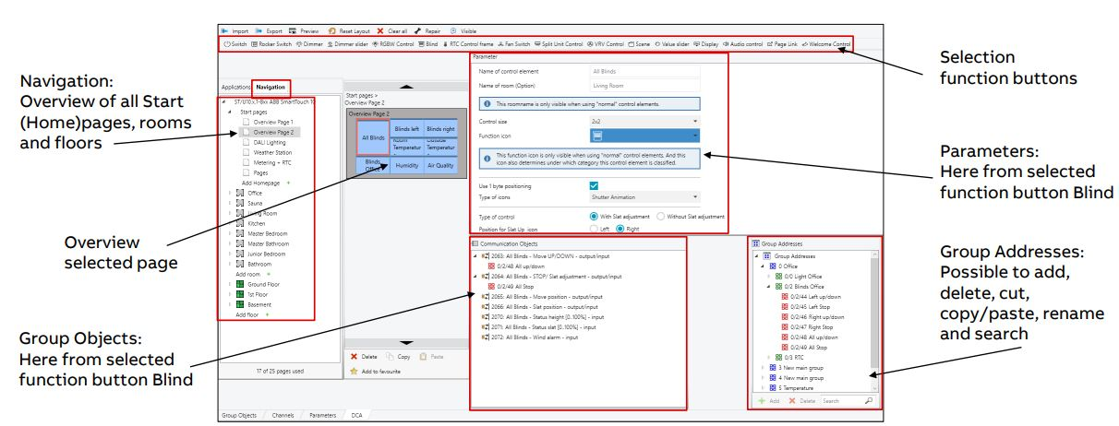
Figure 29: Configuring a KNX touch panel using a DCA (Device Configurator App) in ETS

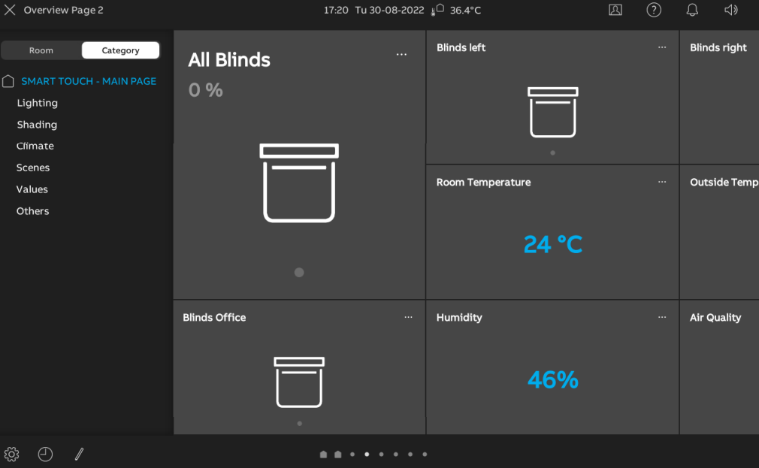
Figure 30:The result on the device after commissioning

Mobile Visualization Software

Description
Mobile devices, such as smartphones and tablets have become important instruments in our daily life and are used for many purposes, e.g. entertainment, business activities, navigation, …. There are several types on the market, most of them equipped with a WiFi adapter and running specific operating systems, on which users are allowed to install external software (usually called ‘apps’).
Therefore, visualization software often takes the form of an app, which can be installed on such devices, performing visualization operations. The visualization of a KNX installation in a mobile device can be realized by installing and configuring the visualization app on the desired device and getting access via its WiFi adapter to a WiFi access point, connected to the installation via a KNXnet/IP tunneling interface.

Figure 31: Schematic diagram of a mobile device visualization

Finding a Mobile Visualization software for KNX
There is a plenty of visualization software in the market for several types of mobile devices with different operating systems. For this, access the ‘store’ of the respective operating system via a mobile device (‘Google Play™’ for devices running on Android™, ‘App Store™’ for devices running on IOS™ and “Windows Store™’ for devices running on Windows Phone™), find and select the app that suits your needs.

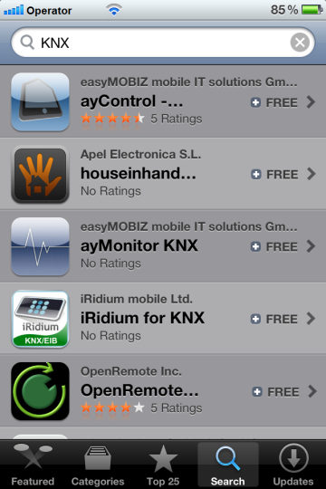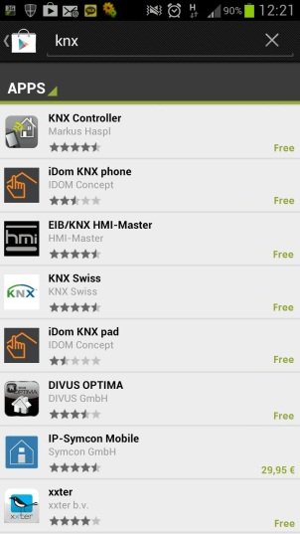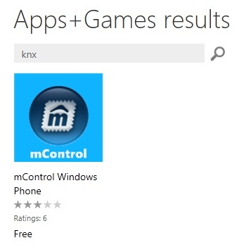
Figure 32: Apps for KNX visualization for IOS, Android and Windows Phones

Configuring a Mobile Visualization Software
In most cases, a visualization app for KNX can be configured in the following way.
- Use of external configuration software, which is the most used and most preferable solution. With this solution, the developer can freely design the visualization project. The project data (i.e. the group addresses) can either be
  - retrieved by importing the previously exported file from ETS, as described in paragraph 1.9, or
  - by adding manually all the necessary group addresses or
  - even using the automatic scan that many apps include in their main functionality, besides the actual visualization.
- Use of the embedded configurator of the app, mostly available in evaluation versions of visualization apps. In this case, one has to manually add all the group addresses or even scan them by reading the telegrams from the bus (mainly applicable for smaller installations).

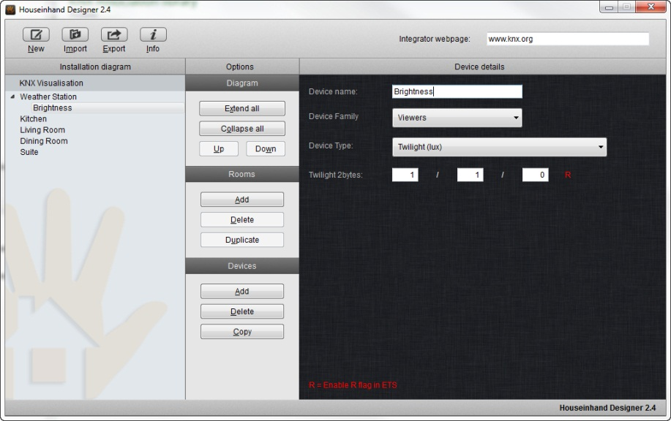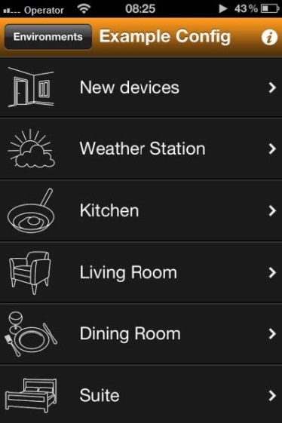
Figure 33: App visualization configuration tool and preview

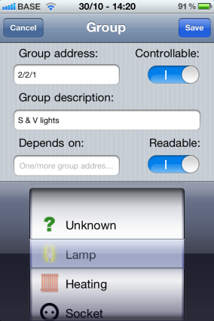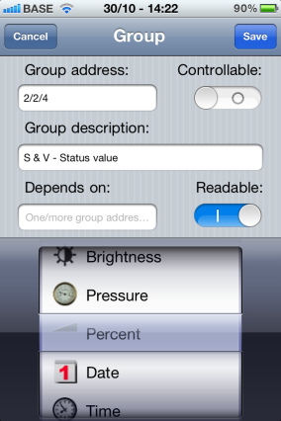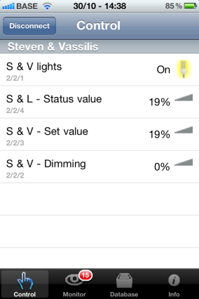
Figure 34: App visualization configuration using the embedded configurator. Adding group addresses manually.

Note: This solution is intended more for the end user than for the system integrator.

Webservers and Logic Controllers

Description

In clause 1.8.2.3, the existence of web servers for KNX installations was already mentioned, which allow us to have a visualization of our installation on smartphones and tablets in an uncomplicated way.

In some cases, these devices can not only serve as a visualization gateway, but also provide other interesting services such as:
- Allowing the configuration of alarms, scenes, macros and schedules
- Record data for representation in graphs.
- Serve as IP Router and IP line coupler
- Offer tunneling type connection
- Offer a secure VPN access configuration to the installation through the device
- Include a logic engine and a script engine for more complex configurations
- Allow voice control and integration with smart assistants like Alexa or Google Home.
- Permit the integration with sound systems like Sonos®.
- Allow direct integration of KNX with other field buses and with other protocols such as Modbus RTU, Modbus TCP, BACnet IP, MQTT, LORA, Zigbee, etc.

Finding a Webserver and a Logic Controller for KNX

Although there are currently multiple Webserver-type solutions for KNX, the number of devices that comply with the characteristics is not as wide as that of the touch screens described above. Several examples are shown in the following figure.

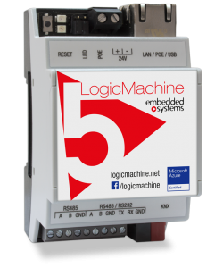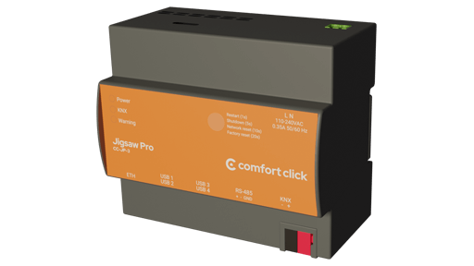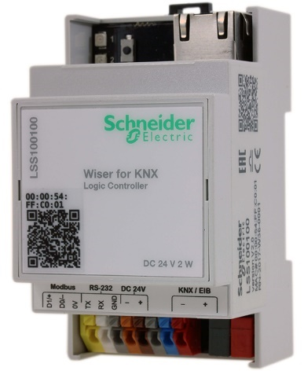
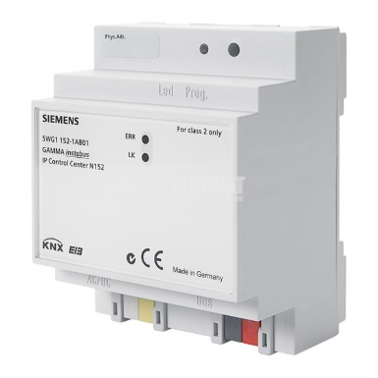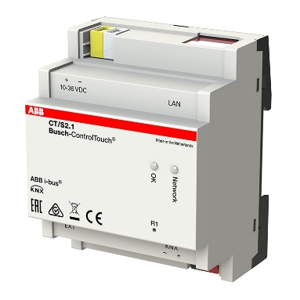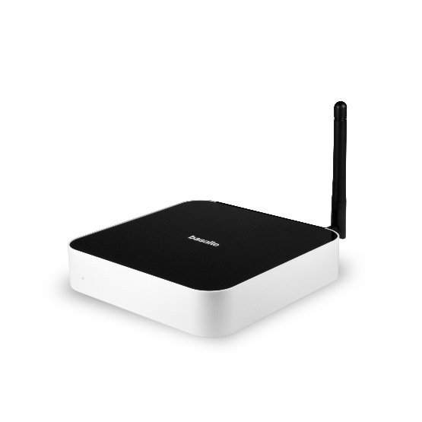
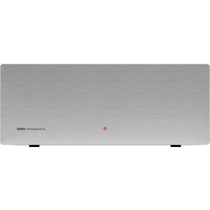
Figure 35: Examples of webservers and Logic controllers for KNX visualization and integration with other services.

Configuring a Webserver and Logic Controller

Obviously, the configuration of a webserver device is done in most cases by accessing the same device via the web. In some cases the devices offer their options in the form of apps and in others through a configuration wizard that makes it easier for the integrator.

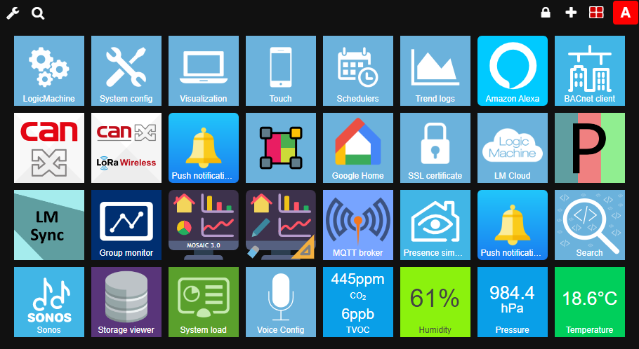

Figure 36: Example of configuration page of a Webserver and logic controller for KNX visualization and integration with other services.

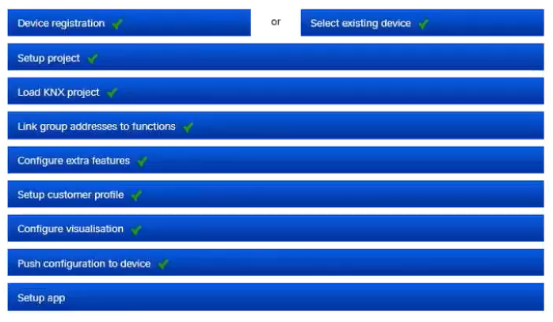

Figure 37: Example of configuration wizard of a Webserver and Logic controller for KNX visualization and integration with other services.

This type of device could also be considered as a client/server visualization, although they are designed for small or medium-sized installations (not more than 1000-2000 process points, depending on the device). In the next and last category we will describe this type of visualization but we will focus on its use in large installations.

Client/Server based Visualization

Description

Since the very beginning of building management systems, there has been a need to visualize installations on central units with the ability to access them by several users and in many cases with different privileges.

Usually a common PC connected to the installation played the role of central unit and other PCs connected to it played the role of users. However, since technology evolves, these devices have been significantly improved, and their size has also decreased. As we have seen in the previous section, the solutions that exist in the market, are not limited only to conventional PCs, but include compact powerful devices with Ethernet connection, which can also have integrated support for audio/video, alarm or logic control functions. They can also play the role of visualization server, where other display devices can connect as clients and supervise or control the installation.

In any case, when we are faced with a large KNX installation, where several thousand process points are managed and it is necessary to use multiple lines accessible via IP routers or IP interfaces, as we have seen in clause 1.10.3, the use of a BMS solution with native KNX connection is very needed.

As we have commented in that section, the BMS solution consists of a Server, which is the part of the software in charge of communicating very efficiently with all KNX lines by means of IP Tunneling services for each line, and the visualization as Client of this server.
This client/server software architecture allows us to have multiple views of different sizes and scopes. Let's imagine a hotel project as an example, where a visualization solution is required on three levels:
- Level 1: a central visualization for the hotel administration, for the reception service and for the management.
- Level 2: different visualizations for each of the hotel floors for the room cleaning service and for the maintenance service
- Level 3: a specific visualization for each hotel room/suite, which allows each user to have control and visualization of their lights, air conditioning, curtains, etc. during their stay.

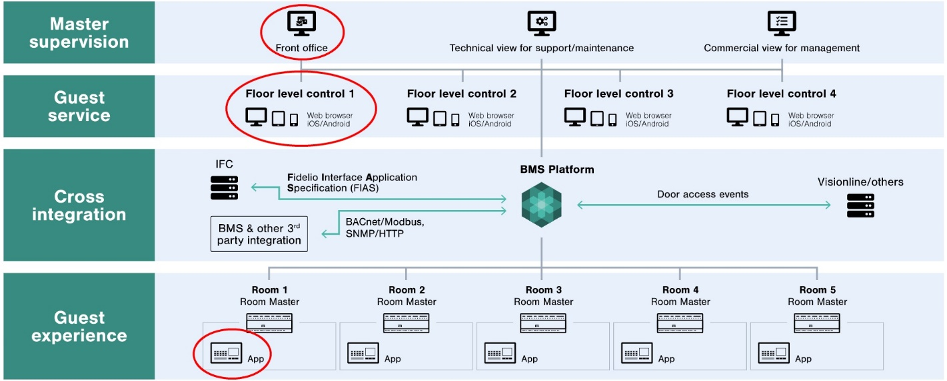
Figure 38: Example of Client/Server BMS solution schema with different visualization levels

These BMS solutions, in addition to allowing the integration of all KNX devices in the property, are also capable of being integrated e.g. with the hotel's PMS management systems, which additionally allows, for example:
- That the person responsible for cleaning each room can see or change the cleaning status of each room, or the name and nationality of the client.
- That each user can request the cleaning of the room (Make Up Room) or the Do not Disturb by means of a KNX pushbutton.
- That the visualization of each room automatically appears in the language of each client and access to it is enabled and disabled depending on the dates of the stay.
- That the receptionist can generate a QR code for the customer upon arrival that allows them to use their own smartphone to view and control their room (BYOD - Bring Your Own Device - solution).
- Etcetera.

Finding Client/Server based Visualization

Visualization solutions based on the client/server model that are offered by the manufacturers can either be
- For big size projects, a standalone software tool, which is installed on a PC, in this way getting access to the bus and other clients able to connect to it, or
- For small and medium size projects, a compact computer with an embedded, freely configurable visualization software and a KNX interface for the access to the bus.

In the first case, Server/Client BMS solutions with native KNX connection and integration with other multiple protocols are referred to as BMS Platform or BMS Architecture in the market. This software solution can be found at software developers that are member of KNX International.

Configuring a Client/Server based Visualization

The configuration of client/server solutions intended for medium-sized projects and based on an embedded device varies from one manufacturer to another and has already been described with some examples in previous sections.

In the case of the software for large KNX projects, the configuration of the server part, intended for communication with the different KNX field elements or from other technologies, must be done first.
Once we have all the process points organized on the server, we can proceed to the design of the different visualizations (clients).

On the server side it is interesting to organize all the process points in a systematic way. For example, if you rename and rearrange all items on the server using "aliases", this makes it easier to use variables for display. This results in a drastic simplification of the integrator's work since it is possible e.g. to design the visualization of all rooms of the hotel with only one or a few single model pages.

All these strategies and tools are explained in different training courses offered by BMS software manufacturers, which are not difficult to find on the internet.

New user interfaces. Voice control and intelligent assistants

Description

Over the years KNX has been able to adapt very well to new market preferences and user needs.

In a significant percentage these changes have come from the side of the user interfaces.
We must not forget the KNX actuators, which have also been updated in a very significant and constant way over time, but the perception of change on these devices is less than in reality.

Although all these user interfaces coexist today in KNX systems, we have gone from using pushbuttons with LEDs to using small display screens. From these to the use of our smartphones and tablets. And KNX has always offered new interfaces to meet this demand.

Voice control is a user interface that was used as an experiment to help people with disabilities many years ago. But today its use has spread massively due to the entry into the market of smart assistants launched on the market by large technology corporations such as Apple (HomeKit), Amazon (Alexa) or Alphabet (Google Home).

These assistants offer the user an automatic visualization from their apps, and the possibility of creating automations in a simple and intuitive way. They also allow the integration of other systems such as security cameras, meteorological sensors, etc.

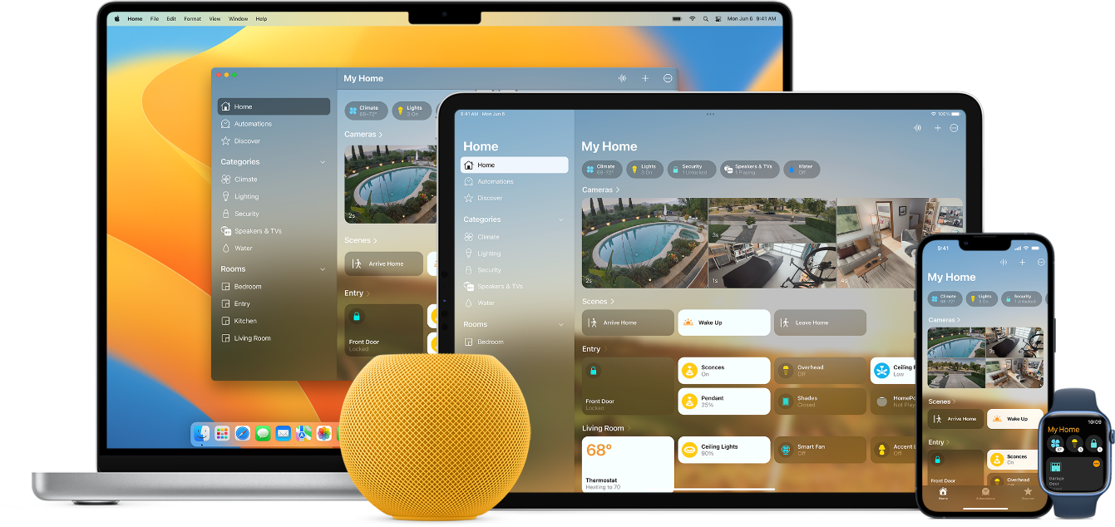
Figure 39: Visualization using Homekit app from Apple

KNX Interfaces with Smart Assistants

There are numerous devices on the market that allow us to integrate our KNX installations with these voice assistants, and therefore with the functions offered by smart assistants, which are not limited to commands or queries by means of voice.

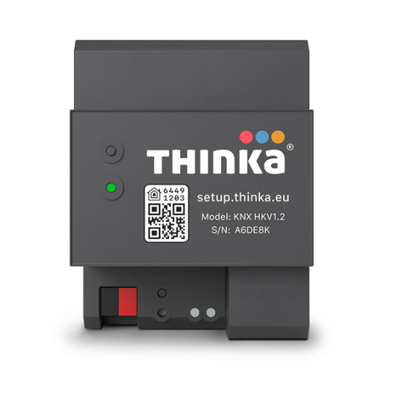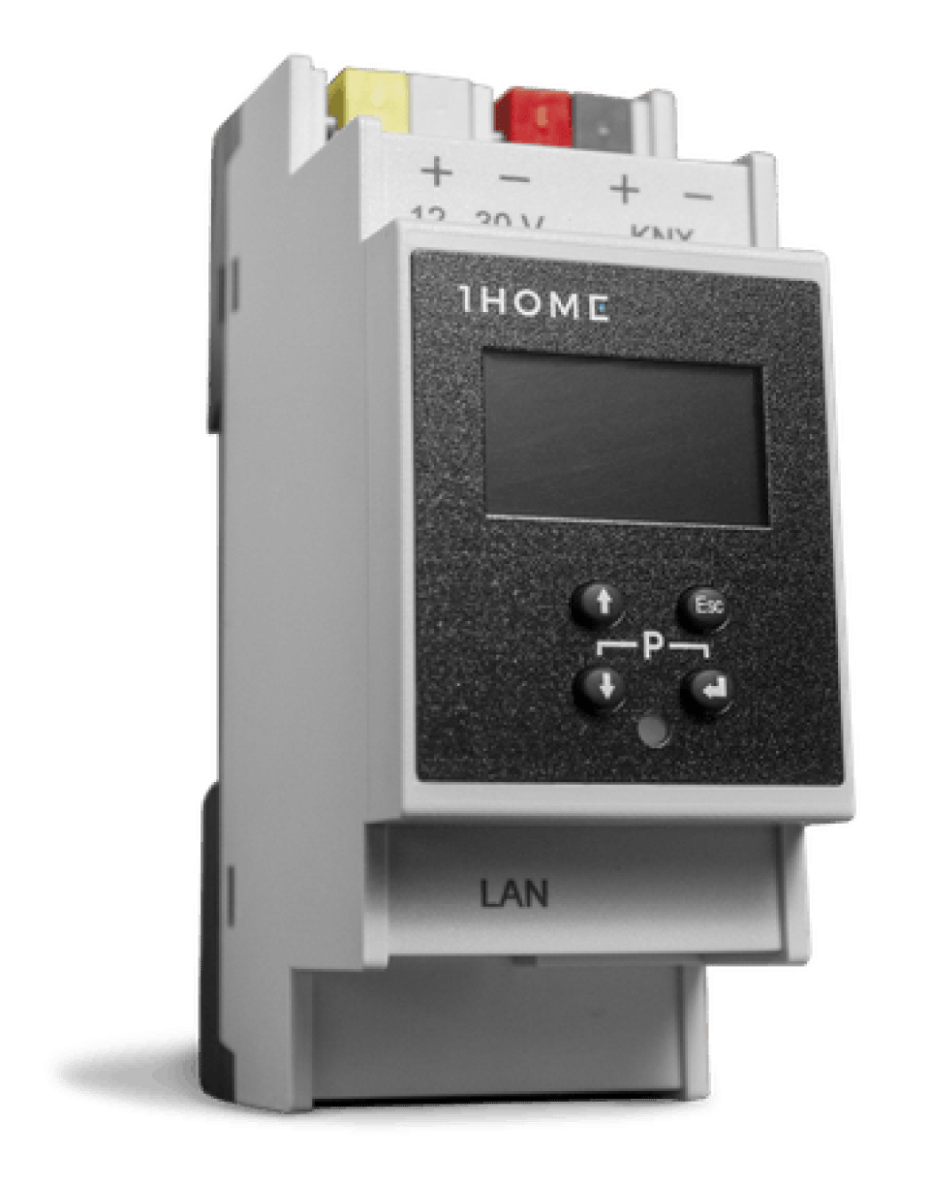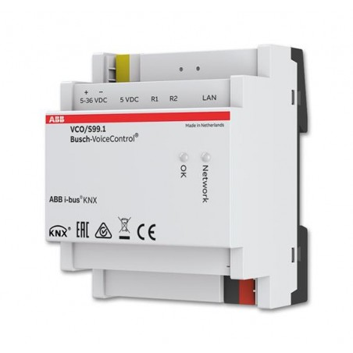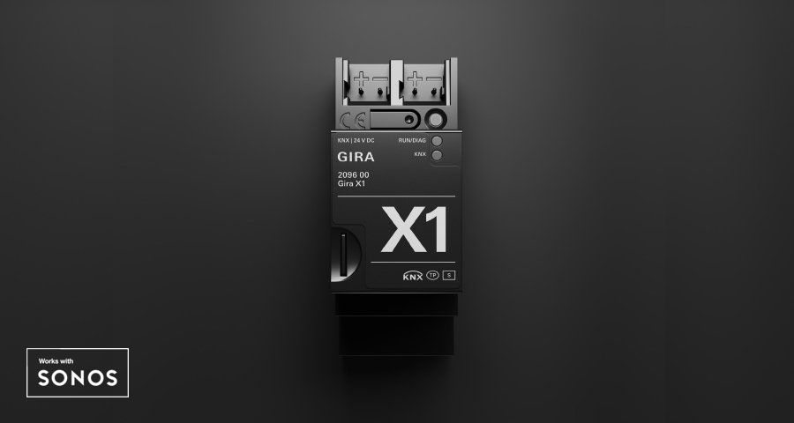

Figure 40: Examples of devices that allow integration of KNX systems with intelligent assistants.

Configuring a KNX Interface with Smart Assistants

The configuration of voice assistants is usually done from a web application on the device. In these applications, you can import the ETS project in ´*.knxproj´ format and later add installation devices configuring them with group addresses (control and/or status) and a name (tag) by which the assistant will respond to voice commands .

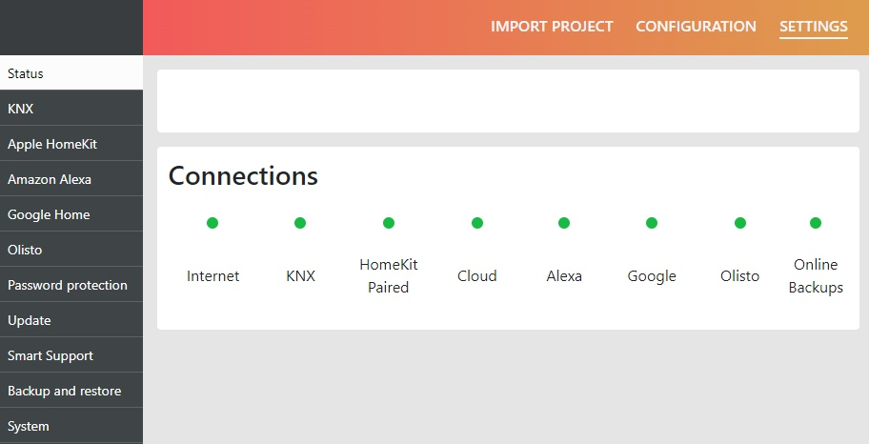

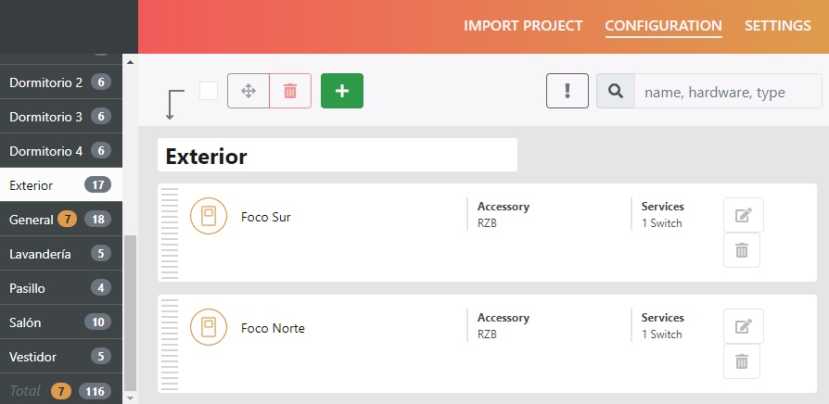

Figure 41: configuration example of a voice assistant via web

Comparison between Smart Assistants

The three solutions shown below account for most of the market share for smart assistant solutions and all have advantages and disadvantages.
As for the number of devices compatible with each of them, there are quite a few differences between them (Alexa is compatible with about 60,000 different devices, compared to approximately 30,000 for Google Home and 500 for Apple Homekit).

However, from the point of view of the KNX solutions, which is the aspect that concerns us, it is worth noting the greater interaction capacity of Homekit compared to the other two solutions, as can be seen in the following comparative table.

These capabilities change frequently, so it's important to stay up to date on them.

Voice control service | 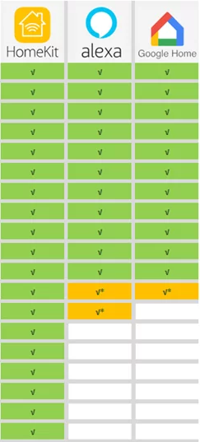
ON/OFF Lights
Dimmable Lights
RGB colored lights
Switches
Sockets
Thermostats
Speakers
Vacuum cleaners
TV
Cameras
Locks
Shutters / Blinds
Temperature sensors
Thermovalve
Humidity sensors
Magnetic contacts
Smoke Sensors
CO₂ Sensors
Leak sensors
v* : only voice control

Figure 42: comparative table with the different capacities of the three intelligent assistant solutions.

EDI: Electronic data interface; e.g., USB, IP Interface, …

