SI main units :

Quantity Unit Symbol
length meter m
weight kilogram Kg
time second sec
current amper A
Tempreture keiven K
illumination candel S

SI derived units :

Quantity unit Symbol
frequency hertz Hz
force newton N
pressure pascal Pa
power watt W
electric charge coulomb C
electric potential volt V
electric resistance ohm Ω
electric conductance siemens S
magnetic flux weber Wb
magnetic flux density tesla T
luminous flux lumen lm
illuminance lux lx
Work/energy Joel J
Speed meter/second m/sec
Density Kg / cubic-mete Kg/m³
Volume cubic-mete m³
Area square meter m²

multiples and sub-multiples of SI units:
Factor | Symbol | Prefix | Factor | Symbol | Prefix
10⁻¹ | d | deci | 10²⁴ | Y | yotta
10⁻² | c | centi | 10²¹ | Z | zetta
10⁻³ | m | milli | 10¹⁸ | E | exa
10⁻⁶ | µ | micro | 10¹⁵ | P | peta
10⁻⁹ | n | nano | 10¹² | T | tera
10⁻¹² | p | pico | 10⁹ | G | giga
10⁻¹⁵ | f | femto | 10⁶ | M | mega
10⁻¹⁸ | a | atto | 10³ | K | kilo
10⁻²¹ | z | zepto | 10² | H | hecto
10⁻²⁴ | y | yocto | 10¹ | Da | deca

Definitions
Ampere: (A)
it’s the a charge of one coulomb passing through a point for one second
Volt: (V)
It’s a potential difference between two points which allows the flow of one ampere current
for one watt power.
Ohm(Ω)
it’s the amount of resistance between two points which allows the flow of one ampere of current when one volt applied between them
Components of electric circuit:
1-source: It may be a battery or a generator.
2-conductors: to transmit current
3-control(s): which allows or breaks the current.
4-load: any item which current passes through
cell
switch
lamp
wires

Main Factors effecting resistance
1- Area (A):Its inversely Proportional to the area measured in m²
R∝1/A. ……………..(1)
2-Length (l):
Its directly Proportional to the length measured by meter
3- Resistivity : Its directly Proportional to the Resistivity measured by Ω.m
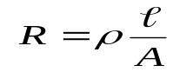From equations 1,2 and 3 we get:
…………….(4)
Example :
Calculate the resistivity of a metal wire of cross-section diameter 0.4mm if a 25cm length of this wire has a resistance of 6Ω
A = π d²/4 = = π x (4 x 10 ⁻ ⁴ m)² / 4 = π x (1.6 x 10 ⁻ ⁷ m²) / 4 = 1.2566 x 10 ⁻ ⁷ m²
ρ = RA/L = (6 Ω) x (1.2566 x 10 ⁻ ⁷ m² ) / (0.25 m) = = 3.02 x 10 ^{– 6} Ω.m

Temperature Effects On resistor value:-
Resistance increases almost linearly with an increase in temperature to the inferred absolute temperature of ̶ 234.5 C
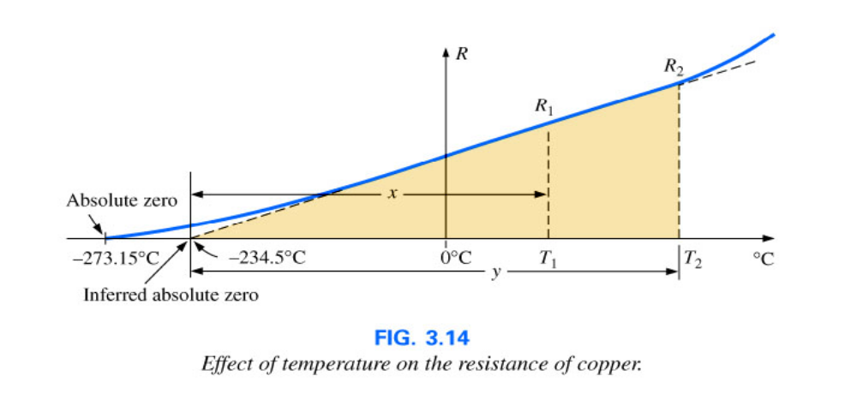
Let R₀ be the resistance at 0 C°
Let R_{t} be the resistance at t C°
ΔR = R_{t} - R₀ ……...…………5
ΔR ∝ R _{O}. t …….………….6
ΔR = ∝ ₀ R _{O}. t …………………7
∝ ₀ is constant called temperature coefficient at 0C°
From 5 and 7 we get:
R_{t} - R₀= ∝ ₀ R ₀. t
R_{t} = R₀ ( 1+ ∝ ₀ t)
…………..8
R_{t} = R₀ ( 1+ ∝ ₀ t) ……………….

Temperature coefficient at different temperatures:Temperature coefficient changes when
temperature changes using the following formula
∝ ₀
∝ _{t} = _________________ ……………..9
1 + ∝ ₀ t
Resistor at two different temperatures
Let R1 be the resistance at t₁ C°
Let R2 be the resistance at t₂ C°
R₁ = R₀(1+ ∝ ₀ t₁) ……...…………10
R₂ = R₀(1+ ∝ ₀ t₂) …….………,,….11

R₁ R₀(1+ ∝ ₀ t₁)
12 …………………… ــــــــــــــــــــــــ = ـــــــ
R₂ R₀(1+ ∝ ₀ t₂)

R₁ R₀(1+ ∝ ₀ t₁)
…………………13 ــــــــــــــــــــــــــــــــ ------ = ـــــــــــــ
R₂ R₀(1+ ∝ ₀ t₂)

Definitions:
Resistance( R ) : The ability of conductors to oppose the flow of electric current is known as resistance, measured in ohm Ω
Conductance(G):
it’s the The ability of conductors to allow the flow of electric current, it is reciprocal of resistance R, Measured by mho( U )
G= 1/R
Resistivity (ρ): it’s the property of conductors for resistance .
Measured by ohm meter (Ω.m)
Conductivity(σ): It’s the property of conductors for conduction . It’s reciprocal of resistivity(ρ) , measured by U /m
Example1:
A Resistor 36Ω at 20 C°, changed to 40 Ω at 50 C°, calculate the following:-
1- temperature coefficient at 0 C° ,
2- temperature coefficient at 100 C°,
3- resistor at 0 C°?
R₁= 36Ω, R ₂ = 40 Ω ,t₁= 20 C° , t₂= 50C°
R₁ R₀(1+ ∝ 0 t1)
ــــــــــــــــــــــــــــ = ـــــــ
R₂ R₀(1+ ∝ ₀ t₂)

36 (1+ ∝ ₀x 20)
ـــــــــــــــــــــــــــــــــــــــــ = ـــــــــــــ
40 (1+ ∝ ₀x 50)
∝ ₀ = 0.0065 1/ C°
∝₁₀₀ = 0.0038 1/ C°
R₀ = R₁/(1+ ∝ ₀ t₁)= R₂/(1+ ∝ ₀ t₂)
= 36/(1+0.0065x20) =31.8 Ω
Example2:If a resistor is 36Ω at 0C° find its value a 50 C° if the temperature coefficient is
2.22x10⁻³ 1/C°,
R₀ = 36 Ω, ∝₀ = 2.22x10-3 1/ 0C° , t = 50 C° ,R_{t} = R₂₀ = ?
R_{t} = R₀ ( 1+ ∝ ₀ t)
R₂₀ = 36(1+ 2.22x10⁻³ x 50)
R₂₀ = 40 Ω
Example3: If the temperature coefficient of resistor is 0.005 1/C° at 0 C° find temperature coefficient 20C°:
t=20 C° , ∝ ₀ = 0.005 1/C° , ∝ ₂₀ = ?
∝ _{t} = ∝ ₀ /(1+ ∝ 0 t), ∝ ₂₀ = ∝ ₀ /(1+ 0.005x 20) =0.0045 1/ C°
Ohms law
The ratio of voltage V and current I in a closed circuit is constant called resistance R.
V=I R , I = V/R , R = V/I
V
V: is the potential difference
R
R
(voltage) in volts
I : Current in amperes (A)
R : resistance in ohm Ω
I

From Ohm’s Law we get

:
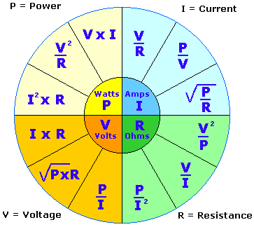

Series connection of resistors: Two elements are in series if their currents are same.
R₂
R₁
Series
R₂
R₁
Not Series
Parallel connection :Two resistors are in parallel if they are (share) the same voltage.
Not Parallel
Parallel
R₁

R₂
R₁
R₂

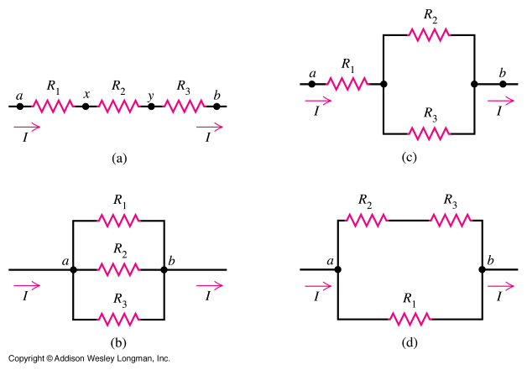
Series connection
V_{t} = V₁ +V₂ +V₃
IR_{t} = IR₁+IR₂+IR₃
IR_{t} = I( R₁ + R₂ + R₃)
R_{t} = ( R₁ + R₂ + R₃)

Parallel
I_{t} = I₁ +I₂ +I₃
V/R_{t} = V/R₁+V/R₂+V/R₃
V/R_{t} =V(1/R₁+1/R₂+1/R₃)
1/R_{t} = 1/ R₁ + 1/R₂ +1/ R₃
Parallel connection
Series connection
Y to Δ Transformation
- There are TWO type of transformations which are Delta (Δ) to star connection (Υ) and vice versa

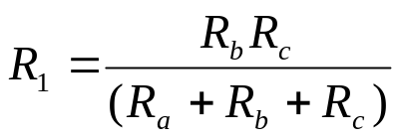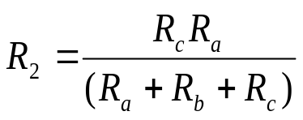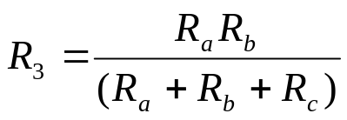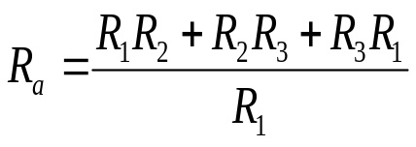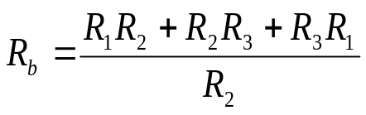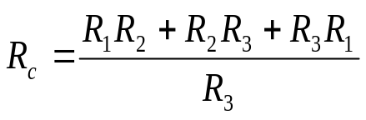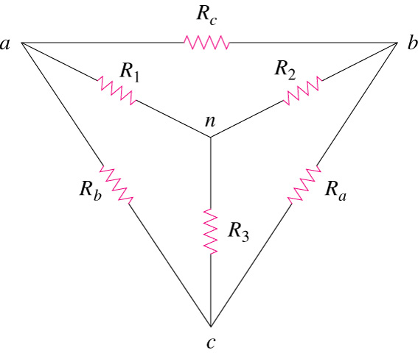
star-Delta Transformations& star-Delta Transformations:
Delta -> Star
Star -> Delta

Example: transform three delta connected resistors 6, 12, 18 Ω to star

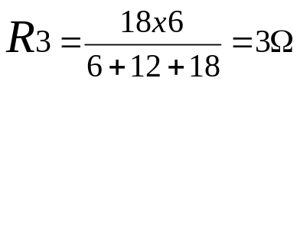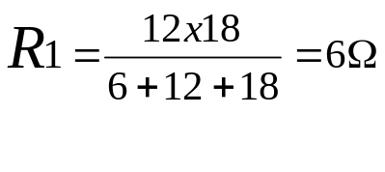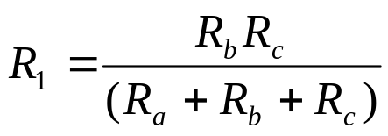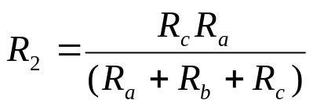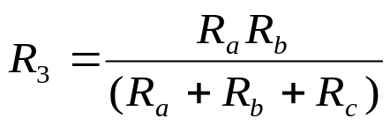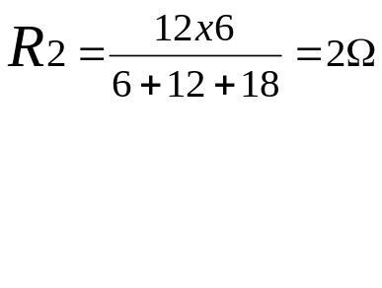
12Ω
18Ω
6Ω

xample: transform three star connected resistors 2,3,6Ω to delta
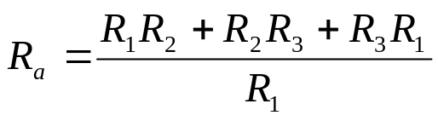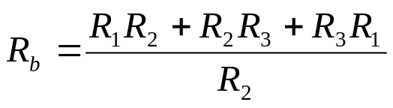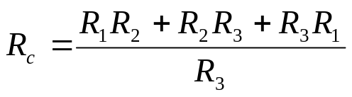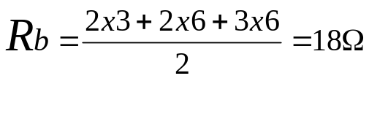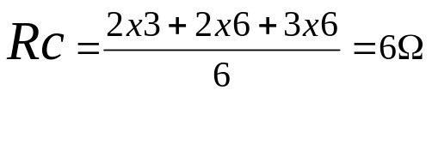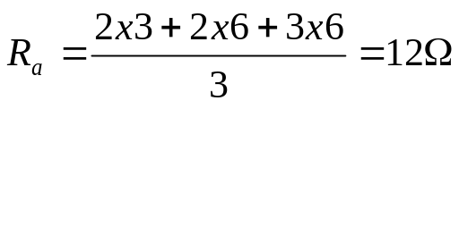
3Ω
2Ω
6Ω

Type of sources
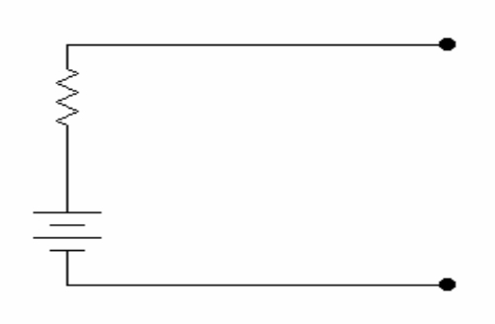
R_{S}
انواع المصادر
مصدرفولتيه
1- Voltage sources:
It is composed of:
a - Voltage of the source V_{S}
V_{S}
b- Internal resistance R_{S} in series
مصدرتيار
2-current source :
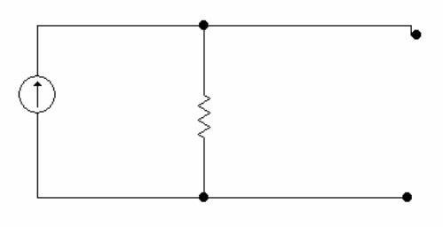
It is composed of:
a- Current of the source I_{S}
R_{S}
I_{S}
b- Internal resistance R_{S} in parallel.

تحويل(تبديل)المصادر
Source transformation :

I
s

R
s

V

+

_

I
Load
+

_

V
S

R
S

V

+

_

I

Load
R_{L}
R_{L}
I = I_{S} R_{S}/(Rs+R_{L}) I = V_{S} / (Rs+R_{L})
Condition for source transformation is I is same:
Vs/(R_{S}+R_{L}) = I_{S} *R_{S} / (R_{S}+R_{L}) OR V_{S} = I_{S}R_{S}
Maximum power transfer:
نقل اعظم قدره للحمل
+

_

V
S

R
S

V

+

_

I

Load
I = Vs/(Rs+R_{L}) , P=I² R_{L}= [Vs/(Rs+R_{L})]² R_{L ,} for maximum power dP/dR_{L}= 0
dP Vs R_{L}*2(Rs+R_{L}) – (Rs+R_{L})²* Vs
=
=
0.
.
dR_{L} (Rs+R_{L})⁴
(Rs+R_{L})⁴ ≠ 0. Result will be infinity (unknown)
Vs R_{L}*2(Rs+R_{L}) – (Rs+R_{L})²* Vs = 0. we get
R_{S}=R_{L}
Condition of maximum power external resistance R_{L} = internal resistance R_{S}
للحصول على اعظم قدره يجب ان تتساوى كل من المقاومة الخارجية R_{L} و المقاومة الداخليه R_{S}

example1:
For the circuit use source transformation to change: 1- current to voltage 2- voltage to current
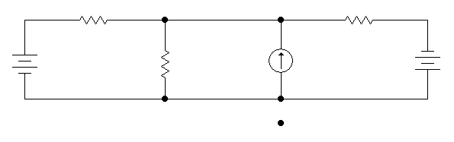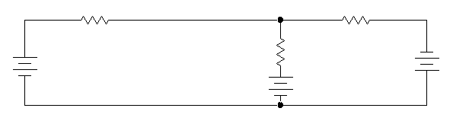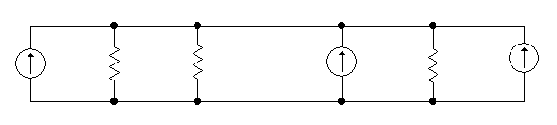
2Ω
6Ω
3Ω
12V
24V
3A
12V
24V
6Ω
2Ω
18V
6A
2Ω
6Ω
3A
8A
3Ω
3Ω
1-current to voltage Vs = Is Rs = 3x6 = 18V
2-voltages to current source Is₁ = Vs /Rs = 12/2=6A,Is₂ = 24/3=8A
example2:
For the circuit find R_{S} for maximum power transfer if the load resistance is
A: 2Ω B : 3Ω C: 6Ω
Answer:
A: making all sources inoperative (voltage sources short circuit current sources open circuit)
then we remove 2 Ω from any circuit R_{S} is=total resistance between 2 Ω
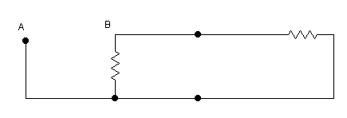
6Ω
3Ω
A- R_{S} =( 3x6) /(3+6) = 3 Ω
B: making all sources inoperative (voltage sources short circuit current sources open circuit)
then we remove 2 Ω from any circuit R_{S} is=total resistance between 2
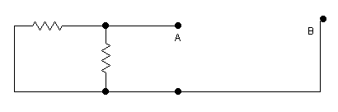
6Ω
2Ω
B- R_{S} =( 2x6) /(2+6) = 3/2= 1.5 Ω
C making all sources inoperative (voltage sources short circuit current sources open circuit)
then we remove 2 Ω from any circuit R_{S} is=total resistance between 2
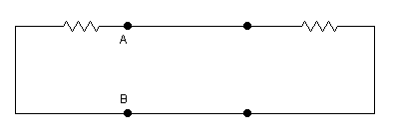
2Ω
2Ω
C- R_{S} =( 2x3) /(3+2) = 6/5=1.2 Ω

