Project Name: Twilio

Manouchehr Azizi(5232287)

I have compiled and assessed this project consist of one solution and 8 project and it has enough commit and collaborator And I will do my best to collaborate core team members and I will try to fix the bugs.

<Signatures of project members>: Manouchehr Azizi

# Project Description

Twilio provides a simple HTTP-based API for sending and receiving phone calls and text messages.the License of project is “Apache License 2.0”. This project consists of one Solution and 8 projects. In last month 20 programmers contribute on this project (in following charts you can see commits and contributors). In this project many web service techniques and tools such as Twilio REST API and TwiML Libraries for .NET, ASP.NET, ASP.NET MVC and WebMatrix are Employed. In some days that I was trying to run this project on my machine I get familiars with some new techniques like “Easy installation using [NuGet](http://nuget.org/packages/RestSharp)” ...

In this way Towilio interested me to know more about these techniques which is employed to meet its targets. Also I have an eye to collaboration between team members who looks are very technical. REST web service which is hired in this project is another reason for choosing Twilio as term project. Following is some chart about contributors and commits:

### Twilio License: Apache License 2.0

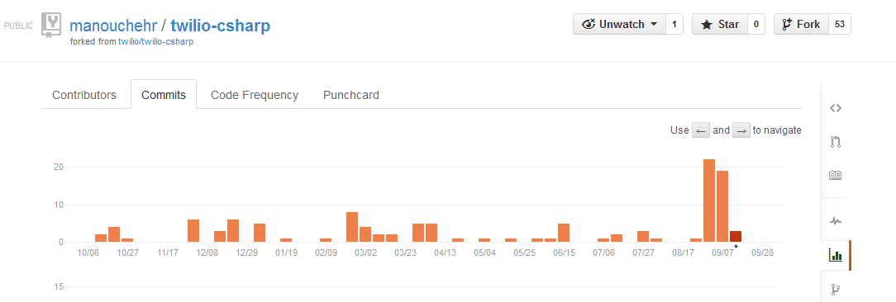

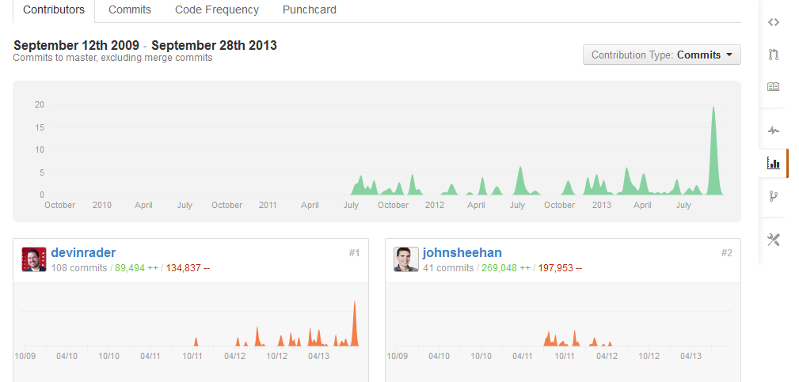

# Project Size and Scope

Twillio has 232 commits, 14 releases and 53 forks. Following image shows Solution and its 8 project metrics which is prepared with MS visual studio tools:

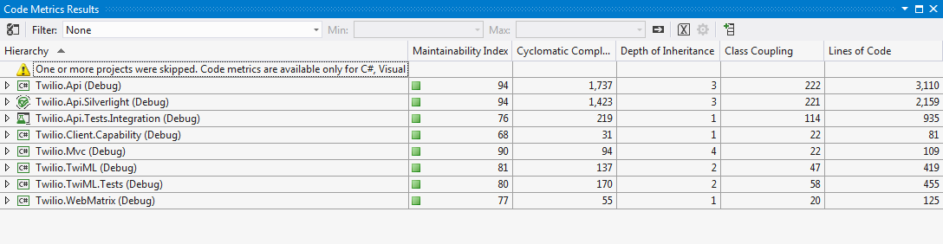

Actually choosing a project that in one side, one person can work on it and in other side also has enough commits and contributors to make it proper to this course, is difficult. Then I decided to take a risk and with choosing this project I have an opportunity to collaborate with a mature team and getting familiar with haired technique in this project.

# Bugs

From following link of Twilio’s issue in Github :

<https://github.com/twilio/twilio-csharp/issues>

Considering my Experience in soap service and familiarity with REST service I will try to solve the bug that is related to [***Twilio REST API Documentation***](http://www.twilio.com/docs/api/rest) ***such as:***

#### [RestSharp 104.2 has broken how TwilioRestClient deserializes RestExceptions](https://github.com/twilio/twilio-csharp/issues/96)

Email of contact with core developers is forwarded to you. And also I put one copy in GitHub.

# Group Members

As you know my name is Manouchehr Azizi and for this course I am working alone on this project and I have 3 years experience of work in Canada in .NET market that related to web services. And also I have some years experience of work on .net in my country before I move to Canada. I have familiarity with Web Services and MVVM pattern (Microsoft famous pattern in Silverlight). And I had some project in java as a course projects. Also I passed a course about soap services and REST services in this reason I selected TWilio REST API for work on it.