# Milestone 1

1) Name of the project:

Abot C# Web Crawler

## 2) The activity (how many commits per month, bugs)

This project which is commenced from last month has 2 contributors and 2 commit.

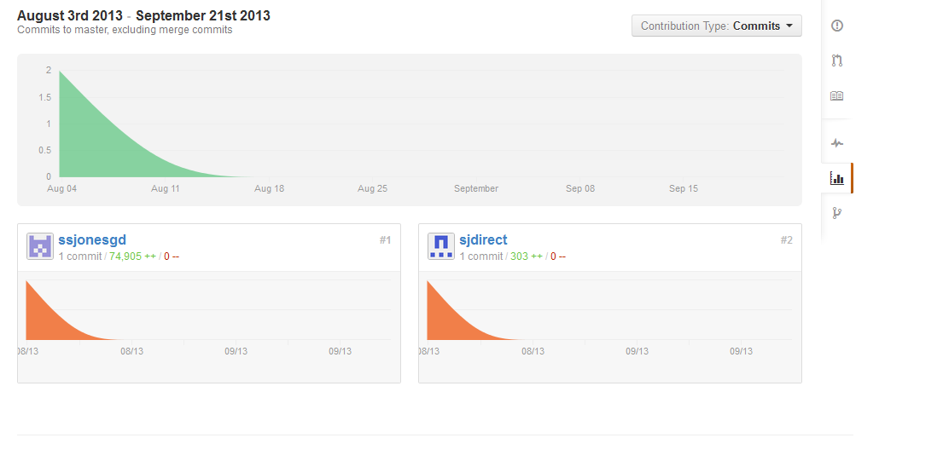

## 3) The size, how many lines of code

Use David Wheeler's SLOCcount program or do a Google search, for example, “tools to count Java lines of code LOC.”

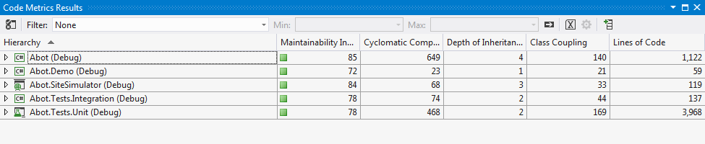

## 4) A starter bug

I will start with following issue:

|  |  |
| --- | --- |
| Issue [110](http://code.google.com/p/abot/issues/detail?id=110): | Seperate http web requests and processing onto seperate threads |