## My email to core developers before start

|  |  |
| --- | --- |
| from: | man az <man67az@gmail.com> |
| to: | devin@twilio.com,  johnsheehan@gmail.com,  matthew@mercuryit.co.uk |
| cc: | Peter Rigby <peter.rigby@concordia.ca> |
| date: | Tue, Oct 1, 2013 at 12:53 AM |
| subject: | bugs or features |
| mailed-by: | gmail.com |

On Tue, Oct 1, 2013 at 12:53 AM, man az <[man67az@gmail.com](mailto:man67az@gmail.com)> wrote:

HI,  
  
I am master computer science students who is required to fix a bug and/or implement a feature in an OSS project. I have some years of experience in .net programing and MVVM pattern in Silverlight. Is there any small bugs or features that you feel I would be able to implement. I have looked over your documentation and system architecture, I am considering the bugs or features like:

[**TwilioRestClient.SendMessage returns SmsSid and SmsStatus instead of MessageSid and MessageStatus**](https://github.com/twilio/twilio-csharp/issues/92)

Which are related To Rest.  
Can you provide me with any information that you think may be helpful to me?

Sincerely,

Manouchehr

1. Devin’s Answer

## Devin Rader’s (core developer) answer

|  |  |
| --- | --- |
| from: | Devin Rader <devin@twilio.com> |
| to: | man az <man67az@gmail.com> |
| date: | Thu, Oct 3, 2013 at 11:25 AM |
| subject: | Re: bugs or features |
| mailed-by: | twilio.com |
| https://mail.google.com/mail/images/cleardot.gif: | Important mainly because of the people in the conversation. |

We gladly accept pull requests, so your always welcome to fork the project and fix issues.

Devin

## My Pull request

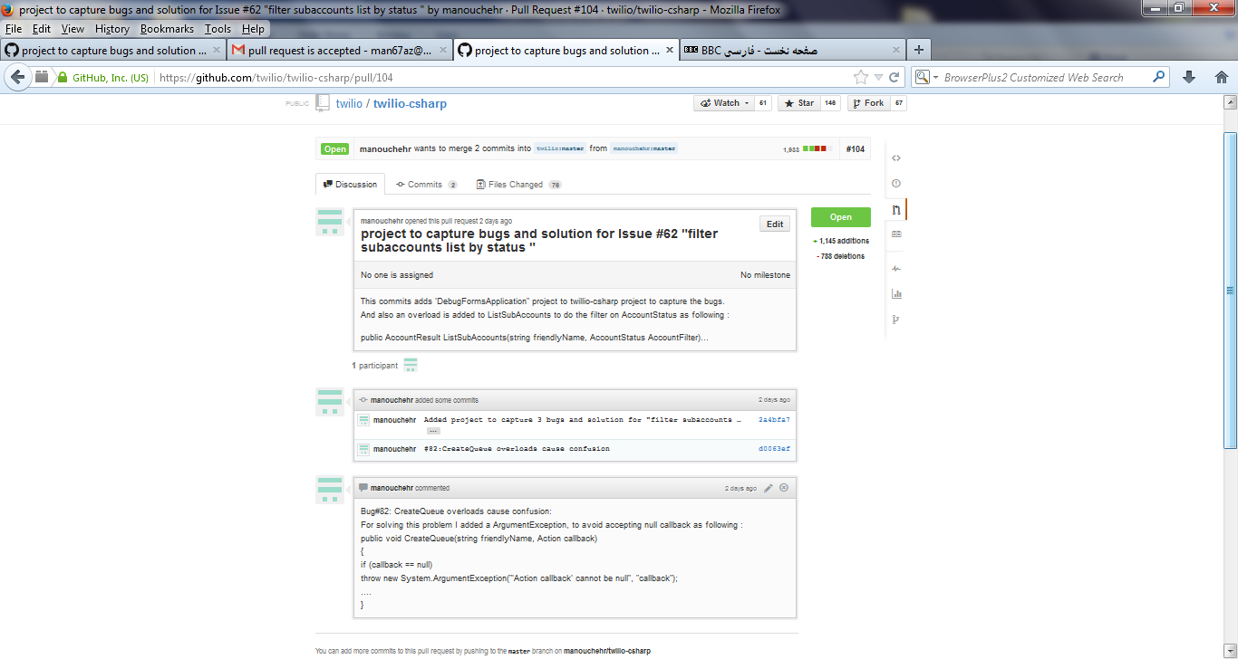

## Pull request Acceptance in Twilio-Csharp website

