Project Name: **Twilio-Csharp**

Manouchehr Azizi(5232287)

# Background on OSS Project

## The history and motivation behind the project

**Twilio** is a [cloud communications](http://en.wikipedia.org/wiki/Cloud_communications) ([IaaS](http://en.wikipedia.org/wiki/Infrastructure_as_a_service" \o "Infrastructure as a service)) company based in [San Francisco](http://en.wikipedia.org/wiki/San_Francisco), [California](http://en.wikipedia.org/wiki/California). Twilio allows [software developers](http://en.wikipedia.org/wiki/Software_developers) to programmatically make and receive [phone calls](http://en.wikipedia.org/wiki/Telephone_call) and send and receive [text messages](http://en.wikipedia.org/wiki/Text_message) using its [web service](http://en.wikipedia.org/wiki/Web_service) [APIs](http://en.wikipedia.org/wiki/Api). Twilio's services are accessed over [HTTP](http://en.wikipedia.org/wiki/HTTP) and are billed based on usage.

As of October 2012, more than 150,000 developers use the service.[[1]](http://en.wikipedia.org/wiki/Twilio#cite_note-1)

Twilio was founded in 2007 by Jeff Lawson, Evan Cooke, and John Wolthuis[[2]](http://en.wikipedia.org/wiki/Twilio" \l "cite_note-Twilio_Raises_.243.7_Million_For_Powerful_Telephony_API-2) and was originally based in both [Seattle, Washington](http://en.wikipedia.org/wiki/Seattle,_Washington) and [San Francisco](http://en.wikipedia.org/wiki/San_Francisco), [California](http://en.wikipedia.org/wiki/California).[3] Twilio uses [Amazon Web Services](http://en.wikipedia.org/wiki/Amazon_Web_Services) to host telephony infrastructure and provide connectivity between [HTTP](http://en.wikipedia.org/wiki/HTTP) and the [public switched telephone network](http://en.wikipedia.org/wiki/Public_switched_telephone_network) (PSTN) through its APIs.[[18]](http://en.wikipedia.org/wiki/Twilio#cite_note-Why_Amazon_Will_Make_or_Break_Twilio-18)

Twilio has raised approximately US$33 million in [venture capital](http://en.wikipedia.org/wiki/Venture_capital) growth funding. Twilio received its first round of seed funding in March 2009 for an undisclosed amount, rumored to be around $250,000,[[13]](http://en.wikipedia.org/wiki/Twilio#cite_note-Twilio_Crunchbase_Profile-13) from [Mitch Kapor](http://en.wikipedia.org/wiki/Mitch_Kapor), [The Founders Fund](http://en.wikipedia.org/wiki/The_Founders_Fund), [Dave McClure](http://en.wikipedia.org/wiki/Dave_McClure), David G. Cohen, [Chris Sacca](http://en.wikipedia.org/wiki/Chris_Sacca), Manu Kumar, and Jeff Fluhr.[[14]](http://en.wikipedia.org/wiki/Twilio#cite_note-TechCrunch_seed_round-14) Twilio's first A round of funding was led by Union Square Ventures for $3.7 million[[2]](http://en.wikipedia.org/wiki/Twilio#cite_note-Twilio_Raises_.243.7_Million_For_Powerful_Telephony_API-2) and its second B round of funding was for $12 million was led by [Bessemer Venture Partners](http://en.wikipedia.org/wiki/Bessemer_Venture_Partners).[[15]](http://en.wikipedia.org/wiki/Twilio#cite_note-Twilio_Raises_.2412_Million_For_Powerful_Telephony_API-15) Twilio received $17 million in a Series C round in December 2011 from Bessemer Venture Partners and Union Square Ventures.[[16]](http://en.wikipedia.org/wiki/Twilio#cite_note-Twilio_Raises_.2417M_Series_C_From_Bessemer_and_Union_Square_To_Expand_Abroad-16) In July 2013 Twilio received another $70 million from Redpoint Ventures, Draper Fisher Jurvetson (DFJ) and Bessemer Venture Partners [[17]](http://en.wikipedia.org/wiki/Twilio#cite_note-Twilio_Raises_A_.2470M_Series_D_As_They_Consider_An_IPO-17)

## Information on who uses the project and the domain

As of October 2012, more than 150,000 developers use the service.[[1]](http://en.wikipedia.org/wiki/Twilio#cite_note-1)

## Information on any interactions or relationships with other projects

Twilio supports the development of [open-source software](http://en.wikipedia.org/wiki/Open-source_software) and regularly makes contributions to the open source community. In June 2010 Twilio launched [OpenVBX](http://www.openvbx.org), an open source product that lets business users configure phone numbers to receive and route phone calls.[[20]](http://en.wikipedia.org/wiki/Twilio#cite_note-Twilio_Releases_OpenVBX.2C_An_Open_Source_Google_Voice_For_Businesses-20) One month later Twilio engineer Kyle Conroy released [Stashboard](http://www.stashboard.org), an open source status dashboard written in the [Python programming language](http://en.wikipedia.org/wiki/Python_%28programming_language%29) that any API or software service can use to display whether their service is functioning properly or not.[21]

Extend communication between applications and services by creating connectivity between Twilio and third party Seas applications, CRM solutions, phone trees, and more with the Anypoint Twilio connector from MuleSoft. Twilio is a cloud based service that enables powerful communication between mobile devices, applications, services, and systems throughout the business in order to bridge the gap between conventional communications. With Twilio, [sales](https://www.mulesoft.com/de/integration-solutions/sales), [marketing](https://www.mulesoft.com/de/integration-solutions/marketing), and services teams can be more mobile and easily connect to customers at any time, through various mobile platforms. The Anypoint Twilio connector offers instant Twilio API connectivity, providing users an easy way to interface with the Twilio API. With API connectivity to the Twilio’s REST API, users can send and receive voice or SMS messages through Twilio. For example, the Twilio connector enables ZenDesk connectivity, streamlining and simplifying integration between the two commonly linked services. Moreover, with MuleSoft’s Twilio connector, integration between Twilio and other popular business applications within the organization such as Salesforce, Marketo, Twitter and more - can be implemented quickly and easily from within the MuleSoft Anypoint™ Platform.

## Level of activity on the project

Twilio provides a simple HTTP-based API for sending and receiving phone calls and text messages. The License of project is “Apache License 2.0”. This project consists of one Solution and 8 projects.

Twilio-Csharp has 232 commits, 14 releases and 53 forks and In last month 20 programmers contribute on this project (in following charts you can see commits and contributors) that shows a growth of attention to this project in last month. In this project many web service techniques and tools such as Twilio-Csharp’s REST API and TwiML Libraries for .NET, ASP.NET, ASP.NET MVC and WebMatrix are employed. In some days that I was trying to run this project on my machine I get familiars with some new techniques like “Easy installation using [NuGet](http://nuget.org/packages/RestSharp)” ...

In this way Towilio interested me to know more about these techniques which is employed to meet its targets. Also I have an eye to collaboration between team members who looks are very technical. REST web service which is hired in this project is another reason for choosing Twilio-Csharp as my bug fixing project. And also growth of commits and contributors in last month made me curious to know about it. Following is some chart about contributors and commits that shows last month growth:

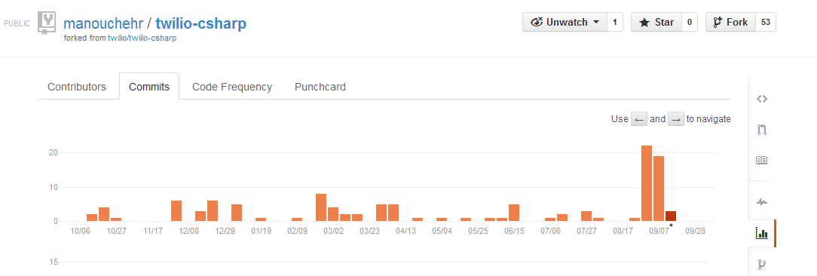

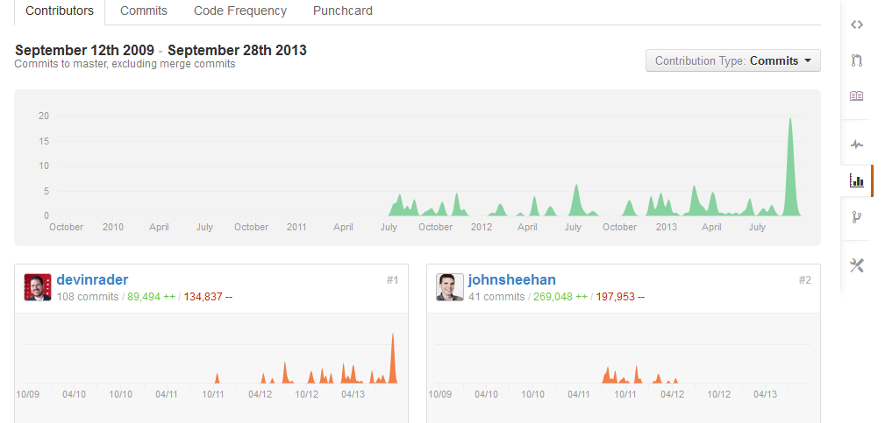

# Management and Process

## The project governance structure:

Twilio, the Communications API Platform, today expanded its offerings on Amazon Web Services (AWS) to address the growing cloud communications market.  As part of this, Twilio has joined the AWS Marketplace and will offer $20 in "Jump Start" credits to developers interested in tapping into the combined power of Twilio and AWS.  Twilio credits can be leveraged to build solutions such as in-application dialing, conference calling, group texting, mobile app distribution, two-factor authentication and more.

(Logo: <http://photos.prnewswire.com/prnh/20121016/SF94172LOGO>)

The Twilio platform is connected to carrier networks all over the globe and exposes those networks via a clean and powerful web API. AWS offers a complete set of infrastructure and application services that enable developers and enterprises to run virtually everything in the cloud. Harnessing the power of two of these platforms makes it easier for developers to communicate and create powerful applications with no upfront costs.

"Businesses of all types and sizes are moving their computing and communications infrastructure to the cloud. The combination of reliable, scalable infrastructure services along with Twilio's powerful communications infrastructure is further accelerating this trend," said Jeff Lawson, Twilio CEO.

"The solution that Twilio is offering on AWS jumpstarts the ability of developers and enterprises to better serve their customers by providing flexible cloud-based communications. With all the innovation in both the AWS and Twilio communities, we can't wait to see what developers will build."

## The projects source code management practices

Over the past twelve months, 9 developers contributed to [twilio-csharp](http://www.ohloh.net/p/twilio-csharp). This project has a relatively large team, in the top 10% of all project teams on Ohloh. For this measurement, Ohloh considers only recent changes to the code. Over the entire history of the project, [17 developers](http://www.ohloh.net/p/twilio-csharp/contributors) have contributed.

[twilio-csharp](http://www.ohloh.net/p/twilio-csharp) is written mostly in C#. Across all C# projects on Ohloh, 22% of all source code lines are comments. For twilio-csharp, this figure is 38%. This very impressive number of comments puts twilio-csharp among the top 10% of all C# projects on Ohloh. A high number of comments might indicate that the code is well-documented and organized, and could be a sign of a helpful and disciplined development team.

Over the last twelve months, [twilio-csharp](http://www.ohloh.net/p/twilio-csharp) has seen a substantial increase in activity. This may be a sign that interest in this project is rising, and that the open source community has embraced this project. Ohloh makes this determination by comparing the total number of commits made by all developers during the most recent twelve months with the same figure for the prior twelve months. The number of developers and total lines of code are not considered.

The first lines of source code were added to [twilio-csharp](http://www.ohloh.net/p/twilio-csharp) in 2009. If this older project has had recent activity, then this project likely is consistently delivering value, and attracts sustained effort from the community. A longer source control history in conjunction with recent activity such as with this project may indicate that this code base and community have enough value to hold contributors' interest for a long time. It may also indicate a mature and relatively bug-free code base, and can be a sign of an organized, dedicated development team.

The source code for twilio-csharp might actually be older than the source control history can reveal. Many new projects begin by incorporating a large amount of source code from existing, older projects. You might be able to tell whether this is the case by looking for a rapid rise in the amount of code early in the project's history.

## How review and bug tracking is handled

In this section for avoiding long Explanation and saving reader time I used some sequential images which explain all process steps. For bug fixing first I registered in Twilio to receive ACCOUNT SID and Twilio phone number and also I added one project to 8 existing project of Twilio and I NuGet Twilio in my project (i.e. To install Twilio api). Now project was ready to do following 4 steps for each bug:

1. Capture the bug: in this step I tried to make precondition to Reproduce the bugs
2. Finding root of issue: In this step I run the project and trace it to find the Twilio core’s root issue
3. Solution: In this step I implemented the solution to root causes
4. Commit : In this step I committed the patch that I made for solving bug

And after doing up steps it is the time of Pull request. Following images briefly Explain the steps:

1. **ACCOUNT SID and Twilio phone number**

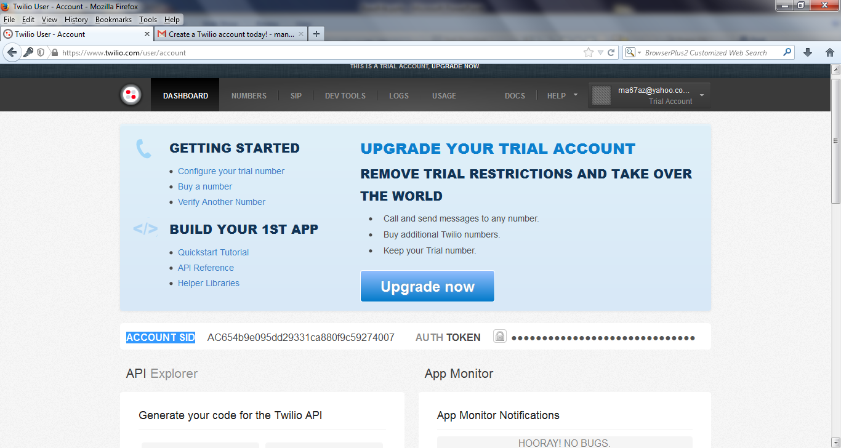

1. **Captured bug list**

**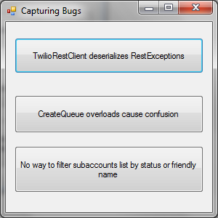**

1. **First Bug : capturing bug code**

**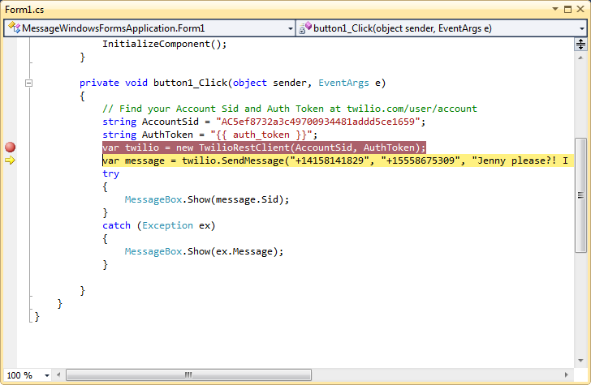**

1. **First Bug : Root causes in Twilio core**

**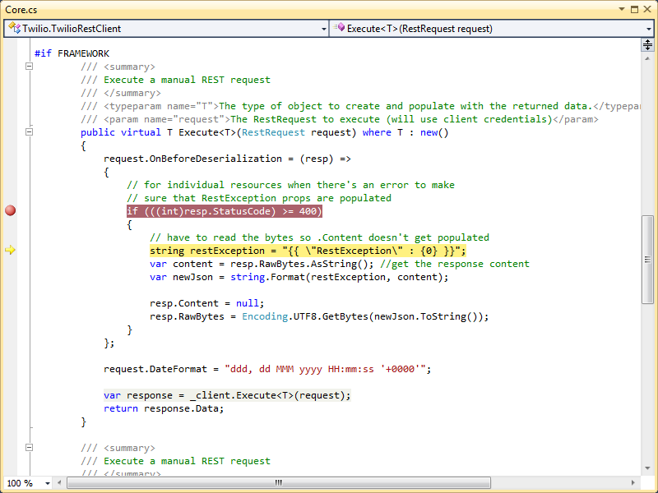**

1. **First Bug solutions : RestSharp’s Issue Reported by Devin Rader(Core developer)**

**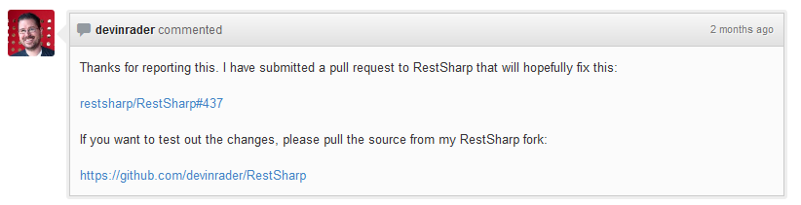**

1. **Second Bug : capturing bug code**

**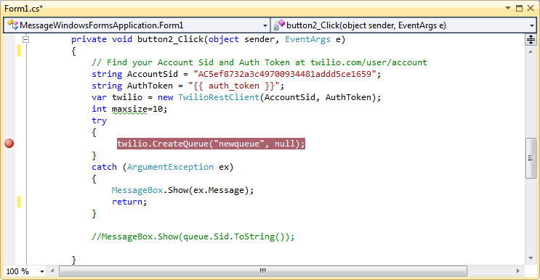**

1. **Second Bug : Root causes and solution in Twilio core**

**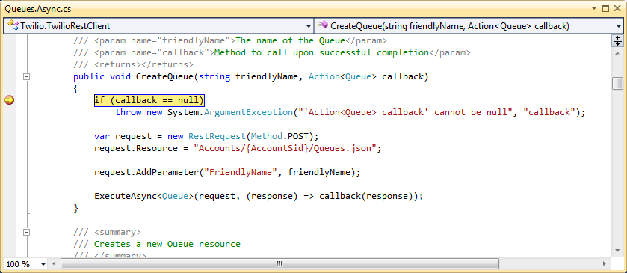**

1. **Third Bug : capturing bug code**

**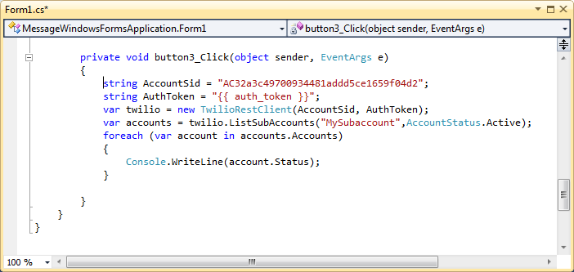**

1. **Third Bug : Root causes and solution in Twilio core**

**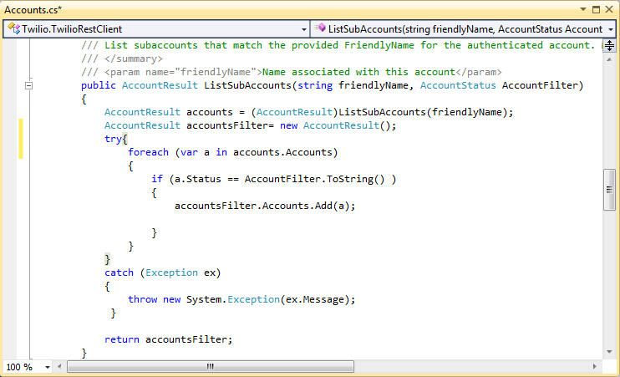**

1. **Pull Request**

**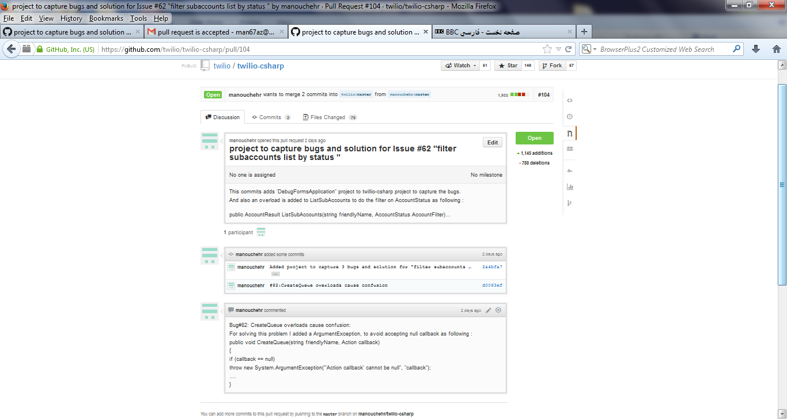**

1. **Pull request Acceptance in the Twilio site**

**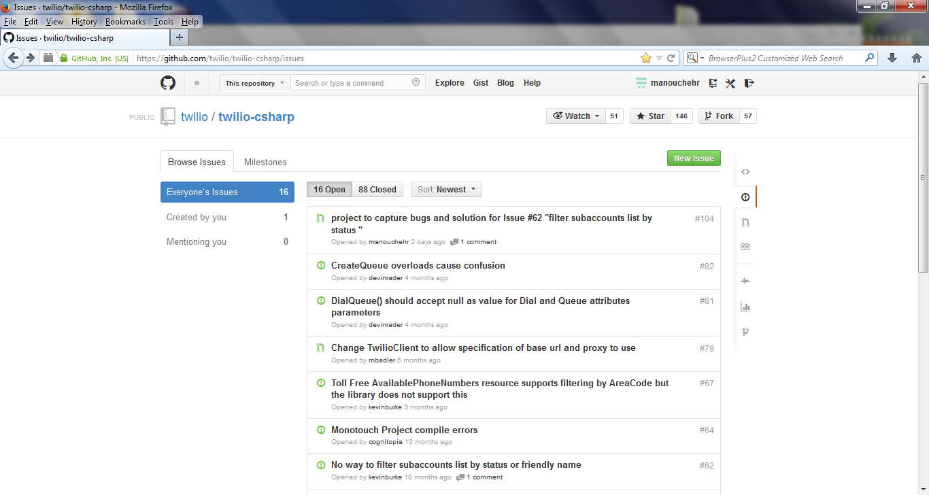**

## Legal and licensing information

This project hired the “Apache License 2.0” as following:

Apache License

Version 2.0, January 2004

http://www.apache.org/licenses/

TERMS AND CONDITIONS FOR USE, REPRODUCTION, AND DISTRIBUTION

1. Definitions.

"License" shall mean the terms and conditions for use, reproduction, and distribution as defined by Sections 1 through 9 of this document.

"Licensor" shall mean the copyright owner or entity authorized by the copyright owner that is granting the License.

"Legal Entity" shall mean the union of the acting entity and all other entities that control, are controlled by, or are under common control with that entity. For the purposes of this definition, "control" means (i) the power, direct or indirect, to cause the direction or management of such entity, whether by contract or otherwise, or (ii) ownership of fifty percent (50%) or more of the outstanding shares, or (iii) beneficial ownership of such entity.

"You" (or "Your") shall mean an individual or Legal Entity exercising permissions granted by this License.

"Source" form shall mean the preferred form for making modifications, including but not limited to software source code, documentation source, and configuration files.

"Object" form shall mean any form resulting from mechanical transformation or translation of a Source form, including but not limited to compiled object code, generated documentation, and conversions to other media types.

"Work" shall mean the work of authorship, whether in Source or Object form, made available under the License, as indicated by a copyright notice that is included in or attached to the work (an example is provided in the Appendix below).

"Derivative Works" shall mean any work, whether in Source or Object form, that is based on (or derived from) the Work and for which the editorial revisions, annotations, elaborations, or other modifications represent, as a whole, an original work of authorship. For the purposes of this License, Derivative Works shall not include works that remain separable from, or merely link (or bind by name) to the interfaces of, the Work and Derivative Works thereof.

"Contribution" shall mean any work of authorship, including the original version of the Work and any modifications or additions to that Work or Derivative Works thereof, that is intentionally submitted to Licensor for inclusion in the Work by the copyright owner or by an individual or Legal Entity authorized to submit on behalf of the copyright owner. For the purposes of this definition, "submitted" means any form of electronic, verbal, or written communication sent to the Licensor or its representatives, including but not limited to communication on electronic mailing lists, source code control systems, and issue tracking systems that are managed by, or on behalf of, the Licensor for the purpose of discussing and improving the Work, but excluding communication that is conspicuously marked or otherwise designated in writing by the copyright owner as "Not a Contribution."

"Contributor" shall mean Licensor and any individual or Legal Entity on behalf of whom a Contribution has been received by Licensor and subsequently incorporated within the Work.

2. Grant of Copyright License.

Subject to the terms and conditions of this License, each Contributor hereby grants to You a perpetual, worldwide, non-exclusive, no-charge, royalty-free, irrevocable copyright license to reproduce, prepare Derivative Works of, publicly display, publicly perform, sublicense, and distribute the Work and such Derivative Works in Source or Object form.

3. Grant of Patent License.

Subject to the terms and conditions of this License, each Contributor hereby grants to You a perpetual, worldwide, non-exclusive, no-charge, royalty-free, irrevocable (except as stated in this section) patent license to make, have made, use, offer to sell, sell, import, and otherwise transfer the Work, where such license applies only to those patent claims licensable by such Contributor that are necessarily infringed by their Contribution(s) alone or by combination of their Contribution(s) with the Work to which such Contribution(s) was submitted. If You institute patent litigation against any entity (including a cross-claim or counterclaim in a lawsuit) alleging that the Work or a Contribution incorporated within the Work constitutes direct or contributory patent infringement, then any patent licenses granted to You under this License for that Work shall terminate as of the date such litigation is filed.

4. Redistribution.

You may reproduce and distribute copies of the Work or Derivative Works thereof in any medium, with or without modifications, and in Source or Object form, provided that You meet the following conditions:

You must give any other recipients of the Work or Derivative Works a copy of this License; and

You must cause any modified files to carry prominent notices stating that You changed the files; and

You must retain, in the Source form of any Derivative Works that You distribute, all copyright, patent, trademark, and attribution notices from the Source form of the Work, excluding those notices that do not pertain to any part of the Derivative Works; and

If the Work includes a "NOTICE" text file as part of its distribution, then any Derivative Works that You distribute must include a readable copy of the attribution notices contained within such NOTICE file, excluding those notices that do not pertain to any part of the Derivative Works, in at least one of the following places: within a NOTICE text file distributed as part of the Derivative Works; within the Source form or documentation, if provided along with the Derivative Works; or, within a display generated by the Derivative Works, if and wherever such third-party notices normally appear. The contents of the NOTICE file are for informational purposes only and do not modify the License. You may add Your own attribution notices within Derivative Works that You distribute, alongside or as an addendum to the NOTICE text from the Work, provided that such additional attribution notices cannot be construed as modifying the License.

You may add Your own copyright statement to Your modifications and may provide additional or different license terms and conditions for use, reproduction, or distribution of Your modifications, or for any such Derivative Works as a whole, provided Your use, reproduction, and distribution of the Work otherwise complies with the conditions stated in this License.

5. Submission of Contributions.

Unless You explicitly state otherwise, any Contribution intentionally submitted for inclusion in the Work by You to the Licensor shall be under the terms and conditions of this License, without any additional terms or conditions. Notwithstanding the above, nothing herein shall supersede or modify the terms of any separate license agreement you may have executed with Licensor regarding such Contributions.

6. Trademarks.

This License does not grant permission to use the trade names, trademarks, service marks, or product names of the Licensor, except as required for reasonable and customary use in describing the origin of the Work and reproducing the content of the NOTICE file.

7. Disclaimer of Warranty.

Unless required by applicable law or agreed to in writing, Licensor provides the Work (and each Contributor provides its Contributions) on an "AS IS" BASIS, WITHOUT WARRANTIES OR CONDITIONS OF ANY KIND, either express or implied, including, without limitation, any warranties or conditions of TITLE, NON-INFRINGEMENT, MERCHANTABILITY, or FITNESS FOR A PARTICULAR PURPOSE. You are solely responsible for determining the appropriateness of using or redistributing the Work and assume any risks associated with Your exercise of permissions under this License.

8. Limitation of Liability.

In no event and under no legal theory, whether in tort (including negligence), contract, or otherwise, unless required by applicable law (such as deliberate and grossly negligent acts) or agreed to in writing, shall any Contributor be liable to You for damages, including any direct, indirect, special, incidental, or consequential damages of any character arising as a result of this License or out of the use or inability to use the Work (including but not limited to damages for loss of goodwill, work stoppage, computer failure or malfunction, or any and all other commercial damages or losses), even if such Contributor has been advised of the possibility of such damages.

9. Accepting Warranty or Additional Liability.

While redistributing the Work or Derivative Works thereof, you may choose to offer, and charge a fee for, acceptance of support, warranty, indemnity, or other liability obligations and/or rights consistent with this License. However, in accepting such obligations, You may act only on Your own behalf and on Your sole responsibility, not on behalf of any other Contributor, and only if You agree to indemnify, defend, and hold each Contributor harmless for any liability incurred by, or claims asserted against, such Contributor by reason of your accepting any such warranty or additional liability.

END OF TERMS AND CONDITIONS

## How releases are managed

Twilio is using Git as its Repository and as we know in Git there is no difference between branch and release. Because base on commits changes, Git computes a different hash for this commit and in this way commits are distinguishable.

The last release of Twilio-Csharp is 3.0 and migrating from version 2.1 or below to 3.0 will require changes to existing code. The library now centers around a TwilioRestClient class from which all operations you can make against the API are rooted. Refer to the [Twilio.Api](https://github.com/twilio/twilio-csharp/wiki/Twilio.Api) REST API wrapper documentation for the list of available methods.

Twilio also benefits of “NuGet package manager”. NuGet is a Visual Studio extension that makes it easy to install and update third-party libraries and tools in Visual Studio. In this way in installation time user can select proper version of Twilio-Csharp via “NuGet package manager”.