Project Name: **Twilio-Csharp**

Manouchehr Azizi(5232287)

# Background on OSS Project

## The history and motivation behind the project

Twilio starts to work in 2007 by Jeff Lawson, Evan Cooke, and John Wolthuis and used the Amazon web service to host telephony infrastructure. Twilio’s financial activity according to Wikipedia is US$33 million in venture capital growth funding, and an undisclosed amount, rumoured to be around $250,000 in 2009, $3.7 million by first round (Union Square), $12 million by second round (Bessemer Venture Partners), $17 million by third Round (Venture Partners and Union Square Ventures) and another $70 million from (Redpoint Ventures, Draper Fisher Jurvetson (DFJ) and Bessemer Venture Partners) in 2013.

## Information on who uses the project and the domain

According to Twilio web site, As of October 2012, more than 150,000 developers use the service. And it shows that well documented and compatibility of marketing needs how increase the usage of Twilio between developers.

## Information on any interactions or relationships with other projects

Twilio is an open source project which has a close communication with open source community such as open VBX (i.e. Lets business users configure phone numbers to receive and route phone calls), party Seas applications, CRM solutions, phone trees, and more with the Anypoint Twilio connector from MuleSoft. Twilio also has Stashboard that API or software service can use to display whether their service is functioning properly or not. Twilio’s cloud base service let to communication between mobile devices, applications, services, and systems to cover the gap between conventional communications. ZenDesk and MuleSoft are two connectors that lets connectivity, streamlining and simplifying integration between separate services and in result interactions or relationships with other projects facilitates.

## Level of activity on the project

Twilio provides a simple HTTP-based API for sending and receiving phone calls and text messages. The License of project is “Apache License 2.0”. This project consists of one Solution and 8 projects.

Twilio-Csharp has 232 commits, 14 releases and 53 forks and In last month 20 programmers contribute on this project (in following charts you can see commits and contributors) that shows a growth of attention to this project in last month. In this project many web service techniques and tools such as Twilio-Csharp’s REST API and TwiML Libraries for .NET, ASP.NET, ASP.NET MVC and WebMatrix are employed. In some days that I was trying to run this project on my machine I get familiars with some new techniques like “Easy installation using [NuGet](http://nuget.org/packages/RestSharp)” ...

In this way Towilio interested me to know more about these techniques which is employed to meet its targets. Also I have an eye to collaboration between team members who looks are very technical. REST web service which is hired in this project is another reason for choosing Twilio-Csharp as my bug fixing project. And also growth of commits and contributors in last month made me curious to know about it. Following is some chart about contributors and commits that shows last month growth:

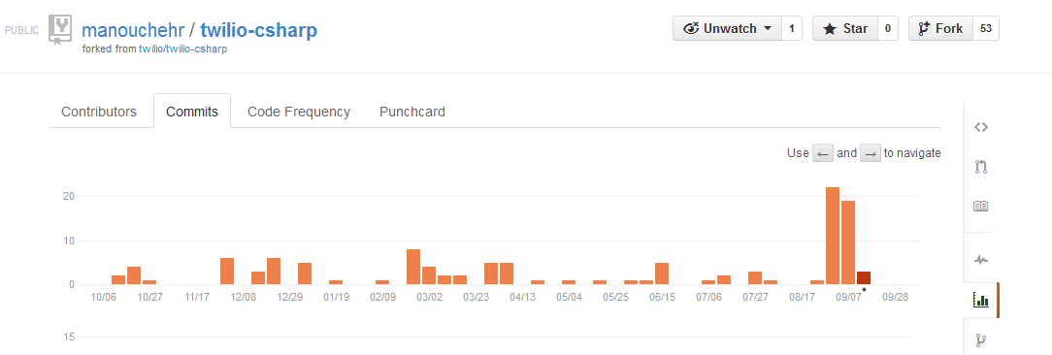

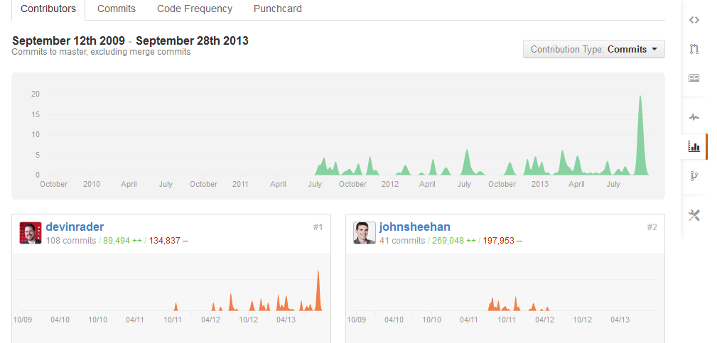

# Management and Process

## The project governance structure:

Twilio, is using Amazon Web Services (AWS) to address the growing cloud communications market. The importance of Communication between company and business made TWilio as a proper C omuication usage like: in-application dialing, conference calling, group texting, mobile app distribution, two-factor authentication and more. And also Twillio with using AWS that offers a complete set of infrastructure and application services that enable developers and enterprises to run virtually everything in the cloud (Just like Azure in mocrosoft). This advantages of service attracts all company and developers to communicate and use more and more Twillio.

## The projects source code management practices

The source code for twilio-csharp might actually be older than the source control history can reveal, but as you see in Twillio in Github, as it starts from July 2011 until now the contributors and commits are rapidly rise in the amount. According their document, twelve months, 9 developers contributed which is top 10% of all project teams on Ohloh. Twilio is written in C# as following code metrics and it has 38% of comments that is very impressive number of comments that indicate the code is well-documented and organized, and could be a sign of a helpful and disciplined development team. More than 150,000 developers use the service that is another sign of well documented and comprehension of this project.

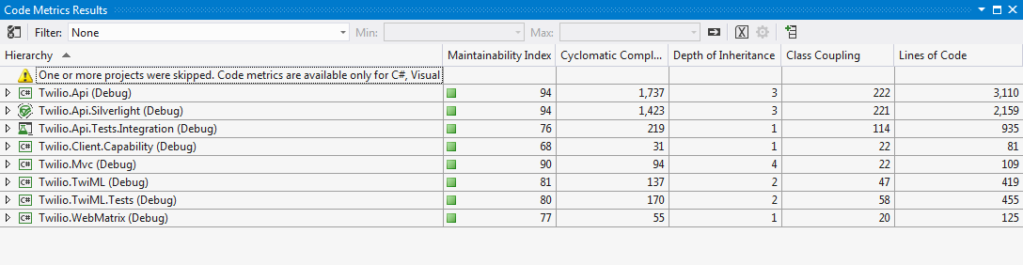

## How review and bug tracking is handled

In this section after a short discussion about the bugs for avoiding long Explanation and saving reader time I used some sequential images which explain all process steps.

**Bugs brief discussion:**

In this project I find 3 bugs to solve. The bug that I selected was from bug issue list in git because core developer control site very precisely and any unrelated or wrong concept is deleted. And when we see one issue in the web site that core developer comment on that the issue is serious and need to fix.

First one of bugs was related to serialization and deserialization that in java called marshal and unmarshal. And in serialization and deserialization they transfer outside file like xml to a class inside the code. Twillio is using Rest sharp to rest communicate and in RestSharp there was a problem and Devin Rader (one of core developer) Reported as a RestSharp bug.(Image 5)

Second bug was about createQueue that has two overload which has conflict when for second parameter we use Null (image 6). For resolving this bug I added on parameter checking and in case of null it generates an error (image 7).

Third bug was about lack of filtering of subacuntlist by status which was reported. I solve it by adding an overload which gets an additional parameter for status and filter the list depend on status parameter. “Image 9” shows the overload that I wrote.

After bug fixing I sent a pull request for Twillio that you see in “image 10”. And it takes one week that my pull request added in Twilio Issue list by Devin Rader (Image 11).

**Steps of bug fixing:**

For bug fixing first I registered in Twilio to receive ACCOUNT SID and Twilio phone number and also I added one project to 8 existing project of Twilio and I NuGet Twilio in my project (i.e. To install Twilio api). Now project was ready to do following 4 steps for each bug:

1. Capture the bug: in this step I tried to make precondition to Reproduce the bugs (image 2)
2. Finding root of issue: In this step I run the project and trace it to find the Twilio core’s root issue
3. Solution: In this step I implemented the solution to root causes
4. Commit : In this step I committed the patch that I made for solving bug

And after doing up steps it is the time of Pull request. Following images briefly explain the steps:

1. **ACCOUNT SID and Twilio phone number**

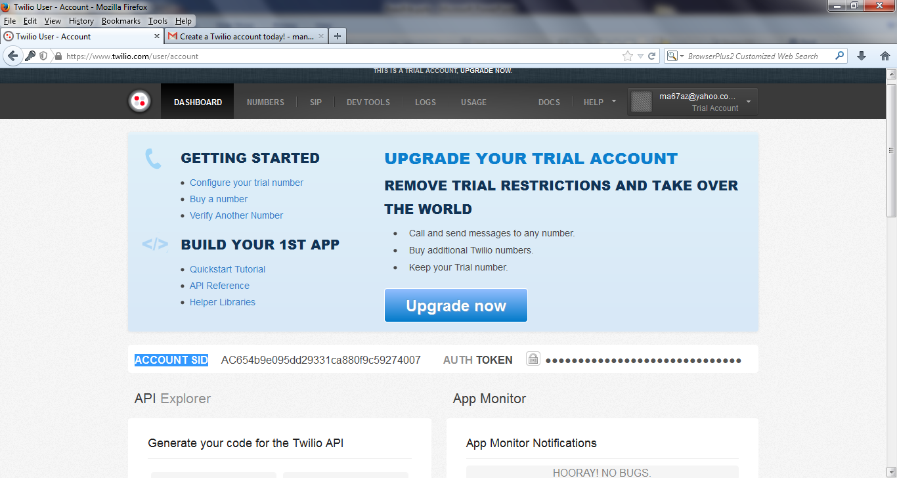

Image 1

1. **Captured bug list**

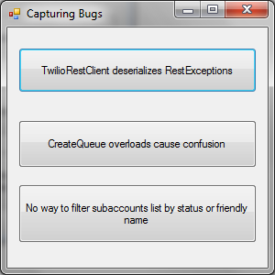

**Image 2**

1. **First Bug : capturing bug code**

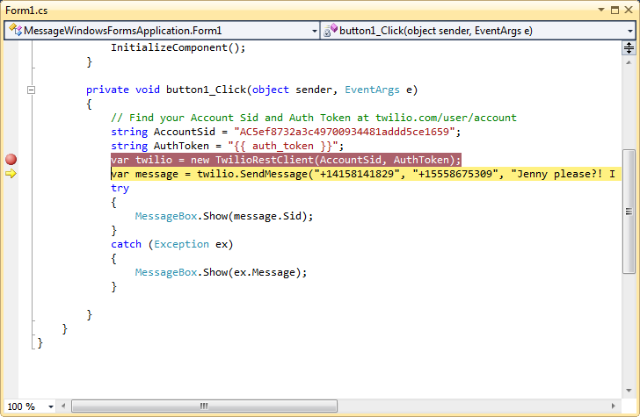

**Image 3**

1. **First Bug : Root causes in Twilio core**

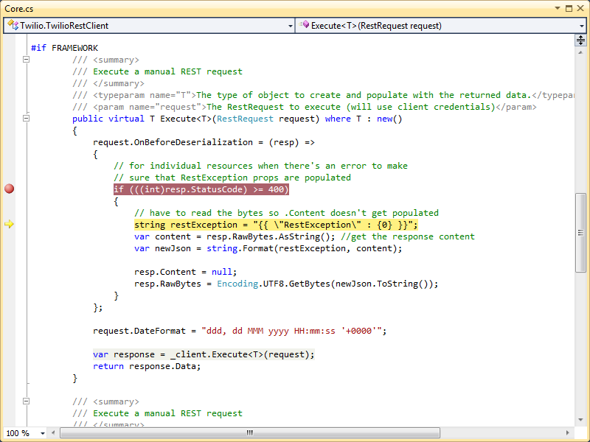

**Image 4**

1. **First Bug solutions : RestSharp’s Issue Reported by Devin Rader(Core developer)**

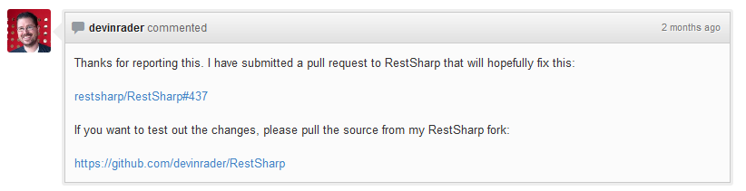

**Image 5**

1. **Second Bug : capturing bug code**

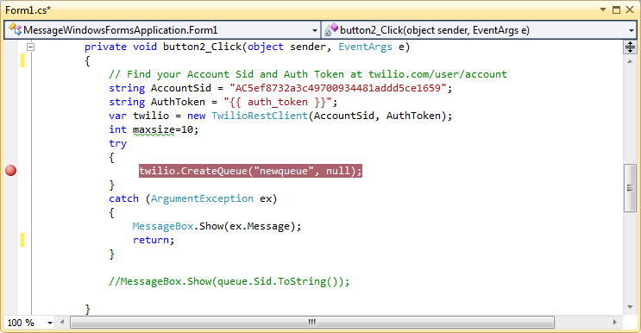

**Image 6**

1. **Second Bug : Root causes and solution in Twilio core**

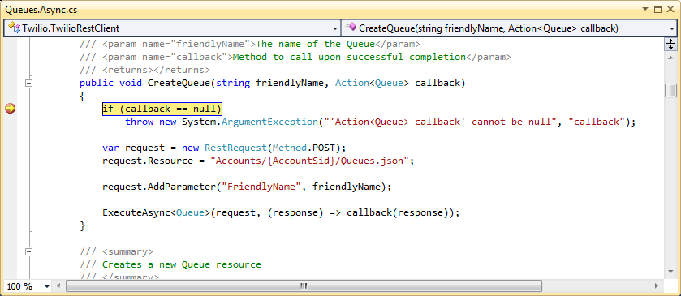

**Image 7**

1. **Third Bug : capturing bug code**

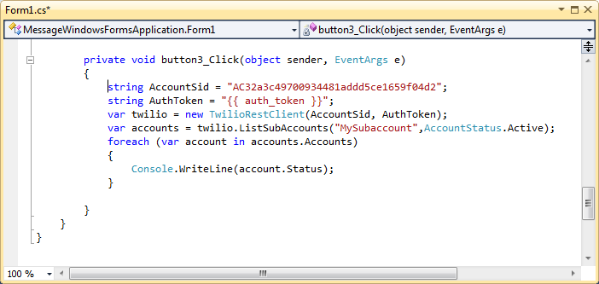

**Image 8**

1. **Third Bug : Root causes and solution in Twilio core**

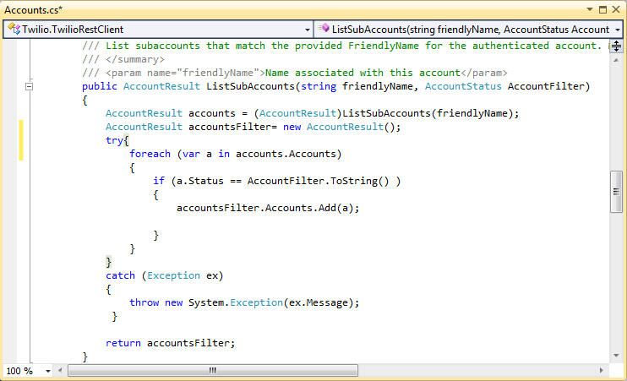

**Image 9**

1. **Pull Request**

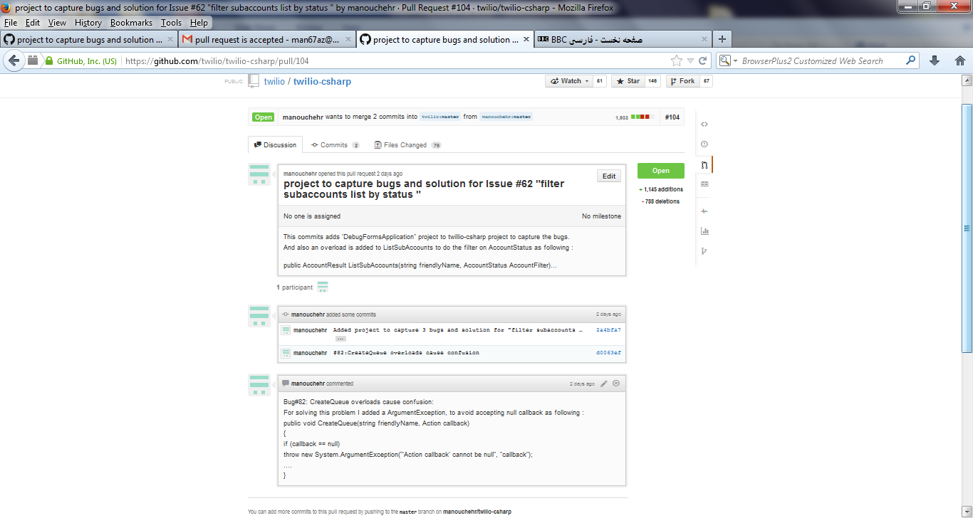

**Image10**

1. **Pull request Acceptance in the Twilio site**

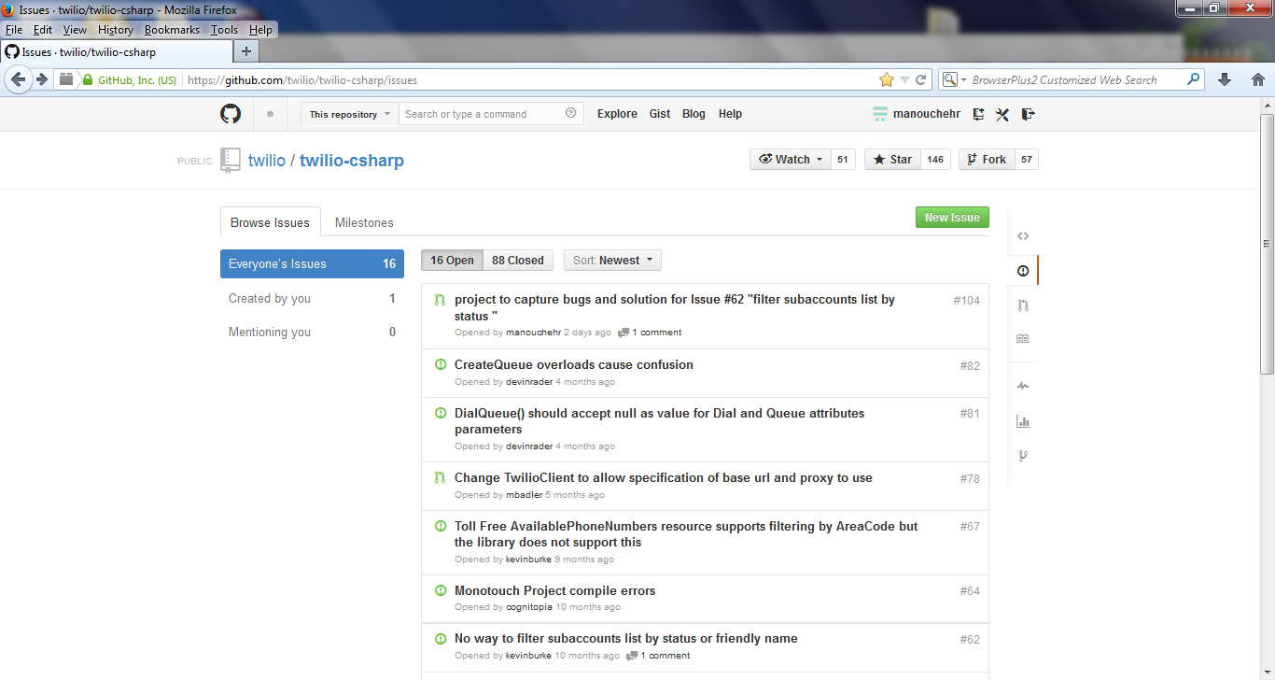

**Image 11**

## Legal and licensing information

This project hired the “Apache License 2.0” that you can find the complete text file in following link:

<https://github.com/twilio/twilio-csharp/blob/master/LICENSE.txt>

**Licence Discussion:**

According our discussed in class, Apache License 2.0 Approved by the Apache Foundation in Jan. 2004. And following attribute that we discussed in class you can see in this Licence items:

* It explicitly grants to the licensee
* A non-exclusive copyright license(Item 2)
* A non-exclusive patent license(Item 3)
* Explicitly states conditions for redistribution : mainly(Item 4)
* Include license and keep any notices
* State if you modified any files
* Any new contributions to the product are to be licensed in the same way(Item 5)
* No grant of trademark license(Item6)
* Disclaimer of warranty and limitation of liability(Item 7)
* Allows a third party to offer warranty and liability on the product(Item9)

In Addition, as we know this version of apache is compatible with GPL 3.and we can use them as a dual licence.

## How releases are managed

Twilio is using Git as its Repository and as we know in Git there is no difference between branch and release. Because base on commits changes, Git computes a different hash for this commit and in this way commits are distinguishable. The last release is 3.0 and migrating from version 2.1 or below to 3.0 will require changes to existing code.

Twilio also benefits of “NuGet package manager”. Visual studio explain nugget as following:

“NuGet is a Visual Studio extension that makes it easy to install and update third-party libraries and tools in Visual Studio.”

In this way in installation time user can select proper version of Twilio-Csharp via “NuGet package manager”.