# Milestone 1

1) Name of the project: Twilio

## 2) The activity (how many commits per month, bugs)

Twilio provides a simple HTTP-based API for sending and receiving phone calls and text messages. This project consists of one Solution and 8 projects. In last month 20 programmers contribute on this project (in following charts you can see commits and contributors).In this project many techniques and tools such as Twilio REST API and TwiML Libraries for .NET, ASP.NET, ASP.NET MVC and WebMatrix are Employed. In some days that I was trying to run this project on my machine I get familiars with some new techniques. In this way Towillio interested me to know more about these techniques which is employed to meet its targets. Also I have an eye to collaboration between team members who looks are very technical. Rest web service which is hired in this project is another reason for choosing Twilio for me.

As you know my name is Manouchehr Azizi and for this course I am working alone on this project and I have 3 years experience of work in Canada in .NET market. And also I have some years experience of work on .net in my country before I move to Canada. I have familiarity with Web Services and MVVM pattern (Microsoft famous pattern in Silverlight). And also I had some project in java as a course projects.

Project GitHub link:

https://github.com/manouchehr/twilio-csharp

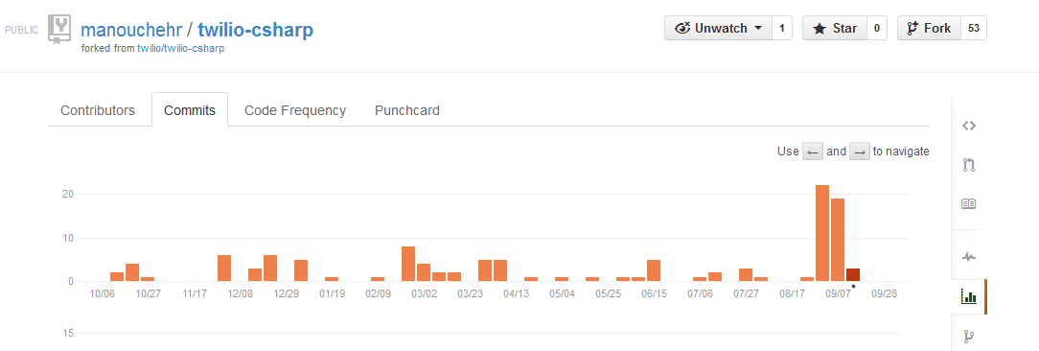

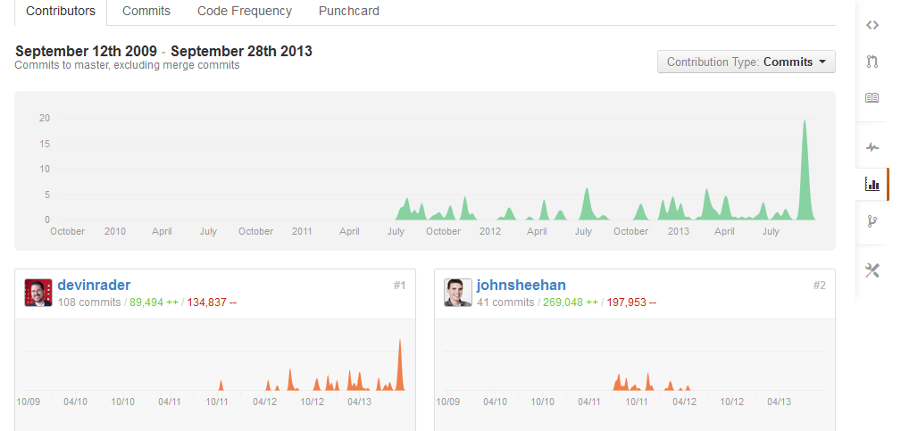

## 3) The size, how many lines of code

Twillio has 232 commits, 14 releases and 53 forks. Following image shows Solution and its 8 project metrics which is prepared with MS visual studio tools:

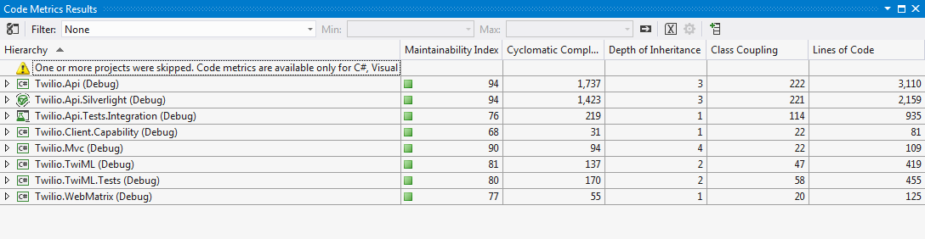

## 4) A starter bug

Actually I found fowling link Issue and I am contacting with Devinrader and Tonshehan, two of the most committers about these Issues:

https://github.com/twilio/twilio-csharp/issues