**FULL STACK WEB DESIGNER/DEVELOPER**

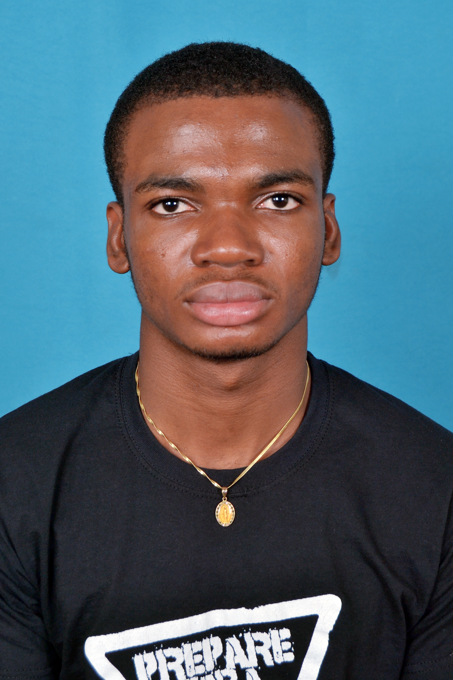

**DJESSOU**

**Bada Emmanuel Christian**

Ivorian

Born : 24/02/ 1995 in Abidjan

Single

Tel : (+86) 18758064731

[manourez@hotmail.](mailto:marcopolo371992@gmail.com)fr

Driving License : B

**LANGUAGES:**

* French : Mother tongue
* English : Good leved **(**language of studies)

**INTEREST:**

Sport, new technologies, travelling, music, reading.

**STRENGH AND CHARACTERISTICS :**

* Ready to work under pressure
* Ready to work in a team
* Can understand quickly

**SKILLS**

* WEB design : HTML , CSS , BOOTSTRAP , SEMANTIC UI
* WED development : Node.js, Javascript , Java EE, PHP, SQL, MongoDB
* Mobile development : Android(Xml, Java,SQLlite)
* Stand-alone and Runtime development : Java, C, Python, C++

**EDUCATION**

2017-Present: Master in Computer sciences and technology – *Zhejiang Gongshang University* (China)

2016-2017: Certification in Java, Web designing, PHP, JavaScript, Web development – *https://openclassrooms.com*

2013-2016: Bachelor of Computer Sciences in computer application - *Loyola Business school accredited to Bangalore University* (India)

2012-2013: Learning English at Alliance Francaise(Ghana)

2011-2012: Baccalauréat – *Collège Saint Viateur Abidjan* (Ivory Coast)

**PROJECTS AND EXPERIENCE**

2015 : Library Management System

2016 : Student Management System

2017-Present: Garage(A small app made with Java), Color Game, Todo List projects, Patatap Clone, YelpCamp …