AWS Client VPN
Complete Setup Guide from Scratch
Step-by-Step Documentation

1. Overview
AWS Client VPN is a managed client-based VPN service that enables users to securely access AWS resources and on-premises networks from any location. This guide walks through the complete setup process from certificate creation to connecting your first client.

Component | Description
Client VPN Endpoint | The VPN server managed by AWS
Certificate Authority (CA) | Root certificate to sign server/client certs
Server Certificate | Authenticates the VPN server to clients
Client Certificate | Authenticates clients to the VPN server
Target Network | The VPC subnet clients will access
Security Group | Controls traffic to/from VPN endpoint

2. Prerequisites

2.1 Required Tools
- AWS CLI installed and configured
- Easy-RSA installed (brew install easy-rsa on Mac)
- AWS Account with appropriate IAM permissions
- A VPC with at least one subnet

2.2 Required IAM Permissions
- acm:ImportCertificate
- ec2:CreateClientVpnEndpoint
- ec2:AssociateClientVpnTargetNetwork
- ec2:AuthorizeClientVpnIngress

3. Step 1: Generate Certificates (Mac)

3.1 Find Easy-RSA Path
brew --prefix easy-rsa
Output (Apple Silicon Mac):
/opt/homebrew/opt/easy-rsa

3.2 Add Easy-RSA to PATH
export PATH="/opt/homebrew/opt/easy-rsa/bin:$PATH"

3.3 Setup Easy-RSA Directory
mkdir -p ~/easy-rsa
cp -r /opt/homebrew/opt/easy-rsa/etc/easy-rsa/* ~/easy-rsa/
cd ~/easy-rsa

3.4 Initialize PKI
easyrsa init-pki
Expected output:
'init-pki' complete; you may now create a CA or requests.

3.5 Build Certificate Authority (CA)
easyrsa build-ca nopass
When prompted for Common Name, enter your domain:
Common Name: vpn.yourdomain.com

3.6 Create Server Certificate
easyrsa build-server-full vpn.yourdomain.com nopass

3.7 Create Client Certificate
easyrsa build-client-full client.vpn.yourdomain.com nopass

rm -rf pki
easyrsa init-pki\n
easyrsa build-ca nopass
easyrsa build-server-full server nopass
easyrsa build-client-full client nopass

3.8 Copy Certificates to Working Folder
mkdir -p ~/Downloads/vpn1-certs
cp /opt/homebrew/etc/easy-rsa/pki/ca.crt ~/Downloads/vpn1-certs/
cp /opt/homebrew/etc/easy-rsa/pki/issued/vpn.yourdomain.com.crt ~/Downloads/vpn1-certs/
cp /opt/homebrew/etc/easy-rsa/pki/private/vpn.yourdomain.com.key ~/Downloads/vpn1-certs/
cp /opt/homebrew/etc/easy-rsa/pki/issued/client.vpn.yourdomain.com.crt ~/Downloads/vpn1-certs/
cp /opt/homebrew/etc/easy-rsa/pki/private/client.vpn.yourdomain.com.key ~/Downloads/vpn1-certs/

⚠️ Replace yourdomain.com with your actual domain name throughout all commands.

4. Step 2: Import Certificates to AWS ACM

4.1 Import Server Certificate
aws acm import-certificate \
--certificate fileb://~/Downloads/vpn1-certs/vpn.yourdomain.com.crt \
--private-key fileb://~/Downloads/vpn1-certs/vpn.yourdomain.com.key \
--certificate-chain fileb://~/Downloads/vpn1-certs/ca.crt \
--region us-east-1

4.2 Import Client Certificate
aws acm import-certificate \
--certificate fileb://~/Downloads/vpn1-certs/client.vpn.yourdomain.com.crt \
--private-key fileb://~/Downloads/vpn1-certs/client.vpn.yourdomain.com.key \
--certificate-chain fileb://~/Downloads/vpn1-certs/ca.crt \
--region us-east-1

4.3 Verify Certificates in ACM
aws acm list-certificates \
--region us-east-1 \
--query 'CertificateSummaryList[*].[DomainName,CertificateArn]' \
--output table

⚠️ Copy the Certificate ARNs — you will need them in the next step.

5. Step 3: Create Security Groups

5.1 VPN Security Group

Direction | Type | Protocol | Port | Source/Destination
Inbound | Custom UDP | UDP | 443 | 0.0.0.0/0
Inbound | Custom TCP | TCP | 443 | 0.0.0.0/0
Outbound | All traffic | All | All | 0.0.0.0/0

5.2 RDS Security Group (MySQL)

Direction | Type | Protocol | Port | Source
Inbound | MySQL/Aurora | TCP | 3306 | VPN Security Group ID
Outbound | All traffic | All | All | 0.0.0.0/0

5.3 Private EC2 Security Group

Direction | Type | Protocol | Port | Source
Inbound | SSH | TCP | 22 | VPN Security Group ID
Inbound | MySQL/Aurora | TCP | 3306 | VPN Security Group ID
Outbound | All traffic | All | All | 0.0.0.0/0

6. Step 4: Create Client VPN Endpoint

6.1 Via AWS Console
1. Go to AWS Console → VPC → Client VPN Endpoints
2. Click Create Client VPN Endpoint
3. Fill in the following details:

Field | Value
Name | my-client-vpn
Client IPv4 CIDR | 19.0.0.0/16
Server Certificate ARN | ARN from ACM (server cert)
Authentication type | Mutual authentication
Client Certificate ARN | ARN from ACM (client cert)
DNS Server | Your VPC DNS (e.g. 10.0.0.2)
Transport Protocol | UDP
VPN Port | 443
Full Tunnel | Enable (recommended)
DNS Config | 8.8.8.8  8.8.4.4

⚠️ Client CIDR (10.0.0.0/22) must NOT overlap with your VPC CIDR range.

7. Step 5: Associate Target Network
1. Go to your Client VPN Endpoint
2. Click Target Network Associations tab
3. Click Associate Target Network
4. Select your VPC and subnet

7.1 Via AWS CLI
aws ec2 associate-client-vpn-target-network \
--client-vpn-endpoint-id cvpn-endpoint-xxxxxxxxx \
--subnet-id subnet-xxxxxxxxx \
--region us-east-1

8. Step 6: Add Authorization Rule

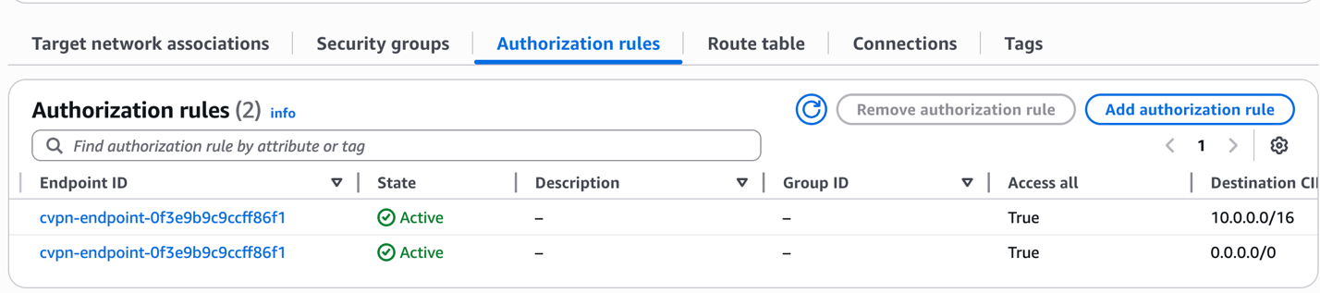

8.1 Allow Access to VPC CIDR
aws ec2 authorize-client-vpn-ingress \
--client-vpn-endpoint-id cvpn-endpoint-xxxxxxxxx \
--target-network-cidr 10.0.0.0/16 \
--authorize-all-groups \
--region us-east-1

8.2 Via AWS Console
1. Go to Client VPN Endpoint → Authorization Rules tab
2. Click Add Authorization Rule
3. Destination network: your VPC CIDR (e.g. 10.0.0.0/16)
4. Select Allow access to all users
5. Click Add Authorization Rule

8. Step 6: Add Route Table

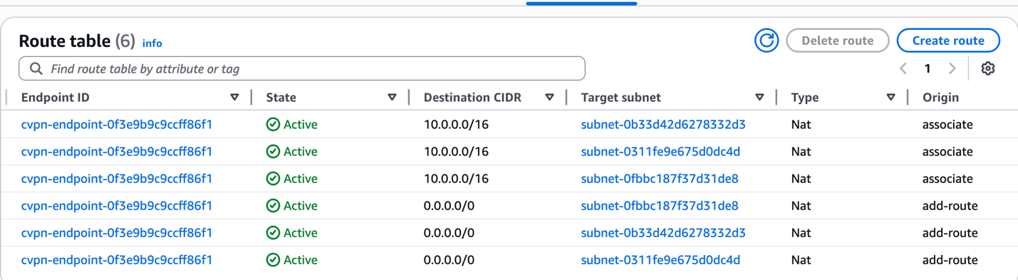8.2 Via AWS Console
1. Go to Client VPN Endpoint → Route Table
2. Click Create routes
3. Destination network: your VPC CIDR (e.g. 10.0.0.0/16) with all Associated subnets
4.Destination network: your VPC CIDR (e.g. 0.0.0.0/0) with all Associated subnet

9. Step 7: Download VPN Configuration

9.1 Via AWS Console
1. Go to Client VPN Endpoint
2. Click Download Client Configuration
3. Save the .ovpn file

9.2 Via AWS CLI
aws ec2 export-client-vpn-client-configuration \
--client-vpn-endpoint-id cvpn-endpoint-xxxxxxxxx \
--output text > client-config.ovpn \
--region us-east-1

9.3 Embed Client Certificate in Config
Open the .ovpn file and add the client certificate and key at the bottom:
<cert>
(paste contents of client.vpn.yourdomain.com.crt)
</cert>
<key>
(paste contents of client.vpn.yourdomain.com.key)
</key>

10. Step 8: Connect to VPN

10.1 Install AWS VPN Client
Download from: https://aws.amazon.com/vpn/client-vpn-download/

10.2 Connect
1. Open AWS VPN Client
2. Click File → Manage Profiles
3. Click Add Profile
4. Select your .ovpn file
5. Click Connect

11. Step 9: Test RDS MySQL Connection

11.1 Via MySQL CLI
mysql -h your-rds-endpoint.amazonaws.com -u admin -p

11.2 Via MySQL Workbench
Field | Value
Connection Method | Standard TCP/IP
Hostname | your-rds-endpoint.amazonaws.com
Port | 3306
Username | admin
Password | your-rds-password

12. Troubleshooting

Error | Cause | Fix
Certificate has no domain | Built cert without domain name | Rebuild with domain: easyrsa build-server-full vpn.domain.com nopass
403 Forbidden on ECR | Missing ECR policy on role | Attach AmazonEC2ContainerRegistryFullAccess
Cannot connect to RDS | RDS SG missing inbound rule | Add MySQL/3306 inbound from VPN SG
VPN not connecting | Wrong CIDR or missing auth rule | Check authorization rules and CIDR overlap
Permission denied on curl | Wrong directory permissions | cd /tmp before downloading files

13. Quick Reference Summary

Step | Action | Tool
1 | Generate CA, Server & Client certificates | Easy-RSA (Mac)
2 | Import certificates to ACM | AWS CLI / Console
3 | Create Security Groups | AWS Console
4 | Create Client VPN Endpoint | AWS Console
5 | Associate Target Network (Subnet) | AWS Console
6 | Add Authorization Rule | AWS Console
7 | Download VPN Config (.ovpn) | AWS Console
8 | Connect using AWS VPN Client | AWS VPN Client App
9 | Test RDS/EC2 connection | MySQL CLI / Workbench

Commands for check the ip and location

curl ipinfo.io/ip check the current ip
curl ipinfo.io check the current ip location

vashant@MANOs-MacBook-Air ~ % which brew
/opt/homebrew/bin/brew
vashant@MANOs-MacBook-Air ~ % brew --prefix
/opt/homebrew
vashant@MANOs-MacBook-Air ~ % brew list | grep easy-rsa
easy-rsa
vashant@MANOs-MacBook-Air ~ % brew --prefix easy-rsa
/opt/homebrew/opt/easy-rsa
vashant@MANOs-MacBook-Air ~ % cd /opt/homebrew/opt/easy-rsa
vashant@MANOs-MacBook-Air easy-rsa %
— End of Document —

