System validation

1. Data validation
2. Current system vs random entry system
3. Parameters’ verification
4. Model /data overfitting
5. Conclusion
6. System results

System overview and basic assumptions

More often than not US stock market is biased for upward moves when economic times are relatively quiet and calm from an economic news (or long periods of time without wars, valiance or any major events). Also, based on my observations I found out that when there is a major negative event the market volatility increases significantly for short period of time until the point where reaches a pick and slowly decreases. In my system I’ve tried to exploit this finding. So, the system is simple. I use volatility as signal for entry (long position only). Volatility parameter of the previous day should have exceeded certain limit and next day open value (stock exchange open time) should be decreased with x-% amount (let’s call it а gap).

For measuring the volatility, I use in the current system the so called VIX index which generates a 30-day forward projection of volatility in combination with the Average True Range (with fix value) of the previous day candle (bar on the chart). More info: <https://www.cboe.com/tradable_products/vix/>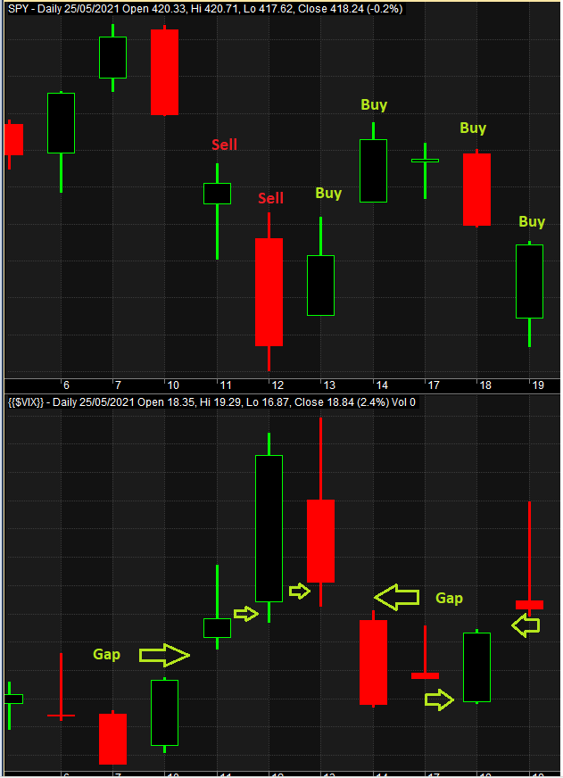

SPDR S&P 500 ETF Trust (SPY) - Daily

VIX index (COBE) - Daily

Basic overview:

Testing methods: in sample / out of sample data backtesting; walk forward backtesting  
Symbol testing: SPDR S&P 500 ETF Trust (SPY), transaction costs – 0.03 USD/share (min 1 USD per trade)  
Index filter: CBOE:VIX (Daily)  
Data – OHLC (Daily) – Open position starting session of NYSE and closing at the end of the session  
Position value – 400% of available capital. No stop-loss   
Software – Amibroker  
Data providers: Tradingview, Nortgate Data

1. **Data validation**

To validate the data integrity and correctness I have compared 3 databases provided by different vendors of data. If there is a significant difference between the data, I consider the model inappropriate for analysis.

The comparison of the date showed no major difference and I conclude the data is correct and could be used for exploration analysis and backtesting.

1. **Current system vs random entry/exit system**

On the chart below are show the results from system that enters at Open of the market with no predefined rule (it enters randomly) and closes the position at the end of the day (so the conditions are exactly the same as with current system just the condition for entry is different – random). There is only one system that produced positive return out of 10 on average out of 100 tests. Therefore, I would conclude that the currently investigated system (gap system) performs better than a random one. It worth mentioning that if we increase the period the chances of a random entry showing a positive expectancy is greatly reducing due to the effect of the commissions and transaction cost.

1. **Parameters’ verification**

Parameters’ smoothness

Every system has some parameters. For example, the **current system parameter is the percentage difference between today’s open price and yesterday’s close price for VIX index**. The parameters value greatly affects the system performance and can differentiate a profitable system from a losing one. The charts below showing the results of different parameter sets in the period **1.01.2000 – 1.1.2018**

*The* ***compound annual growth*** *rate (CAR) is the rate of return of an investment from start to finish, with annual returns that are reinvested. A* ***maximum drawdown*** *(MDD) is the* ***maximum*** *observed loss from a* ***peak*** *to a trough of a portfolio, before a new* ***peak*** *is attained.* ***Maximum drawdown*** *is an indicator of downside risk over a specified time period.* ***CAR/MMD*** *– system performance metrics*

Table 3.2

Table 3.1 / Table 3.2: Testing period (in sample data): 1.01.2000 – 1.1.2018

It is noticeable that the range of the results produced by the system are relatively close and with smooth change (parameter performance results obtained from In-Sample data). Therefore, I would conclude that those parameter values are appropriate for further analysis with out of sample data.

Out of sample results

I am backtesting the system on out-of-sample data to evaluate and validate the potential predictability of the system. In the current case (Table 3.3) it shows over performing parameters (higher than expected profits). This is a positive result and supports the In-Sample results, however, there should be noticed that the results differ significantly and further investigation is needed (I suspect the reason is in the short period of time where COVID crisis affected the market and the volatility was extremely high where the system shows really good results when volatility is on the extreme (2001-2003 Dot com bubble) and (2008 – 2009 financial crisis). Those results should decrease as the volatility decreased over time.

Trade statistics with different parameter values (out of sample data): 2.1.2018 – 27.05.2021:

|  |  |  |  |  |  |  |  |  |  |  |  |
| --- | --- | --- | --- | --- | --- | --- | --- | --- | --- | --- | --- |
| No. | Net % Profit | Exposure % | CAR | Max. Sys % Drawdown | Recovery Factor | **CAR/MDD** | Trades | Avg % Profit/Loss | % of Winners | L. Avg % Loss | **Parameter** |
| 2 | 83.51 | 4.52 | 19.57 | -38.26 | 1.19 | 0.51 | 324 | 0.07 | 58.33 | -0.69 | 0.50% |
| 3 | 148.99 | 3.79 | 30.8 | -32.62 | 1.94 | 0.94 | 272 | 0.1 | 59.93 | -0.68 | 1.00% |
| 4 | 225.94 | 2.82 | 41.59 | -23.1 | 4.78 | 1.8 | 202 | 0.17 | 61.39 | -0.68 | 1.50% |
| 5 | 199.86 | 2.15 | 38.16 | -22.74 | 4.23 | 1.68 | 154 | 0.2 | 61.69 | -0.65 | 2.00% |
| 6 | 148.02 | 1.67 | 30.65 | -22.74 | 3.6 | 1.35 | 120 | 0.22 | 62.5 | -0.79 | 2.50% |
| 7 | 158.11 | 1.34 | 32.2 | -22.74 | 3.84 | 1.42 | 96 | 0.28 | 63.54 | -0.77 | 3.00% |
| 8 | 167.47 | 1.02 | 33.59 | -22.74 | 3.78 | 1.48 | 73 | 0.37 | 69.86 | -0.91 | 3.50% |
| 9 | 157.97 | 0.79 | 32.17 | -22.74 | 3.51 | 1.41 | 57 | 0.46 | 73.68 | -1.18 | 4.00% |
| 10 | 113.52 | 0.64 | 25.02 | -22.74 | 2.88 | 1.1 | 46 | 0.47 | 73.91 | -1.28 | 4.50% |
| 11 | 69.21 | 0.54 | 16.74 | -22.74 | 1.74 | 0.74 | 39 | 0.39 | 74.36 | -1.35 | 5.00% |
| 12 | 55.37 | 0.49 | 13.85 | -22.74 | 1.45 | 0.61 | 35 | 0.37 | 74.29 | -1.45 | 5.50% |
| 13 | 23.08 | 0.38 | 6.3 | -26.98 | 0.57 | 0.23 | 27 | 0.25 | 70.37 | -1.49 | 6.00% |
| 14 | 33.79 | 0.28 | 8.95 | -14.01 | 2.22 | 0.64 | 20 | 0.4 | 70 | -1.04 | 6.50% |
| 15 | 20.4 | 0.25 | 5.62 | -14.01 | 1.37 | 0.4 | 18 | 0.3 | 66.67 | -1.04 | 7.00% |

Comparison between walk forward optimization results and standard optimization

One simple method for validating parameters and expectancy of a system is the so-called Walk forward approach where the software obtains best performing parameter value from In-Sample period and test it on Out-Of-Sample period. Another method for validating the system is obtaining best parameter only from one In-Sample period but with longer duration. I compare the results from the two methods where I see correlation in the performance.

Equity (USD)

*Results obtained from 154 trades*

Equity (USD)

*Results obtained from 83 trades*

Walk forward – 20 years’ period

I use also the Walk Forward optimization for long period which I consider for most closely representation of future performance.

*In-Sample period: 2 years, Out-Of-Sample test period: 6 months.   
Total trades for Out-Of-Sample period- 671*

The results from the walk forward shows performance metrics of the system for an Out-Of-Sample data. It is clearly seen that the system shows good performance in, 2002 – 2003 and 2008 – 2009, 2020 – 2021 however, for the rest of the time **the system does not perform so well and thus the average CAR/MDD for the whole period is 0.25 which is below the standard target of 0.5**

1. **Model / data overfitting evaluation**

Outlier’s effect (how much single events/trades affect the system performance)

I take 1% of the trades and evaluate how they affect (regardless of positively or negatively) the performance of the system. (in sample data): 1.01.2000 – 1.1.2018

Pn = Absolute value of profit   
N = number of trades

There are only 4 trades which affect the system significantly (regardless positively or negatively). So I consider the results not over fitted.

**Overfitted score = 1.98**

Critical value 12 (over that the model is over fitted)

**5. Conclusion:**

This system has relatively good performance in volatile periods and very unprofitable long periods in times with low volatility which does not suit my style of trading.

The sample size of the tests is relatively small for high gap parameter (difference between Open / Previous day Close) and there will be long periods without execution of trades.

Nevertheless, this system shows on paper better performance compared to Buy and Hold SP500 and may be used for diversifying buy and hold (if the correlation between buy and hold and this system is relatively low).

**At the end my personal view is that this system is not good enough for live trading or further investigation.**

**6. System results**

5.1. Out of sample results with best performing parameter – 2% gap (**norgatedata** – Daily)

Position value = 400% of equity. Commissions: 0.03 USD per trade per share

1.1.2018 – 03.06.2021

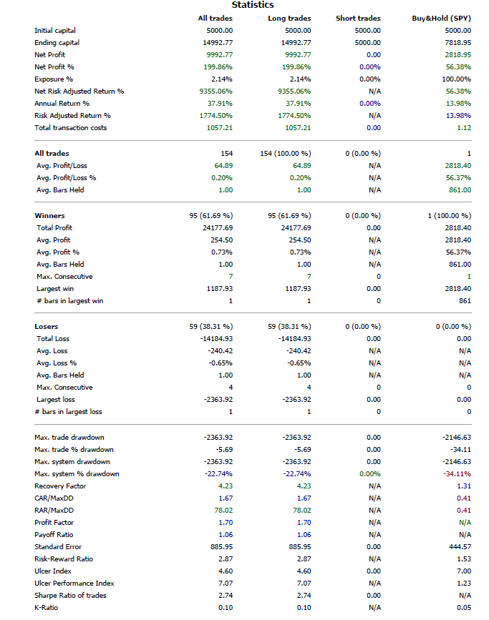

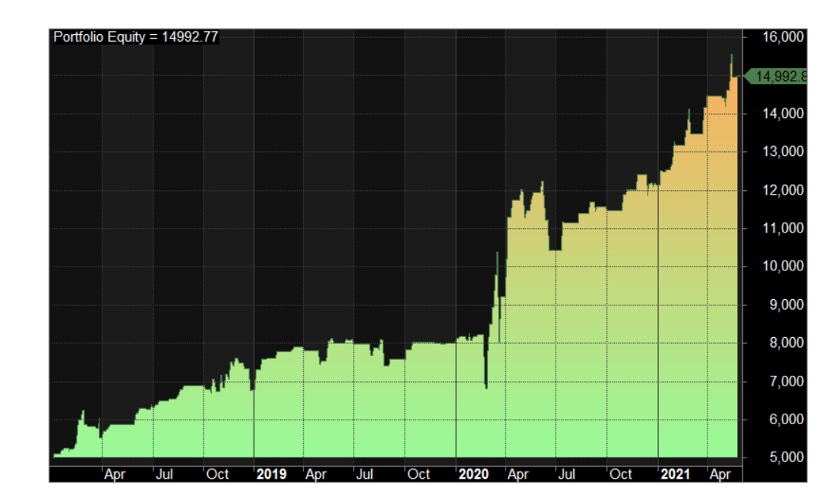

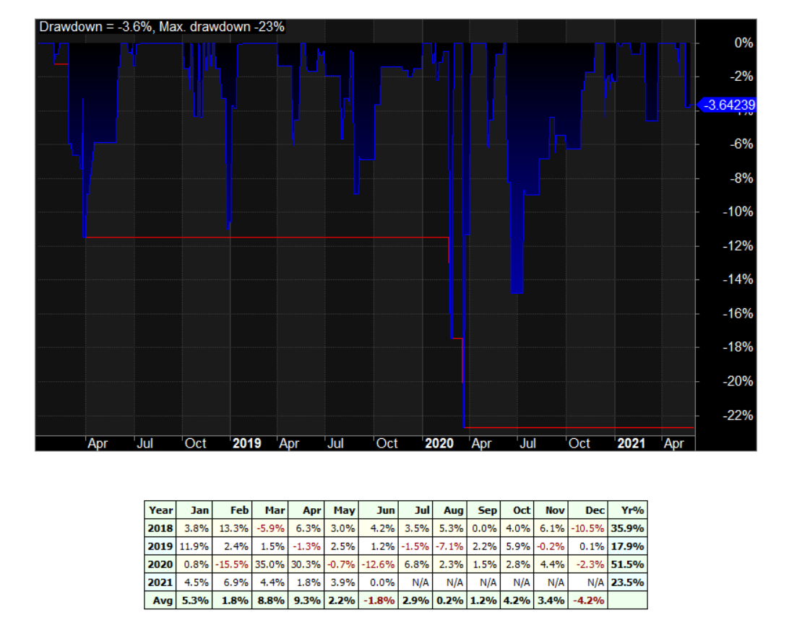

5.2. Out of sample results with best performing parameter – 2% gap (**tradingview.com** – Daily)

Position value = 400% of equity. Commissions: 0.03 USD per trade per share

1.1.2018 – 03.06.2021

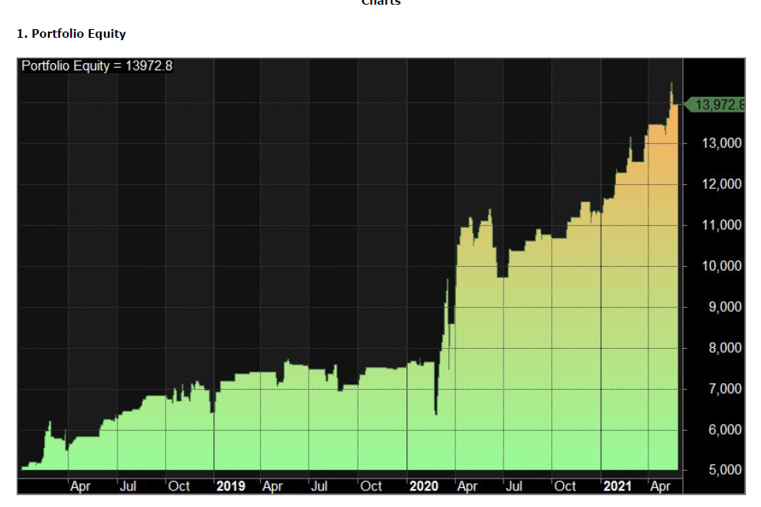

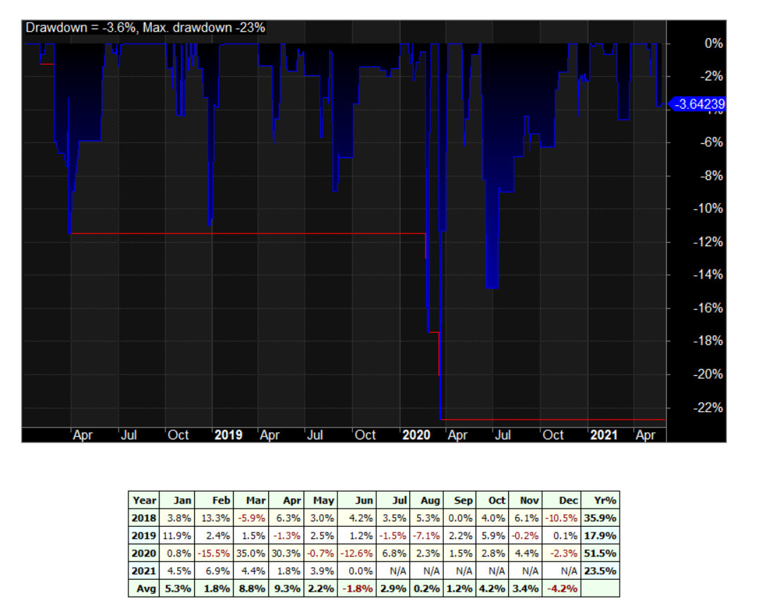

2.1. Walk Forward (**norgatedata** – Daily)

Position value = 400% of equity. Commissions: 0.03 USD per trade per share

1.1.2018 – 03.06.2021 Out-of-Sample period results

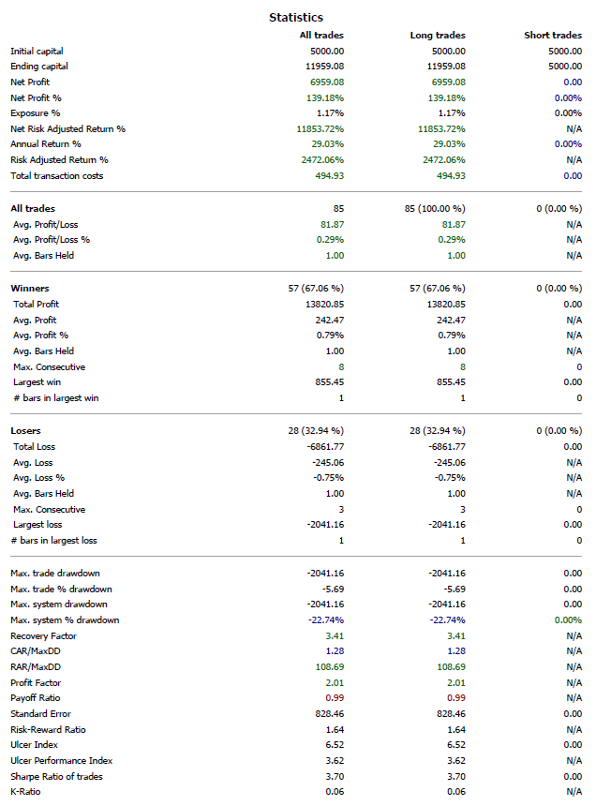

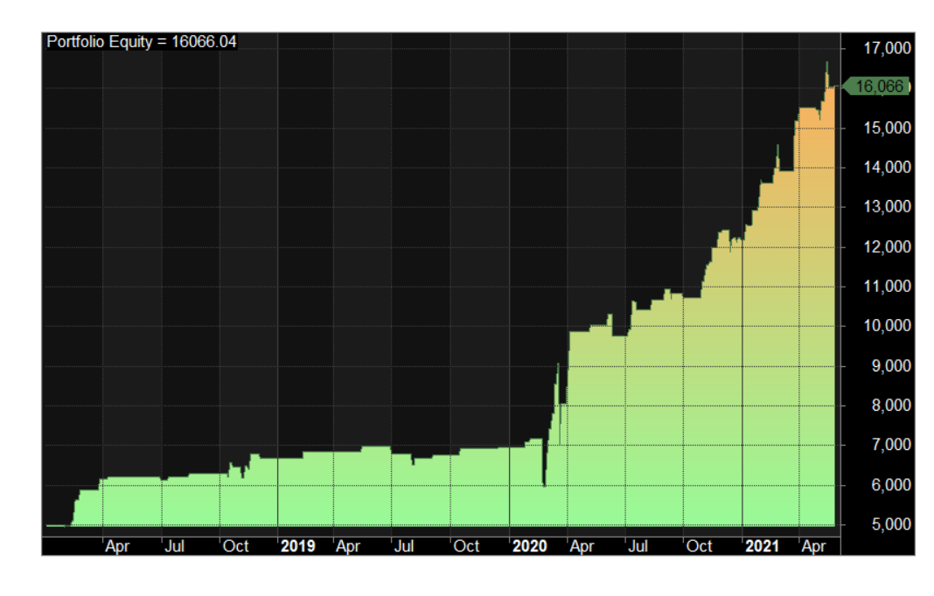

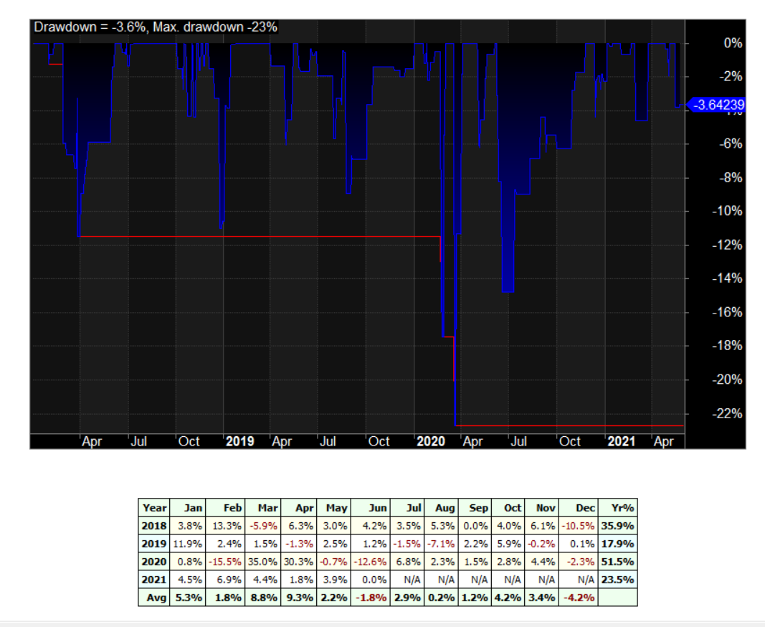

2.2. Walk Forward (**tradingview.com** – Daily)

Position value = 400% of equity. Commissions: 0.03 USD per trade per share

1.1.2018 – 03.06.2021 / sample period: 2 years, out-of-sample: 6 months

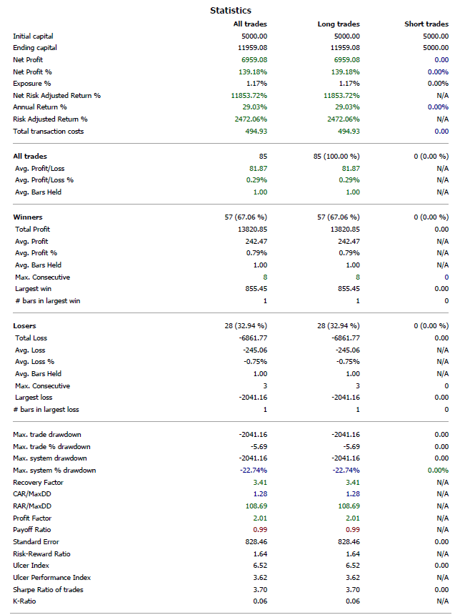

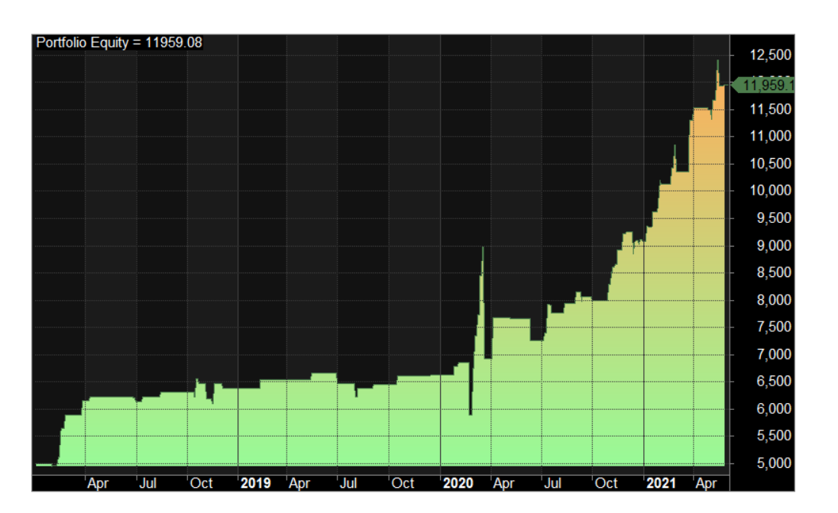

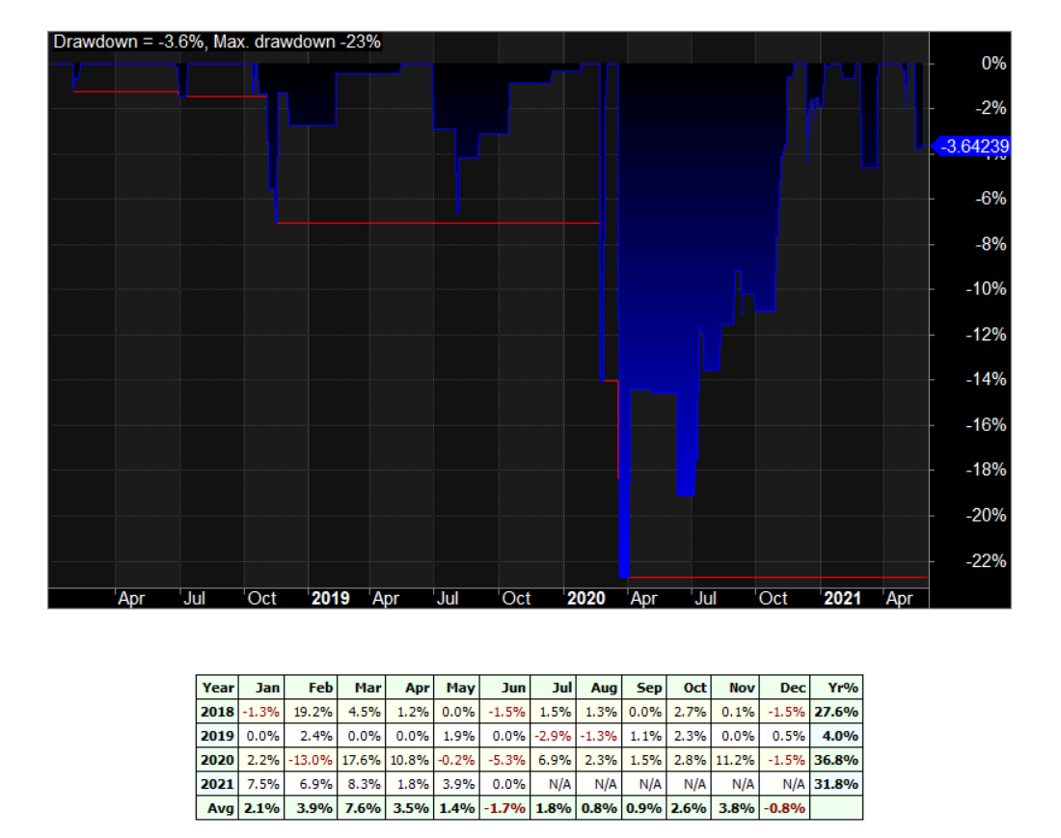

3.1. Walk Forward (**norgatedata.com** – Daily)

Position value = 400% of equity. Commissions: 0.03 USD per trade per share

1.1.2000 – 03.06.2021 / sample period: 2 years, out-of-sample: 6 months

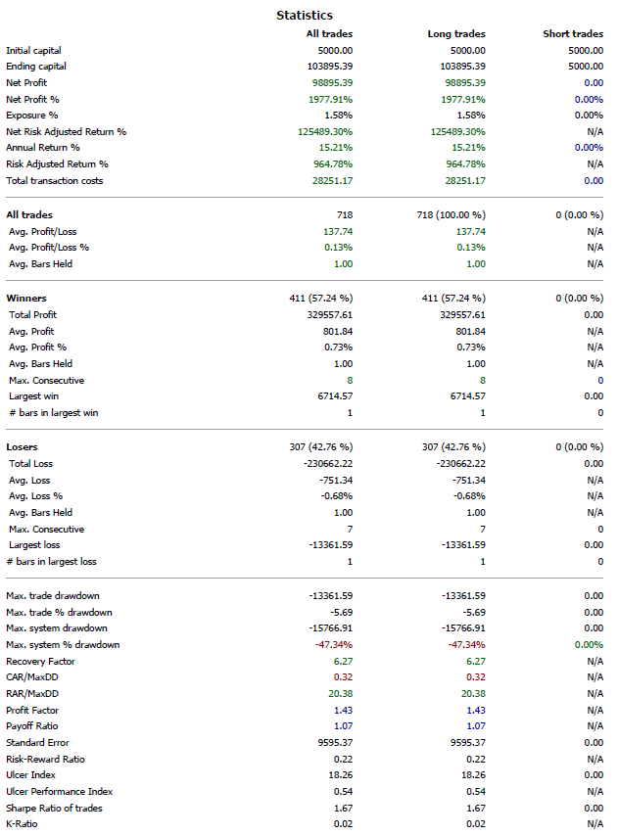

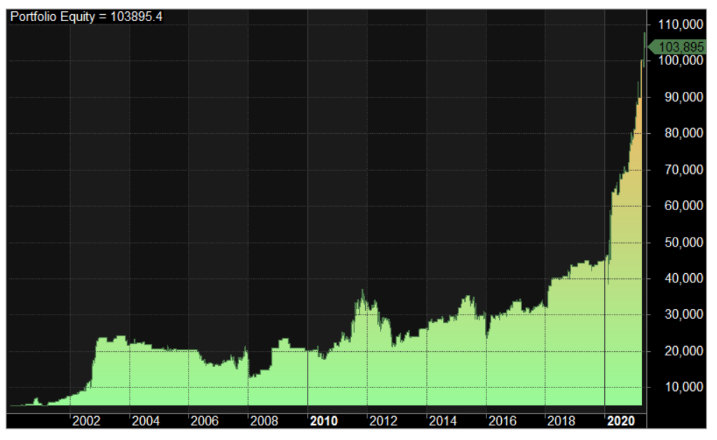

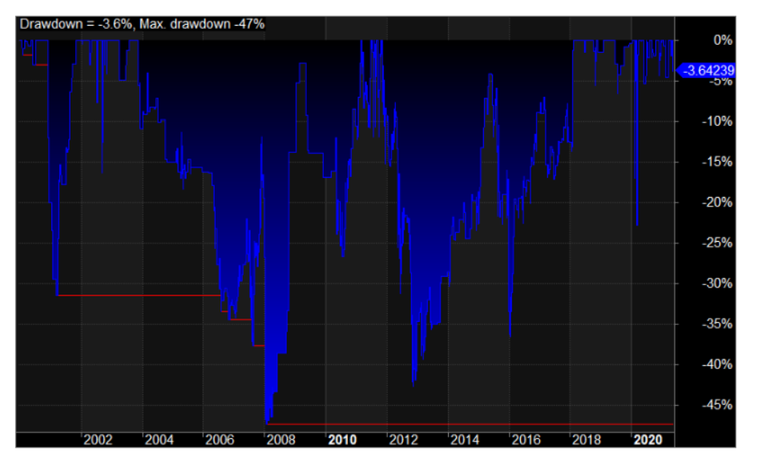

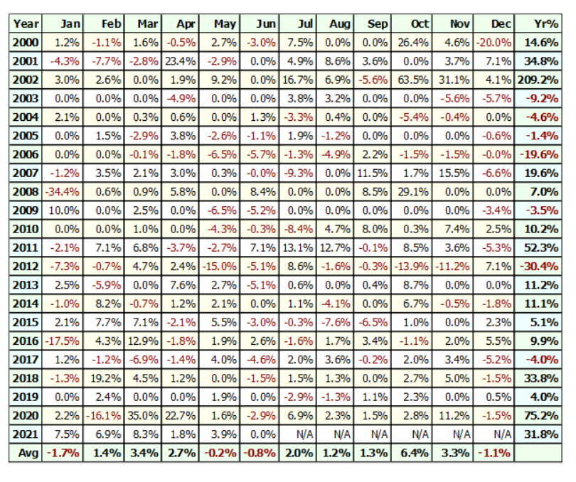

Software package used for analysis: Amibroker, Excel.

Data providers:

<https://norgatedata.com/>

<https://www.tradingview.com/>

<https://www.cboe.com/tradable_products/vix/vix_historical_data/>

3. Additional results comparison.

The report above was done in end of May and here are the test results from June 2021 to present showing the integrity of the results from a two different databases (Tradingview and Norgate Data)

