|  |  |
| --- | --- |
| **Team:** | **Team C** |
| **Team Members:** | **Jeremy Adams, Taunyl Bailey, Tim Olson, Rachel Spiegelhoff** |
| **Date:** | **8/25/2014** |
| **Project Title** | **Taylor’s Professional Services – Web Site eCommerce** |
| **Team Leader** | **Tim Olson** |

# System Overview

Taylor’s Professional Services has requested a web site with the following features:

* Allow clients to complete staffing request online
* Provide clients with a listing of potential candidates
* Provide automated response to client that staffing request will be validated in 24 hours
* Allow TPS staff members to update their resumes and pictures online

The completed TPS system will have three types of accounts, Client, Staff and Manager. Only clients with valid contract numbers and passwords will be allowed to enter the client area and only staff with valid employee numbers and passwords will be allowed to enter the staff area. Only contract managers will have access to both locations.

# Methodology Description

We will be using the Waterfall Development Methodology during the development of this project. We have chosen this methodology because we have strict deadlines for each phase of development and once one phase is complete there is no turning back. We will also be using Microsoft Visio to develop UML diagrams to help design and plan the structure of this site and its database.

# Requirements

* The project must be compatible with a GoDaddy IIS server.
* Database modification must be performed using a SQL script.
* All code must be compatible with ASP.NET version 3.5.
* Server side code is to be programmed in C#.
* Must use ftp to upload/download system files to/from server.

## Data Requirements

### Data Dictionary Definitions

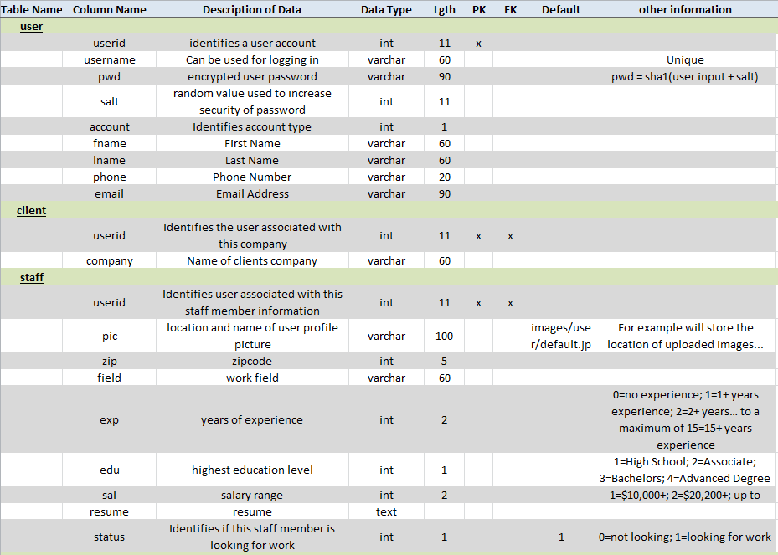

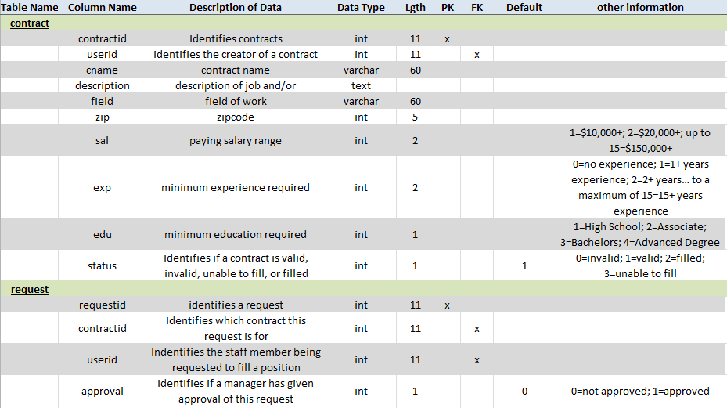

### Data Model

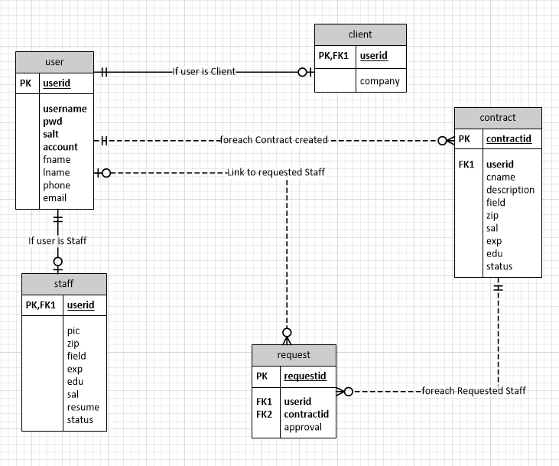

The database consists of five tables: user, client, staff, contract and request.

## System Hierarchy

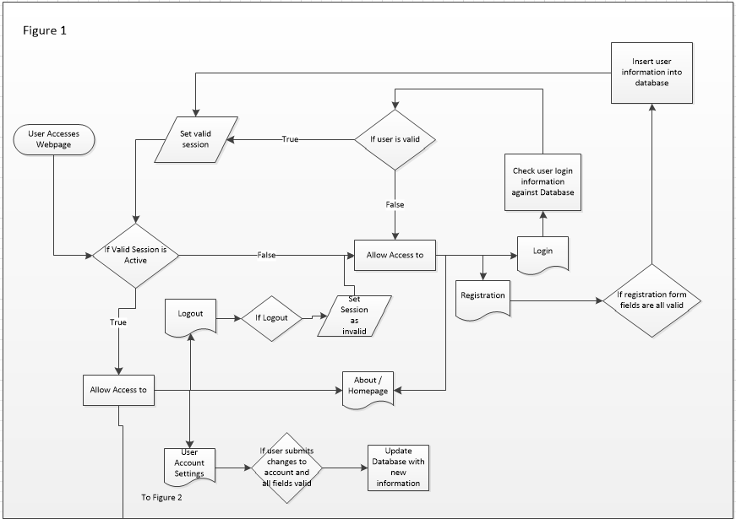

Figure 1. This diagram shows the processes required for authenticating users of the website. If a user has a valid session active they can access the members area if not they will be limited to the main page, register and login.

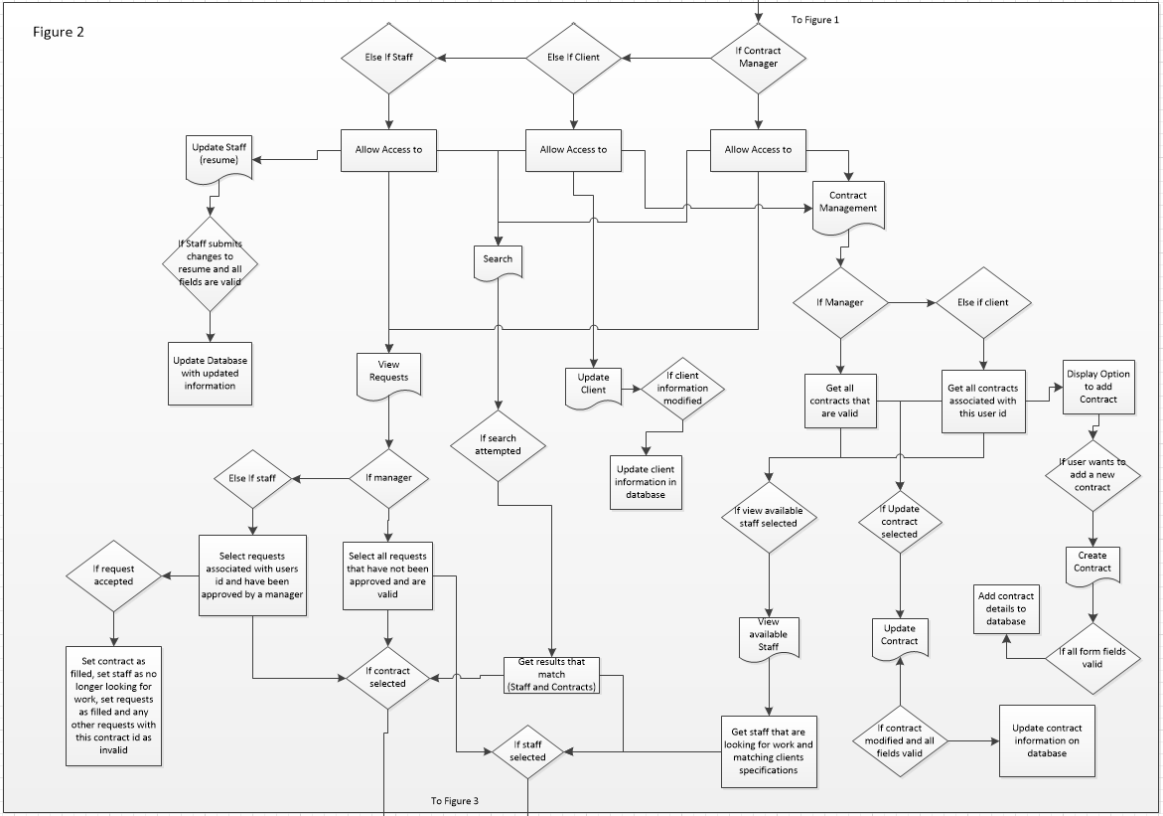

Figure 2. This diagram shows what processes occur when users have a valid session active. Manager, clients and staff will have different processes that can happen.

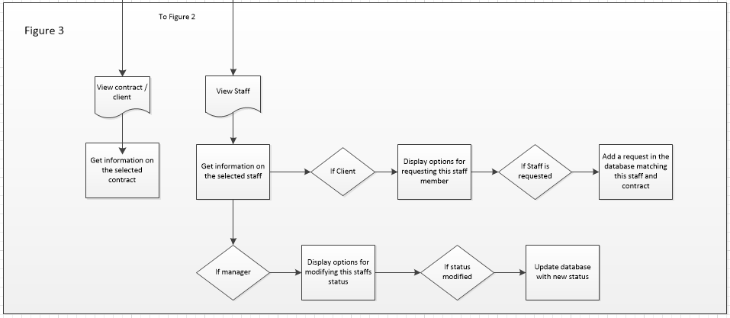

Figure 3. This diagram is a continuation of figure 2. The processes related to viewing contracts and staff members are shown in this diagram.

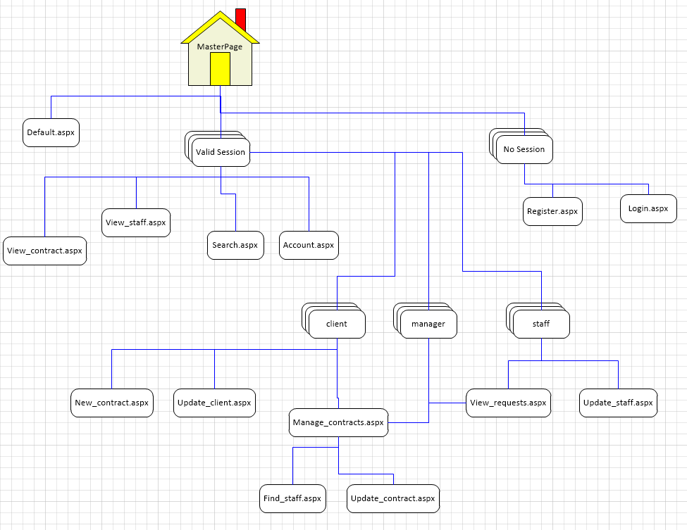

3.4 Invalid Session

3.5 Valid Session

3.3 User Validation

## User Validation

Inputs: user Session  
Outputs: navigation matching session type

* + The master page will check for a valid user session
  + If session matches a manager, client or staff account the session is valid
  + else the session is invalid

## Invalid Session

Inputs: None  
Outputs: Navigation for invalid session

When no session is valid or set only home, register and login pages will be available.

## Valid Session

Inputs: user Session  
Outputs: access to account settings

When a valid session is found, this user will gain the ability to search, view staff and contract profiles and be able to modify information related to their account.

**3.6 Client**

Inputs: Client Session  
Outputs: access to client area

Users that have a valid client session will also have access to create new contracts, manage their contracts and find staff matching contract requirements.

**3.7 Manager**

Inputs: Manager Session  
Outputs: access to manager area

Users that are valid managers will be able to manage all contracts and requests. While also being able to find staff members that match contract requirements.

**3.8 Staff**

Inputs: Staff Session  
Outputs: access to staff area

Users that are valid staff will be able to update their resume and profile image. They will also be able to see requests made for them by clients.

**Document Work Log:**

*To assist in assessing the contributions made by the individual team members, the team must complete the table below:*

|  |  |  |
| --- | --- | --- |
| ***Section*** | ***Team Member - Primary*** | ***Team Member - Secondary*** |
| 1. *System Overview* | *R. Spiegelhoff* | *J. Adams* |
| 1. *Methodology Description* | *J. Adams* | *T. Bailey* |
| 1. *Requirements* |  |  |
| * 1. *Data Requirements* | *T. Olson* | *R. Spiegelhoff* |
| *ERD* | *J. Adams* | *R. Speigelhoff* |
| *Data Dictionary* | *J. Adams* | *T. Bailey* |
| * 1. *System Hierarchy* | *J. Adams* | *T.Olson* |
| * 1. *Definition of Individual Requirements* | *J. Adams* | *T. Olson* |
| *Process or Function Definitions/Descriptions* | *J. Adams* | *T. Olson* |
| *Other requirements definitions/descriptions* | *J. Adams* |  |