0. Add host record as follows: <ipaddress will be changed by dhcp>

10.54.142.220 csssDebianTest csssDebianTest.swd.hksarg

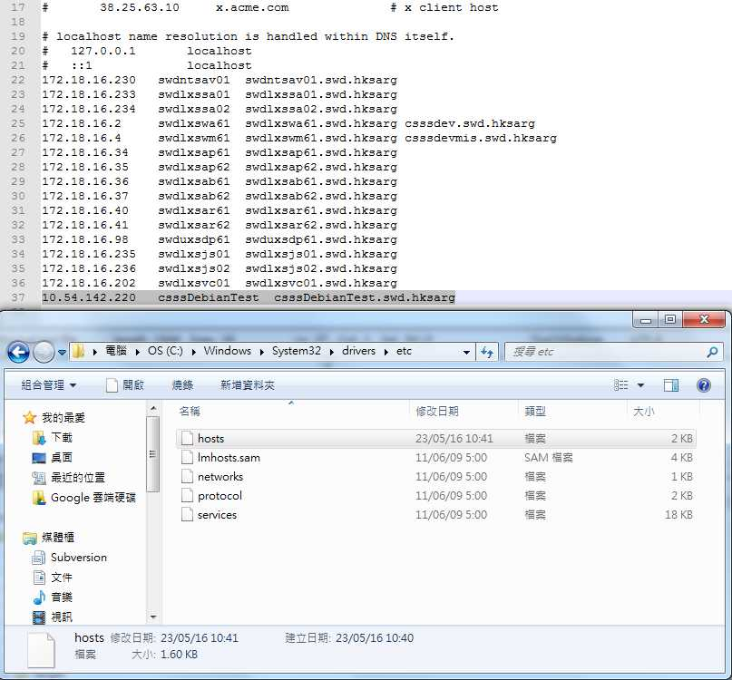

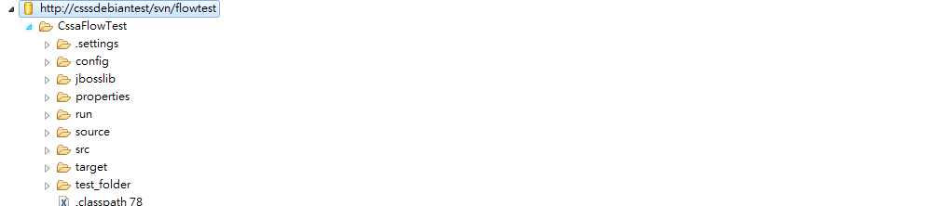

1. Copy apache-maven-3.3.9 to d:\
2. Add MAVEN_HOME

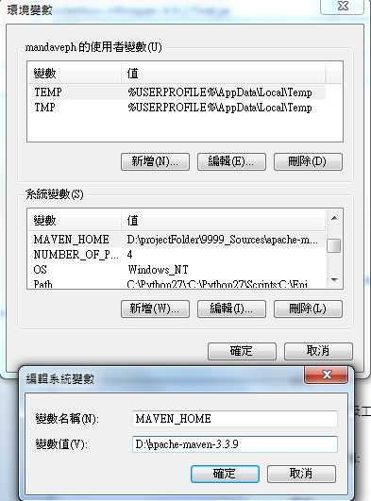

1. Add %MAVEN_HOME%\bin to Path

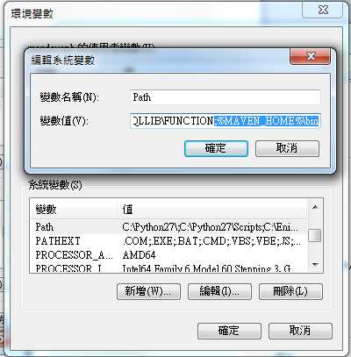

1. modify settings.xml and add

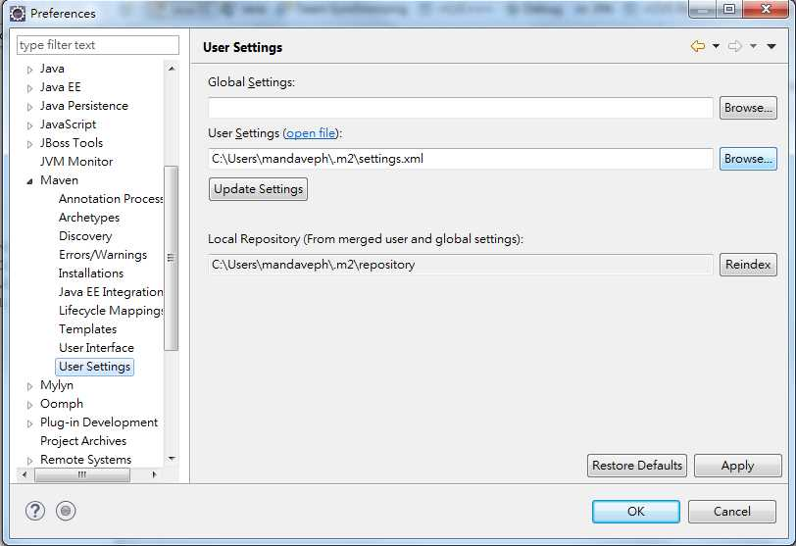

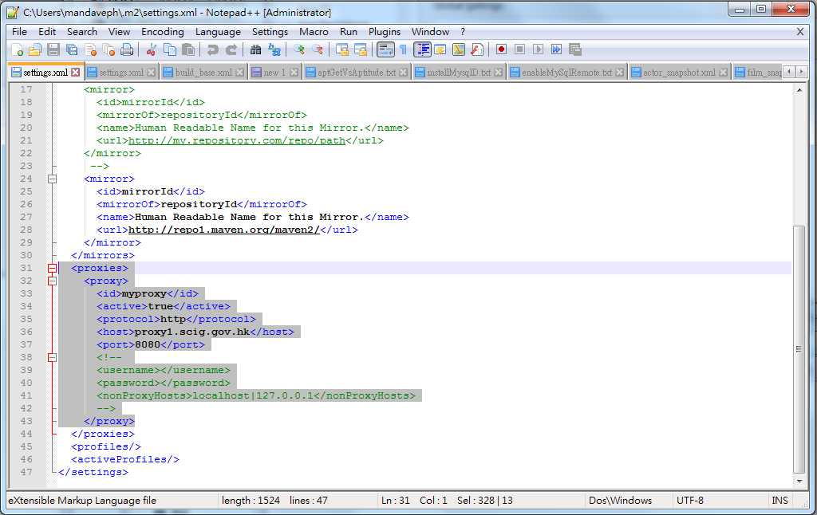

<proxies>

<proxy>

<id>myproxy</id>

<active>true</active>

<protocol>http</protocol>

<host>proxy1.scig.gov.hk</host>

<port>8080</port>

<!--

<username></username>

<password></password>

<nonProxyHosts>localhost|127.0.0.1</nonProxyHosts>

-->

</proxy>

</proxies>

1. run ant build to build frw.jar, you can find the built jar under /FRW/dist/frw.jar

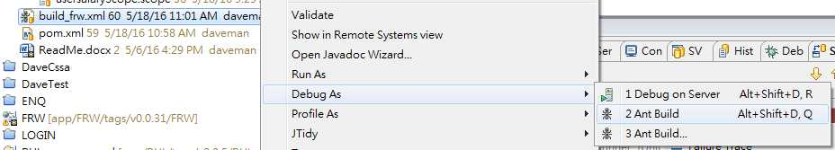

1. cmd, run: <change driver letter c: to your DevEnv drive:> to test whether your maven in dos is functional

mvn -X org.apache.maven.plugins:maven-install-plugin:2.5.2:install-file -Dfile=C:/DevEnv/workspace/FRW/dist/Frw.jar -DgroupId=hksarg.swd.csss -DartifactId=Frw -Dversion=1.0 -Dpackaging=jar -DgeneratePOM=true

check maven puts the Frw-x.x.jar into your local maven repository:

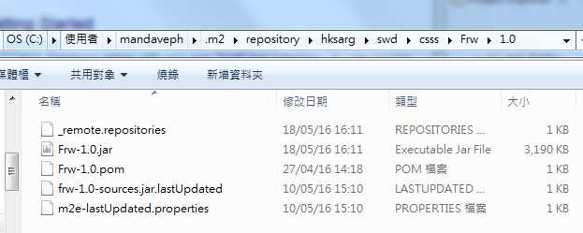

1. right-click the root of the project folder, do Update Project…

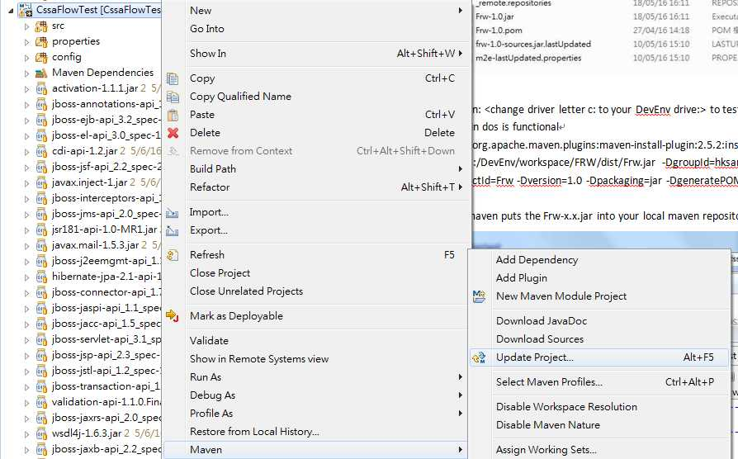

1. right-click pom.xml to package, install the project

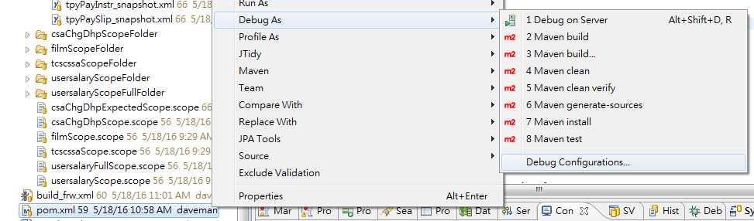

Goals: package install

Check: C:\Users\mandaveph\AppData\Roaming\PixelMetrics\CaptureWiz\Temp\6.jpg

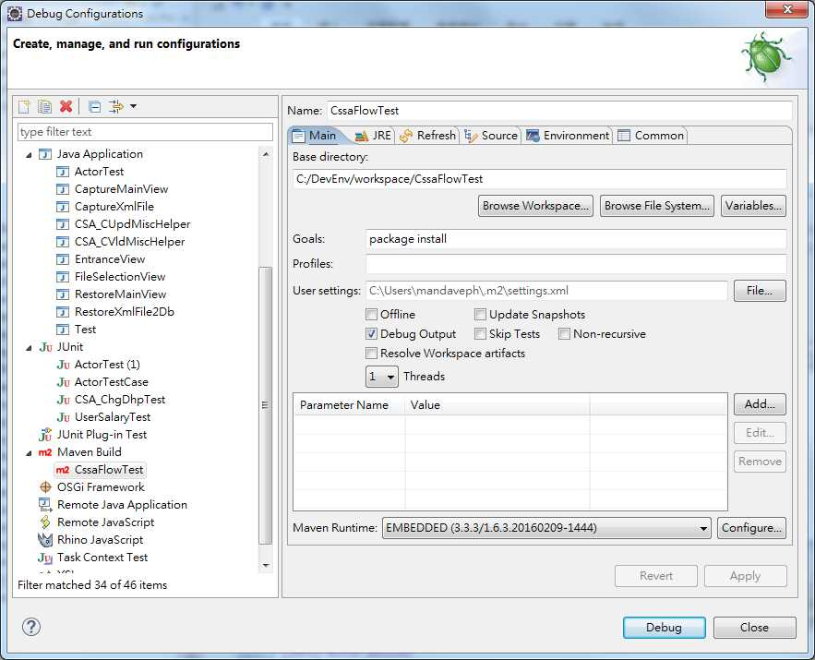

1. flowTestNewDb and flowTestOldDb are found at: C:\DevEnv\workspace\CssaFlowTest\source, copy flowTestOldDb folder to the root of usb, double click: runFlowTest[Old|New].bat to run

