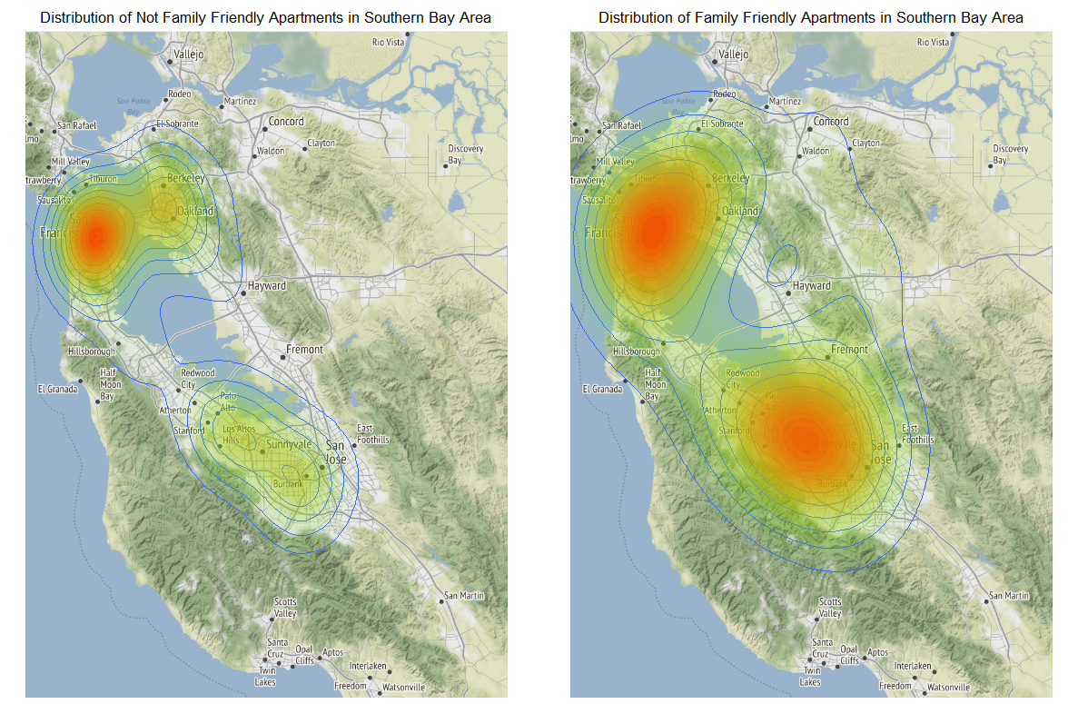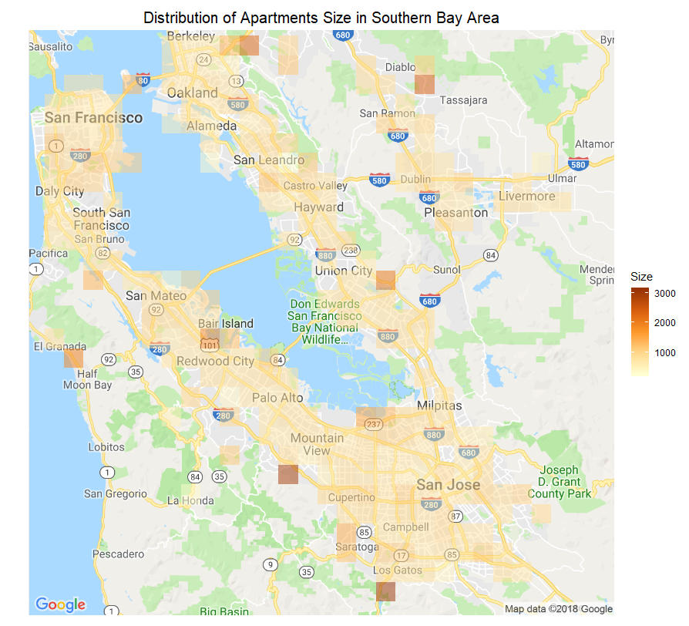

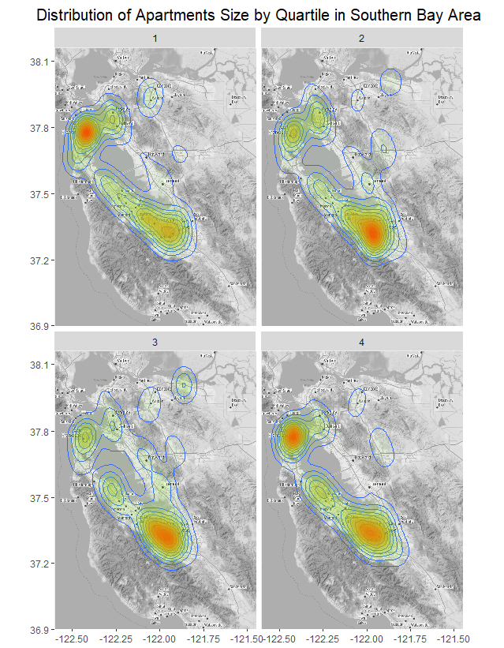

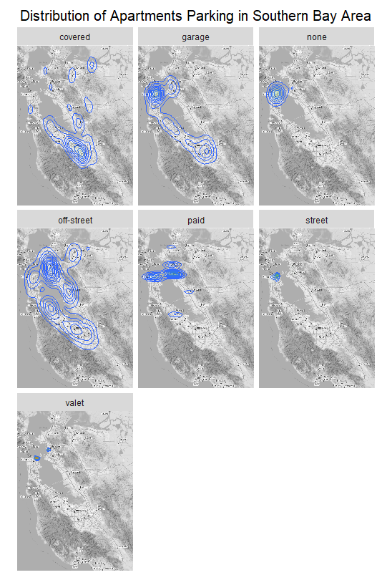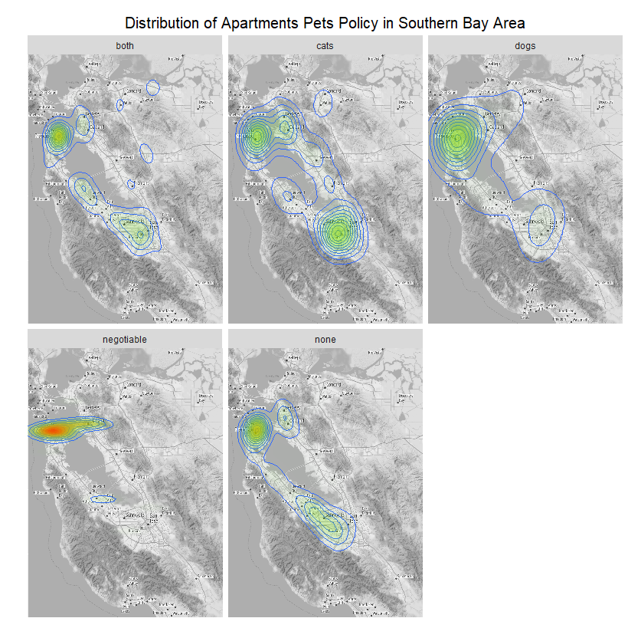

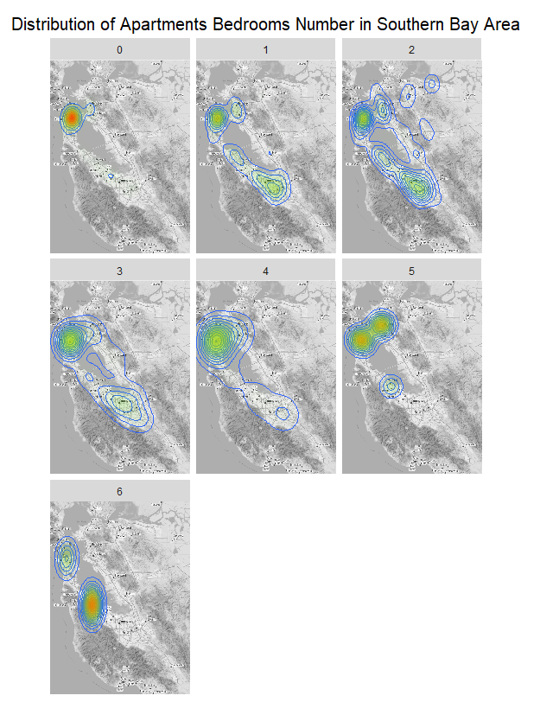

As the picture shows: 0 bedrooms/studios are concentrated in San Francisco; 1 bedroom apartments are scattered in San Francisco, Berkeley and San Jose; 2 bedrooms apartments are scattered in all southern Bay Area; 3 or 4 bedrooms apartments are in SF, San Jose and Mountain View; 5 or 6 bedrooms Apartments are mainly located around Redwood city. From this picture, we cannot find obvious rules about the relation of location and the number of bedrooms. I think that is because San Francisco has larger set set than others, also SF has a much more diverse apartments than other cities.

