**Example of communication targrting young men**



**Example of a communication using two step flow strategy**

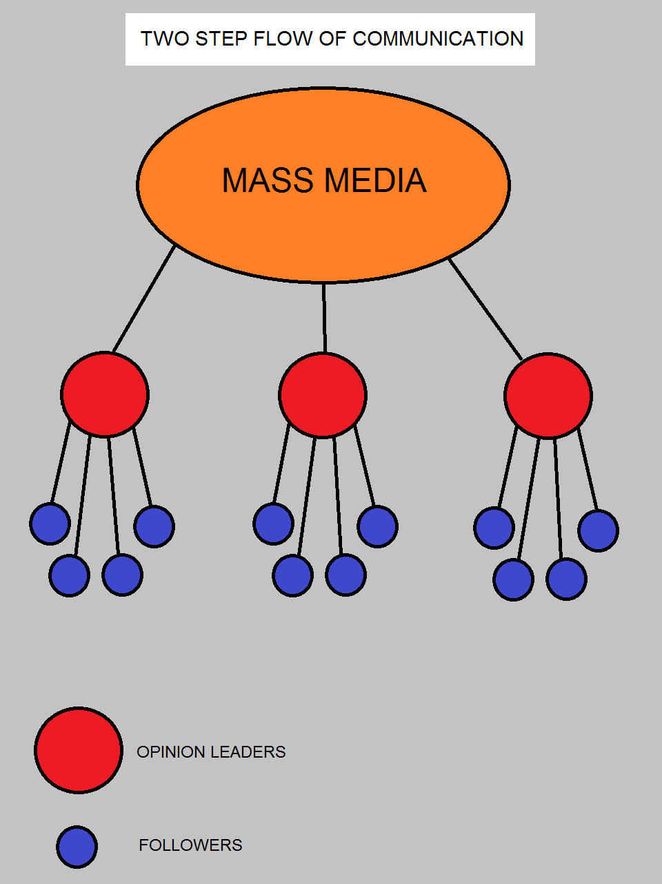

**Example of propaganda communication**

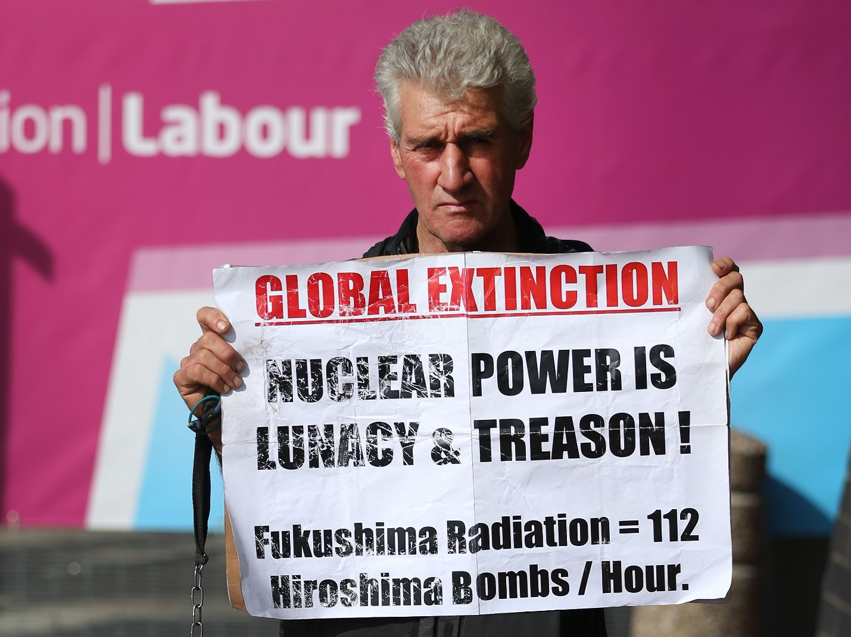

**Example of communication targeting young women**

unication targeting young womenicationg women 

**Example of public service communication**

