**Impact of internet**

 Due to the widely use of internet all over the world it produces powerful societies over the globe

The main attraction point come when we see this in a positive way like awareness and unity. Although at the same time, we can not ignore its negative consequences. It is widely misused by the groups, societies and even by the huge firms. Specially when we talk about personal privacy of an individual people engaged over the social websites are more connected in comparison to a society. Which further impacting societies in between personal, social, economic and political activities. People over the globe are broadly influenced by educational resources, social media websites, shopping sites, online business, internet marketing, research and automation of social skills in both manner towards positive as well as negative.

Nowadays, internet become the backbone of youth society specially the teenagers. They do not feel happy if they spend a single day without the internet. why, what is the reason behind their thinking and the reason is addiction. They are addicted to internet. The information provided over the internet resources is without the basic understanding of the subject which further making our youth physically and mentally unstable this is the major negative impact of the internet on our society and especially on over upcoming bread . Now WhatsApp and Facebook, Instagram, Twitter and many more social sites are the best places to create a imaginary world all over the globe. Moreover, the friendship over these sites is artificial and not contributing to practical life.

. 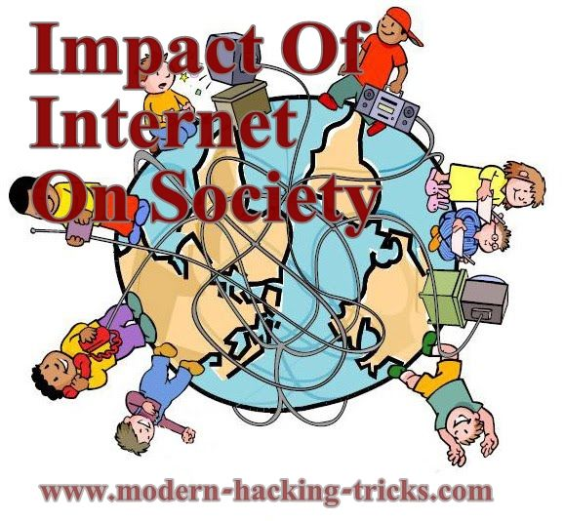

### Internet Affects over pupils

The major contribution in using internet is from our students.in present scenario, it is not a wonder thing that a ten year kid can easily operate a cellphone tablet and even computer. Even children have their own tablets and social accounts over sites. And students nowadays have their own cellphones. So it’s no wonder up to which extent internet woven itself into the lifestyle of our pupil society.

Student society took internet as a refreshing activity and the harm is that rather using this in their free time they are making their time free to use this. In my opinion internet having more negative impacts over student life in comparison to its brighter side. While the internet can be a reliable resource to help them with homework and school project, things can easily turn downhill when youth waste their whole time over social websites without learning new things. Face to face social skills are not emphasised so they feel down when its come under the category of face to face interaction. Friends over social sites are not real they can not give you the sympathy and support like a real life friends and these friends are uncountable who even never met each other and may be from different countries. In this internet era they forgot how to interact with people personally which is a huge loss of social life of societies.

**Lack of creativity**

As almost everything is available over internet, so student nowadays have less belief doing thir on assignment and projects by researching over the topic they just become more copy cat. With the help of internet every classes are video recorded, so they do not pay much attention in class to listen carefully, think, or make more effort and this all become possible due to easy and convenient access of internet.

**Less family times**.

The quality time of families stolen away by this ghost whose name is internet. Even its very commonly seen over family get together, every member of family seems indulged into their own devices. so can we imagine a family where people having no personal bonding no day routine sharing.s

**Late nights sleeping habits**

Some students go to bed when the calendar date change they waste their hole valuable time just to wondering over the junk and sick sites this routine is very harmful for the growth of mind of teenagers . The consequences of these type of habits can be seen in the form of laziness in school or even sometimes students fall asleep in the classrooms.

**Unhealthy lifestyle**.

In this time era student spend nearly 6 to 8 hours of their schedule over the internet which further give birth to sedentary lifestyle. These types of people feel more mental stress in comparison to those who believe to spend time over outdoor activities like sports and walk outside

**Addiction**

According to psychology the person who become addicted internet can not be kept his or herself normal if he or she not using interne over long time. These types of persons who become addicted to internet can not leave without it. This is become like inhaling drugs for them without which they can not imagine life.

**Cheating cases**

Nowadays, students have more believe in spoon feeding rather than doing hard work and further this kind of behavior further put them into day to day hassle like they face cheating case and even can face suspension from their academics.

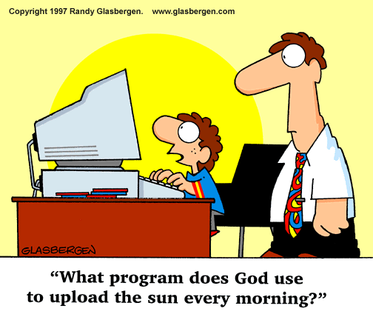

**Impact of internet on business**

Overall impact of the web is properly established and recognized. Penetration rate of the web has been marvelous; very nearly 1/third of Human population are getting to the web. The manner in which business is led in this computerized age has changed due to such a significant number of individuals signed on to the web. There is a case of Walmart. Money Street was stuck to that number since CEO Doug McMillon is scrambling to change the world's biggest physical retailer for the advanced period. Walmart anticipates that online deals should increment 40% for the entire year. Online business makes up just 4% of offers in the United States, assessed Laura Kennedy, VP of retail experiences at Kantar Consulting. "The main problem with Walmart is that the majority of what they move is nourishment and individuals don't purchase food on the web”. Walmart has set out on a driven long haul intend to move impression of its image. It needs to fabricate its client base from low-and center salary family units to more youthful, wealthier Americans charmed by Amazon. The web has turned into a basic device for promoting and publicizing. A business can introduce itself to clients with the utilization of a site or online commercials. Numerous organizations presently utilize the web as a method for making clients mindful of their present advancements. This can be valuable to organizations that are focusing on a more youthful gathering of people. Correspondence and communication with clients are indispensable to any business. The web has guaranteed this can be effectively accomplished. Organizations can impart and collaborate with clients through email or texting. Web communication, for example, Skype is currently a famous technique for correspondence and is utilized every now and again by organizations so as to direct virtual gatherings with the two clients and different organizations. The utilization of the web likewise makes it less demanding for organizations to convey messages to individuals working inside the association.

[**https://www.youtube.com/watch?v=TILEIIyvgZk**](https://www.youtube.com/watch?v=TILEIIyvgZk)

**Affect of internet over politics**

The political scene has changed a considerable amount over the most recent few decades. The web has assumed an extensive job in this change. Online networking, specifically, is presently a genuine factor in political campaigns and in the way, individuals consider issues. The most one of a kind elements of the principal Twitter-based administration in the United States is the serious and phenomenal utilization of the web as a political apparatus. There is an example of how the Trump administration and its supporters use internet based life, for example, Facebook and Twitter, to state impact. Similarly, likewise with every single other part of present-day life, the web is rapidly getting to be joined into political battles, making another type of "smart" legislative issues. We see explicitly from the Trump battle the likelihood of what can be accomplished from using web-based life and the web for factional gain. In this way, in breaking down the attributes of Trump's online nearness, we can all the more completely understand the idea of political issues in the web period. The idea of globalisation is the main reason for the success of Trump’s campaign as its ability to continuously connecting with public of America and this is the main reason of the success of the winning elections by Trump so by increasing trend of social media and internet leads to the increasing popularity Trump and influence people in many ways. From Trump's hyper-active social media presence, we see a novel political relationship between Trump and his followers. This is how internet affect the politics and the elections in 2016 of the Trump as this is the way to connect more and more people and more public get aware of the politics and many online sites earn more than the expectations. Most of the companies such as CNN channel and such other companies earns a lot of money by showing voting and Trump news.

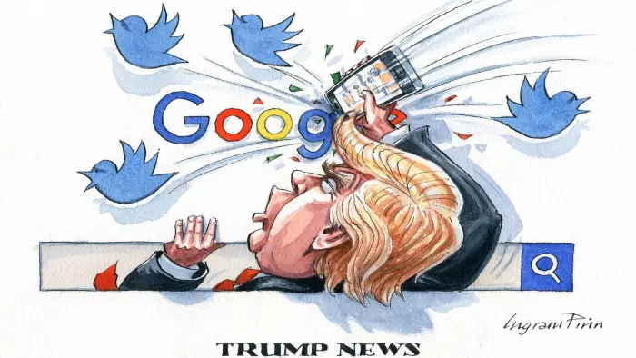

**Conclusion**

As we can see that internet is the main master of all the information related to any information and it is so advanced that all the business earns more than the expectations. we can see that the Internet is a totally new world emerging at the 20th century. All in all, we can not say with the supreme conviction that the Internet does great or damage to our life. The Internet is much the same as a twofold edged sword. Regardless of whether it does great or damage to individuals' life rely upon how we misuse it and how the Internet motivate human insight. Along these lines, as I would like to think, the Internet is eventually more advantageous than negative to individuals. the most troublesome inquiry for the fate of the Internet isn't the means by which the innovation will change, however how the general population will change with the advancement of the innovation. Internet is the main key to everything in these days so for the business point of view is the main path for the success and growth as with the help of this companies can easily reach person to person very easily and quickly. Overall it has a huge impact on each and every person of all age group today.