

**Programming for problem solving using python**

**B.TECH CSE CORE SECTION (A) SEMESTER - 1**

**Course code : ETCCPP102**

**ASSIGNMENT NO. : 1**

**ASSIGNMENT TITLE : DAILY CALORIE TRACKER**

**SUBMITTED BY : MANPREET KAUR**

**SUBMITTED TO : FEROZ AHMAD SIR**

**DATE OF SUBMISSION : 20 OCTOBER 2025**



**DAILY CALORIE TRACKER :-**

* **INTRODUCTION:-**

**The “Daily Calorie Tracker” program takes input from the user of their number of meals taken and then it loops according to the user input multiple times. Then it takes the input from the user of the meal name and the amount of calories in the meal. After taking all these inputs it appends the meal names in a separate list and the amount of calories in a separate list. Then it calculates the total calories and average calories. It also takes another input from the user to enter the daily calories limit, So that it can compare the amount of calories taken in the day with the daily calorie limit and print messages accordingly. After all this, it will print total calories taken, average calories taken and a table showing all the meal names and their corresponding calories.**

* **TASK–1 :- SET UP AND INTRODUCTION :-**

**INPUT :-**

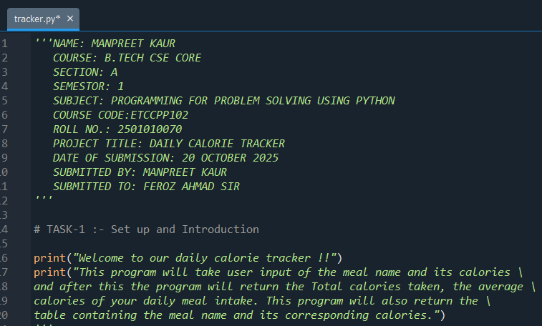

**OUTPUT :-**

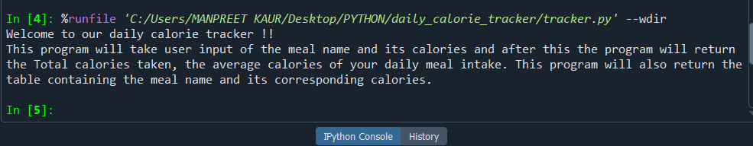

**In Task-1 we have to do set up and introduction, here in the above screenshot under the input heading, I have added a multi-line comment showing all my details and under the comment Task-1 I have added a print statement which will print the welcome message and the introduction about the “Daily Calorie Tracker” and in the second screenshot under the output heading you can see the output of the above code.**

* **TASK–2 :- INPUT AND DATA COLLECTION :-**

**INPUT :-**

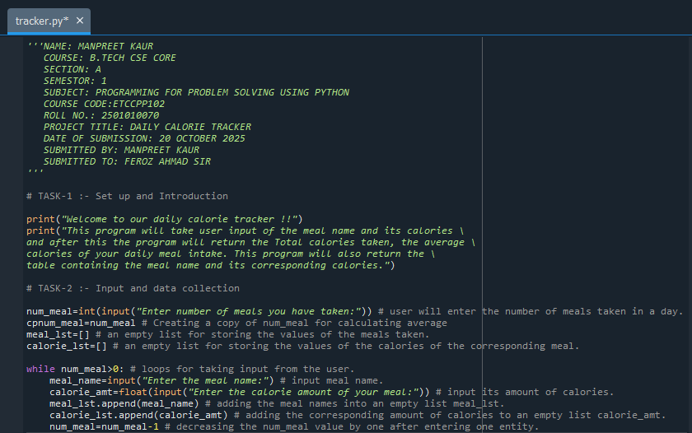

**OUTPUT :-**

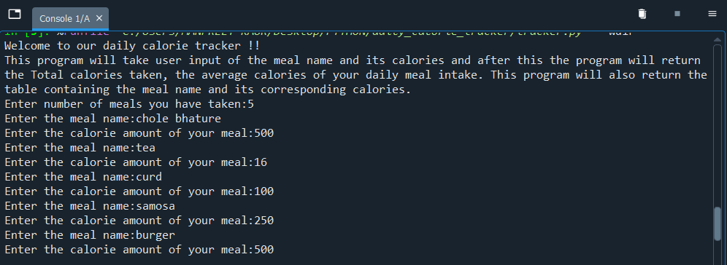

**In Task-2 we have to do input and data collection, here in the above screenshot under the input section Task-2 I have taken input from the user that how many meals he/she has taken in the day. After that, I have copied the variable so that I can easily do further operations. Then I have created two lists one for storing the meals and other for storing their corresponding calories. Then I have run a while loop, this loop will run the number of times equal to the number of meals taken in the day. When the loop runs and user enter their data, the meal names are stored in a separate list and the amount of calories corresponding to the meal name. In the last line of the code I have decreased the value of number of meals taken by the user by 1, so that we can enter the data a certain number of times. For example :- If user have taken 5 meals then the loop will run five times. This statement is used to give step value to the while loop or to do increment or decrement.**

* **TASK-3 :- CALORIE CALCULATIONS :-**

**INPUT :-**

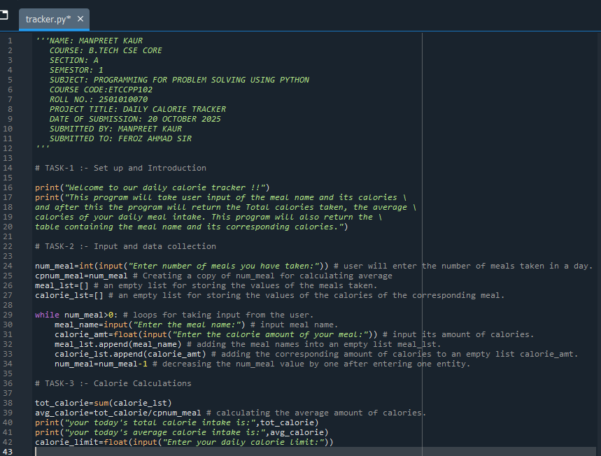

**OUTPUT :-**

**In Task-3 we have done the calorie calculations, I have calculated the total number of calories taken in the day by using sum() function. Them I have calculated the average calories by dividing the total calories to the number of meals taken in the day. After that I have printed the result of both the total calories and the average calories by using the print() function. Then I have taken the input that what is the user’s daily calories limit for further comparing.**

* **TASK-4 :- EXCEED LIMIT WARNING SYSTEM :-**

**In Task-4 I have made the exceed limit warning system, in which I have used the if else statements to compare the total calories taken by the user to the daily calorie limit inputted by the user.**

**In if statement, if the total calories consumed by the user is greater than the daily calorie limit inputted by the user then it will print the warning message otherwise it will print the motivational message to stay committed.**

**INPUT :-**

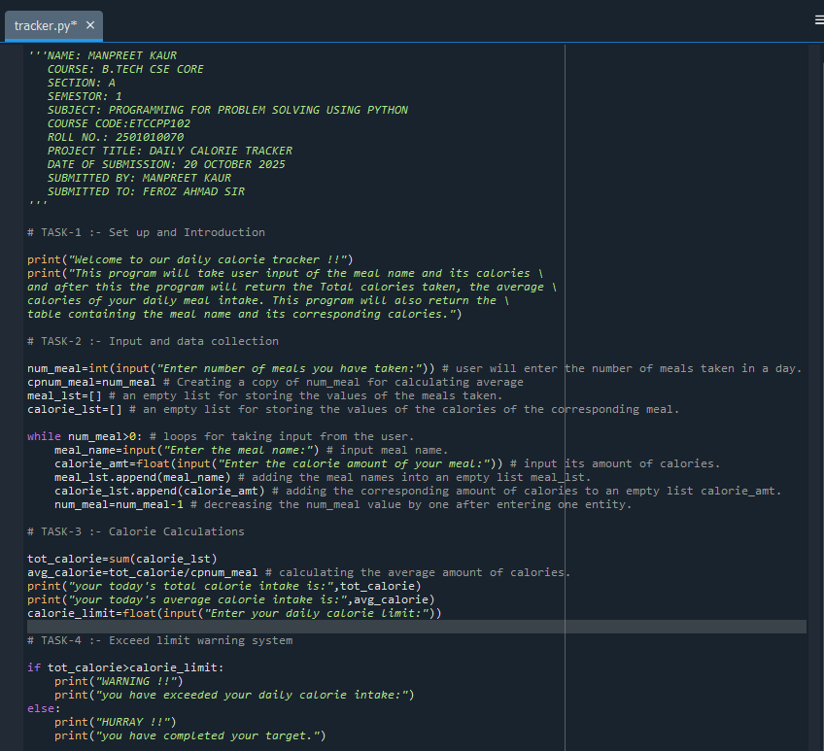

**OUTPUT :-**

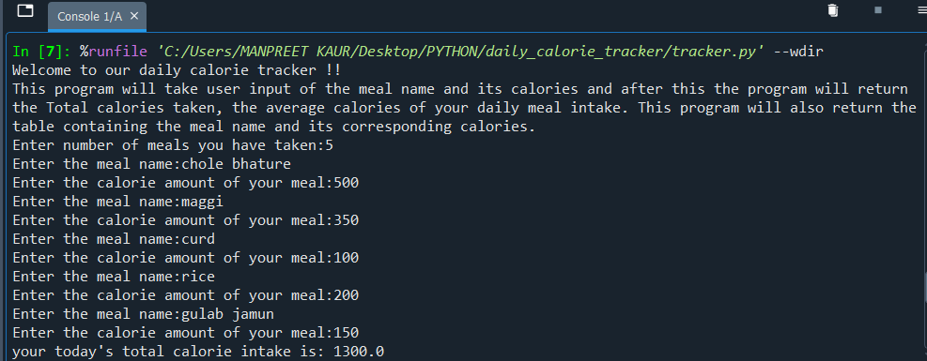

* **TASK-5 :- NEATLY FORMATTED OUTPUT :-**

**INPUT :-**

**In Task-5 I have to display the output in the tabular form in neat way so I have run a loop and printed the output in tabular form along with the total calories consumed and the average calories consumed.**

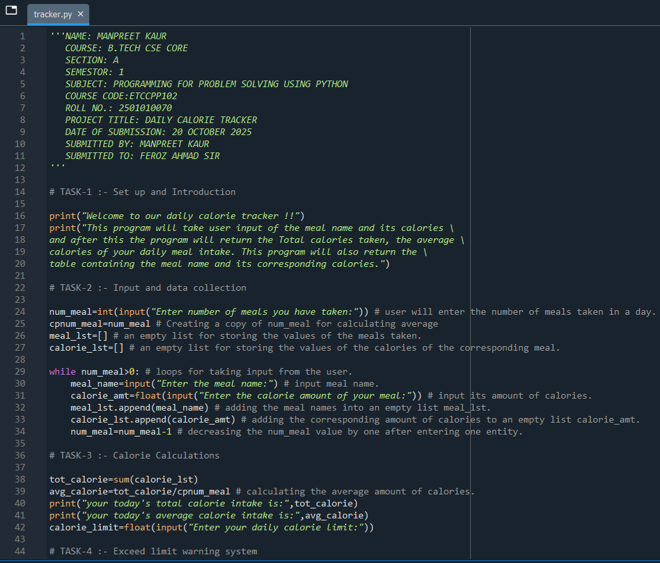

**OUTPUT :-**

**The 3 different outputs of the complete code is shown below :-**

1. **First Run:-**

1. **Second Run:-**

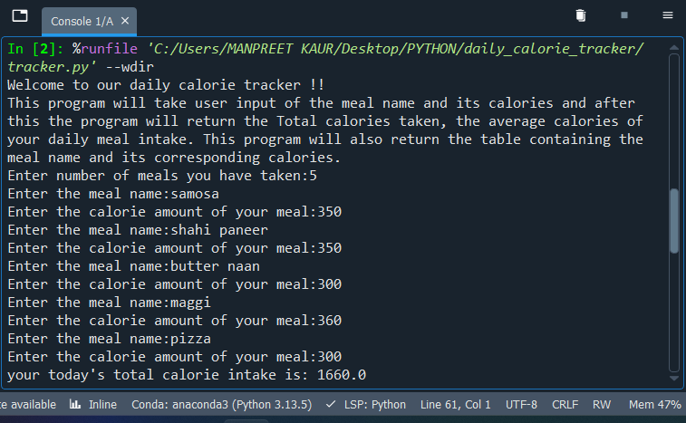

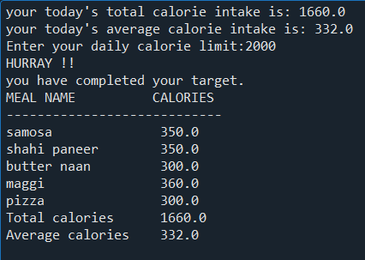

1. **Third Run:-**

**THANK YOU !!**