

Programming for problem solving using python
B.TECH CSE CORE SECTION (A) SEMESTER - 1
Course code : ETCCPP102
ASSIGNMENT NO. : 2
ASSIGNMENT TITLE : grade book analyzer
SUBMITTED BY : MANPREET KAUR
SUBMITTED TO : FEROZ AHMAD SIR
DATE OF SUBMISSION : 5 december 2025

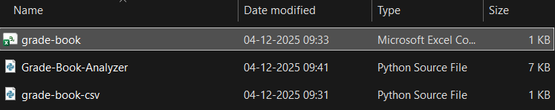
GRADE-BOOK-ANALYZER.PY
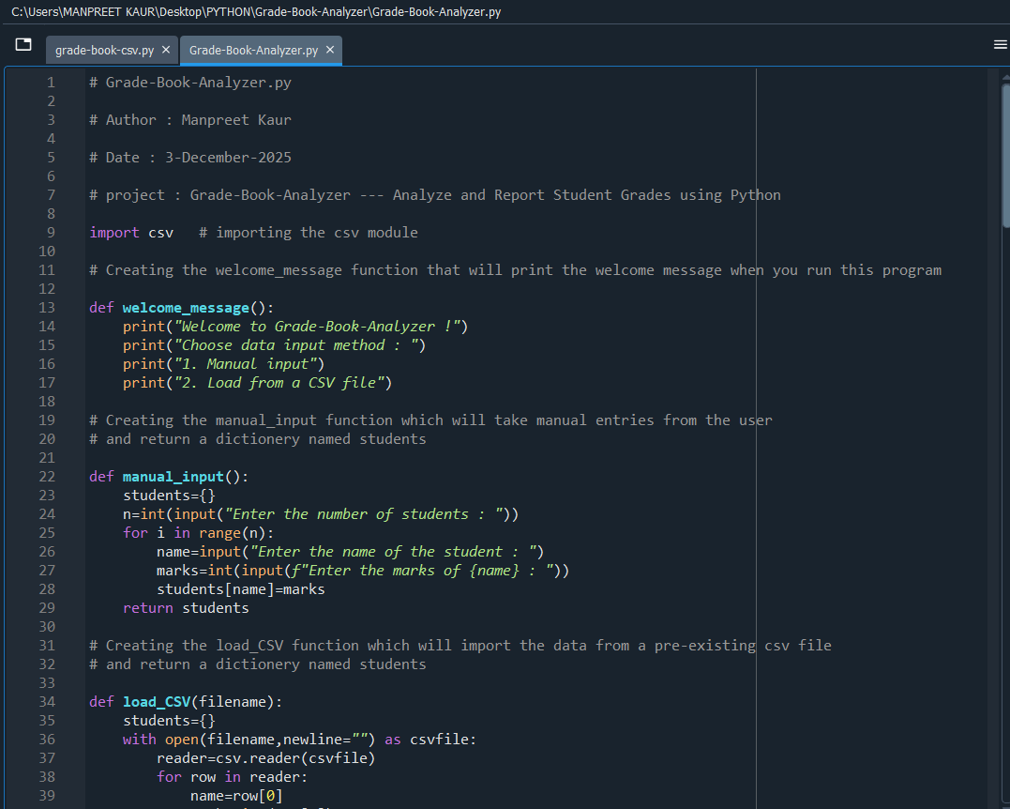
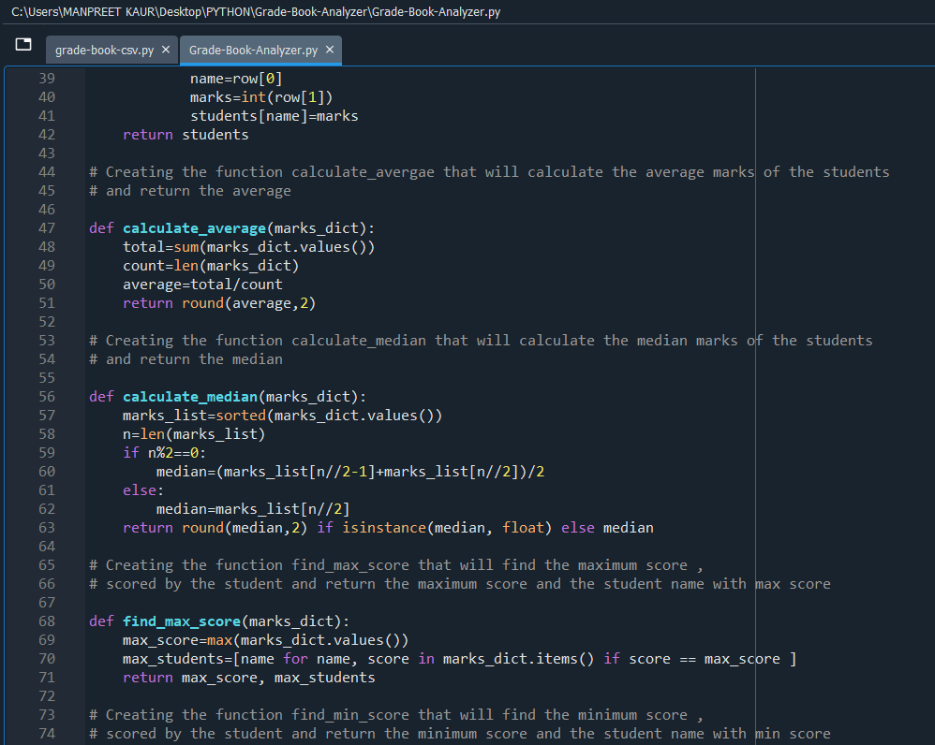
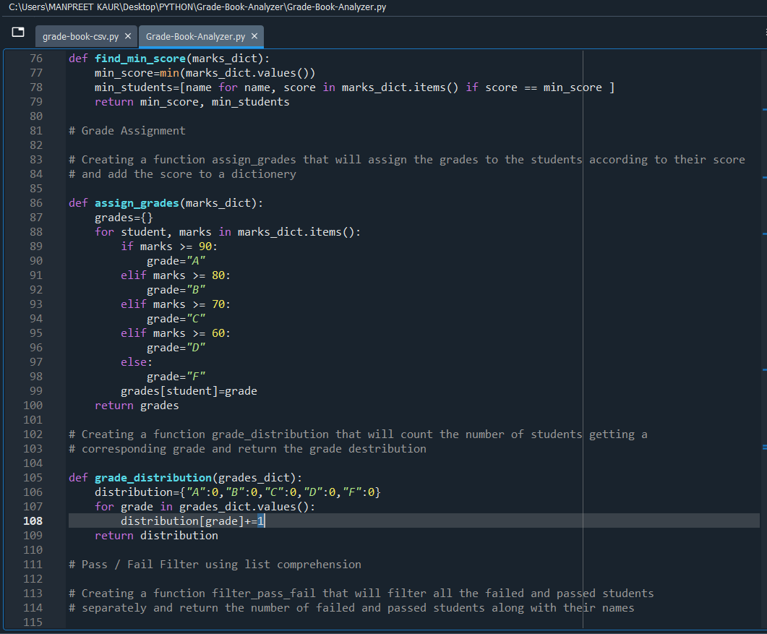
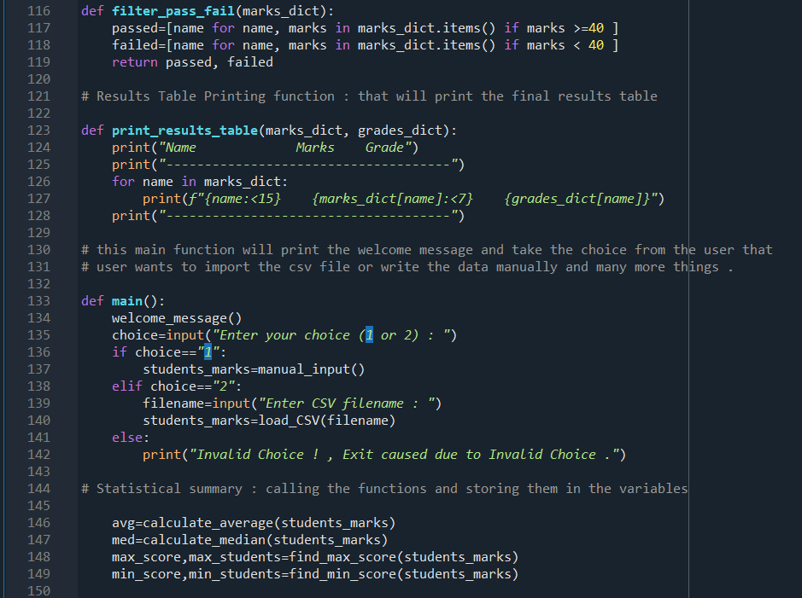
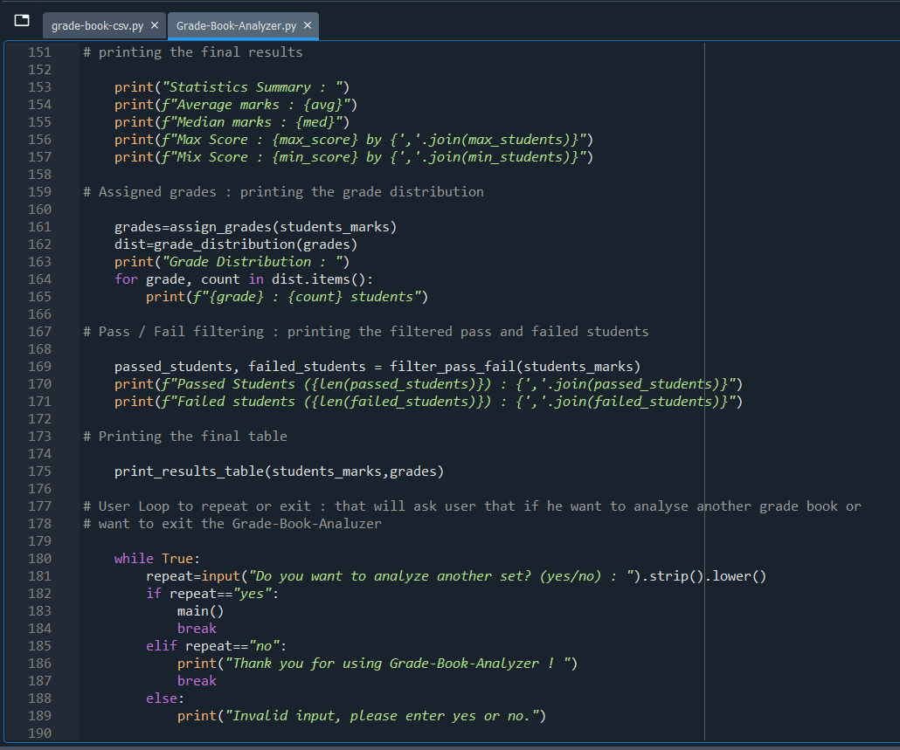
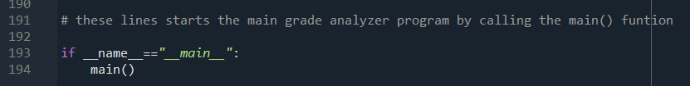
GRADE-BOOK-CSV.PY
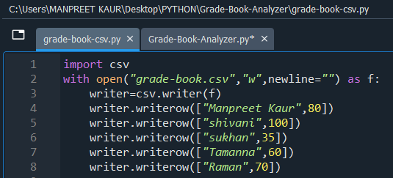
GRADE-BOOK-CSV.CSV
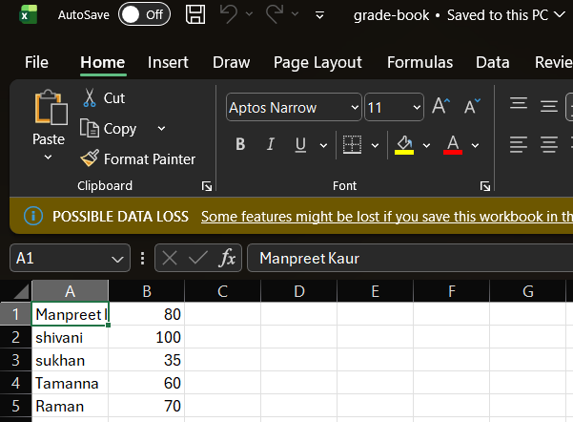
OUTPUT
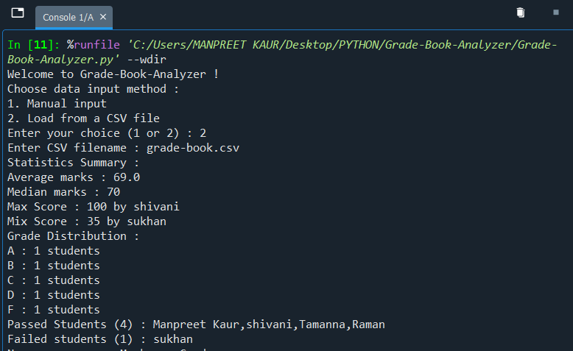
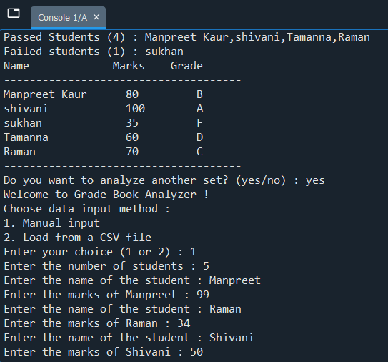
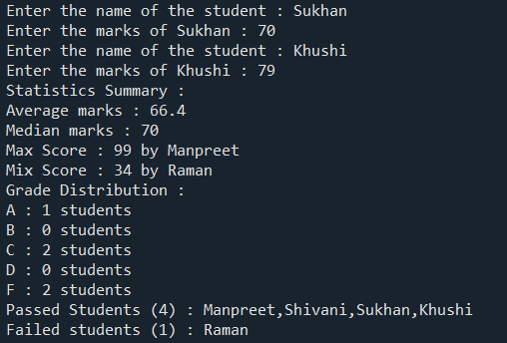
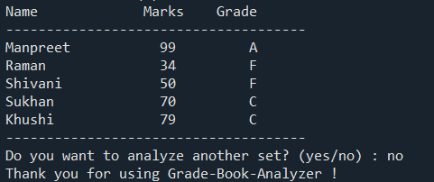

THANK YOU !

