

**COMPUTER SCIENCE FUNDAMENTAL AND CAREER PATHWAYS**

**B.TECH CSE CORE SECTION (A) SEMESTER-I**

**COURSE CODE: ETCCCP105**

**ASSIGNMENT NO. : 1**

**ASSIGNMENT TITLE: DESIGN AND SIMULATE A REAL-WORLD PROCESS USING FLOWCHARTS**

**SUBMITTED BY SUBMITTED TO**

**MANPREET KAUR RAJESH KUMAR SIR**

**ROLL NO. 2501010070**



**INTRODUCTION:-**

**LIBRARY BOOK BORROWING SYSTEM**

In a student's life there is a great importance of a library. Library is a place where they can go and study without any disturbance. Students can borrow books from the library for their study and can read these books while sitting there also. My problem statement is **" *LIBRARY******BOOK BORROWING SYSTEM* "**,this is a system in which students can search books, borrow books, return books etc. Then the records will be maintained in the library records and will be updated on any new issuance or return of the books. Every student will have a library membership due to which every student can do all the above mentioned things.

**PROBLEM ANALYSIS:-**

* **ABSTRACTION:-**

The " Library Book Borrowing System " have following essential elements :-

* Book Management
* Members Management
* Issuing Books
* Returning Books
* Searching Books
* Reports Making and Updating
* **DECOMPOSITION:-**

All the above mentioned essential elements can be decomposed in the following way:-

* BOOK MANAGEMENT:-

The BOOK MANAGEMENT includes the storing of the details of the books, adding new books on arrival, removing old books and books those are in bad conditions and adding new edition of these books.

* MEMBERS MANAGEMENT:-

The MEMBERS MANAGEMENT includes adding new members and updating their records in the library record and including all the necessary details of the student in the library record.

* ISSUING BOOKS:-

The ISSUING BOOKS includes the searching for the book and checking for its availability and then borrowing or issuing the books to the student. The book will be issued if the student

have not exceeded the issued books limits (for example: 5 books at a time).

* RETURNING BOOKS:-

Before the time period gets over, the student must return the book back to the library (let say after 15 days). If the student fails to do then he/she have to pay the fine on exceeding the day limit and the fine will be applied on daily basis (let say 10 RS. per day).

* SEARCHING BOOKS:-

The students can search the books and check that the particular book is available in the library or not.

* REPORT MAKING:-

The librarian have to make the detailed reports about everything like which book is issued, which book is returned, which book is available which book is not and which book is old or in bad condition and is to be replaced or changed etc. They also have to maintain and update the students account that who have issued books and returned book and how many books they have issued and to check for the fine amount of the students who have not returned the book within the time limit.

* **PATTERN RECOGNITION:-**

In this part, we have to recognize the pattern in our problem.

This problem follows the pattern that is explained below in detail:-

Each person who want to issue books etc he/she have to take the membership of the library

and have to submit all their details to the library for the management of the student accounts.

After that the Student can search the required book and check for its availability and issue the book if the book is available in the library. The students can issue the limited amount of books at one time (for example 5 books at a time). They have to return the book within the time limit, otherwise they have to give the fine that will apply on the daily basis (let say 10 RS. per day). All these details will get updated in the library records.

**SOLUTION DESIGN:-**

**[A] FLOWCHART:-**

The flowchart representation of the above mentioned problem is displayed below:-

**YES**

**UPDATE RECORDS**

**ISSUE FINE RECEIPT AND RETURN THE BOOK**

**BOOK RETURN SUCCESSFUL**

**NO**

**EXCEED THE DAY LIMIT?**

**RETURNING THE BOOK**

**ISSUE THE BOOK**

**BOOK CANNOT BE ISSUED. YOU HAVE EXCEEDED THE BOOK LIMIT.**

**NO**

**YES**

**EXCEEDED THE BOOK LIMIT ?**

**BOOK NOT AVAILABLE**

**NO**

**YES**

**IF THE BOOK IS AVAILABLE OR NOT?**

**SEARCHING FOR THE REQUIRED BOOK**

**TAKE LIBRARY MEMBERSHIP**

**[B] PSEUDO-CODE:-**

The pseudo-code of the above shown flowchart is explained below.

1. START
2. Take Library Membership
3. Search for the Book
4. IF the Book is available
5. Check that the person exceed the book limit
6. IF exceed the book limit
7. PRINT "Book cannot be issued. you exceeded the book limit."
8. ELSE
9. PRINT "Book issued successfully."
10. END NESTED IF
11. ELSE
12. PRINT "Book not available."
13. returning the book
14. IF exceed the day limit
15. PRINT "Fine issued and book returned."
16. ELSE
17. PRINT "Book returned successfully."
18. END NESTED IF
19. UPDATE THE RECORDS
20. END IF
21. END

**IMPLEMENTATION:-**

The implementation of the above problem is shown in the following screenshot of the python code along with its output.

Please find my GITHUB repository link along with this:-

**GITHUB REPOSITORY:-**

<https://github.com/manpreetkaur292006-design/LIBRARY-BOOK-BORROWING-SYSTEM>

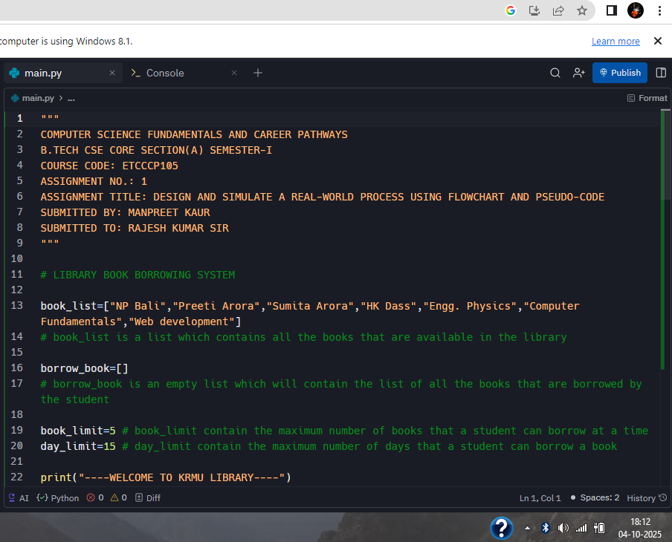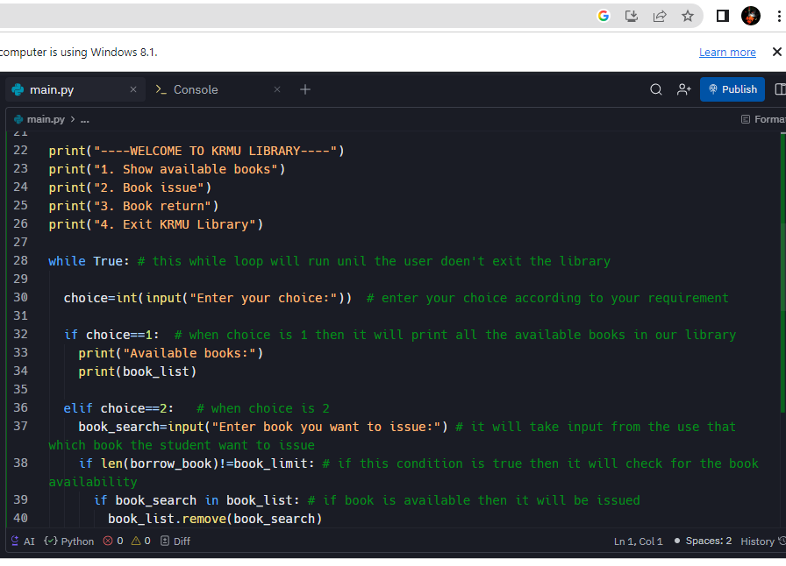

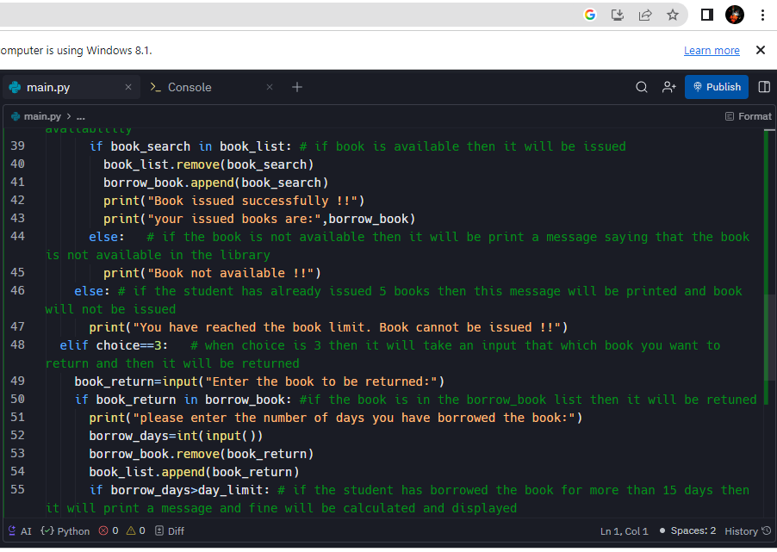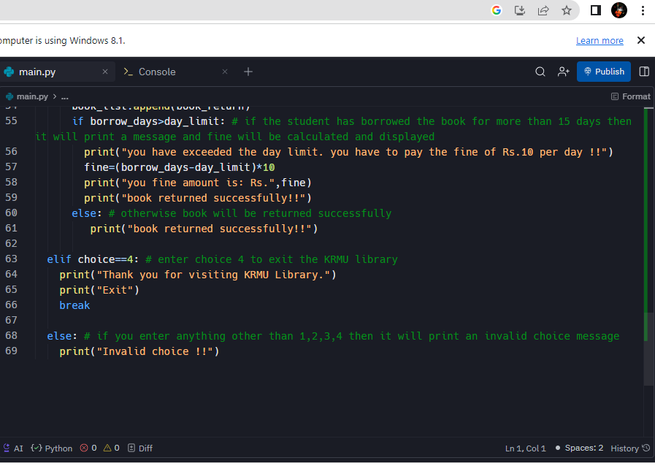

The output of the above code is shown below:-

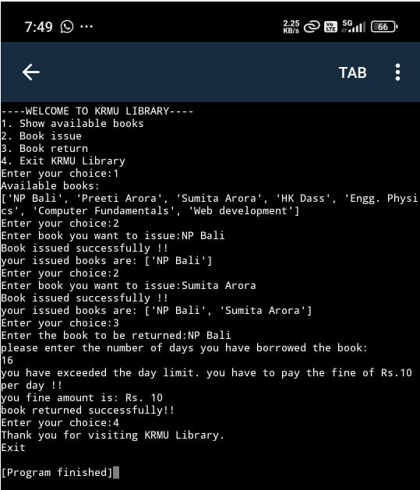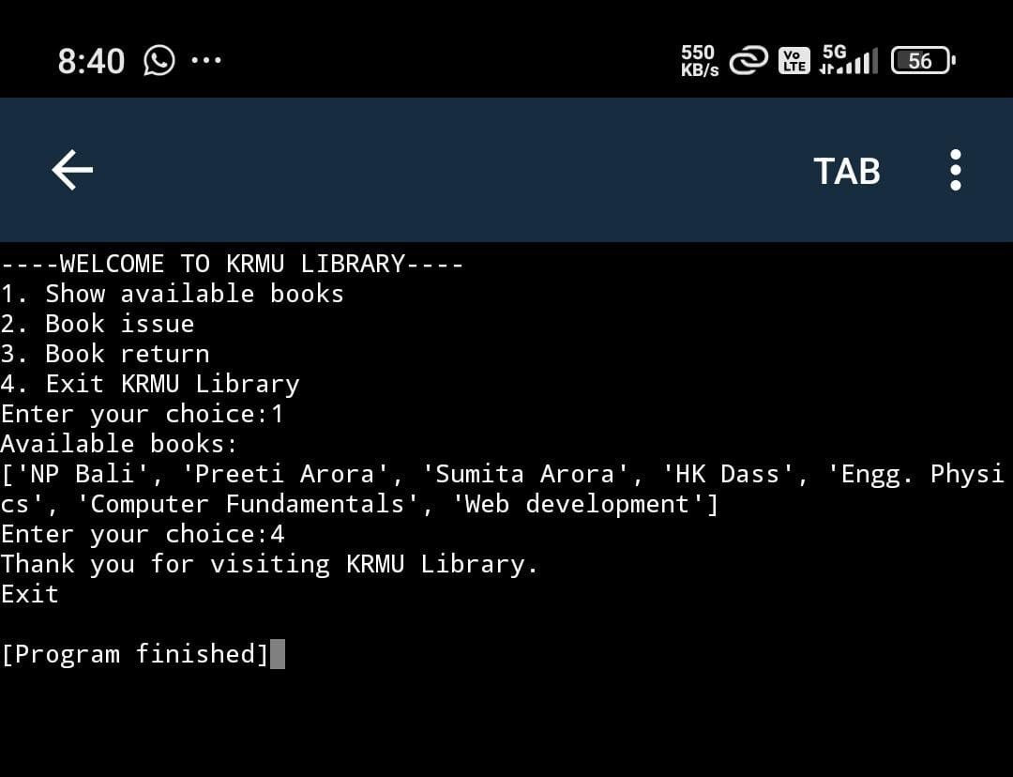

**REFLECTION:-**

**The challenges faced me while doing this assignment is that, it took a lot of time for me to find that how the library management system works i.e. what are the things included in the library management system and the schedule of the library.**

**I have understood the concept of all the steps of computational thinking in detail while doing this assignment and I improved my flowchart making skills, pseudo-code writing skills and Researching skills.**

**This project also helped me in recapping the while loop in python and revising topics like append and remove functions in lists , loops and if-else statements.**

**In a nutshell, I have improved my knowledge, computational thinking skills and python programming skills by the completion of this assignment.**

THANK YOU !!