

**PDF BOOKMARK SAMPLE**

|  |  |
| --- | --- |
| **Sample Date:** | May 2001 |
| **Prepared by:** | Accelio Present Applied Technology |
| **Created and Tested Using:** | • Accelio Present Central 5.4  • Accelio Present Output Designer 5.4 |
| **Features Demonstrated:** | • Primary bookmarks in a PDF file.  • Secondary bookmarks in a PDF file. |

**Overview**

This sample consists of a simple form containing four distinct fields. The data file contains eight separate records.

By default, the data file will produce a PDF file containing eight separate pages. The selective use of the bookmark file will produce the same PDF with a separate pane containing bookmarks. This screenshot of the sample output shows a PDF file with bookmarks.

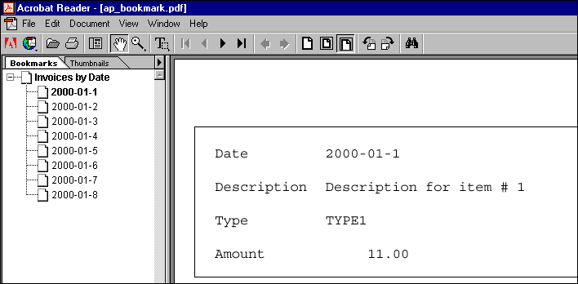

The left pane displays the available bookmarks for this PDF. You may need to enable the display of bookmarks in Adobe Acrobat Reader by clicking **Window > Show Bookmarks**.

Selecting a date from the left pane displays the corresponding page within the document.

Note that the index has been sorted according to the specification in the bookmark file, and that pages within the file are created according to the original order in the data file.

PDF Bookmark Sample Page 1 of 4



***Sample Data File***

^reformat trunc   
^symbolset WINLATIN1   
^field trans_date   
2000-01-1   
^field description   
Description for item #1 ^field trans_type   
TYPE1   
^field trans_amount   
11.00   
^page 1   
^field trans_date   
2000-01-2   
^field description   
Description for item #2 ^field trans_type   
TYPE2   
^field trans_amount   
11.00   
^page 1   
^field trans_date   
2000-01-3   
^field description   
Description for item #3 ^field trans_type   
TYPE3

***Sample Bookmark File***

[invoices]   
Invoices by Date=0   
trans_date=1,A   
[type]   
Invoices by Item Type=0   
trans_type=1,A   
[amount]   
Invoices by Transaction Amount=0 trans_amount=1,D

The example bookmark file includes three distinct sections:

• Invoices sorted, ascending, by date.

• Invoices sorted, ascending, by item type.

• Invoices sorted, descending, by transaction amount.

PDF Bookmark Sample Page 2 of 4



**Sample Files**

This sample package contains:

|  |  |
| --- | --- |
| **Filename** | **Description** |
| ap_bookmark.IFD | The template design. |
| ap_bookmark.mdf | The template targeted for PDF output. |
| ap_bookmark.dat | A sample data file in DAT format. |
| ap_bookmark.bmk | A sample bookmark file. |
| ap_bookmark.pdf | Sample PDF output. |
| ap_bookmark_doc.pdf | A document describing the sample. |

**Deploying the Sample**

To deploy this sample in your environment:

1. Open the template design **ap_bookmark.IFD** in Output Designer and recompile the

template for the appropriate presentment target.

2. Modify the **-z** option in the **^job** command in the data file **ap_bookmark.dat** to:

|  |  |
| --- | --- |
| •  •  • | Identify the target output device.  Identify the bookmark file using the **-abmk** command.  Identify the section for which to generate bookmarks, if desired, using the **-abms** command. |

For example,

|  |  |
| --- | --- |
| **To bookmark by …** | **Use the command line parameter …** |
| Invoices | **-abmk**ap_bookmark.bmk **-abms**invoices |
| Type | **-abmk**ap_bookmark.bmk **-abms**type |
| Amount | **-abmk**ap_bookmark.bmk **-abms**amount |

PDF Bookmark Sample Page 3 of 4



3. Place the accompanying files in directories consistent with your implementation:

• Place **ap_bookmark.IFD** in the **Designs** subdirectory for Output Designer.

• Place **ap_bookmark.mdf** in the forms subdirectory accessible to Central.

• Place **ap_bookmark.bmk** in an addressable directory.

**Running the Sample**

• To run this sample, place **ap_bookmark.dat** in the collector directory scanned by Central.

PDF Bookmark Sample Page 4 of 4