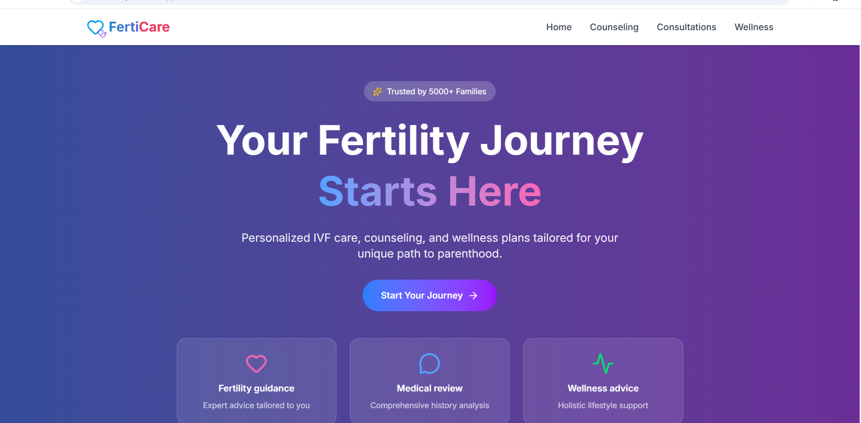

Hero heading: Your Journey to Parenthood Starts Here

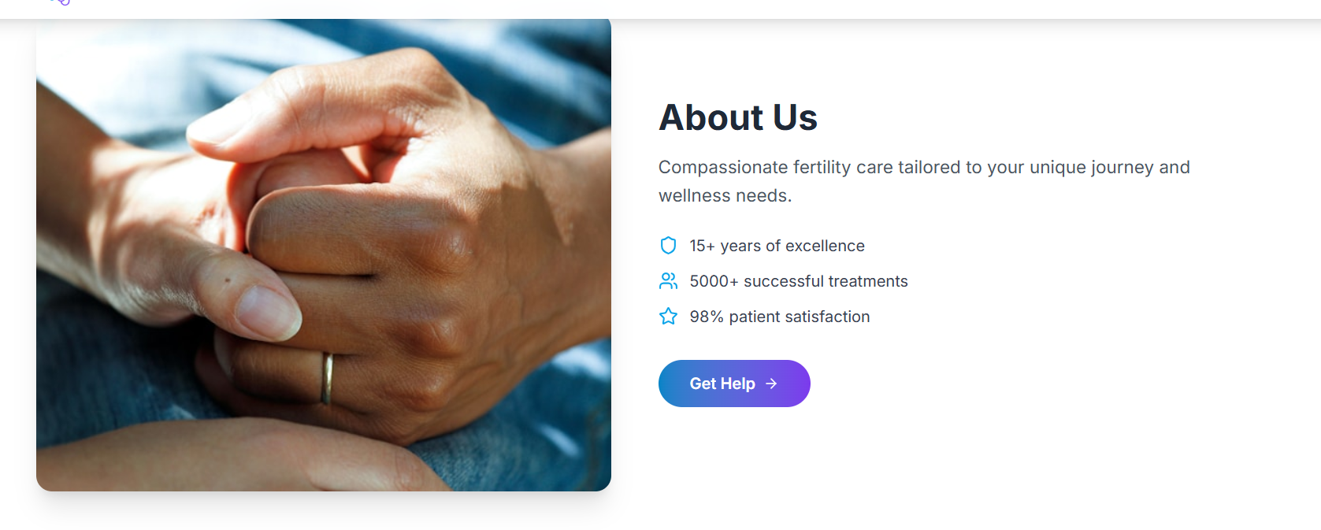
Under About Us
Compassionate Fertility Care, Backed by Expertise
At FertiCare, we understand that every fertility journey is unique. That’s why we combine medical expertise, emotional support, and personalized guidance to help you move forward with confidence.
Whether you're just starting to explore your options or actively seeking treatment, our platform connects you with the right specialists, the right information, and the right care, at the right time.

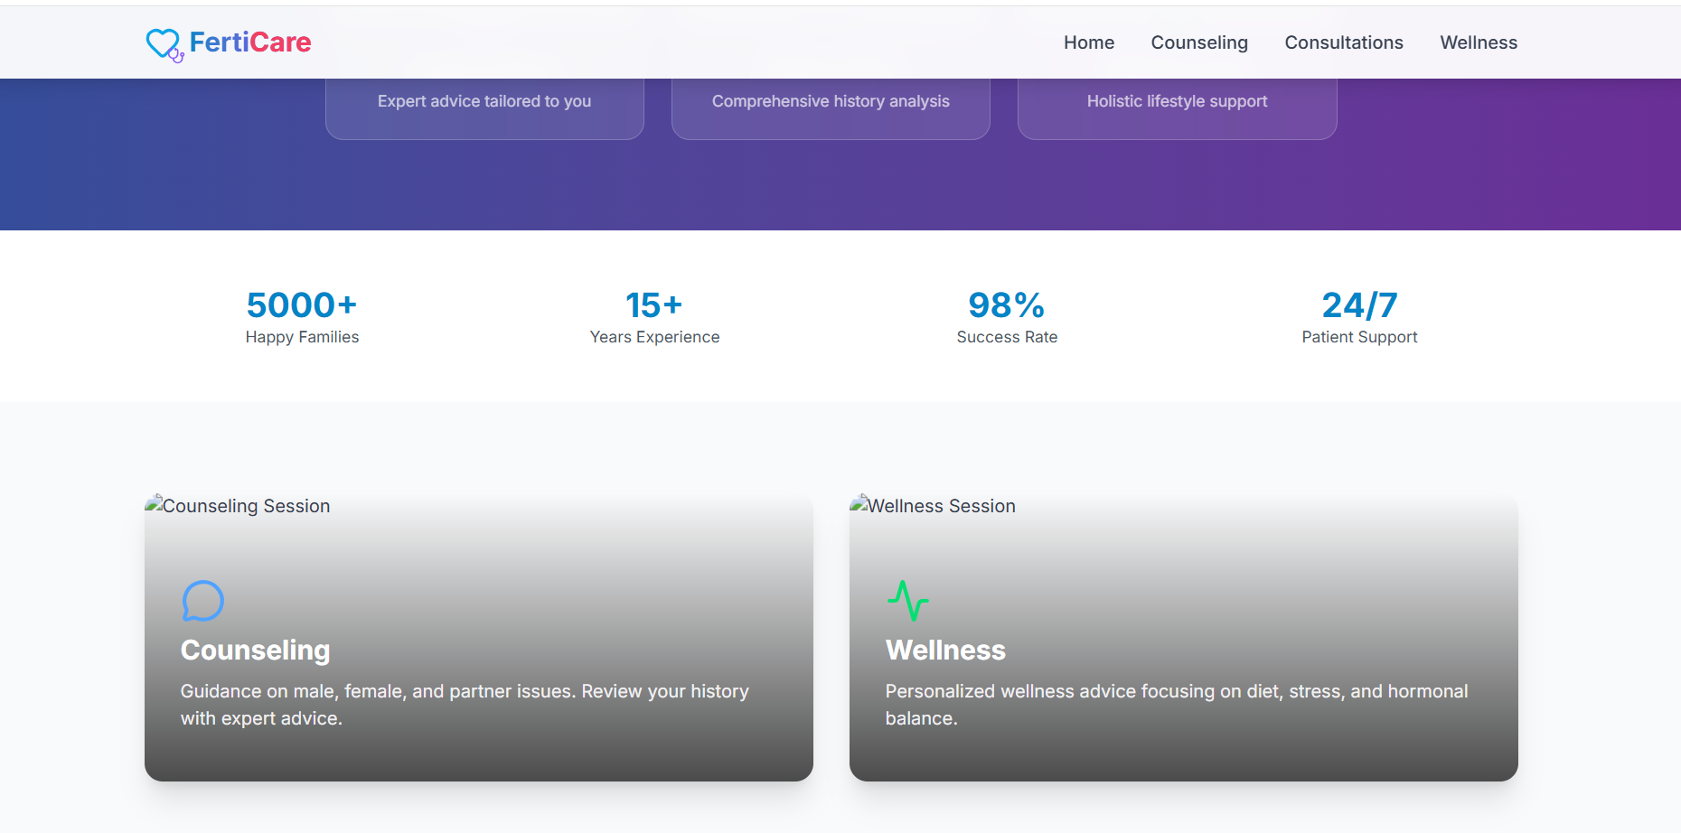

How It Works
Start Your Journey in 3 Simple Steps
Understand Your Fertility
Access expert-backed information to better understand your body, options, and next steps.
Connect with Specialists
Find and consult with verified fertility experts who guide you through every stage.
Move Forward with Confidence
Get personalized treatment plans, continuous support, and complete transparency.

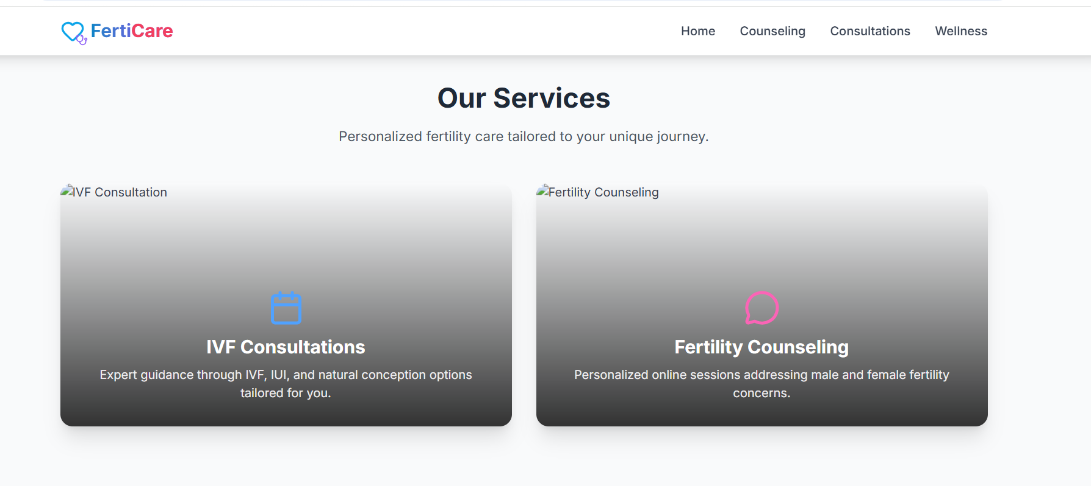

Our Services

Comprehensive Fertility Solutions
From diagnosis to advanced treatments, we offer end-to-end fertility care tailored to your needs.
Please check if the below content could be used as a service :--
- Fertility Assessment
Identify underlying concerns with detailed diagnostics and expert evaluation.
- IVF Treatment
Advanced assisted reproductive techniques with high success rates.
- IUI Procedure
A less invasive option designed to improve your chances of conception.
- Egg & Sperm Freezing
Preserve your fertility for the future with safe and reliable methods.
- Genetic Testing
Ensure healthier outcomes with advanced screening technologies.

Kindly add this section on home page

Why Families Trust FertiCare
- Verified fertility experts and clinics
- Personalized guidance at every stage
- Transparent process with no hidden confusion
- Emotional and medical support combined
- Seamless digital experience

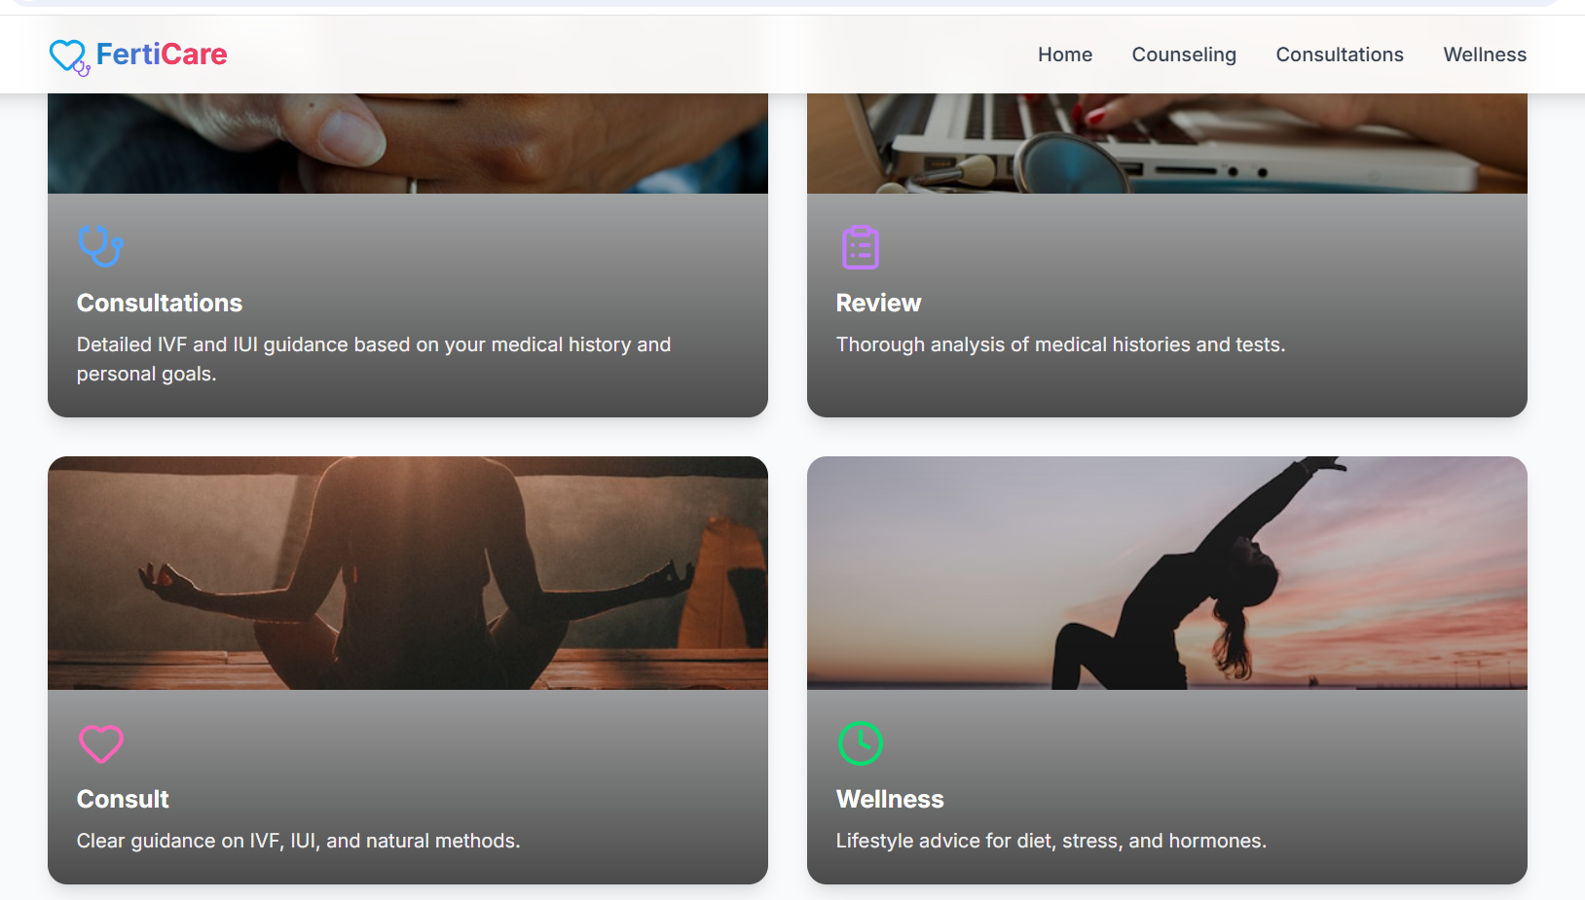

1. Initial Consultation
Personalized fertility consultation based on your medical history, lifestyle, and goals to identify the right path forward.

2. Medical Review
In-depth evaluation of reports, test results, and past treatments to build a clear and accurate fertility plan.

3. Treatment Guidance
Expert recommendations on IVF, IUI, or natural methods, helping you choose what works best for your body and situation.

4. Wellness Support
Holistic support covering nutrition, stress management, and hormonal balance to improve overall fertility health.

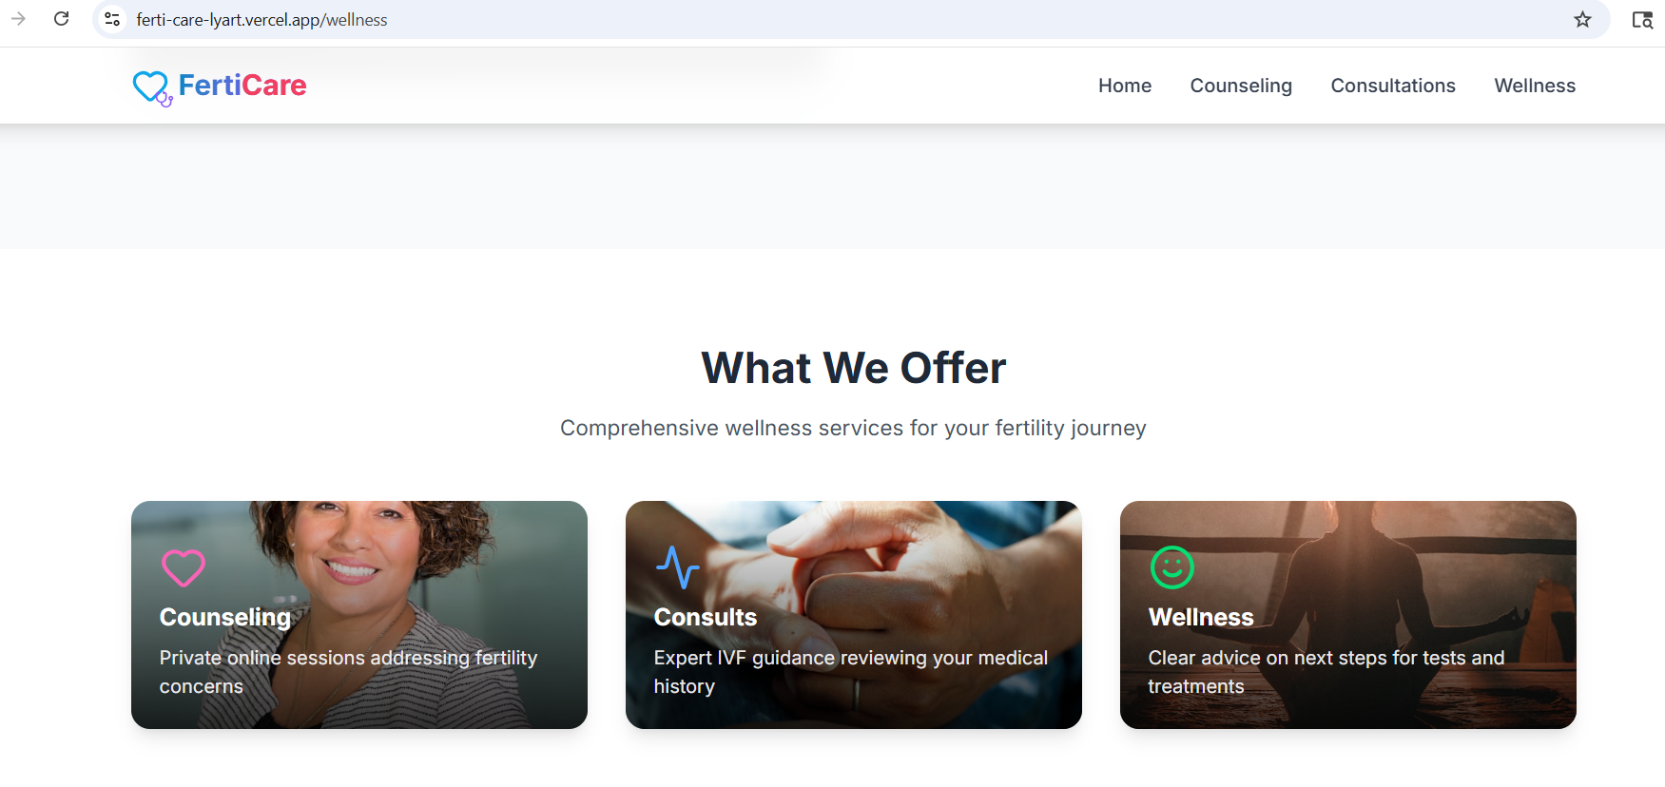
1. Fertility Nutrition
Tailored nutrition plans designed to nourish your body for optimal fertility
2. Mind-Body Wellness
Holistic techniques to reduce stress and enhance emotional wellbeing
3. Hormonal Wellness
Supportive lifestyle changes to maintain balance and improve reproductive health
4. Lifestyle Optimization
Healthy routines and habits that strengthen your overall fertility journey

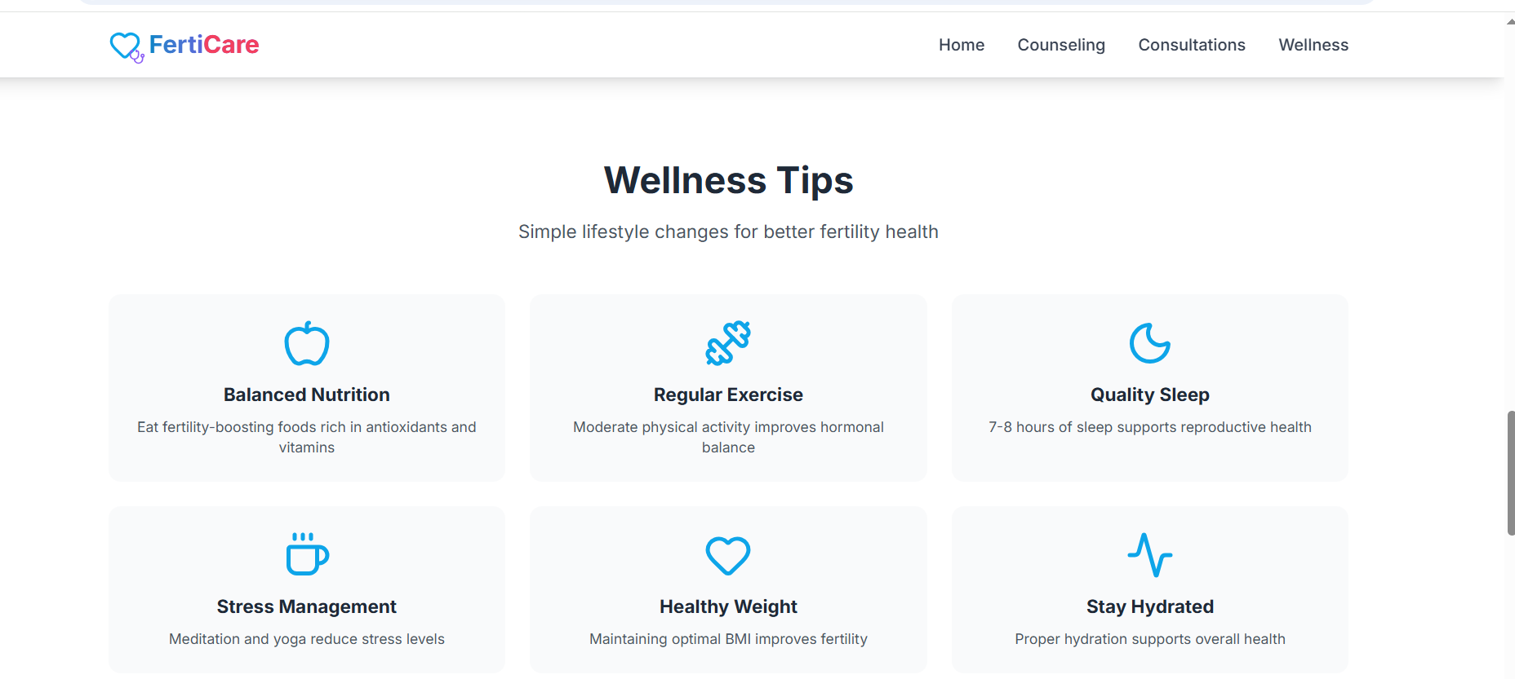

1. Balanced Nutrition
Nourish your body with fertility-supporting foods rich in essential nutrients, antioxidants, and healthy fats

2. Regular Movement
Incorporate mindful physical activity to improve circulation, hormonal balance, and overall vitality

3. Restorative Sleep
Prioritize deep, consistent sleep to support hormonal regulation and reproductive health

4. Stress Balance
Adopt calming practices like mindfulness and yoga to reduce stress and support emotional wellbeing

5. Optimal Weight
Maintain a healthy body composition to enhance hormonal function and improve fertility outcomes

6. Hydration & Detox Support
Stay well-hydrated to support metabolism, detoxification, and overall reproductive health

