Screenshots
- running container
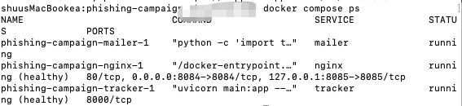
- landing page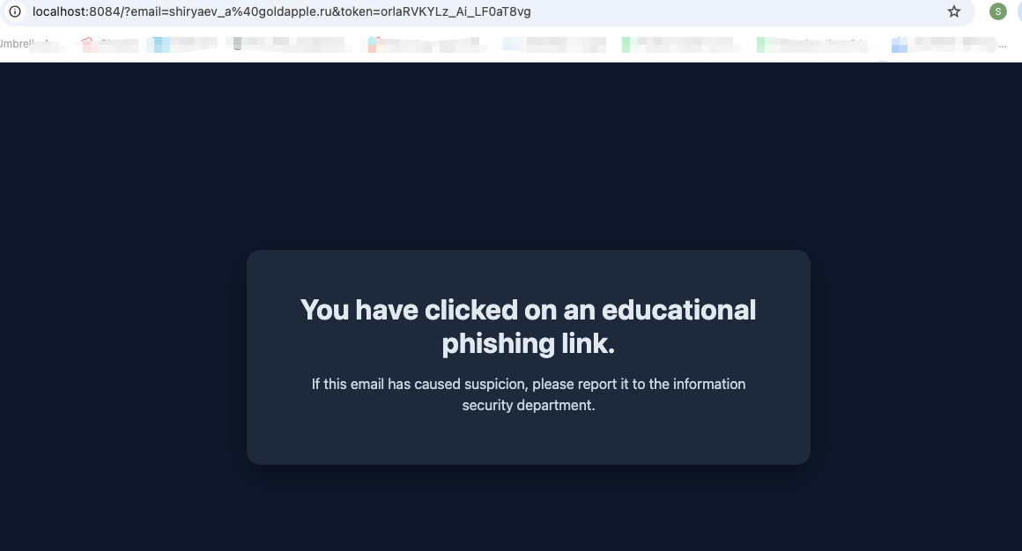
- database information
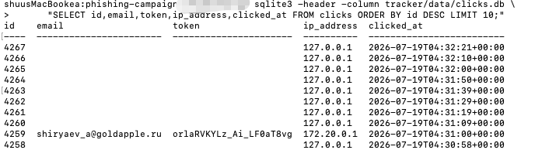
- mailer sent log
- Sent mail
