

21-Day MERN Stack with AI Internship

Internship Report

Man Rami ( AD PATEL INSTITUTE OF TECHNOLOGY)

Day 1 – Introduction to AI & Setup

- Install Python, VS Code and Git

- Python Installation

Step 1: Open the official Python website
Go to: Python Official Website
You’ll see a yellow “Download Python” button.

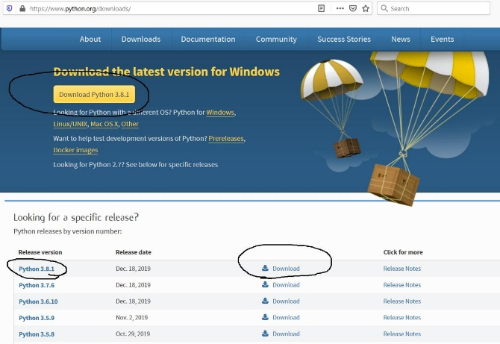

Step 2: Download Python
- Click Download Python
- Wait for the .exe file to download

Step 3: Run the Installer
VERY IMPORTANT:
✅ Tick “Add Python to PATH”

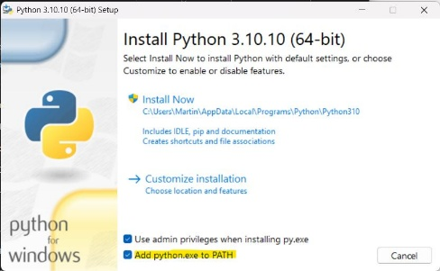

Step 4: Verify Installation
Open Command Prompt and type:
python --version
If installed correctly, you’ll see something like:
Python 3.13.0
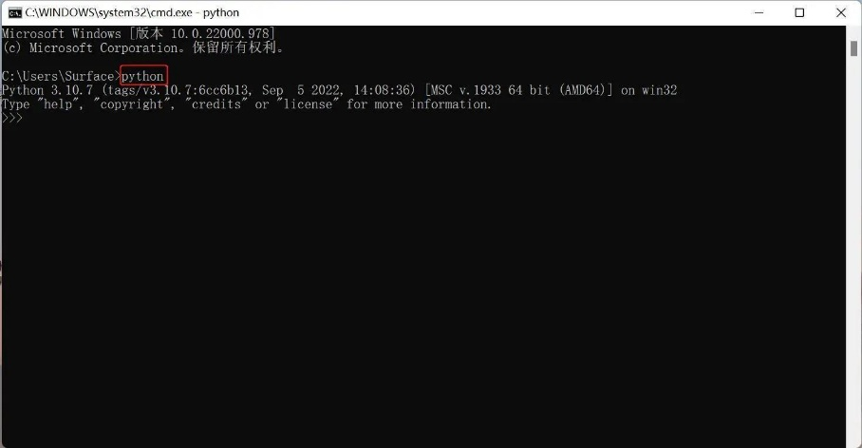

- Visual Code Installation

Step 1: Open VS Code website
Go to: Visual Studio Code
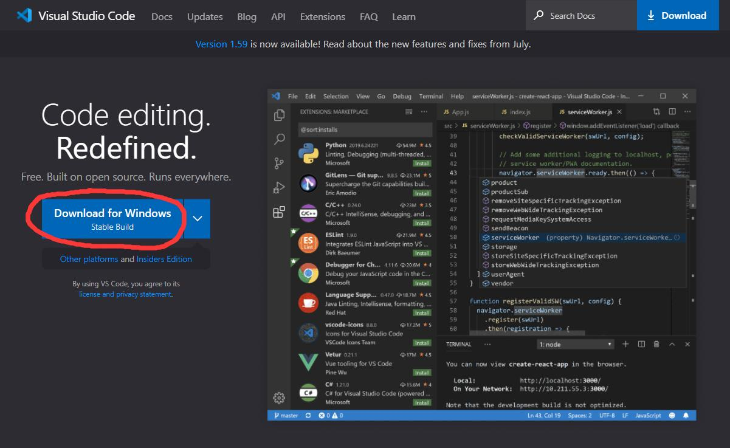

Step 2: Download VS Code
- Click Download for Windows

Step 3: Run Installer
During installation:
✅ Tick these options:
- Add to PATH
- Register Code as editor
- Create Desktop Icon
Then click:
- Next
- Install
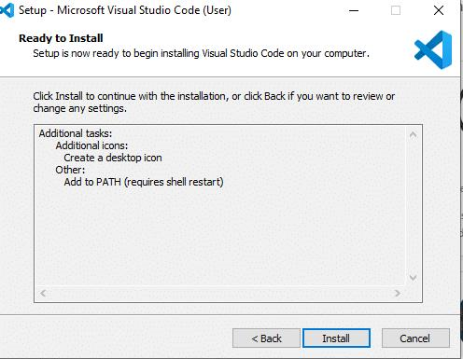

Step 4: Open VS Code
After installation:
- Launch VS Code
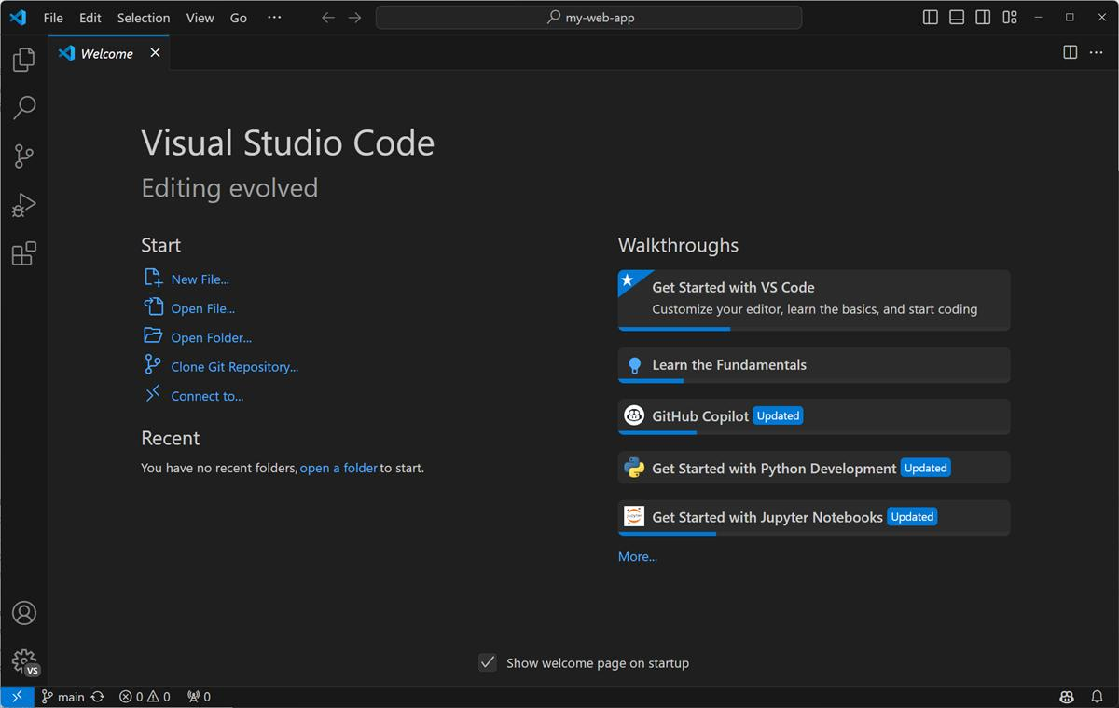

- Install Git

Step 1: Open Git website
Go to: Git Official Website
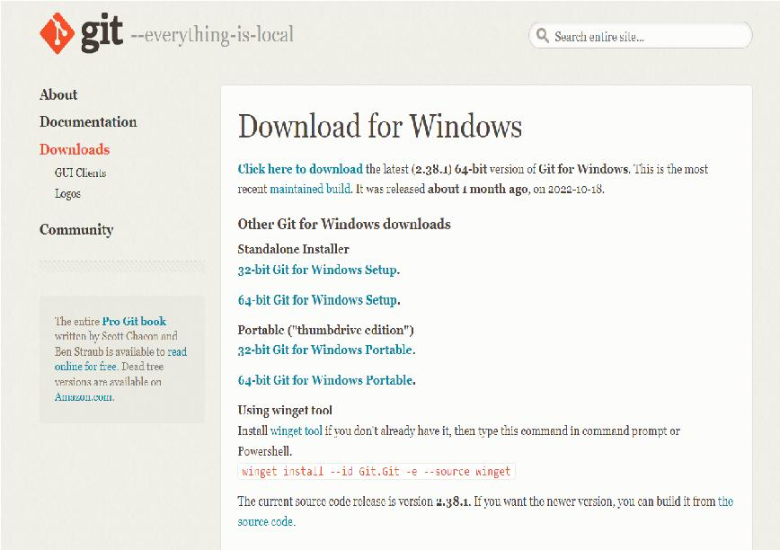

Step 2: Download Git
Click Download for Windows
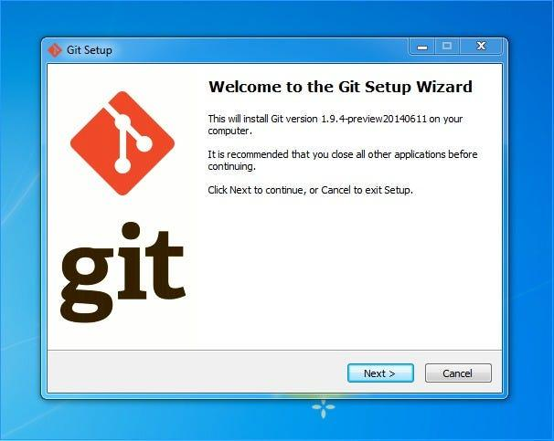
Step 3: Install Git
Mostly keep clicking:
- Next
- Next
- Install
Recommended:
✅ Select Git from command line
Step 4: Verify Git
Open Command Prompt and type:
git --version
You should see:
git version 2.xx.x

2. Create GitHub Account
- Open https://github.com
- Click on “Sign Up”
- Enter:
  - Your email
  - Password
  - Username
- Verify your email address from Gmail
- Complete the captcha/security verification
- Skip or complete the personalization questions
- Your GitHub account is now created
- Click on your profile picture → “Your repositories”
- Click “New” to create your first repository
- Enter repository name and click “Create Repository”
- Open VS Code
- Go to Accounts → “Sign in with GitHub”
- Authorize VS Code in browser
- GitHub is now connected with VS Code

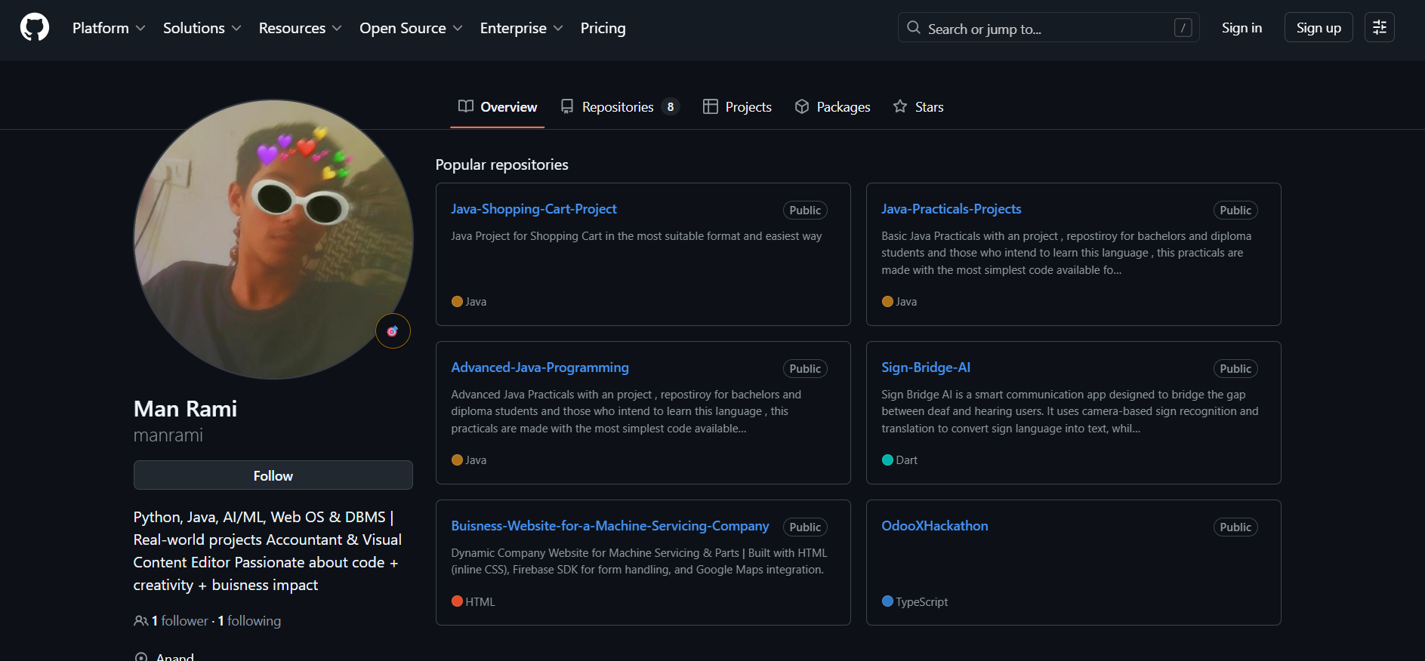

3. Understand AI,ML, DeepLearning Basics

- Artificial Intelligence (AI)
  - AI means making computers think and act like humans
  - Example:
    - ChatGPT
    - Self-driving cars
    - Voice assistants like Siri
- Machine Learning (ML)
  - ML is a subset of AI
  - Instead of programming every rule, we train the computer using data
  - Example:
    - Spam email detection
    - Netflix recommendations
    - YouTube suggestions
- Deep Learning (DL)
  - DL is a subset of Machine Learning
  - Uses Neural Networks inspired by the human brain
  - Works very well with:
    - Images
    - Voice
    - Videos
    - Large AI models
- Simple Difference
  - AI = Smart machines
  - ML = Learning from data
  - DL = Advanced ML using neural networks
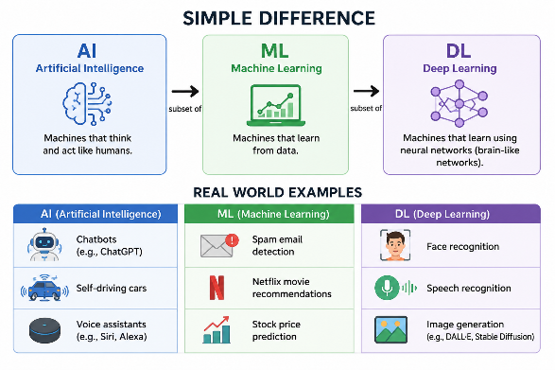
- Real World Examples
  - AI:
    - Chatbots
    - Robots
  - ML:
    - Stock prediction
    - Fraud detection
  - DL:
    - Face recognition
    - ChatGPT
    - Self-driving systems
- Main Things to Learn
Step 1:
  - Python
Step 2:
  - Math basics
    - Linear Algebra
    - Probability
    - Statistics
Step 3:
  - Libraries
    - NumPy
    - Pandas
    - Matplotlib
Step 4:
  - Machine Learning
    - Regression
    - Classification
    - Clustering
Step 5:
  - Deep Learning
    - Neural Networks
    - TensorFlow
    - PyTorch
- Popular AI/ML Tools
  - Python
  - Jupyter Notebook
  - VS Code
  - Google Colab
  - TensorFlow
  - PyTorch
- Beginner Roadmap
  - Learn Python
  - Learn data handling
  - Learn ML algorithms
  - Build projects
  - Learn Deep Learning
  - Build AI applications
- Beginner Projects
  - Spam classifier
  - Face detection
  - Chatbot
  - AI image generator
  - Recommendation system
- Goal
- AI = Intelligence
- ML = Learning
- DL = Brain-like learning

4. Run First Python Program

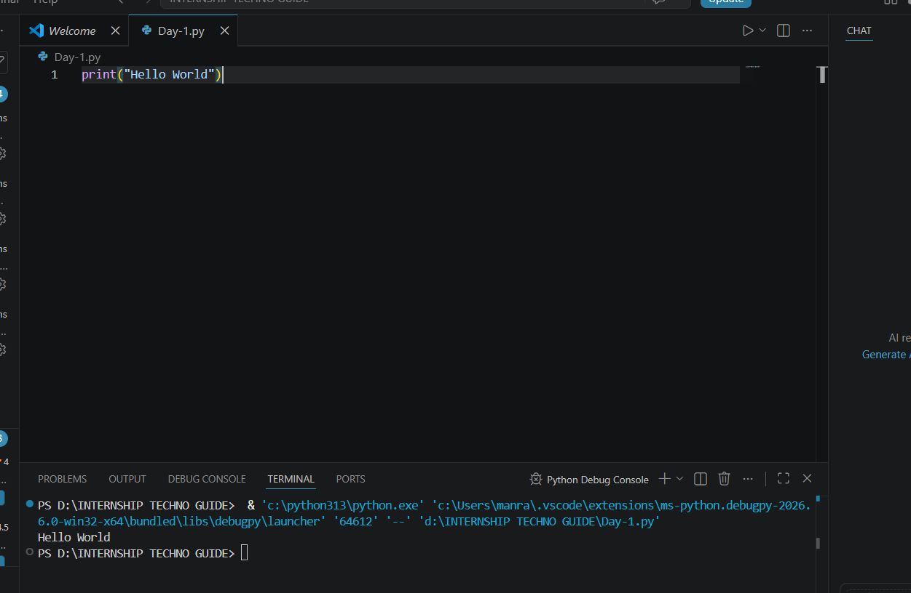

5. Conclusion
Successfully installed:
- Python
- VS Code
- Git

Created:
- GitHub account

Learned basics of:
- Artificial Intelligence (AI)
- Machine Learning (ML)
- Deep Learning (DL)

Understood:
- Difference between AI, ML, and DL
- Real world applications

Completed:
- First Python program setup
- Fixed VS Code Python execution issue
- Ran “Hello World” successfully
Now the development environment is fully ready for:
- Python programming
- AI/ML learning
- Deep Learning projects
- GitHub project management
- Future software development and automation

Nextstep:
Start learning Python fundamentals and build small projects consistently 🚀

Day – 2 Python Basics

1. Learn variables, loops, conditions.

1. Variables
Variables are used to store data in programming.
Example:
- Name
- Age
- Marks
- City
Python automatically detects the data type.
Types of Variables
- String → Text
- Integer → Numbers
- Float → Decimal Numbers
- Boolean → True / False
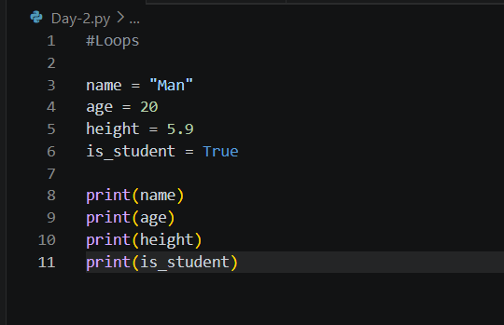
Output:
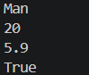

2. Conditions
Conditions help programs make decisions.
Python uses:
- if
- elif
- else
Comparison Operators
- == Equal
- != Not Equal
- > Greater Than
- < Less Than
- >= Greater Than Equal
- <= Less Than Equal

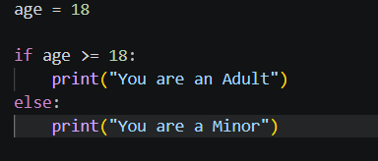
Output

3.Loops
Loops are used to repeat code multiple times.
Types of Loops
- for loop
- while loop

FOR LOOP
A for loop runs code a fixed number of times.
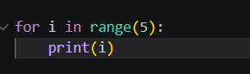
Output
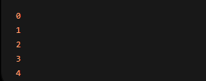

WHILE LOOP
A while loop runs until a condition becomes false.
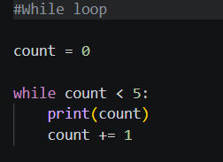
Output
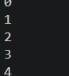

2. Create Calculator Application
import math
def add(a, b):
return a + b
def subtract(a, b):
return a - b
def multiply(a, b):
return a * b
def divide(a, b):
if b == 0:
return "Error: Division by zero"
return a / b

def power(a, b):
return a ** b
def square_root(a):
if a < 0:
return "Error: Negative number"
return math.sqrt(a)
def percentage(a, b):
return (a / b) * 100

def calculator():
print("\n==============================")
print(" ADVANCED PYTHON CALCULATOR")
print("==============================")
while True:
print("\nChoose Operation:")
print("1. Addition")
print("2. Subtraction")
print("3. Multiplication")
print("4. Division")
print("5. Power")
print("6. Square Root")
print("7. Percentage")
print("8. Exit")

choice = input("\nEnter choice (1-8): ")
if choice == "8":
print("\nCalculator Closed Successfully 🚀")
break
elif choice in ["1", "2", "3", "4", "5", "7"]:

num1 = float(input("Enter first number: "))
num2 = float(input("Enter second number: "))

if choice == "1":
print("Result =", add(num1, num2))
elif choice == "2":
print("Result =", subtract(num1, num2))
elif choice == "3":
print("Result =", multiply(num1, num2))
elif choice == "4":
print("Result =", divide(num1, num2))
elif choice == "5":
print("Result =", power(num1, num2))
elif choice == "7":
print("Result =", percentage(num1, num2), "%")
elif choice == "6":

num = float(input("Enter number: "))
print("Result =", square_root(num))

else:
print("Invalid Choice! Please try again.")

calculator()

Output:
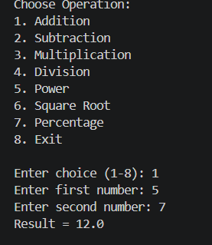

3. Build Age Calculator Mini Project
from datetime import datetime

print("================================")
print(" AGE CALCULATOR APP")
print("================================")

name = input("Enter your name: ")
birth_year = int(input("Enter your birth year: "))

current_year = datetime.now().year

age = current_year - birth_year

print("\n================================")
print("Hello,", name)
print("Your Age is:", age)
print("Current Year:", current_year)
print("================================")

Output:
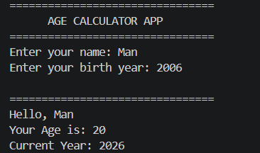

Conclusion
Today we learned the core fundamentals of Python programming.
Topics Covered:
- Variables
- Data Types
- Conditions (if, elif, else)
- Loops (for, while)
- User Input
- Basic Logic Building
Projects Built:
- Advanced Calculator Application
- Age Calculator Mini Project
Skills Gained:
- Storing and managing data
- Making decisions in programs
- Repeating tasks using loops
- Taking user input dynamically
- Creating real-world mini applications
Understanding Achieved:
- How Python programs work internally
- How logic is built step-by-step
- How real applications use conditions and loops together
Day-2
Outcome:
You are now able to create beginner-level real applications using Python fundamentals and structured logic.
NextStep:
Learn Functions, Lists, Tuples, Dictionaries, and Modules to build more advanced applications and AI projects 🚀

