Usman Institute of Technology

**End-Term Examination Fall 2020 Semester**

**Course Code:** HS351 **Course Title:** Human Resource Management  **Date:** 25.02.21

**Maximum Marks:** 60 **Max Time Allowed:** 3 hours

**PLEASE FILL IN THE FOLLOWING BEFORE PROCEEDING**

**Seat No. ST-18045** **Roll No.** **18B-129-SE**

**Batch**: **2018**  **Enrollment No.** **UIT/147/2018-19**

# **Important**

This is **NOT AN OPEN-BOOK EXAMINATION** conducted in line with the online academic policies developed by the NED University of Engineering and Technology. All necessary information about the online examination has been shared with students in advance.

# **Declaration**

I guarantee that all submissions are based on my independent work without any unauthorized help. All activities are completed with full adherence to the “Ethics Policy” of the Institute. I understand that any breach would result in disciplinary action against me as per Institute rules.

I **have read and understood the Students Ethics Policy for Online Assessments.**

**(paper will not be graded if the above is not checked)**

**Note:** Submission of this paper certifies that you are agreed to the Students Ethics Policy for Online Assessments and are liable to be judged according to it.

**AWARD**

|  |  |  |  |  |  |  |  |  |  |  |  |
| --- | --- | --- | --- | --- | --- | --- | --- | --- | --- | --- | --- |
|  | |  | **Q1** | **Q2** | **Q3** | **Q4** | **Q5** | **Q6** | **Q7** | **Q8** | **Q9** |
| **Examiner** | |  |  |  |  |  |  |  |  |  |  |
| **ERC** | |  |  |  |  |  |  |  |  |  |  |
|  | **Total Marks in Figures** | | | |  | **Total Marks in Words** | | |  | | |

**Q1.** Please read the following case and answer the questions given at the end. [10 marks]

|  |
| --- |
| Jennifer Carter graduated from State University in June 2011 and, after considering several job offers, decided to do what she always planned to do—go into business with her father, Jack Carter.  Jack Carter opened his first laundromat in 1991 and his second in 2001. The main attraction of these coin laundry businesses for him was that they were capital—rather than labor—intensive. Thus, once the investment in machinery was made, the stores could be run with just one unskilled attendant and none of the labor problems one normally expects from being in the retail service business.  The attractiveness of operating with virtually no skilled labor notwithstanding, Jack had decided by 2007 to expand the services in each of his stores to include the dry cleaning and pressing of clothes. He embarked, in other words, on a strategy of “related diversification” by adding new services that were related to and consistent with his existing coin laundry activities. He added these for several reasons. He wanted to better utilize the unused space in the rather large stores he currently had under lease. Furthermore, he was, as he put it, “tired of sending out the dry cleaning and pressing work that came in from our coin laundry clients to a dry cleaner 5 miles away, who then took most of what should have been our profits.” To reflect the new, expanded line of services, he renamed each of his two stores Carter Cleaning Centers and was sufficiently satisfied with their performance to open four more of the same type of stores over the next 5 years. Each store had its own on-site manager and, on average, about seven employees and annual revenues of about $550,000. It was this six-store chain that Jennifer joined after graduating.  Her understanding with her father was that she would serve as a troubleshooter/consultant to the elder Carter with the aim of both learning the business and bringing to it modern management concepts and techniques for solving the business’s problems and facilitating its growth. |

Q1a. Make a list of five specific HR problems you think Carter Cleaning will have to grapple with.

Although the CARTER’S business is very resilient as it is not requiring as much skilled labor and rich capital. But due to lack of diversity and converged target audience there could be problems that could arouse to HR side.

* **Productivity**.

There would be lack at productive side as their work is quite primitive. That doesn’t require much upgradations.

* **Health and safety.**

Health and safety of employees must be provided.

* **Recruitment**.

No such recruits are required as their business is comfortable with one unskilled attendant.

* **Wrapping** **up**.

For many startups and SMEs, the value of HR isn’t always apparent. Unknowingly to many, the role of HR in a company is important to its survival and success. This doesn’t require so.

* **Training of Employees**

As this business in less technical in nature it doesn’t require neither much employees nor employee trainings.

Q1b. What would you do first if you were Jennifer?

If I would be at the place of Jennifer, Firstly I would try to modernize all the functional aspects of business. That would increase the employment factor to my business as well as the increase in production amount.

More business-associated individuals would have a higher chance of reaching a success rate, and more technological progress would raise the rate of productivity that eventually contributes to us.

**Q2.** Please read the following case and answer the questions given at the end. [10 marks]

|  |
| --- |
| Starbucks is progressive in terms of gender equity policies. By the 1990s it was offering health insurance coverage to Starbucks partners (employees) who were in lesbian and gay relationships, and its health care insurance covers gender reassignment surgery. More recently it announced that it had eliminated its partners’ gender wage gap: Starbucks male and female partners performing similar work are paid almost exactly the same—within 99.7% of each other (compared with about 70% nationwide).  However, several large Starbucks shareholders think its gender efforts still fall short. For example, Zevin Asset Management proposed that Starbucks report on whether its paid family leave policy was discriminatory. According to Starbucks, the policy is generous and competitive for a retail chain. For example, it gives Starbucks corporate office workers 16 weeks paid leave if they gave birth, and 12 weeks if they are new fathers or adoptive parents. Starbucks says its program is exceptional because even employees who work just 20 hours a week can use it. But Zevin says the problem is that the policy is discriminatory because retail store workers who give birth or adopt only get six weeks of paid leave and fathers get none. Some shareholders say this will harm Starbucks’ reputation, because it is on record as saying that it tries to treat corporate and retail partners the same.  Although shareholders often reject proposals like these, employers may still implement the recommendations, particularly when they involve equitable treatment. Several years ago, for instance another investment firm proposed that several tech giants like Amazon and Apple pay male and female employees equitably. The proposal never came to a vote, because the tech firms soon closed their gender wage gaps.  So at the end of the day, such proposals present top managers with a dilemma. Starbucks, for instance, believed that its parental leave policy was already one of the best in the industry, and that was probably true. Yet it did seem somewhat inequitable to offer better benefits to corporate office workers then to those in the retail stores. |

Q2a. Do you agree that it is inequitable to offer the corporate workers better benefits then the store partners? Why? Is that what the law would seem to say?

I still believe it is unjust for business employees to get more salaries than retail workers. It departs from the status that businesses are better off than retailers regardless of their positions. In a company that offers compensation only to workers at a higher rank, this is itself unfair. A retail worker may have a condition that would prohibit them from being able to work in a certain sort of job. This type of situation is expressly regulated by the ADA.

Q2b. What arguments would you make as Starbucks’ CEO concerning why the current policy is fair?

As Starbuck's CEO, I can strongly suggest that the quality of work that office employees do and the relatively higher bar that they have to reach to get employed justifies this discrepancy of treatment. The strategy is completely legal and is much stronger than other companies on the market and supermarket workers are not getting mistreated in any way.

Q2c. How would you handle this situation if you were running a company that was confronted by a shareholder making these demands?

I will meet these issues with an open mind and listen to the issues posed by my shareholder before I make a decision that I believe is just and right. And all of the decisions made by me would be under the law and obligiations of the firm and the MOU if signed.

**Q3.** Please read the following case and answer the questions given at the end. [10 marks]

|  |
| --- |
| Starting as a single hotel in a Paris suburb in 1995, the Hotel Paris is now a chain of nine hotels, with two in France, one each in London and Rome, and others in New York, Miami, Washington, Chicago, and Los Angeles. As a corporate strategy, the Hotel Paris’s management and owners want to continue to expand geographically. They believe doing so will let them capitalize on their reputation for good service, by providing multicity alternatives for their satisfied guests. The problem is, their reputation for good service has been deteriorating. If they cannot improve service, it would be unwise for them to expand, since their guests might prefer other hotels after trying the Hotel Paris.  Several things are complicating their problem. Tourists increasingly stay at short-term rental apartments (often through sites such as airbnb .com) for a fraction of what fine hotels cost. In 2018 Airbnb agreed to more stringently comply with the limits on the lengths of rentals in the heart of Paris, but not elsewhere. Marriott recently acquired the Starwood hotels chain (including many brands such as Ritz-Carlton) and will present increased competition. And the election as French president of Emmanuel Macron in 2017 prompted widespread optimism among many in France regarding the country’s growth prospects, but also the possibility of some labor strife, at least in the short run.  **The Strategy**  Top management, with input from the HR and other managers, and with the board of directors’ approval, chooses a new competitive strategy and formulates new strategic goals. It decides: “The Hotel Paris International will use superior guest services to differentiate the Hotel Paris properties, and to thereby increase the length of stays and the return rate of guests, and thus boost revenues and profitability.” All Hotel Paris managers—including the director of HR services—must now formulate strategies that support this competitive strategy.  **The Strategically Required Organizational Outcomes**  The Hotel Paris’s basic strategy is to use superior guest services to expand geographically. For HR director Lisa Cruz, reviewing the hotel’s activities makes it clear that achieving the hotel’s strategic aims means achieving a number of required organizational outcomes. For example, Lisa and her management colleagues must take steps that produce fewer customer complaints and more written compliments, more frequent guest returns and longer stays, and higher guest expenditures per visit.  **The Strategically Relevant Workforce Competencies and Behaviors**  The question facing Lisa, then, is this: What competencies and behaviors must our hotel’s employees exhibit, if we are to produce required organizational outcomes such as fewer customer complaints, more compliments, and more frequent guest returns? Thinking through this question helps Lisa come up with an answer. For example, the hotel’s required employee competencies and behaviors would include, “high-quality front-desk customer service,” “taking calls for reservations in a friendly manner,” “greeting guests at the front door,” and “processing guests’ room service meals efficiently.” All require motivated, high-morale employees.  **The Strategically Relevant HR Policies and Activities**  The HR manager’s task now is to identify and specify the HR policies and activities that will enable the hotel to produce these crucial workforce competencies and behaviors. For example, “high-quality front-desk customer service” is one such required behavior. From this, the HR director identifies HR activities to produce such front-desk customer service efforts. For example, she decides to institute practices to improve the disciplinary fairness and justice in the company, with the aim of improving employee morale. Her assumption is that enhanced fairness will produce higher morale and that higher morale will produce improved front-desk service.  **The Strategy Map**  Next, Lisa, working with the hotel’s chief financial officer (CFO), outlines a strategy map for the hotel. This outlines the cause-and-effect links among the HR activities, the workforce behaviors, and the organizational outcomes.  This map and its linkages reflect certain assumptions on Lisa’s part. For example, based on experience and discussions with the firm’s other managers, she formulates the following hypothesis about how HR affects hotel performance: Improved grievance procedures cause improved morale, which leads to improved front-desk service, which leads to increased guest returns, which leads to improved financial performance. The HR director then chooses metrics to measure each of these factors. For example, she decides to measure “improved disciplinary procedures” in terms of how many grievances employees submit each month. She measures “improved morale” in terms of “scores on our hotel’s semiannual attitude survey,” and measures “high-quality front-desk customer service” in terms of “customer complaints per month.”  She moves on to quantifying the cause-and-effect links among these measures. For example: “Can we show top management that there is a measurable, sequential link between improved disciplinary procedures, high morale, improved front-desk service, number of guest return visits, and hotel financial performance (revenues and profits)?” If she can show such links, she has a persuasive case that shows HR’s measurable contribution to the hotel’s bottom-line financial performance.  In practice, the HR manager may well just rely on a largely subjective but logical argument to make the case for such cause-and-effect linkages. But ideally, she will use statistical methods such as correlation analysis to determine if measurable links exist, and (if so) what their magnitudes are. In this way, she might find, for instance, that a 10% improvement in grievance rates is associated with an almost 20% improvement in morale. Similarly, a 20% improvement in morale is associated with a 30% reduction in customer front-desk complaints. Furthermore, a 30% reduction in complaints is associated with a 20% increase in guest return visits, and a 20% increase in return rate is associated with a 6% rise in hotel revenues. It would appear that a relatively small HR effort in reducing grievances might have a big effect on this hotel’s bottom-line performance!  Several things complicate this measurement process. For example, it’s risky to draw cause–effect conclusions from correlation measures like these (do fewer grievances lead to higher morale, or vice versa?). Furthermore, it’s rare that a single factor (such as grievance rates) will have such effects alone, so we may want to measure the effects of several HR policies and activities on morale simultaneously.  Computerization could enable Lisa to build a more comprehensive HR scorecard process, one that might handle links among dozens of cause-and-effect metrics. (Several vendors supply such scorecard software.) If not, then she will rely more on the logic and common sense underlying the strategy map to make her case.  How We Will Use the Hotel Paris Case A Hotel Paris case in each chapter will show how Lisa, the Hotel Paris’s HR director, uses that chapter’s concepts and techniques to: (1) create HR policies and practices that help the Hotel Paris, (2) produce the employee competencies and behaviors the company needs, and (3) to produce the customer service the Hotel Paris requires to achieve its strategic goals.  For example, she will endeavor to improve workforce competencies and behaviors by instituting improved recruitment (processes Chapter 5), and measure improved recruitment in terms of “number of qualified applicants per position.” Similarly, she will recommend to management that they change the company’s pay policies, so that the “target percentile for total compensation is in the top 25%.” She could argue, based on competitors’ experience, that doing so will translate into improved customer service behavior, more satisfied customers, and improved hotel performance. In practice, all the human resource management functions we discuss in this book influence employee competencies and behaviors, and thereby organizational performance. |

Q3a. Using Table 1 and Figure 1, list at least 15 metrics the Hotel Paris could use to measure its HR practices.

5 HR Activities to help the hotel's competitive approach are as follows:

1. Amount recruited on the basis of a validated screening test

i) The hotel should recruit staff solely on the basis of the validated hiring examination. This would mean that the hotel employs workers with the necessary attributes.

ii) Initially, they will ask general questions in order to identify whether the applicant is primarily appropriate for consideration. For eg, to interact with the hotel, one must have strong communication skills.

iii) They should then review their professional expertise on the basis of the job criteria. For eg, the accounting program would have been used by an applicant applying for an account.

(iv) The personal round of interviews should be performed by a jury composed of one from the functional team and one from the HR.

2. Percentage of jobs filled in:

This will show how many employees are motivated by new strategic policies. If they are able to work in line with the new strategy, only their work will be recognized. They can be absorbed in higher positions. Such employees would be much more productive than an external new employee, as an internal employee would know the strategy, culture, and value of the hotel.

3. Percentage of employees receiving regular performance assessment.

This measure will show how many employees follow the company's strategy. If the maximum staff is able to meet all the performance criteria, they will receive a regular performance assessment.

4 Percentage of employees who received feedback from multiple sources on performance

This measure will reflect if employees really do give their best. An employee may receive a regular performance assessment if he or she is just completing his or her assigned task. But if he goes beyond assigned tasks and adds some value to his work, he will receive positive feedback from his superior, colleague and cross-functional team members.

5. Percentage of workers eligible for Incentive pay

If employees are able to provide their customers with excellent services by different means, such as prompt guest service, receiving guests, providing hotel relevant information, etc., they will be eligible for incentive pay.

Q3b. Summarize in your own words an example of the hierarchy of links among the hotel’s HR ­practices, necessary workforce competencies and behaviors, and required organizational outcomes.

The technique of Hotel Parsi’s is to use superior guest facilities to maximize the duration of stay and the rate of return of visitors. To execute the plan, a professional worker is the first prerequisite and to hire an acceptable person, we need a job description. But most job specifications are out of date. Lisa cruz must also create a job description with the appropriate qualifications.

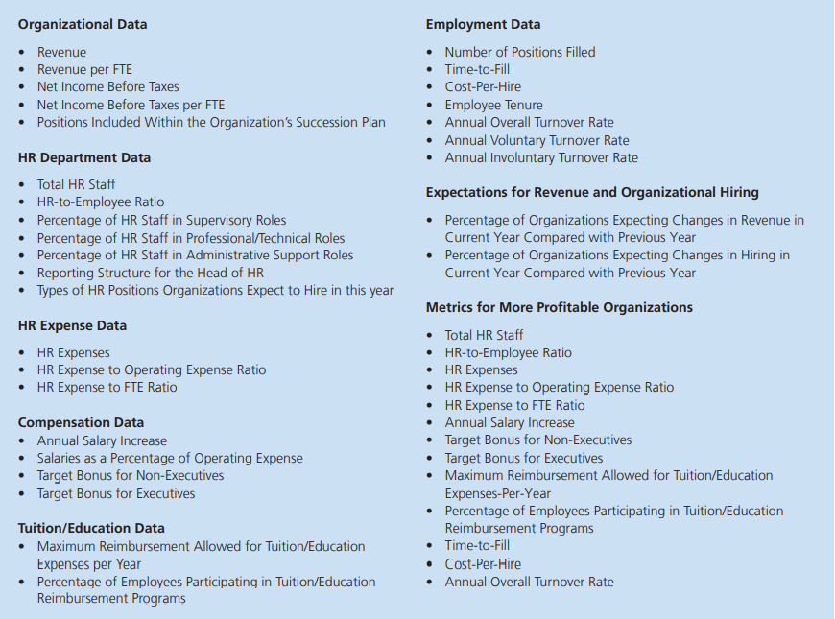

**Figure 1**

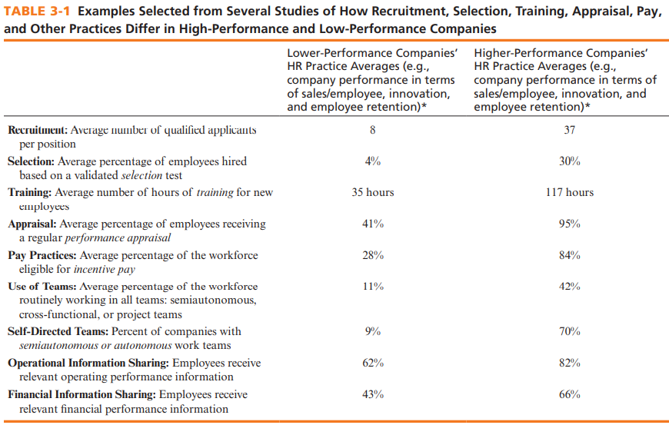

**Table 1**

**Q4.** Please read the following case and answer the questions given at the end. [10 marks]

|  |
| --- |
| The Hotel Paris’s competitive strategy is “To use superior guest service to differentiate the Hotel Paris properties, and to thereby increase the length of stay and return rate of guests, and thus boost revenues and profitability.” HR manager Lisa Cruz must now formulate functional policies and activities that support this competitive strategy and boost performance by eliciting the required employee behaviors and competencies.  As an experienced human resource director, the Hotel Paris’s Lisa Cruz knew that recruitment and selection processes invariably influenced employee competencies and behavior and, through them, the company’s bottom line. Everything about the workforce—its collective skills, morale, experience, and motivation—depended on attracting and then selecting the right employees.  In reviewing the Hotel Paris’s employment systems, she was therefore concerned that virtually all the company’s job descriptions were out of date, and that many jobs had no descriptions at all. She knew that without accurate job descriptions, all her improvement efforts would be in vain. After all, if you don’t know a job’s duties, responsibilities, and human requirements, how can you decide whom to hire or how to train them? To create human resource policies and practices that would produce employee competencies and behaviors needed to achieve the hotel’s strategic aims, Lisa’s team first had to produce a set of usable job descriptions.  A brief analysis, conducted with her company’s CFO, reinforced that observation. They chose departments across the hotel chain that did and did not have updated job descriptions. While they understood that many other factors might be influencing the results, they believed that the statistical relationships they observed did suggest that having job descriptions had a positive influence on various employee behaviors and competencies. Perhaps having the descriptions facilitated the employee selection process, or perhaps the departments with the descriptions just had better managers. In any case, Lisa received the go-ahead to design new job descriptions for the chain.  While the resulting job descriptions included numerous traditional duties and responsibilities, most also included several competencies unique to each job. For example, job descriptions for the front-desk clerks included competencies such as “able to check a guest in or out in five minutes or less.” Most service employees’ descriptions included the competency, “able to exhibit patience and guest supportiveness even when busy with other activities.” Lisa knew that including these competencies would make it easier for her team to devise useful employee selection, training, and evaluation processes. |

**Q4a.** Based on the hotel’s stated strategy, list at least four more important employee behaviors important for the Hotel Paris’s staff to exhibit.

Hotel is an industry that needs the best possible hospitality for all service-oriented industries. Both staff in the hotel industry are obliged to operate in such a manner that their guests stay because of their hospitality. The following are few predicted habits of hotel employees:

* Ability to solve complaints and problem with patience and smile.
* Ability to multitask efficiently
* Always offer quick service
* Supportive, friendly and humble

**Q4b.** If time permits, spend some time prior to class observing the front-desk clerk at a local hotel. In any case, create a job description for a Hotel Paris front-desk clerk.

Job identification:

Job Title: Front Desk Clerk

Date: 25/02/2021

**Job Summary:**

In the first place, the front desk clerk would warmly welcome the guests who arrive, greet them, provide them with the relevant details, answer their queries politely, be humble and welcome to the guest and make them feel wanted, give advice and support.

**Responsibilities:**

* Greet Guests in Manner Way.
* Collect information.
* Answer the queries if asked.

**Standards of Performance:**

* Multi-tasker.
* Be polite in person or on phone.
* Keep a check on guest responsively.

**Job Specification:**

* Convincing.
* Have Dressing Sense
* Intelligent.

**Q5.** Please read the following case and answer the questions given at the end. [10 marks]

|  |
| --- |
| It’s been estimated that there are more than 600,000 unfilled technical jobs (systems engineers, programmers, and so on) in the United States. Therefore, IT companies like Techtonic Group are continually battling for good applicants.  For many years, Techtonic outsourced app software development to Armenia; CEO Heather Terenzio flew twice a year to work with the people there. However, programmers’ salaries in Eastern Europe were rising, and the distances involved and the language differences complicated managing the projects. Therefore, the CEO decided there had to be a better way. Since the programmers abroad required more and more detailed instructions, she decided she could hire junior people closer to home. Then with about the same effort and instructions Techtonic could do its programming locally.  The problem was, how do you recruit talent when the unemployment rate for tech workers is close to zero? Ms. Terenzio had a novel solution. Rather than looking for college graduates with technical degrees, Techtonic set up a training/apprenticeship program. The aim was to attract people who didn’t necessarily have college degrees but who expressed a strong desire for doing programming. People apply for the five-week program at “Techtonic Academy,” where they learn basic computer coding skills. Some of the graduates than qualify for an eight-month paid apprenticeship at Techtonic, where they learn software development.  The program is successful. They usually get about 400 applicants for each of the 15 spots in each five-week Academy program. The city of Boulder helps subsidize the program, and the applicants don’t pay for classes. The company is now expanding its academy/apprenticeship programs to other U.S. cities. |

Q5a. Specifically what recruiting sources would you use to attract participants to the Techtonic Academy, and apprenticeship programs?

Although the application notes that it does not generally pursue college graduates with professional degrees, the recruiting of college or late high school may be a choice for the business. Most students don't really know whether they want to receive a college degree. Recruiting graduate students or students to train for high school graduation, in which candidates do not pay for classes, and A work may be assigned prior to school, and students may be drawn to the organisation.

Q5b. What other recruitment sources (other than the academy and apprenticeship programs) would you recommend Techtonic use, and why?

Other recruitment sources that we would recommend for technical use are

1. Job boards, as they tend to get more popular thanks to online job searches.
2. Platforms like Linkedin are a perfect example of how people share their achievements and experiences on a platform that serves as a virtual cirricam vitac for people.
3. Company websites are a good start-up measure as large companies like Microsoft post job requirements on their recruitment pages and make it easier to implement recruitment drives than to put them on some other platform
4. Social Media as infamous as they are. They now serve as a good platform not only for average joe but as an advertising platform for even job recruters.

5. Newspaper while outdated is still being read by millSions of people so a recruitment post on it might seem tempting

Q5c. What suggestions would you make to Techtonic for improving its recruiting processes?

My suggestions Int that case would be that interviews should be streamlined and provided information should be clear and cut.

**Q6.** Please read the following case and answer the questions given at the end. [10 marks]

|  |
| --- |
| Maria Fernandez is a bright, popular, and well-informed mechanical engineer who graduated with an engineering degree from State University in June 2018. During the spring preceding her graduation, she went out on many job interviews, most of which she thought were conducted courteously and were reasonably useful in giving both her and the prospective employer a good impression of where each of them stood on matters of importance to both of them. It was, therefore, with great anticipation that she looked forward to an interview with the one firm in which she most wanted to work: Apex Environmental. She had always had a strong interest in the environment and believed that the best use of her training and skills lay in working for a firm like Apex, where she thought she could have a successful career while making the world a better place.  The interview, however, was a disaster. Maria walked into a room where five men—the president of the company, two vice presidents, the marketing director, and another engineer—began throwing questions at her that she felt were aimed primarily at tripping her up rather than finding out what she could offer through her engineering skills. The questions ranged from being unnecessarily discourteous (“Why would you take a job as a waitress in college if you’re such an intelligent person?”) to being irrelevant and sexist (“Are you planning on starting a family anytime soon?”). Then, after the interview, she met with two of the gentlemen individually (including the president), and the discussions focused on her technical expertise. She thought that these later discussions went fairly well. However, given the apparent aimlessness and even mean-spiritedness of the panel interview, she was astonished when several days later the firm made her a job offer.  The offer forced her to consider several matters. From her point of view, the job itself was perfect. She liked what she would be doing, the industry, and the firm’s location. And in fact, the president had been quite courteous in subsequent discussions. She was left wondering whether the panel interview had been intentionally tense to see how she’d stand up under pressure, and, if so, why they would do such a thing. |

Q6a.How would you explain the nature of the panel interview Maria had to endure? Specifically, do you think it reflected a well-thought-out interviewing strategy on the part of the firm or carelessness on the part of the firm’s management? If it were carelessness, what would you do to improve the interview process at Apex Environmental?

As per the aforementioned case study, what we consider to be the essence of the panel interview that Maria had to undergo was not up to par, although it could be said to be awful. It wasn't a positive thing though the technique of questioning gently seemed the reverse.

Although the last moments with the two gentlemen were appropriate, this kind of interview leads to extreme discrimination and not to appropriate discrimination either. For the most part, we must have assumed that half of the panel was not really involved in the interview and just turned up to satisfy the criteria of the committees, but we deem it to be irresponsible on the part of the management of the company.

To rectify the current interview structure we would rather have to adopt some of these factors.

1. Choose the appropriate and able interviewer.
2. Restrict the discriminatory questions if asked during interview.
3. Question about the market culture.
4. Try to question regarding the practical information about the job description for the employee.

Q6b.Would you take the job offer if you were Maria? If you’re not sure, what additional information would help you make your decision?

I don't know whether I'm going to go for it or not. Since I'm unsure, the first question I need to get answers is if what transpired during the panel interview was a calculated and well thought out tactic or it was simply a lack of coordination and then behave accordingly. This would be very important, as it would decide the workers of the company, because if it were the same as the interview, that is carelessness. I will get a second thought. On the opposite, if it were only a deliberate act to assess the scenario response, and the conduct of the second conversation is already performed, then it would be the perfect working atmosphere and would certainly give it a shot. I would also like to know the working climate of the organization and its practices. If it is optimistic, I will accepts the bid, otherwise, no!

Q6c. The job of applications engineer for which Maria was applying requires (a) excellent technical skills with respect to mechanical engineering, (b) a commitment to working in the area of pollution control, (c) the ability to deal well and confidently with customers who have engineering problems, (d) a willingness to travel worldwide, and (e) a very intelligent and well-balanced personality. List 10 questions you would ask when interviewing applicants for the job.

**IF I would be the interviewer I would refer to ask:**

General Questions:

* What makes you unique?
* Are you able to multi-task? Can you give me some examples?
* If you could go back five years in time, would you do anything differently?
* If I hire you, what is the first contribution you will make to the company?

Engineering Background Questions:

* What do you think makes a great engineer?
* What is the biggest challenge you have ever faced as an engineer?
* Do you ever lose your temper while working? If so, how do you recover?
* What is your idea of having a successful team?
* What checks and balances do you use to make sure that you don’t make mistakes?
* Do you have any patents? If so, tell me about them. If not, is that something that you see yourself pursuing? Why or why not?