**USMAN INSTITUTE OF TECHNOLOGY**

**Department of Computer Science**

**CS311 Introduction to Database Systems**

Lab#7

**Objective:**

**-** **Data manipulation operations in SQL**

**Name of Student: ___MANSOOR AHMED ____________________**

**Roll No: _____18b-129-se____________Sec. ___A____**

**Date of Experiment: ________11-December-2020_____________**

**Marks Obtained/Remarks: _____________________________**

**Signature: _____________________________**

**THEORY**

**Data-Manipulation Language**

D

ata manipulation language is a core part of SQL. When we want to add, update or delete data in the database, we execute a DML statement. A collection of DML statements that

form a logical unit of work is called a *transaction*.

Consider a banking database. When a bank customer transfers money from a savings account to a checking account, the transaction might consist of three separate operations: decrease the savings account, increase the checking account, and record the transaction in the transaction journal. The Oracle server must guarantee that all three SQL statements are performed to maintain the accounts in the proper balance. When something prevents one of the statements in the transaction from executing, the other statements of the transaction must be undone.

The SQL DML includes statements to perform following operations:-

|  |  |
| --- | --- |
| **Statement** | **Description** |
| INSERT | Enter new rows into tables |
| UPDATE | To change existing rows |
| DELETE | To delete existing rows |

**Table 6.1**

**Adding a new row to a table**

We can add new rows to a table by using the INSERT statement. The syntax is

*INSERT INTO table [(column [, column …] ) ]*

*VALUES (value [, value …]);*

**Examples**

1. Inserting a new row in the dept table

INSERT INTO dept (deptno, dname, loc)

VALUES (50, ‘DEVELOPMENT’, ‘DETROIT’);

**Note**: If the column list is not included, the values must be listed according to the default order of the columns in the table. The order can be seen using the DESCRIBE command in SQL*PLUS (See lab session 1)

1. Inserting rows with Null values o *Implicit Method*: Omit the column from the column list.

INSERT INTO dept (deptno, dname)

VALUES (60, ‘MIS’); o *Explicit Method:* Specify the NULL keyword

INSERT INTO dept

VALUES (70, ‘FINANCE’, NULL);

**Note**: The oracle server automatically enforces all datatypes, data ranges and data integrity constraints. Any column that is not listed explicitly obtains a null value in the new row.

1. Using special values, for example, SYSDATE function, to obtain data for a column when inserting a row in a table

INSERT INTO emp (empno, ename, job, mgr, hiredate, sal, comm, deptno)

VALUES (7196, ‘GREEN’, ‘SALESMAN’, 7782, SYSDATE, 2000, NULL, 10); Similarly we can also use the USER function when inserting rows in a table. The USER function records the current username.

1. Adding a new employee by inserting specific date values

INSERT INTO emp

VALUES (2296, ‘AROMANO’, ‘SALESMAN’, 7782, TO_DATE(‘FEB 3, 97’,

‘MON DD, YY’), 1300, NULL, 10);

1. We can produce an INSERT statement that allows the user to add values interactively by using SQL*Plus substitution variables.

INSERT INTO dept (deptno, dname, loc)

VALUES (&department_id, ‘&department_name’, ‘&location’);

Enter value for department_id: 80

Enter value for department_name: EDUCATION

Enter value for location: ATLANTA

1 row created

1. Copying rows from another table

We can use the INSERT statement to add rows to a table where the values are derived from some other existing table. In place of the VALUES clause, we use a subquery. e.g. to insert rows from EMP table to EMP10 table,

INSERT INTO EMP10

SELECT * FROM EMP

WHERE DEPTNO = 10;

**Changing data in a table**

We can modify existing rows in a table with the UPDATE statement. The syntax is

*UPDATE table*

*SET column = value [, column = value , …]*

*[WHERE condition];*

As shown in the above syntax, we can update more than one row at a time depending on a condition.

**Examples**

1. To transfer an employee with number 7782 to department 20.

UPDATE emp

SET deptno = 20

WHERE empno = 7782;

1. All rows in the table are modified if the WHERE clause is omitted.

UPDATE emp

SET deptno = 20; iii. Updating with multiple column subquery: Update employee 7698’s job and department to match that of employee 7499.

UPDATE emp

SET (job, deptno) =

(SELECT job, deptno

FROM emp

WHERE empno = 7499)

WHERE empno = 7698;

**Removing a row from a table**

We can remove existing rows from a table by using the DELETE statement. The syntax is

DELETE [FROM] table

[WHERE condition];

**Examples**

1. Specific rows are deleted from a table by specifying the WHERE clause.

DELETE FROM department

WHERE dname = ‘DEVELOPMENT’;

1. All rows in the table are deleted if we omit the WHERE clause.

DELETE FROM department; iii. Remove all employees who started after January 1, 1997.

DELETE FROM employee

WHERE hiredate > TO_DATE(’01.01.97’, ‘DD.MM.YY’); iv. Deleting rows based on another table by using subqueries in DELETE statements.

DELETE from employee

WHERE deptno =

(SELECT deptno

FROM dept

WHERE dname = ‘SALES’);

Delete record of employees in department 30

DELETE FROM employee

WHERE DEPTNO = 30;

**Database Transactions**

The oracle server ensures data consistency based on transactions. Transactions consist of DML statements that makeup one consistent change to the data. For example, a transfer of funds between two accounts should include the debit to one account and a credit to another account in the same amount. Both actions should either fail or succeed together. The credit should not be committed without the debit.

**Transaction Types**

|  |  |
| --- | --- |
| **Type** | **Description** |
| Data Manipulation language (DML) | Consists of any number of DML statements that the Oracle Server treats as a single entity or a logical unit of work |
| Data Definition language (DDL) | Consists of only one DDL statement |
| Data Control language (DCL) | Consists of only one DCL statement |

**Table 6.2**

A transaction begins when the first executable SQL statement is encountered and terminates when one of the following occurs:

v. A COMMIT or ROLLBACK statement is issued vi. A DDL statement, such as CREATE, is issued vii. A DCL statement is issued

1. The user exits SQL*Plus
2. A machine fails or the system crashes

After one transaction ends, the next executable SQL statement automatically starts the next transaction. A DDL or DCL statement is automatically committed and therefore implicitly ends a transaction.

**Transaction Control**

COMMIT: Ends the current transaction by making all pending data changes permanent.

ROLLBACK: Ends the current transaction by discarding all pending data changes. SAVEPOINT: Marks a savepoint within the current transaction.

**Example**

To create a new advertising department with at least one employee and make the data changes permanent.

INSERT INTO dept (deptno, dname, loc)

VALUES (50, ‘ADVERTISING’, ‘ATLANTA’);

UPDATE EMP

SET DEPTNO = 50

WHERE EMPNO = 7566;

COMMIT;

**EXERCISES**

1. Define Transaction. How it is terminated? Describe the different operations included in a transaction.

A transaction is a set of changes that must all be made together. It is a program unit whose execution mayor may not change the contents of a database. Transaction is executed as a single unit.

A transaction in a database system must maintain Atomicity, Consistency, Isolation, and Durability − commonly known as ACID properties − in order to ensure accuracy, completeness, and data integrity.

1. Write a transaction to insert following rows in EMP table.

|  |  |  |  |  |  |  |  |
| --- | --- | --- | --- | --- | --- | --- | --- |
| **EMPNO** | **ENAME** | **JOB** | **MGR** | **HIREDATE** | **SAL** | **COMM** | **DEPTNO** |
| 7123 | RALPH | DESIGNER | 7566 | 21-APR-85 | 2300 |  | 50 |
| 7890 | GEORGE | CLERK | 7566 | 03-MAY-85 | 1235 |  | 50 |
| 7629 | BOB | SALESMAN | 7698 | 06-MAR-86 | 1800 | 1000 | 30 |

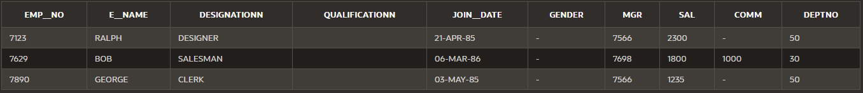

1. Write down SQL statements to perform following functions.
2. Increase the salary by 250 of all clerks with a salary less than 900

UPDATE emp2 SET sal = sal+250 WHERE sal<900;

1. Transfer the employee with number 7890 to department 20 and increase his salary by 15%.

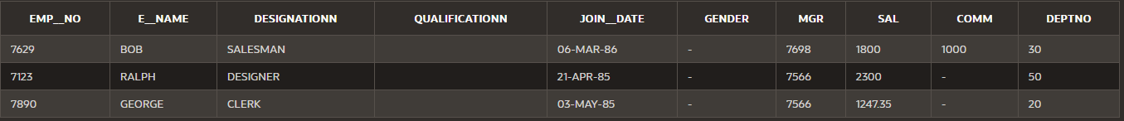UPDATE emp2 SET deptno = 20 , sal=sal+(sal/100) WHERE EMP__NO=7890;

1. Increase the salary of employee with number 7369 by 10% of the salary of employee with number 7499.

UPDATE emp2

SET (sal) = sal+((SELECT sal

                FROM emp2

                WHERE  emp__no = 7499)*10/100)

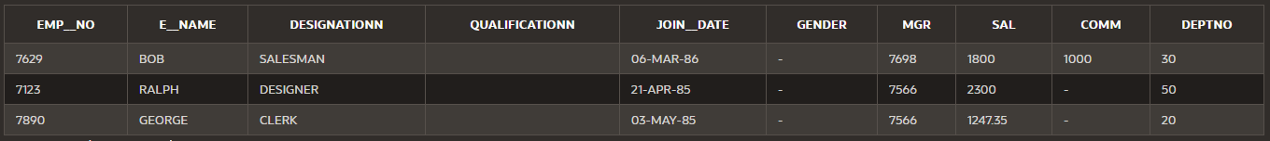WHERE emp__no = 7369;

1. Assign to employee 7876 the same manager as the employee 7900.

UPDATE emp2 SET mgr = (select mgr from emp2 where EMP__NO=7900) WHERE EMP__NO=7876;

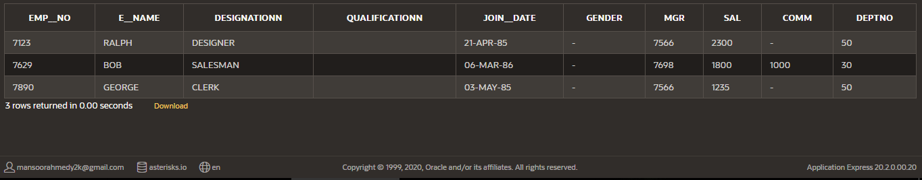

1. Remove all employees who were hired before 1981.

delete from emp2 where JOIN__DATE>'1-1-1981'

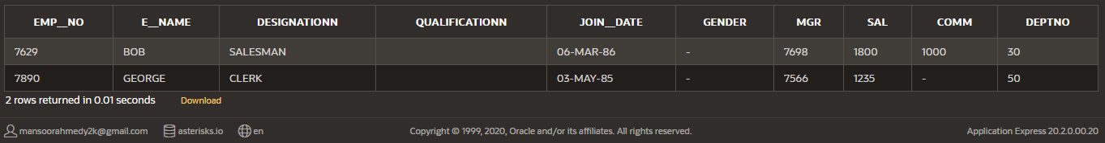

* * * * *

|  |  |
| --- | --- |
| emp | |
| ename | gpa |
| naymat | 3.0 |
| ali | 3.3 |
| ali | NULL |
| NULL | 4.0 |

create table emp (ename varchar2(20), gpa number(3,2),sal number(7));

insert into emp (ename,gpa) values ('naymat',3.0)

insert into emp values ('ali',3.3)

insert into emp (ename) values ('ali')

insert into emp (gpa) values (4.0)

insert into emp values ('fakhir',NULL)

insert into emp (gpa,ename)values (NULL,’fakhir’)

create table Emp_Temp (a varchar2(20), b number(3,2))

insert into Emp_Temp select ename,gpa from emp where gpa>3.0;

# update

UPDATE emp

SET ename = 'kamal'

WHERE e_id = 1122;

UPDATE emp

SET branch = 'Islamabad',

comm = 3200

WHERE sal > 10000;

UPDATE emp

SET ename = 'Ahsan';

## Update table with data from another table

UPDATE customers

SET c_details = (SELECT contract_date

FROM suppliers

WHERE suppliers.supplier_name = customers.customer_name)

WHERE customer_id < 1000

## Delete

DELETE FROM customers

WHERE last_name = 'Smith';

DELETE FROM contacts

WHERE contact_id BETWEEN 5000 AND 5999;