**USMAN INSTITUTE OF TECHNOLOGY**

**Department of Computer Science**

**CS311 Introduction to Database Systems**

Lab#11

**EXERCISES**

Consider the schema of the previous lab session that represents information about *employees*, *grades*, *training* and *projects* in an organization and answer the following questions.

1. Create a sequence to generate the primary key column EMPNO of EMPLOYEE table in the lab session 06. The sequence should start with 1, increment by 1 and have maximum value of 10000.
2. create sequence emp_new_emp increment by 1 start with 1 maxvalue 10000

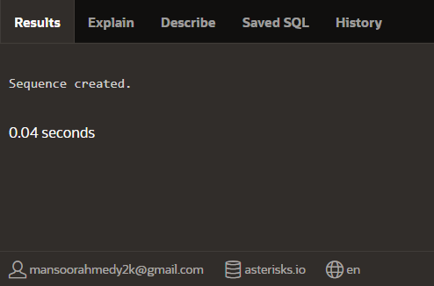

1. Create **B-Tree** indexes on i) **Name** column of EMP table ii) **Designation** column of EMP table iii) First 10 characters of **Title** in TRAINING table
2. create index new_employee on employee(NAMEE)

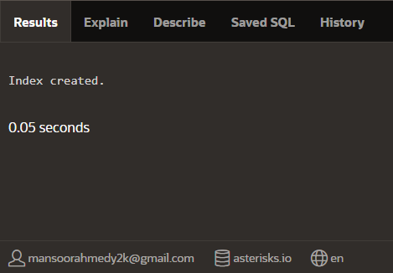

create index new_employee_des on employee(DESIGNATION)



create index title_training on TRAINING(substr(title,1,10))



1. Create **bitmapped** indexes on i) **Gender** column of EMP table ii) **Performance** column of EMP_PROJECT table
2. create bitmap index gender_emp on employeee(gender);



create bitmap index perf_emp_project on emp_projectt(PERFORMANCEE);

