LAB 11

**CRUD APP**

LAB11/URLS.py

from django.urls import path, include urlpatterns = [

path('', include('crud.urls'))

]

CRUD/URLS.py

from django.urls import path from . import views urlpatterns = [

path('', views.index, name='index'), path('new_form', views.new_form, name='New_Form'), path('add_new', views.add_new, name='New_Record'),

path('show', views.view_all, name='Show All Record'), path('edit/<int:id>', views.edit, name='Edit Record'), path('update/<int:id>', views.update), path('delete/<int:id>', views.delete, name='Delete Record'), path('search', views.search, name='Search Data'),

]

CRUD/VIEWS.py

from django.shortcuts import render, redirect from django.http import HttpResponse

from .forms import StudentsForm from .models import Students

def index(request): return(render(request, 'index.html'))

def new_form(request): form = StudentsForm

return (render(request, 'new_form.html', {'form':form}))

def add_new(request): form=StudentsForm(request.POST) form.save()

return redirect('/show')

def view_all(request):

stud = Students.objects.order_by('-id')

return render(request,'view_all.html', {'stud': stud})

def edit(request, id):

stud = Students.objects.get(id=id)

return render(request,'edit.html', {'stud': stud})

def update(request, id):

stud = Students.objects.get(id=id) if request.method == "POST":

form = StudentsForm(request.POST, instance=stud) if form.is_valid():

form.save()

return redirect('/show') else:

return (HttpResponse("Updatation Failed")) def delete(request, id):

stud = Students.objects.get(id=id) stud.delete()

return redirect('/show') def search(request):

s_name = request.POST['sname']

stud= Students.objects.filter(std_name icontains=s_name) return render(request,'view_all.html',{'stud': stud})

CRUD/MODEL.py

from django.db import models

class Students(models.Model):

std_rn = models.CharField(max_length=100) std_name = models.CharField(max_length=100) std_email = models.EmailField()

std_contact = models.CharField(max_length=100)

def str (self): return self.std_name

CRUD/FORMS.py

from django import forms from .models import Students

class StudentsForm(forms.ModelForm): class Meta:

model = Students fields = ' all '

CRUD/TEMPLATES

Base.html

<html lang="en">

<head>

<meta charset="utf-8">

<meta name="viewport" content="width=device-width, initial-scale=1">

<link rel="stylesheet" href="https://maxcdn.bootstrapcdn.com/bootstrap/3.4.1/css/bootstrap.min.css">

<script src="https://ajax.googleapis.com/ajax/libs/jquery/3.5.1/jquery.min.js"></scri pt>

<script src="https://maxcdn.bootstrapcdn.com/bootstrap/3.4.1/js/bootstrap.min.js"></s cript>

</head>

<body>

<div class="container">

<nav class="navbar navbar-inverse">

<div class="container-fluid">

<div class="navbar-header">

<a class="navbar-brand" href="#">CRUD Operations</a>

</div>

<ul class="nav navbar-nav">

<li class="active"><a href="/">Home</a></li>

<li><a href="new_form">Add Students</a></li>

<li><a href="show">show data</a></li>

</ul>

<form class="navbar-form navbar-left" action="/search" method="post">

{%csrf_token%}

<div class="form-group">

<input type="text" class="form-control" name="sname" placeholder="Search">

</div>

<button type="submit" class="btn btn-default">Submit</button>

</form>

</div>

</nav>

</div>

{% block content %}

{% endblock %}

</body>

</html>

Edit.html

<!DOCTYPE html>

{% extends 'base.html' %}

<html lang="en">

<head>

<meta charset="UTF-8">

<title>Crud Edit page</title>

</head>

<body>

{% block content %}

<form method="POST" action="../update/{{ stud.id }}">

{% csrf_token %}

<label>Student Roll no.</label><br>

<div><input type="text" name="std_rn" value="{{stud.std_rn}}"></div>

<label>Student Name.</label> <br>

<div><input type="text" name="std_name" value="{{stud.std_name}}"></div>

<label>Student Email.</label> <br>

<div><input type="text" name="std_email" value="{{stud.std_email}}"></div>

<label>Student Contact.</label> <br>

<div><input type="text" name="std_contact" value="{{stud.std_contact}}"></div>

<br>

<a href="../show">Go Back</a>

<button type="submit"> Submit </button>

</form>

{% endblock%}

</body>

</html>

Index.html

{% extends 'base.html' %}

<html lang="en">

<head>

<meta charset="UTF-8">

<title>CRUD Home Page</title>

</head>

<body>

{% block content %}

{% endblock %}

</body>

</html>

New_form.html

{% extends 'base.html' %}

{% block content %}

<html lang="en">

<head>

<meta charset="UTF-8">

<title>Add New Student</title>

</head>

<body>

<form method="POST" action="add_new" class="form-inline">

{% csrf_token %}

<label>Roll no.</label><br> <div>{{form.std_rn}}</div>

<label>Student Name.</label> <br> <div> {{form.std_name}}</div>

<label>Student Email.</label> <br> <div> {{form.std_email}}</div>

<label>Student Contact.</label> <br> <div>{{form.std_contact}}</div>

<br>

<button type="submit">Add New Student</button>

</form>

</body>

</html>

{% endblock%}

Views_all.html

{% extends 'base.html' %}

<html lang="en">

<head>

<meta charset="UTF-8">

<title>CRUD Home Page</title>

</head>

<body>

{% block content %}

<table class="table table-striped">

<tr>

<th>Student Roll no </th>

<th>Student Name </th>

<th>Student Email </th>

<th>Student Contact </th>

<th>Actions</th>

</tr>

{%for s in stud%}

<tr>

<td>{{s.std_rn}}</td>

<td>{{s.std_name}}</td>

<td>{{s.std_email}}</td>

<td>{{s.std_contact}}</td>

<td><a href="edit/{{s.id}}">Edit </a> | <a href="delete/{{s.id}}">Delete</a></td>

</tr>

{% endfor %}

</table>

{% endblock %}

</body>

</html>

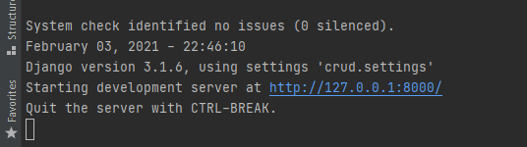

**Terminal:**

Data Base:

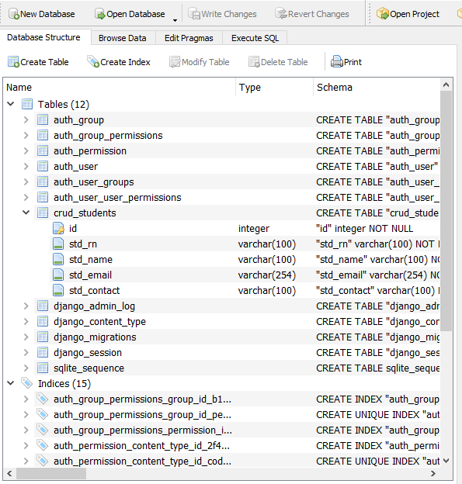

Homepage



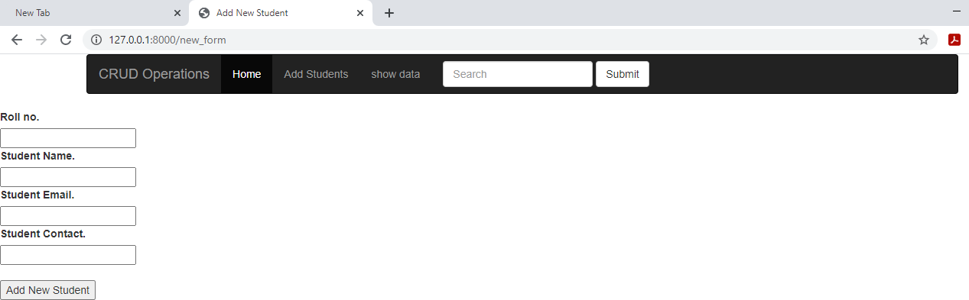Add Student Page