**USMAN INSTITUTE OF TECHNOLOGY**

**Department of Computer Science**

**CS311 Introduction to Database Systems**

Lab#12

**Exercise:**

1. Create a trigger that fill hiredate column with the current date, If the newly inserted record in employee has null hireDate field.

create trigger emp_hiredate before insert on emp for each row

DECLARE

temp date;

Begin

select sysdate into temp from dual;

if(:NEW.hiredate IS NULL)

THEN :NEW.hiredate:=temp;

end if;

End;

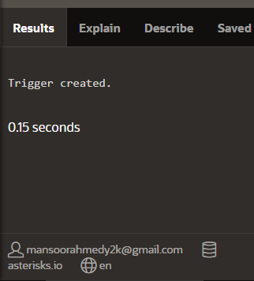

1. Create a trigger that will fill the commission attribute in Employee table always 3% of the salary attribute.

create trigger emp_comm before insert or update on emp for each row

Begin

:new.COMM := :new.SAL * 0.03;

End;



1. Study INSTEAD OF Triggers and explain it with examples.

**INSTEAD OF trigger:** is the special type of trigger. It helps you to change data in tables through their view that cannot be explicitly changed by DML statements.

**Example:** Instead-of trigger can be best demonstrated using a View joining two or more tables. Thus in this example I will create two simple tables and will then create a view over them. After that I will create an Instead of trigger for Insert operation on this view.

**Trigger:**

CREATE OR REPLACE TRIGGER tr_Io_Insert

INSTEAD OF INSERT ON vw_rebellionrider

FOR EACH ROW

BEGIN

INSERT INTO trainer (full_name) VALUES (:new.full_name);

INSERT INTO subject (subject_name) VALUES (:new.subject_name);

END