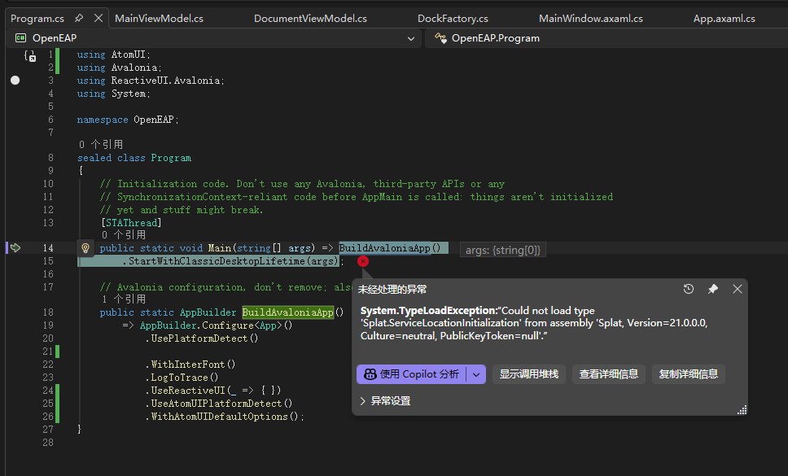
将using ReactiveUI.Avalonia;
替换为using ReactiveUI.Avalonia.Reactive;

