ROLE ASSIGNMENT

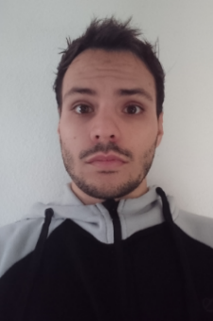

* Member N.º 1:
  + Surname: Liébana Fuentes
  + Name: Rafael
  + E-mail: [rafliefue@alum.us.es](mailto:rafliefue@alum.us.es)
  + Photo:
  + Role: Developer, Tester
  + Tasks: General contribution to the development, as well as to develop the feature corresponding to: Become Employer, Worker and Sponsor, the feature corresponding to the Employer and the feature corresponding to the Sponsor. Also the development of the spam filter and functional requirements of level C and A. Tester of the entire project.

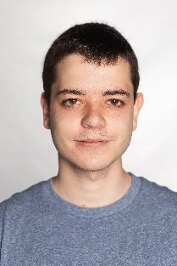

* Member N.º 2:
  + Surname: Cobos Ramos
  + Name: Pedro Manuel
  + E-mail: [pedcobram@alum.us.es](mailto:pedcobram@alum.us.es)
  + Photo:
  + Role: Analyst, Developer
  + Tasks: Organizer of tasks in repository. General contribution to the development, as well as to develop the Audits feature and the entire Dashboard feature. Also the development of functional requirements of level B and A.



* Member N.º 3:
  + Surname: Sánchez Rodríguez
  + Name: Manuel
  + E-mail:  [mansanrod4@alum.us.es](mailto:rafliefue@alum.us.es)
  + Photo:
  + Role: Project Manager, Developer, Deployer
  + Tasks: General contribution to the development, as well as to develop the feature Apply for a job and functional requirements of level C. Deployer of the project in Clevercloud.

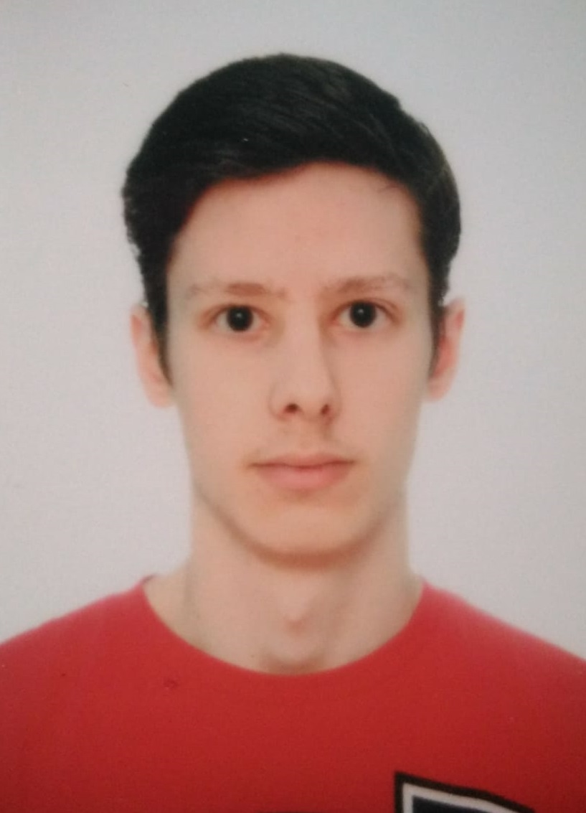

* Member N.º 4:
  + Surname: Fernández Jiménez
  + Name: Gonzalo
  + E-mail: [gonferjim@alum.us.es](mailto:gonferjim@alum.us.es)
  + Photo:
  + Role: Developer
  + Tasks: General contribution to the development, as well as to develop the feature: Become a Sponsor and become Auditor. Also the development of functional requirements of level B and A.
* 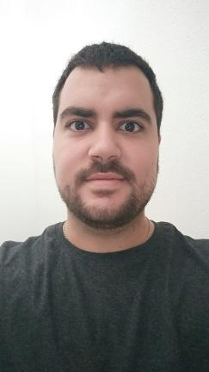Member N.º 5:
  + Surname: Rodríguez Flores
  + Name: Ignacio José
  + E-mail: [ignrodflo@alum.us.es](mailto:ignrodflo@alum.us.es)
  + Photo:
  + Role: Developer
  + Tasks: General contribution to the development, as well as to develop the entire Message Threads feature. Also the development of functional requirements of level B.

Fecha: 18/12/2019, Sevilla Firmas del equipo de trabajo:

