**ONLINE BUS TICKET RESERVATION SYSTEM**

**(OBTRS)**

STUDENT ID : student504427

STUDENT: TUVSHINBAYAR DAVAA

APTECH BANASWADI, KALYAN NAGAR, BANGALORE

**TABLE OF CONTENTS**

* **Introduction**
* **Requirement**
* **Tables**
* **State Diagram**
* **USE CASE Diagram**
* **DFD Diagram**
* **E-R Diagram**
* **UI Design**
* **Conclusion**
* **Bibliography**

**INTRODUCTION**

Online Bus Ticket Reservation System is Windows based application that works within centralized network. The software program “Online Bus Reservation System” provides bus transportation system, a facility to reserved seats, cancellation of seats and different types of enquiry which need an instant and quick reservation. OBTRS is built for manage and computerize the traditional database, ticket booking and tracking bus and travel made easy. It allows counter employee check bus ticket availability and make reservation on particular customer. It maintains all datas of employees, users , bus details, reservation details, booking details, customer details.

Default username is admin and password is root.

**REQUIREMENT**

***Introduction :***

SRC Travel Agencies is a domestic privatized transportation company that runs the vehicles all over the country. They have several branches at different locations of the country, so that they can provide the transportation facilities between the places. They want an online application to be developed, where the details of the bookings done and the customer will be updated from time to time and one can track the details of the available seats immediately.

***Problem statement :***

Customers have to go to the counter to buy bus ticket or ask for bus schedule. Customers need to pay cash when they buy bus tickets and sometimes needs to queue up for hours to get bus tickets. Besides that, customers are also not allowed to buy bus tickets through telephone because the bus company's telephone line is always busy.

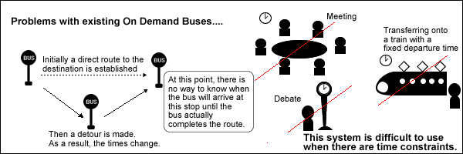

***Existing Scenario :***

SRC Travel Agencies is the agency that provides the transportation facility to the customers based on their requirements. They provide different buses like Express, Luxury, and Volvo (Has two types A/C and Non A/C). The charges are different for different buses. The charges are in the below mentioned format.

Express < Luxury < Volvo (Non A/C) < Volvo (A/C)

The charges also depend on the distance the customer wants to travel and as well on the age of the customer. The charges also depends on the age, i.e., up to the age of 5 years there will not be any charges, in between 5 12 there will be half charges and for above twelve the charges will be full till the age of 50 and for the age above fifty they will get a discount of 30%. They implement this in order to attract the customers. They maintain all the records of the bus reservation counter through Online service itself but the application is only accessed by the Admin and the Employers Alone. Until now they used to issue the tickets in the buses alone as it is difficult to track the details of the bookings done as it provides the service allover the country.

***Proposed Solution :***

Now they want incorporate an online service application where they can maintain the records of the buses along with the details of the customers. The customer can now book the tickets by visiting the booking counters at their place (near by) to the respective destination as required. They want the application to be linked with the database, so that what ever details are entered like the details of the customers, buses, and bookings can be viewed by the other centers as well as it is an online application. They also want to incorporate some feature which performs the tasks that they actually perform, and an application where the customer can register with the site and then book the tickets online instead of visiting the booking counter A database should be maintained where the bus details along with the bus number, route, the places it covers through out the distance and also the timings are needed to be maintained. Also the details of the customers that are entered at the time of booking the tickets are needed to be gathered in the database. So that they can track the details of the customer at any time using the search option based on the starting place, age, name, destination place and Date and Time and even based on the bus they had chosen.

The database should also maintain the list of the Employers as they alone book the tickets with the username and password. The list that is to be maintained is personal details, contact details, location, qualification, age, etc are needed to be gathered. There should be buttons like New, Update and Cancel are to be included. Based on the button chosen the respective action is needed to be performed. Also if the Employee record is entered (The Employee details will be maintained by the Admin alone), it should automatically generate a six digit code, and it will ask for the username and the password (the password can be changed by the Employee) through which he can login in to the a/c so as to perform the booking tasks. Also for canceling the ticket, there is a limit like, if cancelled before 2 days then the whole money will be returned, and if done one day before, then 15% is debited from the total amount and the remaining amount is returned and if done on that day 30% is debited from the total amount and the remaining is to be returned back. This action is also to be performed by the application alone. They want the application to be maintained in different details like the buses and the bookings information. When they try to book a ticket it should ask for the customer details like the name of the customers for whom the tickets are booked, Date and Time, Starting and Destination place and the age ( as the charges depends on the age). Also the Bus no. and the seat no. for which the ticket (s) booked are to be entered so that they can keep track of the bookings done. Whenever a customer enquires for the availability they can check through the Enquiry form where the details like Destination Place, Starting Place, Date and Time are asked, by entering these details (all fields are not mandatory) the availability details should be displayed. Also there should be a search option through which the records of the customers and the buses can be known easily with the same above options. After the ticket is booked, one should be able to print the ticket, including the details like age, name, Date and time for which the ticket is booked and as well the destination and Starting locations and the charges for the ticket including the taxes. The application alone should be able to calculate the payments as per the age criteria and the distance. Also it has to be updated in the site.

Note :

* To book the ticket or to fetch the details (Search and Enquiry) first they need to

Login and only then they will be able to perform such actions.

* This application is solely for the booking department to book the tickets and is

purely maintained by them. It is not applicable for the customers and they

(customers) cannot book the tickets online by themselves.

* The Admin maintains the list of the buses and as well the Employees which

cannot be accessed by the Employee. The Employee can alone change his

Password from the booking window)

**Non-Financial :**

An online application needed to be developed which is to be solely used and maintained by the booking department alone (regarding the bookings like booking, Enquiry and Updating and canceling). It is implemented so as to automate the process. Also the total authority is taken care of by the admin (Employee, Buses and charges)

Also for booking or to perform other actions one has to login with the username and the password assigned. There will be a new, Update, Cancel, search buttons available on each page with which the employee details The customer needed to visit to the booking to enquire or book the tickets and he can collect the tickets in the bus alone. It also maintains a database that consists of the list of buses along with the five digit code that will be assigned to each bus for easy reference. Also the application should develop a unique six digit code whenever a new employee detail is entered. Employee s personal, contact, age, qualifications etc are needed to be collected. There will be an Enquiry form, Booking Form, and the also a page where the search options will be available. Also the Price list is to be maintained separately, where one can access the details of the price by entering the details of the Place of starting and destination, age, number of seats, etc. The charges are as per the age, bus type and the distance and are to be maintained by the application alone.

**Financial :**

The charges vary depending on the type of the bus opted, distance of travel and as well the age of the customer, which is to be calculated by the application alone. The price list can be updated by the Admin alone. Also the Reimbursement of the amount will also be as defined by the admin and is calculated by the application alone by considering the above parameters.

***Functional Requirements :***

1. The details of the buses, Price list, and Employee details are to be maintained and

controlled solely by the (Manager) Admin alone.

1. The Employer can change alone the password assigned to him.
2. Also first the employer needed to login first in order to perform the booking

actions.

1. Calculations of the charges and the reimbursements are to be implemented by the

application alone as designated by the Admin

1. The details of the buses and seats available are to be maintained and can be

updated regularly (of course only by the admin)

1. Enquiry form, Booking form and the pricing list are to be maintained in separate

pages.

1. 7. There should be new, update, cancel and search options available

**TABLES**

**Table : busDetail**

|  |  |  |  |  |  |  |  |  |
| --- | --- | --- | --- | --- | --- | --- | --- | --- |
| **Column_name** | **Type** | **Computed** | **Length** | **Prec** | **Scale** | **Nullable** | **TrimTrailingBlanks** | **FixedLenNullInSource** |
| busId | int | no | 4 | 10 | 0 | no | (n/a) | (n/a) |
| busRegNo | varchar | no | 50 |  |  | yes | no | yes |
| busType | varchar | no | 20 |  |  | yes | no | yes |
| busCapacity | smallint | no | 2 | 5 | 0 | yes | (n/a) | (n/a) |

**Table : cityDetail**

|  |  |  |  |  |  |  |  |  |
| --- | --- | --- | --- | --- | --- | --- | --- | --- |
| **Column_name** | **Type** | **Computed** | **Length** | **Prec** | **Scale** | **Nullable** | **TrimTrailingBlanks** | **FixedLenNullInSource** |
| **cityId** | **int** | **no** | **4** | **10** | **0** | **no** | **(n/a)** | **(n/a)** |
| cityName | varchar | no | 50 |  |  | yes | no | yes |

|  |  |  |  |  |  |  |  |  |
| --- | --- | --- | --- | --- | --- | --- | --- | --- |
| **Column_name** | **Type** | **Computed** | **Length** | **Prec** | **Scale** | **Nullable** | **TrimTrailingBlanks** | **FixedLenNullInSource** |
| **custId** | **bigint** | **no** | **8** |  |  | **no** | **(n/a)** | **(n/a)** |
| custFirstname | varchar | no | 100 |  |  | yes | no | yes |
| custLastname | varchar | no | 100 |  |  | yes | no | yes |
| custDob | datetime | no | 8 |  |  | yes | (n/a) | (n/a) |
| custEmail | varchar | no | 50 |  |  | yes | no | yes |
| custAddress | varchar | no | 100 |  |  | yes | no | yes |
| custPhone | bigint | no | 8 |  |  | yes | (n/a) | (n/a) |

**Table : customerDetail**

**Table : freqDetail**

|  |  |  |  |  |  |  |  |  |
| --- | --- | --- | --- | --- | --- | --- | --- | --- |
| **Column_name** | **Type** | **Computed** | **Length** | **Prec** | **Scale** | **Nullable** | **TrimTrailingBlanks** | **FixedLenNullInSource** |
| **freqId** | **int** | **no** | **4** | **10** | **0** | **no** | **(n/a)** | **(n/a)** |
| mon | int | no | 4 | 10 | 0 | yes | (n/a) | (n/a) |
| tue | int | no | 4 | 10 | 0 | yes | (n/a) | (n/a) |
| wed | int | no | 4 | 10 | 0 | yes | (n/a) | (n/a) |
| thu | int | no | 4 | 10 | 0 | yes | (n/a) | (n/a) |
| fri | int | no | 4 | 10 | 0 | yes | (n/a) | (n/a) |
| sat | int | no | 4 | 10 | 0 | yes | (n/a) | (n/a) |
| sun | int | no | 4 | 10 | 0 | yes | (n/a) | (n/a) |

**Table : groupDetail**

|  |  |  |  |  |  |  |  |  |
| --- | --- | --- | --- | --- | --- | --- | --- | --- |
| **Column_name** | **Type** | **Computed** | **Length** | **Prec** | **Scale** | **Nullable** | **TrimTrailingBlanks** | **FixedLenNullInSource** |
| **groupId** | **int** | **no** | **4** | **10** | **0** | **no** | **(n/a)** | **(n/a)** |
| groupName | varchar | no | 100 |  |  | yes | no | yes |
| permissionId | int | no | 4 | 10 | 0 | yes | (n/a) | (n/a) |

**Table : permissionDetail**

|  |  |  |  |  |  |  |  |  |
| --- | --- | --- | --- | --- | --- | --- | --- | --- |
| **Column_name** | **Type** | **Computed** | **Length** | **Prec** | **Scale** | **Nullable** | **TrimTrailingBlanks** | **FixedLenNullInSource** |
| **permissionId** | **int** | **no** | **4** | **10** | **0** | **no** | **(n/a)** | **(n/a)** |
| userAdd | smallint | no | 2 | 5 | 0 | yes | (n/a) | (n/a) |
| userEdit | smallint | no | 2 | 5 | 0 | yes | (n/a) | (n/a) |
| userDelete | smallint | no | 2 | 5 | 0 | yes | (n/a) | (n/a) |
| travelAdd | smallint | no | 2 | 5 | 0 | yes | (n/a) | (n/a) |
| travelEdit | smallint | no | 2 | 5 | 0 | yes | (n/a) | (n/a) |
| travelDelete | smallint | no | 2 | 5 | 0 | yes | (n/a) | (n/a) |
| routeAdd | smallint | no | 2 | 5 | 0 | yes | (n/a) | (n/a) |
| routeEdit | smallint | no | 2 | 5 | 0 | yes | (n/a) | (n/a) |
| routeDelete | smallint | no | 2 | 5 | 0 | yes | (n/a) | (n/a) |
| busAdd | smallint | no | 2 | 5 | 0 | yes | (n/a) | (n/a) |
| busEdit | smallint | no | 2 | 5 | 0 | yes | (n/a) | (n/a) |
| busDelete | smallint | no | 2 | 5 | 0 | yes | (n/a) | (n/a) |
| groupAdd | smallint | no | 2 | 5 | 0 | yes | (n/a) | (n/a) |
| groupEdit | smallint | no | 2 | 5 | 0 | yes | (n/a) | (n/a) |
| groupDelete | smallint | no | 2 | 5 | 0 | yes | (n/a) | (n/a) |
| reservationRead | int | no | 4 | 10 | 0 | yes | (n/a) | (n/a) |
| reservationAdd | int | no | 4 | 10 | 0 | yes | (n/a) | (n/a) |
| reservationEdit | int | no | 4 | 10 | 0 | yes | (n/a) | (n/a) |
| reservationDelete | int | no | 4 | 10 | 0 | yes | (n/a) | (n/a) |
| reportRead | int | no | 4 | 10 | 0 | yes | (n/a) | (n/a) |
| enquiry | int | no | 4 | 10 | 0 | yes | (n/a) | (n/a) |
| userRead | int | no | 4 | 10 | 0 | yes | (n/a) | (n/a) |
| groupRead | int | no | 4 | 10 | 0 | yes | (n/a) | (n/a) |
| travelRead | int | no | 4 | 10 | 0 | yes | (n/a) | (n/a) |
| routeRead | int | no | 4 | 10 | 0 | yes | (n/a) | (n/a) |
| busRead | int | no | 4 | 10 | 0 | yes | (n/a) | (n/a) |

**Table : purchaseDetail**

|  |  |  |  |  |  |  |  |  |
| --- | --- | --- | --- | --- | --- | --- | --- | --- |
| **Column_name** | **Type** | **Computed** | **Length** | **Prec** | **Scale** | **Nullable** | **TrimTrailingBlanks** | **FixedLenNullInSource** |
| **purchaseId** | **bigint** | **no** | **8** |  |  | **no** | **(n/a)** | **(n/a)** |
| custId | bigint | no | 8 |  |  | yes | (n/a) | (n/a) |
| purchaseAmt | money | no | 8 | 19 | 4 | yes | (n/a) | (n/a) |
| purchaseDate | datetime | no | 8 |  |  | yes | (n/a) | (n/a) |

**Table : reservationDetail**

|  |  |  |  |  |  |  |  |  |
| --- | --- | --- | --- | --- | --- | --- | --- | --- |
| **Column_name** | **Type** | **Computed** | **Length** | **Prec** | **Scale** | **Nullable** | **TrimTrailingBlanks** | **FixedLenNullInSource** |
| **custId** | **bigint** | **no** | **8** |  |  | **yes** | **(n/a)** | **(n/a)** |
| travelId | bigint | no | 8 |  |  | yes | (n/a) | (n/a) |
| purchaseId | bigint | no | 8 |  |  | yes | (n/a) | (n/a) |
| resId | bigint | no | 8 |  |  | yes | (n/a) | (n/a) |
| resDate | datetime | no | 8 |  |  | yes | (n/a) | (n/a) |
| resNoOfSeat | int | no | 4 | 10 | 0 | yes | (n/a) | (n/a) |
| departureDate | datetime | no | 8 |  |  | yes | (n/a) | (n/a) |

**Table : routeDetail**

|  |  |  |  |  |  |  |  |  |
| --- | --- | --- | --- | --- | --- | --- | --- | --- |
| **Column_name** | **Type** | **Computed** | **Length** | **Prec** | **Scale** | **Nullable** | **TrimTrailingBlanks** | **FixedLenNullInSource** |
| **routeId** | **int** | **no** | **4** | **10** | **0** | **no** | **(n/a)** | **(n/a)** |
| routeDistance | bigint | no | 8 |  |  | yes | (n/a) | (n/a) |
| routeFromId | int | no | 4 | 10 | 0 | yes | (n/a) | (n/a) |
| routeToId | int | no | 4 | 10 | 0 | yes | (n/a) | (n/a) |

**Table : travelDetail**

|  |  |  |  |  |  |  |  |  |
| --- | --- | --- | --- | --- | --- | --- | --- | --- |
| **Column_name** | **Type** | **Computed** | **Length** | **Prec** | **Scale** | **Nullable** | **TrimTrailingBlanks** | **FixedLenNullInSource** |
| **travelId** | **bigint** | **no** | **8** |  |  | **no** | **(n/a)** | **(n/a)** |
| busId | int | no | 4 | 10 | 0 | yes | (n/a) | (n/a) |
| routeId | int | no | 4 | 10 | 0 | yes | (n/a) | (n/a) |
| travelDepartureTime | datetime | no | 8 |  |  | yes | (n/a) | (n/a) |
| travelArrivalTime | datetime | no | 8 |  |  | yes | (n/a) | (n/a) |
| travelFare | money | no | 8 | 19 | 4 | yes | (n/a) | (n/a) |
| travelFreqId | int | no | 4 | 10 | 0 | yes | (n/a) | (n/a) |

**Table : userDetail**

|  |  |  |  |  |  |  |  |  |
| --- | --- | --- | --- | --- | --- | --- | --- | --- |
| **Column_name** | **Type** | **Computed** | **Length** | **Prec** | **Scale** | **Nullable** | **TrimTrailingBlanks** | **FixedLenNullInSource** |
| **userId** | **bigint** | **no** | **8** |  |  | **no** | **(n/a)** | **(n/a)** |
| userFirstname | varchar | no | 100 |  |  | yes | no | yes |
| userLastname | varchar | no | 100 |  |  | yes | no | yes |
| userUsername | varchar | no | 100 |  |  | yes | no | yes |
| userPassword | varchar | no | 100 |  |  | yes | no | yes |
| userDob | datetime | no | 8 |  |  | yes | (n/a) | (n/a) |
| userGender | varchar | no | 15 |  |  | yes | no | yes |
| userDesignation | varchar | no | 100 |  |  | yes | no | yes |
| userEmail | varchar | no | 100 |  |  | yes | no | yes |
| userContactNo | bigint | no | 8 |  |  | yes | (n/a) | (n/a) |
| userAddress | varchar | no | 100 |  |  | yes | no | yes |
| groupId | int | no | 4 | 10 | 0 | yes | (n/a) | (n/a) |
| userJoinDate | datetime | no | 8 |  |  | yes | (n/a) | (n/a) |

**STATE DIAGRAM**

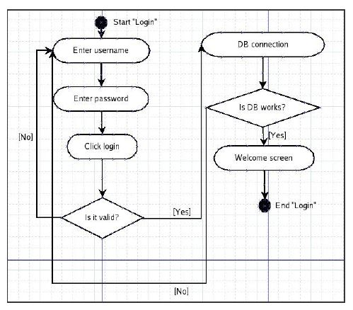

**USE CASE DIAGRAM**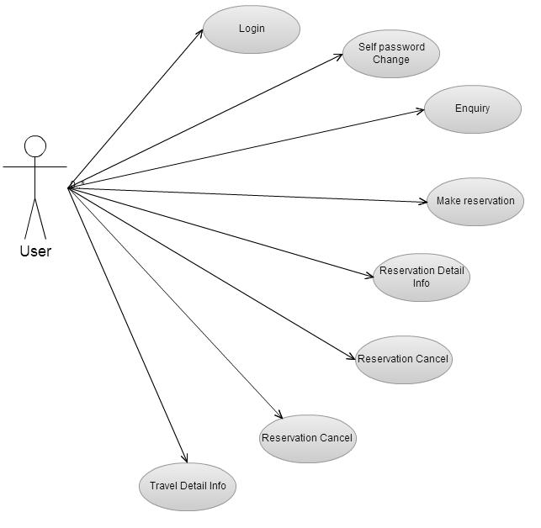

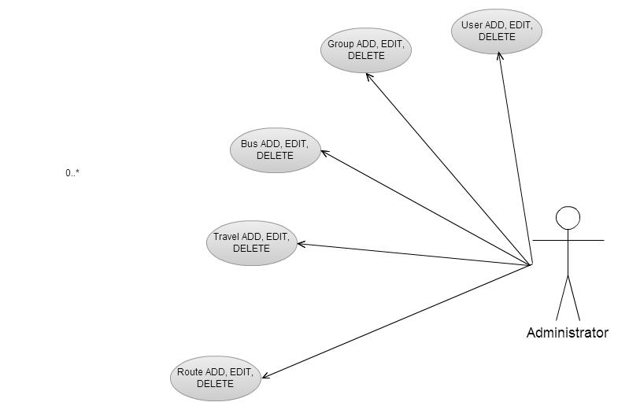

**DFD DIAGRAM**

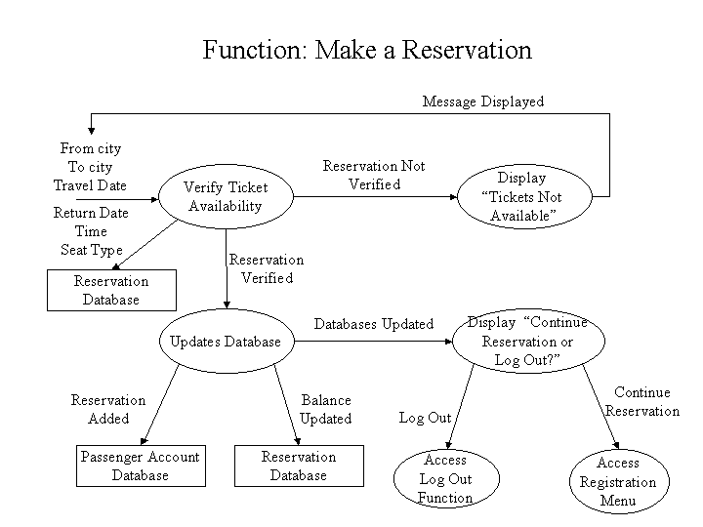

**E-R DIAGRAM**

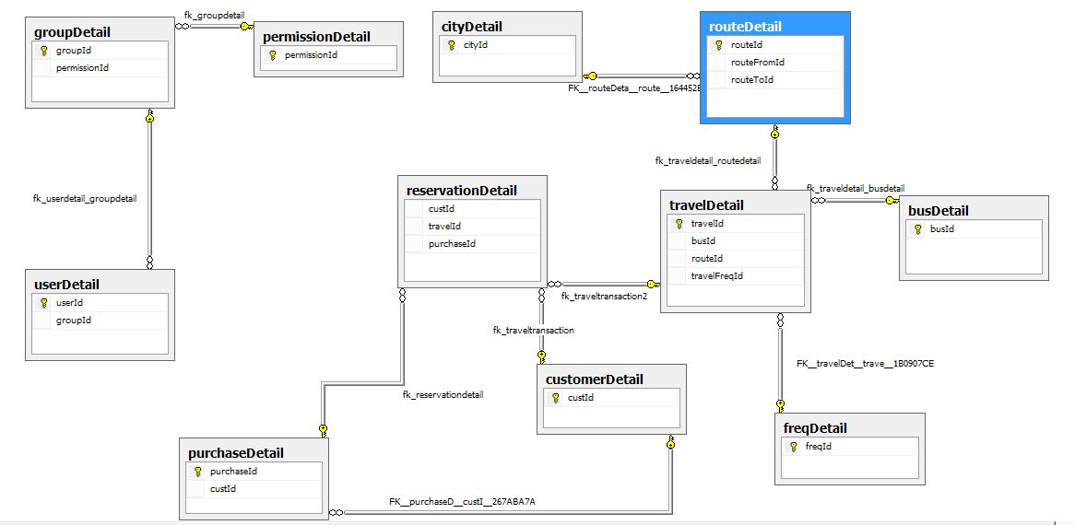

**UI DESIGN**

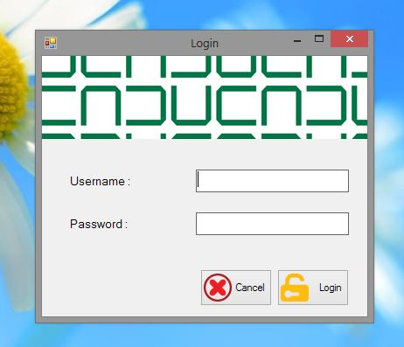

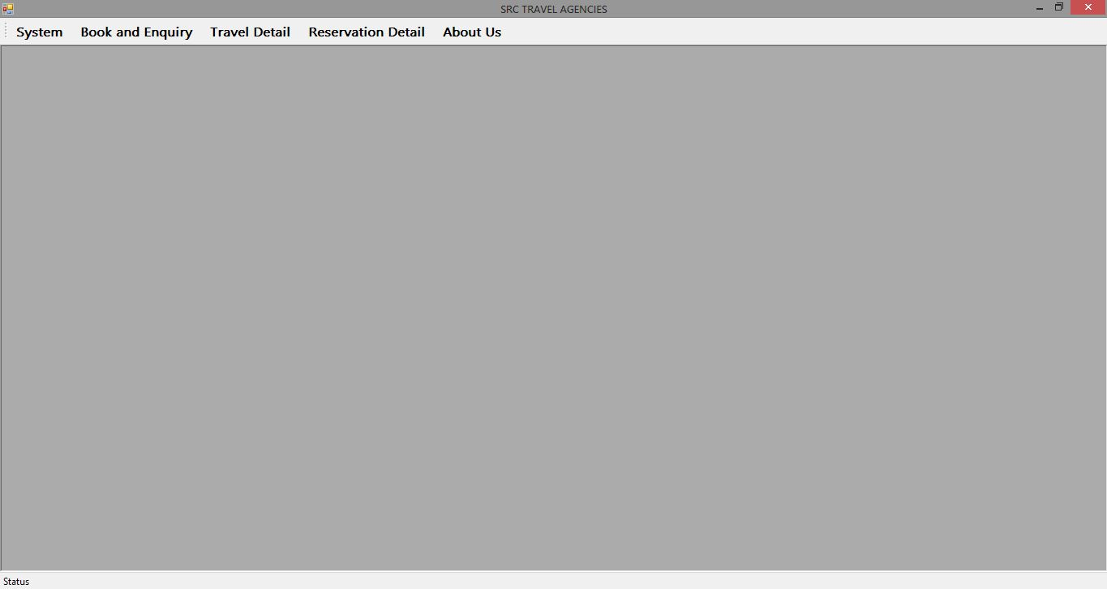

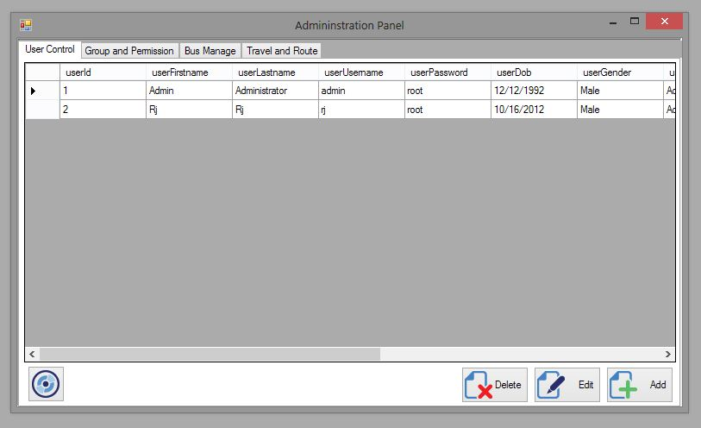

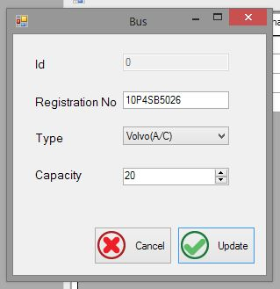

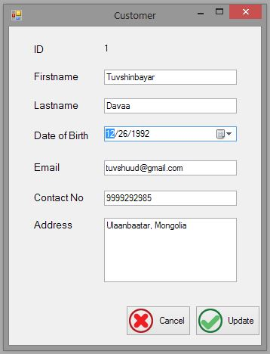

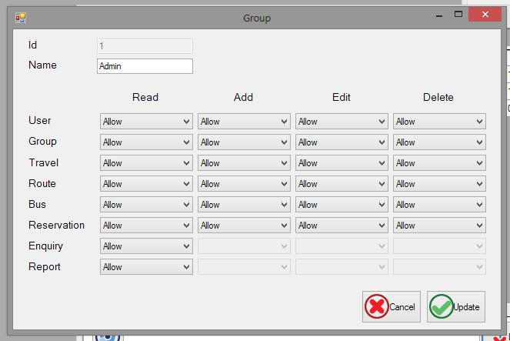

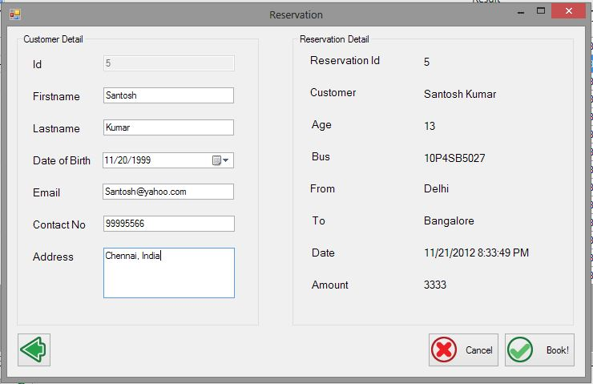

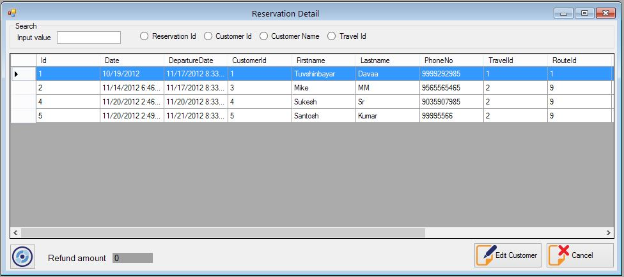

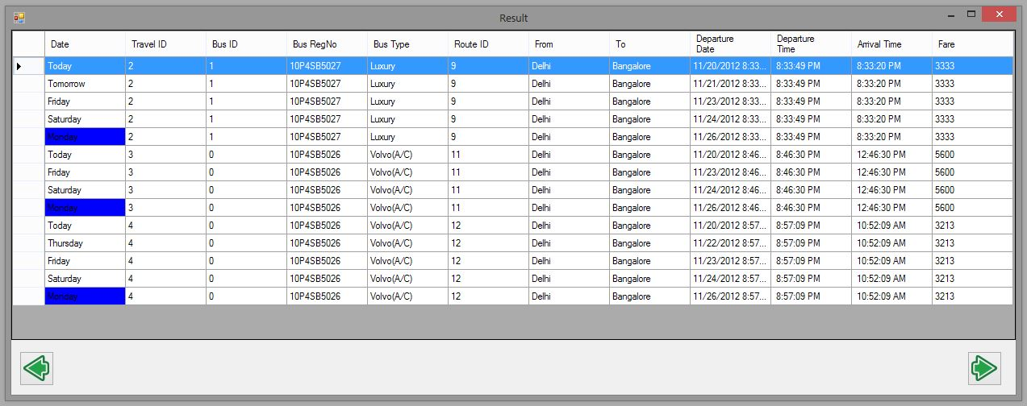

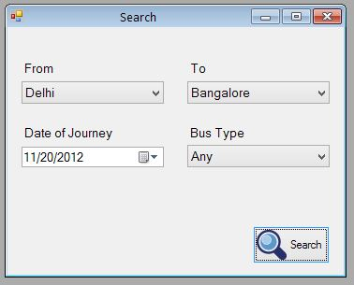

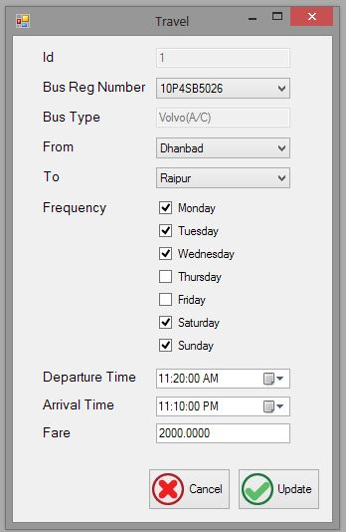

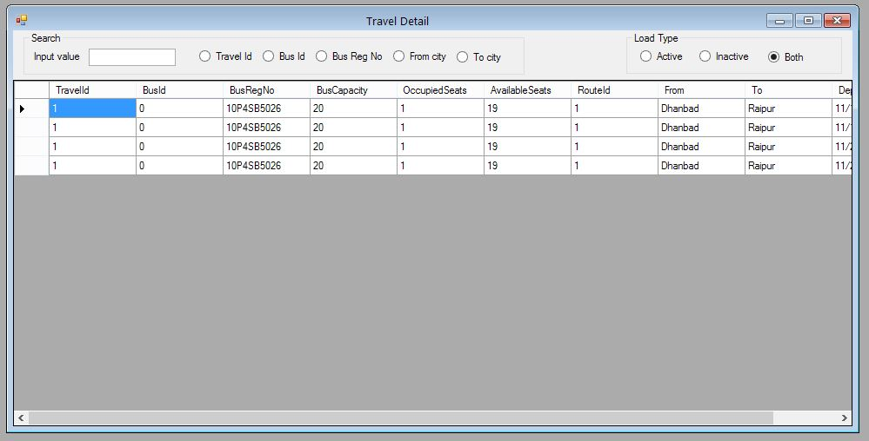

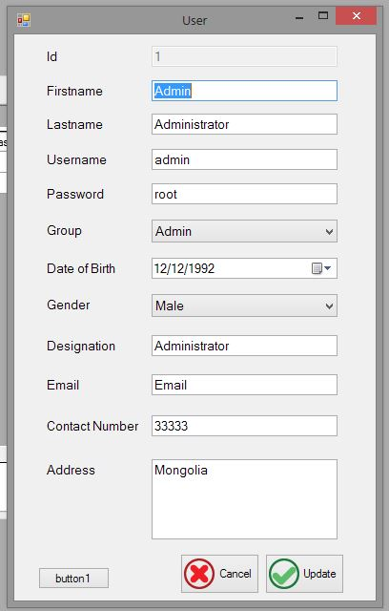

**Bibliography**

<http://zetcode.com/gui/csharpwinforms/>

<http://msdn.microsoft.com/en-us/library/aa288436(v=vs.71).aspx>

<http://codeproject.com/>

http://daniweb.com/