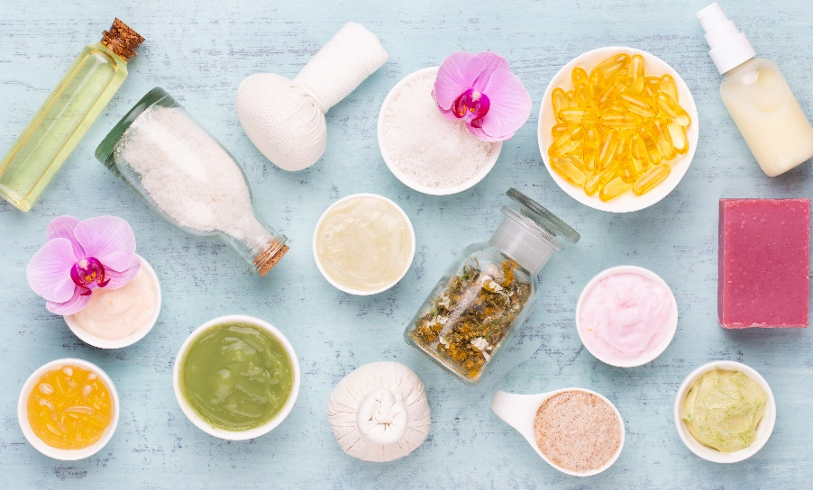

**The Health Package**

**Health & Ayurveda Wellness Package**

Revitalize your **body, mind, and spirit** with our **14-day wellness retreat**, blending **Ayurvedic healing** and **modern therapies** for **detox, relaxation, and vitality**. Enjoy **luxurious spa treatments, Panchakarma, yoga, healing waters, and expert guidance**, ensuring **lasting balance and well-being**.

**Experience the power of ancient healing and modern wellness—your journey to optimal health begins here!**



**What makes us unique:**

Grand Hotel Bad Pyrmont offers a luxurious wellness retreat, combining authentic Ayurveda, modern therapies, and natural healing in a 5-star tranquil setting. With expert-led Panchakarma, healing water treatments, personalized spa therapies, yoga, and fitness programs, our holistic approach ensures deep rejuvenation, detox, and long-term well-being.

**What’s Included in Our Exclusive Health Package**

# 1. Spring Tasting with Healing Sources

Natural Detoxification, Energy Boosting, Inner Well-Being, Therapeutic Hydration. (on card)

For card

Inner page: with image

Experience **nature’s healing power** through our **Spring Water Tasting sessions**, where you’ll enjoy **mineral-rich waters** known to **detoxify the body, boost energy levels, and promote inner well-being**.

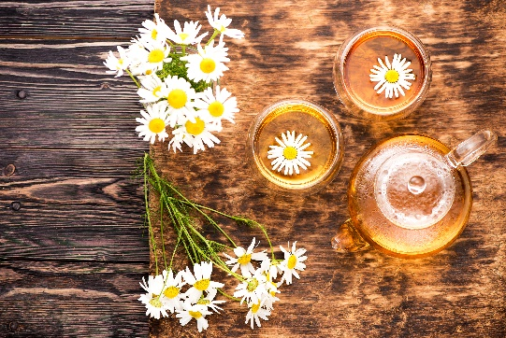

**How It Helps:**

1. **Natural Detoxification** – Mineral-rich spring water helps flush out toxins, supporting liver and kidney function for a cleaner, healthier body.
2. **Boosts Energy Levels** – Essential minerals such as magnesium and calcium enhance metabolic functions, reducing fatigue and improving vitality.
3. **Enhances Hydration** – Natural electrolytes in spring water improve hydration at the cellular level, promoting better digestion, skin health, and overall body function.
4. **Promotes Inner Well-Being** – The purity of natural spring water supports mental clarity, reduces stress, and balances the body’s pH levels, leading to an improved sense of well-being.
5. **Supports Digestive Health** – Alkaline properties aid in maintaining a healthy gut environment, reducing acidity and supporting better digestion.

**When It’s More Effective:**

* **Morning on an Empty Stomach** – Maximizes detoxification, kickstarts metabolism, and hydrates the body after overnight fasting.
* **Before Meals** – Aids digestion and prepares the stomach for better nutrient absorption.
* **Post-Workout** – Replenishes lost minerals and electrolytes, reducing fatigue and muscle soreness.
* **During a Detox or Cleanse** – Enhances the body’s natural ability to eliminate toxins and restore balance.
* **In Times of Stress or Fatigue** – Supports relaxation, mental clarity, and overall rejuvenation.

By incorporating **Spring Water Tasting** into your daily routine, you can experience **optimal hydration, enhanced energy, and improved overall well-being**, making it a vital part of a holistic health approach.

# 2. Healing Water Therapy

Relax Muscles, Improve Circulation, Restore Balance, Mineral-Rich Therapy. (on Card)



Inner page: with image

Tap into the **therapeutic properties of our unique Healing Waters**, rich in minerals that **relax muscles, improve circulation, and restore balance**.



**How It Helps:**

1. **Relaxes Muscles** – The high mineral content, including magnesvium and calcium, helps reduce muscle tension, relieve stiffness, and promote relaxation.
2. **Improves Circulation** – Warm healing waters stimulate blood flow, enhancing oxygen and nutrient delivery to muscles and tissues, reducing swelling and fatigue.
3. **Restores Balance** – The natural mineral composition supports the body’s electrolyte balance, aiding in stress reduction, joint mobility, and overall wellness.
4. **Supports Detoxification** – Mineral absorption through the skin helps eliminate toxins, cleansing the body and rejuvenating the skin.
5. **Soothes Joint Pain** – Healing waters provide relief from arthritis, inflammation, and chronic pain by reducing stiffness and improving mobility.

**When It’s More Effective:**

* **After Physical Activity** – Helps relax muscles, reduce soreness, and enhance post-workout recovery.
* **During Stress or Fatigue** – Provides deep relaxation, reducing stress hormones and promoting mental clarity.
* **For Chronic Pain or Inflammation** – Eases joint stiffness and muscular pain, especially beneficial for arthritis and fibromyalgia.
* **Before Sleep** – Encourages relaxation and deeper sleep by calming the nervous system.
* **As Part of a Detox Regimen** – Enhances the body's natural cleansing processes, flushing out toxins and improving overall vitality.

By **immersing in mineral-rich Healing Waters**, you can experience **deep relaxation, improved circulation, and restored balance**, making it a vital therapy for both physical and mental rejuvenation.

# 3. 24/7 Personal Coaching & Support

24/7 Wellness Coaching, Personalized Guidance, Motivation, Lifestyle Recommendations. (on card)

Inner page : with image

Receive **round-the-clock wellness coaching** from our expert team. Whether you need **motivation, advice, or lifestyle recommendations**, we’re here to guide you every step of the way.

**How It Helps:**

1. **Personalized Guidance** – Tailored health and wellness plans based on individual needs, goals, and challenges.
2. **Continuous Motivation** – Keeps you inspired and on track with your wellness journey, preventing setbacks and burnout.
3. **Lifestyle Optimization** – Expert advice on nutrition, fitness, stress management, and overall well-being to create sustainable healthy habits.
4. **Emotional & Mental Support** – Encouragement and strategies to manage stress, anxiety, and emotional well-being effectively.
5. **Real-Time Adjustments** – Ongoing monitoring and modifications to your wellness plan for maximum effectiveness and progress.

**When It’s More Effective:**

* **During Major Lifestyle Changes** – Provides necessary support when transitioning to a healthier routine, such as starting a new diet or fitness program.
* **For Maintaining Long-Term Goals** – Helps ensure consistency in wellness efforts, keeping you accountable and motivated.
* **In Times of Stress or Fatigue** – Offers guidance to manage burnout, stress, and mental exhaustion with tailored solutions.
* **Before & After Treatments** – Enhances recovery, rehabilitation, and the effectiveness of wellness therapies.
* **For Individuals Seeking Personalized Attention** – Ideal for those who need one-on-one expert support to navigate their health journey successfully.

By **receiving 24/7 expert wellness coaching**, you gain **constant guidance, motivation, and tailored advice**, ensuring **a smooth and sustainable path to optimal health and well-being**.

# 4. Custom Diet Plans & Detox Options

Personalized Meal Plans, Detox Programs, Vitality Enhancement, Weight Management, Digestive Health Support. (on card)

Discover **personalized meal plans and detox programs**, carefully crafted to **enhance vitality, promote weight management, and support digestive health**.



**How It Helps:**

1. **Enhances Vitality** – Nutrient-dense meals and detox plans help boost energy levels, improve metabolism, and promote overall well-being.
2. **Promotes Weight Management** – Customized meal plans support healthy weight loss or maintenance by balancing portion sizes, macronutrients, and calorie intake.
3. **Supports Digestive Health** – Detox programs and gut-friendly foods improve digestion, reduce bloating, and enhance nutrient absorption.
4. **Eliminates Toxins** – A well-structured detox helps the liver, kidneys, and digestive system cleanse the body naturally.
5. **Balances Nutrients** – Tailored plans ensure an optimal intake of vitamins, minerals, and essential nutrients for long-term health.

**When It’s More Effective:**

* **During a Detox or Cleanse** – Helps the body reset, eliminate toxins, and improve digestion for a fresh start.
* **For Weight Loss & Management** – Supports gradual and sustainable weight loss while maintaining energy levels.
* **For Gut & Digestive Health Issues** – Reduces bloating, inflammation, and indigestion by optimizing food choices.
* **After Periods of Overindulgence** – Restores balance after unhealthy eating habits, excessive sugar intake, or processed foods.
* **For Boosting Immunity & Energy** – Provides the body with essential nutrients to enhance immune function and maintain high energy levels.

By **following a personalized meal plan and detox program**, you can achieve **better digestion, sustainable weight management, and improved vitality**, leading to long-term health and wellness.

# 5. Sports and Training Therapy

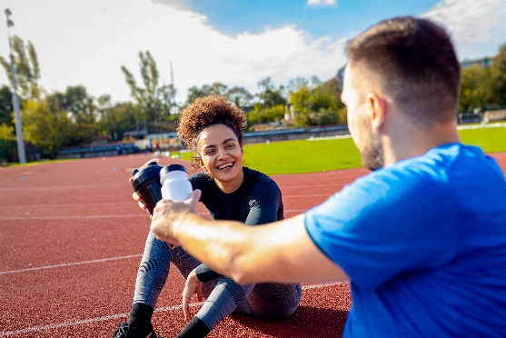Customized Fitness Programs, Muscle Toning, Flexibility Improvement, Endurance Building, Expert-Led Training. (on Card)

Inner page with image

Strengthen and tone your body with **customized fitness programs** led by expert trainers. Whether your goal is **muscle toning, flexibility, or overall endurance**, we tailor each session to your needs.



**How It Helps:**

1. **Muscle Toning & Strengthening** – Targeted exercises enhance muscle definition, build strength, and improve overall body composition.
2. **Flexibility Improvement** – Stretching routines and mobility training increase flexibility, reduce stiffness, and prevent injuries.
3. **Endurance Building** – Cardiovascular and resistance training boost stamina, allowing for improved physical performance and energy levels.
4. **Personalized Training** – Expert-led sessions are tailored to individual fitness levels, goals, and physical conditions for maximum results.
5. **Holistic Approach to Wellness** – Combines strength, flexibility, and endurance training for a well-rounded fitness routine that supports long-term health.

**When It’s More Effective:**

* **For Weight Management & Toning** – Helps sculpt the body, enhance muscle definition, and burn fat effectively.
* **During Rehabilitation & Recovery** – Supports recovery from injuries or medical conditions with controlled, low-impact exercises.
* **For Boosting Athletic Performance** – Enhances endurance, stamina, and strength for individuals engaging in sports or high-performance activities.
* **To Improve Mobility & Prevent Aging Effects** – Beneficial for older adults or those with mobility restrictions, ensuring long-term joint and muscle health.
* **As Part of a Holistic Wellness Plan** – Works best when combined with proper nutrition, hydration, and recovery strategies.

By **following a customized fitness program**, you achieve **muscle strength, flexibility, endurance, and overall body fitness**, ensuring a sustainable and well-balanced approach to health and wellness.

# 6. Rejuvenating Kneipp Therapy

Immune System Boost, Improved Circulation, Hot & Cold Water Therapy, Invigoration, Refreshing Treatment. (on card)

Inner page with image

Boost your **immune system and circulation** with **Kneipp Therapy**, an alternating hot and cold water treatment that leaves you **invigorated and refreshed**.



**How It Helps:**

1. **Boosts Immune System** – Alternating hot and cold water exposure strengthens the body’s natural defense system, reducing susceptibility to illness.
2. **Improves Circulation** – Stimulates blood flow, enhances oxygen supply to organs, and supports overall cardiovascular health.
3. **Hot & Cold Water Therapy** – The contrast between hot and cold water promotes detoxification, soothes muscles, and enhances vascular flexibility.
4. **Invigorates & Refreshes the Body** – Activates the nervous system, relieves fatigue, and leaves the body feeling rejuvenated.
5. **Reduces Stress & Muscle Tension** – Helps relax the body, reduce inflammation, and improve overall mental well-being.

**When It’s More Effective:**

* **For Strengthening Immunity** – Ideal during seasonal changes or after illness to enhance resistance against infections.
* **To Improve Circulation & Energy Levels** – Beneficial for those with poor circulation, low energy, or sedentary lifestyles.
* **After Intense Physical Activity** – Helps soothe sore muscles, accelerate recovery, and reduce inflammation.
* **For Stress & Anxiety Relief** – Promotes relaxation, improves mood, and reduces symptoms of stress or burnout.
* **To Support Detoxification** – Enhances the body’s ability to eliminate toxins and promote metabolic efficiency.

By **incorporating Kneipp Therapy into your wellness routine**, you can experience **enhanced immunity, better circulation, reduced stress, and overall physical rejuvenation**, making it an essential part of a holistic health regimen.

# 7. Barefoot Paths for Grounding

Stimulate Circulation, Reduce Stress, Restore Energy Balance, Reconnect with Nature. (on card)



Inner page with image  
Reconnect with nature by walking on **barefoot trails**, designed to **stimulate circulation, reduce stress, and restore your natural energy balance**.

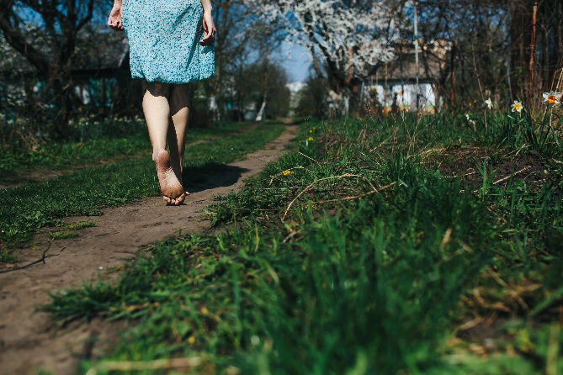

**How It Helps:**

1. **Stimulates Circulation** – Walking barefoot on natural surfaces like grass, sand, or stones enhances blood flow, improving overall circulation and oxygen delivery.
2. **Reduces Stress & Anxiety** – Direct contact with the earth (grounding) calms the nervous system, lowers cortisol levels, and promotes relaxation.
3. **Restores Natural Energy Balance** – Grounding helps neutralize free radicals, balance the body’s electrical charge, and increase vitality.
4. **Strengthens Foot Muscles & Joints** – Walking barefoot naturally activates muscles, improving posture, balance, and foot health.
5. **Enhances Sensory Stimulation** – Different textures underfoot stimulate nerve endings, activating reflexology points for overall wellness.

**When It’s More Effective:**

* **Early Morning or Evening** – Maximizes the benefits of fresh air, natural light, and cooler temperatures for relaxation.
* **After a Stressful Day** – Helps reset the body’s stress response, promoting calmness and mental clarity.
* **For Circulatory or Joint Issues** – Ideal for individuals with poor circulation, arthritis, or muscle stiffness to improve movement and reduce pain.
* **Post-Exercise Recovery** – Assists in relieving tension, improving flexibility, and enhancing post-workout recovery.
* **As Part of a Holistic Wellness Routine** – Works best when combined with meditation, yoga, or breathwork for complete mind-body balance.

By **walking barefoot on natural surfaces**, you experience **improved circulation, reduced stress, enhanced energy balance, and overall physical and mental well-being**, making it an essential practice for reconnecting with nature and restoring inner harmony.

# 8. Endurance Training for Vitality

Cardiovascular Health, Stamina Building, Strength Enhancement, Long-Term Wellness. (on card)

Improve your **cardiovascular health and stamina** with our **endurance training sessions**, customized to help you build strength and energy for long-term wellness.

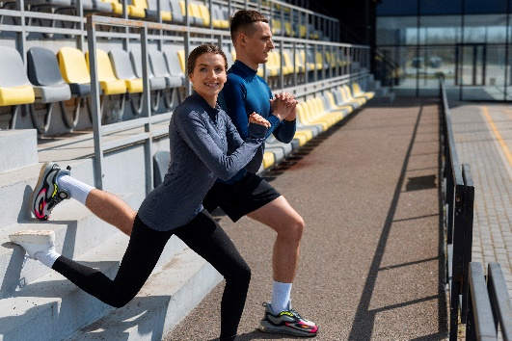

**How It Helps:**

1. **Enhances Cardiovascular Health** – Strengthens the heart, improves circulation, and lowers the risk of heart disease by increasing oxygen efficiency.
2. **Builds Stamina & Energy Levels** – Increases lung capacity, endurance, and overall physical performance, reducing fatigue and boosting vitality.
3. **Strengthens Muscles & Joints** – Improves muscular endurance, flexibility, and resilience, reducing the risk of injury and enhancing mobility.
4. **Supports Weight Management** – Burns calories efficiently, aids in fat loss, and helps maintain a healthy metabolism for long-term wellness.
5. **Improves Mental Well-Being** – Releases endorphins, reducing stress, anxiety, and improving focus, mood, and sleep quality.

**When It’s Important:**

* **For Heart & Lung Health** – Beneficial for those looking to strengthen cardiovascular function and improve breathing efficiency.
* **During Fitness & Weight Loss Goals** – Helps individuals working on fitness, muscle toning, and body transformation.
* **For Athletic Performance & Endurance Sports** – Ideal for athletes or individuals preparing for marathons, cycling, or high-intensity sports.
* **For Energy & Fatigue Management** – Effective for those experiencing low energy levels, helping to sustain higher physical and mental productivity.
* **As Part of a Long-Term Wellness Plan** – Supports overall health, mobility, and longevity, making it essential for aging adults or those seeking sustained fitness.

By incorporating **customized endurance training**, you achieve **better heart health, increased stamina, stronger muscles, and long-term wellness**, making it a crucial component of a balanced fitness routine.

# 9. Water Gymnastics for Flexibility

Low-Impact Exercise, Joint-Friendly Movement, Flexibility Enhancement, Balance Improvement, Strength Building. (on Card)



Engage in **low-impact, joint-friendly exercises** in soothing thermal waters. Water gymnastics enhance **flexibility, balance, and strength**, making them perfect for all fitness levels.

**How It Helps:**

1. **Low-Impact & Joint-Friendly Exercise** – Water reduces stress on joints, making movements smooth and pain-free, ideal for individuals with arthritis or mobility issues.
2. **Enhances Flexibility & Mobility** – The buoyancy of water supports a greater range of motion, allowing for gentle stretching and improved flexibility.
3. **Improves Balance & Coordination** – Water resistance naturally engages stabilizing muscles, enhancing balance and coordination.
4. **Strengthens Muscles & Core Stability** – The resistance of water helps build muscle strength while reducing the risk of strain or injury.
5. **Supports Cardiovascular Health** – Gentle water exercises increase heart rate and circulation without excessive strain, promoting better heart health.

**When It’s More Effective:**

* **For Joint Pain & Arthritis Relief** – Ideal for individuals with knee, hip, or joint issues who need a pain-free way to exercise.
* **During Injury Recovery & Rehabilitation** – Supports gentle movement and strength rebuilding without putting pressure on injured areas.
* **For Older Adults & Mobility Challenges** – Provides a safe and effective way to maintain strength, flexibility, and balance.
* **As a Full-Body Workout Alternative** – Offers a complete workout that combines cardio, strength training, and flexibility in one session.
* **For Stress Reduction & Relaxation** – The soothing effect of warm water helps relax muscles, reduce stress, and promote mental well-being.

By incorporating **water gymnastics into your fitness routine**, you experience **joint-friendly movement, improved flexibility, better balance, and enhanced muscle strength**, making it a perfect exercise for all fitness levels.

# 10. Rejuvenating Yoga Sessions

Mind-Body Balance, Flexibility Improvement, Stress Reduction, Inner Peace Enhancement, Guided Yoga Practice. (on card)

Inner page with image

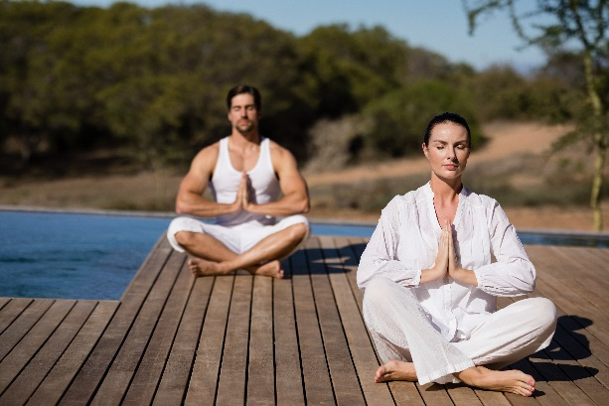Balance your **mind and body** with **yoga sessions** designed to **improve flexibility, reduce stress, and enhance inner peace**. Whether you're a beginner or an advanced practitioner, our experienced instructors guide you through **relaxing and energizing poses**.

**How It Helps:**

1. **Mind-Body Balance** – Yoga integrates breath control, movement, and mindfulness to create harmony between the body and mind.
2. **Flexibility Improvement** – Regular practice enhances mobility, reduces stiffness, and increases the range of motion in joints and muscles.
3. **Stress Reduction** – Deep breathing and relaxation techniques lower cortisol levels, helping to alleviate stress and anxiety.
4. **Inner Peace Enhancement** – Meditation and mindful movement cultivate self-awareness, emotional stability, and a sense of calm.
5. **Guided Yoga Practice** – Experienced instructors tailor sessions for all levels, ensuring proper alignment, safety, and effectiveness.

**When It’s More Effective:**

* **In the Morning for Energy & Focus** – Activates the body, clears the mind, and prepares you for the day ahead.
* **Before Bed for Relaxation** – Helps release tension, quiet the mind, and promote deep, restful sleep.
* **For Stress & Anxiety Management** – Ideal for those dealing with high stress, offering instant relaxation and mental clarity.
* **To Improve Posture & Mobility** – Beneficial for individuals with sedentary lifestyles, reducing stiffness and correcting alignment.
* **As Part of a Holistic Wellness Routine** – Works best when combined with meditation, a balanced diet, and overall healthy living practices.

By incorporating **guided yoga sessions**, you experience **enhanced flexibility, reduced stress, inner peace, and improved mind-body balance**, making it an essential practice for overall well-being.

# 11. Expert Lectures for Lifelong Health

Expert Health Insights, Nutrition Guidance, Fitness Education, Mindfulness Training, Long-Term Well-Being Knowledge. (on card)

Inner page with image

Gain valuable insights from **health and wellness experts** on topics like **nutrition, fitness, and mindfulness**, ensuring that you leave with **knowledge for long-term well-being**.



**How It Helps:**

1. **Expert Health Insights** – Provides evidence-based information from professionals on maintaining optimal health and wellness.
2. **Nutrition Guidance** – Helps understand the importance of balanced diets, meal planning, and dietary adjustments for better health.
3. **Fitness Education** – Offers knowledge on effective workout routines, posture correction, and injury prevention for a sustainable fitness journey.
4. **Mindfulness Training** – Teaches stress management, mental well-being strategies, and techniques for emotional resilience.
5. **Long-Term Well-Being Knowledge** – Equips individuals with lifelong skills to maintain a healthy lifestyle and make informed wellness decisions.

**When It’s More Important:**

* **For Preventive Health & Disease Management** – Helps individuals adopt healthier habits to prevent illnesses and manage existing conditions.
* **When Starting a New Health or Fitness Journey** – Provides essential guidance for beginners to create a safe and effective plan.
* **During Lifestyle Transitions** – Beneficial for those undergoing changes like aging, pregnancy, or recovering from illness or injury.
* **For Stress & Mental Health Support** – Helps in managing anxiety, depression, and emotional well-being through expert-backed techniques.
* **To Build Sustainable Healthy Habits** – Ensures individuals make informed decisions about nutrition, fitness, and overall well-being for long-term health benefits.

By gaining **expert insights into health, nutrition, fitness, and mindfulness**, you empower yourself with **the knowledge and tools needed for lifelong well-being and a balanced lifestyle**.

# 12. High-Quality Wellness Treatments (Modular)

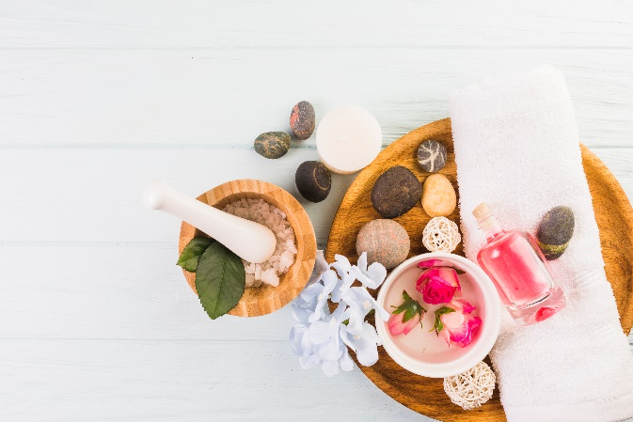Customized Spa Therapies, Deep Relaxation, Muscle Recovery, Skin Rejuvenation, Personalized Wellness Treatments. (on card)

Inner page with image

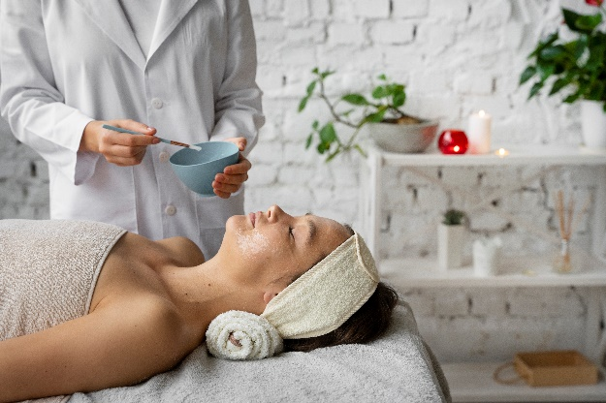Indulge in **customized spa therapies**, tailored to meet your body’s unique needs. Whether you seek **deep relaxation, muscle recovery, or skin rejuvenation**, our modular wellness treatments provide the perfect remedy.

**How It Helps:**

1. **Deep Relaxation** – Relieves stress, calms the nervous system, and promotes a sense of overall well-being.
2. **Muscle Recovery** – Soothes sore muscles, alleviates tension, and enhances post-exercise recovery.
3. **Skin Rejuvenation** – Nourishes and hydrates the skin, promoting a youthful, glowing complexion.
4. **Personalized Wellness Treatments** – Tailored to specific needs, whether for relaxation, pain relief, or detoxification.
5. **Improved Circulation & Detoxification** – Enhances blood flow, removes toxins, and supports overall body function.

**When It’s More Important:**

* **After Periods of High Stress** – Helps the body and mind unwind, reducing tension and anxiety.
* **Following Intense Physical Activity** – Supports muscle recovery and reduces inflammation after workouts or sports.
* **For Skin & Beauty Enhancement** – Beneficial for maintaining healthy, radiant skin through deep hydration and nourishment.
* **During Detox or Wellness Programs** – Enhances the body’s natural detoxification process, aiding in renewal and balance.
* **For Chronic Pain or Stiffness Relief** – Helps alleviate muscle tightness, joint pain, and tension headaches.

By indulging in **customized spa therapies**, you experience **relaxation, muscle relief, skin rejuvenation, and overall wellness**, making them an essential part of self-care and holistic health.

# 13. Cosmetic Treatments for Radiance

Premium Cosmetic Treatments, Nourishing Facials, Revitalizing Skincare, Anti-Aging Therapies, Radiant & Refreshed Skin. (on Card)

Inner page with image

Glow from the inside out with **premium cosmetic treatments**, including **nourishing facials, revitalizing skincare, and anti-aging therapies** that leave your skin **radiant and refreshed**.



**How It Helps:**

1. **Nourishing Facials** – Deeply hydrate and replenish the skin, improving texture, elasticity, and overall health.
2. **Revitalizing Skincare** – Targets skin concerns like dullness, uneven tone, and dehydration, leaving the skin fresh and glowing.
3. **Anti-Aging Therapies** – Reduces fine lines, wrinkles, and signs of aging by stimulating collagen production and improving skin firmness.
4. **Radiant & Refreshed Skin** – Enhances skin brightness, reduces fatigue, and restores a youthful appearance.
5. **Detox & Deep Cleansing** – Removes impurities, unclogs pores, and balances oil production for a clear, healthy complexion.

**When It’s More Important:**

* **To Maintain Youthful Skin** – Ideal for preventing premature aging, maintaining hydration, and enhancing skin elasticity.
* **Before Special Events** – Ensures a radiant, flawless glow for weddings, celebrations, or important occasions.
* **After Exposure to Environmental Stressors** – Helps repair skin damage caused by sun exposure, pollution, and harsh weather conditions.
* **For Dry, Dull, or Uneven Skin** – Replenishes lost moisture, smooths rough texture, and evens out skin tone.
* **As Part of a Self-Care Routine** – Encourages regular skin maintenance, promoting long-term health and beauty.

By indulging in **premium cosmetic treatments**, you achieve **deeply nourished, youthful, and radiant skin**, making it an essential part of self-care and beauty wellness.

**What’s Included in Our Exclusive Health Package**

**Ayurvedic Detox & Rejuvenation**

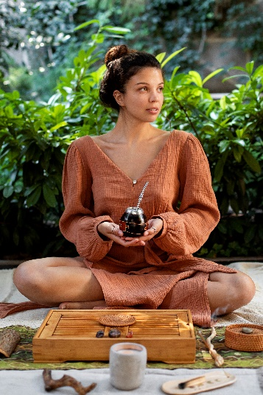Ayurvedic Detox, Holistic Rejuvenation, Natural Cleansing, Restorative Healing, Balance & Vitality. (on card)

Inner page with image  
Ayurveda, the ancient science of holistic healing, focuses on **natural detoxification, balance, and rejuvenation** through personalized therapies, herbal treatments, and mindful practices. Rooted in centuries-old wisdom, it restores **harmony between body, mind, and spirit**, promoting long-term health and vitality.

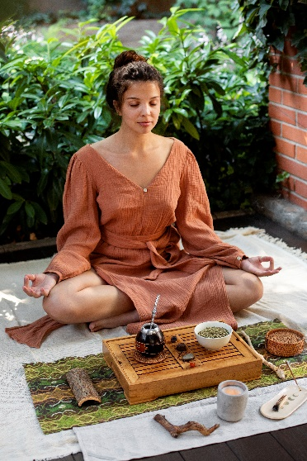

**Why It’s Important:**

1. **Eliminates Toxins Naturally** – Ayurvedic detox (Panchakarma) helps remove accumulated toxins from the body, supporting liver and kidney function.
2. **Restores Balance & Vitality** – Aligns the body's natural energies (Doshas: Vata, Pitta, Kapha), promoting overall well-being and inner harmony.
3. **Boosts Digestion & Metabolism** – Enhances gut health, regulates digestion, and improves metabolic efficiency.
4. **Strengthens Immunity** – Helps the body fight diseases by purifying the system and increasing natural resistance.
5. **Reduces Stress & Mental Fatigue** – Supports relaxation, mental clarity, and emotional balance through holistic healing therapies.

**When It’s More Important:**

* **After Periods of Unhealthy Eating or Lifestyle Habits** – Helps reset the body after consuming processed foods, alcohol, or exposure to pollutants.
* **During Seasonal Transitions** – Ideal for detoxing and preparing the body for seasonal changes, especially in spring and autumn.
* **For Chronic Fatigue & Low Energy** – Revitalizes the body by eliminating sluggishness and boosting energy levels.
* **When Experiencing Digestive Issues** – Alleviates bloating, constipation, and digestive discomfort by enhancing gut function.
* **For Stress, Anxiety, or Emotional Imbalance** – Supports mental well-being by promoting relaxation and reducing tension.

By undergoing **Ayurvedic Detox & Rejuvenation**, you experience **deep cleansing, restored vitality, improved immunity, and enhanced mental clarity**, making it a crucial practice for long-term health and wellness.

✔ **1 x Personal Ayurvedic Consultation** – Tailored wellness guidance from Dr. Yasmin Blumenberg.  
✔ **3 x Abhyanga** – Full-body warm oil massage for deep relaxation and nourishment.  
✔ **2 x Mukabhyanga** – A soothing Ayurvedic facial massage for skin health.  
✔ **2 x Shirodhara** – Meditative oil therapy on the forehead to calm the nervous system.  
✔ **2 x Udvarthana** – Invigorating dry herbal massage to tone the body.  
✔ **2 x Matra-Basti** – Herbal oil enema therapy for nourishment.  
✔ **1 x Anuwasan Basti** – Deep oil enema for rejuvenation.  
✔ **1 x Asthapana Basti** – Detoxifying herbal decoction enema.  
✔ **1 x Nasya** – Ayurvedic nasal cleansing for respiratory wellness.  
✔ **1 x Svedana** – Herbal steam bath for detoxification.  
✔ **1 x Jambira Pinda Sweda** – Specialized herbal therapy for muscle relief.  
✔ **1 x Padabhyanga** – Relaxing foot and lower leg oil massage.  
✔ **2 x Ayurveda Lectures** – Learn the principles of Ayurveda for lifelong health.  
✔ **1 x Ayurveda Workshop** – Hands-on learning of Ayurvedic self-care.  
✔ **1 x Final Consultation** – Personalized guidance for post-retreat wellness.

**Holistic Wellness & Healing Therapies**

✔ **Spring Water Tasting** – Experience mineral-rich healing waters that boost energy and detoxify the body.  
✔ **Healing Water Therapy** – Soothe muscles and improve circulation with therapeutic water treatments.  
✔ **24/7 Personal Coaching & Support** – Continuous guidance for a seamless wellness journey.  
✔ **Custom Diet Plans & Detox Options** – Tailored nutrition programs for weight balance and vitality.  
✔ **Rejuvenating Kneipp Therapy** – Alternating hot & cold water treatments to enhance circulation.  
✔ **Barefoot Paths for Grounding** – Restore natural energy with grounding barefoot trails.  
✔ **Endurance Training for Vitality** – Boost cardiovascular health and stamina with expert-led training.  
✔ **Water Gymnastics for Flexibility** – Low-impact aquatic exercises for mobility and strength.  
✔ **Rejuvenating Yoga Sessions** – Holistic yoga to enhance flexibility, reduce stress, and balance energy.  
✔ **Sports & Training Therapy** – Customized fitness programs for strength and endurance.  
✔ **Expert Health Lectures** – Gain insights from specialists on fitness, nutrition, and longevity.  
✔ **High-Quality Wellness Treatments (Modular)** – Personalized spa therapies for deep relaxation.  
✔ **Cosmetic Treatments for Radiance** – Rejuvenating facials and skin therapies for a healthy glow.

**Why Choose the Ultimate Ayurveda & Wellness Retreat?**

✅ **Comprehensive Healing:** A fusion of ancient Ayurveda & modern wellness therapies.  
✅ **Personalized Approach:** Tailored treatments for individual health goals.  
✅ **Detox & Rejuvenate:** Remove toxins, restore balance, and boost vitality.  
✅ **Expert Guidance:** Ayurvedic & wellness specialists at your service.  
✅ **Serene Environment:** A luxurious escape for deep healing and relaxation.

📍 **Transform Your Health Today!**  
Book your **Ultimate Ayurveda & Wellness Retreat** at **Grand Hotel Bad Pyrmont** for an **unparalleled journey of healing and rejuvenation.**

**🌿 Limited slots available – Secure your spot now! 🌿**

The **Health & Ayurveda Wellness Package** at **Grand Hotel Bad Pyrmont** is more than just a retreat—it’s a **personalized journey to optimal well-being**. Designed to **restore balance, enhance vitality, and promote deep relaxation**, this program blends **ancient Ayurvedic healing** with **modern wellness practices** for a **truly transformative experience**.

✔ **Deep Relaxation & Stress Relief**  
✔ **Holistic Fitness & Endurance Training**  
✔ **Ayurvedic Detox & Nutritional Balance**  
✔ **Personalized Coaching & Expert Guidance**

Embark on a **wellness journey tailored to your needs**, where every treatment, therapy, and practice is carefully curated to **nourish your body, calm your mind, and elevate your spirit**. **Discover true rejuvenation—because your best self deserves the best care.**

**Indulge in Wellness Like Never Before—Book Your Ultimate Health Package Today!**