TBMI26 – Computer Assignment Reports  
Deep Learning

Deadline – March 14 2021

Author/-s: Niclas Hansson: nicha207  
 Måns Aronsson: manar189

In order to pass the assignment you will need to answer the following questions and upload the document to LISAM. Please upload the document in PDF format. **You will also need to upload the Jupyter notebook as an HTML-file (using the notebook menu: File -> Export Notebook As…)**. We will correct the reports continuously so feel free to send them as soon as possible. If you meet the deadline you will have the lab part of the course reported in LADOK together with the exam. If not, you’ll get the lab part reported during the re-exam period.

Disclaimer from the authors: We forgot to save the html file during the lab. The file provided with this report is the same file used to achieve the images for this report, however the results may differ slightly since we needed to rerun the code and save it again.

1. **The shape of X_train and X_test has 4 values. What do each of these represent?**

In order: Number of images, pixel size of the images and the 3 color channels of the input.

1. **Train a Fully Connected model that achieves above 45% accuracy on the test data. Provide a short description of your model and show the evaluation image.**

The model uses two dense layers with a rectified linear unit as an activation-function. It uses >600 000 trainable parameters. The result does not improve with more training after reaching a cap on the validation data around 46-47%.

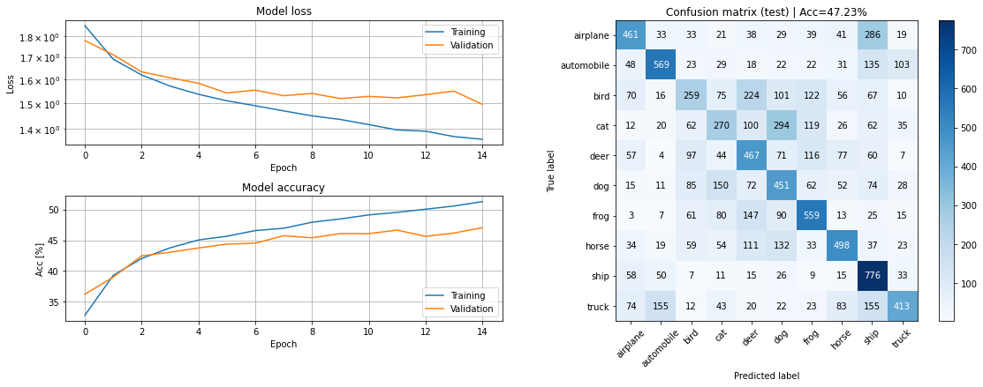

1. **Compare the model from Q2 to the one you used for the MNIST dataset in the first assignment, in terms of size and test accuracy. Why do you think this dataset is much harder to classify than the MNIST handwritten digits?**

Numbers always have the same orientation. In this dataset a cat in one image can be angled one way and another cat can be its mirror image, meaning that the network must train more variables to identify objects and cannot heavily rely on a few defining features.

1. **Train a CNN model that achieves at least 62% test accuracy. Provide a short description of your model and show the evaluation image.**

The CNN uses 2 blocks, where each block consists of a convolution with a 3x3 kernel and a pooling. The pooling down samples the image to half the size. The network uses about 40’000 trainable parameters but performs almost 20% better than just the dense layers.

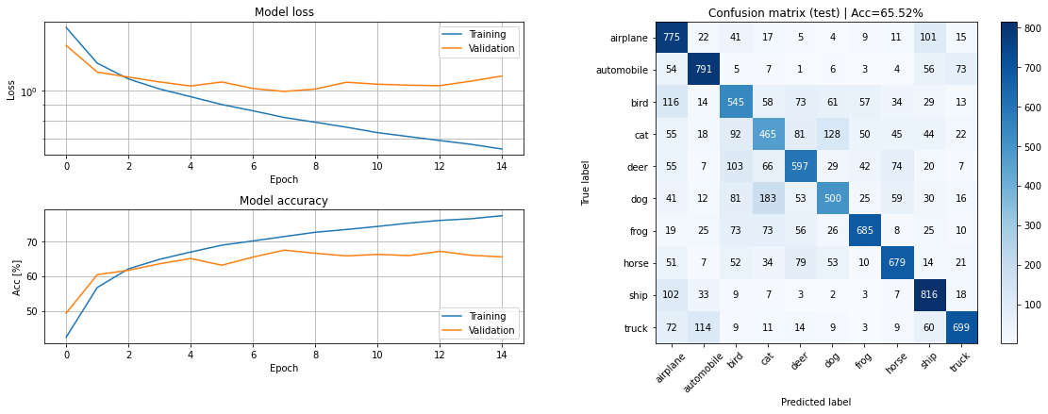

1. **Compare the CNN model with the previous Fully Connected model. You should find that the CNN is much more efficient, i.e. achieves higher accuracy with fewer parameters. Explain in your own words how this is possible.**The dense network uses about 14 times more variables but scores 20% lower. CNN learns more information about each image due to the convolution and down sampling, meaning that it takes fewer variables to make a more well-informed decision.

In an image the features are shift invariant, the CNN trains kernels (detectors) and shifts them over the image and compute a scalar product between the image and the kernel. This means only the coefficients of the kernels needs to be learned. Since the kernels are much smaller than the image this greatly reduces the number of variables the system needs to learn and reduces the risk of overfitting.

1. **Train the CNN-model with added Dropout layers. Describe your changes and show the evaluation image.**

Added a dropout-layer after each pooling which discards the output of 20% of the variables.

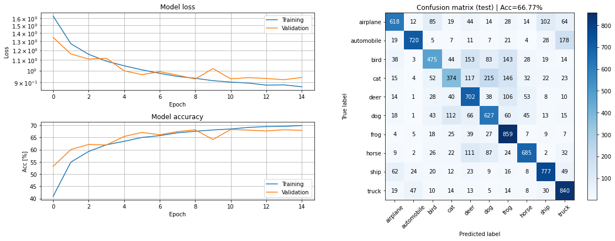

1. **Compare the models from Q4 and Q6 in terms of the training accuracy, validation accuracy, and test accuracy. Explain the similarities and differences (remember that the only difference between the models should be the addition of Dropout layers).  
   Hint: what does the dropout layer do at test time?**The models perform similarly in terms of time and test accuracy. In Q4 the training data gains a higher score, about 80%, compared to Q6, about 70%. In Q4 the test data has a score of about 65% and in Q6 the test data scores about 68%. The training and test data in Q6 is more similar than the training and test data in Q4 meaning that the results in Q6 are better generalized. Thanks to the dropout-model, there is lower overfitting since the dropouts forces the network to not rely on a few strong variables.
2. **Train the CNN model with added BatchNorm layers and show the evaluation image.**

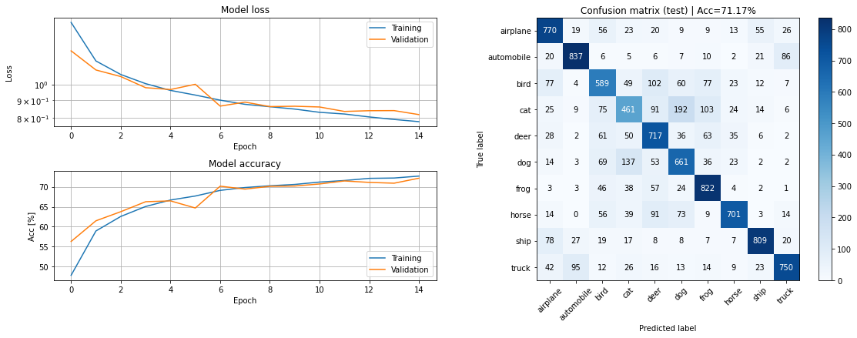

1. **When using BatchNorm one must take care to select a good minibatch size. Describe what problems might arise if the wrong minibatch size is used.**

**You can reason about this given the description of BatchNorm in the Notebook, or you can search for the information in other sources. Do not forget to provide links to the sources if you do!**

Since BatchNorm calculates mean and variance for each batch the reliability of the result decreases if the batches become too small, this may cause the network to become unstable.

But too big batch sizes will not generalize well because when we test the system on individual images the features might not be close to the training data sets mean and variance, then a smaller batch size will more accurately represent individual images.

To accurately represent the data a batch size needs to be sufficiently large to form a gaussian distribution but not so large that the distribution is not representative for individual images.

<https://towardsdatascience.com/curse-of-batch-normalization-8e6dd20bc304#_=_>

1. **Design and train a model that achieves at least 75% test accuracy in at most 25 epochs. Explain your model and motivate the design choices you have made and show the evaluation image.**We tried to implement the ResNetmodel from lecture 4. It uses blocks where most blocks consist of convolutions, normalizations and two relu activation function, one in the middle. The input to a block is added to the result of the block before the last activation function.

The network is trying to estimate a function and the feedforward within each block can be seen as F(x). This means that each consecutive block only needs to estimate the residual F(x)-x since x is added after the residual layer. The network will act as a shallower network during the early stages of the training process and as a deeper network in the later stages.

