**COMSATS University Islamabad, Abbottabad Campus**

**Department of Computer Sciences**

**Project Proposal**

**Readit (Learning Management System)**

**CSC392 Object Oriented Software Engineering**

Submitted on: <21-10-2022 >

**Group Members:**

**Group Leader:** Muhammad Umair (SP21-BSE-058)

Syed Ali Kazmi (SP21-BSE-072)

Rimsha Muneer (SP21-BSE-082)

Muhammad Saeed (SP21-BSE-071)

Shahwaiz Iqbal (SP21-BSE-061)

Abdullah (SP21-BSE-002)

Muhammad Ali Zain (SP21-BSE-065)

Haris Naeem (SP21-BSE-066)

Muhammad Uzair (SP21-BSE-059)

Table of Contents

CHAPTER 1 PROJECT PROPOSAL 4

Introduction 4

Vision and Business Case 4

Use-Case Model 5

Supplementary Specification 5

Glossary 5

Risk List & Risk Management Plan 5

CHAPTER 2 USE CASES 6

Use Case Distribution Table 6

Use Case Diagram 7

Brief Level Use Cases 7

Muhammad Saeed (SP21-BSE-071) 7

Rimsha Muneer, Ali Kazmi (SP21-BSE-082) 7

Muhammad Umair (SP21-BSE-058) 7

Abdullah (SP21-BSE-002) 7

Shah waiz Iqbal (SP21-BSE-061) 8

Haris Naeem (SP21-BSE-065) 8

Muhammad Ali Zain (SP21-BSE-066) 8

Muhammad Uzair (SP21-BSE-057) 8

Fully Dressed Use Cases 8

Muhammad Umair (SP21-BSE-058) 8

Screenshots: 9

Abdullah (SP21-BSE-002) 11

Muhammad Saeed (SP21-BSE-071) 12

Rimsha Muneer, Ali Kazmi (SP21-BSE-082, SP21-BSE-072) 14

Muhammad Uzair (SP21-BSE-059) 17

Haris Naeem (SP21-BSE-066) 18

Shah waiz Iqbal (SP21-BSE-061) 21

Chapter 3. System Sequence Diagrams 21

Muhammad Saeed (SP21-BSE-071): 21

Shahwaiz Iqbal (SP21-BSE-061): 22

Abdullah (SP21-BSE-002) 23

Chapter 4. Operation Contracts 25

Muhammad Saeed (SP21-BSE-071): 25

Muhammad Umair and Abdullah (SP21-BSE-058,SP21-BSE-002): 25

Shahwaiz Iqbal (SP21-BSE-061): 25

Rimsha Muneer & Ali Kazmi (SP21-BSE-082, SP21-BSE-072): 26

Haris Naeem & Zain (SP21-BSE-065, SP21-BSE-066): 28

Muhammad Uzair (SP21-BSE-059): 28

Chapter 5. Domain Model 28

Chapter 6. Architecture Diagram 28

Chapter 7. Class Diagrams: 28

# CHAPTER 1 PROJECT PROPOSAL

## Introduction

**Readit** is a Learning management system (LMS) written in Java. It is a Desktop application software. The Primary purpose of this is to help educational institutes, teachers, and Students. Readit LMS not only delivers content, but also handles registering courses, course administration, monitor user’s progress and performance. A learning management system provides an instructor with a way to create and deliver content, monitor student participation, and assess student performance.

The main objective of Learning Management Systems is to enhance the learning process. LMSs also include a performance management system. Educational Institutes use an LMS to teach and train students from kindergarten to graduation. Learning management systems are also used in almost all leading universities and colleges. An LMS can also be used to provide students with blended learning experiences. Blended learning combines traditional teaching in the classroom with online learning tools. This method is more effective than simple face-to-face education because it enriches the classroom-based experience with additional digital content that can be customized to fit a student's specific learning needs. They can also upload assignments and get their results very easily. This makes LMS platforms incredibly convenient for remote students who are enrolled in online courses. Learning management systems have faced a massive growth in usage due to the emphasis on remote learning during the COVID-19 pandemic.

## Vision and Business Case

Our motive behind this program is to create a LMS system which will help teachers and students to learn with the use of technology. This software will help our students understand the importance of technology as well as familiarize with it. This program will be executable at basic levels at first for instance a small portion of students but later with improvements in it, we will be able to provide it on market level. For instance, it can be used by schools as well universities.

LMS are also beneficial for corporate sector. Mostly corporate sector uses LMSes for training purposes. Other uses in corporate sector are employee development and retention. An LMS can save an organization time and money.

## Use-Case Model

1. Multi-User Account System
2. Student Attendance management
3. Daily Attendance
4. Exam Management

## Supplementary Specification

* **Security:** All usage requires authentication.
* **Visibility:**

1. Keep things simple.
2. Text should be Easily visible.
3. Follow design standards.
4. Make user interface consistent.

* **Performance:**
* **Reliability:** System will behave in user acceptable manner.

## Glossary

1.LMS, Learning Management System

## Risk List & Risk Management Plan

* No futuristic vision.
* No regular monitoring.
* Technical Limitations.
* Using tech available in labs.
* Looks static and ugly.
* Confusing for new users to navigate.
* No app for smartphones and tablets.

# CHAPTER 2 USE CASES

## Use Case Distribution Table

|  |  |  |
| --- | --- | --- |
| **ID** | **NAME** | **ASSIGNED USECASES** |
| **1** | **Muhammad Saeed** | **Login, Remove Students** |
| **2** | **Muhammad Haris Naeem, Ali Zain** | **View Students, Search Students** |
| **3** | **Shah waiz Iqbal** | **Approve Students** |
| **4** | **Rimsha Muneer and Ali Kazmi** | **View Quiz Marks, Mark Quiz, Generate Assignment, Upload Assignment.** |
| **5** | **Muhammad Umair & Abdullah** | **Submit Content, View Content, Download Content.** |
| **6** | **Muhammad Uzair** |  |

## Use Case Diagram

## Brief Level Use Cases

### Muhammad Saeed (SP21-BSE-071)

Use Case: Register

The use case starts when the user clicks the Register button.. The system displays the signup page that allow users to fill in their username/email address, first and last name and their password. The user keys in the details and clicks “Sign Up” button. The system displays the user’s profile page.

#### Use Case: Log In

A user wants to interact with the system. The system prompts for username and password and user will enter his/her name and password. The system will validate the entered name and password and logs the user into the system.

#### Use Case: Remove Student

In this use case, admin will have all the access in which he can remove those students whose performance is poor in assignments and quizzes.

### Rimsha Muneer, Ali Kazmi (SP21-BSE-082)

*Use Cases:*

*View Quiz Marks:*

Quiz result is the section which will be controlled by teacher and students will be shown their marks accordingly. For this, student will have to log in, open quiz section, view quiz result and then the marks will be displayed to him.

*Mark Quiz:*

This is a mark quiz section controlled by teacher. After logging into the system teacher will open quiz section then mark quiz section and select the student, his quiz. Then teacher will mark it and enter the marks, then after clicking on upload marks they will be uploaded.

*Generate Assignment:*

*Upload Assignment:*

There is upload assignment use case, for which primary actor is student. Where students can upload assignment against assigned task. Firstly, students will check the given assignment and then submits assignment. They cannot change file once it is uploaded. Teacher will check assignments and mark them accordingly. Further students will be able to check their marks uploaded by teacher.

### Muhammad Umair (SP21-BSE-058)

#### Use Case: Submit Content

In this Use Case teacher will submit content related to subjects they are teaching. It can be in the form of doc file, pdf file, ppt file or may be some links of websites.

### Abdullah (SP21-BSE-002)

#### Use Case: View Content

In this use case student will view the course content uploaded by subject teacher. Student can view the list of all uploaded lectures of enrolled courses.

#### Use Case: Download Content

In this Use Case student will download the uploaded lectures. Student can download all of the lectures uploaded by subject teacher, that taught by teacher in classroom. The student can download all the lectures uploaded by the subject teacher, which are taught by the teacher in the classroom.

### Shah waiz Iqbal (SP21-BSE-061)

#### Use Case: Approved Student

In this use case, the admin will manage the students. Admin will have approved students for enrollment in class and submit assignment and give quiz, which teacher Generate on portal. Students have unique ID and password through which they can login and logout.

### Haris Naeem (SP21-BSE-065)

#### Use Case: View Students

In this use case teacher simply view list of all students in LMS.

### Muhammad Ali Zain (SP21-BSE-066)

#### Use Case: Search Students

This use case is used for searching student from any department. Admin and teacher can view student’s profile from any department using this use case. Teacher and admin can see the CGPA, attendance, course registered and marks of student in the profile. When admin or teacher go to search bar, they need to select department and section of student first than they need to enter registration number of students to view student’s profile.

### 

### Muhammad Uzair (SP21-BSE-057)

#### Use Case: Give Quiz, Take Quiz

In this use case the teacher will login to a website and create a quiz and enter its question and the probable answers, then the student will use their phone to login and chose the teacher and select the required quiz, then answer the questions and view the results at the end on the phone, in addition the teacher can view the quiz results on the website.

## Fully Dressed Use Cases

### Muhammad Umair (SP21-BSE-058)

**Use Cases: Submit Content**

|  |  |
| --- | --- |
| Submit Content |  |
| Scope | Learning Management System |
| Level | User goal |
| Primary Actor | Teacher |
| Stakeholders and Interests | Students and Teachers. Students want that teacher must submit content related to topic which teacher taught in class. |
| Pre-Conditions | Teacher are required to log in the system.  They Submit Only that content which they taught in the class not any irrelevant content. |
| Success Guarantee | Submitted the Content, |
| Main Success Scenarios | Students can now see that content is uploaded or not. If uploaded they can download the content. |
| Exceptions | If there is a glitch in the application, they will check their Courses. |
| Special Requirements | Teacher must be teaching course. |
| Technology and data Variation List | The Programming language is java. |
| Frequency of Occurrences | Often. |
| Miscellaneous |  |

### Screenshots:

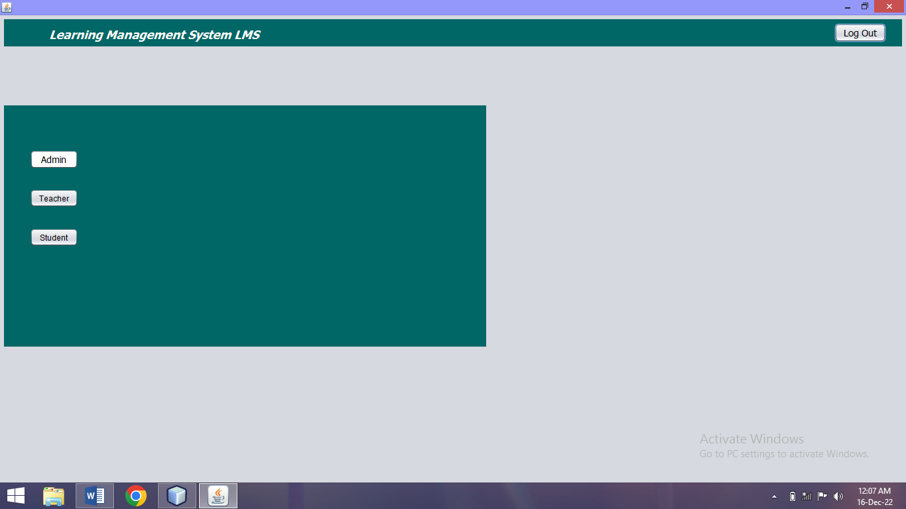

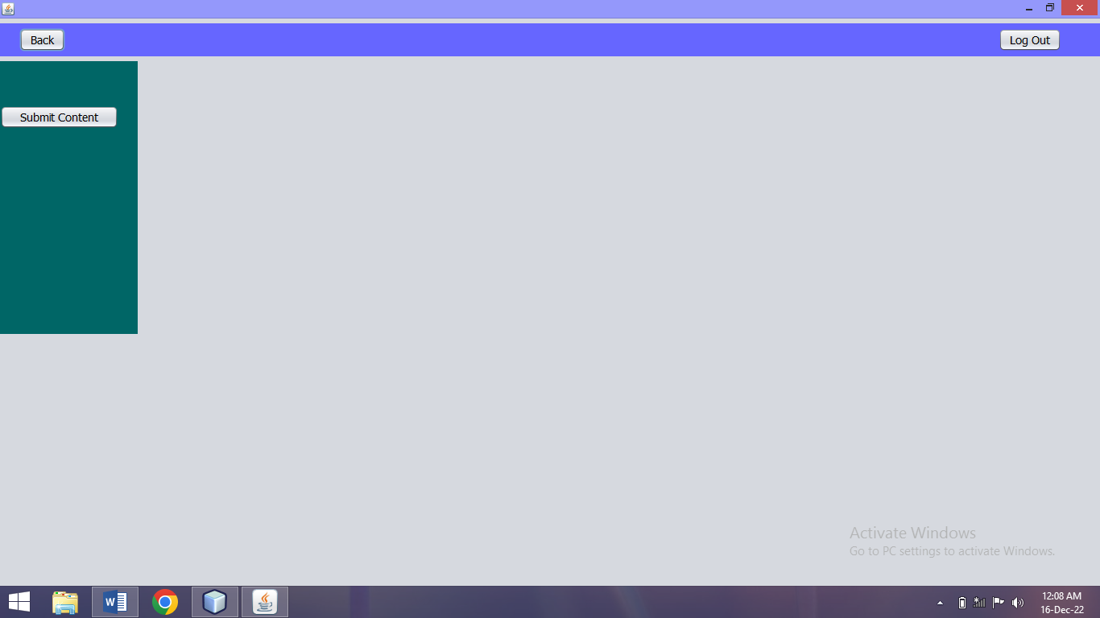

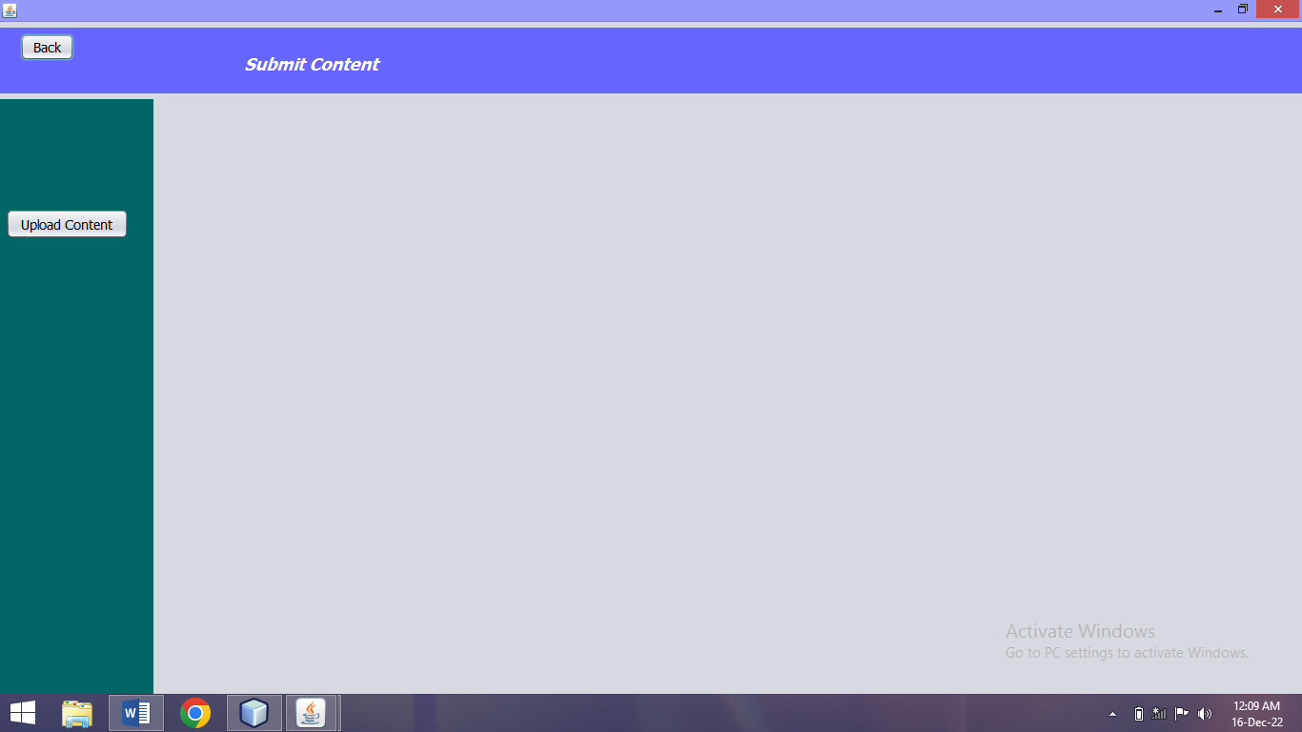

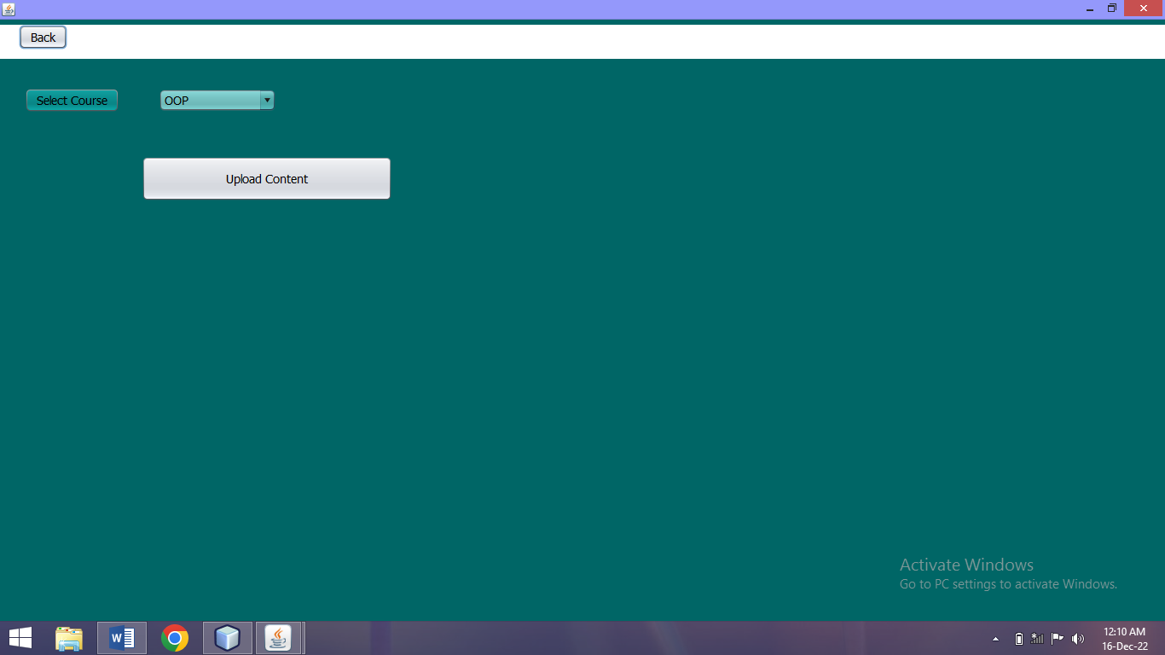

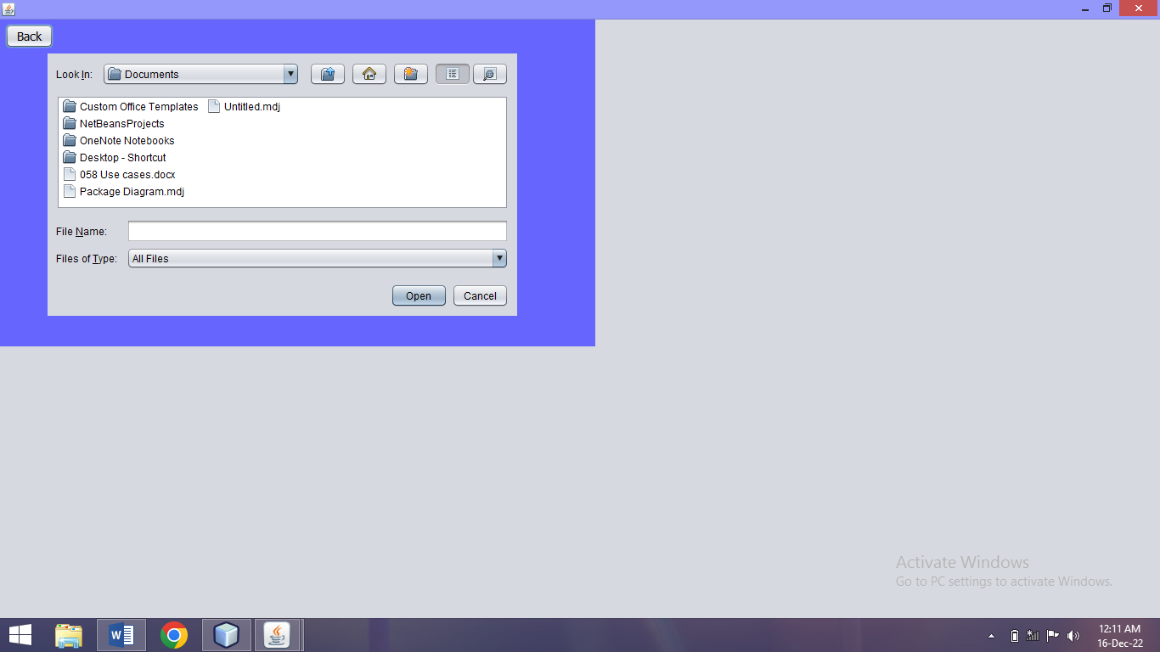

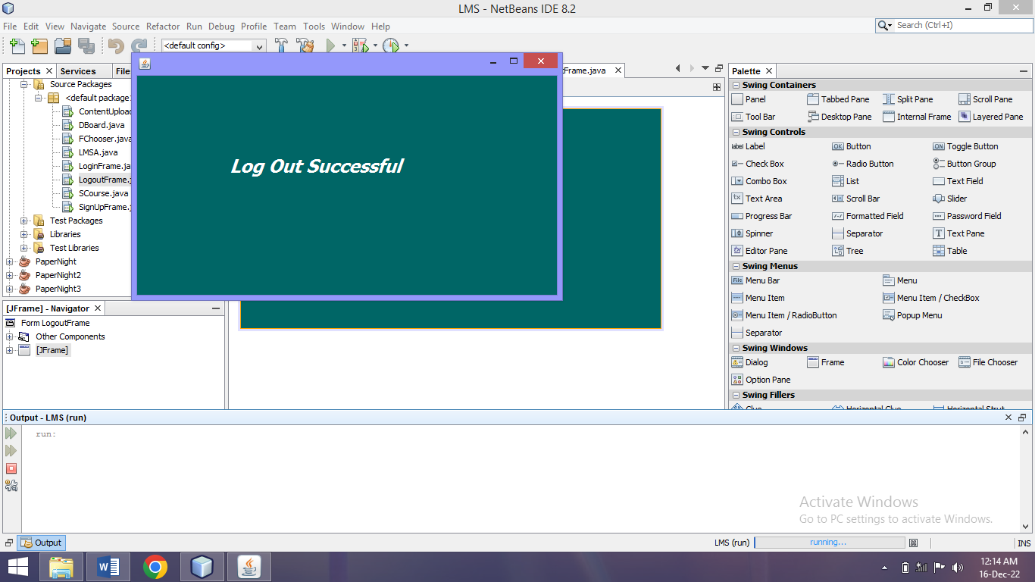

### Abdullah (SP21-BSE-002)

#### Use Case: View Content

|  |  |
| --- | --- |
| View Content |  |
| Scope | Learning Management System |
| Level | User goal |
| Primary Actors | Students |
| Stakeholders and Interests | Students |
| Pre-Conditions | Lectures must be uploaded by subject teacher. |
| Success Guarantee | Student view the lectures uploaded by subject teacher |
| Main Success Scenarios | Teachers and Students can now see that they are logged out of the system. |
| Exceptions | If there is a glitch in the application |
| Special Requirements | Teacher has to ensure that the uploaded lectures belong to same course |
| Technology and data Variation List | The Programming language is java.  GitHub. |
| Frequency of Occurrences | Often. |
| Miscellaneous |  |

#### Use Case: Download Content

|  |  |
| --- | --- |
| Download Content |  |
| Scope | Learning Management System |
| Level | User goal |
| Primary Actor | Students |
| Stakeholders and Interests | Students: Students will download uploaded lectures of enrolled courses. |
| Pre-Conditions | teachers uploaded the lectures of relevant courses. |
| Success Guarantee | Lecture files downloaded |
| Main Success Scenarios | Lecture file downloaded successfully by student. Now student can view their downloaded lectures in download location file. |
| Exceptions | If there is a glitch in the application |
| Special Requirements | Teacher has to ensure that the uploaded lectures belong to same course. |
| Technology and data Variation List | The Programming language is java. |
| Frequency of Occurrences | Often. |
| Miscellaneous |  |

### Muhammad Saeed (SP21-BSE-071)

|  |
| --- |
| **Scope**: ReadIT (Learning Management System)  **Level**: user goal  **Primary** **Actor**: Admin, Teacher, Student  **Stakeholders and Interests**:  **Preconditions**: User must have an account with the Learning Management system i.e., he/she must be a registered user. |

**Success Guarantee** (or Post conditions): If the use case was successful, the actor is now logged into the system. If not, the system state is unchanged.

**Main Success Scenario (or Basic Flow):**

* The 'login' action is initiated when a registered user chooses to 'login'.
* The system prompts for username and password.
* The actor enters his/her name and password.
* The system validates the entered name and password and logs the actor into the system

**Extensions (or Alternative Flows):**

**1.Invalid Name/Password:**

If in the basic flow the system cannot find the name or the password is invalid, an error message is displayed. The actor can type in a new name or password or choose to cancel the operation, at which point the use case ends.

**Special Requirements:**

There are no special requirements associated with this use case.

**Open Issues:**

**Screen Shots:**

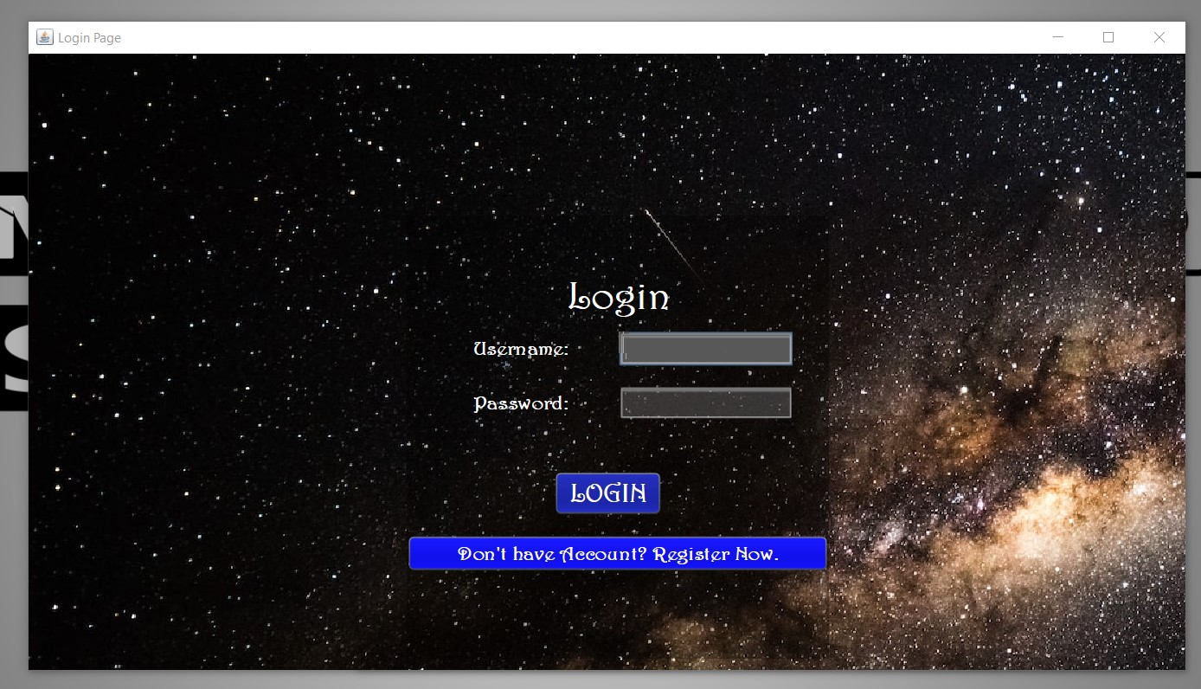

**Use Case:** Register Account

**Description:**

The use case describes how an owner can register their institute.

**Primary Actors:**

Students,Admin,Teacher

**Secondary Actors:**

None

**Preconditions:**

The institute registration web page is displayed to the User

**Main success Scenario:**

* The use case starts when the user clicks the Register button
* The system displays the signup page that allow users to fill in their username/email address, first and last name and their password.
* The user keys in the details and clicks “Sign Up” button.
* The system displays the user’s profile page.

**Alternative Flow:**

* If the username is invalid, the owner is asked to choose another username.
* If owner enter incomplete details, system displays “please complete personal details” message.

**Post Conditions:**

User is registered

#### Use Case: Remove Students

|  |  |
| --- | --- |
| Scope | Learning Management System |
| Primary actor | Admin |
| Precondition | Admin must be registered in System to perform this action. |
| Stakeholder and interest | Admin: Admin view register Students, remove students, view students record. |
| Post condition | With every registration, the admin will receive a notification and an updated list in the system. Then admin can check their profiles. |
| Extensions (or Alternative Flows): | * Students can visit physically to admin for registration. |
| Main success scenario | * Admin will login through their account. * Admin will approve and remove student. * Approved students have their registered account through which they login and logout. * Students download and upload Assignment. * Students give a quiz. |
| Special requirement | * No special requirement. |
| Frequency of Use: | * Medium |
| Exception | When the server is down or in maintenance, in this condition students cannot register in the system. |
| Technology and data variation list | * Java language is used. |
| Priority | High |
| Miscellaneous | Students cannot perform any activities if he is not registered. |

### Rimsha Muneer, Ali Kazmi (SP21-BSE-082, SP21-BSE-072)

**Use Case:**

View Quiz Result

**Description:**

Here students will attempt quizzes.

**Primary Actors:**

Students

**Secondary Actors:**

Teachers

**Preconditions:**

Students needs to login firstly.

**Main success Scenario:**

* The use case starts when the student opens the quiz section.
* The system displays the quiz section page that allow the students to view the quiz.
* Start quiz.

**Post Conditions:**

Teacher will review the quiz. And mark them accordingly. Once teacher uploads quiz marks, students can view their quiz result.

**Use Case:**

Generate assignment

**Description:**

The use case describes how a teacher can assign tasks to students.

**Primary Actors:**

Teachers

**Secondary Actors:**

Student

**Preconditions:**

Teachers need to login to their account before assigning task.

**Main success Scenario:**

* The use case starts when the teacher opens the assignment section.
* The system displays the assignment section page that allow teachers to upload any file as an assignment.
* Teachers select the due date for the assignment.
* Show uploaded status.

**Alternative Flow:**

* If the student upload assignment after the due date so it won’t be accepted by the system.
* If the file uploaded by student is a large file so system does not complete the submission process.

**Post Conditions:**

Students will upload their assignment.

**Use Case:**

Upload Assignments

**Description:**

Here students can upload assignments.

**Primary Actors:**

Students

**Secondary Actors:**

Teachers

**Preconditions:**

Students needs to login firstly.

**Main success Scenario:**

* The use case starts when the student opens the assignment section.
* The system displays the assignment section page that allow the students to view the given assignment.
* Student open upload assignment section and chose file.
* Show submitted status.

**Alternative Flow:**

* If the student upload assignment after the due date so it won’t be accepted by the system.
* You cannot change the submitted file once it is uploaded.

**Post Conditions:**

Teacher will review the assignments. And mark them accordingly.

### Muhammad Uzair (SP21-BSE-059)

| Use Case: |
| --- |

|  |  |
| --- | --- |
| Use case name | Give Quiz, Take Quiz |
| Scope | Learning management system |
| level | Student and teacher goal |
| Primary actor | * Student * Teacher |
| Stakeholder and interest | * Teacher: Teacher will upload the quiz and the checking process. * Student: Student will attempt the answers and result will be displayed. |
| precondition | * Student must have a proper internet connection. * Student must log in. * Student must start quiz on time. |
| Success guarantee | Student must complete the quiz within given time and attempt all questions correctly. |
| Main success scenario | 1. Teacher will log in with his id. 2. Teacher upload the quiz on time. 3. student will open the website. 4. Log in to his account. 5. Visit the quizzes dashboard. 6. Attempt the quiz. |
| Exception | * if student doesn’t see the quiz questions or it gets stuck, he will refresh website. * If teacher uploads the quiz and it gives error, he will try to re-upload the quiz. |
| Special requirement | Teacher and student both will have to log in  If the page doesn’t show up he must refresh the page. |
| Technology and data variation list | * Java language is used here. * Student and teacher both will require a keyboard and mouse. |
| Frequency of occurrence | This will occur at different times only when teacher wants to assess the students.  Less often. |

### Haris Naeem (SP21-BSE-066)

|  |
| --- |
| View Students |
| Stakeholders and Interest | Teacher, Student. |
| Use Case Name | View Students. |
| Scope | Learning Management System. |
| Level | User goal. |
| Primary Actor | Admin, Teachers. |
| Stakeholders and Interests | Student, Teachers. |
| Pre-conditions | Users must register itself and login in the system. |
| Success Guarantee | User must watch list of students. |
| Main success scenarios | User will review the list of students. |
| Exceptions | If there is any glitch, then user must check their registration. |
| Special Requirements | User must be registered itself and login in system. |
| Technology and Data variations List | Programming language JAVA. |
| Frequency of Occurrences | Often. |
| Miscellaneous |  |

**Use Case: Search Students**

|  |  |
| --- | --- |
| **Use case section** | **Comments sections** |
| Use case name | * View student |
| scope | * Learning management system |
| level | * User goal |
| Primary actor | * Admin and teacher |
| Stakeholders and interests | * Admin and teacher are the stakeholders * Their interest is to view search and see student’s profile |
| preconditions | * Admin and teacher must be registered in the system * Admin and teacher will need to login first to view profile of student. |
| Success guarantee | * Profile of student |
| Main success scenarios | * Admin and teacher can view full profile of a student. |
| Exceptions | * If admin and teacher are not registered in the system than they can’t access any info of student. |
| Special requirement | * High speed internet can minimize the time of page loading. |
| Technology and data variations list | * Programming language is java. |
| Frequency of occurrences | * Often |
| Miscellaneous |  |

**Screenshots:**

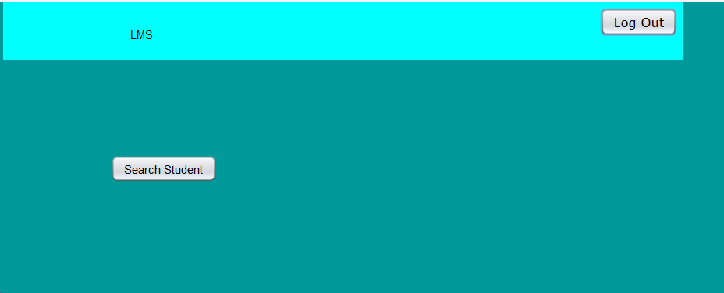

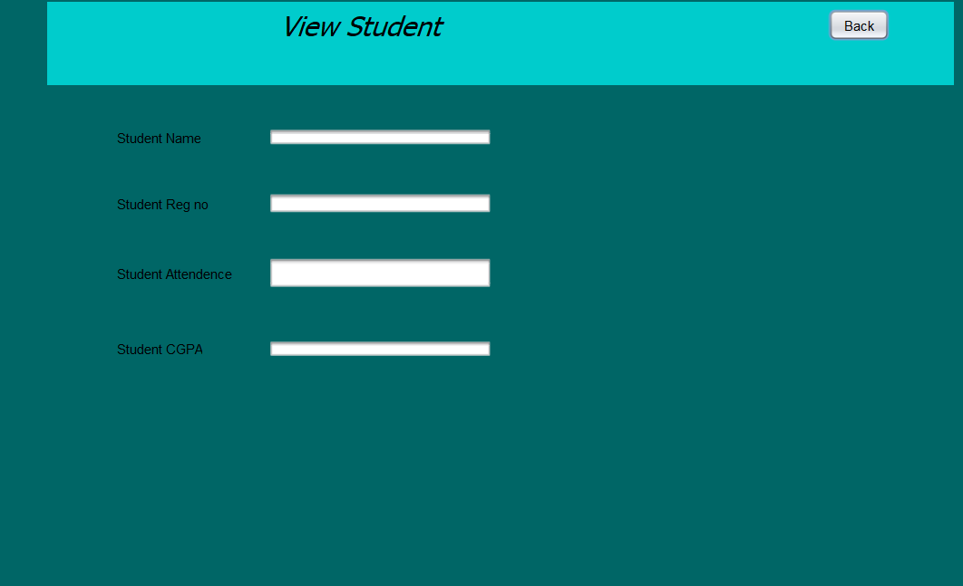

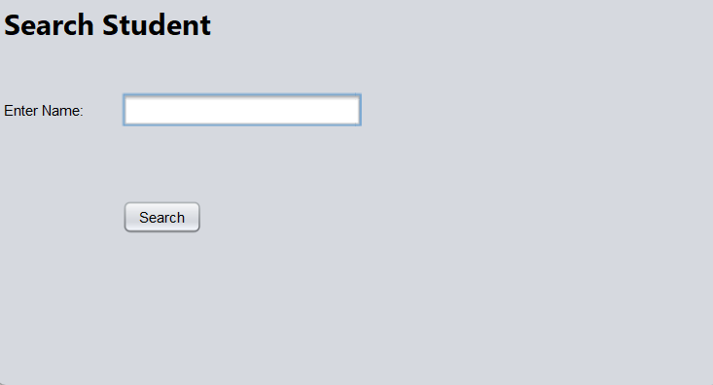

|  |
| --- |

### Shah waiz Iqbal (SP21-BSE-061)

Use Case: Approve student

|  |  |
| --- | --- |
| Scope | Learning Management System |
| Primary actor | Admin |
| Precondition | Admin must be registered in System to perform this action. |
| Stakeholder and interest | Admin: Admin will register Students, view students record. |
| Post condition | With every registration, the admin will receive a notification and an updated list in the system. Then admin can check their profiles. |
| Extensions (or Alternative Flows): | * Students can visit physically to admin for registration. |
| Main success scenario | * Admin will login through their account. * Admin will approve and remove student. * Approved students have their registered account through which they login and logout. * Students download and upload Assignment. * Students give a quiz. |
| Special requirement | * No special requirement. |
| Frequency of Use: | * Medium |
| Exception | When the server is down or in maintenance, in this condition students cannot register in the system. |
| Technology and data variation list | * Java language is used. |
| Priority | High |
| Miscellaneous | Students cannot perform any activities if he is not registered. |

# Chapter 3. System Sequence Diagrams

### Muhammad Saeed (SP21-BSE-071):

**Use case: Login**

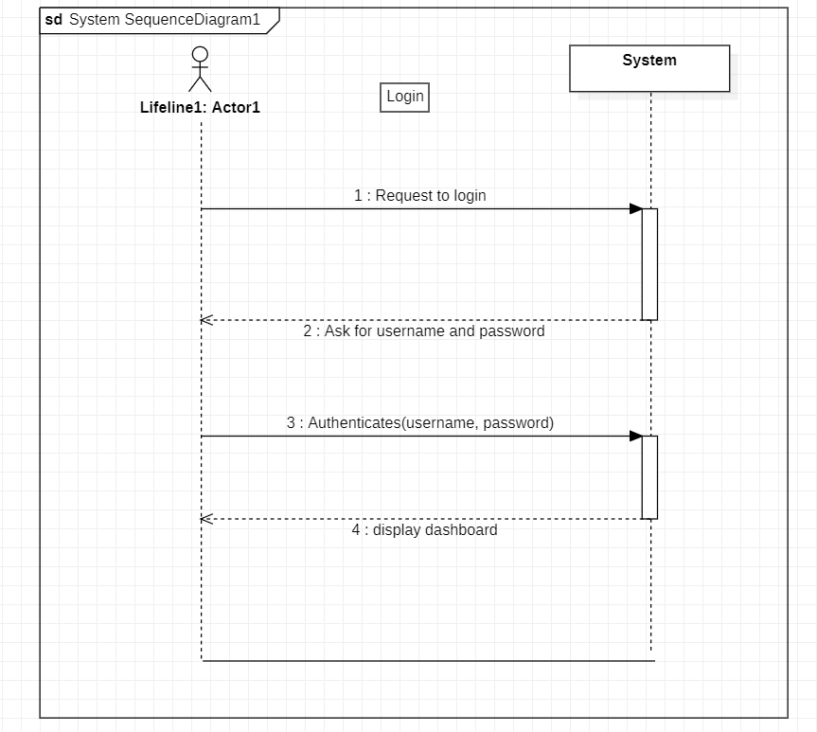

**Use case:Register**

**Use case: Login**

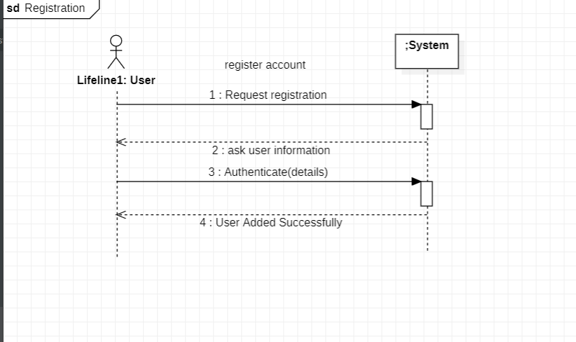

**Use Case: Remove Student**

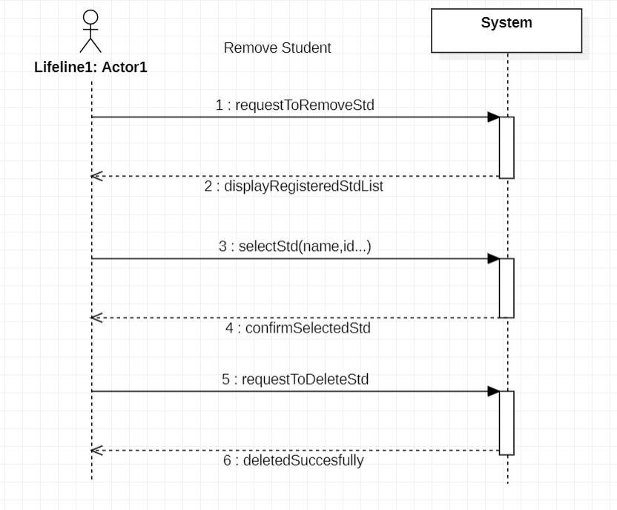

## Shahwaiz Iqbal (SP21-BSE-061):

**Use Case: Approve Student:**

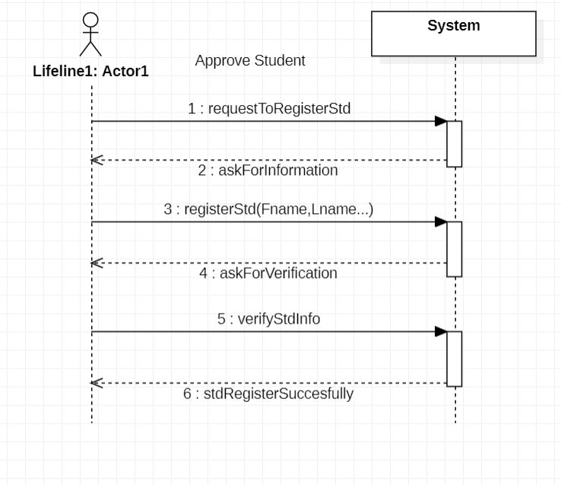

### Abdullah (SP21-BSE-002)

**View Content:**

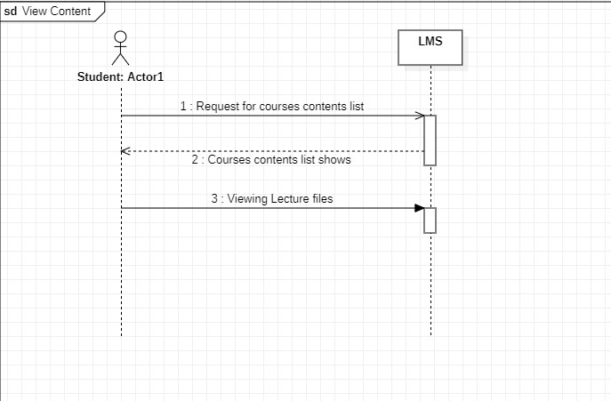

**Haris Naeem and Muhammad Ali Zain (SP21-BSE-066, SP21-BSE-065):**

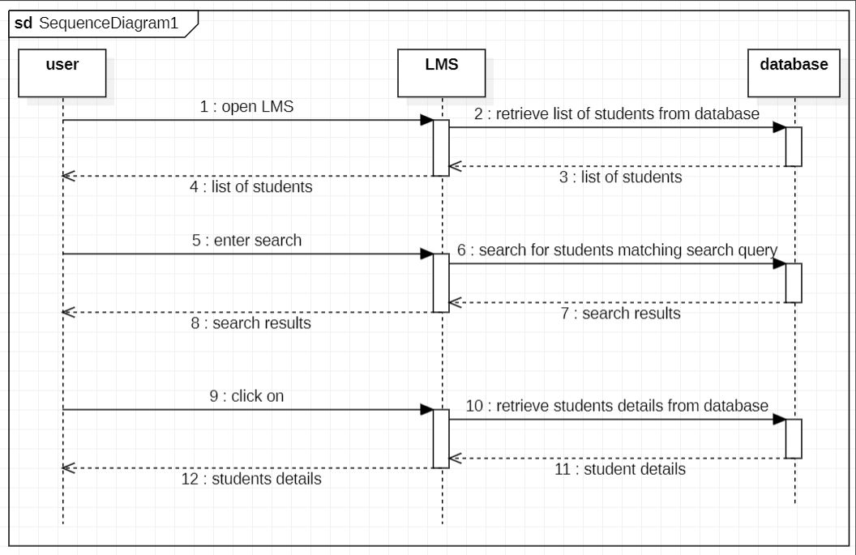

# Chapter 4. Operation Contracts

### Muhammad Saeed (SP21-BSE-071):

|  |  |
| --- | --- |
| **Contract ID:** | **Authenticate** |
| **Operation:** | Authenticate (username, password) |
| **Cross Reference:** | Process Login |
| **Pre-conditions** | User is already registered, and login form is displayed. |
| **Post conditions:** | * A new user was searched in database. * Object was created against that user. * User type was determined by user object. * Dashboard based on his type was displayed. |

**Usecase: Register**

|  |  |
| --- | --- |
| **Contract ID:** | **addUser** |
| **Operation:** | addUser (username, password) |
| **Cross Reference:** | Register |
| **Pre-conditions** | * User is not registered. * The System is running correctly. * Registration Form displayed |
| **Post conditions:** | * **User is registered and Account is created successfully.** |

**Usecase:Remove Student**

|  |  |
| --- | --- |
| **Contract ID:** | deleteStudent |
| **Operation:** | deleteStudent (Username) |
| **Cross Reference:** | Remove Student |
| **Pre-conditions** | Admin is logged in |
| **Postconditions:** | * A user was searched in database. * Record against that user was removed. * Removed Successfully screen displayed. |

### Muhammad Umair and Abdullah (SP21-BSE-058,SP21-BSE-002):

**Operation Contracts:**

**Submit Content:**

**Download Content:**

|  |  |
| --- | --- |
| **Contract ID:** | **Download file** |
| **Operation:** | Download uploaded lecture file |
| **Cross Reference:** | Download Content |
| **Pre-conditions** | Lecture Uploaded by Subject Teacher. |
| **Postconditions:** | * Student Downloaded uploaded lecture. * Student now can view and read the lecture file. |

**View Content**

|  |  |
| --- | --- |
| **Contract ID:** | **Lecture Files** |
| **Operation:** | Viewing Lecture files |
| **Cross Reference:** | View Content |
| **Pre-conditions** | Lecture content uploaded by subject teacher. |
| **Post-conditions:** | * Student can view the lecture files. * Student can be able to download that lectures file whenever they are desire too. |

### Shahwaiz Iqbal (SP21-BSE-061):

|  |  |
| --- | --- |
| **Contract ID:** | RegisterStudent |
| **Operation:** | RegisterStudent (Fname, Lname…) |
| **Cross Reference:** | Approved Students |
| **Pre-conditions** | Admin is already registered, and list is displayed. |
| **Postconditions:** | * Name of student displayed in Approved Students List . * Object was created against that student. * Approved Successfully screen was displayed. |

### Rimsha Muneer & Ali Kazmi (SP21-BSE-082, SP21-BSE-072):

*Upload Assignment*

Contract CO1: Upload Assignment

Operation: Upload assignment

Cross-References: Use case: upload assignment

Pre-condition:

Assignment had been generated by teacher.

Assignment was being uploaded before due date.

Post condition:

Assignment should be uploaded

Display a message of assignment uploaded successfully.

*Generate Assignment*

Contract CO2: Generate Assignment

Operation: Generate Assignment

Cross-References: Use case: Generate Assignment

Pre-condition:

Teacher has selected due date.

Teacher has selected a correct format of file.

Post condition:

Assignment generated successfully.

It should be visible to all students.

Display a message of assignment generated successfully, to teacher.

*Mark Quiz:*

|  |  |
| --- | --- |
| Operation: | Mark quiz |
| Cross-References: | Use case: Mark quiz |
| Pre-condition: | Teacher should have selected the student.  Student should have attempted the quiz and it’s uploaded there. |
| Post condition: | Marks will be uploaded and visible to student |

*View Quiz Marks:*

|  |  |
| --- | --- |
| Operation: | View Result |
| Cross-References: | Use case: View Result |
| Pre-condition: | Marks were uploaded by teacher. |
| Post condition: | Marks should be visible against quiz number. |

### Haris Naeem & Zain (SP21-BSE-065, SP21-BSE-066):

### Muhammad Uzair (SP21-BSE-059):

# Chapter 5. Domain Model

# Chapter 6. Architecture Diagram

# Chapter 7. Class Diagrams:

**Haris Naeem and Muhammad Ali Zain (SP21-BSE-066, SP21-BSE-065):**

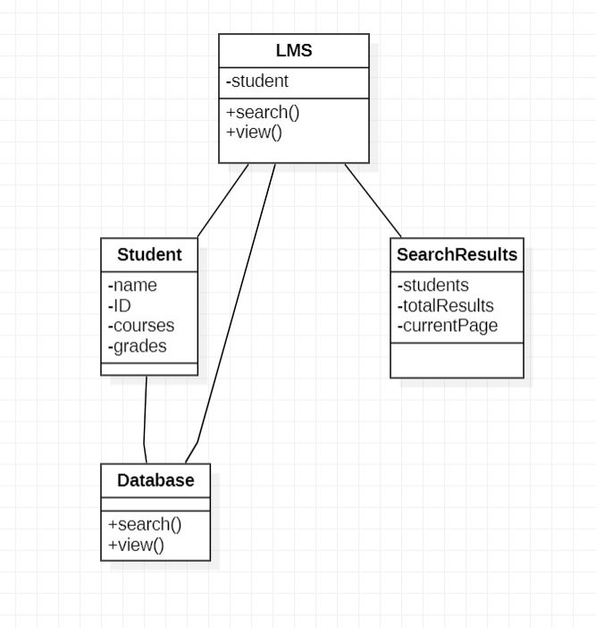

Create

# Chapter 8. Interaction Diagrams:

### Muhammad Saeed (SP21-BSE-071):

#### Use Case: login

#### Use Case: Remove Student

#### Use Case: Register