**COMSATS University Islamabad, Abbottabad Campus**

**Department of Computer Science**

**Project Proposal**

**Learning Management System**

**CSC392 Object Oriented Software Engineering**

Submitted on: <Date Time>

Group Members:

Muhammad Umair (SP21-BSE-058)

Syed Ali Kazmi (SP21-BSE-072)

Rimsha Muneer (SP21-BSE-082)

Muhammad Saeed (SP21-BSE-071)

Shahwaiz Iqbal (SP21-BSE-061)

Abdullah (SP21-BSE-0)

Muhammad Ali Zain (SP21-BSE-0)

Haris Naeem (SP21-BSE-0)

Muhammad Uzair (SP21-BSE-0)

Table of Contents

CHAPTER 1 PROJECT PROPOSAL 3

Introduction 3

Vision and Business Case 3

Use-Case Model 3

Supplementary Specification 3

Glossary 3

Risk List & Risk Management Plan 3

CHAPTER 2 USE CASES 3

Use Case Diagram 3

Brief Level Use Cases 3

Muhammad Saeed (SP21-BSE-071) 3

Rimsha Muneer (SP21-BSE-082) 3

Muhammad Umair (SP21-BSE-058) 3

Shahwaiz Iqbal (SP21-BSE-061) 3

Haris Naeem (SP21-BSE-0) 3

Muhammad Ali Zain (SP21-BSE-0) 3

Fully Dressed Use Cases 4

Muhammad Umair (SP21-BSE-058) 4

Muhammad Saeed (SP21-BSE-071) 4

Rimsha Muneer (SP21-BSE-082) 4

Muhammad Uzair (SP21-BSE-058) 4

Haris Naeem (SP21-BSE-058) 4

Muhammad Ali Zain (SP21-BSE-058) 4

Shahwaiz Iqbal (SP21-BSE-061) 4

# CHAPTER 1 PROJECT PROPOSAL

## Introduction

## Vision and Business Case

***Describes the high-level goals and constraints, the business case, and provides an executive summary.***

## Use-Case Model

Describes the functional requirements. During inception, the names of most use cases will be identified, and perhaps 10% of the use cases will be analyzed in detail.

## Supplementary Specification

## Glossary

## Risk List & Risk Management Plan

***Describes the risks (business, technical, resource, schedule) and ideas for their mitigation or response.***

# CHAPTER 2 USE CASES

## Use Case Diagram

<Paste your semester project diagram imported from CASE Tool i.e. starUML here>

## Brief Level Use Cases

### Muhammad Saeed (SP21-BSE-071)

#### Use Case: Process Sale

### Rimsha Muneer (SP21-BSE-082)

#### Use Case: Process Sale

### Muhammad Umair (SP21-BSE-058)

#### Use Case: Process Sale

In this use case admin will manage the student activities, admin can add newly registered students to list. It can view and edit profile of student, it can also remove student from list.

### Shahwaiz Iqbal (SP21-BSE-061)

#### Use Case: Process Sale

### Haris Naeem (SP21-BSE-0)

#### Use Case: Process Sale

### Muhammad Ali Zain (SP21-BSE-0)

#### Use Case: Process Sale

### Muhammad Uzair (SP21-BSE-0)

#### Use Case: Quiz Management

In this use case the teacher will login to a website and create a quiz and enter its question and the probable answers, then the student will use their phone to login and chose the teacher and select the required quiz, then answer the questions and view the results at the end on the phone, in addition the teacher can view the quiz results on the website.

## Fully Dressed Use Cases

### Muhammad Umair (SP21-BSE-058)

| Use Case: Manage Student |
| --- |
| |  |  | | --- | --- | | **Scope** | Learning Management System | | **Level** | Admin goal | | **Primary actor** | Admin, Student | | **Stakeholder and interest** | * Student: Student will register them self-first to interact with the system for their academic activates. * Admin: Admin will have a check on the registered student profiles and their academic activates. | | **Precondition** | Student must be registered to a system and have admitted to their desire institute. | | **Success guarantee (post condition)** | With every registration, admin will receive updated list of students to system. Then admin will have check over to their profiles. | | **Main success scenario** | 1. Registered student will enroll him/her self into offered courses 2. The admin will have check into enrolled students profile, they can check their registration info, enrolled courses list, their current academic record. | | **Exception** | * When the server is down due to some reason the admin wont be able to check over the activates of student | | **Miscellaneous** | Is student is registered in their desire institute? | |

### Muhammad Saeed (SP21-BSE-071)

| Use Case: Process Login |
| --- |
| **Scope**: Learning Management System  **Level**: user goal  **Primary** **Actor**: Admin, Teacher, Student  **Stakeholders and Interests**:  **Preconditions**: User must have an account with the Learning Management system i.e., he/she must be a registered user. |

**Success Guarantee** (or Postconditions): If the use case was successful, the actor is now logged into the system. If not, the system state is unchanged.

**Main Success Scenario (or Basic Flow):**

* The 'login' action is initiated when a registered user chooses to 'login'.
* The system prompts for username and password.
* The actor enters his/her name and password.
* The system validates the entered name and password and logs the actor into the system

**Extensions (or Alternative Flows):**

**1.Invalid Name/Password:**

If in the basic flow the system cannot find the name or the password is invalid, an error message is displayed. The actor can type in a new name or password or choose to cancel the operation, at which point the use case ends.

**Special Requirements:**

There are no special requirements associated with this use case.

**Open Issues:**

**Screen Shots:**

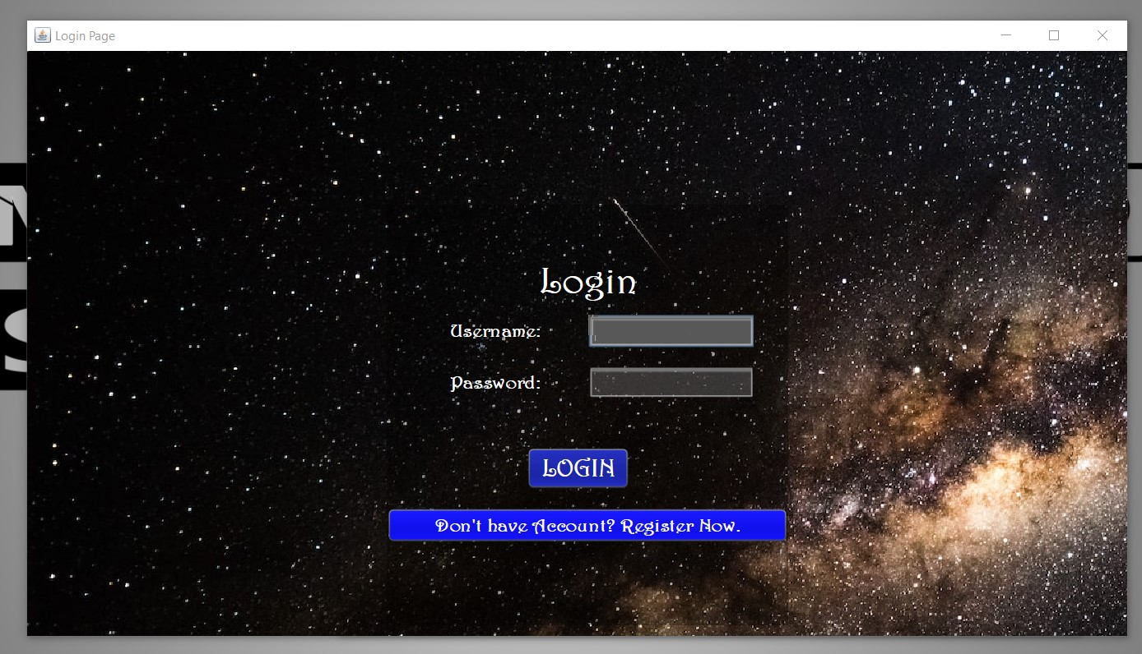

### Rimsha Muneer (SP21-BSE-082)

| Use Case: manage Assignments |
| --- |
| **ID:** | **07** |
| **Title:** | Manage Assignments |
| **Description:** | This use case describe how teacher assign task/assignments to students. |
| **Primary Actor:** | Teachers, Student |
| **Preconditions:** | Before uploading the assignment, teachers have to login, after selecting the subject the task is uploaded there. |
| **Postconditions:** | If the use case was successful, After the assignment is uploaded, its last date and time are shown to the student. |
| **Main  Success Scenario:** | 1. Teacher uploads task/assignment. 2. Student downloads file. 3. Submit task/assignment against given task. |
| **Extensions:** | Student can change assignment once it is uploaded. Teacher will upload marks after checking the assignment. |
| **Frequency of Use:** | Often |
| **Status:** | Elaboration Phase |
| **Priority:** | Medium |

**Screenshots:**

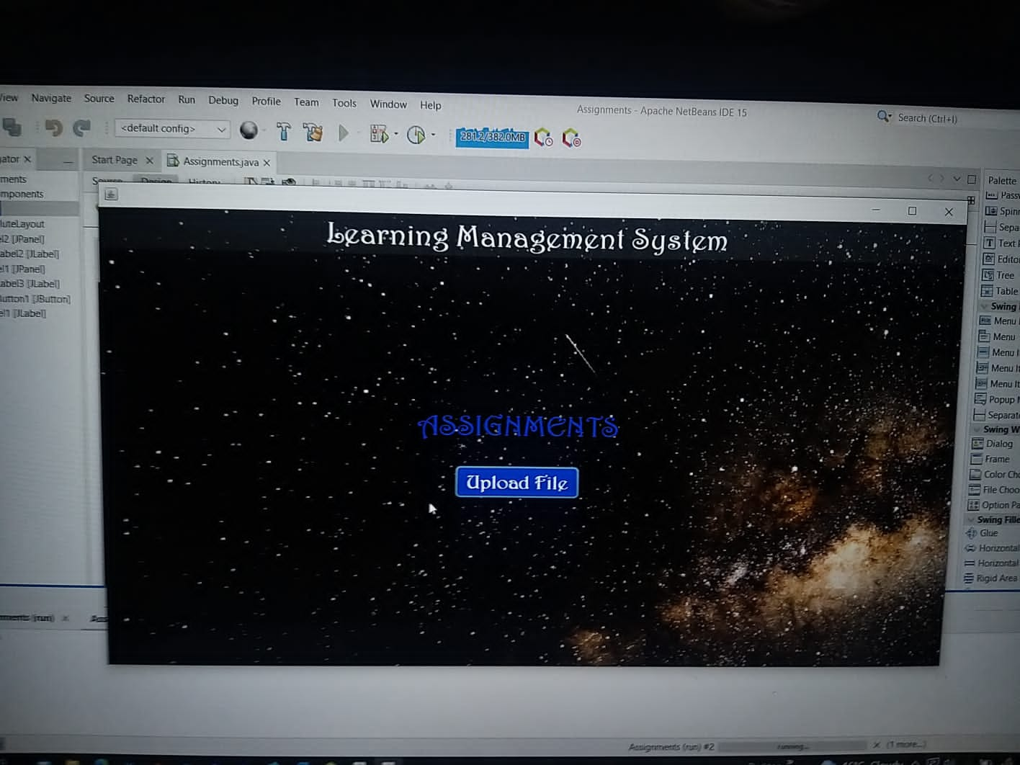

### Muhammad Uzair (SP21-BSE-058)

| Use Case: Process Sale |
| --- |

|  |  |
| --- | --- |
| Use case name | Quiz management |
| Scope | Learning management system |
| level | Student and teacher goal |
| Primary actor | * Student * Teacher |
| Stakeholder and interest | * Teacher: Teacher will upload the quiz and the checking process. * Student: Student will attempt the answers and result will be displayed. |
| precondition | * Student must have a proper internet connection. * Student must log in. * Student must start quiz on time. |
| Success guarantee | Student must complete the quiz within given time and attempt all questions correctly. |
| Main success scenario | 1. Teacher will log in with his id. 2. Teacher upload the quiz on time. 3. student will open the website. 4. Log in to his account. 5. Visit the quizzes dashboard. 6. Attempt the quiz. |
| Exception | * if student doesn’t see the quiz questions or it gets stuck, he will refresh website. * If teacher uploads the quiz and it gives error, he will try to re-upload the quiz. |
| Special requirement | Teacher and student both will have to log in  If the page doesn’t show up he must refresh the page. |
| Technology and data variation list | * Java language is used here. * Student and teacher both will require a keyboard and mouse. |
| Frequency of occurrence | This will occur at different times only when teacher wants to assess the students.  Less often. |

### Haris Naeem (SP21-BSE-058)

| Use Case: Process Sale |
| --- |

### Muhammad Ali Zain (SP21-BSE-058)

| Use Case: Process Sale |
| --- |

### Shahwaiz Iqbal (SP21-BSE-061)

| Use Case: Process Sale |
| --- |