**A PROJECT REPORT**

**on**

**“PNEUMONIA DETECTION USING CHEST XRAYS”**

**Submitted to**

**KIIT Deemed to be University**

**In Partial Fulfillment of the Requirement for the Award of**

**BACHELOR’S DEGREE IN**

**COMPUTER SCIENCE & ENGINEERING**

**BY**

**PRATIKSHYA BEHERA**

**AAKARSH KR SINGH**

**MANSHA PATRA**

2105050

21052721

21052769

**UNDER THE GUIDANCE OF**

**DR.ALEENA SWETAPADMA**



**SCHOOL OF COMPUTER ENGINEERING**

**KALINGA INSTITUTE OF INDUSTRIAL TECHNOLOGY**

**BHUBANESWAR, ODISHA - 751024**

**April 2023-24**

A PROJECT REPORT

on

“PNEUMONIA DETECTION USING CHEST XRAYS”

Submitted to

KIIT Deemed to be University

In Partial Fulfillment of the Requirement for the Award of

BACHELOR’S DEGREE IN COMPUTER SCIENCE & ENGINEERING

BY

PRATIKSHYA BEHERA

AAKARSH K SINGH

MANSHA PATRA

2105050

21052721

21052769

UNDER THE GUIDANCE OF

DR.ALEENA SWETAPADMA



SCHOOL OF COMPUTER ENGINEERING

KALINGA INSTITUTE OF INDUSTRIAL TECHNOLOGY

BHUBANESWAR, ODISHA -751024

April 2023-24

KIIT Deemed to be University

School of Computer Engineering

Bhubaneswar, ODISHA 751024



CERTIFICATE

This is certify that the project entitled

“PNEUMONIA DETECTION USING CHEST XRAYS “

submitted by

PRATIKSHYA BEHERA

AAKARSH K SINGH

MANSHA PATRA

2105050

21052721

21052769

is a record of bonafide work carried out by them, in the partial fulfilment of the requirement for the award of Degree of Bachelor of Engineering (Computer Sci-ence & Engineering OR Information Technology) at KIIT Deemed to be university, Bhubaneswar. This work is done during year 2023-2024, under our guidance.

Date: 13/04/2024

(DR.ALEENA SWETAPADMA)

Project Guide

**Acknowledgements**

We are profoundly grateful to **DR.ALEENA SWETAPDAMA** of **Affiliation** for his expert guidance and continuous encouragement throughout to see that this project rights its target since its commencement to its completion. .....................

PRATIKSHYA BEHERA

AAKARSH K SINGH

MANSHA PATRA

**ABSTRACT**

Pneumonia detection using MobileNetV2 (commonly referred to as MobileNetV2) is a method of using a deep learning model to identify pneumonia from medical images, typically X-rays or CT scans, using a lightweight convolutional neural network (CNN) architecture called MobileNetV2.

MobileNetV2 is an improvement over its predecessor, MobileNet, designed specifically for mobile and embedded vision applications. It is known for its efficiency and effectiveness in image classification tasks while being computationally lightweight, making it suitable for deployment on mobile devices with limited computational resources.

In the context of pneumonia detection, MobileNetV2 is trained on a dataset of medical images labeled as either pneumonia-positive or pneumonia-negative. During training, the model learns to extract relevant features from the images and make predictions based on those features.

Once trained, the MobileNetV2 model can be deployed on mobile devices, allowing for real-time or near-real-time pneumonia detection directly from medical imaging devices or from images captured by smart phones. This enables quicker diagnosis and potentially faster treatment for patients with pneumonia, particularly in settings where access to specialized medical facilities or trained personnel may be limited.

The use of deep learning models like MobileNetV2 for medical image analysis has shown promising results in various studies and applications, demonstrating the potential for improving healthcare outcomes through the integration of artificial intelligence technologies. However, it's important to note that such systems should be thoroughly validated and integrated into clinical workflows with appropriate regulatory oversight to ensure safety and efficacy in practice.

Contents

|  |  |  |  |
| --- | --- | --- | --- |
| 1 | Introduction | | 1 |
| 2 | Basic Concepts/ Literature Review | | 2 |
|  | 2.1 | Deep learning framworks | 2 |
|  | 2.2 | Data Augmentation | 2 |
|  | 2.3 | Data Preprocessing | 2 |
|  | 2.4 | Transfer Learning | 3 |
|  | 2.5 | Model Evaluation | 3 |
| 3 | Problem Statement / Requirement Specifications | | 4 |
|  | 3.1 | Project Planning | 4 |
|  | 3.2 | Project Analysis | 4 |
| 4 | Implementation | | 5 |
|  | 4.1 | Methodology / Proposal | 5 |
|  | 4.2 | Result Analysis | 6-9 |
| 5 | Standard Adopted | | 10 |
|  | 5.1 | Design Standards | 10 |
|  | 5.2 | Coding Standards | 10 |
|  | 5.3 | Testing Standards | 11 |
| 6 | Conclusion and Future Scope | | 12 |
|  | 6.1 | Conclusion | 12 |
|  | 6.2 | Future Scope | 12 |
| References | | | 13 |
| Individual Contribution | | | 14-16 |

List of Figures

|  |  |  |
| --- | --- | --- |
| 1.1 | CLASS DISTRIBUTION OF TRAIN DATASET | 6 |
| 1.2 | CLASS DISTRIBUTION OF TEST DATASET | 6 |
|  |  |  |
| 2.1 | CHEST X-RAY OF PNEUMONIA CASES | 7 |
| 2.2 | CHEST X-RSYS OF NORMAL CASES | 7 |
| 3.1 | ACCURACY | 8 |
| 3.2 | CLASSIFICATION REPORT BEFORE SMOTE | 8 |
| 3.3 | CLASSIFICATION REPORT AFTER SMOTE | 8 |
| 4.3 | CONFUSION MATRIX | 9 |

*PNEUMONIA DETECTION USING CHEST XRAYS*

Chapter 1

Introduction

This section must discuss the current need of the project and details about the utilization of pneumonia detection using MobileNetV2 addresses important challenges in healthcare, specifically in areas with restrained get right of entry to to specialized and superior clinical infrastructure and knowledge. Pneumonia is a leading reason of  mortality globally, in particular amongst inclined populations together with children and the aged. rapid and accurate diagnosis is crucial for beginning well timed remedy and preventing headaches. by using leveraging deep mastering fashions like MobileNetV2, which might be optimized for cellular deployment, healthcare providers can expand diagnostic skills to remote or resource-confined areas. This generation allows on-the-spot analysis of scientific pictures, facilitating set off identity of pneumonia instances without the need for centralized laboratories or specialized radiologists, consequently reducing the time to prognosis and enhancing affected person consequences.

The importance of pneumonia detection the use of MobileNetV2 extends beyond mere efficiency to embody scalability and affordability in healthcare delivery. traditional diagnostic strategies regularly require high priced imaging equipment and educated employees, making them inaccessible to many groups, in particular in low-earnings areas. via harnessing the power of mobile gadgets and lightweight deep mastering architectures, which includes MobileNetV2, healthcare vendors can democratize get admission to to pneumonia prognosis. This method now not most effective reduces the burden on centralized healthcare structures, however additionally empowers  the frontline healthcare employees with gear which will take informed selections. ultimately, the enormous adoption of pneumonia detection the use of MobileNetV2 has the potential to revolutionize healthcare delivery, making timely prognosis and remedy available to underserved populations international.

*School of Computer Engineering, KIIT, BBSR* 1

*PNEUMONIA DETECTION USING CHEST XRAYS*

Chapter 2

Basic Concepts/ Literature Review

Pneumonia detection using MobileNetV2 commonly entails numerous equipment and techniques from the fields of system learning, pc vision, and medical imaging analysis.

2.1 Deep Learning Frameworks

Deep learning frameworks like TensorFlow or PyTorch are commonly used to implement and train MobileNetV2 models for pneumonia detection. These frameworks provide efficient APIs for building, training, and deploying deep neural networks.

2.2 Data Augmentation

Preprocessing techniques such as image normalization, resizing, and augmentation are applied to medical images to enhance the quality and consistency of the dataset. Data augmentation techniques like rotation, flipping, and zooming help increase the diversity of training samples, leading to improved model generalization.

2.3 Data Preprocessing

SMOTE, or Synthetic Minority Over-sampling Technique, is a machine learning technique that addresses class imbalance by creating synthetic samples for the minority class. It finds the minority class, chooses cases, and generates synthetic examples by interpolating between them and their closest neighbours. This approach will continue until the dataset has a more balanced distribution. The efficiency of SMOTE varies based on the nearest neighbour selected and the data structure used. Variations such as Borderline-SMOTE and ADASYN improve upon this technique by creating synthetic samples around decision boundaries or adapting to local density.

*School of Computer Engineering, KIIT, BBSR* 2

*PNEUMONIA DETECTION USING CHEST XRAYS*

2.4 Transfer Learning

Transfer learning is a key technique used to leverage pre-trained MobileNetV2 models on large-scale image datasets (e.g., ImageNet) for pneumonia detection tasks. By fine-tuning the pre-trained MobileNetV2 model on pneumonia-specific datasets, it can adapt its learned features to the task at hand, requiring less training data and computation compared to training from scratch.

2.5 Model Evaluation

Techniques such as cross-validation or holdout validation are used to assess the performance of the trained MobileNetV2 model. Metrics like accuracy, precision, recall, and F1 score are commonly used to quantify the model's ability to correctly classify pneumonia cases.

.

The dataset was highly imbalanced. There were 3875 pneumonia cases and 1341 normal cases. To balance the data we’ve used smote and after applying it the count was 3875 for both normal and pneumonia cases.

*School of Computer Engineering, KIIT, BBSR* 3

*PNEUMONIA DETECTION USING CHEST XRAYS*

Chapter 3

Problem Statement / Requirement Specifications

The wide range of interpretations of chest X-ray pictures, as well as the possibility of healthcare providers making mistakes, impedes pneumonia diagnosis. Automated detection systems solve this issue by providing consistent, objective assessments, lowering the likelihood of misdiagnosis and enhancing patient treatment. These devices, which take use of the widespread availability and effectiveness of chest X-ray imaging, provide a quick and easy way to improve pneumonia diagnosis accuracy. By expediting the diagnosis process, they enable healthcare providers to make educated treatment decisions faster, resulting in better patient outcomes.

3.1 Project Planning

* Gathered Data:--We collected the dataset from Kaggle.
* Defined Project Scope:-We outlined the project scope and base model, ensuring it aligned with our objectives.
* Preparing the data:-We use augmented data that aligned without base model.
* Development of projects:-We broke down the main project into multiple subtasks.
* Developed Detailed Project Plan:-We crafted a comprehensive project plan with tasks, timelines, and milestones.
* Implemented Features and Tested:-We executed development based on the plan and evaluated it using various metrics to ensure that our model performed well.

3.2 Project Analysis

The pneumonia detection model, which used the MobileNetV2 architecture, obtained an accuracy of 91.51% on the test set. The model performs well in recognizing pneumonia cases from chest X-ray pictures. Challenges such as class imbalance were solved using data augmentation. Future study may focus on fine-tuning the model on larger datasets in order to improve it further.

*School of Computer Engineering, KIIT, BBSR* 4

*PNEUMONIA DETECTION USING CHEST XRAYS*

Chapter 4

Implementation

4.1 Methodology OR Proposal

Data Collection: - A dataset of chest X-ray pictures labeled for pneumonia-positive and pneumonia-negative cases was compiled from reliable sources.   
  
Data Preprocessing: - Images were resized to uniform size, normalized, and augmented with rotation, flipping, and scaling.   
  
Model Selection: - The pneumonia detection model is based on MobileNetV2, a high-performing and efficient architecture.   
  
Model training: - The pre-trained MobileNetV2 model was fine-tuned on the pneumonia dataset with transfer learning.   
- Training was carried out using a batch size of 32, an Adam optimizer with a learning rate of 0.001, and a categorical cross-entropy loss function.   
  
Validation: - A separate validation set was used to evaluate the model's performance and avoid over fitting.   
- Early halting was implemented in response to validation loss.

Evaluation: -The trained model's performance was assessed on a hold-out test set using metrics such as accuracy, precision-recall curve.

Discussion: -Data augmentation and preprocessing approaches were used to solve project challenges, such as class imbalance and image quality variability.   
The insights gathered from the evaluation process were reviewed, as well as suggested areas for future improvement

*School of Computer Engineering, KIIT, BBSR* 5

*PNEUMONIA DETECTION USING CHEST XRAYS*

4.2 Result Analysis

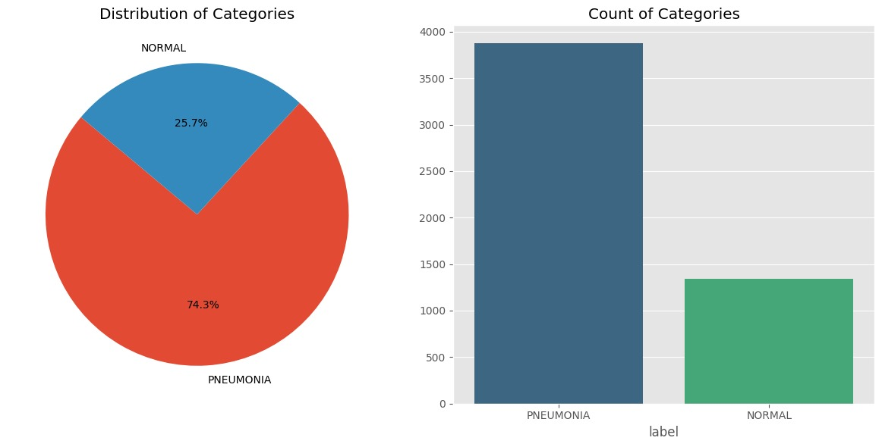

Figure 1.1: Class distribution of Train dataset

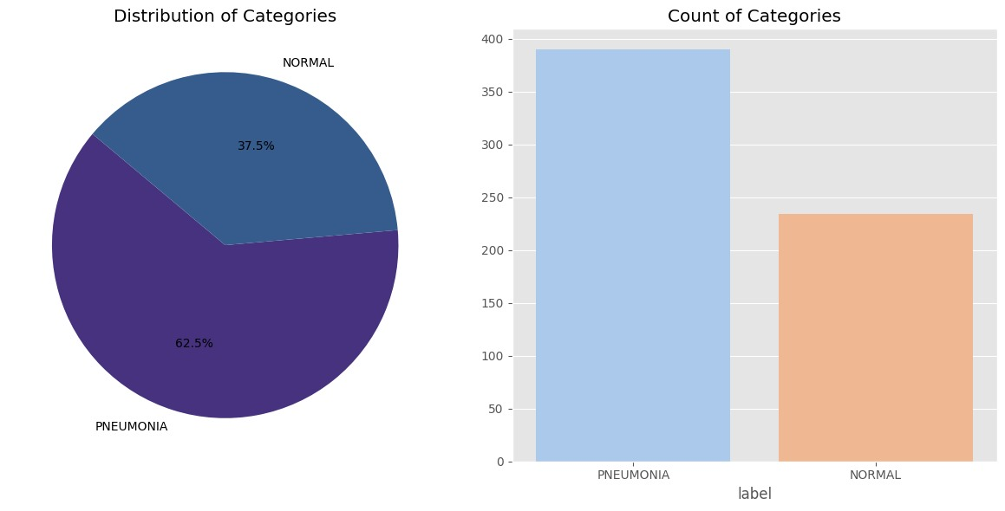

Figure 1.2: Class Distribution of Test

*School of Computer Engineering, KIIT, BBSR* 6

*PNEUMONIA DETECTION USING CHEST XRAYS*

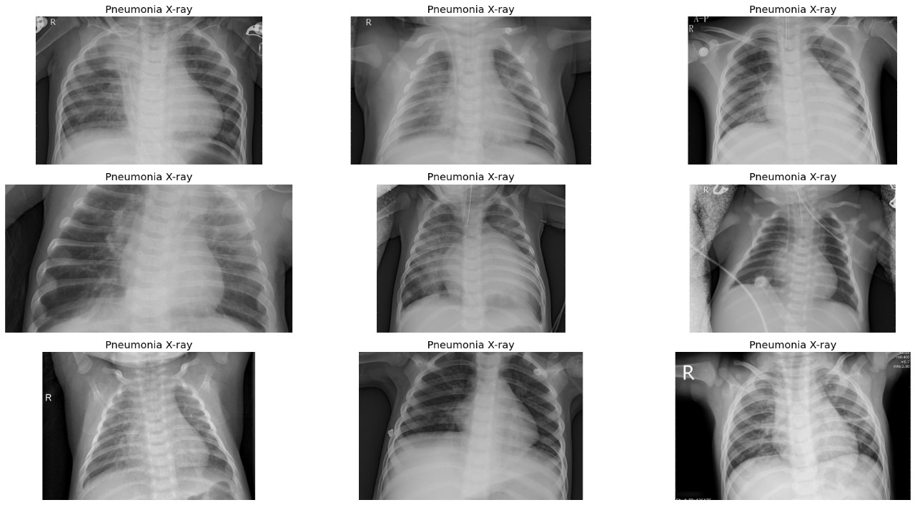

Figure2.1 Chest x-rays of Pneumonia cases

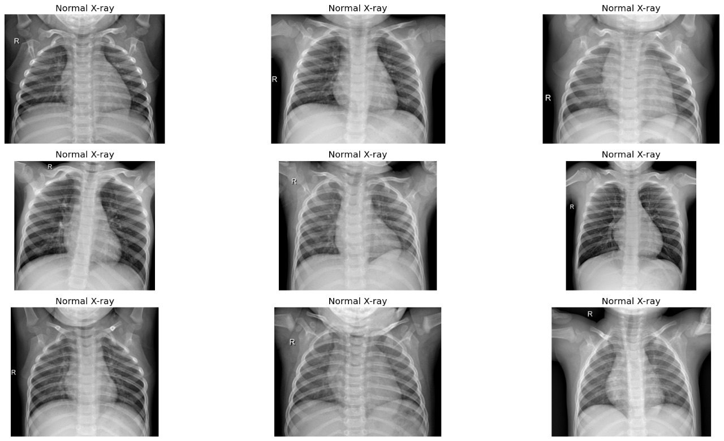

Figure2.2 Chest x-rays of Normal cases

*School of Computer Engineering, KIIT, BBSR* 7

*PNEUMONIA DETECTION USING CHEST XRAYS*



Figure 3.1 Accuracy

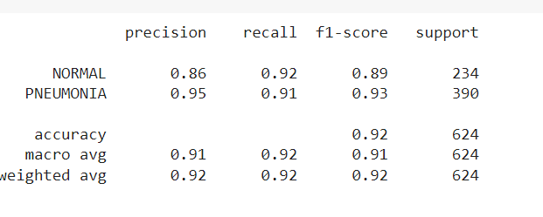

Figure3.2 Classification Report before Applying SMOTE

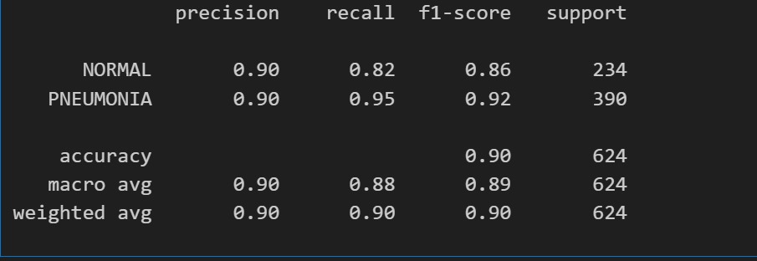

Figure 3.3 Classification report after applying SMOTE

*School of Computer Engineering, KIIT, BBSR 8*

*PNEUMONIA DETECTION USING CHEST XRAYS*

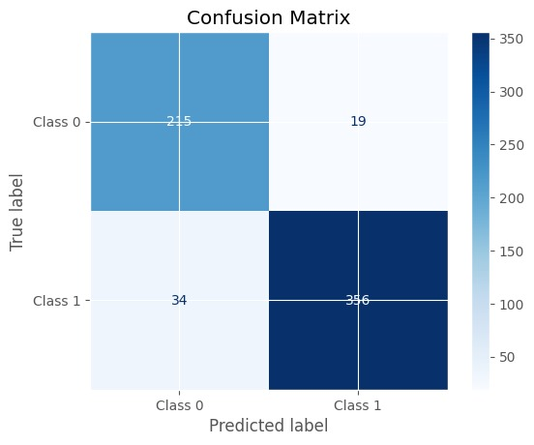

Figure4.1 Confusion Matrix

*School of Computer Engineering, KIIT, BBSR* 9

*PNEUMONIA DETECTION USING CHEST XRAYS*

Chapter 5

Standards Adopted

5.1 Design Standards

Design standards are essential for creating a solid and efficient system for diagnosing pulmonary problems in your chest X-ray analysis project. We arrange the software with modularity in mind, breaking down complex image analysis tasks into simple components that allow for code reuse and clarity. We ensure that the system is understandable and easily adaptable to future upgrades or alterations by providing extensive documentation and adhering to uniform coding rules. By focusing on scalability and flexibility, the system can adapt to changing datasets and diagnostic needs, paving the way for long-term development and improvement.

5.2 Coding Standards

Throughout the construction of our pneumonia detection model, we followed strict coding standards to assure code quality, dependability, and maintenance. We divided our code into modular components, each of which focused on a specific area of the workflow, such as data preprocessing, model definition, training, and evaluation. Clear comments were used to clarify the purpose and functionality of each function, which improved readability. Our testing method included creating unit and integration tests to confirm code functionality, as well as using performance optimisation techniques including profiling and efficiency optimisation. By following these coding standards, we ensured the stability and effectiveness of our pneumonia detection model throughout the development process.

*School of Computer Engineering, KIIT, BBSR* 10

*PNEUMONIA DETECTION USING CHEST XRAYS*

5.3   Testing Standards

Testing standards are paramount in ensuring the accuracy, reliability, and safety of chest X-ray analysis software. Rigorous testing practices are employed to validate the performance of each algorithm and feature, both independently and in conjunction with others. Unit testing enables meticulous examination of individual image processing modules to verify their correctness and robustness. Integration testing ensures seamless interaction between various components, guaranteeing the integrity of the overall system. Regression testing is conducted systematically to detect any unintended consequences of code changes and updates, preserving the stability and functionality of the software over time. Automation of testing procedures streamlines the validation process, facilitating frequent and consistent assessment of the system's performance. Performance testing evaluates the efficiency and responsiveness of the software under different workload scenarios, ensuring optimal performance in real-world diagnostic environments. Incorporating security testing is essential to identify and mitigate potential vulnerabilities, safeguarding patient data and maintaining compliance with healthcare regulations. By adhering to these testing standards, we ensure the reliability and effectiveness of our chest X-ray analysis solution, ultimately enhancing patient care and clinical decision-making.

*School of Computer Engineering, KIIT, BBSR* 11

*PNEUMONIA DETECTION USING CHEST XRAYS*

Chapter 6

Conclusion and Future Scope

6.1 Conclusion

Our experiment successfully demonstrated the usefulness of using MobileNetV2 to detect pneumonia from chest X-ray pictures.Healthcare providers can improve the diagnostic process by utilising the model's efficiency and accuracy, resulting in faster treatment initiation and lower costs. Furthermore, the technology has the ability to enhance remote healthcare services and inform public health initiatives using data-driven insights. Overall, adopting this paradigm has the potential to alter healthcare delivery by making it more effective, accessible, and responsive to patient demands.

6.2 Future Scope

Using MobileNetV2's compatibility with mobile devices, the project can broaden its reach and increase user engagement by developing mobile applications. These apps enable simple access to the project's features and functionalities while on the road, leveraging native smartphone capabilities to deliver a more immersive user experience. With offline capability, platform compatibility, and performance optimisation, the apps adapt to a wide range of mobile devices and operating systems, while also providing revenue prospects for long-term growth. Overall, MobileNetV2-powered mobile apps enable the project to provide users with seamless, efficient, and engaging experiences, hence increasing adoption and customer satisfaction.

*School of Computer Engineering, KIIT, BBSR* 12

*PNEUMONIA DETECTION USING CHEST XRAYS*

***References***

[1 ]https://ieeexplore.ieee.org/document/9487731

1. https://www.ncbi.nlm.nih.gov/pmc/articles/PMC9759647/
2. https://ieeexplore.ieee.org/document/8869364
3. https://www.kaggle.com/code/aviadl/starter-chest-x-ray-images-pneumonia-d498de7c-3
4. https://www.sciencedirect.com/science/article/pii/S1877050923000182

*\*

*School of Computer Engineering, KIIT, BBSR* 13

**SAMPLE INDIVIDUAL CONTRIBUTION REPORT:**

**PNEUMONIA DETECTION USING MOBILENET V2**

PRATISKHYA BEHERA

21052050

**Abstract:** The goal of the pneumonia detection model with MobileNetV2 is to create a precise and efficient system for classifying chest X-ray pictures as pneumonia-positive or pneumonia-negative. This model attempts to help healthcare practitioners make accurate and fast diagnoses, improve patient outcomes, and reduce the likelihood of misdiagnosis. It aims to attain high accuracy and dependability while keeping computationally efficient for clinical use. Finally, the initiative intends to advance medical technology by developing a reliable technique for detecting pneumonia.

**Individual contribution and findings:** I have contributed to our project by performing data visualization on chest X-ray pneumonia files using Python libraries. By leveraging visualization tools such as Matplotlib and Seaborn, generated insightful images to enhance our understanding of the dataset.utilized keras from TensorFlow to efficiently load and preprocess image data directly from a directory structure. This allowed for seamless integration of the dataset into our analysis pipeline. Additionally, implemented pixel value normalization to enhance the interpretability of visualizations, ensuring consistency and accuracy in our analysis. These visualizations helped us identify patterns, anomalies, and trends within the data, enabling more informed decision-making and deeper analysis for our project. There were about 5216 images in the training folder. Out of this about 74.3% cases were pneumonia and 25.7% were normal.

**Individual contribution to project report preparation:** I have contributed to report preparation by writing the standards adopted for our project**.**

**Individual contribution for project presentation and demonstration:** I have contributed to project presentation by adding the essentials images of data visualization.

Full Signature of Supervisor: Full signature of the student: ALEENA SWETAPDMA. PRATIKSHYA BEHERA

*School of Computer Engineering, KIIT, BBSR* 14

**SAMPLE INDIVIDUAL CONTRIBUTION REPORT:**

**PNEUMONIA DETECTION USING MOBILENET V2**

AAKARSH K SINGH

21052721

**Abstract:** The goal of the pneumonia detection model with MobileNetV2 is to create a precise and efficient system for classifying chest X-ray pictures as pneumonia-positive or pneumonia-negative. This model attempts to help healthcare practitioners make accurate and fast diagnoses, improve patient outcomes, and reduce the likelihood of misdiagnosis. It aims to attain high accuracy and dependability while keeping computationally efficient for clinical use. Finally, the initiative intends to advance medical technology by developing a reliable technique for detecting pneumonia.

**Individual contribution and findings:** I have contributed to projectby fine-tuning hyperparameters, optimising model architecture, and assuring robust testing techniques, I have built an accurate and efficient diagnostic tool for healthcare practitioners.

**Individual contribution to project report preparation:** I have contributed to project report preparation by providing the reference links in the report and adding the output of the trained model.

**Individual contribution for project presentation and demonstration:** I have contributed for project presentation by adding graphics and the outputs of the trained models.

Full Signature of Supervisor: Full signature of the student: ALEENA SWETAPDMA. AAKARSH K SINGH

*School of Computer Engineering, KIIT, BBSR* 15

**SAMPLE INDIVIDUAL CONTRIBUTION REPORT:**

**PNEUMONIA DETECTION USING MOBILENET V2**

MANSHA PATRA

21052769

**Abstract:** The goal of the pneumonia detection model with MobileNetV2 is to create a precise and efficient system for classifying chest X-ray pictures as pneumonia-positive or pneumonia-negative. This model attempts to help healthcare practitioners make accurate and fast diagnoses, improve patient outcomes, and reduce the likelihood of misdiagnosis. It aims to attain high accuracy and dependability while keeping computationally efficient for clinical use. Finally, the initiative intends to advance medical technology by developing a reliable technique for detecting pneumonia.

**Individual contribution and findings:** I have contributed to the project by reviewing the model and included the confusion matrix and precision accuracy curve considerably improved the pneumonia detection system's interpretability and performance. By implementing these advanced evaluation indicators, I was able to gain deeper insights into the model's categorization performance, indicating areas of strength and places for growth. The confusion matrix provides a comprehensive breakdown of true positives, true negatives, false positives, and false negatives, allowing for a thorough review of the model's predicted accuracy. The classification report which consists of precision, recall,f1 score help with classification threshold optimisation. Overall, this boosted the model evaluation process, allowing for more informed decision-making and continued refining of the pneumonia detection system.

.

**Individual contribution to project report preparation:** I havecontributed to project report preparation by writing the content of overall report and by adding the images of confusion matrix and precision accuracy curve.

**Individual contribution for project presentation and demonstration:** I have contributed to project presentation by adding resources to the presentation, making it informative and useful**.**

Full Signature of Supervisor: Full signature of the student:

ALEENA SWETAPADMA MANSHA PATRA

*School of Computer Engineering, KIIT, BBSR* 16

