Manuscript

Title: Exploring microRNA-mRNA Relationships Mediated by Transcription Factors in Melanoma

Authors: Mansi Aggarwal, Dr. Miles Andrews, Peinan Zhao
Date Created: 21 May 2025
Table of Contents
1. Abstract 3
2. Background 4
2.1. Regulators of gene expression 4
2.2. Coordinated activity of TF and miRNA 5
2.3. Measurement and normalisation strategies for gene and miRNA expression 6
2.4. Predicting miRNA targets 7
2.5. Limitations of sequencing-based approaches to resolving miRNA-mRNA interactions 8
3. Methodology 10
3.1. Data Collection 10
3.2. Data Preparation 10
3.3. Correlation Analysis 10
3.4. Identification of miRNA-TF interactions 11
3.5. Identification of TF target genes 11
3.6. Over-representation analysis 11
4. Results 14
5. Discussion 23
6. References 25

Abstract
MicroRNAs (miRNAs) are small RNA molecules, measuring around 22 nucleotides in length, that bind to specific target sequences on messenger RNAs (mRNAs) and control gene expression. This binding results in translational repression, which lowers the production of proteins from those mRNAs (Fattore et al., 2017; Friedman et al., 2009). However, transcription factors (TFs), which are essential for controlling gene networks in a variety of biological systems, are also targeted by miRNA (Zhao et al., 2016)

Conventional methods for identifying miRNA targets often rely on correlations between miRNA and mRNA expression levels (Joung et al., 2007). However, this approach may overlook indirect regulatory relationships, particularly when miRNAs target transcription factors (TFs), which themselves control expression of the target gene through DNA binding.

This study investigates the regulatory interplay between microRNAs (miRNAs), transcription factors (TFs), and messenger RNAs (mRNAs) in the context of cancer biology. Using publicly available gene and miRNA expression datasets, we first identified strongly correlated miRNA–mRNA pairs through correlation analysis. Recognising that miRNAs often regulate gene expression indirectly by targeting TFs — key regulators of transcription — we focused on miRNAs predicted to target TFs but not the mRNAs those TFs regulate. Yet, these miRNAs still showed statistically significant high correlation with the corresponding mRNAs. This pattern suggests the presence of indirect regulatory relationships mediated by TFs within miRNA–TF–mRNA triplets. By integrating target prediction databases and TF binding profiles from ChIP-seq data, we identified numerous such triplets across both melanoma and breast cancer datasets. Further investigation may provide deeper insights into the molecular biology of cancer.

Background

Regulators of gene expression
The central dogma of molecular biology states that genes guide protein synthesis through mRNA molecules. Since the information carried by genes cannot be converted into proteins directly, information is first transferred to complementary coding mRNA molecules produced from a DNA template in a process called transcription. Each mRNA molecule encodes information for one protein and migrates through the nuclear envelope to the cytoplasm, where it may undergo additional modification (e.g. splicing) prior to being translated into protein by the ribosome. Simplistically, the quantity of mRNA molecules should be directly related to the quantity of the protein it encodes. However, this process is complex due to multiple regulatory mechanisms that directly influence protein production and degradation. Recent findings have elucidated the roles of miRNAs and TFs as the two main classes of molecules that influence gene expression and protein synthesis (Guzzi et al., 2015).

TFs regulate gene transcription through binding to specific sites in the DNA near target genes (Chen & Rajewsky, 2007; Suter, 2020; Wang et al., 2015). These binding sites, known as transcription-factor binding sites (TFBS), often form clusters called cis-regulatory modules (CRMs). CRMs, spanning hundreds of nucleotides, can contain multiple binding sites for around 3 to 10 transcription factors, producing the initial spatio-temporal expression patterns of target genes by integrating concentrations of various transcription factors present within a specific cell at a given time. This reliance on cellular context and combinatorial control underscores the intricate nature of transcriptional regulation (Chen & Rajewsky, 2007).

TFs are not only central to normal gene regulation but are also critical carcinogenesis, where their sustained activity supports tumor growth and survival. Inflammatory TFs like NF-κB, STAT3, and AP1 promote genes linked to tumor initiation, while HIFs activate programs that enable invasion, angiogenesis, and maintenance of cancer stem cell traits (Vishnoi et al., 2020). In melanoma, for instance, microphthalmia-associated transcription factor (MITF) is a key regulator in melanocyte development and differentiation. MITF governs the expression of a multitude of pigmentation genes, facilitating melanocyte differentiation, while also regulating fundamental genes crucial for cell homeostasis. These include genes encoding proteins involved in apoptosis, such as BCL2, and those governing the cell cycle, such as CDK2 (Kawakami & Fisher, 2017). Several TF families contribute to breast cancer malignancy as well, notably the STAT proteins. Since their identification, STATs have been shown to play diverse roles in tumor progression and immune regulation (Wong et al., 2022).

Small non-coding RNAs (ncRNAs) have also been discovered to control gene expression in a sequence-specific manner. High-throughput sequencing and computational prediction methods have classified ncRNAs into small interfering RNAs (siRNAs), microRNAs (miRNAs), PIWI-interacting RNAs (piRNAs), endogenous small interfering RNAs (esiRNAs), promoter associated RNAs (pRNAs), small nucleolar RNAs (snoRNAs), and sno-derived RNAs – miRNAs being the most important regulators of gene expression (Catalanotto et al., 2016).
MiRNAs primarily bind to the 3' untranslated region (UTR) of their target mRNAs based on sequence complementarity, although interactions with the 5' UTR and coding regions have also been observed (Hofacker, 2007). The fate of an mRNA after miRNA binding depends on the degree of complementarity in this so-called seed sequence; complete seed sequence binding leads to mRNA degradation, while partial binding results in translational repression, often during translation initiation (Bartel, 2004).

Coordinated activity of TF and miRNA
In development, TFs act as switches to turn genes on or off, while miRNAs regulate gene expression and cellular development (Flynt & Lai, 2008). Dysregulation of miRNAs can lead to disease, particularly in cancer. In fact, Lu et al. (2005) reported the potential of using miRNA expression profiles over mRNA expression profiles in cancer diagnosis for classification of tumour states. The expression patterns of miRNA are tissue and stage-specific, influenced by transcriptional regulators, signaling networks, and chromatin modifiers (Arora et al., 2013). TFs regulate miRNA expression through cell-specific pathways, often interacting with cis-regulatory motifs near transcription start sites.

Cui et al. (2007) observed that the complexity of transcriptional regulation of a given gene is positively correlated with the probability that the gene is regulated by a miRNA. Gene regulatory networks of CRM-miRNA modules are composed of feedforward loops (FFLs), where a TF and a miRNA jointly regulate a target gene (Arora et al., 2013). There are different types of FFLs, each with distinct regulatory effects on gene expression. In a miRNA-mediated FFL, the miRNA simultaneously represses a TF and its target gene. When the miRNA is downregulated, the target gene expresses, demonstrating a quick-OFF-slow-ON switching mechanism (Sevignani et al., 2006). This buffering of noise helps minimise leaky expression. An example of this type of FFL involves miR-208, GATA-4, and the target gene, α-myosin heavy chain (α-MHC), in cardiac muscle regulation. GATA-4 stimulates α-MHC expression, while miR-208 represses both GATA-4 activity and α-MHC expression, regulating cardiac hypertrophy.

In TF-mediated FFLs, the TF activates or represses both the miRNA and its target gene simultaneously. This can lead to either coherent or incoherent effects on target gene expression, depending on the regulatory relationships. In coherent TF-mediated FFLs, the TF either activates both the miRNA and its target gene or inhibits both. This results in a coherent effect on target gene expression, with both pathways having the same effect. An example of a coherent TF-mediated FFL is observed between TGF-β, miR-29, and cardiac fibrotic genes in the heart. TGF-β negatively regulates miR-29, which, in turn, suppresses cardiac fibrotic genes. In contrast, an incoherent TF-mediated FFL can be seen between Pnt-P1, miR-7, and the target gene Yan in D. melanogaster, where the loop ensures inhibition of Yan expression by activation on miR-7.

Measurement and normalisation strategies for gene and miRNA expression
RNA-Seq is a protein coding RNAs (mRNAs) profiling methodology using Next Generation Sequencing (NGS) platforms to investigate all RNA in a sample, typically after selection or enrichment for mRNA species (Sa et al., 2018). It converts total RNA into fragmented cDNA which is then amplified and sequenced in high-throughput. Current methods target RNAs with at least 200 base pairs, while short noncoding RNAs require separate isolation and protocols. Read lengths range between 30-500 base pairs depending on the sequencing platform, and library size or read depth is crucial for sensitive and precise transcript identification and quantitation.

RNA-Seq reads are computationally mapped to a human reference genome, revealing a transcriptional map (Wang et al., 2015). Alignment is challenging due to extensive alternative splicing and multiple short read assignments. The most popular RNA-Seq alignment software packages employ gene annotation to improve spliced read placement and, in the great majority of cases, appropriately handle multiple short read assignments (Sa et al., 2018).

In RNA-Seq studies, a technical bias arises due to the impact of gene length and library size on the estimation of gene abundances. Larger genes tend to have higher read counts compared to smaller genes simply because they produce longer mRNAs (Abbas-Aghababazadeh et al., 2018). R/FPKM (reads/fragments per-kilobase transcript per million mapped reads) are a commonly reported measure of normalised gene expression from RNA-Seq analysis. For RPKM (single-end sequencing), total reads in a sample are divided by 1,000,000 to obtain a "per million" scaling factor. Read counts are divided by the scaling factor to normalise for sequencing depth, resulting in reads per million (RPM). RPM values for each gene are further divided by the length of that gene in kilobases to calculate RPKM. FPKM is the equivalent metric for paired-end RNA-seq, where two reads (forward and reverse) uniquely identify each original transcript fragment, and ensures that fragments are not counted twice due to paired-end sequencing.

TPM (transcripts per kilobase per million) normalisation divides read counts by gene length to obtain reads per kilobase (RPK), then scales these values to ensure a constant sum of one million across samples, simplifying inter-sample comparisons. The difference here is the order of operations — we first normalise for gene length first and then normalise for sequencing depth.

TPM is unit-less and adheres to the invariance property — because it normalises expression levels by the total number of transcripts in the sample, ensuring that the average expression level is consistent across samples (Zhao et al., 2020). It represents the normalised transcript abundance per gene, maintaining proportionality and facilitating compatibility with modern computational algorithms for transcript quantification, such as RSEM (Li & Dewey, 2011). TPM is widely used for gene expression analysis, particularly for comparison across samples.

In the case of miRNA, mature miRNA is the active species that binds to the 3′ UTR of mRNA; quantification of the mature miRNA, rather that the inactive, pre-miRNA, is usually desirable (Schmittgen et al., 2008). Studies have shown that pre-miRNA is often detectable while mature miRNA is undetectable (Michael et al., 2003). Small RNA-seq using NGS offers a powerful method for miRNA expression profiling as well, enabling detection of known and novel miRNAs with precise identification of sequences, including variants differing by a single nucleotide (Alexiou et al., 2020). However, NGS-based studies may yield numerous small RNAs of novel sequence, necessitating rigorous criteria for miRNA annotation. Emerging technologies like single molecule sequencing (SMS) promise less biased output but face challenges of higher error rates and cost (Pritchard et al., 2012).

Currently, the practice for normalising small RNA-seq experiments is scaling to library size. This technique divides reads by the total number of short RNA-seq reads aligning to the genome. Alternatively, normalising miRNA reads against the overall count of 18–22 nucleotide reads or the total number of reads that map to known miRNAs, respectively, yields the relative frequency of miRNAs. After normalisation, the data is reported for each library as reads per million (Meyer et al., 2010).

Predicting miRNA targets
Numerous computational techniques were developed to discover putative miRNA targets in the lack of high-throughput biological approaches.

Sequence-based miRNA prediction approaches – such as TargetScan (John et al., 2004), and miRanda (John et al., 2004) – utilise computational algorithms to scan the 3' UTRs of target genomes for potential miRNA binding sites (John et al., 2004; Lewis et al., 2003; Liu et al., 2014). These algorithms typically consider factors such as sequence complementarity between the miRNA and target site, predicted binding energy of the miRNA-target duplex, and evolutionary conservation of the target site sequence. Predicted target genes are identified based on conserved pairing to the miRNA and the number and quality of complementary sites.

However, most statistical approaches in standard sequence analyses are unable to detect miRNAs significantly regardless of the binding sites due to their short length. Since some miRNAs lack conserved targets, most algorithms use the cross-species conservation criterion to lower the number of false positives, even if there is a chance that this may increase the number of false negatives (Liu et al., 2014).

MiRNA target predictions can be experimentally validated using both gene-specific and high-throughput techniques. Importantly, the sheer number of potential miRNA targets is largely unfeasible to validate experimentally using high confidence techniques. Gene-specific methods include reporter gene assays, co-expression analysis of miRNA and target mRNA (e.g., northern blotting or qPCR), and evaluation of the impact of miRNA on target proteins (e.g., ELISA, western blotting, immunohistochemistry) (Kuhn et al., 2008). High-throughput techniques extend these methods to a larger scale, such as using microarray screening instead of qPCR. They also include novel methods like RNA-Seq, (micro)RNA-induced silencing complex (RISC) component immunoprecipitation, high-throughput sequencing of RNA isolated by crosslinking immunoprecipitation (HITS-CLIP), photoactivatable-ribonucleoside-enhanced crosslinking immunoprecipitation (PAR-CLIP), biotin-tagging of miRNAs, parallel analysis of RNA ends (PARE), and various proteomics approaches like SILAC (Thomson et al., 2011), which involves crosslinking immunoprecipitation to isolate mRNA transcripts associated with the miRISC from cellular lysates (Chi et al., 2009; Liu & Wang, 2019). This technique captures short RNA fragments, or transcript tags, which are protected from RNase digestion by RISC-associated Argonaute proteins. The captured RNA fragments are then subjected to high-throughput sequencing to identify their sequences.

Despite the accuracy of above experiments in identifying miRNA-target genes, these methods do not specify which regions of the mRNA are targeted by miRNAs. To locate the specific regions, luciferase reporter assays are extensively used (Hsu et al., 2011) and involve fusing the 3′ UTR of a target gene to a luciferase reporter construct and validation occurs by observing changes in reporter activity detected by luminescence. This helps pinpoint specific mRNA regions involved in miRNA targeting, providing direct confirmation of miRNA-mRNA interaction (Xiao et al., 2009).

Limitations of sequencing-based approaches to resolving miRNA-mRNA interactions
Based on the notion that the canonical action of microRNA is to reduce gene expression of target genes, miRNA-mRNA associations identified through inverse correlation of paired miRNA and RNA sequencing data are ubiquitous throughout the literature, fuelled by the high-throughput and relative simplicity of next generation sequencing. Such approaches can be paired with experimental validation leading to discovery of new biological insights (Andrews et al., 2016). However, because miRNA act post-transcriptionally, the most appropriate strategy would be to examine correlations between miRNA abundance and matched quantitative whole-proteomics, but such data are expensive to produce and complex to analyse. Furthermore, as not all miRNA-target mRNA interactions lead to degradation of the target mRNA, the validity of sequencing-based inverse correlations is questionable and subject to potentially large numbers of false positive and negative associations.

Refined probabilistic or correlation-based approaches also exist to identify miRNA-regulated modules by integrating miRNA-target binding information and expression profiles of miRNAs and mRNAs (Joung et al., 2007). The method combines heterogeneous data sources using a fitness function, incorporating correlation coefficients between miRNA or mRNA pairs and binding scores of miRNA-mRNA pairs. Through co-evolutionary learning and estimation-of-distribution algorithms, optimal groups of miRNAs and mRNAs are mined iteratively, enabling the detection of correlated miRNA-mRNA modules with biological significance, as demonstrated in a human cancer dataset.

Le et al. (2013) proposed a causal modelling and discovery approach to infer causal regulatory links between miRNA and mRNA from gene expression data; and the results of the subsequent gene knockdown studies were shown to share a significant amount of overlap with the identified miRNA–mRNA causal regulatory connections. This result has shown that the computational method can obtain a high level of accuracy. However, this approach, and most approaches, still do not differentiate if the causal linkages are direct, or indirect – where an indirect regulation of an mRNA by a miRNA is mediated by other regulator(s), such as TFs.

To address this limitation, we focused on exploring the role of TFs acting as intermediaries of observed miRNA-mRNA correlations in sequencing datasets. We hypothesised that miRNAs may regulate mRNAs indirectly by targeting transcription factors that, in turn, modulate those mRNAs. To test this, we focused on cases where a miRNA targets a TF but not its downstream mRNA targets, yet the mRNAs show significant correlation with the miRNA, suggesting a mediated effect. This approach allowed us to identify candidate miRNA–TF–mRNA regulatory networks consistent with indirect regulation. By considering TFs as potential mediators, our study aimed to provide a more nuanced understanding of the complex regulatory landscape governing gene expression in cancer.

Methodology

Data Collection
We used data from the SKCM (Skin Cutaneous Melanoma) and BRCA (Breast Invasive Carcinoma) cohorts of The Cancer Genome Atlas (https://portal.gdc.cancer.gov/projects/TCGA-SKCM and https://portal.gdc.cancer.gov/projects/TCGA-BRCA). TCGA is a large, curated collection of multi-platform genomic, clinical, and pathologic data, for over 20,000 cancer and/or matched normal samples spanning 33 cancer types, obtained via international collaboration. Both datasets include miRNA expression profiling by small-RNAseq (available for 452 cases in SKCM, 1207 cases in BRCA) and gene expression profiling by mRNA-seq (available for 473 cases, 1231 cases in BRCA).

Processed count data summarised at gene and miRNA level respectively was downloaded using the TCGAbiolinks (Colaprico et al., 2016), R/Bioconductor package (v2.29.6).

Data Preparation
The expression data were cleaned and processed before further analysis. For clarity, gene expression refers to mRNA sequencing-derived abundance quantified as “Transcripts Per Kilobase Million” (TPM), and microRNA expression refers to mature-strand microRNA abundance derived from small RNA sequencing and quantified as “Reads Per Million Mapped” (RPM).

- Protein-coding filter: Gene expression data were filtered to retain only protein-coding transcripts.
- Sample-ID harmonisation: Sample IDs were matched and made consistent across both datasets.
- Dataset matching: Only samples with matched gene and miRNA data (SKCM: n=451, BRCA: n=1198) were retained for further analysis.
- Removal of non-expressed features: Genes and miRNAs with no expression (i.e.: TPM or RPKM, respectively) across all samples were removed from further consideration.
- Expression prevalence filter: Low-prevalence genes/miRNAs, being genes/miRNAs expressed in less than 40% of samples, were filtered out.
- Log-transformation: The final expression data matrices were log₂ transformed (after adding a dummy count of 1 to all observations to avoid infinity values) to stabilise variance across different expression levels (Law et al., 2014).

For gene expression data, gene symbols and ENSEMBL IDs were retained for downstream analysis.

Correlation Analysis
We calculated the Spearman correlation coefficient between each gene and each miRNA within each cohort as this non-parametric measure is best suited to monotonic correlations in genomic data unlike the Pearson coefficient, which requires normally distributed data for linear relationships (Siska & Kechris, 2017). Correlation coefficients and their associated p-values were calculated using the “rcorr” function in the Hmisc package in R (Harrell Jr, 2023). Statistical significance was adjusted for multiple comparisons using the Benjamini-Hochberg (BH) procedure in order to calculate the False Discovery Rate (FDR). Correlations with an adjusted p-value of less than 0.05 were retained for further analysis. No threshold was set for correlation coefficient.

Identification of miRNA-TF interactions
A list of known human TFs identified through functional characterisation of over 1600 likely TFs and binding motifs was downloaded in csv format as provided by Lambert et al. (2018). Potential TF genes were filtered for “Is.TF” = “Yes”.

We used the multiMiR (Ru et al., 2014) package in R (v1.20.0) to obtain miRNA-target interactions. The multiMiR database includes data from 14 external databases, including validated, predicted, and disease-/drug-related databases. These data were downloaded and pre-processed before loading into multiMiR’s MySQL database.

To obtain miRNA-TF interactions, we queried interactions in the multiMiR database that had been experimentally validated using any technique (such as luciferase reporter assays, western blot, qRT-PCR, immunohistochemistry, immunoprecipitation) — and then retained miRNAs shown to target any of TFs in the list obtained from Lambert et al. (2018) as above.

Identification of TF target genes
Chromatin immunoprecipitation sequencing (ChIP–seq) is widely used to map DNA-binding proteins and histone modifications in a genome-wide manner at base-pair resolution (Park, 2009). To determine the genes targeted by TFs, we used ChIP-Atlas, a web service of comprehensive ChIP-seq datasets (Zou et al., 2022). This study involved aligning the data to the human reference genome (hg38) and performing peak calling. Significant peaks indicative of TF-binding sites were identified, and genes with peaks overlapping with transcription start site regions within a specified distance were considered as potential TF targets.

We also curated melanoma and breast cancer cell lines from both ChIP-Atlas metadata and the Cellosaurus (Bairoch, 2018) database. For each TF in the list from Lambert et al. (2018), we downloaded the list of genes that demonstrated significant TF binding within 5000 base pairs of the gene’s transcription start site, and to reduce false positives from individual ChIP-seq experiments, we applied a consensus threshold: a gene was retained as a TF target only if it showed TF binding in at least 50% of the cancer-specific cell lines with available ChIP-seq data. To avoid introducing arbitrary biases, we did not apply any minimum threshold on the number of ChIP-seq replicates or distinct cell lines per TF. A Spearman correlation analysis revealed no significant association between the number of biological replicates and the number of target genes identified per TF (Figure 1). This indicates that variation in replicate count did not systematically inflate or deflate TF target counts.

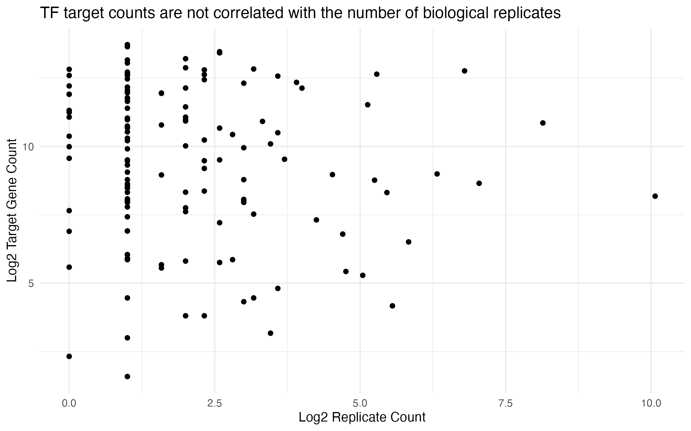
Figure 1. Correlation Between TF Target Counts and Number of Biological Replicates. This is the plot for BRCA (SKCM exhibited a similar pattern). Each point represents a TF, with the x-axis indicating the log₂-transformed count of cell lines across relevant breast cancer cell lines, and the y-axis showing the log₂-transformed number of genes identified as TF targets. The absence of a discernible trend supports the decision to avoid replicate-based filtering and instead rely on peak consensus across cell lines.

Over-representation analysis
Over-representation analysis (ORA) is a method used in bioinformatics studies to evaluate whether a list of genes is over-represented in or by a previously annotated gene set or pathway (Karp et al., 2021).

We implemented an over-representation analysis, using the method of (Boyle et al., 2004) who described the inference of statistical significance of overlapping gene sets by calculating a p-value using the hypergeometric distribution according to the following formula:

$$p=1-\sum_{i=0}^{k-1}{\frac{\left({M \atop i}\right)\left({N-M \atop n-i}\right)}{\left({N \atop i}\right)}}$$

By way of example, from our BRCA data, let us consider a miR-107. It positively correlated with 2,936 genes, 1,467 of which are indirect targets of the miR, and the miR is known to interact with the TF MAX. Out of the 17,638 in our final gene expression matrix, MAX is known to target 1,598 genes. Now we find that of the genes that positively correlate with miR-107 and are indirect targets of the mir, 187 are also found within the genes targeted by MAX. To determine whether this overlap may reflect an indirect miR-FOXC1-mRNA regulatory relationship, we test whether this overlap is statistically significant rather than expected by chance using the hypergeometric model. Here, N is the full background (17,636 genes), M is the number of FOXC1 targets (1,598), n is the number of miR-correlated genes (1,467), and k is the overlap (187 genes).

This images will be removed, I put it here to give context of numbers I used above and for Miles and Peinan to cross-check.

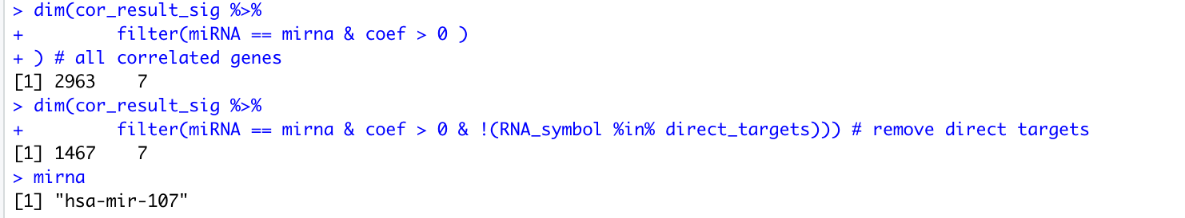

It is important to note that for each miRNA–TF pair, we first removed direct miRNA targets from the correlated gene set prior to ORA. This step ensures that the significance of gene overlap with TF targets reflects potential TF-mediated effects rather than direct miRNA action. This filtered list was then used to assess enrichment among the TF’s target genes.

Notably, for miRs that interact with multiple TFs, performing separate overlap analyses for each TF targeted by a miRNA is crucial to accurately assess their regulatory network interactions. Pooling all interacting TFs and their target genes may lead to misleading conclusions in ORA because the more TFs a miR targets, the more of the genome those TFs would target collectively, thus the overlap proportions of miR-target genes and pooled TF-target genes would be expected to be almost universally high and not reflective of the potential molecular interaction between the miR and any single TF. Finally, the resulting enrichment p-values were subjected to Benjamini-Hochberg correction to control the false discovery rate across all TF–miRNA combinations. Only those pairs with an adjusted p-value < 0.05 were retained as statistically significant.

To perform ORA, we used “clusterProfiler”, an R/Bioconductor package (Wu et al., 2021). When first released in 2012, this suite of tools performed functional enrichment analyses from gene expression data by querying the enrichment of biological or metabolic functional annotations in an input gene set of interest, against functional gene databases such as GO and KEGG. However, now, clusterProfiler also supports more generalised ORA of any input and reference gene sets using the “enricher” function. This function accepts a parameter called TERM2GENE, a data frame with first column of term ID and second column of corresponding mapped gene – this data frame is a user-specified custom annotation list. All mRNAs used for correlation analysis formed the background set (here, ID was “background”). Then, for each TF, we created a gene set consisting of its target genes that were also present in the background set (here, ID was “TF target”, e.g., “MAX target”). This allowed us to investigate whether miRNA-correlated genes (positively or negatively correlated minus the direct targets of the miRNA) were over-represented among the targets of TFs known to interact with that miRNA, providing insights into potential two-step regulatory mechanisms. If the miRNA was known to interact with multiple TFs, the ORA was performed for each TF separately.

Results
Both datasets were retrieved for miRNA expression which was available for 452 cases in SKCM and 1,207 cases in BRCA, and for gene expression which was available for 473 cases in SKCM and 1,231 cases in BRCA. Normalised gene and miRNA expression data (TPM for gene expression, RPM for miRNA expression) were obtained. The sample IDs were matched across gene and miRNA datasets. Datasets were pre-processed to remove non-expressed and low prevalence features (expressed in <40% of samples), and log₂-transformed. These steps produced a final dataset comprising expression data for 17,384 genes and 779 miRNAs across 451 matched cases in SKCM, and 17,638 genes and 572 miRNAs across 1,198 matched cases in BRCA, suitable for downstream correlation analysis.

Pairwise Spearman correlation analysis identified a substantial number of significantly (adjusted p < 0.05) correlated miRNA-mRNA pairs: in SKCM, 1,991,909 positive correlations and 1,115,724 negative correlations; in BRCA 1,846,380 positive correlation and 2,503,820 negative correlations.

By integrating ≥1600 known human TFs and previously experimentally-validated miRNA-target interactions, we identified 61 miRNAs that displayed significant correlations with mRNAs including interaction with at least one TF in SKCM, and 92 such miRNAs in BRCA.

We further assessed the significance of indirect interactions through TFs, for which, we employed over-representation analysis (ORA). This analysis examined whether genes correlated with and indirectly by a specific miRNA were statistically over-represented among the targets of TFs known to interact with that miRNA. Out of the 779 miRs analysed in SKCM, 163 were found to target at least one TF. Of these 163 miRs, 11 had significant overlap between the miR’s negatively correlated genes and targets of TFs that the miR interacts with, and 32 had significant overlap between the miR’s positively correlated genes and targets of TFs that the miR interacts with. For BRCA, 54 out of 92 miRs had had significant overlap between the miR’s negatively correlated genes and targets of TFs that the miR interacts with, and 57 had significant overlap between the miR’s positively correlated genes and targets of TFs that the miR interacts with (Figure 2).

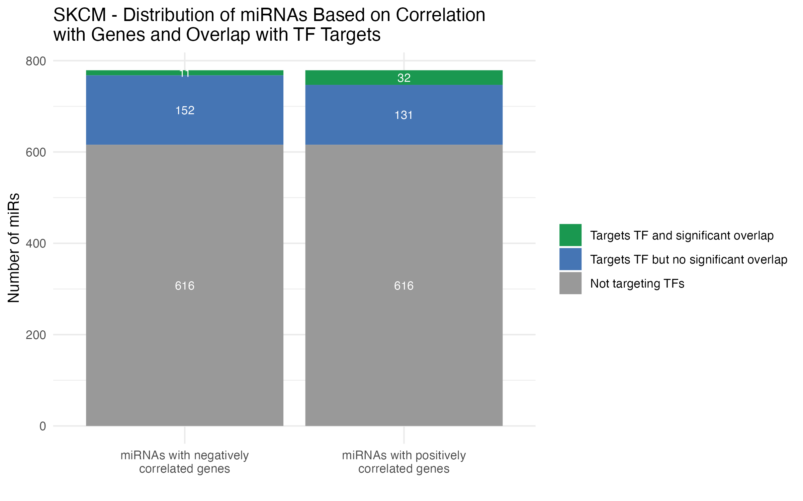
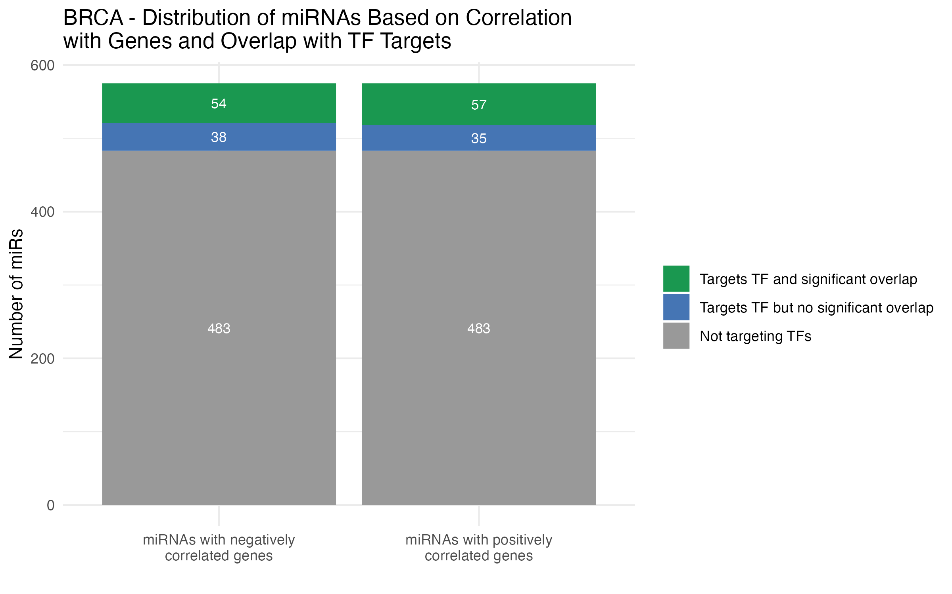
Figure 2. Distribution of miRNAs Based on Correlation with Genes and Overlap with TF Targets. Top graph is for SKCM and bottom one is for BRCA. In SKCM, all 779 miRNAs had statistically significantly positively and negatively correlated genes; 718 (grey) did not target a known TF whereas 61 miRNAs targeted at least one known TF. The green portion is the number of miRNAs where genes correlated with a specific miRNA were statistically over-represented among the targets of TFs known to interact with that miRNA. Blue indicates the number of miRNAs whose correlated genes were not significantly over-represented among the corresponding interacting TF.

There were 44 miR-TF pairs that had a significant overlap (adjusted p-value < 0.05) between positively miR-correlated genes and TF target genes, and 15 miR-TF pairs having significant overlap between negatively miR-correlated genes and TF target genes in SKCM. In these overlapping sets of miR-correlated and TF target genes, we retrieved the gene with the strongest correlation (or highest absolute value correlation coefficient) with the miR. The miR-TF pairs were arranged in descending order of this correlation coefficient and then in ascending order of the q-value (for most significant overlap).

In BRCA cohort, 388 miR-TF pairs had a significant overlap (adjusted p-value < 0.05) between positively miR-correlated genes and TF target genes, and 300 miR-TF pairs having significant overlap between negatively miR-correlated genes and TF target genes.

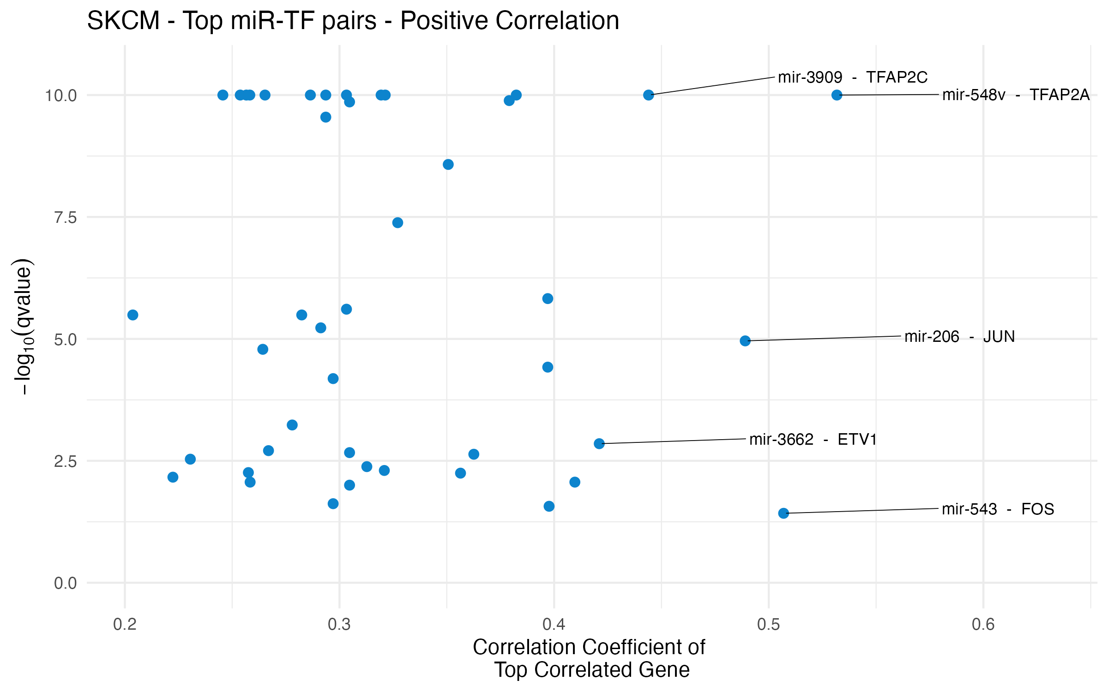
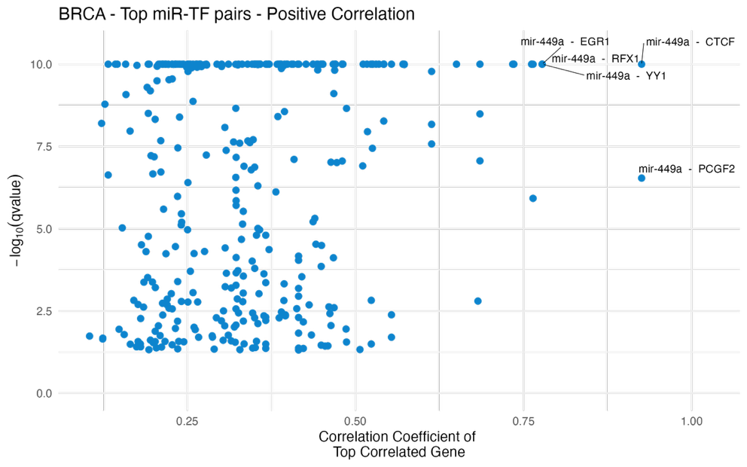
Figure 3. Scatter plot of the most highly-correlated gene for each miRNA-TF pair among the set of overlapping genes. 44 miR-TF pairs in SKCM and xxx miR-TF pairs in BRCA had a significant overlap (adjusted p-value < 0.05) between miR’s positively correlated genes and target genes of TFs that the miR interacts with. In that overlapping gene set, the strongest correlated gene’s coefficient has been shown. The five annotated pairs represent those with the highest positive correlation coefficient and most significant overlap (least q-value).

We conducted the same analysis for miRs with negatively correlated genes. The miR-TF pairs were arranged in descending order of the absolute (negative) correlation coefficient and then in ascending order of the q-value.
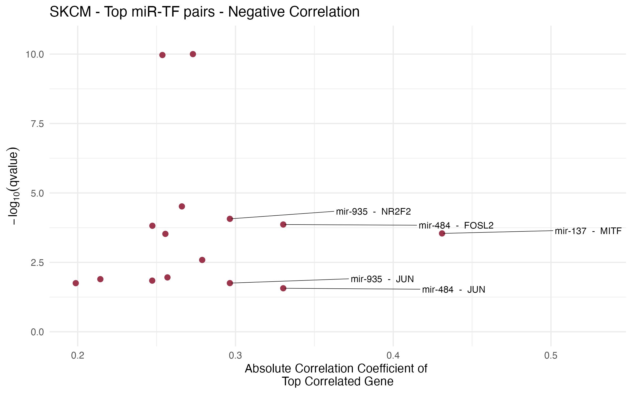

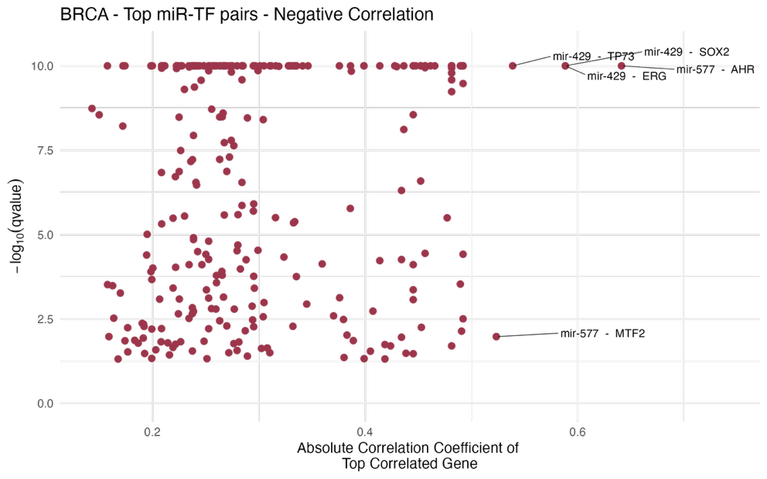
Figure 4. Scatter plot of the most highly-correlated gene for each miRNA-TF pair among the set of overlapping genes. 15 miR-TF pairs in SKCM and xxx miR-TF pairs in BRCA had a significant overlap (adjusted p-value < 0.05) between miR’s negatively correlated genes and target genes of TFs that the miR interacts with. In that overlapping gene set, the strongest correlated gene’s coefficient has been shown. The five annotated pairs represent those with the highest positive correlation coefficient and most significant overlap (least q-value).

In SKCM, miR-935, miR-484 and TF JUN appear more time that others in top 5 pairs in both positively and negatively correlated genes ORA. In BRCA, miR-449a is present in all top 5 pairs in positively correlated genes. In negatively correlated genes, miR-439 and miR-577 are present in the top 5 pairs, however the TFs are varied in both cases.

All the miR-TF interactions queried from multiMiR were experimentally validated, however, to refine our results, we focused on miR-TF pairs for which there was high-level evidence of direct interaction based on experimental validation using luciferase assays or western blot — there were 6 such pairs in SKCM and 98 in BRCA.

Among these 6 pairs in SKCM, for miRs with both positively and negatively correlated genes, 1 miR-TF pair each showed a significant overlap.

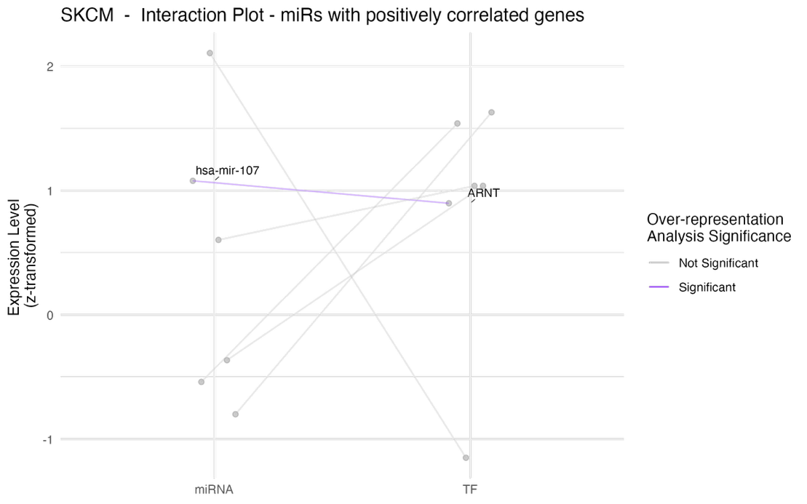
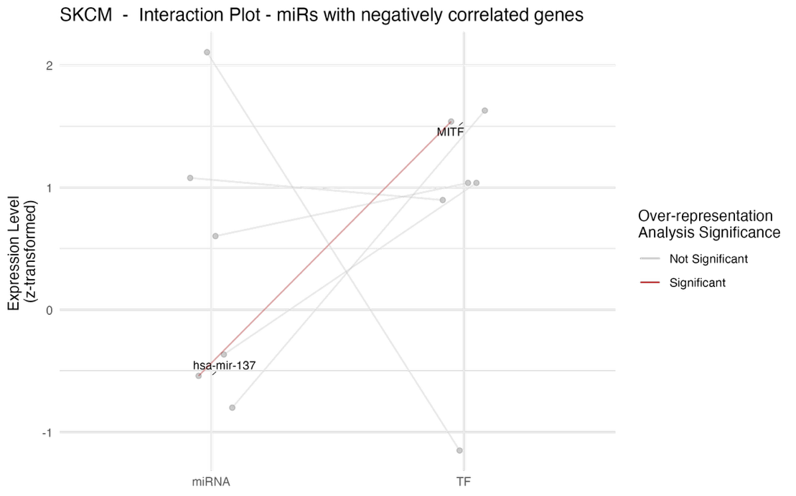
Figure 5. miRNA-TF pairs and over-representation analysis significance between miR’s positively correlated genes and targets of TF that the miR interacts with. These interaction plots are for SKCM and show z-transformed expression level of miRs and TFs. Each connecting line represents a miR to a TF it is known to interact with, and the interaction being experimentally validated by luciferase assay reporters or western blotting techniques; the colour of the line indicates whether the overlap between the miRNA's positively/negatively correlated genes and the TF's target genes is significant.

For BRCA, among the 98 pairs, for miRs with positively and negatively correlated genes, 18 and 17 miR-TF pair each showed a significant overlap respectively.

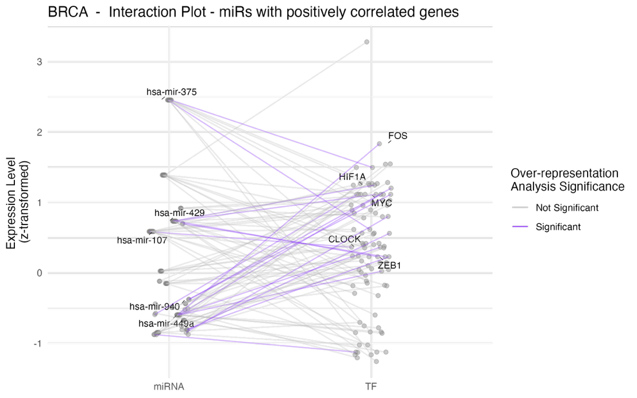
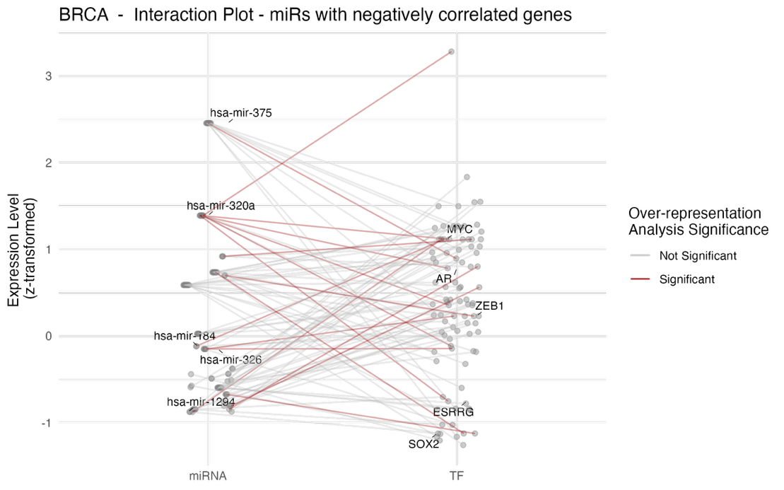
Figure 6. miRNA-TF pairs and over-representation analysis significance between miR’s positively correlated genes and targets of TF that the miR interacts with. These interaction plots are for BRCA and show z-transformed expression level of miRs and TFs. Each connecting line represents a miR to a TF it is known to interact with, and the interaction being experimentally validated by luciferase assay reporters or western blotting techniques; the colour of the line indicates whether the overlap between the miRNA's positively/negatively correlated genes and the TF's target genes is significant.

Only 1 pair each stands out in SKCM in both positively and negatively correlates genes. miR-107 appears in both cohorts in positively correlated genes interactions (Figure 5 and 6). In BRCA, TFs MYC and ZEB1 have most significant interactions with miRs in both positively and negatively correlated cases (Figure 6).

Our findings, including the over-representation of miR-correlated genes among TF targets and identification of specific miR-TF pairs for which the significant over-representation was most likely to be explained by indirect TF actions rather than direct miR-mRNA interactions, suggest that intermediary TFs may play a crucial role in mediating indirect miRNA-mRNA interactions in melanoma.

Discussion
MicroRNAs play a crucial role in regulating gene expression, and their dysregulation is implicated in various diseases, including melanoma (Varrone & Caputo, 2020). Traditional methods for identifying miRNA targets often rely solely on correlations between miRNA and mRNA expression levels, potentially overlooking indirect regulatory relationships, particularly those mediated through TFs. This study aimed to explore the interplay between miRNAs, TFs, and mRNAs in melanoma, focusing on identifying putative indirect miRNA-mRNA interactions mediated by intermediary TFs. Our analysis revealed a substantial number of significant miRNA-mRNA correlation pairs. By integrating known human TFs and experimentally validated miRNA-TF interactions, we identified miRNAs with significant correlations to mRNAs, including at least one TF. Further, the over-representation analysis demonstrated that many miRNA-TF pairs exhibited significant overlap between miRNA-correlated genes and TF target genes, an observed key miRs that not only have highly correlated genes but also do not target most of these genes in the corresponding overlapping sets, suggesting that high correlations could more likely be due to indirect TF actions. These results underscore the pivotal role of TFs in mediating miRNA-mRNA interactions in melanoma, providing new insights into the regulatory networks.

References
Abbas-Aghababazadeh, F., Li, Q., & Fridley, B. L. (2018). Comparison of normalization approaches for gene expression studies completed with high-throughput sequencing. PLoS One, 13(10), e0206312. https://doi.org/10.1371/journal.pone.0206312
Alexiou, A., Zisis, D., Kavakiotis, I., Miliotis, M., Koussounadis, A., Karagkouni, D., & Hatzigeorgiou, A. G. (2020). DIANA-mAP: Analyzing miRNA from Raw NGS Data to Quantification. Genes (Basel), 12(1). https://doi.org/10.3390/genes12010046
Andrews, M. C., Cursons, J., Hurley, D. G., Anaka, M., Cebon, J. S., Behren, A., & Crampin, E. J. (2016). Systems analysis identifies miR-29b regulation of invasiveness in melanoma. Mol Cancer, 15(1), 72. https://doi.org/10.1186/s12943-016-0554-y
Arora, S., Rana, R., Chhabra, A., Jaiswal, A., & Rani, V. (2013). miRNA-transcription factor interactions: a combinatorial regulation of gene expression. Mol Genet Genomics, 288(3-4), 77-87. https://doi.org/10.1007/s00438-013-0734-z
Bairoch, A. (2018). The Cellosaurus, a Cell-Line Knowledge Resource. J Biomol Tech, 29(2), 25-38. https://doi.org/10.7171/jbt.18-2902-002
Bartel, D. P. (2004). MicroRNAs: genomics, biogenesis, mechanism, and function. Cell, 116(2), 281-297. https://doi.org/10.1016/s0092-8674(04)00045-5
Boyle, E. I., Weng, S., Gollub, J., Jin, H., Botstein, D., Cherry, J. M., & Sherlock, G. (2004). GO::TermFinder--open source software for accessing Gene Ontology information and finding significantly enriched Gene Ontology terms associated with a list of genes. Bioinformatics, 20(18), 3710-3715. https://doi.org/10.1093/bioinformatics/bth456
Catalanotto, C., Cogoni, C., & Zardo, G. (2016). MicroRNA in Control of Gene Expression: An Overview of Nuclear Functions. Int J Mol Sci, 17(10). https://doi.org/10.3390/ijms17101712
Chen, K., & Rajewsky, N. (2007). The evolution of gene regulation by transcription factors and microRNAs. Nat Rev Genet, 8(2), 93-103. https://doi.org/10.1038/nrg1990
Chi, S. W., Zang, J. B., Mele, A., & Darnell, R. B. (2009). Argonaute HITS-CLIP decodes microRNA-mRNA interaction maps. Nature, 460(7254), 479-486. https://doi.org/10.1038/nature08170
Colaprico, A., Silva, T. C., Olsen, C., Garofano, L., Cava, C., Garolini, D., Sabedot, T. S., Malta, T. M., Pagnotta, S. M., Castiglioni, I., Ceccarelli, M., Bontempi, G., & Noushmehr, H. (2016). TCGAbiolinks: an R/Bioconductor package for integrative analysis of TCGA data. Nucleic Acids Res, 44(8), e71. https://doi.org/10.1093/nar/gkv1507
Cui, Q., Yu, Z., Pan, Y., Purisima, E. O., & Wang, E. (2007). MicroRNAs preferentially target the genes with high transcriptional regulation complexity. Biochem Biophys Res Commun, 352(3), 733-738. https://doi.org/10.1016/j.bbrc.2006.11.080
Fattore, L., Costantini, S., Malpicci, D., Ruggiero, C. F., Ascierto, P. A., Croce, C. M., Mancini, R., & Ciliberto, G. (2017). MicroRNAs in melanoma development and resistance to target therapy. Oncotarget, 8(13), 22262-22278. https://doi.org/10.18632/oncotarget.14763
Flynt, A. S., & Lai, E. C. (2008). Biological principles of microRNA-mediated regulation: shared themes amid diversity. Nat Rev Genet, 9(11), 831-842. https://doi.org/10.1038/nrg2455
Friedman, R. C., Farh, K. K., Burge, C. B., & Bartel, D. P. (2009). Most mammalian mRNAs are conserved targets of microRNAs. Genome Res, 19(1), 92-105. https://doi.org/10.1101/gr.082701.108
Guzzi, P. H., Di Martino, M. T., Tagliaferri, P., Tassone, P., & Cannataro, M. (2015). Analysis of miRNA, mRNA, and TF interactions through network-based methods. EURASIP J Bioinform Syst Biol, 2015, 4. https://doi.org/10.1186/s13637-015-0023-8
Harrell Jr, F. (2023). Hmisc: Harrell Miscellaneous. R package version 5.1-2. https://hbiostat.org/R/Hmisc/
Hofacker, I. L. (2007). How microRNAs choose their targets. Nat Genet, 39(10), 1191-1192. https://doi.org/10.1038/ng1007-1191
Hsu, S. D., Lin, F. M., Wu, W. Y., Liang, C., Huang, W. C., Chan, W. L., Tsai, W. T., Chen, G. Z., Lee, C. J., Chiu, C. M., Chien, C. H., Wu, M. C., Huang, C. Y., Tsou, A. P., & Huang, H. D. (2011). miRTarBase: a database curates experimentally validated microRNA-target interactions. Nucleic Acids Res, 39(Database issue), D163-169. https://doi.org/10.1093/nar/gkq1107
John, B., Enright, A. J., Aravin, A., Tuschl, T., Sander, C., & Marks, D. S. (2004). Human MicroRNA targets. PLoS Biol, 2(11), e363. https://doi.org/10.1371/journal.pbio.0020363
Joung, J. G., Hwang, K. B., Nam, J. W., Kim, S. J., & Zhang, B. T. (2007). Discovery of microRNA-mRNA modules via population-based probabilistic learning. Bioinformatics, 23(9), 1141-1147. https://doi.org/10.1093/bioinformatics/btm045
Karp, P. D., Midford, P. E., Caspi, R., & Khodursky, A. (2021). Pathway size matters: the influence of pathway granularity on over-representation (enrichment analysis) statistics. BMC Genomics, 22(1), 191. https://doi.org/10.1186/s12864-021-07502-8
Kawakami, A., & Fisher, D. E. (2017). The master role of microphthalmia-associated transcription factor in melanocyte and melanoma biology. Lab Invest, 97(6), 649-656. https://doi.org/10.1038/labinvest.2017.9
Kuhn, D. E., Martin, M. M., Feldman, D. S., Terry, A. V., Jr., Nuovo, G. J., & Elton, T. S. (2008). Experimental validation of miRNA targets. Methods, 44(1), 47-54. https://doi.org/10.1016/j.ymeth.2007.09.005
Lambert, S. A., Jolma, A., Campitelli, L. F., Das, P. K., Yin, Y., Albu, M., Chen, X., Taipale, J., Hughes, T. R., & Weirauch, M. T. (2018). The Human Transcription Factors. Cell, 172(4), 650-665. https://doi.org/10.1016/j.cell.2018.01.029
Law, C. W., Chen, Y., Shi, W., & Smyth, G. K. (2014). voom: Precision weights unlock linear model analysis tools for RNA-seq read counts. Genome Biol, 15(2), R29. https://doi.org/10.1186/gb-2014-15-2-r29
Le, T. D., Liu, L., Tsykin, A., Goodall, G. J., Liu, B., Sun, B. Y., & Li, J. (2013). Inferring microRNA-mRNA causal regulatory relationships from expression data. Bioinformatics, 29(6), 765-771. https://doi.org/10.1093/bioinformatics/btt048
Lewis, B. P., Shih, I. H., Jones-Rhoades, M. W., Bartel, D. P., & Burge, C. B. (2003). Prediction of mammalian microRNA targets. Cell, 115(7), 787-798. https://doi.org/10.1016/s0092-8674(03)01018-3
Li, B., & Dewey, C. N. (2011). RSEM: accurate transcript quantification from RNA-Seq data with or without a reference genome. BMC Bioinformatics, 12, 323. https://doi.org/10.1186/1471-2105-12-323
Liu, B., Li, J., & Cairns, M. J. (2014). Identifying miRNAs, targets and functions. Brief Bioinform, 15(1), 1-19. https://doi.org/10.1093/bib/bbs075
Liu, W., & Wang, X. (2019). Prediction of functional microRNA targets by integrative modeling of microRNA binding and target expression data. Genome Biol, 20(1), 18. https://doi.org/10.1186/s13059-019-1629-z
Lu, J., Getz, G., Miska, E. A., Alvarez-Saavedra, E., Lamb, J., Peck, D., Sweet-Cordero, A., Ebert, B. L., Mak, R. H., Ferrando, A. A., Downing, J. R., Jacks, T., Horvitz, H. R., & Golub, T. R. (2005). MicroRNA expression profiles classify human cancers. Nature, 435(7043), 834-838. https://doi.org/10.1038/nature03702
Meyer, S. U., Pfaffl, M. W., & Ulbrich, S. E. (2010). Normalization strategies for microRNA profiling experiments: a 'normal' way to a hidden layer of complexity? Biotechnol Lett, 32(12), 1777-1788. https://doi.org/10.1007/s10529-010-0380-z
Michael, M. Z., SM, O. C., van Holst Pellekaan, N. G., Young, G. P., & James, R. J. (2003). Reduced accumulation of specific microRNAs in colorectal neoplasia. Mol Cancer Res, 1(12), 882-891. https://www.ncbi.nlm.nih.gov/pubmed/14573789
Park, P. J. (2009). ChIP-seq: advantages and challenges of a maturing technology. Nat Rev Genet, 10(10), 669-680. https://doi.org/10.1038/nrg2641
Pritchard, C. C., Cheng, H. H., & Tewari, M. (2012). MicroRNA profiling: approaches and considerations. Nat Rev Genet, 13(5), 358-369. https://doi.org/10.1038/nrg3198
Ru, Y., Kechris, K. J., Tabakoff, B., Hoffman, P., Radcliffe, R. A., Bowler, R., Mahaffey, S., Rossi, S., Calin, G. A., Bemis, L., & Theodorescu, D. (2014). The multiMiR R package and database: integration of microRNA-target interactions along with their disease and drug associations. Nucleic Acids Res, 42(17), e133. https://doi.org/10.1093/nar/gku631
Sa, A. C. C., Sadee, W., & Johnson, J. A. (2018). Whole Transcriptome Profiling: An RNA-Seq Primer and Implications for Pharmacogenomics Research. Clin Transl Sci, 11(2), 153-161. https://doi.org/10.1111/cts.12511
Schmittgen, T. D., Lee, E. J., Jiang, J., Sarkar, A., Yang, L., Elton, T. S., & Chen, C. (2008). Real-time PCR quantification of precursor and mature microRNA. Methods, 44(1), 31-38. https://doi.org/10.1016/j.ymeth.2007.09.006
Sevignani, C., Calin, G. A., Siracusa, L. D., & Croce, C. M. (2006). Mammalian microRNAs: a small world for fine-tuning gene expression. Mamm Genome, 17(3), 189-202. https://doi.org/10.1007/s00335-005-0066-3
Siska, C., & Kechris, K. (2017). Differential correlation for sequencing data. BMC Res Notes, 10(1), 54. https://doi.org/10.1186/s13104-016-2331-9
Suter, D. M. (2020). Transcription Factors and DNA Play Hide and Seek. Trends Cell Biol, 30(6), 491-500. https://doi.org/10.1016/j.tcb.2020.03.003
Thomson, D. W., Bracken, C. P., & Goodall, G. J. (2011). Experimental strategies for microRNA target identification. Nucleic Acids Res, 39(16), 6845-6853. https://doi.org/10.1093/nar/gkr330
Varrone, F., & Caputo, E. (2020). The miRNAs Role in Melanoma and in Its Resistance to Therapy. Int J Mol Sci, 21(3). https://doi.org/10.3390/ijms21030878
Vishnoi, K., Viswakarma, N., Rana, A., & Rana, B. (2020). Transcription Factors in Cancer Development and Therapy. Cancers (Basel), 12(8). https://doi.org/10.3390/cancers12082296
Wang, G., Wang, F., Huang, Q., Li, Y., Liu, Y., & Wang, Y. (2015). Understanding Transcription Factor Regulation by Integrating Gene Expression and DNase I Hypersensitive Sites. Biomed Res Int, 2015, 757530. https://doi.org/10.1155/2015/757530
Wong, G. L., Manore, S. G., Doheny, D. L., & Lo, H. W. (2022). STAT family of transcription factors in breast cancer: Pathogenesis and therapeutic opportunities and challenges. Semin Cancer Biol, 86(Pt 3), 84-106. https://doi.org/10.1016/j.semcancer.2022.08.003
Wu, T., Hu, E., Xu, S., Chen, M., Guo, P., Dai, Z., Feng, T., Zhou, L., Tang, W., Zhan, L., Fu, X., Liu, S., Bo, X., & Yu, G. (2021). clusterProfiler 4.0: A universal enrichment tool for interpreting omics data. Innovation (Camb), 2(3), 100141. https://doi.org/10.1016/j.xinn.2021.100141
Xiao, F., Zuo, Z., Cai, G., Kang, S., Gao, X., & Li, T. (2009). miRecords: an integrated resource for microRNA-target interactions. Nucleic Acids Res, 37(Database issue), D105-110. https://doi.org/10.1093/nar/gkn851
Zhao, Q., Liu, H., Yao, C., Shuai, J., & Sun, X. (2016). Effect of Dynamic Interaction between microRNA and Transcription Factor on Gene Expression. Biomed Res Int, 2016, 2676282. https://doi.org/10.1155/2016/2676282
Zhao, S., Ye, Z., & Stanton, R. (2020). Misuse of RPKM or TPM normalization when comparing across samples and sequencing protocols. RNA, 26(8), 903-909. https://doi.org/10.1261/rna.074922.120
Zou, Z., Ohta, T., Miura, F., & Oki, S. (2022). ChIP-Atlas 2021 update: a data-mining suite for exploring epigenomic landscapes by fully integrating ChIP-seq, ATAC-seq and Bisulfite-seq data. Nucleic Acids Res, 50(W1), W175-W182. https://doi.org/10.1093/nar/gkac199

