Title: Transcription factors mediate microRNA-gene relationships in cancer

Authors: Mansi Aggarwal¹, Dr Peinan Zhao², Dr. Miles C. Andrews¹
¹ Cancer and Host Dynamics Group, School of Translational Medicine, Monash University, Melbourne, Victoria, Australia
² Cancer Development and Treatment Laboratory, School of Translational Medicine, Monash University, Melbourne, Victoria, Australia

Corresponding author:
Dr Miles C. Andrews
Department of Cancer Medicine, Monash University
Level 4 PFMCC Building
545 St Kilda Road, Melbourne, Victoria, Australia 3004
E: miles.andrews@monash.edu

ABSTRACT
Background: MicroRNAs (miRNAs) are small RNA molecules that regulate gene expression by binding to specific target sequences on messenger RNAs (mRNAs), leading to translational repression (Fattore et al., 2017; Friedman et al., 2009). However, transcription factors (TFs), which are essential for controlling gene networks, are also targeted by miRNA (Zhao et al., 2016). Conventional methods for identifying miRNA targets often rely on miRNA-mRNA correlations (Joung et al., 2007) and may overlook indirect regulatory relationships, particularly when miRNAs may regulate mRNAs via intermediary TFs.
Results: Using publicly available melanoma (SKCM) and breast cancer (BRCA) gene and miRNA expression datasets, we identified a large number of miRNA–mRNA correlations. By integrating known TFs with experimentally validated miRNA–TF interactions, we found miRNAs whose correlated genes were significantly enriched for TF targets. Importantly, many of these miRNAs did not directly target the correlated mRNAs, suggesting indirect regulation through TFs. This analysis uncovered numerous candidate miRNA–TF–mRNA triplets across both cancers.
CONCLUSION: Our findings support a model where TFs act as key intermediaries in miRNA-mRNA regulatory networks. Considering TF-mediated interactions refines the interpretation of sequencing-based correlations and provides new insights into the complexity of gene regulation in cancer biology.

BACKGROUND
MiRNAs and TFs as two major regulators of gene expression and protein synthesis (Guzzi et al., 2015). MiRNAs are ~22-nucleotide non-coding RNAs that bind primarily to the 3′ untranslated region (UTR) of mRNAs to repress translation or promote degradation (Hofacker, 2007), while TFs regulate gene transcription through binding to specific sites in the DNA near target genes (Chen & Rajewsky, 2007; Suter, 2020; Wang et al., 2015).

In cancer, TFs are central to normal gene regulation where sustained activity supports tumour growth and survival. TFs like NF-κB, STAT3, and HIFs promote tumour progression and resistance (Vishnoi et al., 2020), while others such as MITF and STAT family members are implicated in melanoma and breast cancer, respectively. MiRNAs also show distinct tissue-specific and stage-specific expression patterns, with some acting as oncogenes or tumour suppressors (Arora et al., 2013). Importantly, TFs and miRNAs frequently participate in combinatorial gene regulation where a TF and a miRNA co-regulate a gene or each other (Cui et al., 2007).

Experimental validation methods, such as enzyme-linked immunosorbent assay (ELISA), western blotting, immunohistochemistry, help confirm miRNA–mRNA interactions (Kuhn et al., 2008). Among them, luciferase reporter assays are especially useful as they can pinpoint the exact mRNA region bound by a miRNA (Hsu et al., 2011). MiRNA-target interactions validated by luciferase assays and western blotting are considered to have strong experimental evidence and support.
Despite the biological importance of miRNA regulation, standard approaches to identify miRNA–mRNA interactions rely heavily on expression-based inverse correlations (Joung et al., 2007). These methods often miss indirect interactions where miRNAs modulate gene expression through intermediate regulators like TFs. While some computational and experimental methods infer causality or detect binding (Le et al., 2013), they often fail to distinguish direct from TF-mediated effects.

To address this, we examined TFs as potential intermediaries of observed miRNA-mRNA correlations. We hypothesised that miRNAs may regulate mRNAs indirectly by targeting TFs, that regulate those mRNAs. To test this, we focused on cases where a miRNA targets a TF but not its downstream mRNA targets, yet the mRNAs show significant correlation with the miRNA, suggesting a mediated effect. This approach allowed us to identify candidate miRNA–TF–mRNA regulatory networks consistent with indirect regulation. By considering TFs as potential mediators, our study aimed to provide a more nuanced understanding of the complex regulatory landscape governing gene expression in cancer.

METHODS
Sequencing data source and pre-processing
We used data from the SKCM (Skin Cutaneous Melanoma) and BRCA (Breast Invasive Carcinoma) cohorts of The Cancer Genome Atlas (https://portal.gdc.cancer.gov/projects/TCGA-SKCM and https://portal.gdc.cancer.gov/projects/TCGA-BRCA). Both datasets include miRNA expression profiling by small-RNAseq (available for 452 cases in SKCM, 1207 cases in BRCA) and gene expression profiling by mRNA-seq (available for 473 cases, 1231 cases in BRCA). Processed count data summarised at the gene and miRNA level, respectively, were downloaded using the TCGAbiolinks (Colaprico et al., 2016), R/Bioconductor package (v2.29.6).
The expression data were cleaned and processed before further analysis as follows: Gene expression refers to mRNA sequencing-derived abundance quantified as TPM, and microRNA expression refers to mature-strand microRNA abundance derived from small RNA sequencing and quantified as RPM.
- Protein-coding filter: Gene expression data were filtered to retain only protein-coding transcripts
- Sample-ID harmonisation: Sample IDs were matched and made consistent across both datasets
- Dataset matching: Only samples with matched gene and miRNA data (SKCM: n=451, BRCA: n=1198) were retained for further analysis
- Removal of non-expressed features: Genes and miRNAs with no expression (i.e., TPM or RPKM, respectively) across all samples were removed from further consideration
- Expression prevalence filter: Low-prevalence genes/miRNAs, being genes/miRNAs expressed in less than 40% of samples, were filtered out
- Log-transformation: The final expression data matrices were log₂ transformed after adding a dummy count of 1 to all observations to avoid infinity values to stabilise variance across different expression levels (Law et al., 2014).
For gene expression data, gene symbols and ENSEMBL IDs were retained for downstream analysis.
Correlation analysis
We calculated the Spearman correlation coefficient and associated statistical significance between each gene and each miRNA for both cohorts using the “rcorr” function in the Hmisc package in R, without any prior assumptions about the data distributions or linearity of correlation (Siska & Kechris, 2017; Harrell Jr, 2023). Statistical significance was adjusted for multiple comparisons using the Benjamini-Hochberg (BH) procedure to calculate the false discovery rate (FDR). Correlations with an adjusted p-value of less than 0.05 were retained for further analysis. No threshold was set for the correlation coefficient.
Identification of miRNA-TF interactions
A database of known human TFs identified through functional characterisation of over 1600 likely TFs and binding motifs by Lambert et al was downloaded (Lambert et al., 2018). Potential TF genes were filtered for “Is.TF” = “Yes”. We used the multiMiR (Ru et al., 2014) package in R (v1.20.0) to obtain annotated miRNA-target interactions and filtered to miRNA validated to target any of the potential TFs by any experimental technique (such as luciferase reporter assays, western blot, qRT-PCR, immunohistochemistry, immunoprecipitation).
Identification of TF target genes
To determine the genes targeted by TFs, we used ChIP-Atlas, a comprehensive web service of consolidated ChIP-seq datasets aligned to a uniform human genome (hg38) prior to peak calling (Zou et al., 2022). Significant peaks indicative of TF-binding sites were identified, and genes with peaks overlapping with transcription start site regions within a specified distance were considered as potential TF targets.
We also curated melanoma and breast cancer cell lines from both ChIP-Atlas metadata and the Cellosaurus (Bairoch, 2018) database in order to provide cancer cell type-specific support during identification of TFs of interest. For each TF in the list from Lambert et al. (2018), we identified all genes that demonstrated significant TF binding within 5000 base pairs of the gene’s TSS. To reduce false positives from individual ChIP-seq experiments, we applied a consensus threshold such that a gene was retained as a TF target only if it showed TF binding in at least 50% of the cancer-specific cell lines with available ChIP-seq data. We did not apply any minimum threshold on the number of ChIP-seq replicates or distinct cell lines represented in the datasets per TF: A Spearman correlation analysis revealed no significant association between the number of biological replicates and the number of target genes identified per TF (Figure 1), indicating that variation in replicate count (e.g. publication biases) did not systematically inflate or deflate TF target gene counts.
Over-representation analysis
We implemented an over-representation analysis (ORA), using the method described by Boyle et al., 2004 where the inference of statistical significance of overlapping gene sets is calculated using the hypergeometric distribution according to the following formula:
$$p=1- \sum_{i=0}^{k-1}{\frac{\left({M \atop i}\right)\left({N-M \atop n-i}\right)}{\left({N \atop n}\right)}}$$
For example, from our BRCA data, let us consider miR-107. It positively correlated with 2,936 genes, 1,467 of which are indirect targets of miR-107. miR-107 is also known to target TF MAX. Out of the 17,638 in our final gene expression matrix, MAX is known to target 1,598 genes. Now we find that of the genes that positively correlate with miR-107 but are not its direct targets, 187 are also targeted by MAX. To determine whether this overlap may reflect an indirect miR-MAX-mRNA regulatory relationship, we test whether this overlap is statistically significant rather than by chance using ORA. Here, N is the full background (17,636 genes, i.e. excluding hsa-miR-107 and MAX themselves), M is the number of MAX targets (1,598), n is the number of miR-correlated genes (1,467), and k is the overlap (187 genes).
Importantly, for each miRNA–TF pair, we removed direct miRNA targets from the correlated gene set before ORA to ensure that the significance of gene overlap reflects potential TF-mediated effects rather than direct miRNA regulation. For miRNAs targeting multiple TFs, overlap analyses were performed separately for each TF as pooling all TFs and their targets can inflate overlap proportions, as collectively they cover much of the genome, obscuring true miR–TF interactions. The resulting enrichment p-values were corrected using the BH method to account for FDR, and only pairs with adjusted p-value < 0.05 were considered significant.
We used “clusterProfiler”, an R/Bioconductor package (Wu et al., 2021) to perform ORA. The “enricher” function uses TERM2GENE, a user-specified custom annotation list with term ID and corresponding mapped gene. All mRNAs used for correlation analysis formed the background set. For each TF, we created a gene set consisting of its target genes that were also present in the background set (here, ID was “TF target”, e.g., “MAX target”). This allowed us to investigate whether miRNA-correlated genes (positively or negatively correlated minus the direct targets of the miRNA) were over-represented among the targets of TFs known to interact with that miRNA.

RESULTS
Matched gene and miRNA expression datasets were available, after pre-processing as described in Methods, for 17,384 genes and 779 miRNAs across 451 matched cases in SKCM, and 17,638 genes and 572 miRNAs across 1,198 matched cases in BRCA.
Pairwise Spearman correlation analysis identified a substantial number of significantly (adjusted p<0.05) correlated miRNA-mRNA pairs: in SKCM, 1,991,909 positive correlations and 1,115,724 negative correlations; in BRCA, 1,846,380 positive correlations and 2,503,820 negative correlations. By integrating >1600 known human TFs and their previously experimentally validated miRNA-target interactions, we identified 87 miRNAs that displayed significant correlations with expression of at least one TF in melanoma (SKCM) samples, and 92 such miRNAs in breast cancer (BRCA) samples.
Over-representation analysis of miR-TF-mRNA interactions
We next employed ORA to assess whether the miR-correlated but not directly miR-targeted genes were enriched for gene targets of TFs known to be direct targets of that miRNA. Out of the 779 miRs analysed in SKCM, 87 were found to target at least one TF. Of these 87 miRs, 39 had significant overlap between miR’s negatively correlated genes and TF targets, and 57 had significant overlap between miR’s positively correlated genes and TF targets. For BRCA, these numbers were 54 and 57, respectively, both out of 92 total miRs (Figure 2).
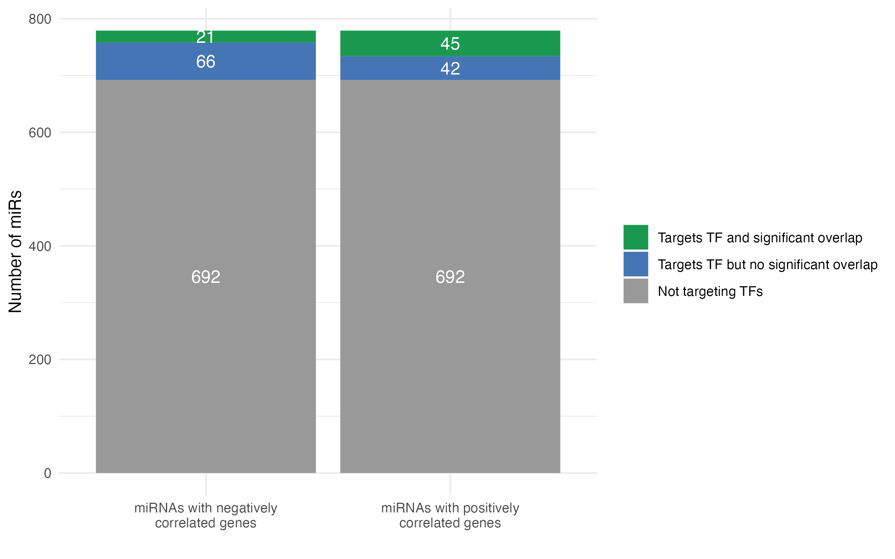
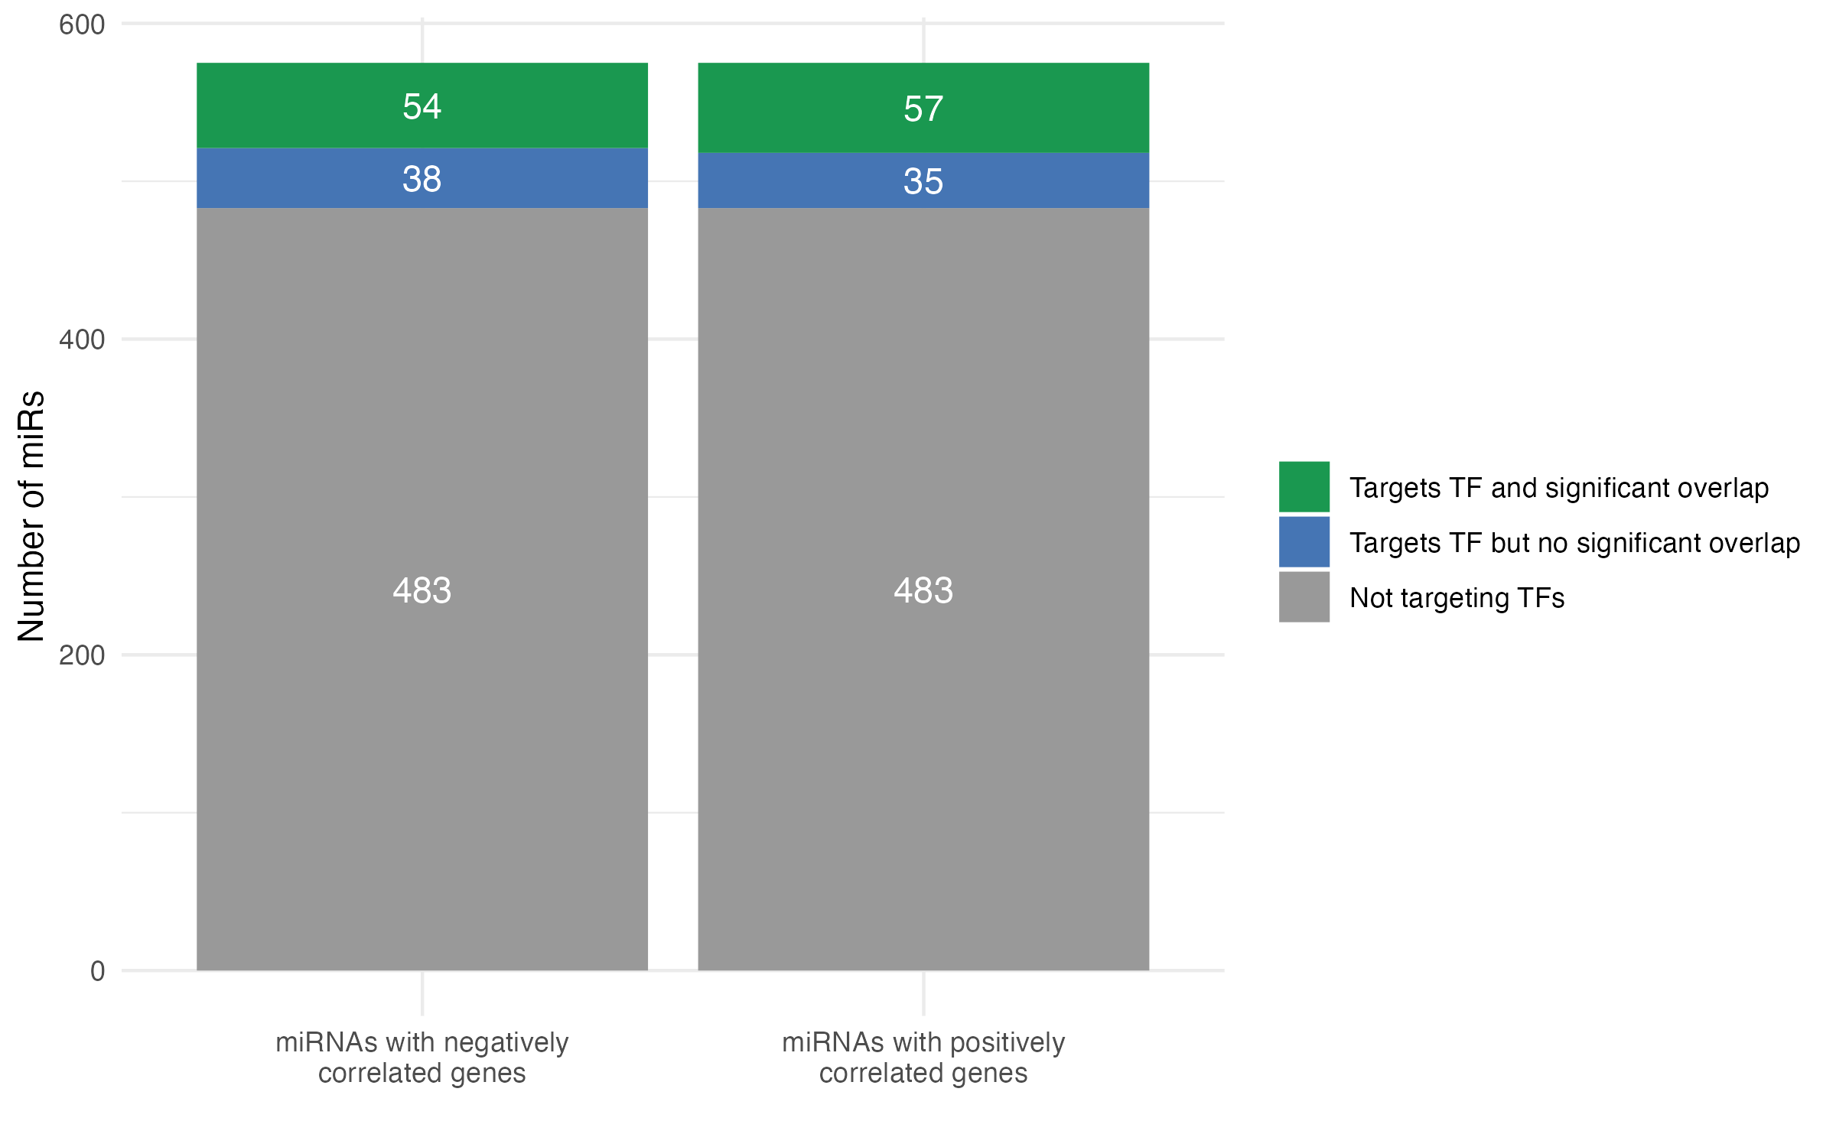
Figure 2. Distribution of miRNAs Based on Correlation with Genes and Overlap with TF Targets. Proportions of all miRNAs that do not target TFs (grey) or target TF with significant (green) of no significant (blue) overlap between miRNA-correlated and TF target genes for (A) melanoma SKCM samples, and (B) invasive breast carcinoma BRCA samples from The Cancer Genome Atlas.
Identifying potential TF-mediated miRNA effects guided by strong correlations
To identify potentially biologically relevant miR–TF relationships within our significant overlap results, we selected the top correlated gene from the overlapping gene set for each miR–TF pair, representing the strongest individual signal, and ranked pairs by correlation strength (descending order of absolute correlation coefficient) and enrichment significance (ascending order of FDR). In melanoma data, significant overlap (FDR < 0.05) between miR-correlated genes and TF targets was found for 44 miR-TF among positively correlated genes 15 miR-TF pairs among negatively correlated genes; in the breast cancer data, there were 388 and 300 miR-TF pairs respectively.
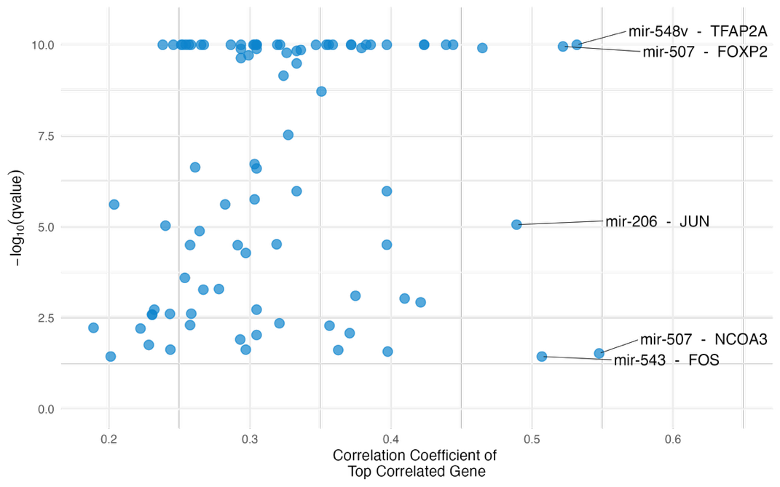

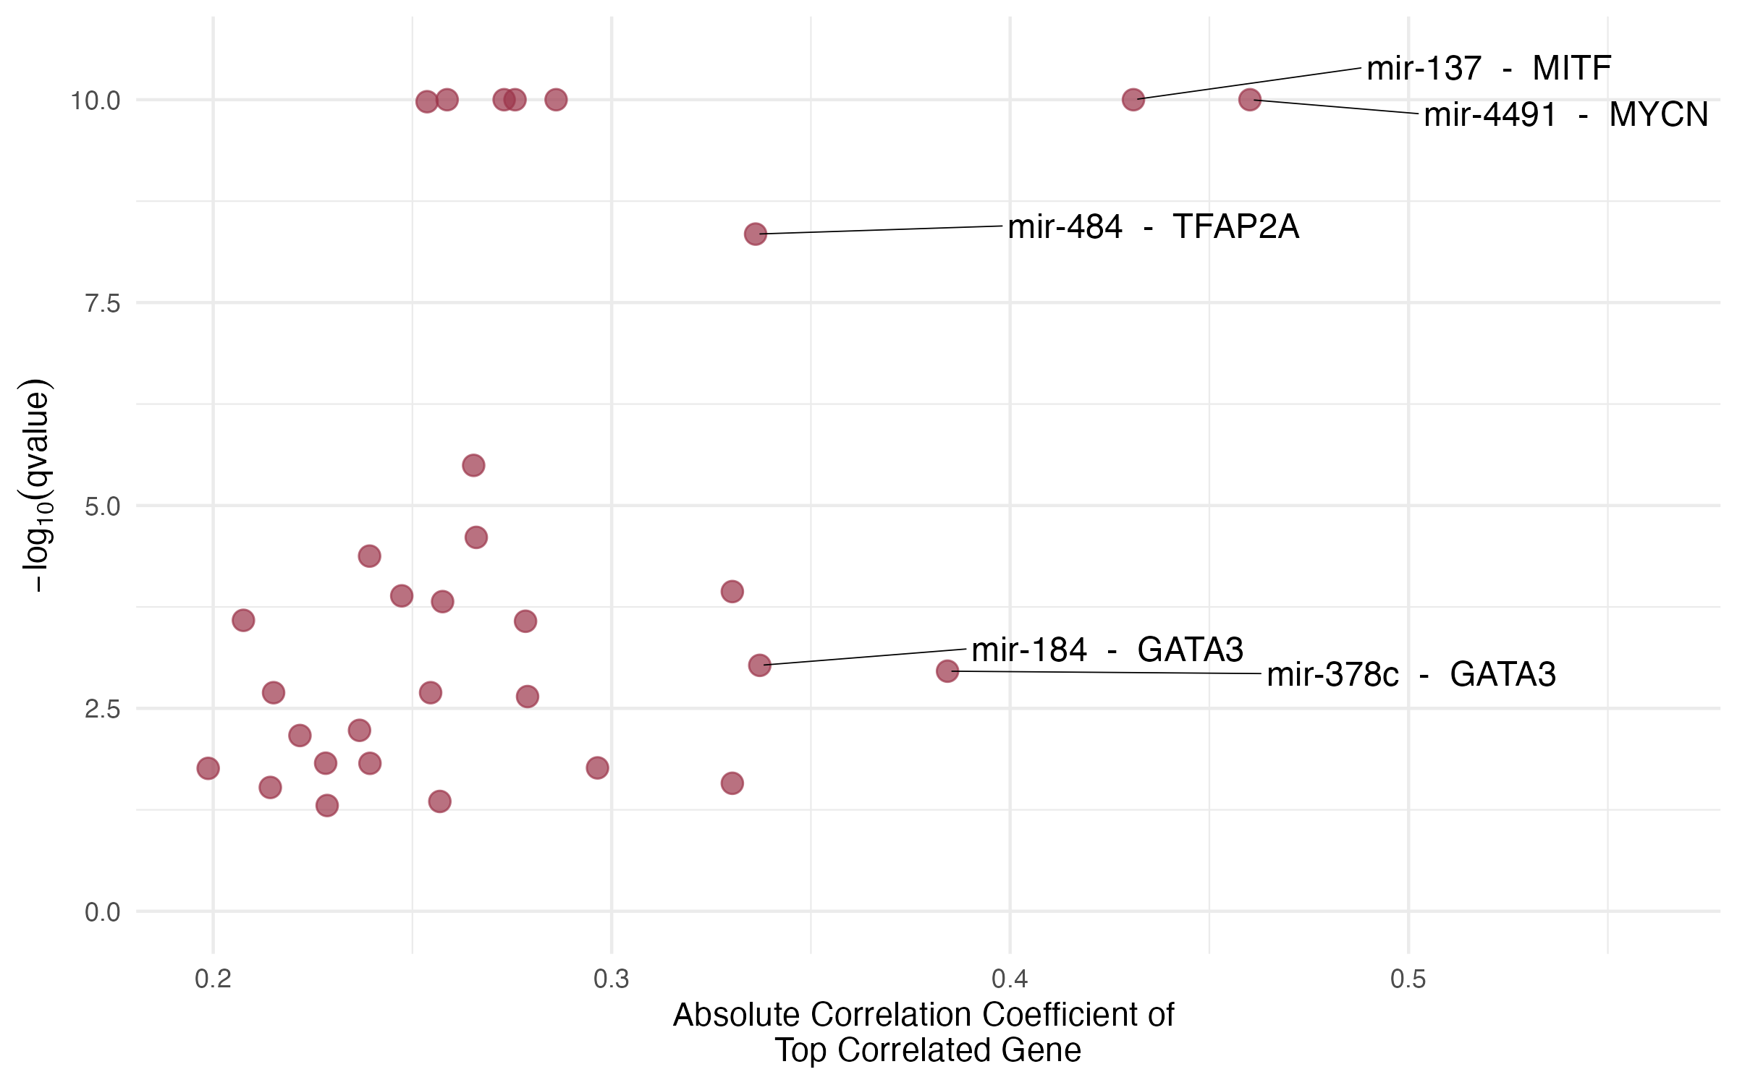
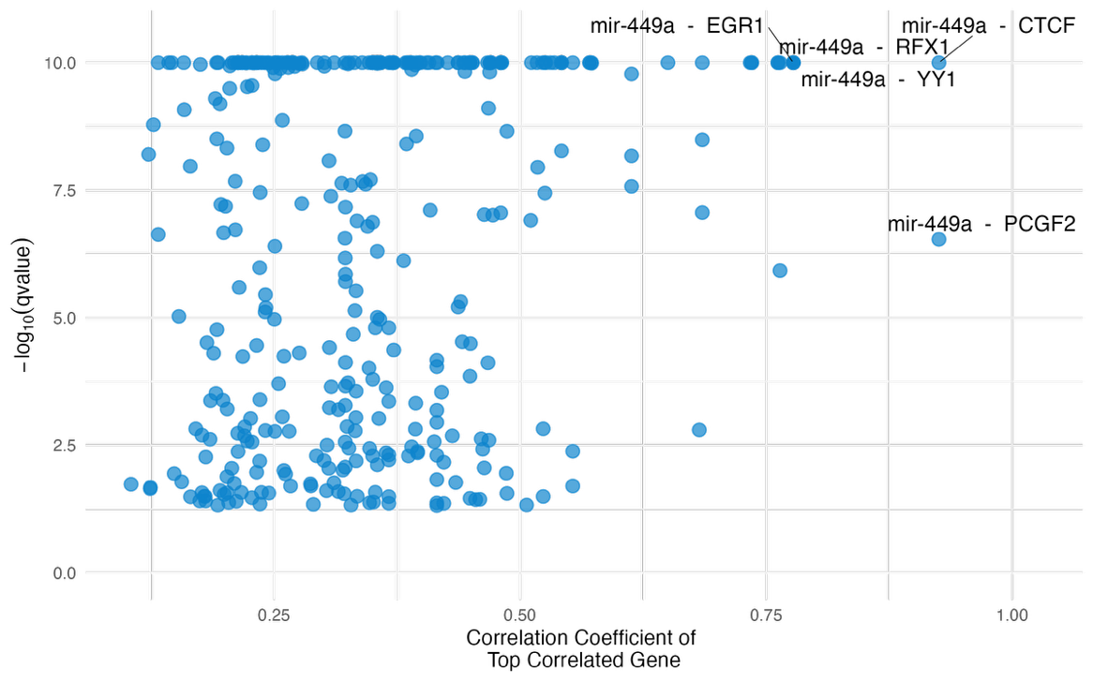
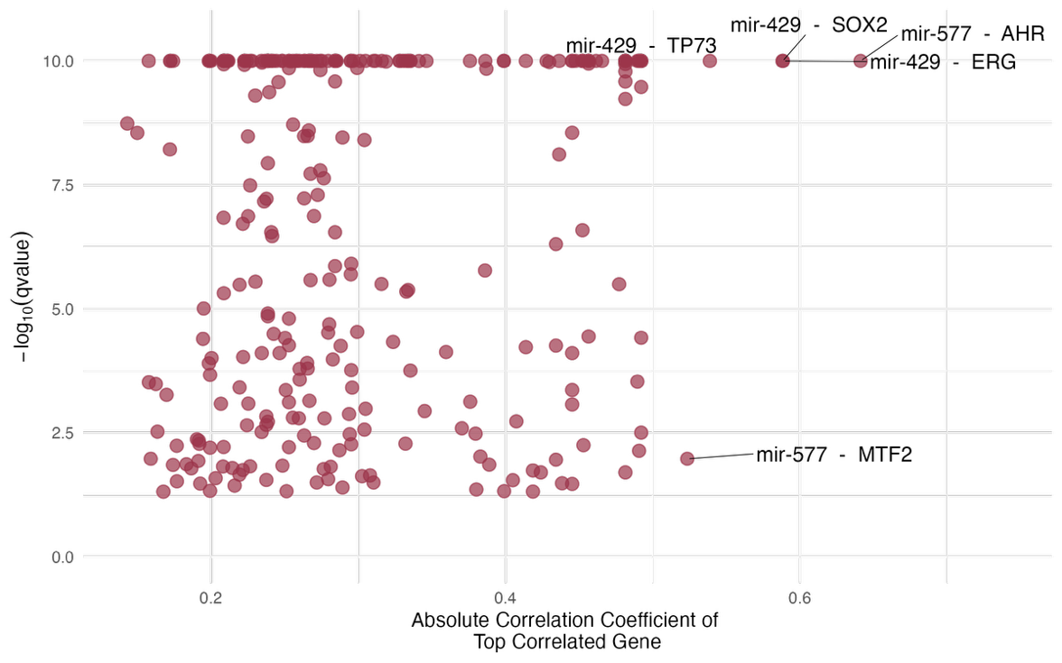

Figure 3. Top correlated gene for each miRNA–TF pair with significant overlap between TF targets and miRNA-correlated genes. (A) positively correlated genes for SKCM samples, (B) negatively correlated genes for SKCM samples, (C) positively correlated genes for BRCA samples, (D) negatively correlated genes for BRCA samples. The top five annotated pairs reflect miRNA–TF combinations with the strongest gene-level correlation and most significant target overlap, highlighting candidates most likely to represent biologically meaningful, TF-mediated regulatory relationships.

In SKCM, GATA3 appears in 2 of 5 top pairs in negatively correlated genes; in BRCA, miR-449a is present in all the top 5 pairs in positively correlated genes. In negatively correlated genes, miR-439 and miR-577 are present in the top 5 pairs; however, the TFs are varied in both cases – suggesting that these could be potential key molecules in melanoma and breast cancer
Experimentally validated miRNA-TF interactions
While all queries miR-TF interactions queried from multiMiR were experimentally validated, we further refined the results to include interactions validated by luciferase assay or western blot since MTIs are considered to have strong support when these techniques are used — there were 22 such pairs in SKCM and 98 in BRCA.
Among these 22 pairs in SKCM, for miRs with both positively and negatively correlated genes, 4 and 3 miR-TF pairs each showed a significant overlap with positively and negatively correlated genes respectively; for BRCA, among the 98 pairs, 18 and 17 miR-TF pairs each showed a significant overlap, respectively.
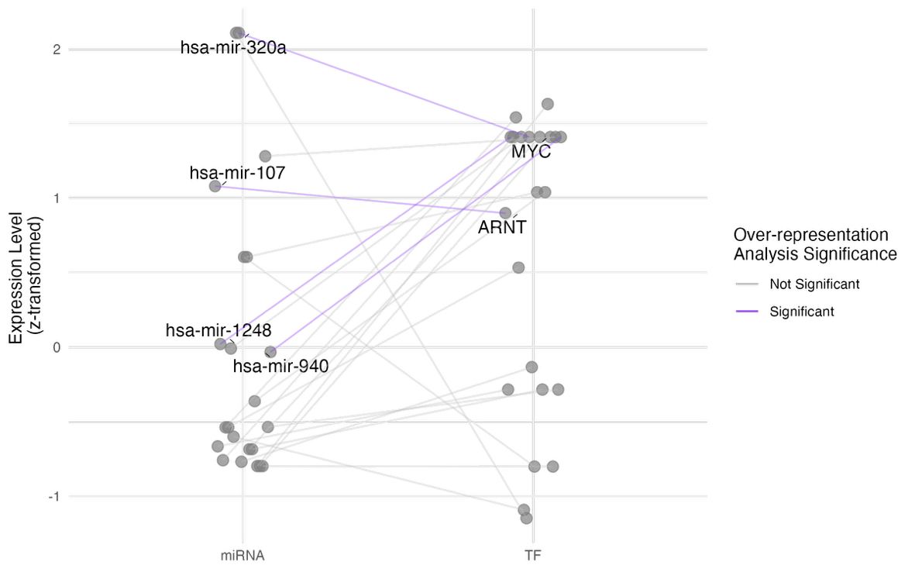
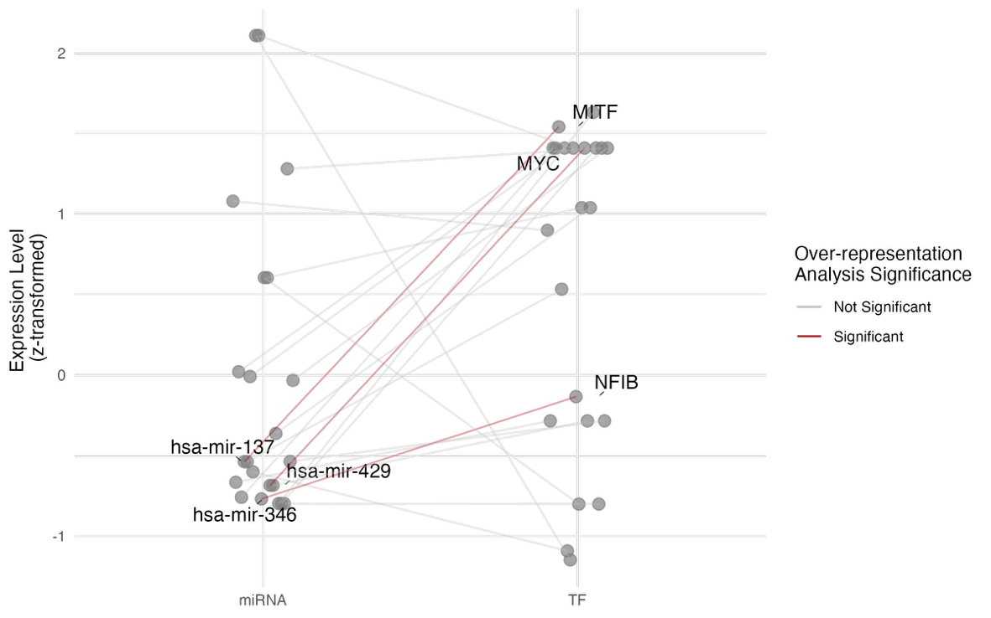

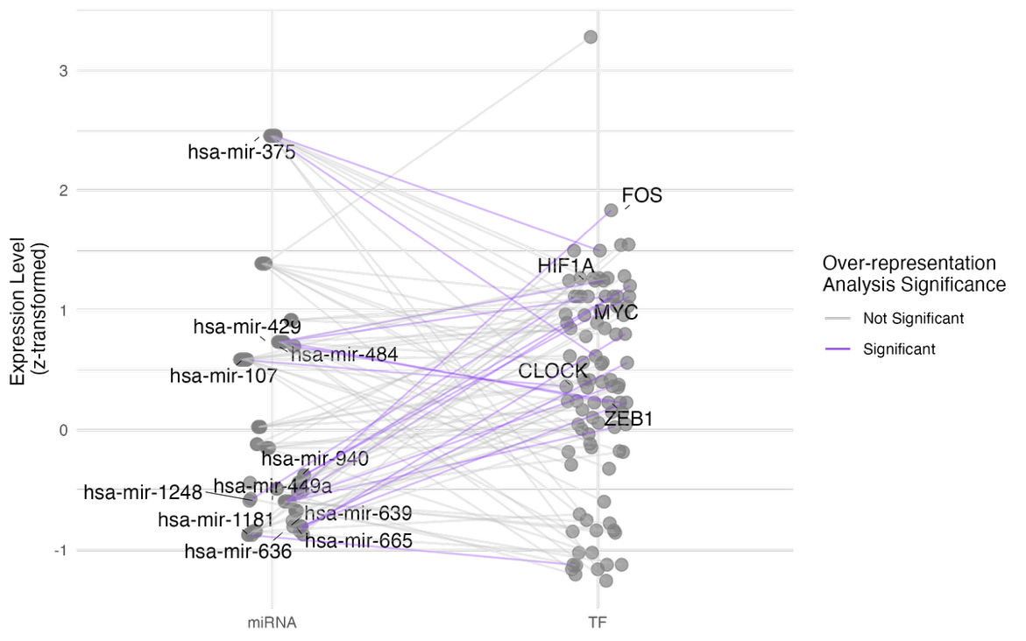
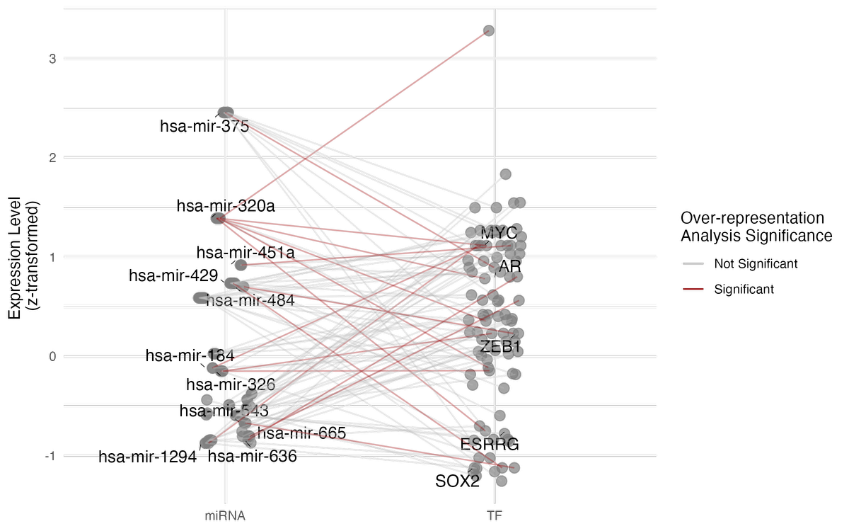
Figure 6. Interaction networks of miRNA–TF pairs with experimentally validated interactions. Each connection represents a miRNA–TF pair confirmed by luciferase or western blot assays, with node positions reflecting z-transformed expression levels of miRNAs and TFs. Line colour indicates whether the overlap between miRNA-correlated genes and TF-target genes was statistically significant (FDR < 0.05). This visualisation highlights the most confidently supported and biologically relevant miRNA–TF relationships driving potential indirect regulation (A) positively correlated genes for SKCM samples, (B) negatively correlated genes for SKCM samples, (C) positively correlated genes for BRCA samples, (D) negatively correlated genes for BRCA samples.

MYC appears in both positively and negatively correlated genes in SKCM, twice in the case positive correlations. MiR-107 appears in both cohorts in positively correlated gene interactions. In BRCA, TFs MYC and ZEB1 have the most number of significant interactions with miRs in both positively and negatively correlated cases (Figure 6).

DISCUSSION
MiRNAs regulate gene expression, and their dysregulation contributes to cancer. Traditional miRNA target identification relies on miRNA-mRNA correlations, overlooking indirect regulatory relationships, particularly via TFs. This study aimed to explore miRNA-TF-mRNA networks in melanoma and breast cancer, and identity significant miRNA-mRNA correlation pairs. By integrating known TFs and validated miRNA-TF interactions, we found that many miRNA-TF pairs showed significant overlap between miRNA-correlated genes and TF targets, and key miRs that not only have highly correlated genes but also do not target most of these genes in the corresponding overlapping sets, suggesting indirect TF actions. Notably, the regulatory relationships that were identified did not depend on absolute miRNA or TF abundance, implying that even moderately expressed miRNAs can exert significant effects if they target critical network nodes (such as master TFs in a network). This lack of strict dependence on expression level underscores that a miRNA’s impact in cancer is defined more by its network connectivity and interactions than by its sheer quantity. However, while miRNAs have distinct mRNA targets, this relationship is not always one-to-one. Instead, they participate in extensive, overlapping networks where cooperativity and redundancy — multiple miRNAs targeting shared genes or pathways — can obscure causal links in correlation-based approaches (PMID: 24875477). This complexity poses a challenge when inferring functional regulation purely from expression data and not supporting with direct experimental validation.

We highlight a few literature-supported examples that reinforce the biological relevance of key miR–TF interactions to cancer biology. MiR-449a, present in all top 5 miRNA–TF pairs with significant overlap between TF targets and miRNA’s negatively correlated genes in BRCA is downregulated in breast cancer and suppresses proliferation, migration, and metastasis by targeting PLAGL2 (PMID: 29653747).
Among experimentally validated interactions, miR-107–ARNT and miR-137–MITF were significant in SKCM, with miR-107 also appearing in BRCA. miR-107 has been shown to suppress melanoma and breast cancer progression (PMIDs: 32169117, 27813254), while ARNT downregulation promotes melanoma metastasis (PMID: 33446631). In BRCA, TFs MYC and ZEB1 have the most number of significant interactions with miRs in both positively and negatively correlated cases; both are well-established drivers of aggressive breast cancer phenotypes, linked to poor prognosis and contributing to tumour initiation, (PMID: 21779462, PMID: 28618162)."

While the role of miRNAs in regulating various aspects of cell biology, both normal and pathological, is well-established, translating these findings into clinical applications remains challenging, as intricate regulatory networks in cancer remain underexplored. More rigorous and comprehensive research is essential to deepen our understanding of their biological mechanisms in models that closely mimic physiological conditions. Bridging this gap requires thorough analyses of miRNA-TF-mRNA relationships, focusing on regulatory layers that may have been previously overlooked. By gaining a deeper understanding of these networks and genetic changes, we can uncover the underlying mechanisms of cancer biology more comprehensively.

REFERENCES
Abbas-Aghababazadeh, F., Li, Q., & Fridley, B. L. (2018). Comparison of normalization approaches for gene expression studies completed with high-throughput sequencing. PLoS One, 13(10), e0206312. https://doi.org/10.1371/journal.pone.0206312
Alexiou, A., Zisis, D., Kavakiotis, I., Miliotis, M., Koussounadis, A., Karagkouni, D., & Hatzigeorgiou, A. G. (2020). DIANA-mAP: Analyzing miRNA from Raw NGS Data to Quantification. Genes (Basel), 12(1). https://doi.org/10.3390/genes12010046
Andrews, M. C., Cursons, J., Hurley, D. G., Anaka, M., Cebon, J. S., Behren, A., & Crampin, E. J. (2016). Systems analysis identifies miR-29b regulation of invasiveness in melanoma. Mol Cancer, 15(1), 72. https://doi.org/10.1186/s12943-016-0554-y
Arora, S., Rana, R., Chhabra, A., Jaiswal, A., & Rani, V. (2013). miRNA-transcription factor interactions: a combinatorial regulation of gene expression. Mol Genet Genomics, 288(3-4), 77-87. https://doi.org/10.1007/s00438-013-0734-z
Bairoch, A. (2018). The Cellosaurus, a Cell-Line Knowledge Resource. J Biomol Tech, 29(2), 25-38. https://doi.org/10.7171/jbt.18-2902-002
Bartel, D. P. (2004). MicroRNAs: genomics, biogenesis, mechanism, and function. Cell, 116(2), 281-297. https://doi.org/10.1016/s0092-8674(04)00045-5
Boyle, E. I., Weng, S., Gollub, J., Jin, H., Botstein, D., Cherry, J. M., & Sherlock, G. (2004). GO::TermFinder--open source software for accessing Gene Ontology information and finding significantly enriched Gene Ontology terms associated with a list of genes. Bioinformatics, 20(18), 3710-3715. https://doi.org/10.1093/bioinformatics/bth456
Catalanotto, C., Cogoni, C., & Zardo, G. (2016). MicroRNA in Control of Gene Expression: An Overview of Nuclear Functions. Int J Mol Sci, 17(10). https://doi.org/10.3390/ijms17101712
Chen, K., & Rajewsky, N. (2007). The evolution of gene regulation by transcription factors and microRNAs. Nat Rev Genet, 8(2), 93-103. https://doi.org/10.1038/nrg1990
Chi, S. W., Zang, J. B., Mele, A., & Darnell, R. B. (2009). Argonaute HITS-CLIP decodes microRNA-mRNA interaction maps. Nature, 460(7254), 479-486. https://doi.org/10.1038/nature08170
Colaprico, A., Silva, T. C., Olsen, C., Garofano, L., Cava, C., Garolini, D., Sabedot, T. S., Malta, T. M., Pagnotta, S. M., Castiglioni, I., Ceccarelli, M., Bontempi, G., & Noushmehr, H. (2016). TCGAbiolinks: an R/Bioconductor package for integrative analysis of TCGA data. Nucleic Acids Res, 44(8), e71. https://doi.org/10.1093/nar/gkv1507
Cui, Q., Yu, Z., Pan, Y., Purisima, E. O., & Wang, E. (2007). MicroRNAs preferentially target the genes with high transcriptional regulation complexity. Biochem Biophys Res Commun, 352(3), 733-738. https://doi.org/10.1016/j.bbrc.2006.11.080
Fattore, L., Costantini, S., Malpicci, D., Ruggiero, C. F., Ascierto, P. A., Croce, C. M., Mancini, R., & Ciliberto, G. (2017). MicroRNAs in melanoma development and resistance to target therapy. Oncotarget, 8(13), 22262-22278. https://doi.org/10.18632/oncotarget.14763
Flynt, A. S., & Lai, E. C. (2008). Biological principles of microRNA-mediated regulation: shared themes amid diversity. Nat Rev Genet, 9(11), 831-842. https://doi.org/10.1038/nrg2455
Friedman, R. C., Farh, K. K., Burge, C. B., & Bartel, D. P. (2009). Most mammalian mRNAs are conserved targets of microRNAs. Genome Res, 19(1), 92-105. https://doi.org/10.1101/gr.082701.108
Guzzi, P. H., Di Martino, M. T., Tagliaferri, P., Tassone, P., & Cannataro, M. (2015). Analysis of miRNA, mRNA, and TF interactions through network-based methods. EURASIP J Bioinform Syst Biol, 2015, 4. https://doi.org/10.1186/s13637-015-0023-8
Harrell Jr, F. (2023). Hmisc: Harrell Miscellaneous. R package version 5.1-2. https://hbiostat.org/R/Hmisc/
Hofacker, I. L. (2007). How microRNAs choose their targets. Nat Genet, 39(10), 1191-1192. https://doi.org/10.1038/ng1007-1191
Hsu, S. D., Lin, F. M., Wu, W. Y., Liang, C., Huang, W. C., Chan, W. L., Tsai, W. T., Chen, G. Z., Lee, C. J., Chiu, C. M., Chien, C. H., Wu, M. C., Huang, C. Y., Tsou, A. P., & Huang, H. D. (2011). miRTarBase: a database curates experimentally validated microRNA-target interactions. Nucleic Acids Res, 39(Database issue), D163-169. https://doi.org/10.1093/nar/gkq1107
Jia, Y., Liu, J., GQ., W., & ZF., S. (2022). miR-484: A Potential Biomarker in Health and Disease. https://doi.org/10.3389/fonc.2022.830420
John, B., Enright, A. J., Aravin, A., Tuschl, T., Sander, C., & Marks, D. S. (2004). Human MicroRNA targets. PLoS Biol, 2(11), e363. https://doi.org/10.1371/journal.pbio.0020363
Joung, J. G., Hwang, K. B., Nam, J. W., Kim, S. J., & Zhang, B. T. (2007). Discovery of microRNA-mRNA modules via population-based probabilistic learning. Bioinformatics, 23(9), 1141-1147. https://doi.org/10.1093/bioinformatics/btm045
Karp, P. D., Midford, P. E., Caspi, R., & Khodursky, A. (2021). Pathway size matters: the influence of pathway granularity on over-representation (enrichment analysis) statistics. BMC Genomics, 22(1), 191. https://doi.org/10.1186/s12864-021-07502-8
Kawakami, A., & Fisher, D. E. (2017). The master role of microphthalmia-associated transcription factor in melanocyte and melanoma biology. Lab Invest, 97(6), 649-656. https://doi.org/10.1038/labinvest.2017.9
Kuhn, D. E., Martin, M. M., Feldman, D. S., Terry, A. V., Jr., Nuovo, G. J., & Elton, T. S. (2008). Experimental validation of miRNA targets. Methods, 44(1), 47-54. https://doi.org/10.1016/j.ymeth.2007.09.005
Lambert, S. A., Jolma, A., Campitelli, L. F., Das, P. K., Yin, Y., Albu, M., Chen, X., Taipale, J., Hughes, T. R., & Weirauch, M. T. (2018). The Human Transcription Factors. Cell, 172(4), 650-665. https://doi.org/10.1016/j.cell.2018.01.029
Law, C. W., Chen, Y., Shi, W., & Smyth, G. K. (2014). voom: Precision weights unlock linear model analysis tools for RNA-seq read counts. Genome Biol, 15(2), R29. https://doi.org/10.1186/gb-2014-15-2-r29
Le, T. D., Liu, L., Tsykin, A., Goodall, G. J., Liu, B., Sun, B. Y., & Li, J. (2013). Inferring microRNA-mRNA causal regulatory relationships from expression data. Bioinformatics, 29(6), 765-771. https://doi.org/10.1093/bioinformatics/btt048
Lewis, B. P., Shih, I. H., Jones-Rhoades, M. W., Bartel, D. P., & Burge, C. B. (2003). Prediction of mammalian microRNA targets. Cell, 115(7), 787-798. https://doi.org/10.1016/s0092-8674(03)01018-3
Li, B., & Dewey, C. N. (2011). RSEM: accurate transcript quantification from RNA-Seq data with or without a reference genome. BMC Bioinformatics, 12, 323. https://doi.org/10.1186/1471-2105-12-323
Li, N. (2016). Low Expression of Mir-137 Predicts Poor Prognosis in Cutaneous Melanoma Patients. Med Sci Monit, 22, 140-144. https://doi.org/10.12659/msm.895207
Liu, B., Li, J., & Cairns, M. J. (2014). Identifying miRNAs, targets and functions. Brief Bioinform, 15(1), 1-19. https://doi.org/10.1093/bib/bbs075
Liu, W., & Wang, X. (2019). Prediction of functional microRNA targets by integrative modeling of microRNA binding and target expression data. Genome Biol, 20(1), 18. https://doi.org/10.1186/s13059-019-1629-z
Lu, J., Getz, G., Miska, E. A., Alvarez-Saavedra, E., Lamb, J., Peck, D., Sweet-Cordero, A., Ebert, B. L., Mak, R. H., Ferrando, A. A., Downing, J. R., Jacks, T., Horvitz, H. R., & Golub, T. R. (2005). MicroRNA expression profiles classify human cancers. Nature, 435(7043), 834-838. https://doi.org/10.1038/nature03702
Meyer, S. U., Pfaffl, M. W., & Ulbrich, S. E. (2010). Normalization strategies for microRNA profiling experiments: a 'normal' way to a hidden layer of complexity? Biotechnol Lett, 32(12), 1777-1788. https://doi.org/10.1007/s10529-010-0380-z
Michael, M. Z., SM, O. C., van Holst Pellekaan, N. G., Young, G. P., & James, R. J. (2003). Reduced accumulation of specific microRNAs in colorectal neoplasia. Mol Cancer Res, 1(12), 882-891. https://www.ncbi.nlm.nih.gov/pubmed/14573789
Park, P. J. (2009). ChIP-seq: advantages and challenges of a maturing technology. Nat Rev Genet, 10(10), 669-680. https://doi.org/10.1038/nrg2641
Peres, J., Kwesi-Maliepaard, E. M., Rambow, F., Larue, L., & Prince, S. (2017). The tumour suppressor, miR-137, inhibits malignant melanoma migration by targetting the TBX3 transcription factor. Cancer Lett, 405, 111-119. https://doi.org/10.1016/j.canlet.2017.07.018
Pritchard, C. C., Cheng, H. H., & Tewari, M. (2012). MicroRNA profiling: approaches and considerations. Nat Rev Genet, 13(5), 358-369. https://doi.org/10.1038/nrg3198
Ru, Y., Kechris, K. J., Tabakoff, B., Hoffman, P., Radcliffe, R. A., Bowler, R., Mahaffey, S., Rossi, S., Calin, G. A., Bemis, L., & Theodorescu, D. (2014). The multiMiR R package and database: integration of microRNA-target interactions along with their disease and drug associations. Nucleic Acids Res, 42(17), e133. https://doi.org/10.1093/nar/gku631
Sa, A. C. C., Sadee, W., & Johnson, J. A. (2018). Whole Transcriptome Profiling: An RNA-Seq Primer and Implications for Pharmacogenomics Research. Clin Transl Sci, 11(2), 153-161. https://doi.org/10.1111/cts.12511
Schmittgen, T. D., Lee, E. J., Jiang, J., Sarkar, A., Yang, L., Elton, T. S., & Chen, C. (2008). Real-time PCR quantification of precursor and mature microRNA. Methods, 44(1), 31-38. https://doi.org/10.1016/j.ymeth.2007.09.006
Sevignani, C., Calin, G. A., Siracusa, L. D., & Croce, C. M. (2006). Mammalian microRNAs: a small world for fine-tuning gene expression. Mamm Genome, 17(3), 189-202. https://doi.org/10.1007/s00335-005-0066-3
Siska, C., & Kechris, K. (2017). Differential correlation for sequencing data. BMC Res Notes, 10(1), 54. https://doi.org/10.1186/s13104-016-2331-9
Suter, D. M. (2020). Transcription Factors and DNA Play Hide and Seek. Trends Cell Biol, 30(6), 491-500. https://doi.org/10.1016/j.tcb.2020.03.003
Thomson, D. W., Bracken, C. P., & Goodall, G. J. (2011). Experimental strategies for microRNA target identification. Nucleic Acids Res, 39(16), 6845-6853. https://doi.org/10.1093/nar/gkr330
Varrone, F., & Caputo, E. (2020). The miRNAs Role in Melanoma and in Its Resistance to Therapy. Int J Mol Sci, 21(3). https://doi.org/10.3390/ijms21030878
Vishnoi, K., Viswakarma, N., Rana, A., & Rana, B. (2020). Transcription Factors in Cancer Development and Therapy. Cancers (Basel), 12(8). https://doi.org/10.3390/cancers12082296
Wang, G., Wang, F., Huang, Q., Li, Y., Liu, Y., & Wang, Y. (2015). Understanding Transcription Factor Regulation by Integrating Gene Expression and DNase I Hypersensitive Sites. Biomed Res Int, 2015, 757530. https://doi.org/10.1155/2015/757530
Wong, G. L., Manore, S. G., Doheny, D. L., & Lo, H. W. (2022). STAT family of transcription factors in breast cancer: Pathogenesis and therapeutic opportunities and challenges. Semin Cancer Biol, 86(Pt 3), 84-106. https://doi.org/10.1016/j.semcancer.2022.08.003
Wu, T., Hu, E., Xu, S., Chen, M., Guo, P., Dai, Z., Feng, T., Zhou, L., Tang, W., Zhan, L., Fu, X., Liu, S., Bo, X., & Yu, G. (2021). clusterProfiler 4.0: A universal enrichment tool for interpreting omics data. Innovation (Camb), 2(3), 100141. https://doi.org/10.1016/j.xinn.2021.100141
Xiao, F., Zuo, Z., Cai, G., Kang, S., Gao, X., & Li, T. (2009). miRecords: an integrated resource for microRNA-target interactions. Nucleic Acids Res, 37(Database issue), D105-110. https://doi.org/10.1093/nar/gkn851
Zhao, Q., Liu, H., Yao, C., Shuai, J., & Sun, X. (2016). Effect of Dynamic Interaction between microRNA and Transcription Factor on Gene Expression. Biomed Res Int, 2016, 2676282. https://doi.org/10.1155/2016/2676282
Zhao, S., Ye, Z., & Stanton, R. (2020). Misuse of RPKM or TPM normalization when comparing across samples and sequencing protocols. RNA, 26(8), 903-909. https://doi.org/10.1261/rna.074922.120
Zou, Z., Ohta, T., Miura, F., & Oki, S. (2022). ChIP-Atlas 2021 update: a data-mining suite for exploring epigenomic landscapes by fully integrating ChIP-seq, ATAC-seq and Bisulfite-seq data. Nucleic Acids Res, 50(W1), W175-W182. https://doi.org/10.1093/nar/gkac199

