Bitcoin Market Sentiment & Trader Performance Analysis
An analysis of Hyperliquid trading behavior across Fear & Greed regimes

1. Executive Summary
This analysis merges 211,224 Hyperliquid trade records from 32 accounts across 246 assets with the daily Bitcoin Fear & Greed Index to test whether market sentiment is associated with trader performance. Trades were matched to the sentiment classification in effect on their execution date, then aggregated at both the daily-account and individual-trade level.
The headline finding is that trader outcomes are not uniform across sentiment regimes. Win rate and average return per trade were both highest during Extreme Greed (89.2% win rate, 7.67% average return) and lowest during Extreme Fear (76.2% win rate, 0.89% average return). A Kruskal-Wallis test confirms these differences in trade PnL across sentiment classes are statistically significant (p < 0.0001, H = 730.3). Position sizing also varies by regime: traders in this dataset took smaller average positions during Extreme Greed ($2,780) than during Fear ($8,041), suggesting the strongest results come with more selective, disciplined sizing rather than larger bets.

2. Methodology

2.1 Datasets
- Bitcoin Fear & Greed Index — daily sentiment classification (Extreme Fear, Fear, Neutral, Greed, Extreme Greed) and numeric score (0-100).
- Hyperliquid historical trade data — 211,224 individual fills across 32 accounts and 246 coins, covering May 2023 to May 2025, including execution price, size, side, direction, and closed PnL.

2.2 Data Preparation
- Parsed trade timestamps and derived a calendar date field to join against the daily sentiment index.
- Left-joined trades to sentiment on date; only 6 of 211,224 rows (<0.01%) had no matching sentiment record and were excluded from sentiment-conditioned analysis.
- Split analysis into two levels: (a) trade-level, restricted to fills with non-zero Closed PnL (104,408 trades) to isolate realized outcomes, and (b) daily account-level, aggregating all fills per account per day regardless of PnL.

2.3 Statistical Testing
A Kruskal-Wallis H-test (non-parametric one-way ANOVA) was used to test whether the distribution of per-trade Closed PnL differs across the five sentiment classes, since PnL is heavily right-skewed and violates normality assumptions required for a standard ANOVA.

3. Findings

3.1 Returns and Win Rate by Sentiment
Average return per trade (Closed PnL as a percentage of position size) rises from 0.89% in Extreme Fear to 7.67% in Extreme Greed, with Fear and Greed sitting in between. Win rate follows a similar, though not perfectly monotonic, pattern.
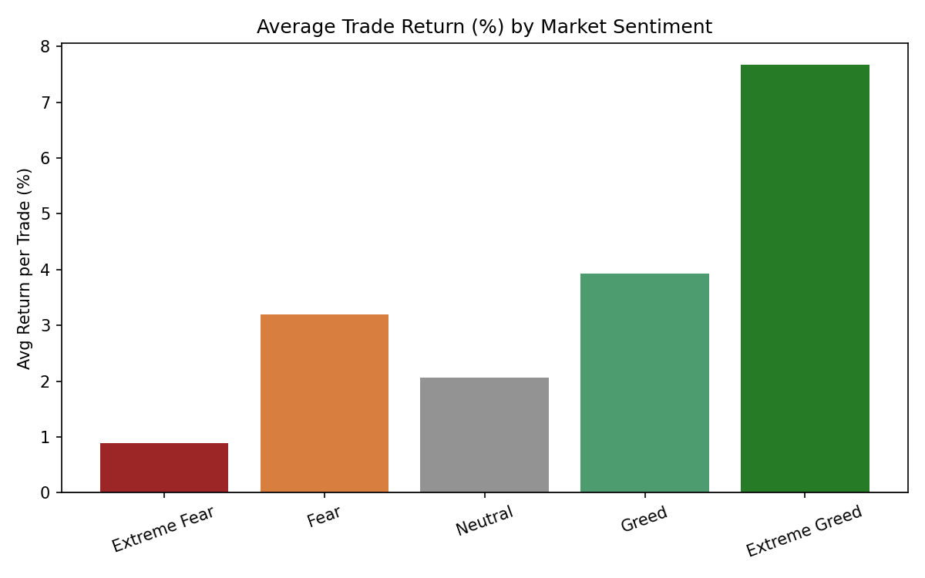
Figure 1. Average trade return (%) by market sentiment regime.
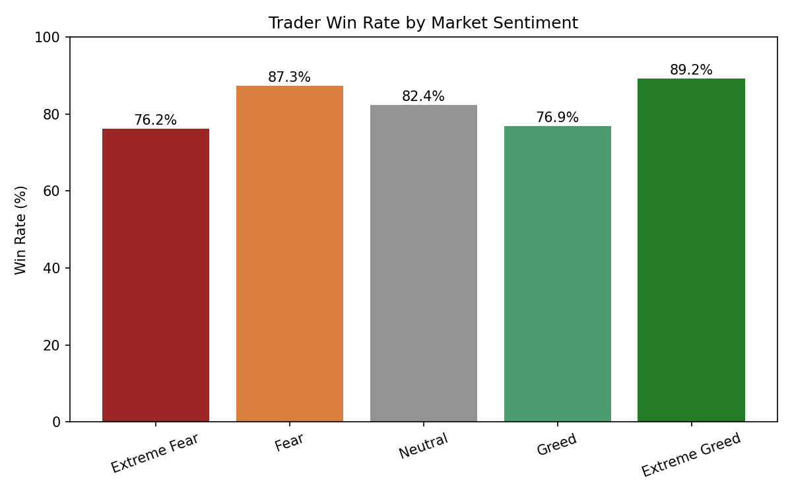
Figure 2. Trader win rate (%) by market sentiment regime.
Sentiment | Avg Return/Trade | Win Rate | Avg Trade Size | Trades (n)
Extreme Fear | 0.89% | 76.2% | $5,468 | 10,406
Fear | 3.20% | 87.3% | $8,041 | 29,808
Neutral | 2.06% | 82.4% | $5,556 | 18,159
Greed | 3.93% | 76.9% | $5,439 | 25,176
Extreme Greed | 7.67% | 89.2% | $2,780 | 20,853

3.2 Distribution of Outcomes
Looking beyond averages, the boxplot below (clipped at ±$2,000 per trade for readability) shows that Extreme Greed and Fear both carry a wider spread of outcomes than Neutral or Greed, meaning higher average returns in those regimes come with higher variance, not just a shifted average.
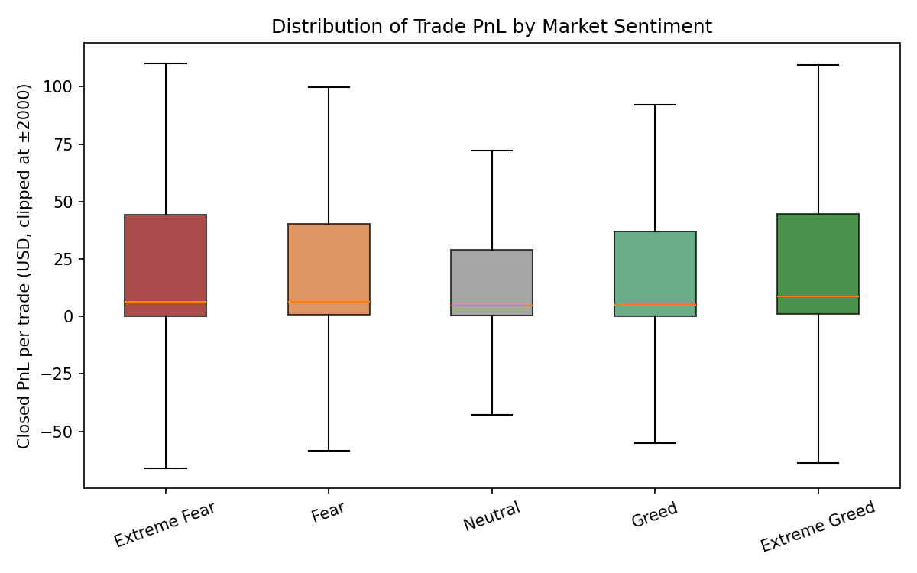
Figure 3. Distribution of per-trade Closed PnL by sentiment (outliers beyond ±$2,000 excluded from view only).

3.3 Position Sizing Behavior
Average position size is smallest during Extreme Greed and largest during Fear. Combined with the return and win-rate results above, this suggests the best-performing trades in this dataset are not driven by traders 'sizing up' when sentiment is euphoric — if anything, the opposite pattern holds, consistent with more selective position-taking during high-sentiment periods.
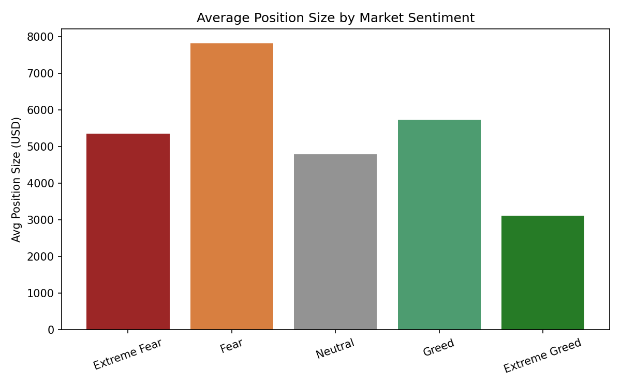
Figure 4. Average position size (USD) by market sentiment regime.

3.4 Sentiment and Aggregate PnL Over Time
Overlaying the daily Fear & Greed Index against daily total realized PnL across all accounts shows that large PnL days are not confined to any single sentiment level; both large gains and drawdowns occur across the sentiment spectrum, though the largest positive spikes cluster in periods where the index is trending upward out of Fear toward Greed.
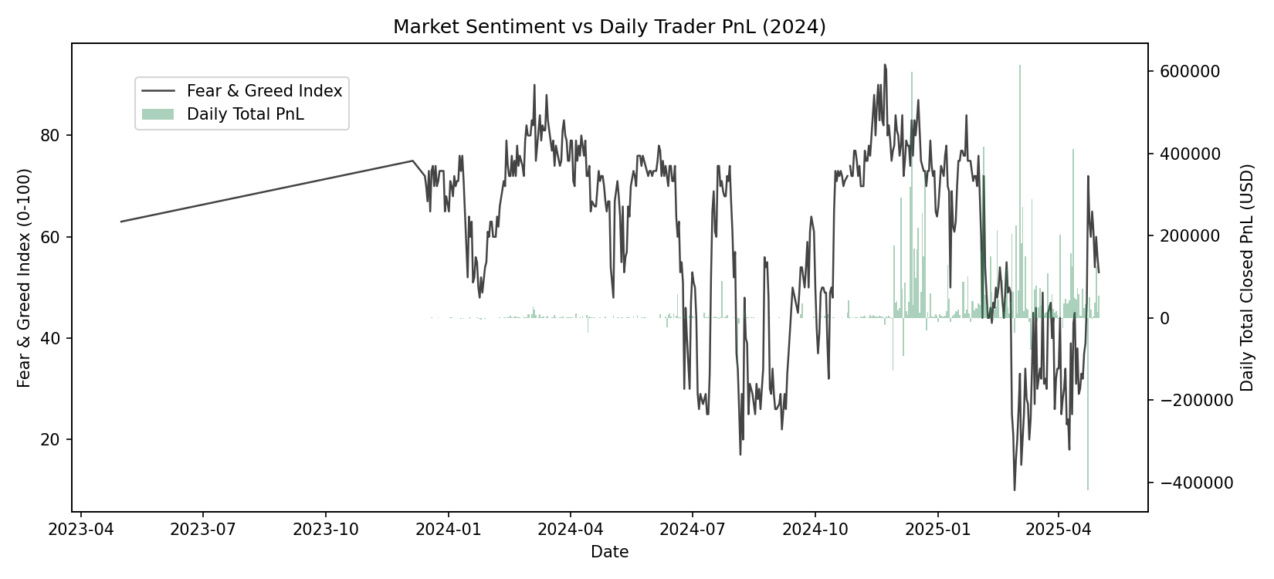
Figure 5. Fear & Greed Index (line, left axis) vs. daily total Closed PnL across all accounts (bars, right axis).

3.5 Directional Bias
Sell-side (short-biased) activity dominates across every sentiment regime in this dataset, at roughly 68-70% of trades, except during Greed, where buy-side activity rises to 45% of trades — the most balanced of any regime. This implies traders in this sample were incrementally more willing to go long specifically as sentiment approached (but had not yet reached) euphoric levels.

4. Statistical Significance
The Kruskal-Wallis test rejects the null hypothesis that per-trade PnL is drawn from the same distribution across all five sentiment classes (H = 730.33, p < 0.0001). This confirms the differences observed above are very unlikely to be due to chance, though the test does not indicate which specific pairs of classes differ, nor does it establish causation between sentiment and performance — both could be driven by a shared underlying factor such as broader trend strength.

5. Insights & Strategy Implications
- Extreme Greed is where this cohort of traders performed best on both win rate and return, but with smaller average size — arguing for selective conviction bets rather than broad exposure increases during euphoric markets.
- Fear regimes show the largest average position sizes but middling returns, suggesting a risk to watch: sizing up during fear does not, in this dataset, correspond to proportionally better outcomes.
- The short bias present in every regime except Greed suggests this trader cohort is structurally more comfortable shorting; a strategy tilting further short-heavy could align with this cohort's demonstrated edge, but this should be validated per-account rather than assumed portfolio-wide, since 32 accounts can mask individual variation.
- Because sentiment and trend direction are correlated (Greed often follows a rally already in progress), a natural next step is to test whether these effects hold after controlling for concurrent price trend, to separate a genuine sentiment effect from a momentum effect.

6. Limitations
- Sentiment is a single daily index applied uniformly to all trades on that date; it does not capture intraday sentiment shifts.
- The dataset spans 32 accounts only, so results reflect this specific cohort's behavior and may not generalize to the broader market.
- Kruskal-Wallis establishes significance across groups but not causation, nor which specific regime pairs differ; pairwise post-hoc tests (e.g., Dunn's test) would sharpen this further.
- PnL figures are realized (closed) PnL only; open positions at the end of the sample are not reflected.

