**ASSIGNMENT (SEO)**

**Ques 1) What is SEO and explain the importance of SEO?**

**Solution:-** SEO stands for search engine optimization.It is a set of processes aimed at improving a website’s visibility in search engines, like Google, with the goal of getting more organic traffic.

SEO is about fulfilling users’ search needs by creating relevant, high-quality content and providing the best possible user experience.

SEO typically involves:

* Keyword research
* Content creation and optimization
* Technical optimization
* Link building

SEO is important for brands as it’s a highly effective way to improve your brand’s visibility through search, drive more traffic to your website, establish your brand as a trusted authority in your industry, sustainably and reliably grow your business, and much more.

Factors contributes to the importance of SEO:-

* **Increase visibility:** SEO helps businesses rank higher in search results, which can lead to more potential customers visiting their site.
* **Generate leads:** SEO can cost-effectively generate leads for businesses.
* **Build trust:** Websites that rank well are generally considered more trustworthy and authoritative. This can lead to brand loyalty.
* **Improve user experience**: A good user experience on a website can help businesses sell their products or services and get their messages heard.
* **Improve brand awareness:** SEO can help businesses increase brand awareness.
* **Optimize for mobile users:** SEO can help businesses optimize their websites for mobile users.

**Ques 2) Create an HTML document with appropriate <title> and <meta> tags for SEO optimization. Ensure the title is descriptive and the meta description is concise.**

**Solution:-**

**<!DOCTYPE html>**

**<html lang="en">**

**<head>**

**<meta charset="UTF-8" />**

**<meta name="viewport" content="width=device-width, initial-scale=1.0" />**

**<title>Home Page - Essay Writing</title>**

**<meta name="title" content="Home Page - Introduction to ME" />**

**<meta name="description"**

**content="My name is Mansi Srivastava. I am from Bareilly, Uttar Pradesh. I have done various web development projects during my course and have a good knowledge of C,C++,C#,HTML,CSS,JavaScript and MS SQL.My strength is that I am a self-motivated person. My weakness is that I am a little bit sentimental." />**

**<meta name="author" content="Mansi Srivastava" />**

**<meta name="robots" content="index, follow, max-image-preview:large, max-snippet:-1, max-video-preview:-1" />**

**<meta http-equiv="X-UA-Compatible" content="ie=edge" />**

**<link rel="stylesheet" href="styles.css" />**

**</head>**

**<body>**

**<h2>My Introduction</h2>**

**<p>**

**My name is Mansi Srivastava. I am from Bareilly, Uttar Pradesh.**

**I have recently completed my MCA from Abdul Kalam Techincal University, Lucknow.Before that, I have done BCA**

**from Rakshpal Bahadur Management Institute, Bareilly.**

**</p>**

**<p>**

**Now, I am looking for an opportunity to bring my knowledge to the table and use it for the success of the**

**organization.**

**I have done various web development projects during my course and have a good knowledge of programming languages**

**like C,C++,C#,HTML,CSS,JavaScript and MS SQL.**

**</p>**

**<p>**

**My strength is that I am a self-motivated person. My weakness is that I am a little bit sentimental. My hobbies**

**are cooking and crafting.**

**I am sure that my technical skills, enthusiasm, and passion for learning new technologies will make me the best**

**person for this vacant position.**

**</p>**

**</body>**

**</html>**

**OUTPUT :-**

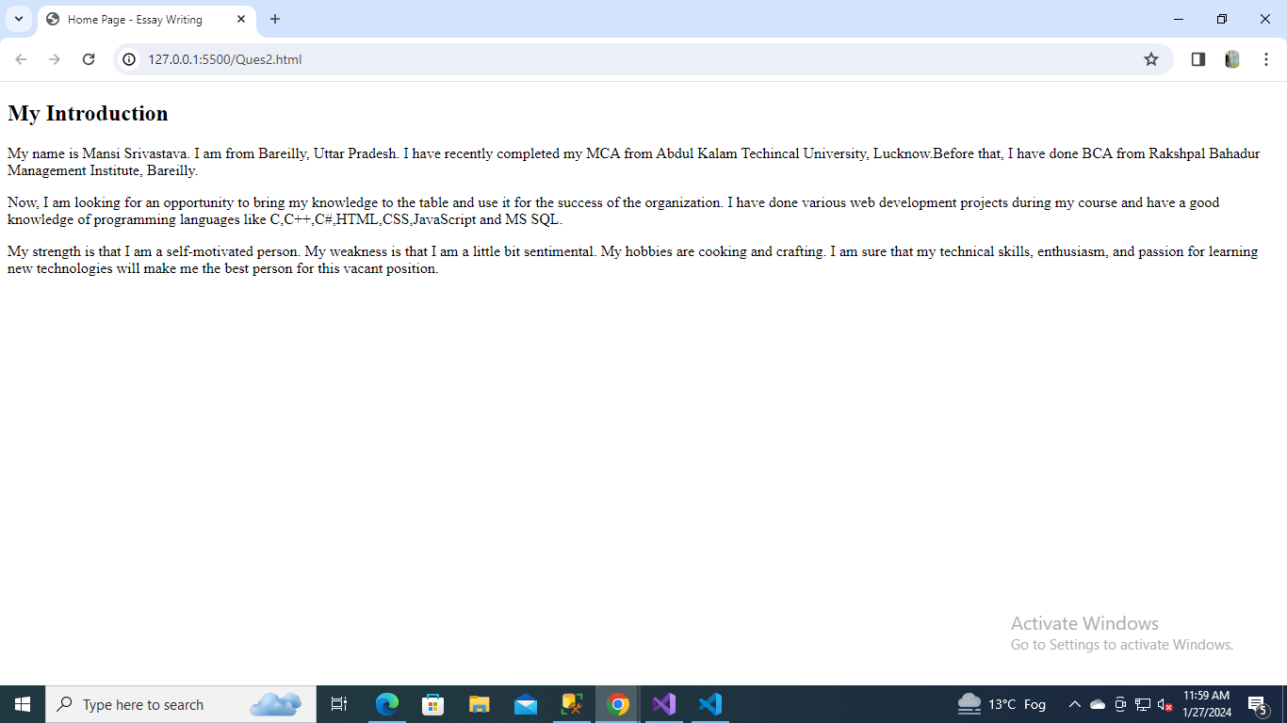

**Ques 3) What are the Benefits of Using meta tags.**

**Solution:-** Meta tags are pieces of information you use to tell the search engines and those viewing your site more about your page and the information it contains.

The Benefits of Using meta tags:-

### **Relevancy:** Meta tags can show search engines how relevant a page is to a user's query.

### **Improved search rankings:** Optimizing specific meta tags can improve search rankings and affect click-through rate (CTR).

### **Better user experience:** Meta tags can provide context for readers and improve the click-through rate.

### **Quick implementation:** Meta tags can be implemented quickly.

### **Better metric tracking:** Meta tags can help with better metric tracking.

* **Time-saving**: Metadata tagging can save time by automating the process of adding descriptive information to digital assets. Many software tools can automatically generate metadata based on the asset’s content.
* **Consistency**: A metadata tagging system can help ensure that all digital assets are consistent with brand guidelines by adding standardized tags and descriptions.
* **Analytics**: Many metadata tagging systems offer analytics tools that can help businesses track asset usage, measure performance, and gain insights into their digital asset management strategy.

**Ques 4) Create an HTML document that properly incorporates semantic elements like <header>,<article>, <section>, or <nav> to improve SEO and document structure.**

**Solution:- Index.html**

**<!DOCTYPE html>**

**<html lang="en">**

**<head>**

**<meta charset="UTF-8" />**

**<meta name="viewport" content="width=device-width, initial-scale=1.0" />**

**<title>Question 4</title>**

**</head>**

**<body>**

**<header>**

**<h1>Welcome to My Personal Portfolio</h1>**

**<nav>**

**<ul>**

**<li><a href="/">Home</a></li>**

**<li><a href="./About.html">About</a></li>**

**<li><a href="./Contact.html">Contact</a></li>**

**</ul>**

**</nav>**

**</header>**

**<article>**

**<header>**

**<h2>Semantic Elements In HTML</h2>**

**</header>**

**<hr>**

**<section>**

**<h3>Introduction</h3>**

**<p>**

**A semantic element clearly describes its meaning to both the browser and the developer.**

**</p>**

**<p>**

**Examples of <strong>semantic</strong> elements: <code class="w3-codespan">&lt;form&gt;</code>, <code**

**class="w3-codespan">&lt;table&gt;</code>, and <code class="w3-codespan">&lt;article&gt;</code> -**

**Clearly defines its content.**

**</p>**

**<br>**

**<h3>Semantic Elements in HTML</h3>**

**<p>**

**Many web sites contain HTML code like:**

**&lt;div id="nav"&gt; &lt;div class="header"&gt; &lt;div id="footer"&gt;**

**to indicate navigation, header, and footer.**

**</p>**

**</section>**

**</article>**

**<hr>**

**<footer>**

**<p>&copy; 2024 Your Personal Portfolio. All rights reserved.</p>**

**</footer>**

**</body>**

**</html>**

**About.html**

**<!DOCTYPE html>**

**<html lang="en">**

**<head>**

**<meta charset="UTF-8" />**

**<meta name="viewport" content="width=device-width, initial-scale=1.0" />**

**<title>About</title>**

**</head>**

**<body>**

**<h2>About</h2>**

**</body>**

**</html>**

**Contact.html**

**<!DOCTYPE html>**

**<html lang="en">**

**<head>**

**<meta charset="UTF-8" />**

**<meta name="viewport" content="width=device-width, initial-scale=1.0" />**

**<title>Contact</title>**

**</head>**

**<body>**

**<h2>Contact</h2>**

**</body>**

**</html>**

**OUTPUT:-**

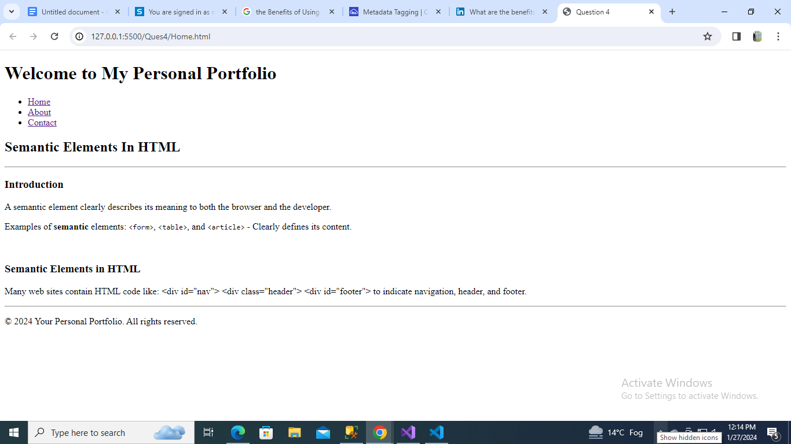

**Ques 5) Define Favicon and give an illustrative example.**

**Solution:-** HTML Favicon is a small icon that represents a website and appears in the browser’s tab or bookmark bar. It is defined in HTML using the <link> tag with the rel attribute set to “icon.” The Favicon is also known as the Favorite icon.

This icon is actually displayed on the address bar, browser's tab, browser history, bookmark bar, etc. The image of a favicon is in .ico file format. There are various file formats, but .ico format is supported by all the browsers.

**Example:-**

<!DOCTYPE html>

<html lang="en">

<head>

<meta charset="UTF-8">

<meta name="viewport" content="width=device-width, initial-scale=1.0">

<title>BookWorld - Your Online Bookstore</title>

<!-- Favicon -->

<link rel="icon" href="favicon.ico" type="image/x-icon">

</head>

<body>

<h1>Hello World!!!</h1>

</body>

</html>

**OUTPUT:-**