File Lifetime Script

files=`ls`
for file in $files
do
if getfattr -n user.flt --only-values $file > /dev/null 2>&1
then
flt=`getfattr -n user.flt --only-values $file`
num="$(echo $flt | cut -d' ' -f1)"
unit="$(echo $flt | cut -d' ' -f2)"
now=`date +"%c"`
fad1=`stat -c %x $file | cut -d' ' -f 1-2`
fad2=`date -d "$fad1" +"%c"`
newdate=`date --date="$fad2 +$num $unit" +"%c"`
d1=`date -d"${newdate}" +%Y%m%d%H%M%S`
d2=`date -d"${now}" +%Y%m%d%H%M%S`
if [ $d1 -lt $d2 ]
then `rm $file`
fi
fi
done

Steps to call the above script automatically after user logs in to desktop :

1) $ nano ~/.config/autostart/my_script.desktop

2) [Desktop Entry]
Type=Application
Name=File Lifetime
Exec=sh fltscript.sh
Icon=system-run
X-GNOME-Autostart-enabled=true
3) Properties --> Permissions --> Allow executing file as program

Screenshots
1) Create a file (testflt.txt)
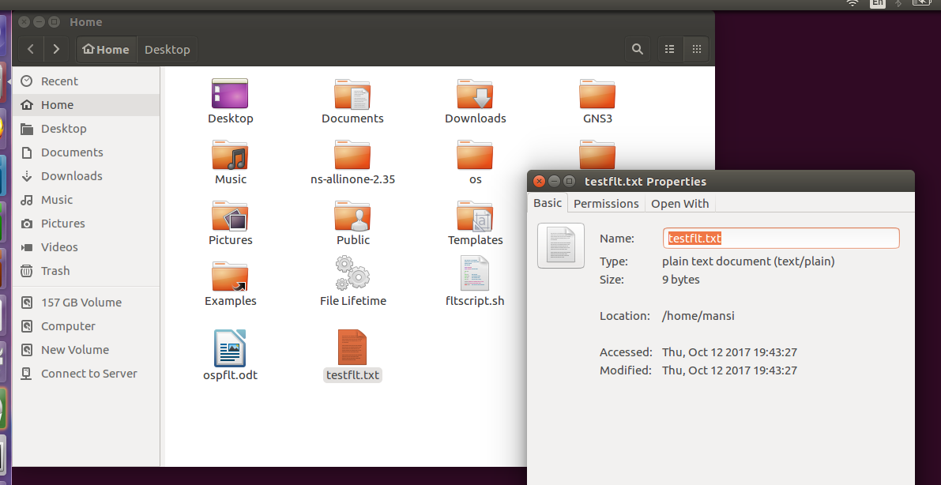
2) Setting user.flt attribute to file indicating file lifetime
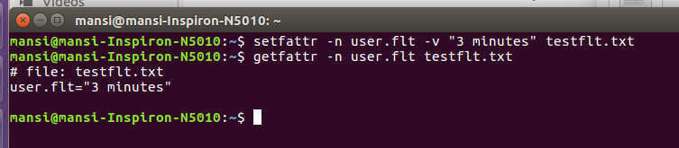
3) Properties of desktop configuration file
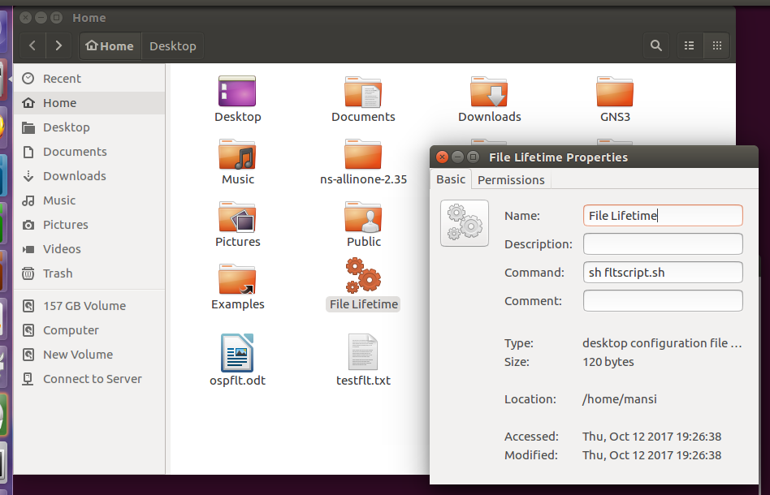
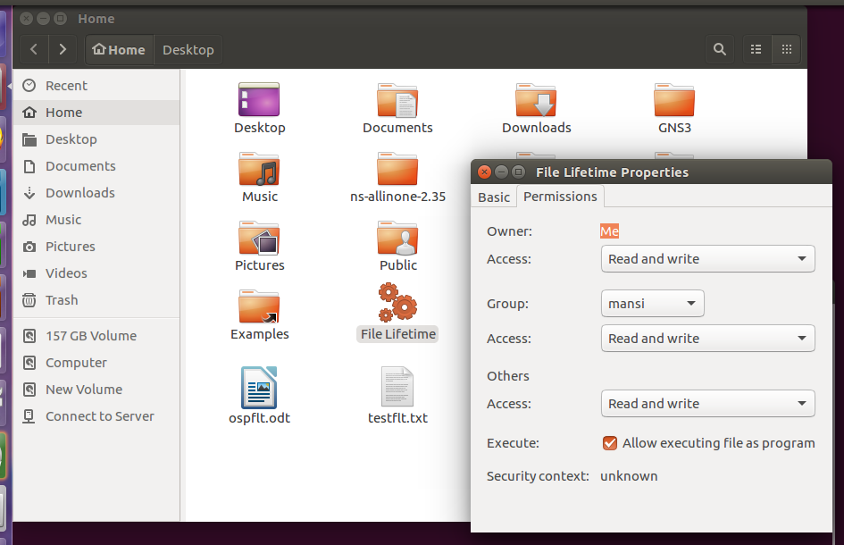
4) File (testflt.txt) deleted after user login
