**Create the following test scenarios using the cucumber framework**

**Preconditions:**

Chrome browser version: 64.0.3282

**TESTCASE 1: *Valid Sign up .***

**Step1:** Create the valid sign up scenario using cucumber framework

**Scenario.feature**

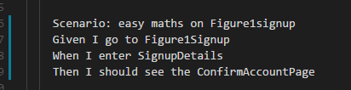

**Steps.js**

const { Given, When, Then } = require('cucumber')

const chai = require('chai')

const should = chai.should()

"use strict";

Given('I go to Figure1Signup', function(callback) {

this.browser

.init()

.url('https://app.figure1.com/account/register').then(function() {

callback();

})

})

When('I enter SignupDetails', function(callback) {

this.browser

.waitForVisible('.register-page__username-input')

.setValue('.register-page__username-input','mansi_sqat_20')

.setValue('.register-page__email-input','figure1.xyz20@gmail.com')

.setValue('.register-page__password-input','Sqat06')

.setValue('.register-page__confirm-password-input','Sqat06')

.addValue('.register-page__specialties-list',' Student')

.waitForVisible('.register-page__specialties-other-list')

.addValue('.register-page__specialties-other-list','Nursing Student')

.click('.box')

.click('.register-page__submit-button')

.then(function(){

callback();

}).catch(function(error){

callback(error);

})

})

Then('I should see the ConfirmAccountPage', function(callback) {

this.browser.waitForVisible('.email-confirmation-intro',3000)

.$('#ember556').getText('div').getText('h2').then(function(result){

result.should.equal("Confirm your account, mansi_sqat_20");

callback();

}).catch(function(error){

callback(error);

})

})

**TESTCASE 2: *In-Valid Sign up – Username Already Exists***

**Step2:** Create the ***In-Valid Sign up – Username Already Exists*** scenario using cucumber framework

**Scenario.feature**

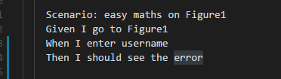

**Steps.js**

Given('I go to Figure1', function(callback) {

this.browser

.init()

.url('https://app.figure1.com/account/register').then(function() {

callback();

})

})

When('I enter username', function(callback) {

this.browser

.waitForVisible('.register-page__username-input')

.setValue('.register-page__username-input','mansi_sqat')

.setValue('.register-page__email-input','mansi.mini@gmail.com')

.setValue('.register-page__password-input','Sqat06')

.setValue('.register-page__confirm-password-input','Sqat06')

.addValue('.register-page__specialties-list',' Student')

.waitForVisible('.register-page__specialties-other-list')

.addValue('.register-page__specialties-other-list','Nursing Student')

.click('.box')

.click('.register-page__submit-button')

.then(function(){

callback();

}).catch(function(error){

callback(error);

})

})

Then('I should see the error', function(callback) {

this.browser

.waitForVisible('.error-message-light',2000)

.getText('.error-message-light').then(function(result){

result.should.equal('An account with that username already exists.');

callback();

}).catch(function(error){

callback(error);

})

})

Given('I go to Figure1Passwords', function(callback) {

this.browser

.init()

.url('https://app.figure1.com/account/register').then(function() {

callback();

})

})

**TESTCASE 3: *In-Valid Sign up –Minimum length of Password Characters***

**Step3:** Create the ***In-Valid Sign up – Minimum length of Password Characters*** scenario using cucumber framework

**Scenario.feature**

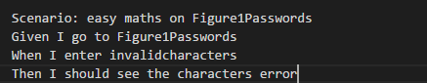

**Steps.js**

Given('I go to Figure1Passwords', function(callback) {

this.browser

.init()

.url('https://app.figure1.com/account/register').then(function() {

callback();

})

})

When('I enter invalidcharacters', function(callback) {

this.browser

.waitForVisible('.register-page__username-input')

.setValue('.register-page__username-input','mansi_sqat')

.setValue('.register-page__email-input','mansi.mini@gmail.com')

.setValue('.register-page__password-input',' ')

.setValue('.register-page__confirm-password-input','Sqat06')

.addValue('.register-page__specialties-list',' Student')

.waitForVisible('.register-page__specialties-other-list')

.addValue('.register-page__specialties-other-list','Nursing Student')

.click('.box')

.click('.register-page__submit-button')

.then(function(){

callback();

}).catch(function(error){

callback(error);

})

})

Then('I should see the characters error', function(callback) {

this.browser

.$('#ember334').getText('span').then(function(result){

result.should.equal('Password must be at least 6 characters long');

callback(); })

.catch(function(error){

callback(error);

})

})

**Step4:** From the command prompt window, enter into the directory using the command **cd SQAT06**

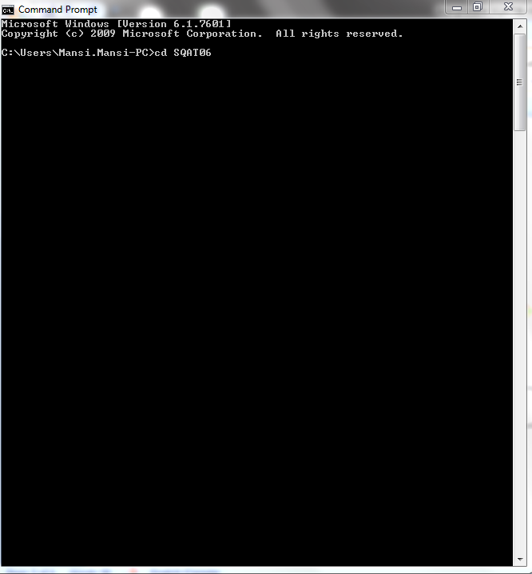

**Step5:** start the selenium server using the command: **selenium-standalone start**

**Step 6:** open up a new GIT BASH command prompt

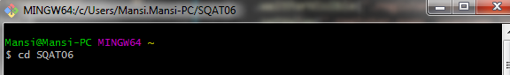

**Step 7:** Enter the command to run the test in GIT BASH



./node_modules/.bin/cucumber-js

**Step 8: TEST RESULTS**

