**Software Requirements Specification**

**for**

University Blog Site

**Version 1.0 approved**

**Prepared by 20CS071**

**CSPIT-CSE**

**02-02-2022**

**Table of Contents**

**Table of Contents ii**

**Revision History ii**

**1.** **Introduction 1**

1.1 Objective 1

1.2 Document Conventions 1

1.3 Intended Audience and Reading Suggestions 1

1.4 Project Scope 1

1.5 References 1

**2.** **Overall Description 2**

2.1 Product Perspective 2

2.2 Product Features 2

2.3 User Classes and Characteristics 2

2.4 Operating Environment 2

2.5 User Documentation 3

2.6 Assumptions and Dependencies 3

**3.** **System Features 3**

3.1 System Feature 1 3

**4.** **External Interface Requirements 4**

4.1 User Interfaces 4

4.2 Hardware Interfaces 5

4.3 Software Interfaces 5

4.4 Communications Interfaces 5

**5.** **Other Nonfunctional Requirements 5**

5.1 Performance Requirements 5

5.2 Safety Requirements 6

5.3 Security Requirements 6

5.4 Software Quality Attributes 6

**6.** **Other Requirements 6**

**Appendix A: Glossary 6**

**Appendix B: Analysis Models 7**

**Appendix C: Issues List 7**

**Revision History**

| **Name** | **Date** | **Reason For Changes** | **Version** |
| --- | --- | --- | --- |
|  |  |  |  |
|  |  |  |  |

# 1) **Introduction**

## 1.1 **Introduction**

*I am designing a website for university blogging because when it comes to education, blogging can be an excellent tool for students to develop their interests, improve their involvement and excitement and most importantly writing skills.*

*The basic motto of this project is to give all the students to express their passion and share their knowledge with other students.*

## 1.2 Document Conventions

I have chosen fonts and highlighted certain information which will be reader friendly.

## 1.3 **Intended Audience and Reading Suggestions**

*This project is a prototype for the micro-blogging site and it is restricted within the college. This has been implemented under the guidance of college professors. The intended audience is the University students and faculty members. The students can reach a broader audience and can receive constructive feedback.*

## 1.4 **Project Scope**

*The basic motto of this project is to allow students and teachers to blog and share their content and knowledge about new innovations and technologies. Blogger always needs to*

* *develop unique and original content (not taken from the internet)*
* *Solve problems*
* *Express their perspective and personality*
* *Respond to others through comments and feedback*

*I hope to provide a comfortable user experience.*

* **1.5 References**

*Reference has been taken from python and web designing using flask tutorials. Many references have been taken from different platforms that provide free notes and information like GeeksForGeeks, StackOverflow etc.*

# 

# 2) **Overall Description**

## 2.1 **Product Perspective**

## 2.2 Product Features

*A university blogging website contains the following information:*

* ***USER MANAGEMENT SYSTEM****We have to register new users. Once they’ve registered they can Login. If they forget their password then they can get a password reset email. There’s an ACCOUNT option, where the user can access information of his account and also update the details.*
* ***NEW POST****This gives the user the ability to write a new post and submit it to the database.*
* ***HOME****The home page allows us to read the blogs posted by other users and update or delete our own blogs.*
* ***INTERACTION AMONGST USERS****This feature allows the user to interact with other users and give feedback through likes and comments.*

## 2.3 **User Classes and Characteristics**

*Users of the system will be able to create new posts which can be of the size of a tweet or can be a descriptive blog. There’ll be two kinds of users, teachers and students. For the current model, both of them will have equal privileges. In further updates, there will be moderators to inspect the content of the blog, so that the blog is not plagiarized or contains any harmful content.*

*The user should be able to do the following functions:*

*• Create, delete or update their blog  
• Interact with other users by the features of likes, comments etc.  
• User Authentication (Sign Up, Login)*

* **2.4 Operating Environment**

*Operating environment for developing University Blog Post is as listed below:*

* *distributed database*
* *client/server system*
* *Operating system: Mac.*
* *database: SQLAlchemy*
* *platform: Python, Flask, Bootstrap*

## 2.5**User Documentation**

* + *The developed system should run under any platform*
  + *All mandatory fields should be filled by individual*
  + Details provided by the user must be stored in the database.

## 2.6 **Assumptions and Dependencies**

*No third-party or commercial components are being used which could affect the requirements stated in this SRS.*

# 3) **System Features**

## 3.1 **System Feature 1**

**3.1.1** **Description and Priority**

*The user enters his email address and a verification code is sent to that email address and when the information checks out the user gets the prompt to create an account. The system shall be reliable and user friendly. The features of login, register, create, update or delete a blog post, and the ability to view and interact with other blogs is given.*

**3.1.2 Stimulus/Response Sequences**

* + *Allows users to blog about innovative, technical or non-technical original content. Regardless of the medium, a blog is always defined by the quality of its published content.*
  + *Allows them to read blogs by other users and have interactions with them by feedback or discussions.*

**3.1.3** **Functional Requirements**

* *The website should be able to manage and store user data.*
* *The website should be able to allow users to create, update, delete and like or comment on a post.*

# 4) **External Interface Requirements**

## 4.1 **User Interfaces**

*Front-end Software: Visual studio code,Bootstrap.*

*Back-end: SQLAlchemy*

* **4.2****Hardware Interfaces**

*Browser which supports Python and Flask*

## 4.3 **Software Interfaces**

*Following are the software used for University Blog Site.*

| ***Software used*** | ***Description*** |
| --- | --- |
| *Operating system* | *I have chosen the Mac operating system for its best support and user-friendliness.* |
| *Database* | *To save the posts, user records I have chosen SQLAlchemy database.* |
| *Visual studio code* | *To implement the project we have chosen Python and Flask* |

## 4.4 **Communications Interfaces**

*This project supports all types of web browsers.*

**5) Other Nonfunctional Requirements**

## 5.1 **Performance Requirements**

*As the project is web based so there are no specifications for performance but in further updates the university management will be able to restrict the registering process only to university students through their university email account and no one outside the university will be able to access it i.e only the faculty members will be able to assign the account. And furthermore, there’ll be moderators to inspect the contents of the post.*

## 5.2 **Safety Requirements**

*If a product’s safety mechanisms work reliably, nobody gets hurt. The system protects users from harm and property from damage.*

## 5.3 **Security Requirements**

*All required standards and provisions are implemented to avoid data breaches. The app should be completely secure: no one can steal anyone’s data or impersonate anyone. Further updates will focus more on the system to protect against malware attacks, intruders, unauthorized users, and data theft.*

## 5.4 **Software Quality Attributes**

* ***AVAILABILITY:*** *This University Blog website is available 24*7.*
* ***DYNAMIC:*** *New entries and regular updates are key to running any kind of blog.*
* ***SIMPLE STRUCTURE:*** *First comes a header with the menu or navigation bar to declutter the page and make a great first impression. It’s followed up by the main content area on which blog posts appear either by order of publishing or by relevance.A sidebar highlights favorite entries and displays social profiles and call-to-actions.*
* ***USABILITY:*** *The University Blog site should help the maximum number of students to improve their writing skills, learn with a community of students and improve their brain’s performance.*
* ***MAINTAINABILITY:*** *The users are easily able to create, update and delete the blogs.*

# **Other Requirements**

*Good internet connection is required. It is a simple user-friendly interface. It is presumed that the user knows how to use the blog site.*

**Appendix A: Glossary**

*Python: A programming Language*

*Flask: A python framework for Web Development*

*Bootstrap: The primary purpose of adding it to a web project is to apply Bootstrap's choices of color, size, font and layout to that project.*

*SQLAlchemy: SQLAlchemy is an open-source SQL toolkit and object-relational mapper for the Python programming language released under the MIT License.*

**Appendix B: Analysis Models**

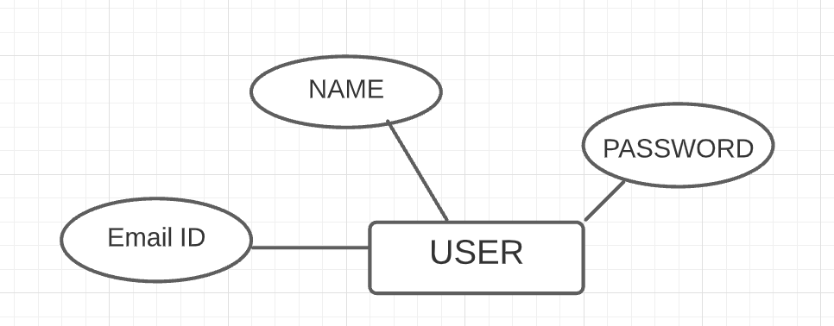

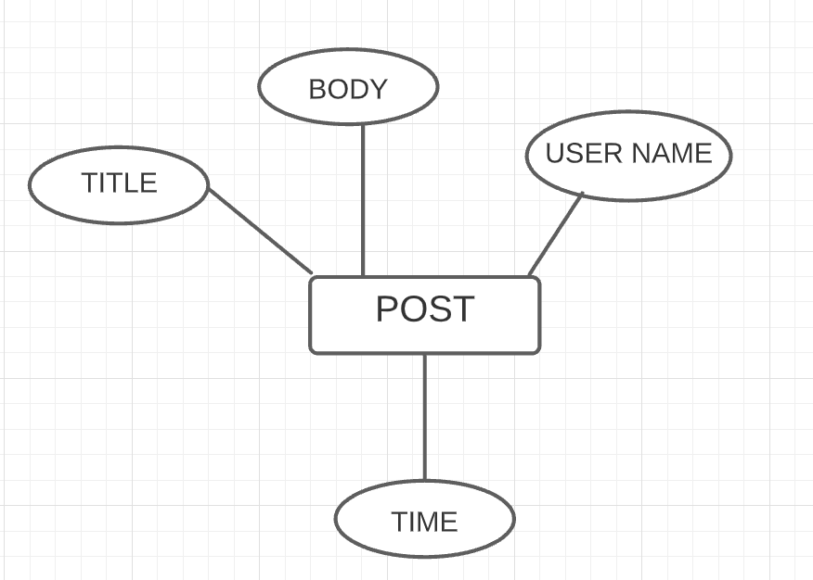

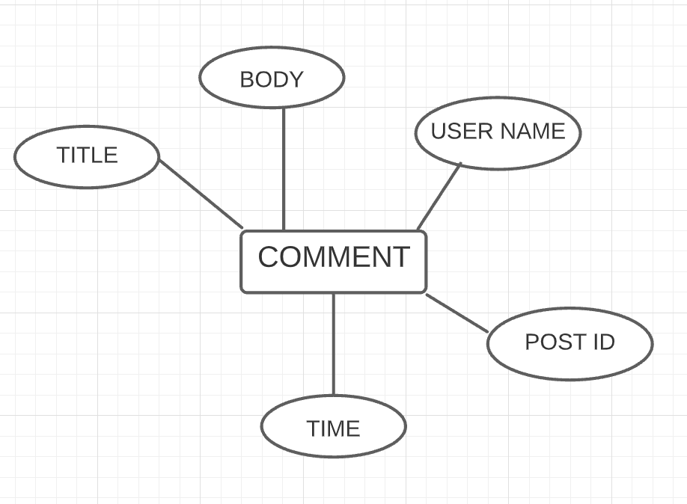

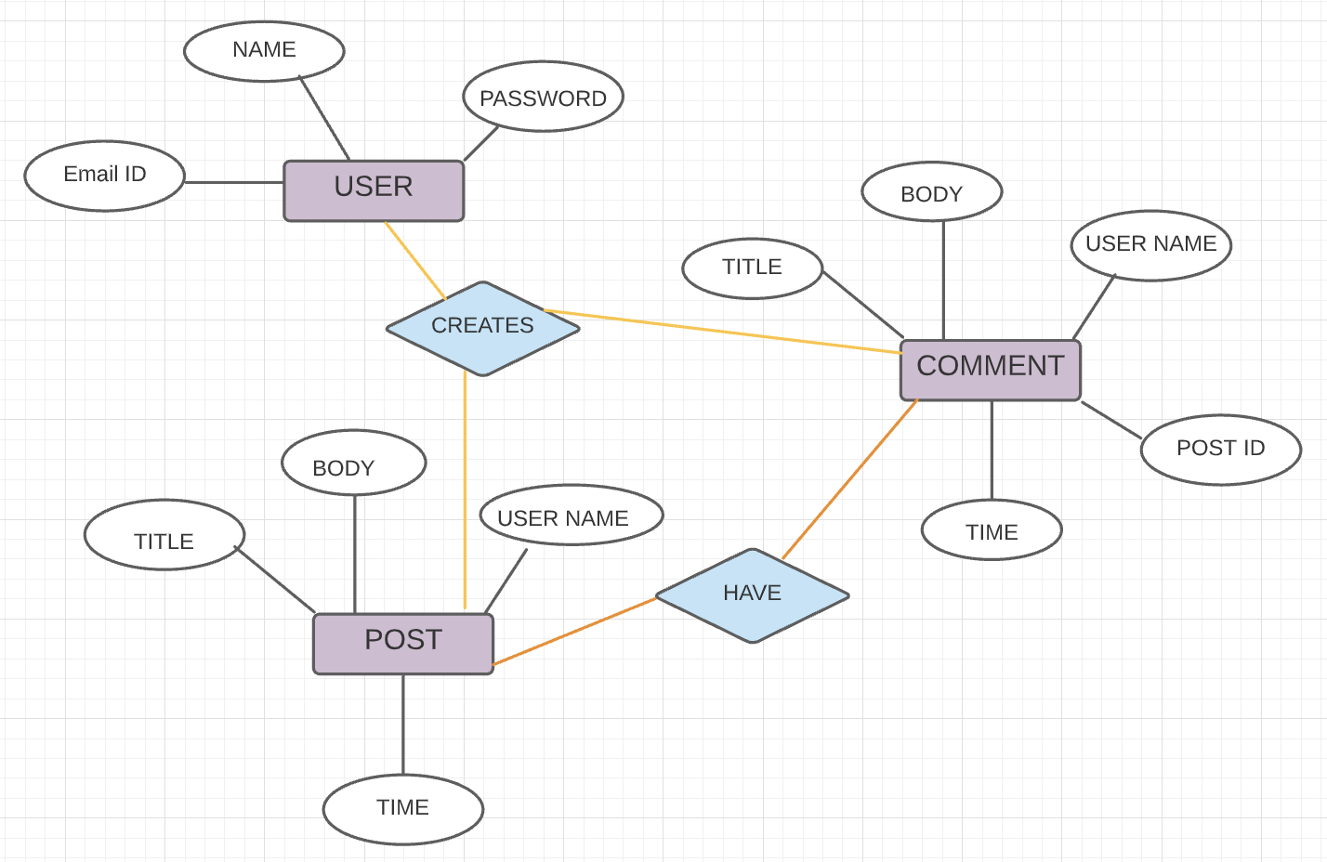

**Appendix C: Issues List**

*References*

[*https://krazytech.com/projects/sample-software-requirements-specificationsrs-report-airline-database*](https://krazytech.com/projects/sample-software-requirements-specificationsrs-report-airline-database)