“Yes, I would like to understand the key priorities for this role and the major challenges the team is currently facing. Also, what would success look like in the first few months?”

Carrier.titan.in

Hardware:
Physical component of any computer (cpu, memory(ram), storage(disk), motherboard and networking interfaces).
OS interacts with hardware using device drivers

Two primary interfaces who want to interact with the hardware or who wants to interact with computer
- Users 2. Software applications
User want to create files/folders on computer or to manage resources of the hardware, to check status of the cpu.
Applications: example Youtube. It needs CPU, memory and some disk space. All of these are available with hardware.
Both users and applications cannot interact with hardware directly.
Intermediate layer OS can help them.
What is os? : special software program that knows how to use hardware
Specifically for users os provides additional layer : CLI/GUI :- Through this layer users interact with OS. Which in turn talk to hardware resources.
OS is intermediate software layer that acts as a bridge between software and hardware or acts as a bridge between user and hardware.
1960’s : unix 1st OS
1970’s : Mimix (on top on unix)
1980’s : windows (rich GUI)
Unix and mimix propietery (paid licence)
1990’s : Person linus worked on development of linux kernel. 1st popular Open source os
Linux is not backed by a single company. It is backed by a community of developers. Due to their active contributions they ensure linux is secure.
Why linux: it is open source, it is free and it is super secure compared to other OS.
Main component of linux OS: Linux kernel. Its like engine of car which does heavy lifting. It takes care of process management, memory management, file system management, network management
System utilities (ls, grep, systemctl etc) rich in featues
System libraries (glibc, libc, openssl etc)
Shell is mandatory.

CLI
System Libraries
System Utilities
kernel

How to install linux in machine?
Wsl : windows subsystem for linux
$wsl –install
user@hostname:~$
: separator
~ /home/user
~ home directory of any user that you logged in
Package Manager: Tool that automates process of installing, updating, configuring and removing software in a linux system. It ensures softwares and its dependencies are managed effectively.

These libraries are used by linux kernel for making system calls with hardware or execute an action.
/sbin: system binaries (/usr/sbin)
/bin: user binaries (/usr/bin)
Parent directory : /usr
/srv: webserver
/opt: common location for 3rd party dependencies
/mnt: folder used by linux administrators to mount new volumes. Volumes are nothing but new disks. Let’s say we have 20GB initially. It got filled and we need 30GB extra. We will procure 30GB disk somewhere. Temporary or permanent disk. They have to mount it or add it to temporary location they they will add disk to file system.
/var: used to store log files or 3rd party libraries
/data: Any data that can be shared with other people in organization or other admins in the organization
/tmp: files and folders inside /tmp are removed after certain time frame.
/run: stores run time data of the processes.
/etc: has lot of system configuration files. It is like settings on your mobile phone or laptop
$which ls
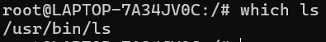
$echo $PATH
User management:
Users and groups.
Create user and each user is granted permissions.
For devops user : admin access

Creating user
$useradd aveeramala

Create user with home directory
$useradd -m aveeramala
Creates user aveeramala
Creates home directory /home/aveeramala

How to check if user is created successfully?
$vi /etc/passwd
$cat /etc/passwd
If vim do not exist install:
apt install vim
How to set up password of user?
$passwd aveeramala

Lock user
$passwd -l aveeramala

Unlock user
$passwd -u aveeramala

$chage -M 90 aveeramala
User should change password every 90 days

How to check if password is created?
$cat /etc/shadow

If someone forgets password there is no way to restore old password

If user leaves org how can I delete user?
To remove user but keep home directory
$userdel aveeramala

To remove user and their home directory
$userdel -r aveeramala

Useradd does not create home directory of user or save user details.
Instead of useradd we should use adduser. Adduser sets user password, ask user details and creates user home directory
How to switch to new user?
$su – aveeramala
Useradd is used in scripts as its noninteractive

At user level, as users grow, managing permissions, deleting permissions, deleting a particular user in the group is going to be difficult.
If we create groups we can do directly at group level.
$groupadd devops
$cat /etc/group
$usermod -aG devops aveeramala
-a : append
-G : supplementary groups

Can we restore password of a linux user?
If password is not stored in file or LDAP or SSO of organization, there is no way to restore the password.

File and Directory Management
- ls – Lists files and directories in the current location.
- cd /path/to/directory – Changes the working directory.
- pwd – Prints the current working directory.
- mkdir new_folder – Creates a new directory.
- rmdir empty_folder – Removes an empty directory.
- rm file.txt – Deletes a file.
- rm -r folder – Deletes a folder and its contents.
- cp file1.txt file2.txt – Copies a file.
- cp -r dir1 dir2 – Copies a directory recursively.
- mv old_name new_name – Moves or renames a file or directory.

Vim is a wrapper on vi

File Viewing and Editing
- cat file.txt – Displays file content.
- tac file.txt – Displays file content in reverse order.
- less file.txt – Opens a file for viewing with scrolling support.
- more file.txt – Similar to less, but only moves forward.
- head -n 10 file.txt – Displays the first 10 lines of a file.
- tail -n 10 file.txt – Displays the last 10 lines of a file.
- nano file.txt – Opens a simple text editor.
- vi file.txt – Opens a powerful text editor.
- echo 'Hello' > file.txt – Writes text to a file, overwriting existing content.
- echo 'Hello' >> file.txt – Appends text to a file without overwriting

/pattern – Search forward for a pattern
?pattern – Search backward for a pattern
n – Repeat last search forward
N – Repeat last search backward
:%s/old/new/g – Replace all occurrences of "old" with "new"
:s/old/new/g – Replace all occurrences in the current line

Permissions for Files
Think of a file like a document 📄
Permission | Meaning (File)
r | Can read/view the file
w | Can edit/modify the file
x | Can run the file as a program
Example:
-rwxr-xr—

Permissions for Directories (Folders)
Think of a directory like a cupboard
Permission | Meaning (Directory)
r | Can see file names inside
w | Can add/delete files
x | Can enter the directory
Important difference:
- For files → x = run program
- For directories → x = enter/open folder

Modify file owner and group:
chown newuser filename # Change owner
chown newuser:newgroup filename # Change owner and group
chown :newgroup filename # Change only group

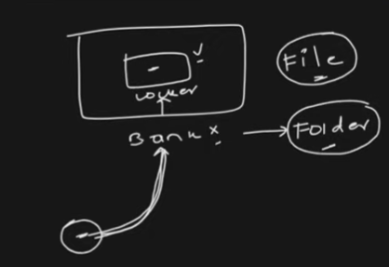

If I am others I need to check if I have access to folder? If yes then if I have access to file?
If I have access to file but not of folder there is no point.

chgrp newgroup filename # Change group
chgrp -R newgroup directory/ # Change group recursively

special permission
SetUID (s on user execute bit)
SUID value = 4000
Allow user to run a file with file owner’s permission
$chmod u+s filename

SetGID (s on group execute bit)
Files: Users run the file with the group's permissions. Directories: Files created inside inherit the group.
chmod g+s filename # Set on file
chmod g+s directory/ # Set on directory
Sticky Bit (t on others execute bit)
Used on directories to allow only the owner to delete their files.
chmod +t directory/
Example: /tmp directory.
Default Permissions: umask
umask defines default permissions for new files and directories. Check current umask:
umask
Set a new umask:
umask 022 # Default: 755 for directories, 644 for files

Process Management
Process is running instance of any program.
Imagine if one of the process is CPU intensive or memory intensive then this process is going to utilize much of your hardware resources.
Example : Python program having ML Model or AI model. It takes much of CPU time.

- Out of memory issue
- View processes or check running processes
- Kill certain processes or stop processes or after a while resume process once everything settles down
- Prioritize or deprioritize processes. CPU has algorithm which decides priority of processes. Most priority , less and least priority of processes

roy.aditiya@marriotthotels.com

View process :
$ps
$ps aux
A : show processes for all users
U : user oriented format
X : include processes not attached to terminal
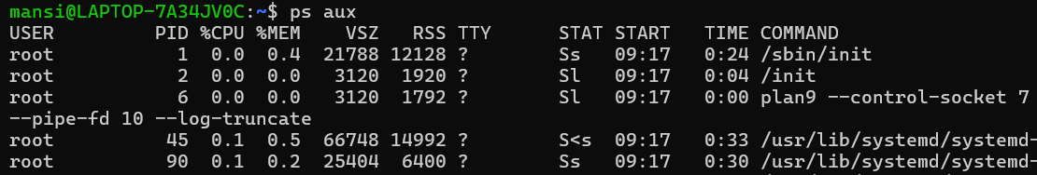

$ps aux | nl

Pipe takes output of first command and forwards to second command.
Nl : Line number

$ps aux | wc -l
32
(same as ps aux | nl)
Difference between ps aux and ps -ef
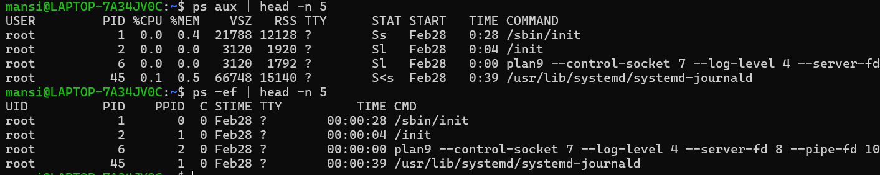

$ps aux shows cpu and memory utilization.
$ps -ef shows cpu utilization but not memory.

There can be some applications that might hang entire linux system. We need to kill that process.

Scenario1 : Can you find java application process that is running on the server and kill the process?
$ps -aux | grep java

$kill PID
This sends SIGTERM(15) – ask process to stop safely.

$kill -9 PID
Sends SIGKILL(9)-stops immediately

Scenario2: Java process takes lot of memory. Share thread dump for process.
$kill -3 <PID>
Sends SIGQUIT(Signal 3)
For normal programs->terminates + core dump
Java processes(JVM) -> prints Thread Dump (does not kill App)

$kill -3 24567

No message appears in terminal
Command runs silently
Check application logs

Temporarily pause or freeze a running process
$kill STOP 4048
Resume the process
$kill CONT 4048
Special process -> services (background process which start at the boot of the server)
Application : python, Java, Shell Script (all these are processes)
Service example (web server). So if linux server goes down and it comes up web server is running automatically.

$systemctl list-units –type=service

How to start, stop and check the services?
Services are special kind of process. Services start at the time of booting of your server.
Whenever server restarts, service starts automatically.

$ps aux
Does not show real time data.
$top
updates real time
real time cpu and memory utilization

$htop
Wrapper on top. Same info with more beautiful user interface.

$vmstat
Reports system performance in real time- cpu, memory, process,swap,I/O
We check if there is lot of free memory or not.
$vmstat 2
Updates every 2 seconds
$vmstat 2 5
Run 5 times at interval of 2 seconds.

Procs-processes
High r – CPU overload
High b – disk I/O issues

Low free memory + high swap = memory pressure
High si/so -> system struggling for memory
High bi/bo -> heavy disk usage
High System(in/cs) -> CPU overhead

$free -m

We cannot use top as it is visual representation.

How to check the number of CPU’s
nproc

CPU -> nproc, htop
Memory -> free, htop
Disk space -> df -h, du -sh *
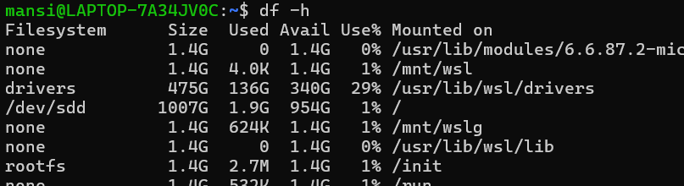

Prometheus scrapes metrics of linux environment using node exporter.
Once it gets this info, it puts in graphana. In graphana we can create dashboards which can send alerts such as email notification or slack notification to the dev team or SRE Team.
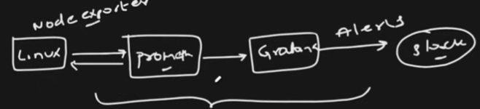

Imagine we are handling linux instance. It can be cloud instance or on premise instance.
Initially we set up instance with a storage or volume.
Imagine 5 applications running on linux instance.
Each application Every second, every minute keep adding logs.
Info logs
Debug logs
Application logs
Audit logs
Every day companies try to zip this or create a archive, compress it and store it on same instance.
After 3 or 6 months Instance will run out of storage.
Either we put it somewhere or backup or increase storage.

More storage is added to critical instances
Instance size is 8GB. Add 10GB to it. See how to format and also how to mount it to the instance.
If I just create a 10GB instance it does not work.
We need to mount it to /mnt or any specific location on linux instance, only then applications or any other programs can use that particular storage.
Volume that we create is of type blob storage.
Applications or programs cannot directly use blob storage.
We need to format the volume that we create to ext4 or xfs.

How to see volume that is added or storage that is added directly?
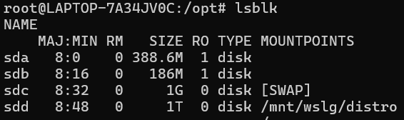

LSBLK: lists blocks that are attached to the instance.

Name starting with loop we can ignore. Virtual discs that are used by EC2 instance for snapshot or ISO images.

Focus on XVDA which is 8GB
We added a disk of 8GB. Disk is partitioned into 4 different parts.
On root (xvda1) :- 7GB
Xvda14/xvda15 :- used by boot
/boot has the images that are used by the EC2 instance during the time of boot typically during time of restart or shutdown.
$fdisk -l usually gives more information compared to lsbl.
Provides more details at the file system level or at the partition level.
What is partition?
You created a volume. Volume is of type block storage. This block storage instead of 8GB on a whole is divided into partitions.
Each partition can be formatted and mounted to a particular location.

On aws this storage is called EBS (Elastic block storage).
Instead of using 8GB and mounting it to a particular location on linux OS we will split this storage into partitions.
We will format each partition (like EXT4 or XFS) and mount that on folders like / or /boot
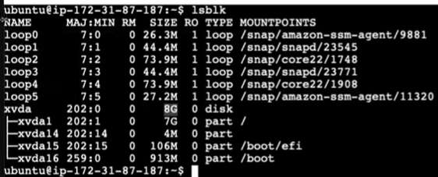
Open EC2 -> EBS (volumes)

EC2 -> instances (i-0e56d21ec9c33b51d) -> Availability Zone (eu-north-1b)
Volume should also be in same Data center.
1a, 1b or 1c are data centers. Only then we can add volume to the instance.
Volume : 10gb -> create volume (should not take much time)
Click on newly created volume (vol-0ef0b3bed1d5101d9) -> Actions -> Attach Volume -> Instance (Instance ID) -> Device name (/dev/sdf) -> Attach volume

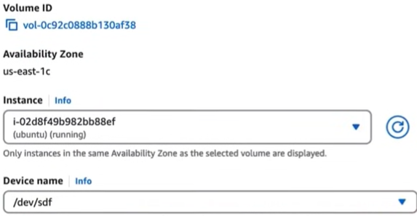

We should see volume status as in-use.

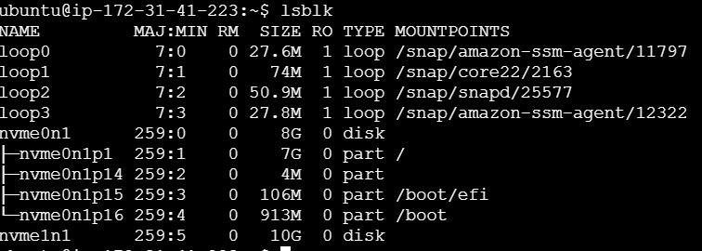

We cannot directly use 10GB at this point. Its of block storage and we have not mounted it yet. We need to split into partitions and format it to particular file system. Even if no partitions we need to format it.
We just have instance or volume at this point of time.
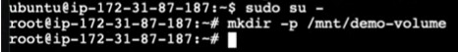

Mkfs -t ext4 /dev/nvme1n1
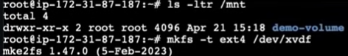

Mkfs Create file system
-t Specify filesystem type
Ext4 Filesystem format
/dev/sdb1 disk partition

Mount is used to mount a particular file system
Ext4 or XFS
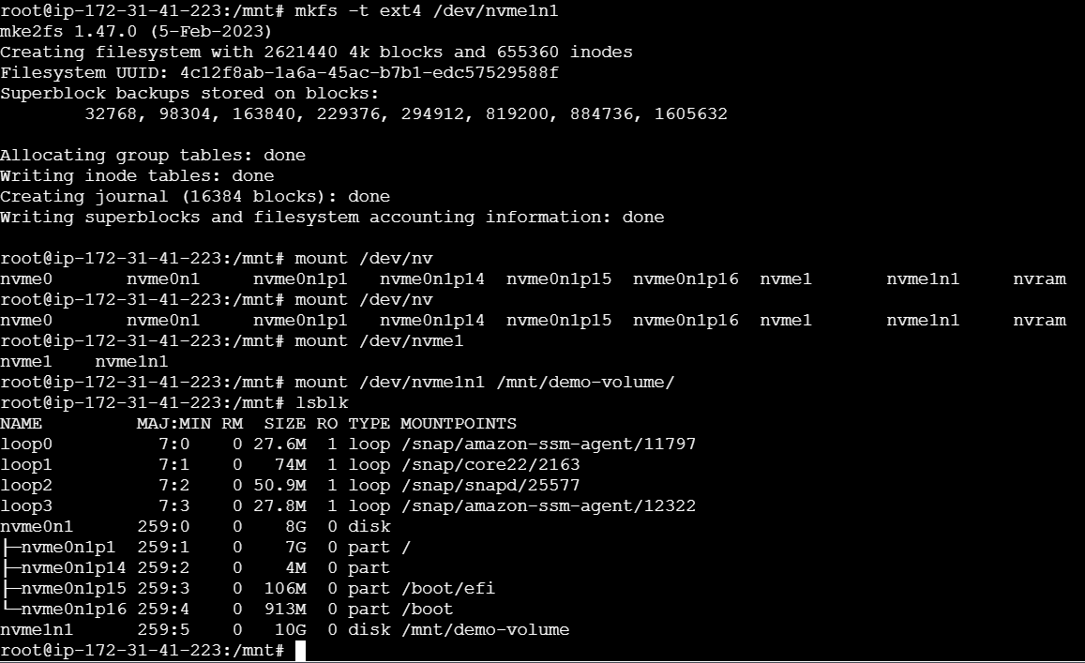

$mount /dev/nvme1n1 /mnt/demo-volume

How to add such instance or how to add volume to the existing instance.
